






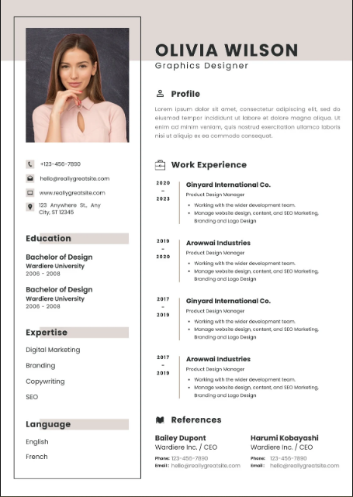
ggggddfdf df
Profile

Harumi Kabayashi
Wardare inc./ CEO
Bailey Dupont
Wardare inc./ CEO
References

Product Design Manager
- Working with the wider development team
- Manage website design content and seo marketing branding and logo design

2013
-
2019
Arawwal Industries

Work Experience

2020
-
2023
Ginyard International Co.
Product Design Manager
- Working with the wider development team
- Manage website design content and seo marketing branding and logo design
Language
English
French

Expertise
Digital Marketing
SEO

123-456-7890
Ab2@gmail.com
www.fahad.com
123 Anywhere St
Karachi 12345

12

erf
Bachelor of Design
Wardare university
2006-2008

Education

show up where you need them. To change the way a picture fits in your document, click it and a button for layout options appears next to it. When you work on a table, click where you want to add a row or a column, and then click the plus sign.

Graphics designer
MUHAMMAD FAHAD

f

