




Shan Fayyaz F2023019003
Hassan Ali F2023019009
M. Faizan F2023019004

Submitted to:
Maryum Shakeel


ABSTRACT

In this lab, the power bank for a Dell/HP laptop will be practically implemented using the concepts of EDC and basic Circuit theory. .

ABSTRACT 2
Problem Statement 4
Objective 4
Design 4
Components 4
Assembling 4
Batteries 4
Inverter 4
Switch and Driver 5
DC Pin 5
Working 5
Conclusion 6



Problem Statement
Battery bank for Dell/HP laptop.

Objective
To design an emergency power bank for Dell/HP laptop using the concepts that we have learned in the lab.

Design
We have to make a 20 Volt and 6 Amp power bank to charge our laptop, for this we are required the following components.

Components
- 2 pair of 4 – series cells ( 3 – 4 Volts )
- Inverter
- Box, switch and Dc pin

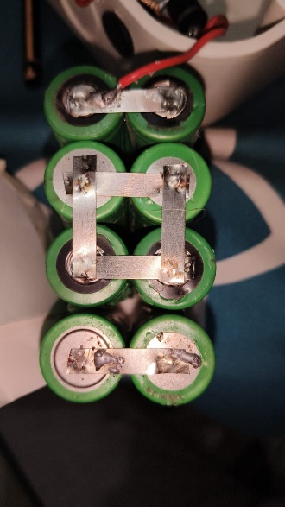
Assembling

Batteries
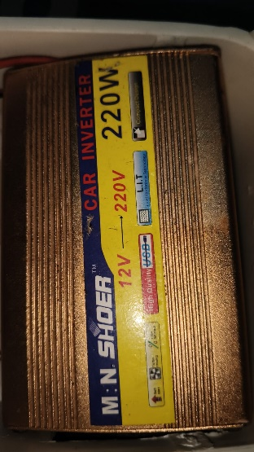
Our each cell is varying between ( 3 to 4 ) volts. So, for 20 Volt and 6 Amp battery we need to combine 4 cells in series and then in parallel with another pair of 4.

Inverter
We are required an inverter to convert DC volt from batteries to AC, for this we are using in-built car inverter that converts 12 Volt DC to 220 Volt AC. Packaging
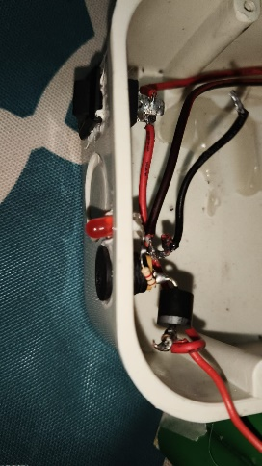
Switch and Driver
We added an ON/OFF switch to control the circuit and a driver to charge the batteries through the DC port.
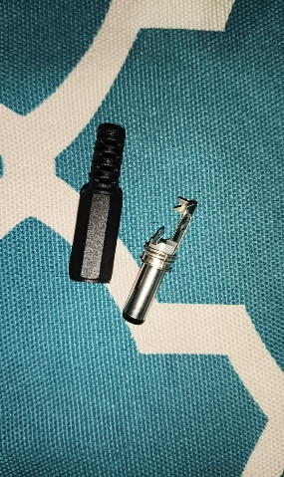

DC Pin
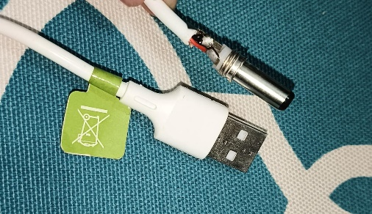
To charge the batteries we required a DC Pin.
We connected it with a USB cable wire. So, now we can charge our batteries using a normal 12 to 16 volt charger.

Working
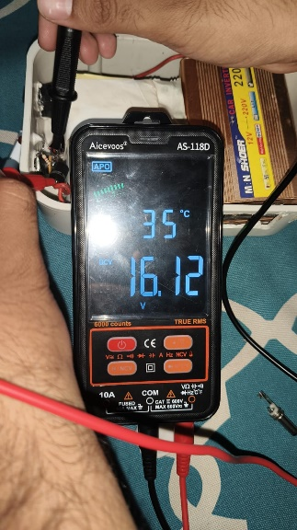
Initially we have to charge the batteries and then we have to connect the laptop charger to the inverter and it starts charging.
After charging the batteries they are on 16 Volts

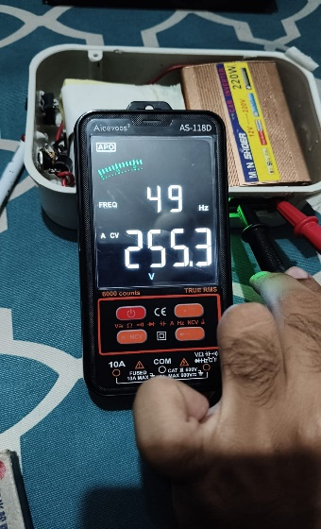
And the output on inverter is 250 Volts with almost 50 Hz frequency

Conclusion
We have successfully implemented the concepts of EDC in building this project and hence learned the inner functionality of this circuit. By converting AC to DC and DC to AC we can make various different devices and hence it is an example of this.

