**ASSIGNMENT # 02**

**OBJECT ORIENTED PROGRAMMING**



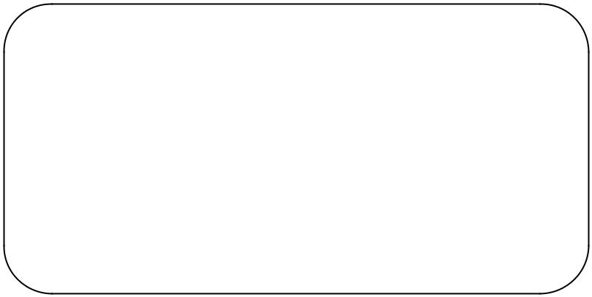

Name : **MUHAMMAD FARAZ ANSAR**

Year : **2019**

Batch : **2018-19**

Roll No : **SE-061**

Department: **SOFTWARE ENGINEERING**

**COURSE INSTRUCTOR: MISS ASMA KHAN**

**Department of Software Engineering**

**NED University of Engineering & Technology,**

**Karachi – 75270, Pakistan**

**FAN**

* **CODING:**

**#include <iostream>**

**#include<conio.h>**

**#include<string>**

**#include<sstream>**

**using namespace std;**

**class fan{**

**private:**

**const int slow=1;**

**const int medium=2;**

**const int fast=3;**

**int speed;**

**bool on;**

**double radius;**

**string color;**

**public:**

**template <class T>**

**string to_string(T t,ios_base & (*f)(ios_base&))**

**{**

**ostringstream oss;**

**oss << f << t;**

**return oss.str();**

**}**

**fan()**

**{**

**speed=slow;**

**on=false;**

**radius=5.0;**

**color="blue";**

**cout<<"speed of default fan is "<<speed<<endl<<"your default fan is "<<on<<endl<<"radius of your default fan is "<<radius<<endl<<"color of your default fan is "<<color<<endl;**

**}**

**void setmutator(int sp,bool state,double rad,string col)**

**{**

**speed=sp;**

**on=state;**

**radius=rad;**

**color=col;**

**}**

**bool getaccess_state(){**

**return on;**

**}**

**double getaccess_rad()**

**{**

**return radius;**

**}**

**int getaccess_speed()**

**{**

**return speed;**

**}**

**string getaccess_color()**

**{**

**return color;**

**}**

**string showdata(int sp,bool state,double rad,string col)**

**{**

**speed=sp;**

**on=state;**

**radius=rad;**

**color=col;**

**string st;**

**string str4="\t";**

**string str1=to_string(speed,hex);**

**string str2=to_string(on,hex);**

**string str3=to_string(radius,hex);**

**string str5=to_string(color,hex);**

**string str_if=str1+str4+str2+str4+str3+str4+str5;**

**string str_else=str2+str4+str3+str4+str5;**

**cout<<"\t\t\t\t data from show data function "<<endl;**

**if(on==true)**

**{**

**cout<<"speed"<<"\t"<<"state"<<"\t"<<"radius"<<"\t"<<"color"<<endl;**

**return str_if;**

**}**

**else**

**{**

**cout<<"state"<<"\t"<<"radius"<<"\t"<<"color"<<endl;**

**return str_else;**

**}**

**}**

**};**

**int main()**

**{**

**cout<<"\t\t\t\tdata from default constructor "<<endl;**

**fan fan1;**

**cout<<"\t\t\t\tdata from mutator and accessor functions "<<endl;**

**fan1.setmutator(0,false,2.0,"red");**

**bool i=fan1.getaccess_state();**

**int s=fan1.getaccess_speed();**

**double d=fan1.getaccess_rad();**

**string str=fan1.getaccess_color();**

**cout<<"speed of mutator-accessor fan is "<<s<<endl<<"your mutator-accessor fan is "<<i<<endl<<"radius of your mutator-accessor fan is "<<d<<endl<<"color of your mutator-accessor fan is "<<str<<endl;**

**string result=fan1.showdata(2,false,2.5,"orange");**

**cout<<result<<endl;**

**getch();**

**return 0;**

**}**

* **OUTPUT:**

**When fan is off in showdata function,output will be;**

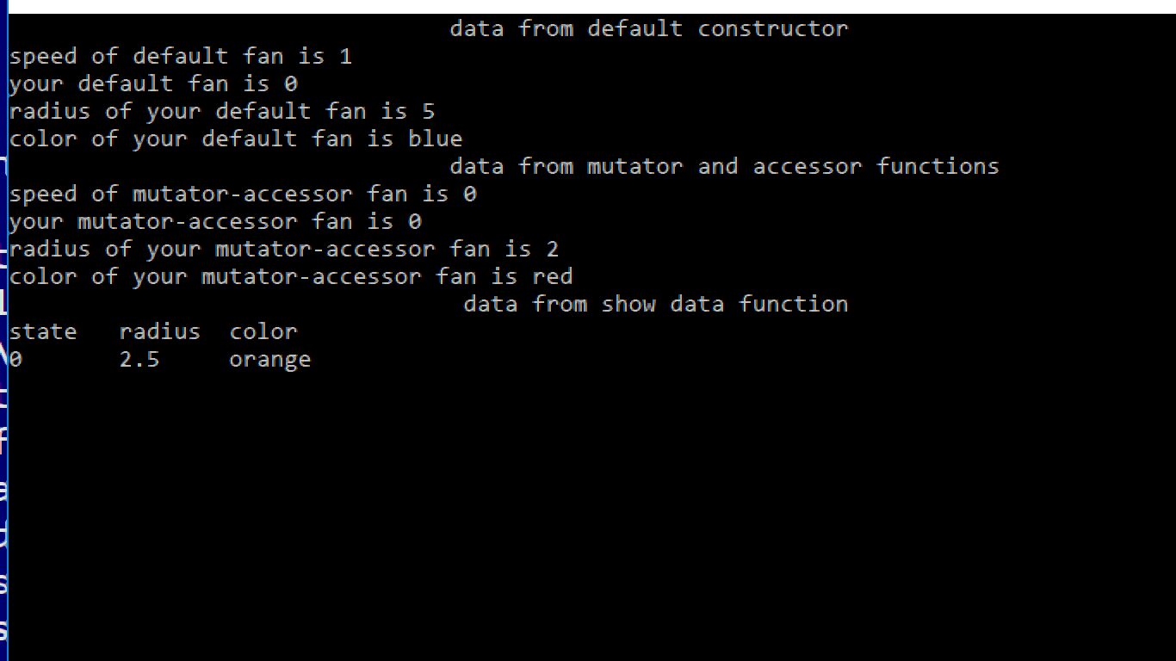

**When fan is on in showdata function output will be;**

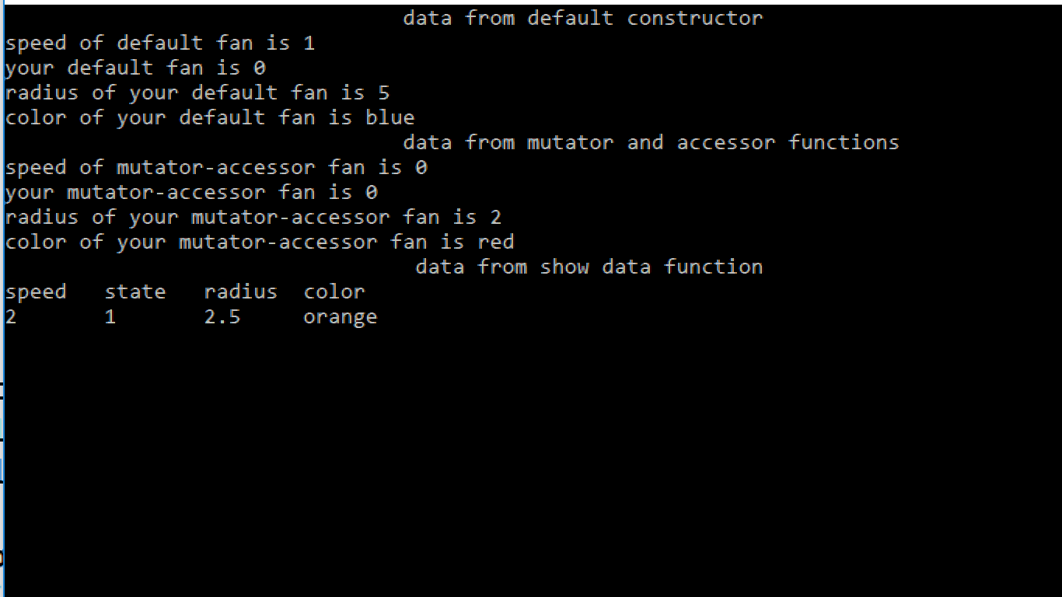

**PREPARED BY : MUHAMMAD FARAZ ANSAR (SE-061)**