**ASSIGNMENT # 01**

**DATABASE MANAGEMENT SYSTEMS**

NAME: MUHAMMAD FARAZ ANSAR

ROLL NO: SE-061

SUBMITTED TO: MISS DR RAHILA ASIF

**QUESTION # 01**

To design the database for the case study mentioned that is Hospital Management System, the first task which we have to perform is to Plan the Tables , Data , and Relationships between data.

* **TABLES FOR THE HOSPITAL MANAGEMENT SYSTEM AND RELATIONSHIP**
* **Wards**

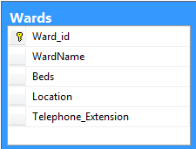

Where **Ward_id** is the **Primary Key**

* **Staff**

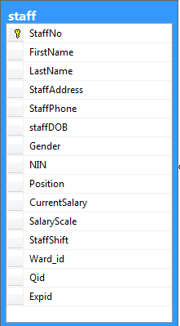

Where **StaffNo** is **Primary** **key** and **Staff** table is associated with **3** more tables that is staff has **Qualification**, staff has **Experience** and staff works in specific **ward. So Qid** and **Expid** are the **Foreign** **keys** in this table

* **Qualification**

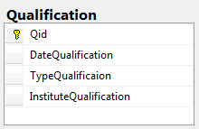

**Where Qualification has QId as Primary Key**

* **Experience**

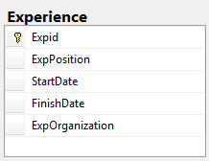

**Where Experience has Expid as Primary Key.**

* **Implementation of above tables Successfully**

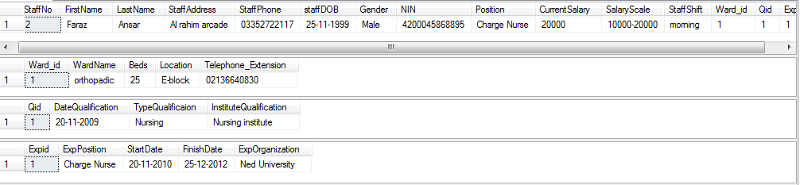

* **Patient**

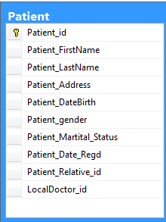

Where **Patient_id** is **Primary** **key** and **Patient** table is associated with **2** more tables that is **Patient** has **Relatives with him,** Patient has **Local Doctor** which referred him to the hospital. So, **Patient_Relative_id** and **Local_Doctor Id** is **Foreign** **Keys** in this table

* **Patient Relative**

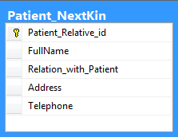

**Where Relative table has Patient_Relative_id** **as Primary Key**

* **Local Doctor**

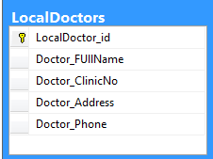

**Where Local Doctor table has Local_Doctor Id** **as Primary Key**

* **Implementation of above tables Successfully**

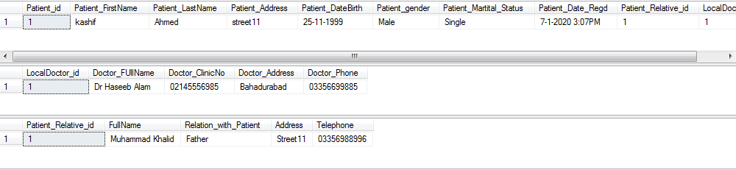

* **Ward Details**

**It is the table which is used when someone is going to admitted in the hospital and acquired a ward for stay.**

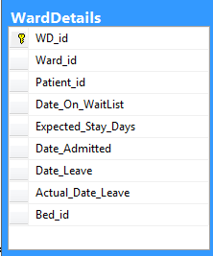

Where **WD_id** is this table’s **primary** **key**. When someone is going to admit in the hospital then he need **ward**, he has some **patient** **id**, he has some **bed** in the **ward**. So 3 tables are associated with admission form. **Ward_id, patient_id and Bed_id** are **Foreign** **Keys.**

* **Bed**

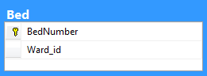

**In the bed table BedNumber is the Primary Key and Ward_id is Foreign Key because every bed is associated with some ward.**

* **Implementation of above tables Successfully**

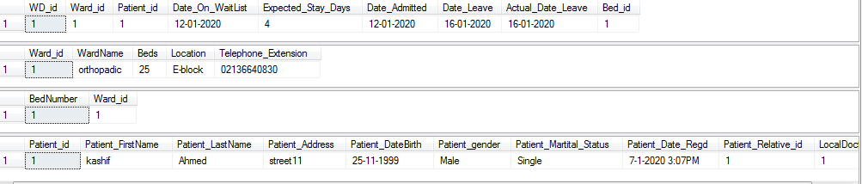

* **Drug**

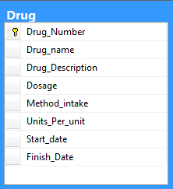

**Where Drug table has Drug_Number** **as Primary Key**

* **Medication Details**

**This table is used when doctor prescribe some medicine to the patient.**

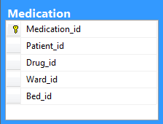

So it must contains **Patient** **record**, **Drug** **record** that which medicine is prescribed, **Ward** **details** that in which ward the patient is, then the **bed** **details** that which bed is acquired by the patient.

**Medication**_**id** is the **primary** **key** and the rest in the above table are **Foreign** **keys**

* **Implementation of above tables Successfully**

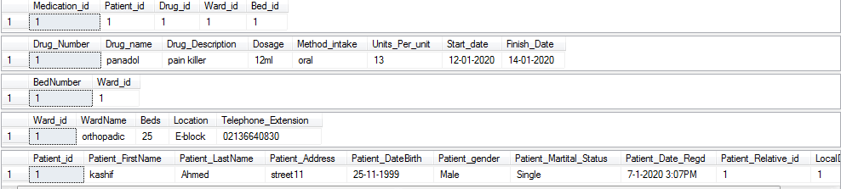

* **Appointment**

**When someone comes to the hospital then Appointment table is filled.**

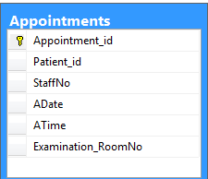

**Appointement_id is primary key and Patient_id and staffNo(doctor) are Foreign keys**

* **Implementation of above tables Successfully**

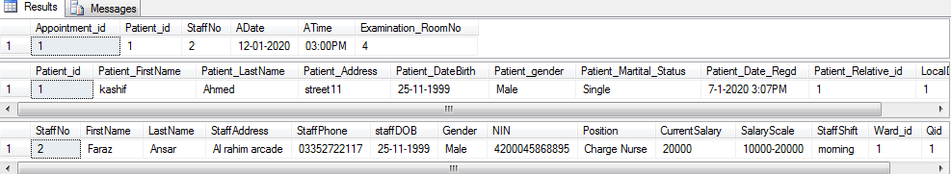

* **Suppliers**

**This table holds the records for Suppliers to the hospitals for surgical, non-surgical and pharmaceuticals Things**

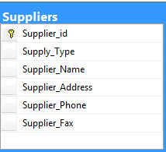



**This table has just a primary key that is Supplier_id**

* **Surgical and non-surgical Items Stock**

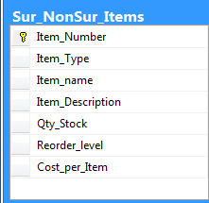

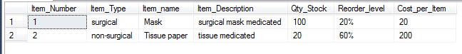

**Where Item Type can hold either Surgical or Non-surgical. Primary key is Item  
_Number.**

* **Pharmaceutical**

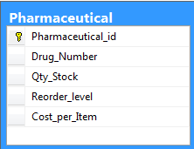

**This table is used to track the records of drug that is medicines into the hospital.**

**It contains Drug_Number as Foreign key. And pharmaceutical_id as Primary key**

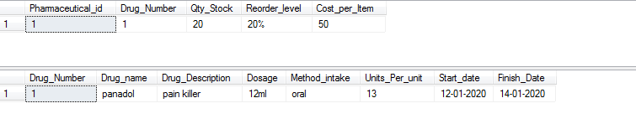

* **Requisition Requests**

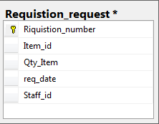

**This table is used by the Admin of each ward to request the surgical, non-surgical and pharma items to brought if the stock in some ward is empty.**

**It contains Item_id that which drug, Item to request and also a staffID that which staff member requested the Item. So, Item_id and StaffID are Foreign Keys and Requistion_id is Primary Key**

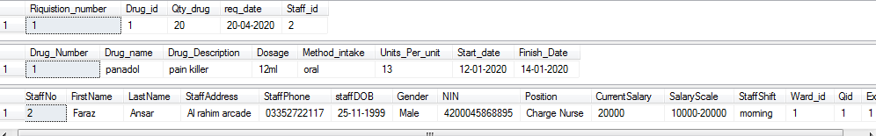

* **Requisition Accepted**

**The Request for the items is accepted by the supply controller. So**

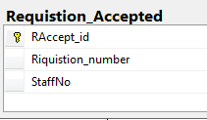

**It requires requisition detail that is Requisition_number and also it needs the details of the staff member who accepted the proposal so staffID they are Foreign Keys**

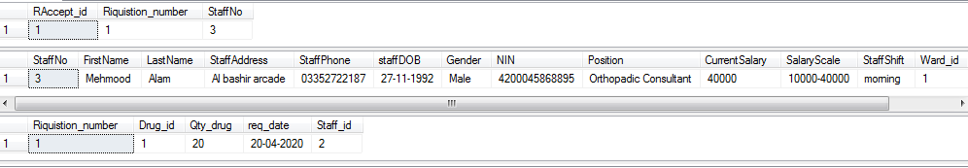

**QUESTION # 02**

* **HOTEL TABLE**
* **Foreign key**
  + There is no Foreign key in the Hotel table because it is the parent table. It only contains the primary key.
* **Entity Integrity Rule**
  + According to Integrity Rule, Primary Key which is Hotel Number cannot be NULL or Illegal Because of 2 reasons one is that Hotel Number is the identity of all hotels so it must be valid and the second reason is that The table Hotel is involved in Base Relations that is it has to referenced many tables so it cannot be NULL.
* **Referential Integrity Rule**
  + Since Guest No will be the Foreign Key in another table so it must be valid Value to referenced.
* **ROOM TABLE**
* **Foreign key**
  + **Hotel No** is the Foreign Key Comes from the Hotel table which is the primary key in that table. It Referenced that which hotel the room belongs.
* **Primary key**
  + **Room No** is the Primary key which uniquely identifies the Room.
* **Entity Integrity Rule**
  + According to Integrity Rule, Primary Key which is Room Number cannot be NULL or Illegal Because It is the Foreign Key in another Table (Guest) and also It uniquely defines the room, so it cannot be NULL.
* **Referential Integrity Rule**
* According to Referential Integrity Rule, The Foreign Key Which is **Hotel No** in this table must be defined correctly in Hotel Table so that it referenced a valid room of Hotel. For example if the Hotel No which is FK is nor defined then it becomes curious to know that from which hotel this room belongs.
* **GUEST TABLE**
* **Foreign key**
  + There is no Foreign key in the Guest table. It only contains the primary key which is Guest No.
* **Entity Integrity Rule**
  + According to Integrity Rule, Primary Key which is Guest Number cannot be NULL or Illegal Because of 2 reasons one is that Guest Number is the identity of all Guests in the Hotel so it must be valid and the second reason is that The table Guest is also involved in the relation such that GuestNo is referenced as a Foreign Key in Booking Table.
* **Referential Integrity Rule**
* Since Guest No will be the Foreign Key in another table so it must be valid Value to referenced.
* **BOOKING TABLE**
* **Foreign keys**
  + **Hotel No, Room No and Guest No** acts as Foreign Key to Book the Room in the hotel.
* **Entity Integrity Rule**
  + According to Integrity Rule, Primary Key which is not Mentioned but must be **BookingID** cannot be NULL or Illegal Because It uniquely defines each Booking, so it cannot be NULL.
* **Referential Integrity Rule**
* According to Referential Integrity Rule, The Foreign Keys Which are **Hotel No, Room No and Guest No** in this table must be defined correctly in Each Table so that it referenced a valid room of Booking. For Example, If the Room No FK is NULL or not defined then the whole booking is invalid and becomes confusion that which room is assigned. So every FK Must be valid ID in their tables.