**REAL ESTATE MANAGEMENT SYSTEM**

**SOFTWARE REQUIRMENT SPECIFICATION AND PLANNING DOCUMENT**

**PREPARED BY:**

**SUBMITTED TO:**

**CHAPTER-1 Introduction**

### 1.1 Project purpose

The purpose of this document is to proceed with the proposed project named “Real Estate Management System and Price Tracking through Web Application.” The document is used to convince the team that a project needs to be kicked-off to solve a particular business problem or opportunity. It describes in depth about how the project is going to be commenced and will execute further so that the observing committee understands what is involved early. The Real Estate Management System using collaborative technology will revolutionize the way real estate business is done. This web application is a real estate online business through which a user (seller or buyer) can access the information regarding the property and manage all the updating, deleting and adding of the assets. The admin can update the information regarding the property buying and selling and the cancellation or approvals of the advertisements as well.

## CHAPTER-2 System Requirement Specifications

**2.1 Scope:**

Its Scope is from the Banking system to the Houses and commercial buildings and farm houses. The Seller can sale his/her apartment, Houses, farm houses, Offices and factories by sitting at their homes and similarly Buyers can purchase them without going outside so its scope is in industrial, commercial and construction sectors.

Since people can do payments online as well as bank visit payment so its scope is also in banking sectors. Since state Agent now does not need to buy a shop for business. He can do the business by sitting at their houses. So its scope is also estate agency system.s

### 2.2 Objectives

The foremost objective of this project was to give attractive visualization styles to the Real Estate Web application which has more features, attractive animations and altogether a new look and furthermore gives a faster and more interactive user interface. Moreover, to make the GUI more features rich, features like customized grid, drag and drop tool and sliding bars will be added to the web app. Other interactive objectives are listed below:

* It is a user-friendly application for real estate which provides the user to search the property according to their requirements and budget in just one click.
* The system should have a sign-up option as either buyer or seller and the Admin.
* The system could have one or more than one admin if the real estate is owned by more than one person.
* Registration will be free of cost.
* The Login page consisting of 3 options including login as an Admin, Seller or Buyer.
* Admin can manage and approved the property ads posted by the Seller or dismiss the property once it is sold.
* Seller can post his/her property with the required details including no. of rooms, location, pictures etc.
* Buyer can use the search filter according to their needs and bid the property that they want to get.
* User or buyer can ask the questions from the seller regarding the property.
* The system is very useful for the companies or builders that can post and edit their properties and their personal info and admin can monitor records of all of them.
* To display matched property details easily and quickly just by one click.

**2.3 Overall description:**

**2.3.1 Product Prospective:**

 **Admin’s interface:** Admin can view sellers and buyers chat. He can view and delete the user for any reasons. He can view the properties and proposals. He can add another admin. He can view the contact details by the non-users and reply them. He can delete the property.

* **User’s interface:** user are of two types that is sellers and buyers. Sellers and buyers can register and login to their accounts. Both have different options. Seller can sale the property by adding property image, video, demand and description etc. Buyer can search the property he desires and can view the details of the property as well as video. He can make the offer to the certain property. After approval the seller will be notified. Seller and buyer can chat as well.

**2.3.3 Assumptions and Dependencies:**

**Assumptions:**

* The code will be clean and understandable
* Efficiency will be good.
* Response time will be good.
* Object oriented programming will be used.
* User friendly environment and functions.

**Dependencies:**

* The Internet connectivity will be necessary.
* The proposed system would be designed, developed and implemented based on the software requirements specifications document.
* End users should have basic knowledge of computer and we also assure that the users will be given software training documentation and reference material.

**2.4 Specific Requirements:**

**Software requirements:**

* Any latest version of web browser is required.
* Internet connectivity is required.
* Operating system is required.

**Hardware requirements:**

* Latest PC is required more than 3rd generation is recommended.

**2.5 Functional and Non-Functional Requirement:**

* **Functional Requirements:**

The functional requirements are:

* **FOR SELLERS**
* Sellers can Add property to the website with the details like image, video, demand, description, no of rooms etc.
* Sellers can register themselves as well as login to the system.
* Seller can chat with the buyer, if buyer asks something.
* Seller can check the property of his owns.
* Seller can check offers to his property.
* Seller can approve one offer.
* Seller can contact admin before registration for ay query. Reply will be given through email.
* **FOR BUYERS**
* Buyer can register and login.
* Buyer can search the property through search filter.
* Buyer can view the property details like image, video and all the description, demand etc.
* Buyer can contact admin before registration for any query. Reply will be given through email.
* Buyer can make offer to any property.
* Buyer will be notified by email if his offer approves.
* **FOR ADMIN**
* Admin can register another admin.
* Admin can view and delete the property.
* Admin can delete and view the user.
* Admin can communicate the buyer after approval of the offer.

**2.6 Non-Functional Requirements**

* **Reliability**

The system should be reliable and cannot crash during working.

* **Availability**

The system should be available 24/7.

* **Security**

The system should not allow unauthenticated users to enter into the system.

* **Maintainability**

There will be no maintenance required for the software. The database is provided by the end-user and therefore is maintained by this user.

* **Portability**

The system should not limited to some networks. It should be portable we can access it anywhere anytime.

## CHAPTER-3 System Design

### 3.1 ER Diagram

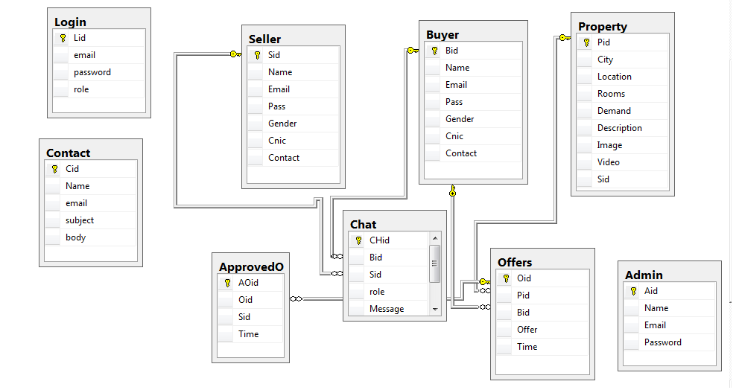

**3.2 Use-Case Diagram**

**3.2.1 ADMIN Use-Case**

ADMIN

Another Admin Registration

View and delete property

View and delete user

Monitor chat

Relpy the contacts

/

Check Approved offers

REAL ESTATE MANAGEMENT SYSTEM

### .2.2 Seller Use-Case

Seller

Upload Property for sale

Check offers

Approve one offer

Reply to buyer

Register/login

Enquiry Property

REAL ESTATE MANAGEMENT SYSTEM

### .2.2 Buyer Use-Case

Buyer

Search filter properties

Make offer to the property

See video images

Ask question about property

Register/login

Notified if offer approved by admin

REAL ESTATE MANAGEMENT SYSTEM

**3.3 Class Diagram of the Project**

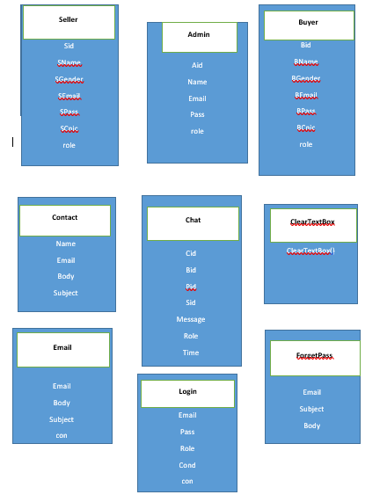

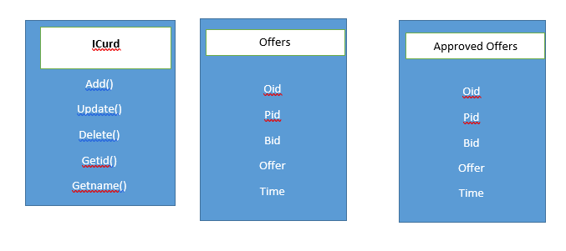

**3.3 Context Diagram of the Project**

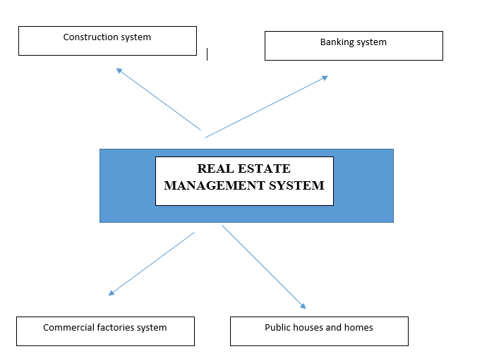

**PROJECT PLANNING CHAPTER 4**

Using the spiral (incremental) development web engineering framework following is the report of planning phase.

**INCREMENT – I: (one week)**

* Requirements gathering for our front-end (i.e UI for project) to analyse the ease of user
* The frontend design for the User panel.
* Creating database design roughly.
* Creating database and related tables in database MS SQL server 2012 plus.
* Creating relationships between table.
* This will be posted to the GitHub repo within one week.

**INCREMENT – II: (one week)**

* Creating the ASP dot net project on Microsoft visual studio 2017.
* Connectivity of database with the project on ASP.
* Creating classes, their attributes, and their behaviours.
* Implement user frontend pages to the ASP pages.
* Creating login/signup page with server rendering and authentication.
* This will be posted to the GitHub repo within one week.

**INCREMENT – III: (one week)**

* The other backend development like property upload page, video show page, show property, make offer logic etc.
* Saving all records to database and retrieving records from database
* Chat logic.
* This will be posted to the GitHub repo within one week.

**INCREMENT – IV: (one week)**

* The frontend design for the admin panel.
* Implementation of frontend to the asp.
* Adding insert, update, delete functions and show in the grid view of asp, the properties, offers, chats, sellers, buyers etc.
* This will be posted to the GitHub repo within one week.