**LAB SESSION # 06**

* **3*8 DECODER CIRCUIT :**

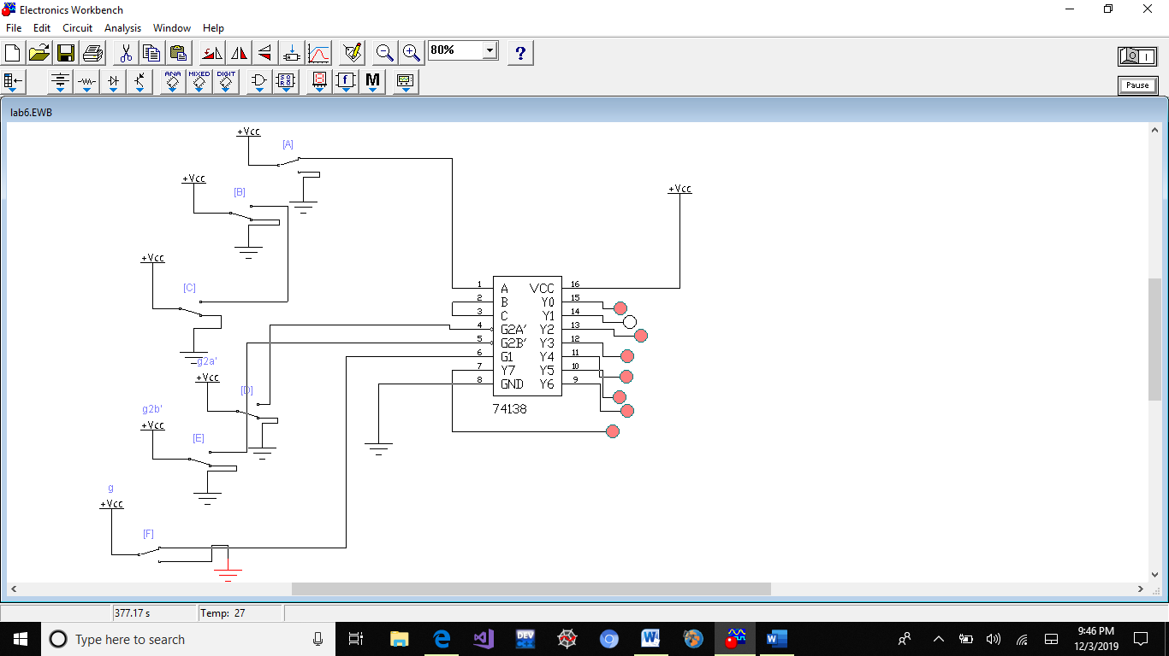

* **WHEN ALL THE ENABLE PINS ARE CONNECTED TO VCC:**

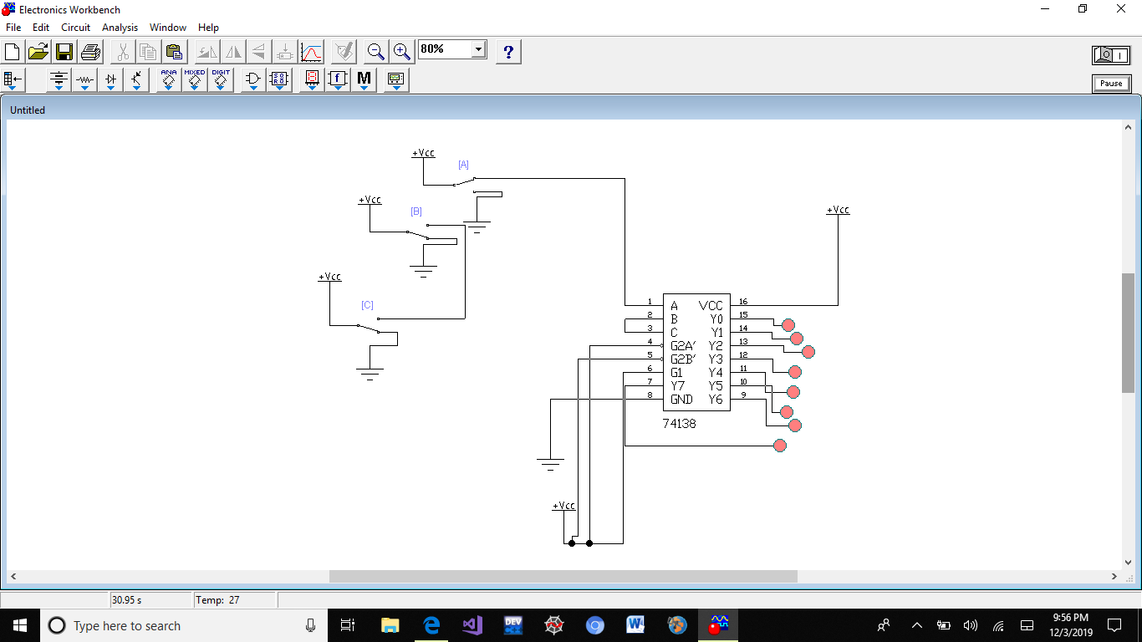

* **WHEN ALL THE ENABLE PINS ARE CONNECTED TO GROUND:**

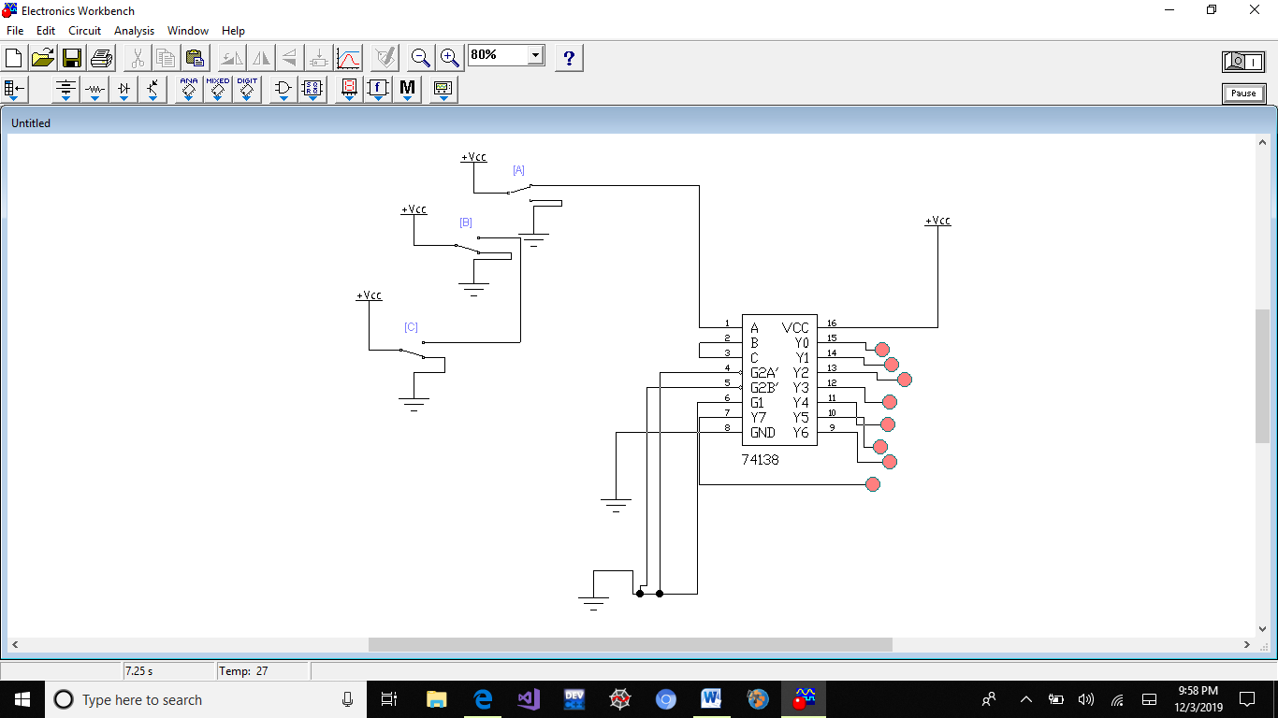

* **CASCADING TWO 2*4 DECODER TO 3*8 DECODER:**

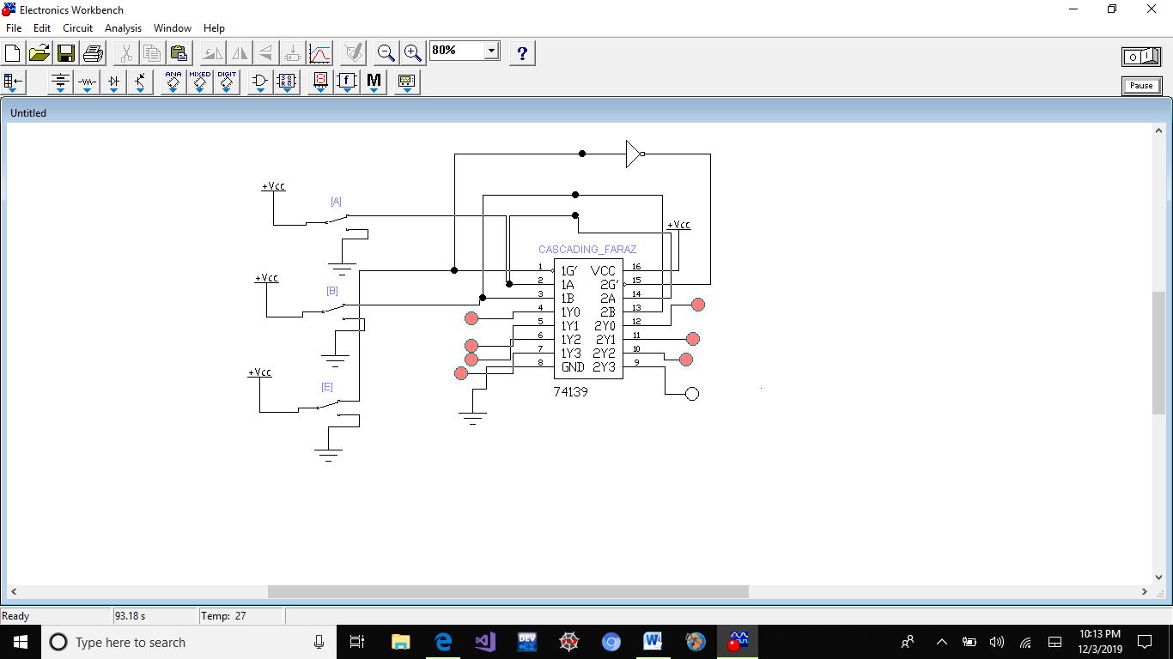

* **Prepared by Muhammad Faraz Ansar (SE-061)**