**QUESTION NO : 6 (a)**

Elaborate logic of CLC that takes 2-bit input value and produces the square of the value in

binary form with the help of truth table. Draw neat & clean logic diagram. (Attach Simulated

circuit diagram as well).

* **EXPECTED TRUTH TABLE FOR 2-bit CLC FOR SQUARE DETERMINATION:**
* The number of inputs should be **2 i-e A and B**
* The range of input will be **0-3**
* The highest square value will be **3­­2 = 9**
* The binary form of 9(max range) is **1001 i-e 4-bit output**

|  |  |  |  |  |  |
| --- | --- | --- | --- | --- | --- |
| **A** | **B** | **P0** | **P1** | **P2** | **P3** |
| **0** | **0** | **0** | **0** | **0** | **0** |
| **0** | **1** | **0** | **0** | **0** | **1** |
| **1** | **0** | **0** | **1** | **0** | **0** |
| **1** | **1** | **1** | **0** | **0** | **1** |

* **BOOLEAN EQUATION FOR P0:**

**AB**

* **BOOLEAN EQUATION FOR P1:**

**AB’**

* **BOOLEAN EQUATION FOR P2:**

**0**

* **BOOLEAN EQUATION FOR P3:**

**A’B+AB**

* **GATE LEVEL DIAGRAM FOR CLC-SQUARE CIRCUIT:**

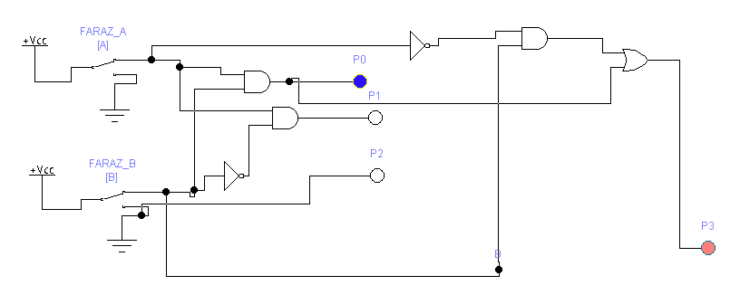

* **IC-LEVEL DIAGRAM FOR CLC-SQUARE CIRCUIT:**

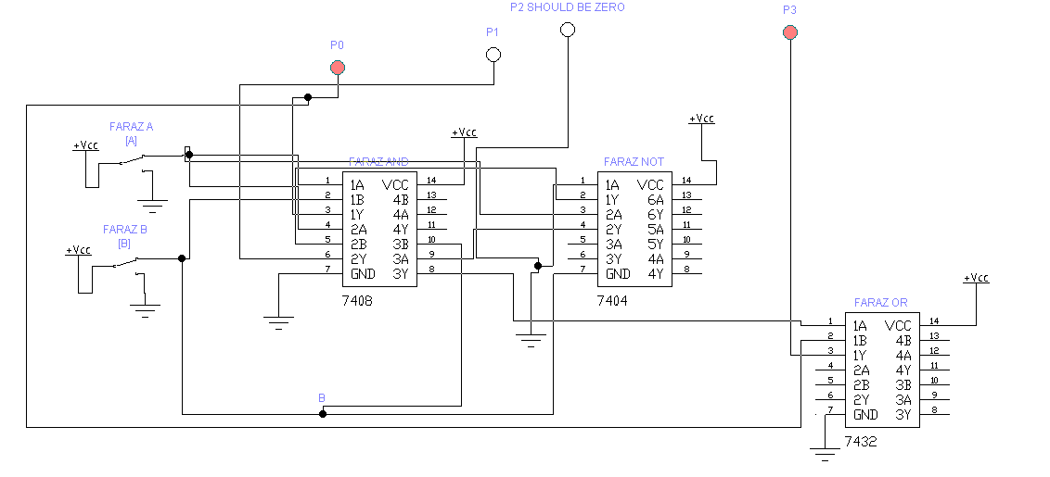

**QUESTION NO : 6 (b)**

1. **Cascade two 8 *1 and one 2 *1 multiplexers to implement 16 *1 multiplexer logic.**

* **TRUTH TABLE OF EXPECTED 16*1 MUX:**
* **Where S0 , S1 , S2 and S3  are selecting input lines and S3 being MSB.**

|  |  |  |  |  |
| --- | --- | --- | --- | --- |
| **S3** | **S2** | **S1** | **S0** | **OUTPUT FROM** |
| **0** | **0** | **0** | **0** | **I0** |
| **0** | **0** | **0** | **1** | **I1** |
| **0** | **0** | **1** | **0** | **I2** |
| **0** | **0** | **1** | **1** | **I3** |
| **0** | **1** | **0** | **0** | **I4** |
| **0** | **1** | **0** | **1** | **I5** |
| **0** | **1** | **1** | **0** | **I6** |
| **0** | **1** | **1** | **1** | **I7** |
| **1** | **0** | **0** | **0** | **I8** |
| **1** | **0** | **0** | **1** | **I9** |
| **1** | **0** | **1** | **0** | **I10** |
| **1** | **0** | **1** | **1** | **I11** |
| **1** | **1** | **0** | **0** | **I12** |
| **1** | **1** | **0** | **1** | **I13** |
| **1** | **1** | **1** | **0** | **I14** |
| **1** | **1** | **1** | **1** | **I15** |

* **ROUGH SKETCH FOR ABOVE CASCADING:**

**1 OUTPUT LINE**

**16 INPUT LINES**

**FARAZ**

**2*1 MUX**

**FARAZ**

**8*1 MUX**

**FARAZ**

**8*1 MUX**

* **IC-LEVEL IMPLEMENTATION FOR 16*1 MUX CASCADING:**

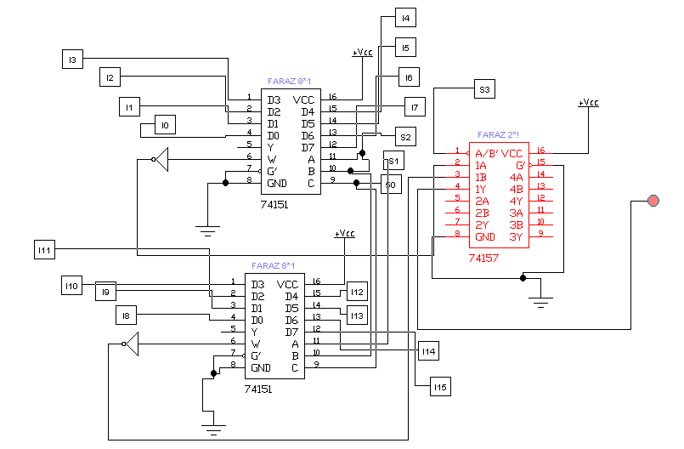

* **SUB-CIRCUIT FOR EACH SWITCH:**
* **Where toggle key for each switch is different**

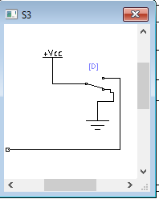 

* **EXPLAINATION:**

In 16*1 multiplexer , there are 16 input lines and one output line with 4 selecting input lines. The selecting input lines decides which input line transmit the signal to output.

To cascade the above from two 8*1 and one 2*1 mux, we have 3 select input lines in both 8*1 mux. So connect the selecting inputs of both 8*1 mux with eachother which are S0 , S1 , S2. The 2*1 MUX has only one selecting input line which become the 4th one which is S3. In the circuit S3  will be MSB.

This S3 will be responsible to switch two 8*1 mux to generate desired output.

For example, if the input is 1000 .Since in this example S3 is ‘1’ then output will be from second 8*1 mux then later bits are ‘000’ hence output will be from ‘D0(from IC)’ which is ‘I8’.

**ii. Draw the logic diagram of a 2-to-4 line decoder using NOR gates only. Include an enable**

**input. (Attach Simulated circuit diagram as well).**

* **TRUTH TABLE FOR 2*4 DECODER:**

|  |  |  |  |  |  |  |
| --- | --- | --- | --- | --- | --- | --- |
| **E** | **A** | **B** | **P0** | **P1** | **P2** | **P3** |
| **1** | **0** | **0** | **1** | **0** | **0** | **0** |
| **1** | **0** | **1** | **0** | **1** | **0** | **0** |
| **1** | **1** | **0** | **0** | **0** | **1** | **0** |
| **1** | **1** | **1** | **0** | **0** | **0** | **1** |
| **0** | **DON’T CARE** | **DON’T CARE** | **0** | **0** | **0** | **0** |

* **BOOLAEN EQUATION FOR P0:**

**E A’ B’**

* **BOOLAEN EQUATION FOR P1:**

**E A’ B**

* **BOOLAEN EQUATION FOR P2:**

**E A B’**

* **BOOLAEN EQUATION FOR P3:**

**E A B**

* **CIRCUIT FOR 2*4 LINE DECODER WITHOUT USING NOR-GATES:**

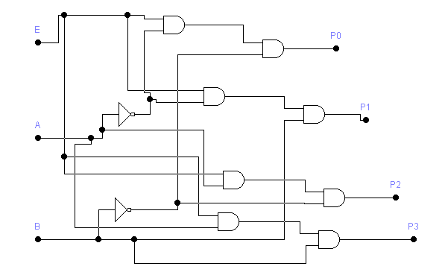

* **NOR – REALIZATION OF ABOVE CIRCUIT:**

By applying NOR-REALIZATION to above simple circuit, we got 2*4 line decoder WITH only NOR-GATES.

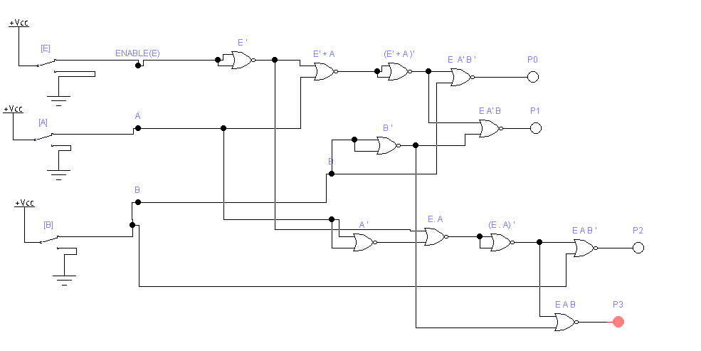

* **IC-LEVEL IMPLEMENTATION FOR ABOVE DECODER:**

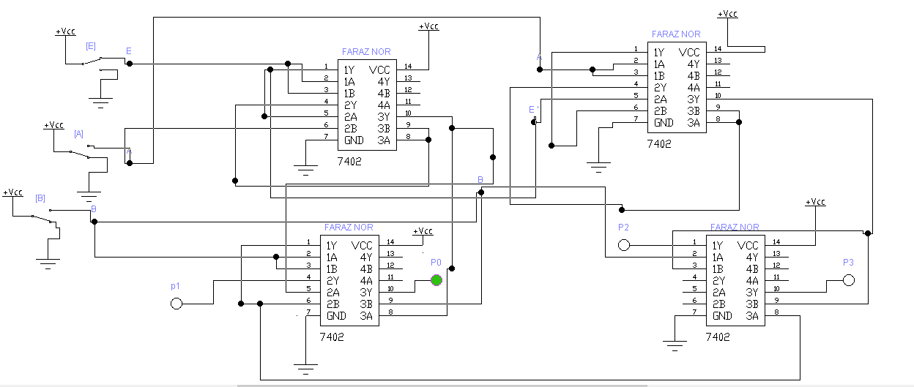

* **EXPLAINATION:**

From truth table of 2*4 line decoder, we pick the Boolean equations for each output lines i-e P0 , P1 , P2 and P3.

Then we draw the simple circuit without using NOR GATES.

After all we applied NOR-REALIZATION METHOD to convert that circuit to NOR-GATES.