**ASP DOT NET CORE API**

**What is Web Api?**

Web Api is a concept (not a technology) that works on HTTP protocol and it is used to extends the functionality of an application.

**What is Asp.Net Api?**

ASP.NET Web API is a framework that makes it easy to build HTTP services that reach a broad range of clients, including browsers and mobile devices.

**These Api Use Many Places:**

* Browsers
* Mobile Applications
* Desktop Applications
* IOT’s

API stands for Application Programming Interface. It is an intermediate software agent that allows two or more applications to interact with each other.

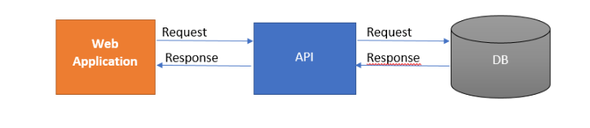

**API LAYER:**

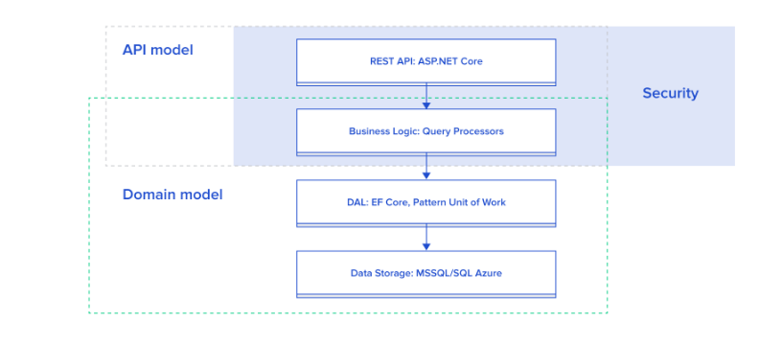

**What are RESTFul Services?**

Representational state transfer is a software architectural style that describes a uniform interface between physically separate components, often across the Internet in a client-server architecture.

**REST FUL Constrainst:**

* Client Server
* Stateless
* Cacheable
* Uniform interface (HTTP VERBS)

**HTTP VERBS:**

**GET:**

The Get method is used to retrieve data.

Example: Get the book data, search a book, etc.

**POST:**

The POST method is used to make a new entry in the database.

Example: Add a new student, etc.

**PUT:**

The Put method is used to update all the properties of current resource in the database.

Example: Update all properties (columns) of an existing student, etc.

**PATCH:**

The Patch method is similar to Put but it is used to update partial properties of current resource in the database.

Example: Update few properties(columns) of an existing student, etc.

**DELETE:**

The Delete method is used to delete the resource from the database.

Example: Delete an existing student from database, etc.

**Response Status codes:**

* 1xx informational response
* 2xx successful
* 3xx Redirection
* 4xx Client error
* 5xx Server error

**Some Actual Code:**

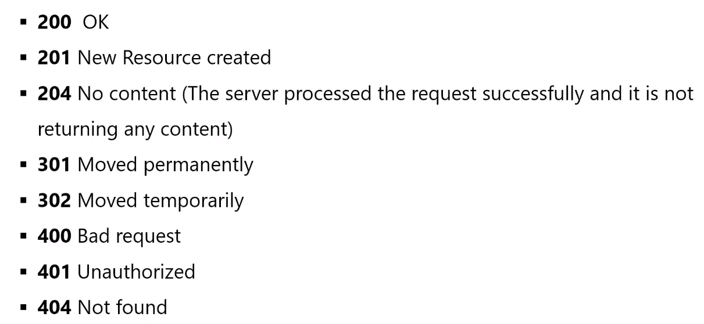

**Software should be installed:**

* Visual Studio
* SQL Server
* Postman