SEO TUTORIALS BY MUHAMMAD FARHAN

**SEO (Search Engine Optimization)**

* Search Engine Optimization (SEO) is the activity of optimizing web pages or whole sites in order to make them search engine friendly, thus getting higher positions in search results.
* Simple SEO techniques to improve the visibility of your web pages for different search engines, especially for Google, Yahoo, and Bing.
* Designing and developing a website to rank well in search engine results.
* Improving the volume and quality of traffic to a website from search engines.
* Marketing by understanding how search algorithms work, and what human visitors might search.

**Search (Search Practice)**

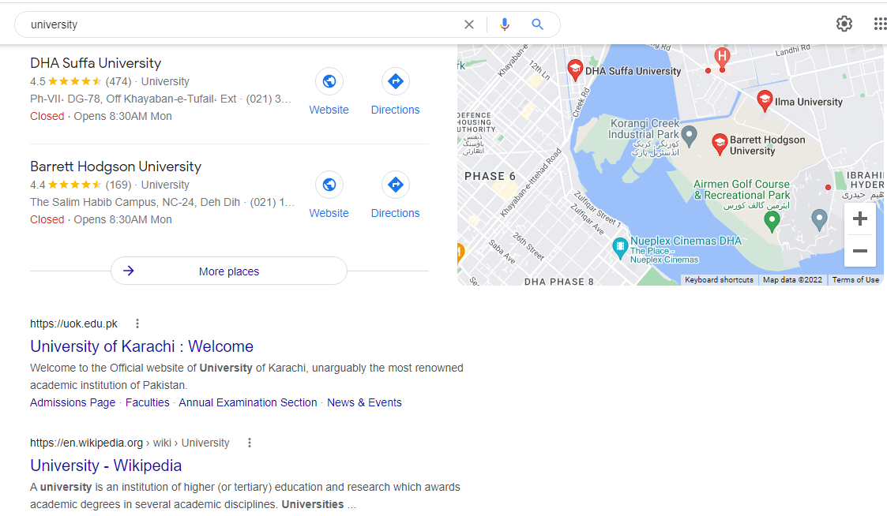

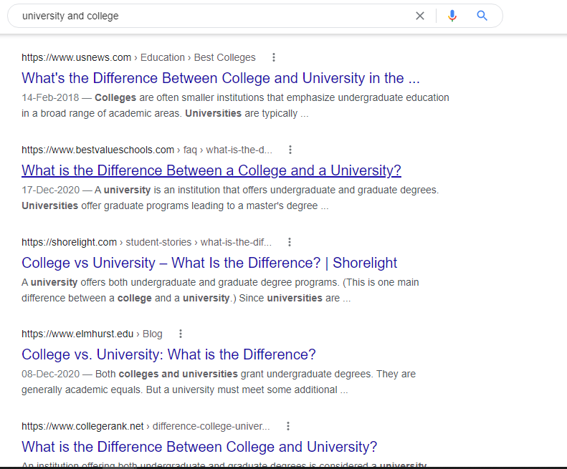

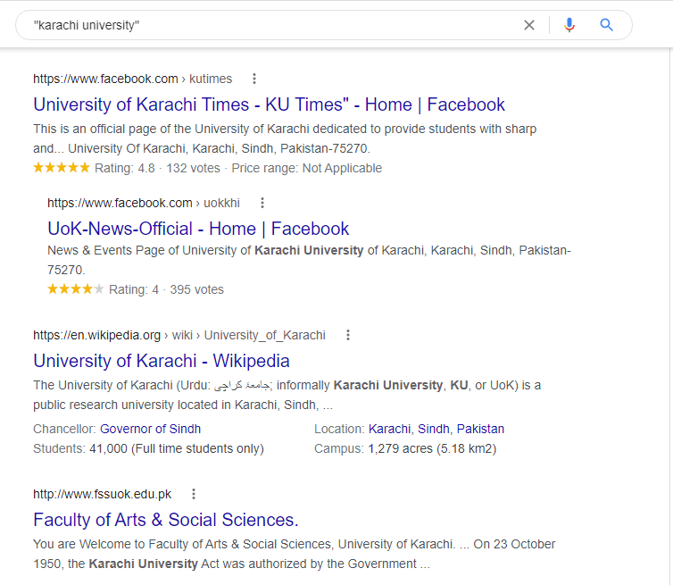

## How Search Engine Works?

Search engines perform several activities in order to deliver search results.

* **Crawling** - Process of fetching all the web pages linked to a website. This task is performed by a software, called a **crawler** or a **spider** (or Googlebot, in case of Google).
* **Indexing** - Process of creating index for all the fetched web pages and keeping them into a giant database from where it can later be retrieved. Essentially, the process of indexing is identifying the words and expressions that best describe the page and assigning the page to particular keywords.
* **Processing** - When a search request comes, the search engine processes it, i.e. it compares the search string in the search request with the indexed pages in the database.
* **Calculating Relevancy** - It is likely that more than one page contains the search string, so the search engine starts calculating the relevancy of each of the pages in its index to the search string.
* **Retrieving Results (serving**) - The last step in search engine activities is retrieving the best matched results. Basically, it is nothing more than simply displaying them in the browser.

Search engines such as Google and Yahoo! often update their relevancy algorithm dozens of times per month. When you see changes in your rankings it is due to an algorithmic shift or something else outside of your control.

## What is Search Engine Rank?

When you search any keyword using a search engine, it displays thousands of results found in its database. A page ranking is measured by the position of web pages displayed in the search engine results. If a search engine is putting your web page on the first position, then your web page rank will be number 1 and it will be assumed as the page with the highest rank.

SEO is the process of designing and developing a website to attain a high rank in search engine results.

**SEO METHODS:**

SEO techniques are classified into three broad categories:

1. **White Hat SEO.** SEO practice following search engine guidelines.
2. **Black Hat SEO.**  SEO practice created against search engine guidelines.
3. **Gray Hat SEO.**  SEO practice without defined guidelines.

## White Hat SEO:

An SEO tactic is considered as White Hat if it has the following features:

* It conforms to the search engine's guidelines.
* It does not involve in any deception.
* It ensures that the content a search engine indexes, and subsequently ranks, is the same content a user will see.
* It ensures that a web page content should have been created for the users and not just for the search engines.
* It ensures good quality of the web pages.
* It ensures availability of useful content on the web pages.

## Black Hat or Spamdexing SEO

An SEO tactic, is considered as Black Hat or Spamdexing if it has the following features:

* Attempting ranking improvements that are disapproved by the search engines and/or involve deception.
* Redirecting users from a page that is built for search engines to one that is more human friendly.
* Redirecting users to a page that was different from the page the search engine ranked.
* Serving one version of a page to search engine spiders/bots and another version to human visitors. This is called **Cloaking** SEO tactic.
* Using hidden or invisible text or with the page background color, using a tiny font size or hiding them within the HTML code such as "no frame" sections.
* Repeating keywords in the metatags, and using keywords that are unrelated to the website content. This is called **metatag stuffing**.
* Calculated placement of keywords within a page to raise the keyword count, variety, and density of the page. This is called **keyword stuffing**.
* Creating low-quality web pages that contain very little content but are instead stuffed with very similar keywords and phrases. These pages are called **Doorway or Gateway Pages**.
* Mirror websites by hosting multiple websites - all with conceptually similar content but using different URLs.
* Creating a rogue copy of a popular website which shows contents similar to the original to a web crawler, but redirects web surfers to unrelated or malicious websites. This is called **page hijacking**.

1. **Gray Hat SEO**

* Grey hat SEO is **an SEO practice that combines white hat and black hat SEO**.
* Grey hat SEO is riskier than white hat SEO because it exploits the search engine guidelines to increase a page's rankings on the SERPs (**Search Engine Results Page**).
* Grey hat SEO techniques are black masquerading as white.

## What is On-Page and Off-page SEO?

Conceptually, there are two ways of optimization:

* **On-Page SEO** - It includes providing good content, good keywords selection, putting keywords on correct places, giving appropriate title to every page, etc.
* **Off-Page SEO** - It includes link building, increasing link popularity by submitting open directories, search engines, link exchange, etc.
* **Technical SEO:** Technical SEO depend on factors. It has many factors below down.
  1. Implement Content Optimization Right Away.
  2. Find Appropriate Word Counts and Keyword Densities
  3. Test Your Meta Titles to Optimize CTR.
  4. Check website speed.
  5. Use Structured Data
  6. Required SSL Certificate.
  7. Good Resolution Image
  8. Info Graphics (charts).
  9. Focus on High Intent Keywords.
  10. prevent dwell time

**Optimization**

**Optimize Metatags:**

There are two important meta tags:

1. Meta description tags
2. Meta keyword tags
3. <meta name="keywords"
4. content="KEYWORD1, KEYWORD2 , KEYPHRASE1 etc.
5. about 30 to 40 unique words">
6. <meta name="description"
7. content="An accurate keyword-rich description
8. about 150 characters">

**Title Optimize:**

An *HTML TITLE* tag is put inside the head tag. The page title (not to be confused with the heading for a page) is what is displayed in the title bar of your browser window, and is also what is displayed when you bookmark a page or add it to your browser Favorites.

This is the one place on a webpage where your keywords MUST be present. Correct use of keywords in the title of every page of your website is extremely important to Google - particularly for the homepage. If you do nothing else to optimize your site, remember to do this!

Here are some considerations while designing the title of a webpage:

* The title shouldn't consist of more than about 9 words or 60 characters.
* Use keywords at the very beginning of the title.
* Do not include your company name in the title unless your company name is very well known.

**Optimize Anchor:**

Use descriptive anchor text for all your text links. Most search engines consider anchor text of incoming links when ranking pages. Here is an example of anchor:

**Example:**

<a href="nextpage.html" title="Anchor Title">Anchor Text</a>

**Another Example:**

<a href="nextpage.html" title="Anchor Title">

<img src="image.jpg " alt="keywords" />

</a>

**Content is Main for SEO:**

Thousands of articles, books, and forum entries are available on how to make your website search engine friendly, but ultimately, one rule stands above the rest: Unique, high-quality, unduplicated content is the king.

Relevant, fresh, and timely content is crucial in attracting visitors to your website. It helps you both draw traffic from search engines and create audience loyalty.

## Unique, High-Quality Content:

Visitors want unique, high-quality site content. It is not only your home page content, but also all the linked pages should have useful and easy-to-understand content.

Now-a-days, search engines have become very smart and they are able to understand complete grammar and complete phrase. Hence while ranking a page against other, the content available on a page matters.

## What is SEO Copywriting (Content Writing)?

* SEO Copywriting is the technique of writing viewable text on a web page in such a way that it reads well for the surfer, and also targets specific search terms. Its purpose is to rank highly in the search engines for the targeted search terms.
* Along with viewable text, SEO copywriting usually optimizes other on-page elements for the targeted search terms. These include the Title, Description, Keywords tags, headings, and alternative text.
* The idea behind SEO copywriting is that search engines want genuine content pages and not additional pages often called "doorway pages" that are created for the sole purpose of achieving high rankings.
* Divide your web page content also into short paragraphs.
* The content should be directed for the specified target audience.
* Do not use confusing, ambiguous, and complex language. Use small statements to make your content more understandable.

## Conclusion:

Creating, editing, and promoting unique high-quality content is difficult and time consuming. But in the end, the golden rule of SEO is that **Content is the King**. It is not because of a search engine, but it is for your site visitors. A page that is read by people is better than a page that is read by bots.

**Traffic on Website (Channels):**

There are four main source:

* Search
* Social
* Direct
* Referral

**Search**

* Organic Traffic
* Paid Traffic (SEM (**Search Engine Marketing)**)

**Social**

Organic Traffic

Paid Traffic

**Design & Layout**

The actual page content should have a keyword density of about 10% and should weigh in at about 200 words - but there are as many opinions about this as there are SEO experts. Some say, keyword density should be 5% and some say it should be 20%. You can go with 10% which is good enough.

Here are a few guidelines that you should keep in mind while designing a web page.

* You should have more text content than HTML elements.
* No frames. They are the enemies of search engines, and search engines are enemies of frames.
* No ads if possible. Because most of the ads use Java-Script which is not advised to be used.
* No JavaScript. If you need JavaScript, call it from an external file rather than dumping the code in the HTML file. JavaScript drop-down menus prevent spiders from crawling beyond your homepage. If you use them, be sure to include text links at the bottom of the page.
* Do not put anything in the page topic that does not fit perfectly.
* No unnecessary directories. Keep your files as close to the root as possible.
* No fancy stuff (Flash, Splash, Animated Gifs, Rollovers, etc.) unless absolutely necessary

**Example:**

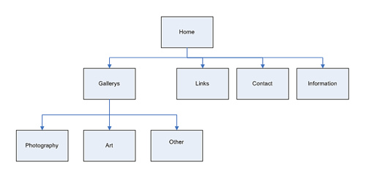

**Verifying Website:**

Use (W3C Organization) validator for Html, CSS.

## What is Mobile SEO?

Mobile Search Engine Optimization is the process of designing a website to make it suitable for viewing on mobile devices of different screen sizes having low bandwidth. Apart from following all the SEO rules which are applicable to a desktop website, we need to take additional care while designing a website for mobile devices. A website is mobile friendly if it has the following attributes −

* A good mobile website has a responsive design which performs well on desktops as well as mobile devices. It not only reduces the maintenance of the website but also makes the content consistent for the search engines.
* The contents of a good mobile website are easy to read on a mobile device without having to zoom the screen. It has appropriate fonts, colors, and layouts.
* It is easy to navigate through a good mobile website on a small screen. It provides links and buttons that can be easily maneuvered using a finger.
* A good mobile website is lightweight such that it takes less bandwidth and time to load on mobile networks.
* The Home Page of a mobile website plays the most important role in connecting users to the content they are looking for. Therefore, good mobile websites make sure the most important links are displayed on the Home Page so that they get enough visibility.

The ranking of a website depends heavily on how user friendly it is. You can follow the guidelines given below to design a great mobile-friendly website.

## Optimize Your Site for Mobile

If your site is already optimized for search engines, then it should not be too difficult to optimize it for mobile devices. First, let us understand what it takes to go mobile. We can categorize the steps into three broad categories −

**Step 1** − Select a Mobile Configuration

**Step 2** − Inform Search Engines

**Step 3** − Avoid Common Mistakes

## Select a Mobile Configuration

There are three different mobile configurations that you can choose from −

**Step 1** − Responsive Web Design

**Step 2** − Dynamic Serving

**Step 3** − Separate URLs

Each has its own advantages and disadvantages. Google recommends responsive design, however it supports all three configurations. The following table shows how the mobile configuration affects your URL and HTML code −

Keywords:

For searching keyword websites.

<https://ads.google.com>

<https://trends.google.com/trends/?geo=PK>

<https://www.semrush.com/analytics/keywordoverview/?q=website&db=us>