**Theory of Website.**

**What is website?**

A website is a collection of web pages and related content that is identified by a common domain name and published on at least one web server. Notable examples are wikipedia.org, google.com, and amazon.com. All publicly accessible websites collectively constitute the World Wide Web.

There are two types of websites:

* Static Website
* Dynamic Website

**Static Website:**

A static website consists of a series of HTML files, each one representing a physical page of a website. On static sites, each page is a separate HTML file. When you visit the homepage, you are viewing only the actual homepage file.

**Dynamic Website:**

A dynamic website is a website that displays different types of content every time a user views it. This display changes depending on a number of factors like viewer demographics, time of day, location, language settings.

A server-side dynamic web page is a web page whose construction is controlled by an application server processing server-side scripts. In server-side scripting, parameters determine how the assembly of every new web page proceeds, including the setting up of more client-side processing.

**Static Website VS Dynamic Website**

|  |  |
| --- | --- |
| **Static Website** | **Dynamic Website** |
| Prebuilt content is same every time the page is loaded. | Content is generated quickly and changes regularly. |
| It uses the **HTML**code for developing a website. | It uses the server side languages such as **PHP,SERVLET, JSP, and ASP.NET**etc. for developing a website. |
| It sends exactly the same response for every request. | It may generate different HTML for each of the request. |
| The content is only changed when someone publishes and updates the file (sends it to the web server). | The page contains "server-side" code which allows the server to generate the unique content when the page is loaded. |
| Flexibility is the main advantage of static website. | Content Management System (CMS) is the main advantage of dynamic website. |

**What is Server?**

In computing, a server is a piece of computer hardware or software that provides functionality for other programs or devices, called "clients". This architecture is called the client–server model.

**What is domain?**

Domain name is the address of your website that people type in the browser URL bar to visit your website.

In simple terms, if your website was a house, then your domain name will be its address.

A domain name is an identification string that defines a realm of administrative autonomy, authority or control within the Internet.

**What is Sub Domain?**

A subdomain is an additional part to your main [domain name](https://www.wpbeginner.com/beginners-guide/how-to-register-a-domain-name-simple-tip-to-get-it-for-free/). Subdomains are created to organize and navigate to different sections of your website. You can create multiple subdomains or child domains on your main domain.

For example:

store.yourwebsite.com

www.youtube.com

In this example, ‘store’ is the subdomain, ‘yourwebsite’ is the primary domain and ‘.com’ is the top level domain (TLD). You can use any text as your subdomain, but you want to make sure it’s easy to type and remember.

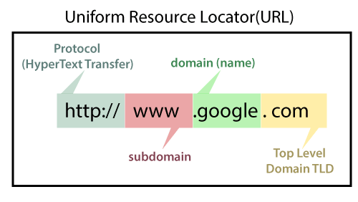

Today we use https because this **“s”** is define security.

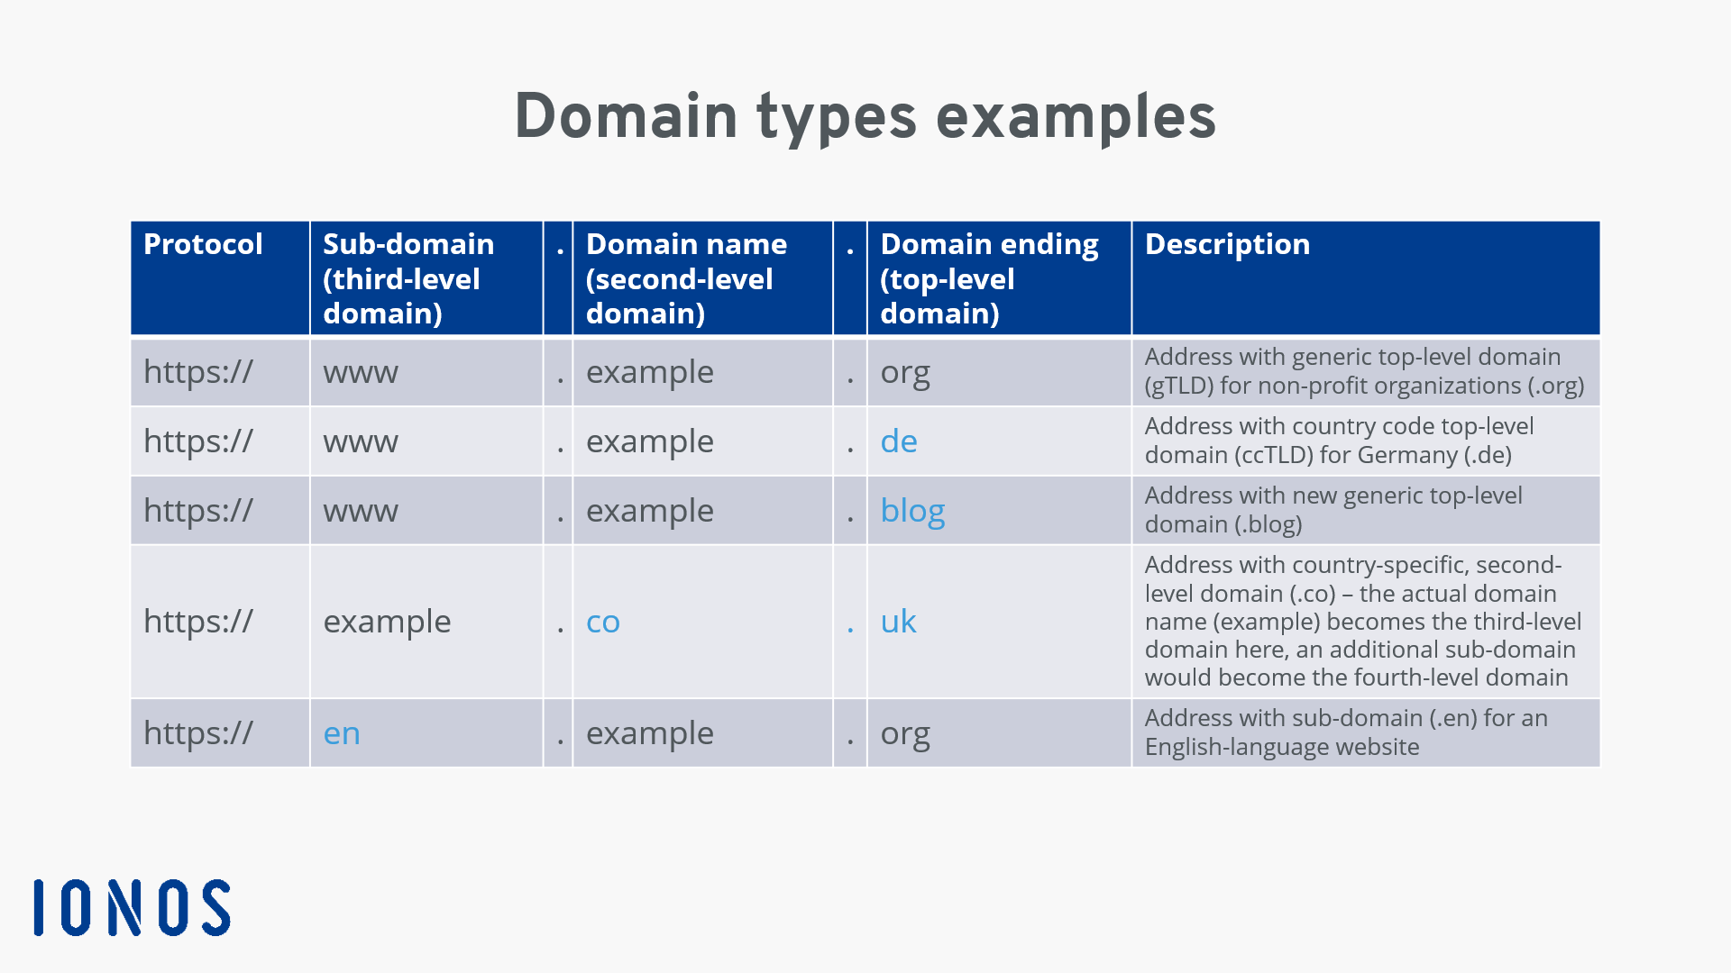

**How Domain works?**

To understand how domain names actually work, we will take a look at what happens when you enter it in your browser.

When you enter a domain name in your web browser, it first sends a request to a global network of servers that form the Domain Name System (DNS).

These servers then look up for the name servers associated with the domain and forward the request to those name servers.

**Who is Responsible for Domain Names Systems?**

Internet Corporation for Assigned Names and Numbers (ICANN) manages the domain names system. It is a non-profit organization that creates and implements the policies for domain names.

ICANN gives permission to companies called Domain Name Registrars for selling domain names. These [domain registrars](https://www.wpbeginner.com/beginners-guide/how-to-choose-the-best-domain-registrar/) are allowed to make changes to domain names registry on your behalf.

Domain name registrars can sell domain names, manage its records, renewals, and transfers to other registrars.

As a domain name owner, you are responsible for telling the registrar where to send requests. You are also responsible for renewing your domain registration.

There are currently more than 350 Million registered domain names and thousands more get registered each day.

**How to Buy a Domain Name?**

You can buy domain names from one of the many domain name registrars. A domain name typically costs $14.99 per year. Some popular domain name companies are:

* [Domain.com](https://www.wpbeginner.com/refer/domain-com/) (Use this [Domain.com coupon](https://www.wpbeginner.com/deals/domain-com-coupon/) to get a discount)
* [Network Solutions](https://www.wpbeginner.com/refer/networksolutions/) (use our [Network Solutions coupon](https://www.wpbeginner.com/deals/network-solutions-coupon/) code to get 25% off).
* [GoDaddy](https://www.wpbeginner.com/refer/godaddy/)
* Hostinger

**What is W3C?**

The **World Wide Web Consortium** (**W3C**) is the main international [standards organization](https://en.wikipedia.org/wiki/Standards_organization) for the [World Wide Web](https://en.wikipedia.org/wiki/World_Wide_Web). Founded in 1994 and currently led by [Tim Berners-Lee](https://en.wikipedia.org/wiki/Tim_Berners-Lee), the [consortium](https://en.wikipedia.org/wiki/Consortium) is made up of member organizations that maintain full-time staff working together in the development of standards for the World Wide Web. As of 4 December 2021, W3C had 455 members.W3C also engages in education and outreach, develops software and serves as an open forum for discussion about the Web.