 | 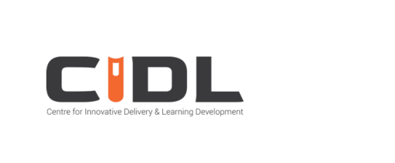
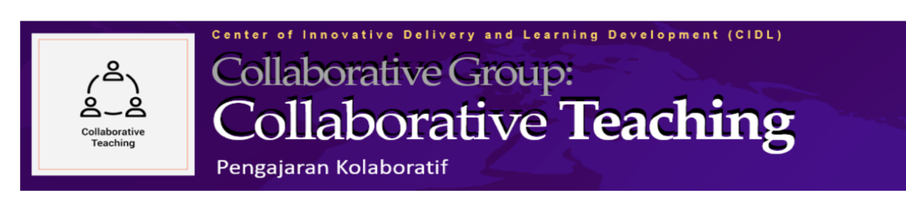

CGCT MODEL 1 REPORT
Collaboration in Content Development

MEQ545 ENGINEERING ECONOMICS
Bachelor of Manufacturing Engineering Technology with Honours
Faculty of Mechanical Engineering · Universiti Teknologi MARA, Cawangan Pulau Pinang
Semester Sesi I 2026/2027 (OCT 2026 – FEB 2027) · Class PEM2433A1
DEVELOPED CONTENT
MEQ545 All-Quiz Tutorial Portal (web application)
10 tutorial sets · 107 questions
Live portal: https://meq545-all-quiz-portal-hub.pages.dev/
PREPARED BY
Muhammad Faris Bin Abd Manap [336994] — Responsible Person (RP) / Content Lead
Muhd Azhar Bin Zainol [336907] — Teaching Team
Industry Panel: En Ahmad Khairul Nizam Bin Bahrinal — Branch Manager Principal, Homefield Real Estate Sdn Bhd
12 October 2026
Centre for Innovative Delivery and Learning Development (CIDL)
Collaborative Group: Collaborative Teaching (CGCT)

COMPLETED CGCT MODEL 1 CHECKLIST
Checklist item | Requirement | Evidence / status
(a) Scheme of work that includes the developed topics | Updated scheme of work showing the topics developed collaboratively | PROVIDED — tuned teaching plan with the Developed Content (CGCT Model 1) column and collaboration block (companion docx/pdf; web app: Section 7.4). Status: complete.
(b) Link / screenshots of the developed content | Access link and screenshots of the developed content | PROVIDED — live portal and repository links (Sections 4.3, 7.4); screenshots: Figures 1–11 (Appendix A). Status: complete.
(c) Evidence of session(s) conducted with students and content | Evidence of sessions conducted involving students and the developed content (e.g., photographs/screenshots) | PROVIDED — student session with content (Figure 3), class roster (Figure 6), submissions with scores and attendance (Figure 7), attendance e-signature (Figure 4) and signed attendance record (Figure 9). Status: complete.

TABLE OF CONTENTS
COMPLETED CGCT MODEL 1 CHECKLIST 2
1. INTRODUCTION 4
1.1 Background 4
1.2 Objectives of the collaboration 4
1.3 Scope and compliance 4
1.4 Documentation map against the CGCT Model 1 checklist 4
2. COURSE AND PROGRAMME INFORMATION 4
3. COLLABORATION STRUCTURE AND ROLES 5
4. DEVELOPED CONTENT — MEQ545 ALL-QUIZ TUTORIAL PORTAL 5
4.1 Overview 5
4.2 Content matrix (10 tutorial sets / 107 questions) 6
4.3 Access 6
4.4 Quality assurance 6
5. COLLABORATION WORKFLOW AND ATTRIBUTION 7
5.1 Workflow 7
5.2 Attribution 7
5.3 Industry panel contribution 7
5.4 Tuned teaching plan (checklist item (a)) 7
6. IMPLEMENTATION EVIDENCE (AS AT 12 OCTOBER 2026) 8
6.1 Usage metrics 8
6.2 Evidence of sessions conducted with students and content (checklist item (c)) 8
6.3 Notes on interpretation 8
7. REFLECTION AND CONTINUATION PLAN 8
7.1 Outcomes 8
7.2 Observations and improvements 8
7.3 Continuation plan 9
7.4 Links 9
APPENDIX A — EVIDENCE: SCREEN CAPTURES 10
APPENDIX B — INDUSTRY PANEL CURRICULUM VITAE 21

1. INTRODUCTION

1.1 Background
This report documents the implementation of Collaborative Teaching (CGCT) Model 1 — Collaboration in Content Development — for MEQ545 Engineering Economics, Semester Sesi I 2026/2027 (OCT 2026 – FEB 2027), Faculty of Mechanical Engineering, Universiti Teknologi MARA, Cawangan Pulau Pinang. The Centre for Innovative Delivery and Learning Development (CIDL) Collaborative Group: Collaborative Teaching (CGCT) encourages academics to collaborate — among colleagues and, where relevant, with industry — in the development and delivery of teaching and learning content. Model 1 specifically covers the joint development of content by a collaborative group.

1.2 Objectives of the collaboration
- Develop a complete, syllabus-mapped bank of interactive tutorial sets for MEQ545 (10 sets; 107 questions) covering Chapters 1–7 of the course syllabus;
- Incorporate industry-context scenarios and industry validation through an industry panel (project appraisal and cost decision-making in real estate);
- Deploy the developed content as a digital tutorial and attendance platform (web application) used by students in and outside class;
- Institutionalise reusable, version-controlled content that can be maintained and extended in future semesters.

1.3 Scope and compliance
The collaboration is additive. The official syllabus, Course Outcomes (CO1–CO3), assessment structure and weights are unchanged (Individual Assignment 20%, Group Project 20%, Test 1 30%, Test 2 30%). The developed tutorial sets supplement the scheduled tutorial sessions and are released according to the tuned teaching plan.

1.4 Documentation map against the CGCT Model 1 checklist
Checklist item | Where documented in this submission
(a) Scheme of work that includes the developed topics | Tuned teaching plan — schedule table with the added 'Developed Content (CGCT Model 1)' column (companion document); summarised in Section 5.4.
(b) Link / screenshots of the developed content | Section 4 and the links table (Section 7.4); screenshots in Appendix A (Figures 1–11).
(c) Evidence of session(s) conducted with students and content | Section 6 (usage evidence as at 12 October 2026); Appendix A (Figures 3–7, 9); roster and submissions monitoring screenshots.
The completed Model 1 checklist is reproduced at the front of this report, immediately after the cover page.

2. COURSE AND PROGRAMME INFORMATION
Item | Details
Course | Engineering Economics (MEQ545)
Programme | Bachelor of Manufacturing Engineering Technology with Honours
Faculty / Campus | Faculty of Mechanical Engineering, UiTM Cawangan Pulau Pinang
Semester | Sesi I 2026/2027 (OCT 2026 – FEB 2027)
Class group | PEM2433A1
Credit hours | 3 credit hours (14 teaching weeks)
Assessment | 100% coursework: Individual Assignment 20% · Group Project 20% · Test 1 30% · Test 2 30%
Course outcomes | CO1 Explain the basic principles and practice of project management [PO1, LO1] (C2); CO2 Display the principles of the engineering economy to manage process design [PO10, LO10] (A5); CO3 Recognise the need for and independently propose engineering economic related analysis in solving economic problems [PO11, LO9] (C4)
Responsible Person (RP) | Muhammad Faris Bin Abd Manap [336994]
Teaching team | Muhd Azhar Bin Zainol [336907]
Industry panel | En Ahmad Khairul Nizam Bin Bahrinal — Branch Manager Principal, Homefield Real Estate Sdn Bhd (CV: Appendix B)
Live course portals | Tutorial portal: https://meq545-all-quiz-portal-hub.pages.dev/ · Teaching plan web app: https://muhammadfaris-prog.github.io/meq545lessonteachingplan/

3. COLLABORATION STRUCTURE AND ROLES
CGCT Model 1 for MEQ545 is delivered through a three-way collaboration: the Responsible Person (content lead and portal developer), the teaching team (co-development and review) and an industry panel (industry co-development and validation).
Member | Role | Contribution to the developed content
Muhammad Faris Bin Abd Manap [336994] | Responsible Person (RP) — Content Lead | Designed the tutorial framework mapped to the MEQ545 syllabus and course outcomes; developed all question sets, worked solutions and answer explanations; developed and deployed the quiz portal web application; monitors usage; prepares CGCT documentation.
Muhd Azhar Bin Zainol [336907] | Teaching Team — Co-Developer | Co-development and item review; vetting of questions and answer keys; contributes to sets T1–T4 and reviews the industry co-developed sets; facilitates tutorial sessions in which the portal is used.
En Ahmad Khairul Nizam Bin Bahrinal | Industry Panel — Industry Co-Developer / Validator | Co-develops and validates the industry-context scenarios for sets T5–T8 (cost estimation, time value of money, project evaluation, comparison of alternatives), grounded in real-estate project appraisal, feasibility studies, cost optimisation and O&M decision-making.
Coordination: regular coordination meetings and blended communication (in-person, WhatsApp, Google Meet), a shared drive for content sources, and the portal repository as the single source of truth for deployed content.

4. DEVELOPED CONTENT — MEQ545 ALL-QUIZ TUTORIAL PORTAL

4.1 Overview
The developed content is a purpose-built web application — the MEQ545 All-Quiz Tutorial Portal — that delivers all tutorial sets, records student attendance and monitors submissions for the course. The portal is a single-page application (HTML/JavaScript) with a Firebase (Firestore) backend, hosted on Cloudflare Pages and version-controlled in a GitHub repository.
- Student access: student-ID login with a personal 4-digit PIN and self-registration on first use, with per-student progress badges.
- Tutorial delivery: 10 tutorial sets; auto-marked multiple-choice and true/false items; short-answer and long-answer items retained for lecturer review; answer explanations revealed for objective items.
- Attendance: an on-screen e-signature is captured before a tutorial can be started and is stored with the session record.
- Staff dashboard: manage and seed tutorial sets, monitor registered students, monitor submissions with scores, and export attendance records and CSV reports in one click.
- Deployment: hosted web application (no installation), mobile-friendly, with content updates managed through the repository.

4.2 Content matrix (10 tutorial sets / 107 questions)
Set | Tutorial title | Chapter | Question mix | Status (12 Oct 2026) | Attribution
T1 | Tutorial 1: Engineering Economy in Everyday Life | Ch. 1 | 10 MCQ | Active — completed by all students | Teaching team (RP-led)
T2 | Tutorial 2: Chapter 1 – Introduction to Engineering Economy | Ch. 1 | 8 MCQ · 2 short · 2 long | Active — completed by all students | Teaching team (RP-led)
T3 | Tutorial 3: Chapter 2 – Cost Concepts and Design Economics | Ch. 2 | 5 MCQ · 3 T/F · 2 short | Developed; scheduled release (W4) | Teaching team (RP-led)
T4 | Tutorial 4: Chapter 2 – Cost Concepts (Applied) | Ch. 2 | 10 MCQ | Developed; scheduled release (W4) | Teaching team (RP-led)
T5 | Tutorial 5: Ch. 3 & 4 – Estimation and Time Value of Money | Ch. 3–4 | 13 MCQ | Developed; scheduled release (W8) | Industry co-developed
T6 | Tutorial 6: Ch. 5 – Evaluating a Single Project | Ch. 5 | 8 MCQ · 2 short | Developed; scheduled release (W11) | Industry co-developed
T7 | Tutorial 7: Ch. 5 – Annual Worth Method (5.1–5.5) | Ch. 5 | 2 MCQ · 3 short | Developed; scheduled release (W11) | Industry co-developed
T8 | Tutorial 8: Ch. 6 – Mutually Exclusive Alternatives | Ch. 6 | 9 MCQ · 3 short | Developed; scheduled release (W12) | Industry co-developed
T9 | Tutorial 9: Ch. 6 – Alternatives (Set 2) | Ch. 6 | 6 MCQ · 6 short | Developed; scheduled release (W13) | Teaching team (RP-led)
T10 | Tutorial 10: Ch. 6 – Alternatives (Set 3) | Ch. 6 | 7 MCQ · 6 short | Developed; scheduled release (W13) | Teaching team (RP-led)
Total | 10 tutorial sets | Ch. 1–7 | 107 questions (78 MCQ · 3 T/F · 24 short · 2 long)

4.3 Access
Live portal: https://meq545-all-quiz-portal-hub.pages.dev/ | Repository: https://github.com/muhammadfaris-prog/meq545-all-quiz-portal-hub
Students access the portal from any device (in class during tutorial sessions and outside class for revision). The staff dashboard is password-protected; assessor access can be arranged on request.

4.4 Quality assurance
All items were internally vetted: the teaching team reviewed questions and answer keys, and worked explanations accompany the objective items. The industry-context scenarios (sets T5–T8) were co-developed and validated with the industry panel. Terminology and notation follow the recommended textbook (Sullivan, Wicks & Koelling, Engineering Economy, 20th Ed.).

5. COLLABORATION WORKFLOW AND ATTRIBUTION

5.1 Workflow
- Step 1 — Topic mapping: the RP mapped each tutorial set to the course syllabus (Chapters 1–7) and the course outcomes (CO1–CO3), using the official scheme of work as the base.
- Step 2 — Content development: the RP drafted the question sets, worked solutions and answer explanations in the portal; the teaching team reviewed the items and contributed content (sets T1–T4).
- Step 3 — Industry co-development: the industry panel co-developed and validated the industry-context scenarios for sets T5–T8 (cost estimation, the time value of money, project evaluation and the comparison of alternatives), drawing on real-estate project appraisal, feasibility studies, cost optimisation and O&M decisions.
- Step 4 — Team extension: the teaching team extended the industry-co-developed framework into additional revision sets T9–T10.
- Step 5 — Deployment and monitoring: sets are released through the portal according to the tuned teaching plan; submissions, scores and attendance e-signatures are monitored through the staff dashboard.

5.2 Attribution
Sets | Attribution | Colour code
T1–T4 (Chapter 1 – Chapter 2) | Developed by the teaching team, RP-led (with team co-development and review) | Blue
T5–T8 (Chapter 3 – Chapter 6) | Co-developed with the Industry Panel (industry scenarios and validation) | Red
T9–T10 (Chapter 6) | Team extension of the industry-co-developed framework | Blue

5.3 Industry panel contribution
En Ahmad Khairul Nizam Bin Bahrinal is Branch Manager Principal at Homefield Real Estate Sdn Bhd and holds a BSc in Mechanical Engineering (Korea University). His expertise covers project management, feasibility studies, cost optimisation, operational and capital expenditure (Opex/Capex) planning, and analytics (Power BI/SPSS), with CAD proficiency. His full CV is at Appendix B. Within Model 1 he contributed and validated industry-context scenarios, including:
- T5 — financing and time-value-of-money settings for property investment appraisal (loan schedules, cash-flow timing, interest computations);
- T6–T7 — single-project evaluation and annual-worth applications using property acquisition, refurbishment and operations cases;
- T8 — comparison of mutually exclusive alternatives with real cost drivers (e.g., refurbishment versus replacement of facilities);
- Validation — review of assumptions, terminology and practicality of the industry questions against current industry practice.

5.4 Tuned teaching plan (checklist item (a))
The official teaching plan for MEQ545 has been tuned to embed the collaboration: the weekly schedule table now includes a 'Developed Content (CGCT Model 1)' column mapping each week to the portal sets (including colour-coded attribution), and a collaboration block (members, industry panel, workflow and attribution legend) has been added. The syllabus, course outcomes, assessment structure and weights are unchanged. The tuned plan (companion document: 'OCT26 MEQ545 TEACHING PLAN (CGCT MODEL 1 – COLLABORATIVE CONTENT DEVELOPMENT)') is the primary evidence for checklist item (a); a web-app version of the plan is available at the link in Section 7.4.

6. IMPLEMENTATION EVIDENCE (AS AT 12 OCTOBER 2026)

6.1 Usage metrics
Metric | Value
Registered students (Class PEM2433A1) | 17
Tutorial sets deployed and active | 2 (Tutorial 1 and Tutorial 2)
Questions deployed (of 107 developed) | 22
Submission records | 42 (21 for Tutorial 1; 21 for Tutorial 2 — includes re-sits)
Unique completions | 34 student–tutorial completions; all 17 registered students completed both active sets
Attendance e-signature records | 58
Average score — Tutorial 1 | 74.3% (7.4 / 10)
Average score — Tutorial 2 | 77.9% (9.3 / 12)
Highest score | 100% on both sets
All metrics are drawn live from the portal database (Firebase Firestore) and are reproducible from the staff dashboard; the screenshots in Appendix A (Figures 5–7, 9) evidence the same.

6.2 Evidence of sessions conducted with students and content (checklist item (c))
Figure 3 shows a live student session: the student is signed in and the portal lists the available tutorial sets with per-student completion badges. Figure 6 shows the roster of all 17 registered students, and Figure 7 shows the staff view of submissions with per-student scores and attendance ticks. Figure 4 shows the attendance e-signature pad presented before a tutorial starts. Figure 8 shows the student question view with a worked explanation, and Figure 9 shows the signed attendance record generated by the portal, in which each student's captured e-signature is printed against the tutorial date.

6.3 Notes on interpretation
Submission record counts (42) exceed unique completions (34) because students may re-sit a tutorial (the portal retains every attempt). Attendance signatures (58) are captured at each tutorial start, including repeat attempts, and serve as the digital equivalent of the tutorial attendance list.

7. REFLECTION AND CONTINUATION PLAN

7.1 Outcomes
Adoption of the developed content was immediate: all 17 registered students completed both active sets within the first three weeks of the semester. Attendance is now captured digitally with signatures stored per session, objective items are marked automatically, and students receive instant answer explanations — freeing tutorial time for discussion.

7.2 Observations and improvements
- Short-answer and long-answer items (26 of the 107 questions) are retained for lecturer review and manual marking; a marking view will be added to streamline this.
- Future versions will add per-set time windows and optional randomised question order to strengthen academic integrity.
- Network conditions during class are manageable: the portal is lightweight and works on student data plans.

7.3 Continuation plan
- Release the remaining sets according to the tuned teaching plan: T3–T4 (Week 4), T5 (Week 8), T6–T7 (Week 11), T8 (Week 12), T9–T10 (Week 13).
- Continue industry panel engagement for the applied scenarios (Chapters 3–6) and extend co-development to Chapter 7 (depreciation and income taxes) in a future semester.
- Reuse and maintain the portal for the next cohort; content is version-controlled in the GitHub repository.
- Share the practice as a CGCT example through CIDL channels (CGCT Padlet).

7.4 Links
Resource | Link
Tutorial portal (live web application) | https://meq545-all-quiz-portal-hub.pages.dev/
GitHub repository (source and content sets) | https://github.com/muhammadfaris-prog/meq545-all-quiz-portal-hub
Teaching plan web app (student-facing) | https://muhammadfaris-prog.github.io/meq545lessonteachingplan/
This report — web version | https://muhammadfaris-prog.github.io/meq545-cgct-model1-report/
CIDL CGCT Padlet (collaborative teaching group) | https://padlet.com/cidlcollaborativeteaching/uitm-cg-collaborative-teaching-94dvrcgck0i2droe

APPENDIX A — EVIDENCE: SCREEN CAPTURES
All captures were taken from the live portal (meq545-all-quiz-portal-hub.pages.dev) and the teaching plan web app, and are provided as separate image files in the accompanying evidence folder; Figure 9 is the signed attendance record exported by the portal (full signed PDF supplied in the evidence folder).
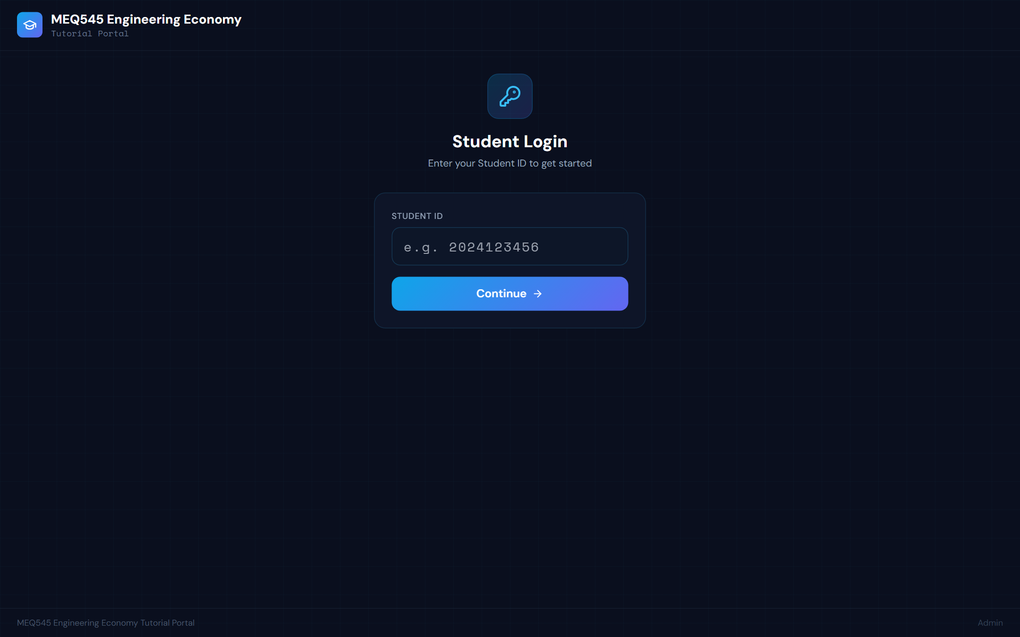
Figure 1 — Student login page of the MEQ545 All-Quiz Tutorial Portal.

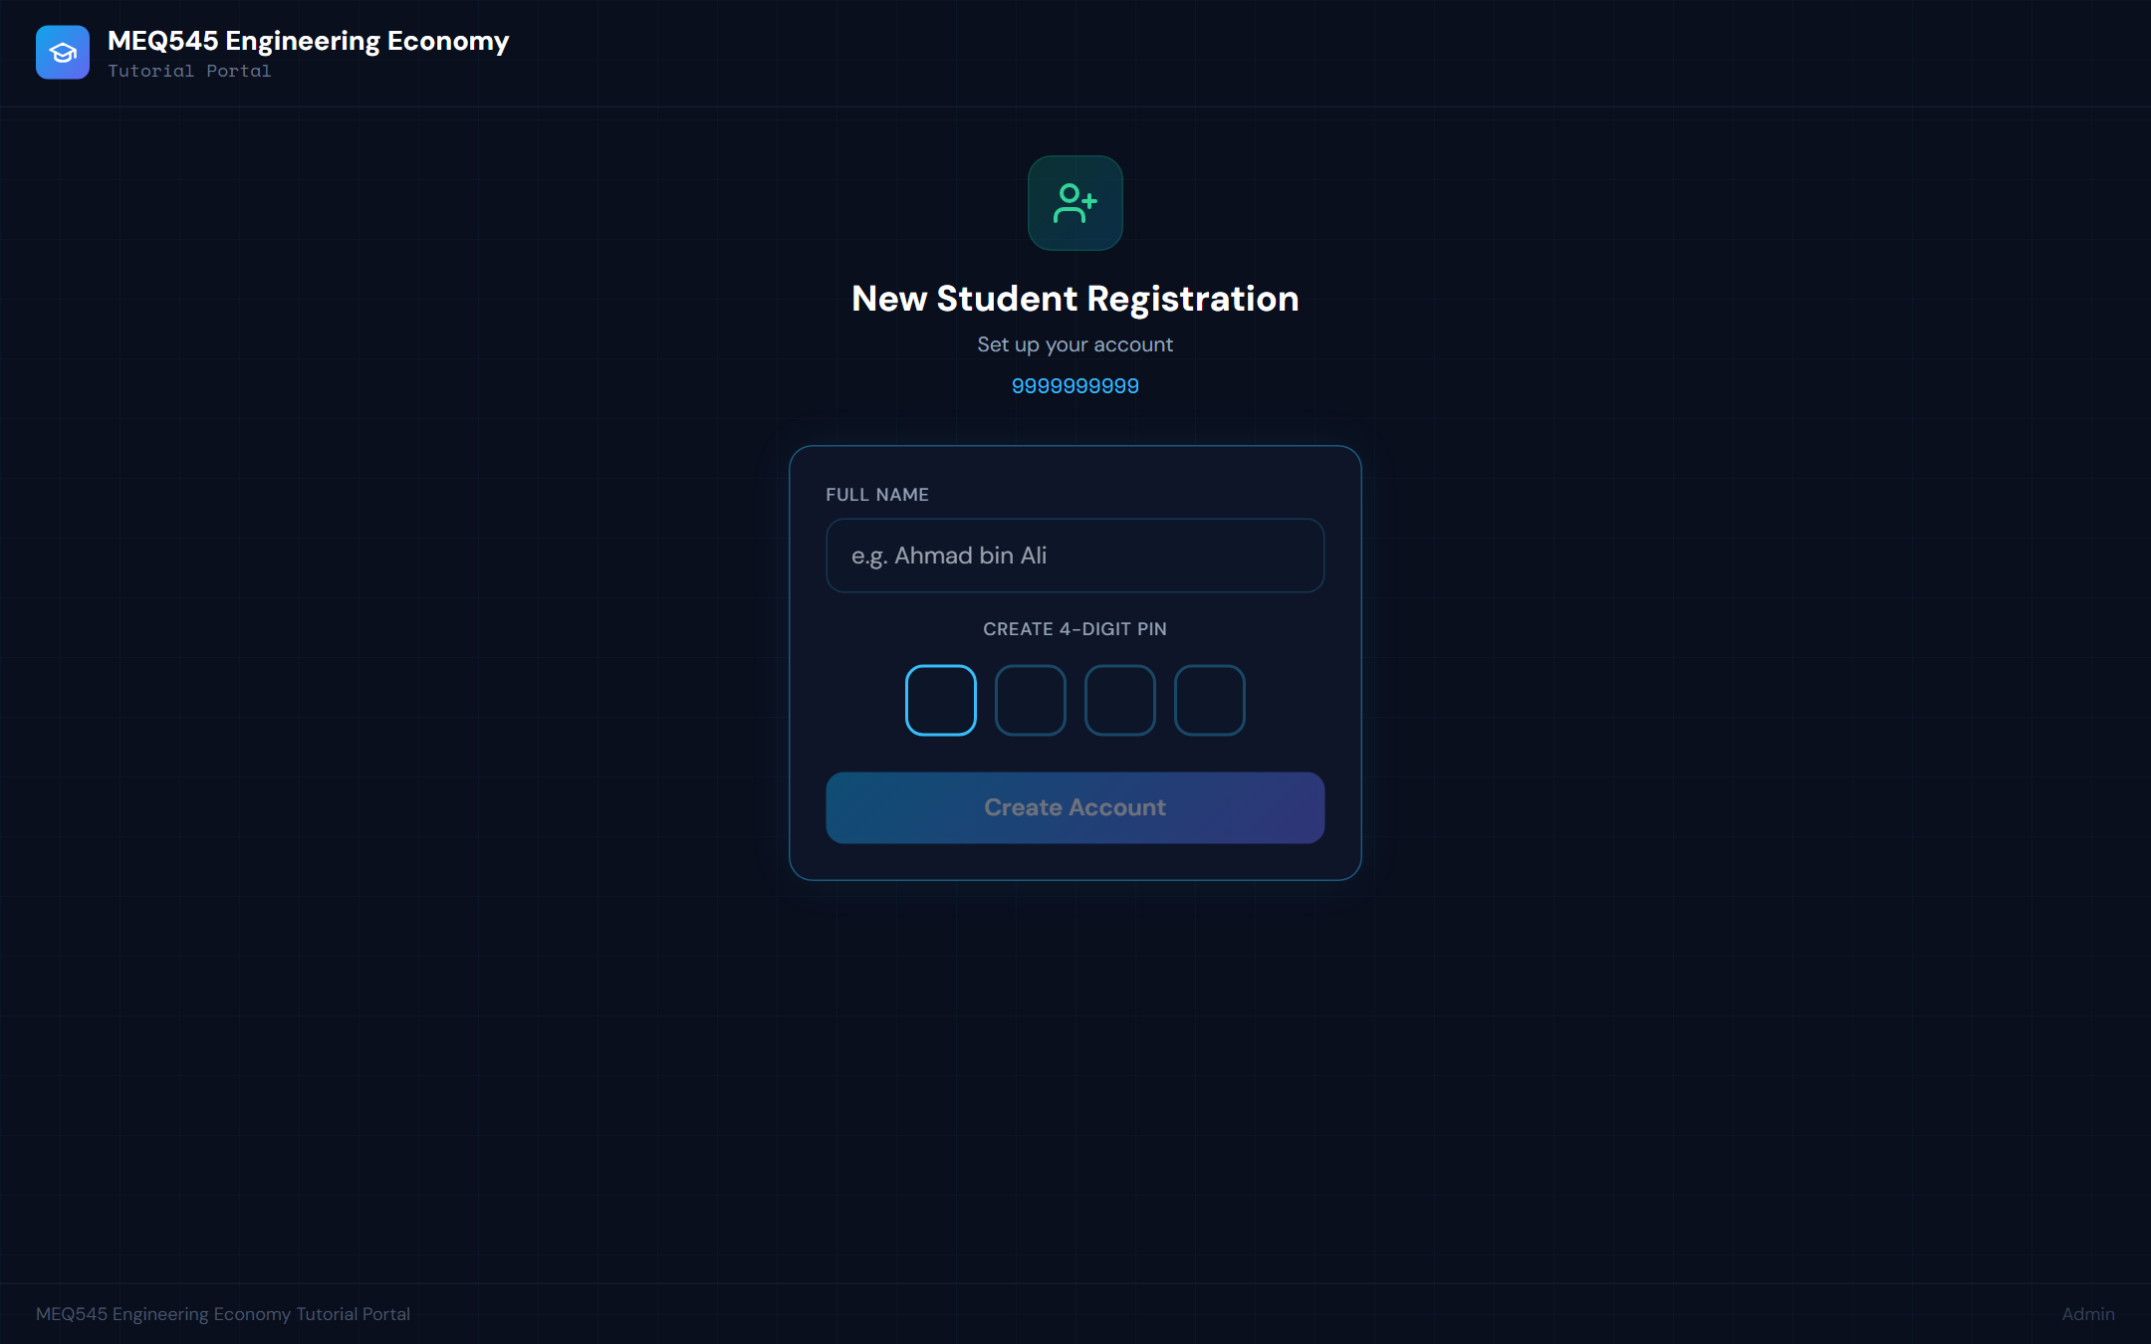
Figure 2 — New student registration (self-service account setup at first login).

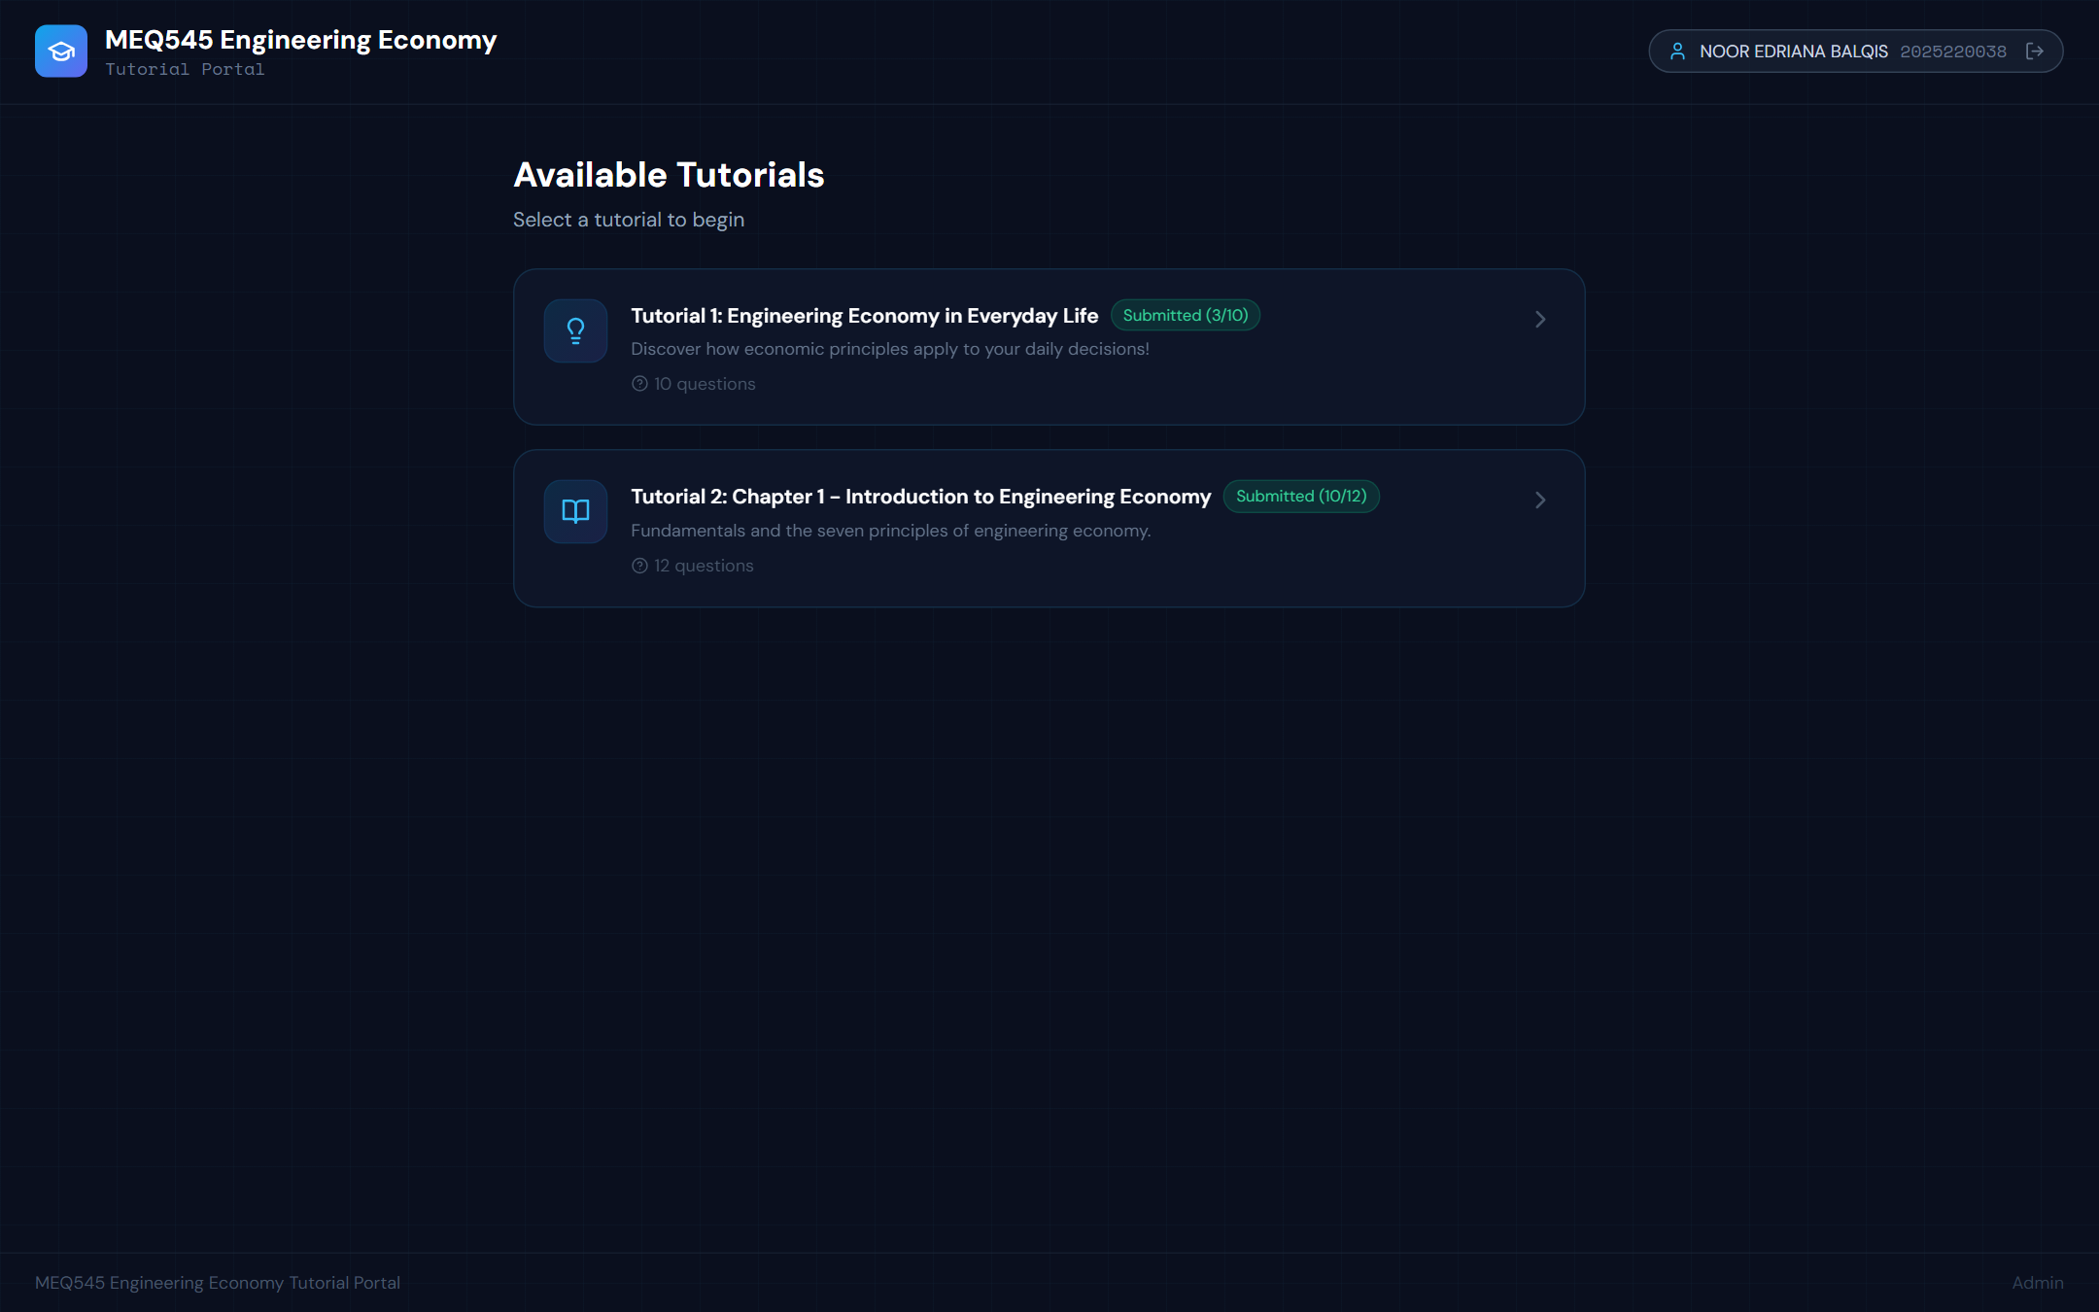
Figure 3 — Live student session: signed-in student badge (name and ID), available tutorial sets and per-student completion badges — session evidence with students and the developed content.

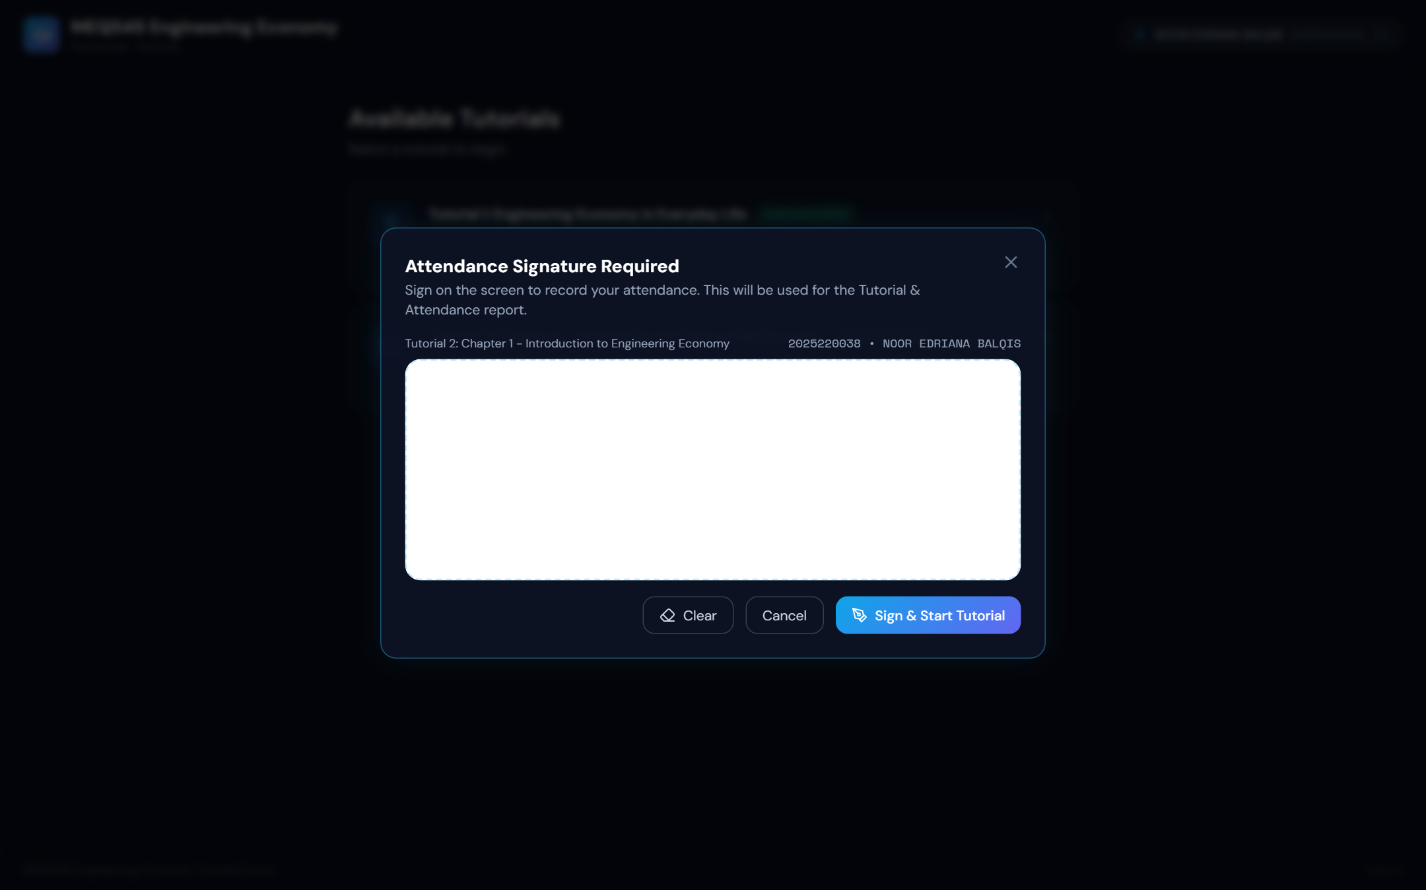
Figure 4 — Attendance e-signature pad presented before a tutorial starts (shown before signing; every captured signature is stored and printed in the signed attendance record — Figure 9).

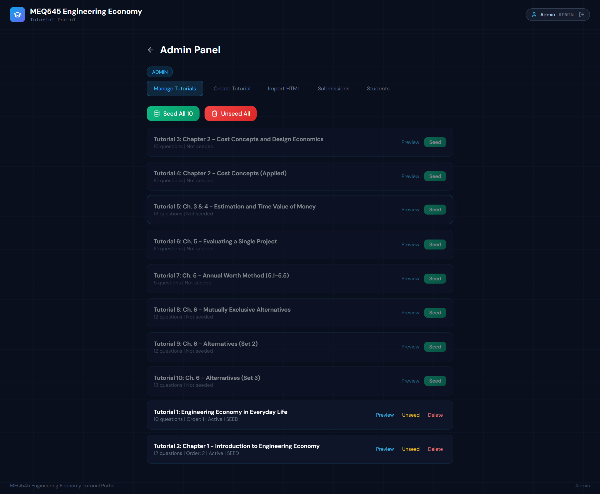
Figure 5 — Staff dashboard: tutorial management (Tutorials 1–2 active; Tutorials 3–10 developed and ready for scheduled release).

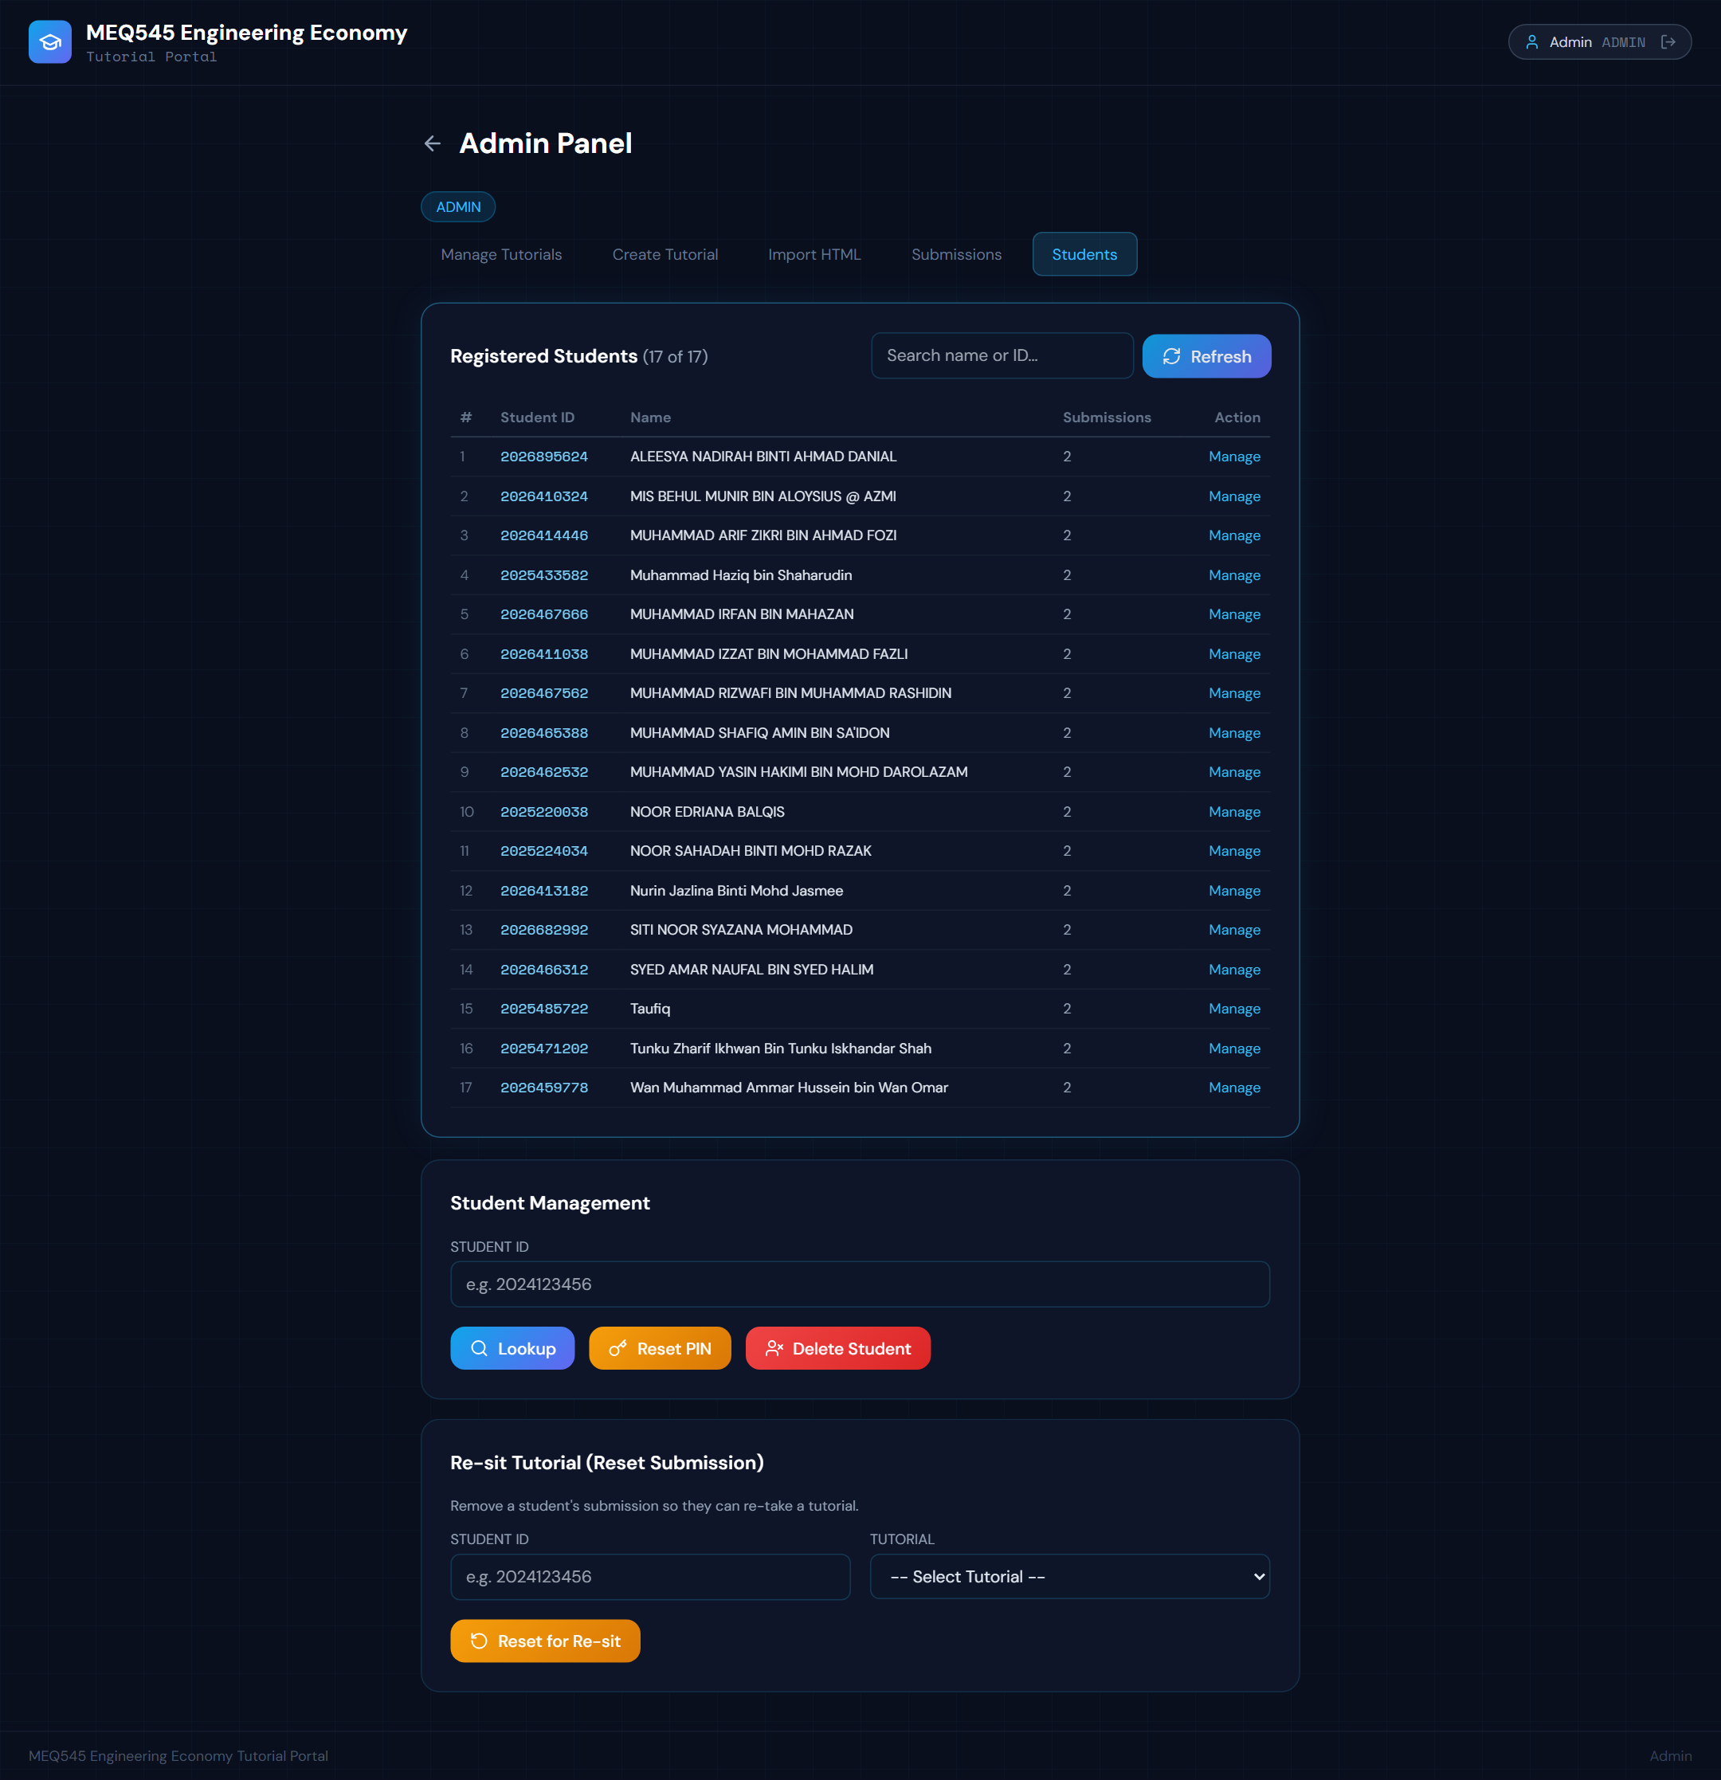
Figure 6 — Registered students of class PEM2433A1 (17 of 17) with submission counts.

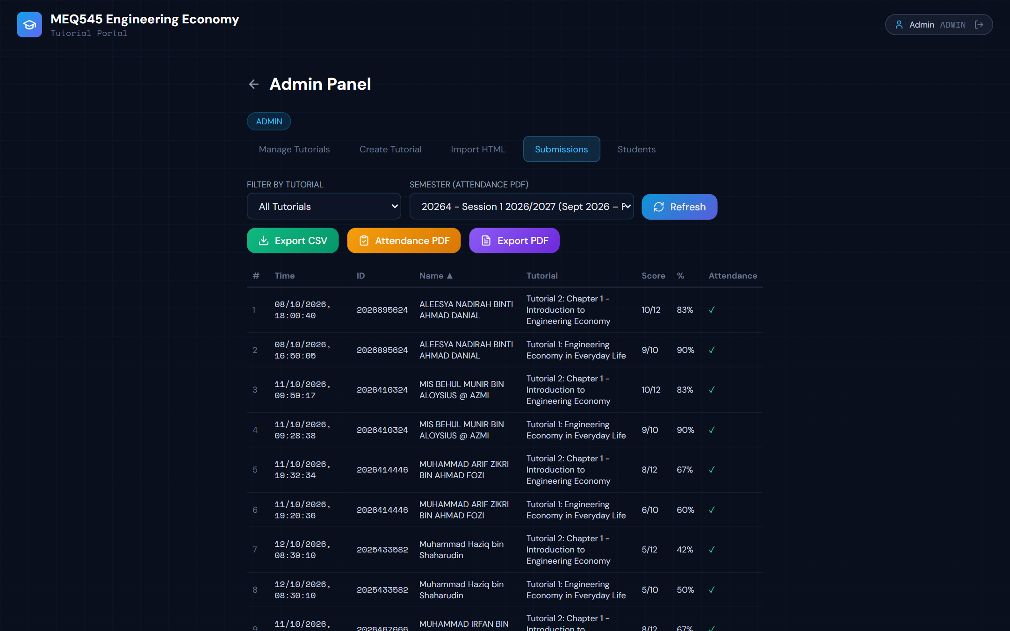
Figure 7 — Submissions monitoring: per-student scores and attendance ticks (extract).

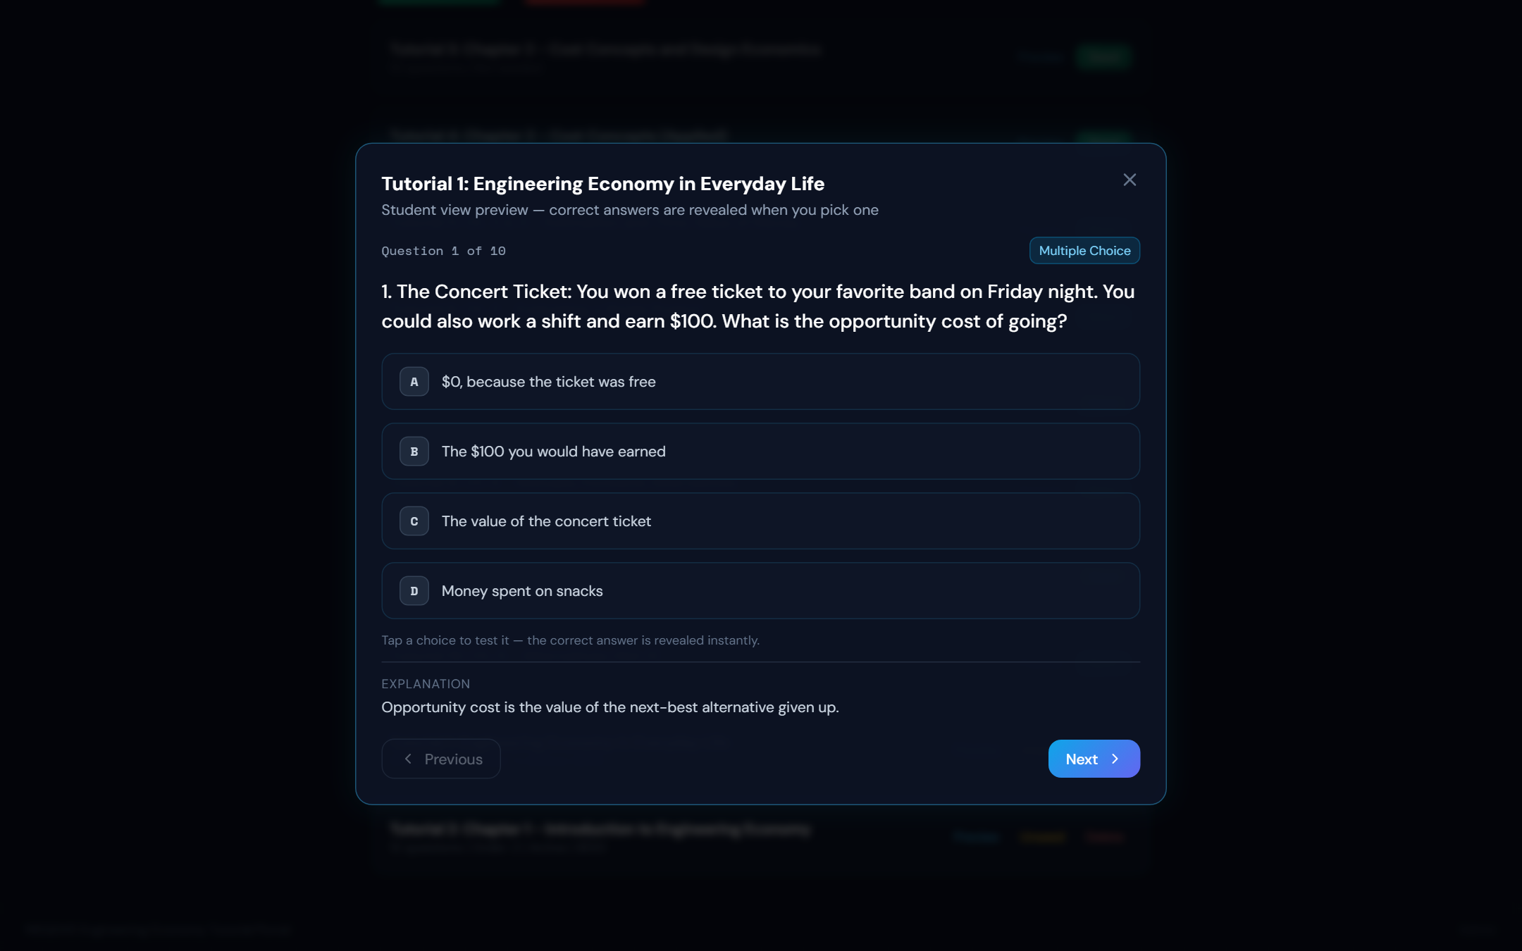
Figure 8 — Student question view (Tutorial 1, Question 1) with answer choices and worked explanation.

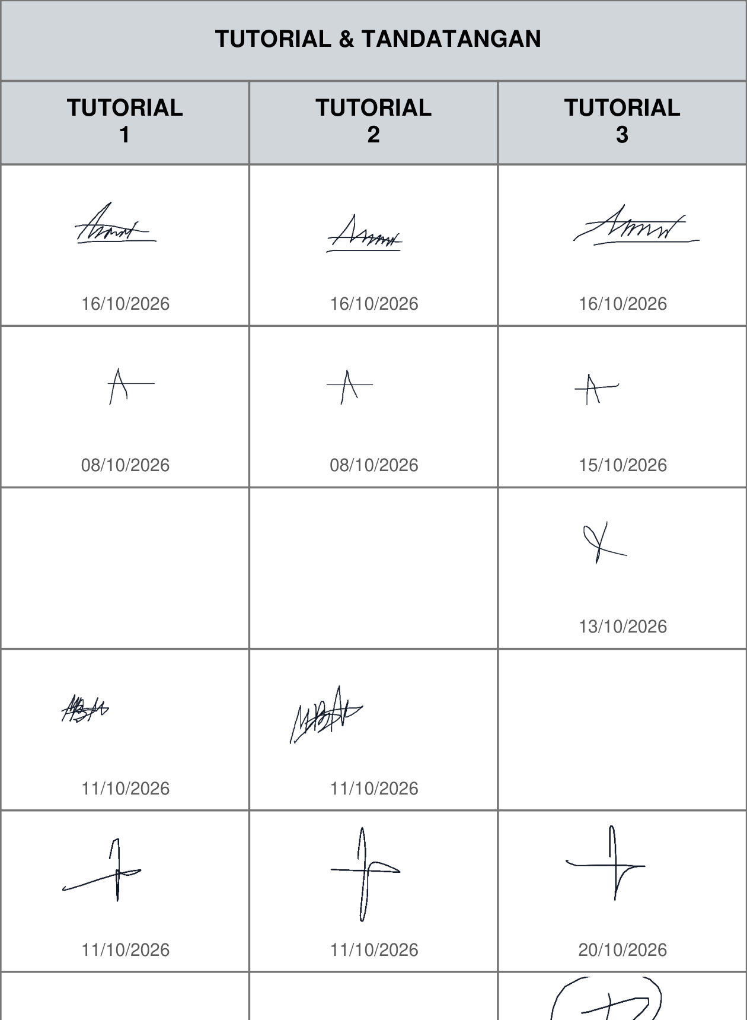
Figure 9 — Signed attendance record generated by the portal ('Attendance PDF' export, official HEA/RP/KH-01 format): detail of the tutorial columns, where each student's captured e-signature is printed under the tutorial date. The full signed PDF is supplied in the evidence folder.

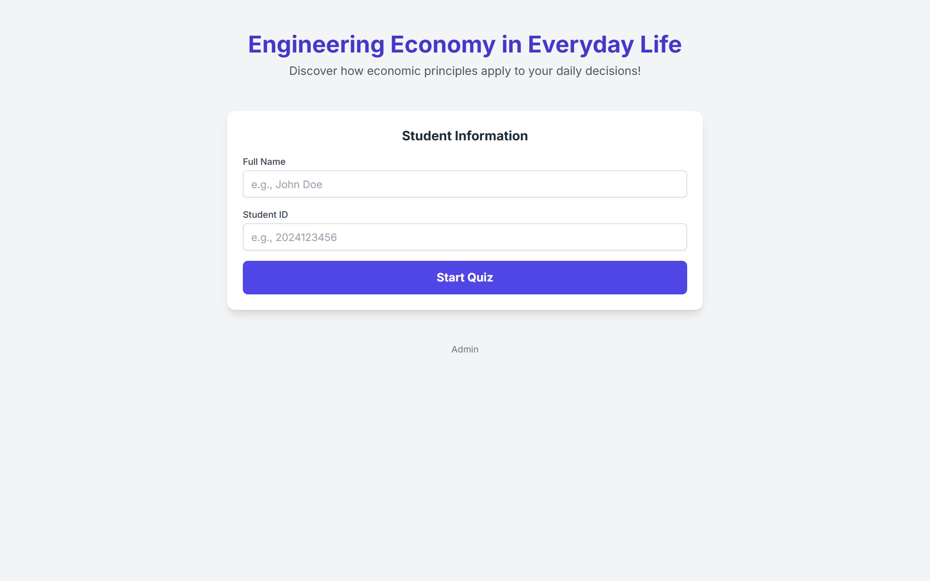
Figure 10 — Standalone tutorial page (Tutorial 1) used for direct-link access.

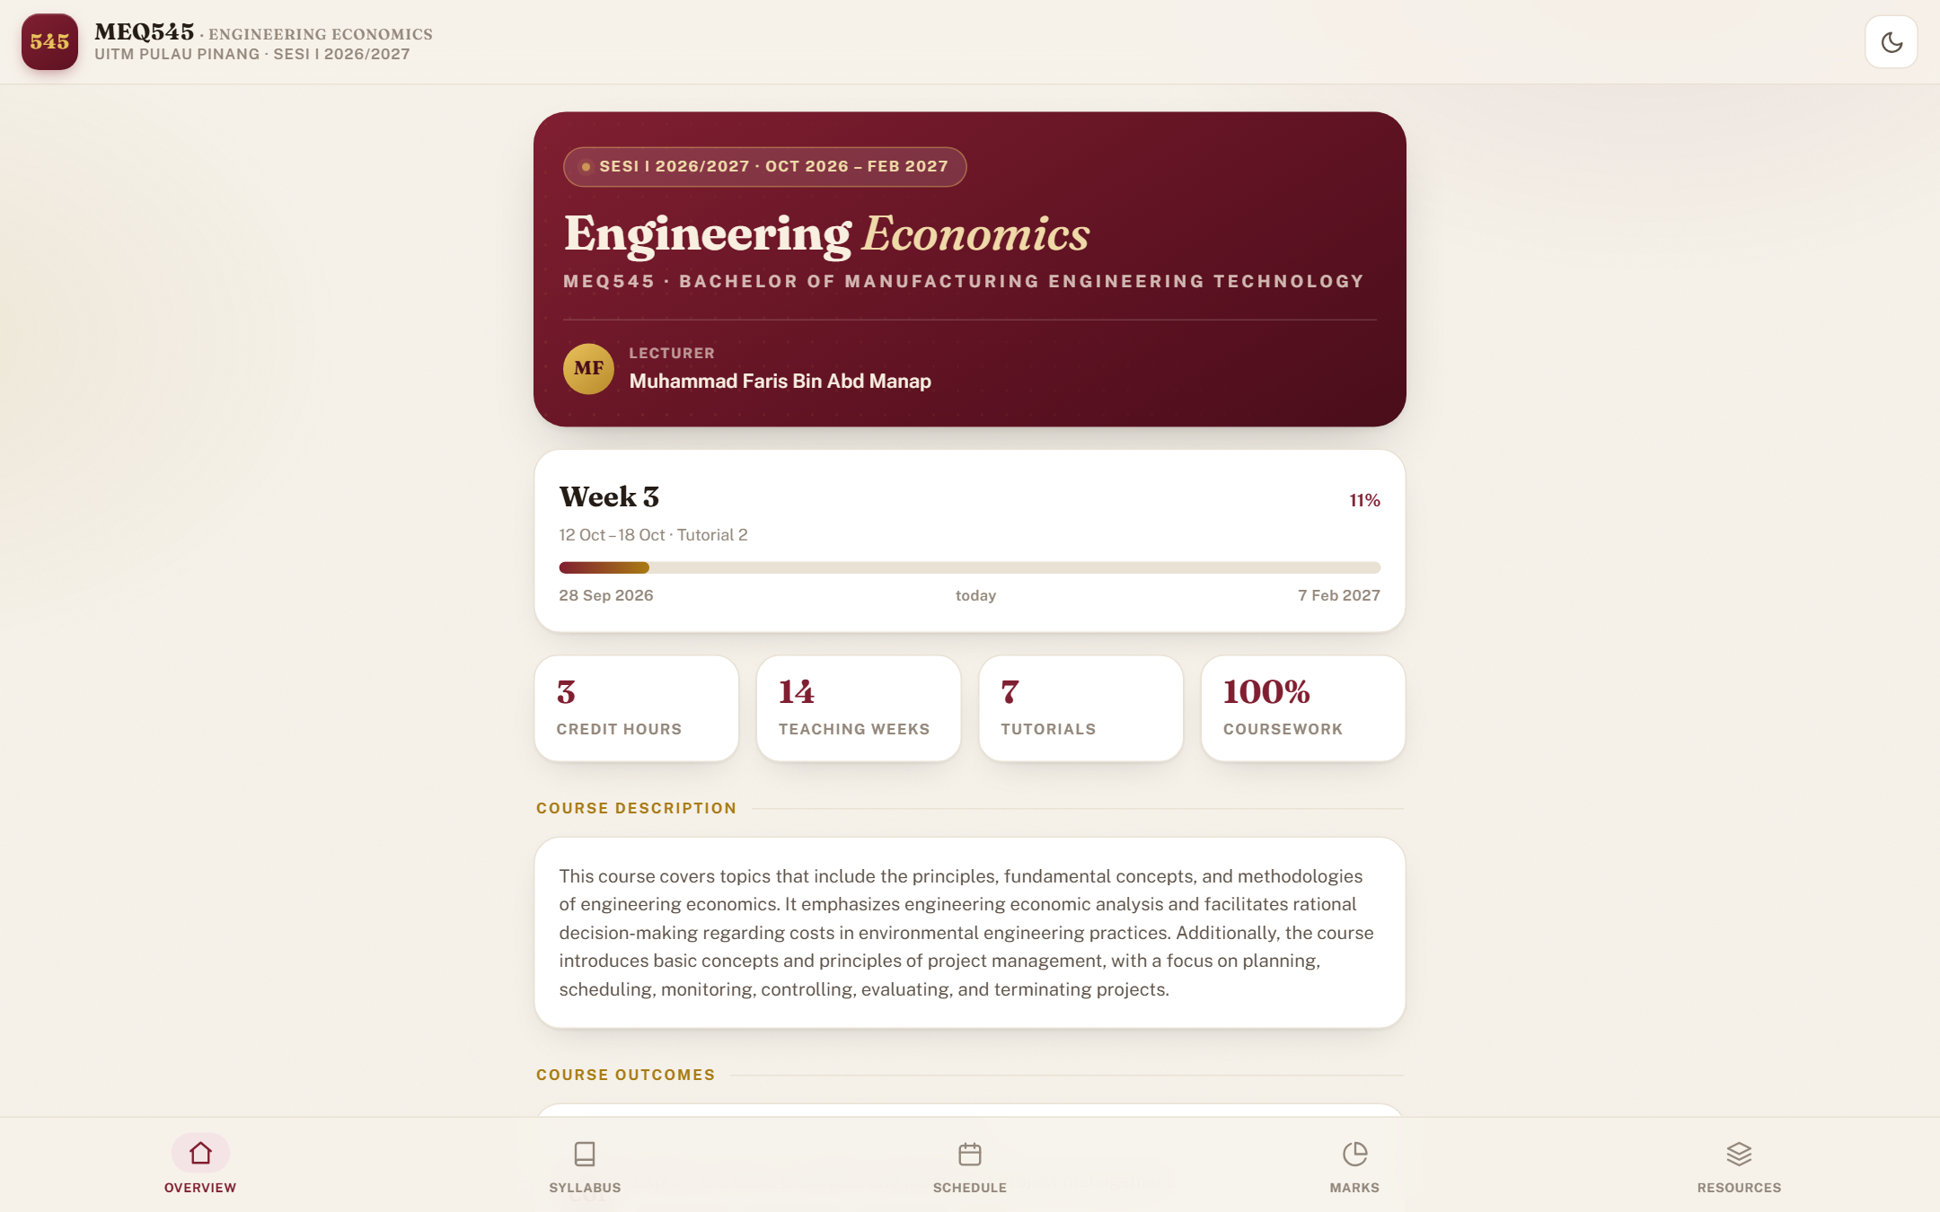
Figure 11 — Teaching plan web app: student-facing view of the tuned teaching plan.

APPENDIX B — INDUSTRY PANEL CURRICULUM VITAE
Curriculum vitae of the industry panel member for this collaboration: En Ahmad Khairul Nizam Bin Bahrinal, Branch Manager Principal, Homefield Real Estate Sdn Bhd.
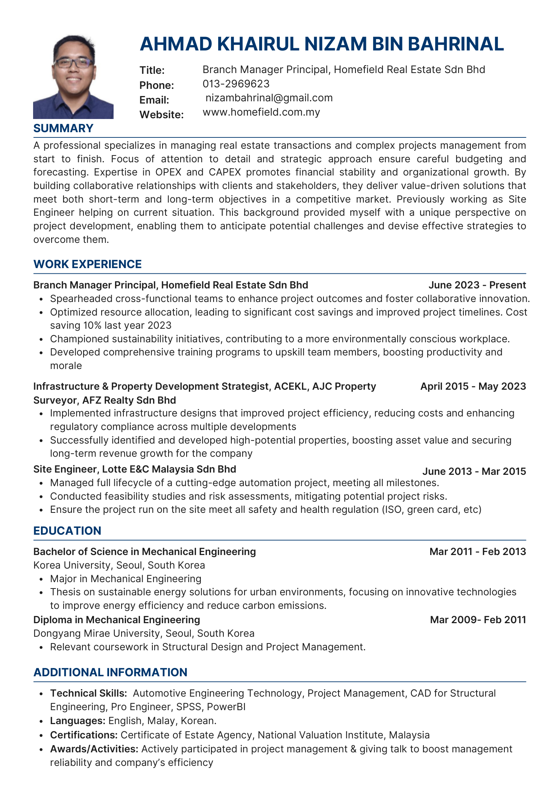
Curriculum vitae of the industry panel member (extract).

