Bcsf25m037

Question no 1
SELECT * FROM Users
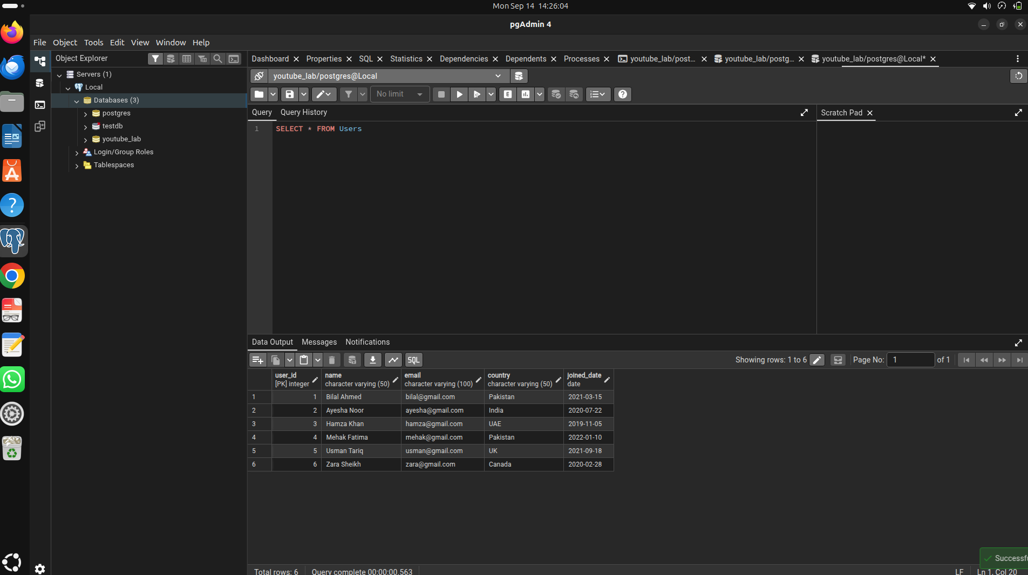
Question No 02
SELECT * FROM Users WHERE joined_date > '2021-01-01'

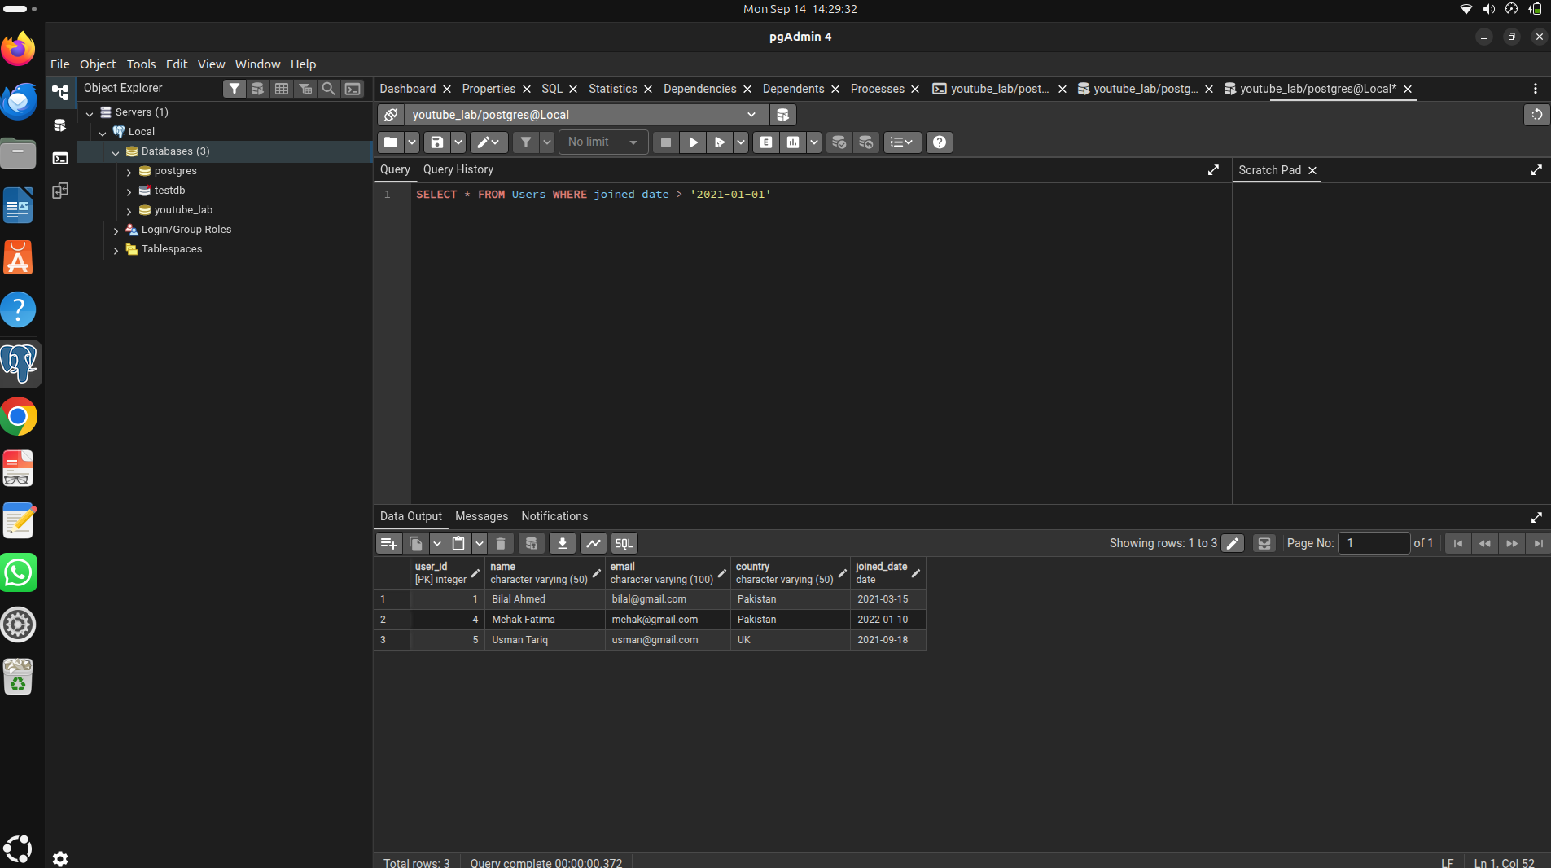
Question no 3
SELECT DISTINCT country FROM Users

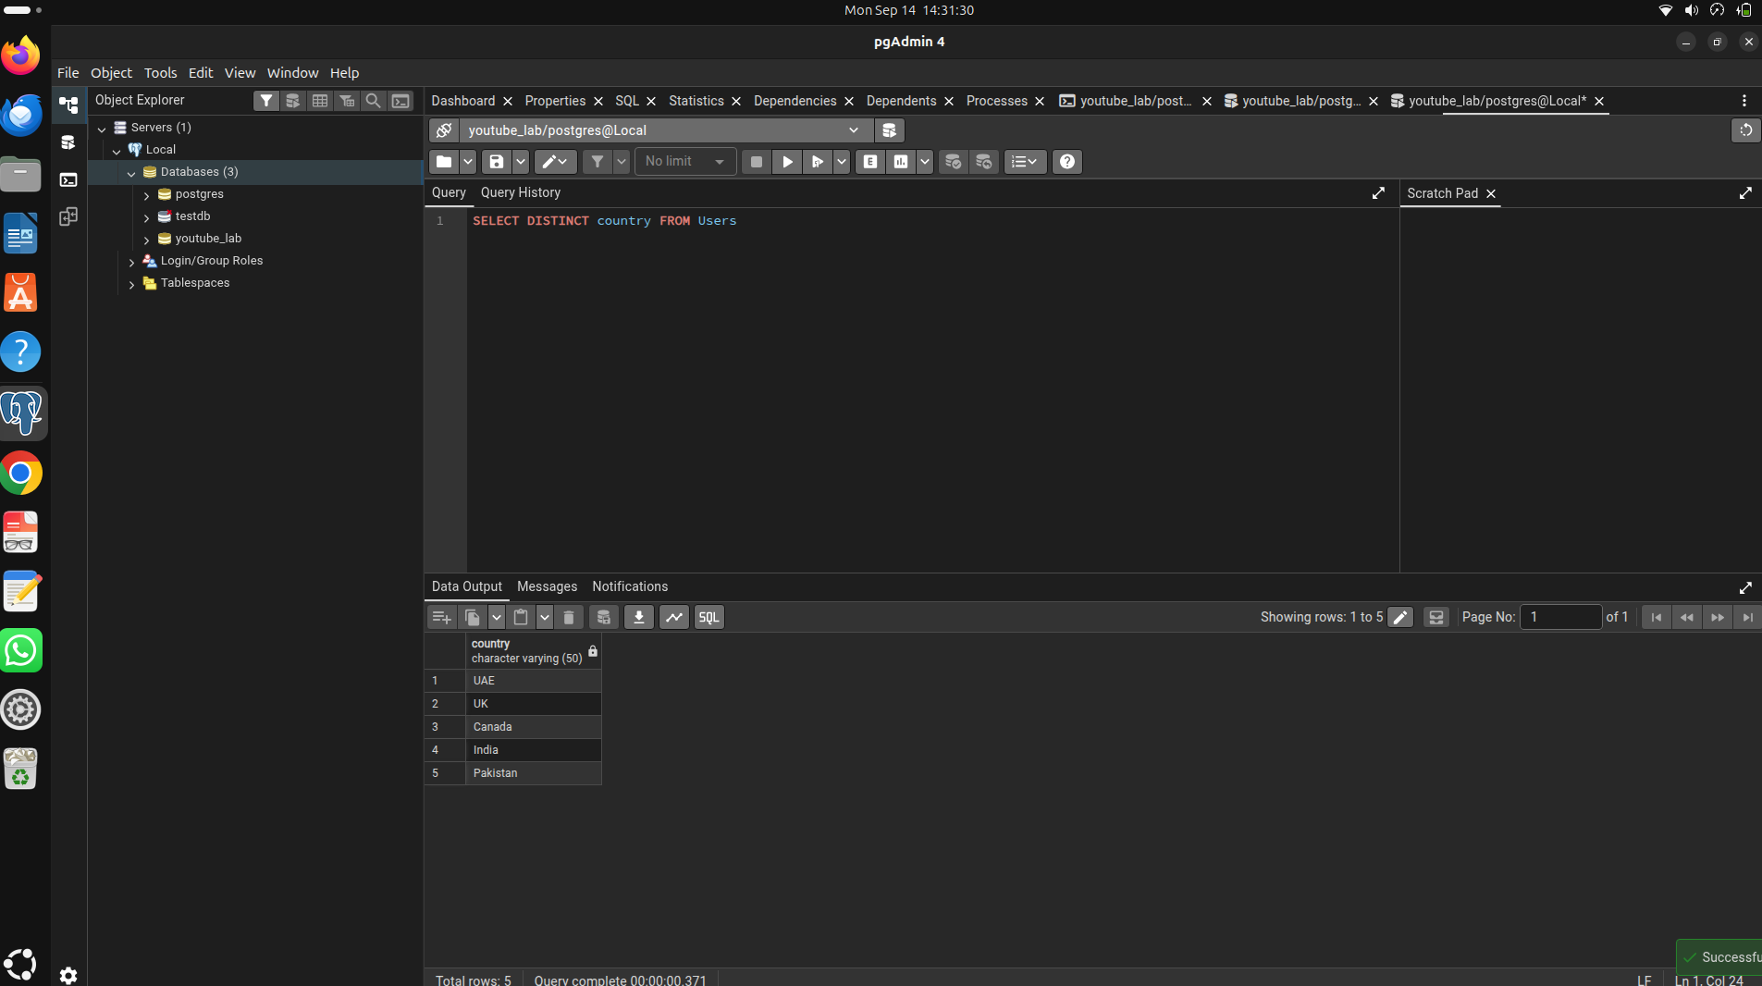
Question 4
SELECT * FROM channels WHERE subscriber_count>100000 AND subscriber_count<300000
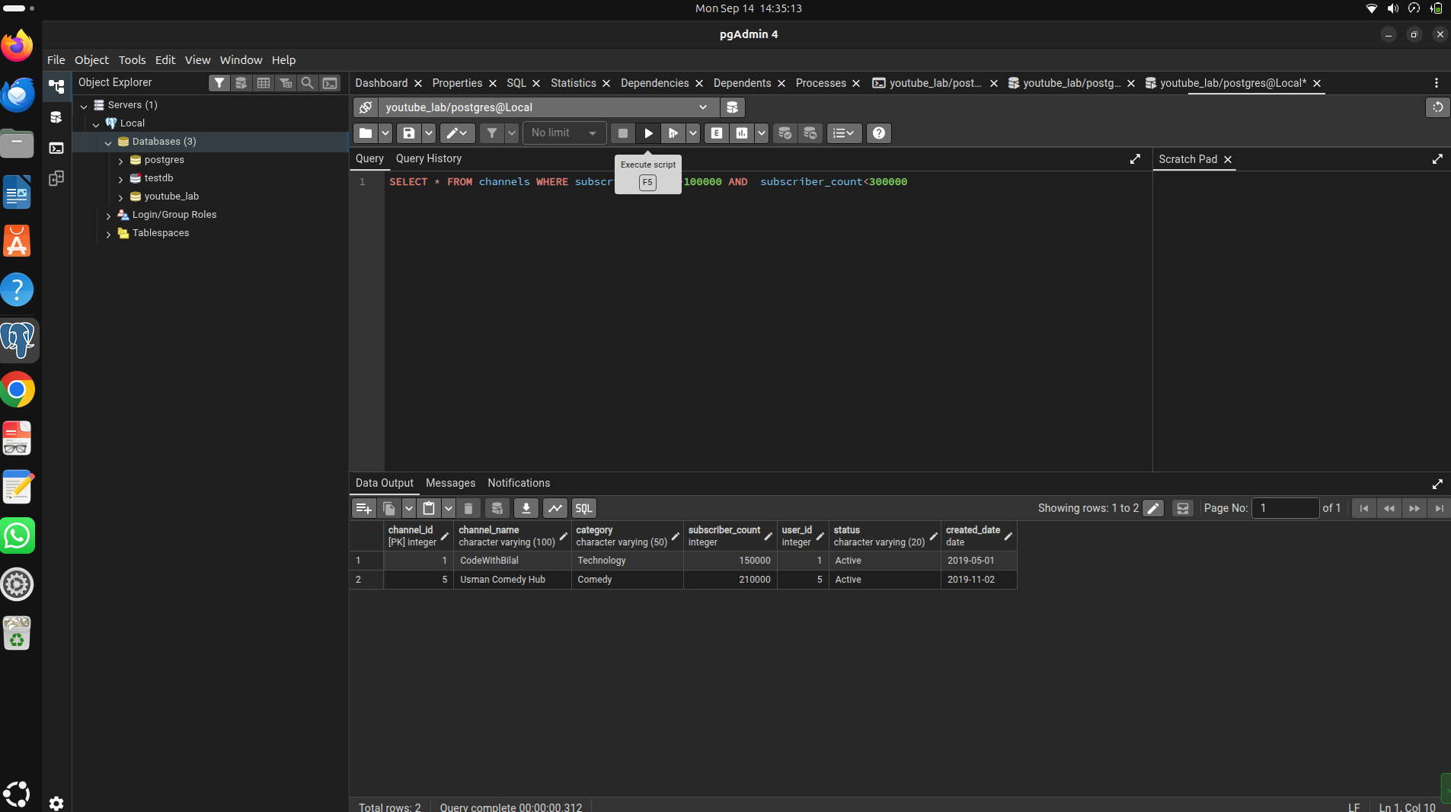
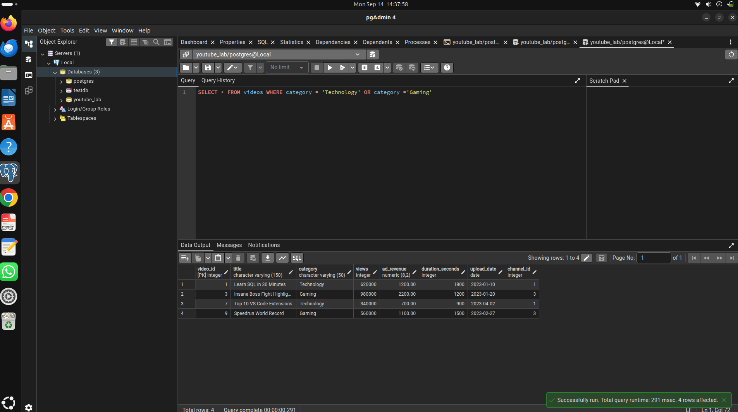
Question NO 05
SELECT * FROM videos WHERE category = 'Technology' OR category ='Gaming'

Question no 06
SELECT * FROM Users WHERE name like'A%'
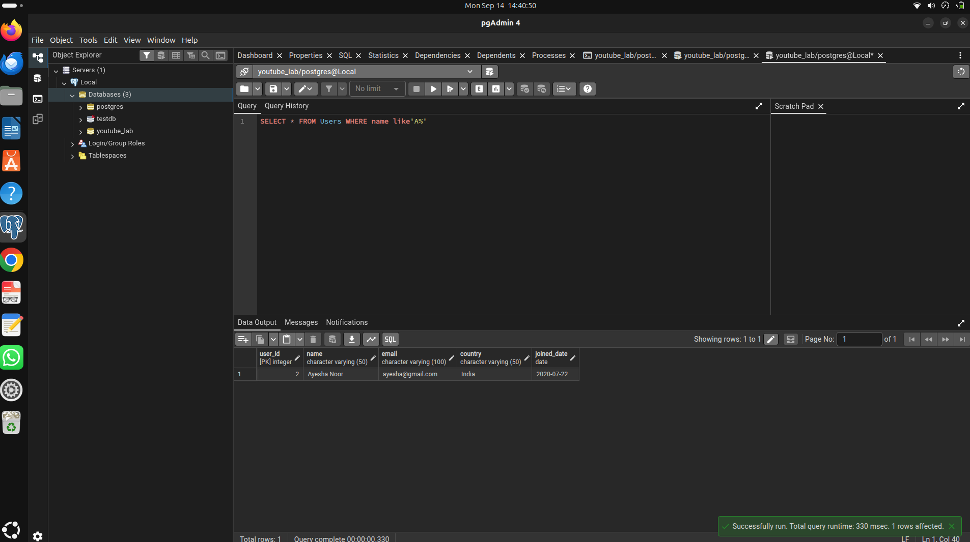
Question No 07
SELECT * FROM comments WHERE rating =5 AND likes>300

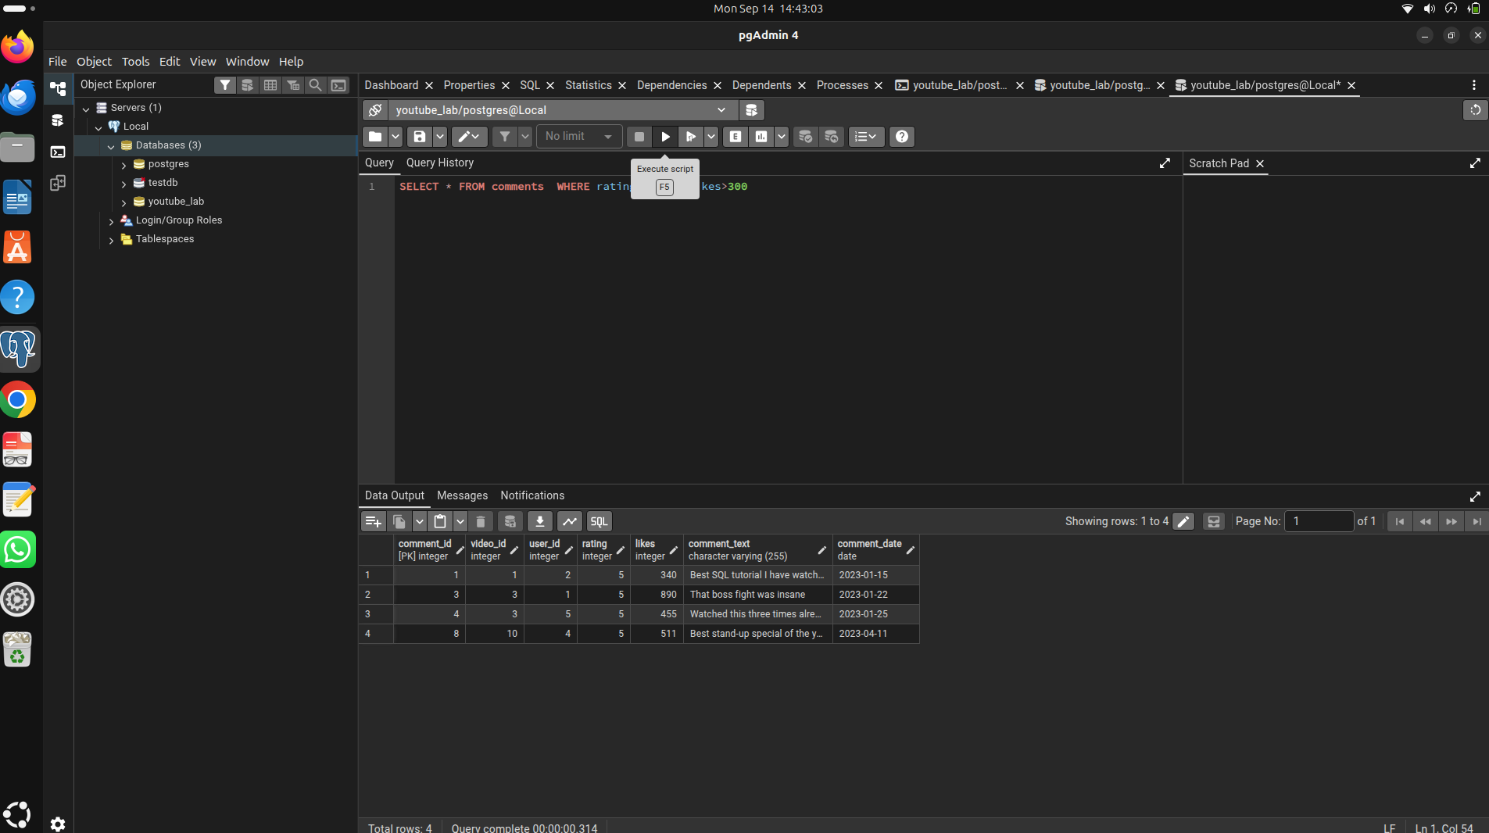
Question no 08
SELECT title, category, ad_revenue FROM Videos ORDER BY ad_revenue DESC

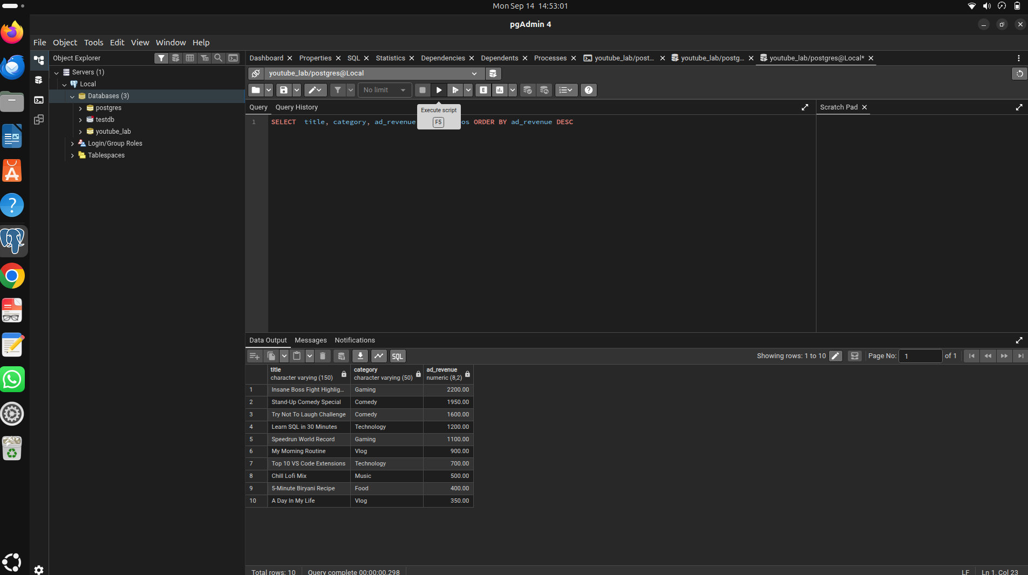
Question 09

Question no 10
SELECT channel_name,subscriber_count FROM channels ORDER BY subscriber_count DESC LIMIT 3;
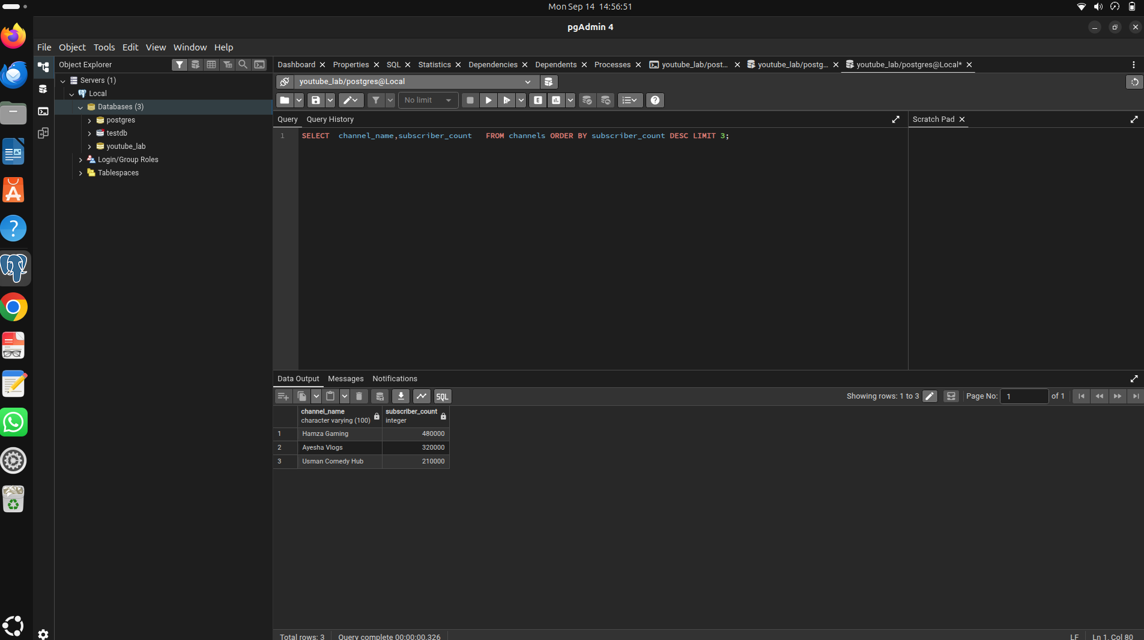
TASK 2
Question no 11

SELECT * FROM videos WHERE category!='Gaming' AND views >50000
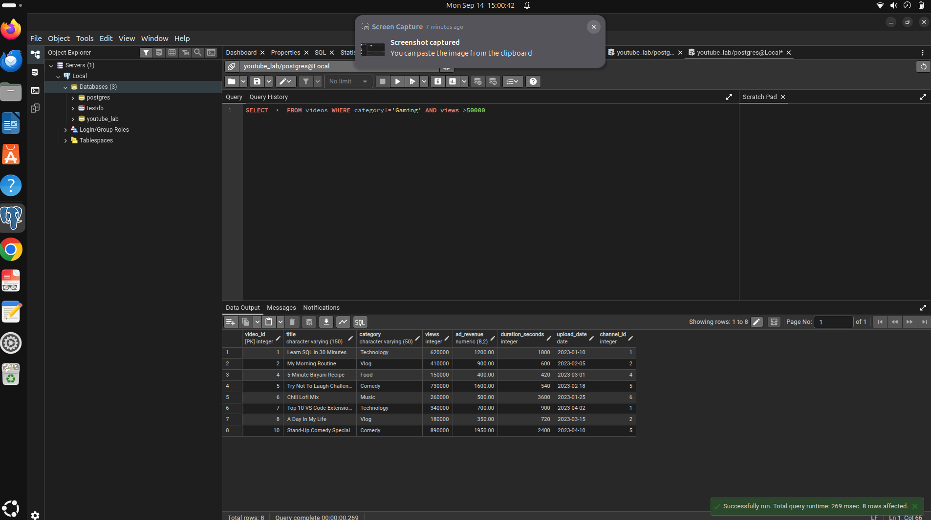

Qestion no 12

SELECT channel_name,subscriber_count FROM channels WHERE subscriber_count >200000 AND (channel_name like '%T'OR channel_name like '%S')
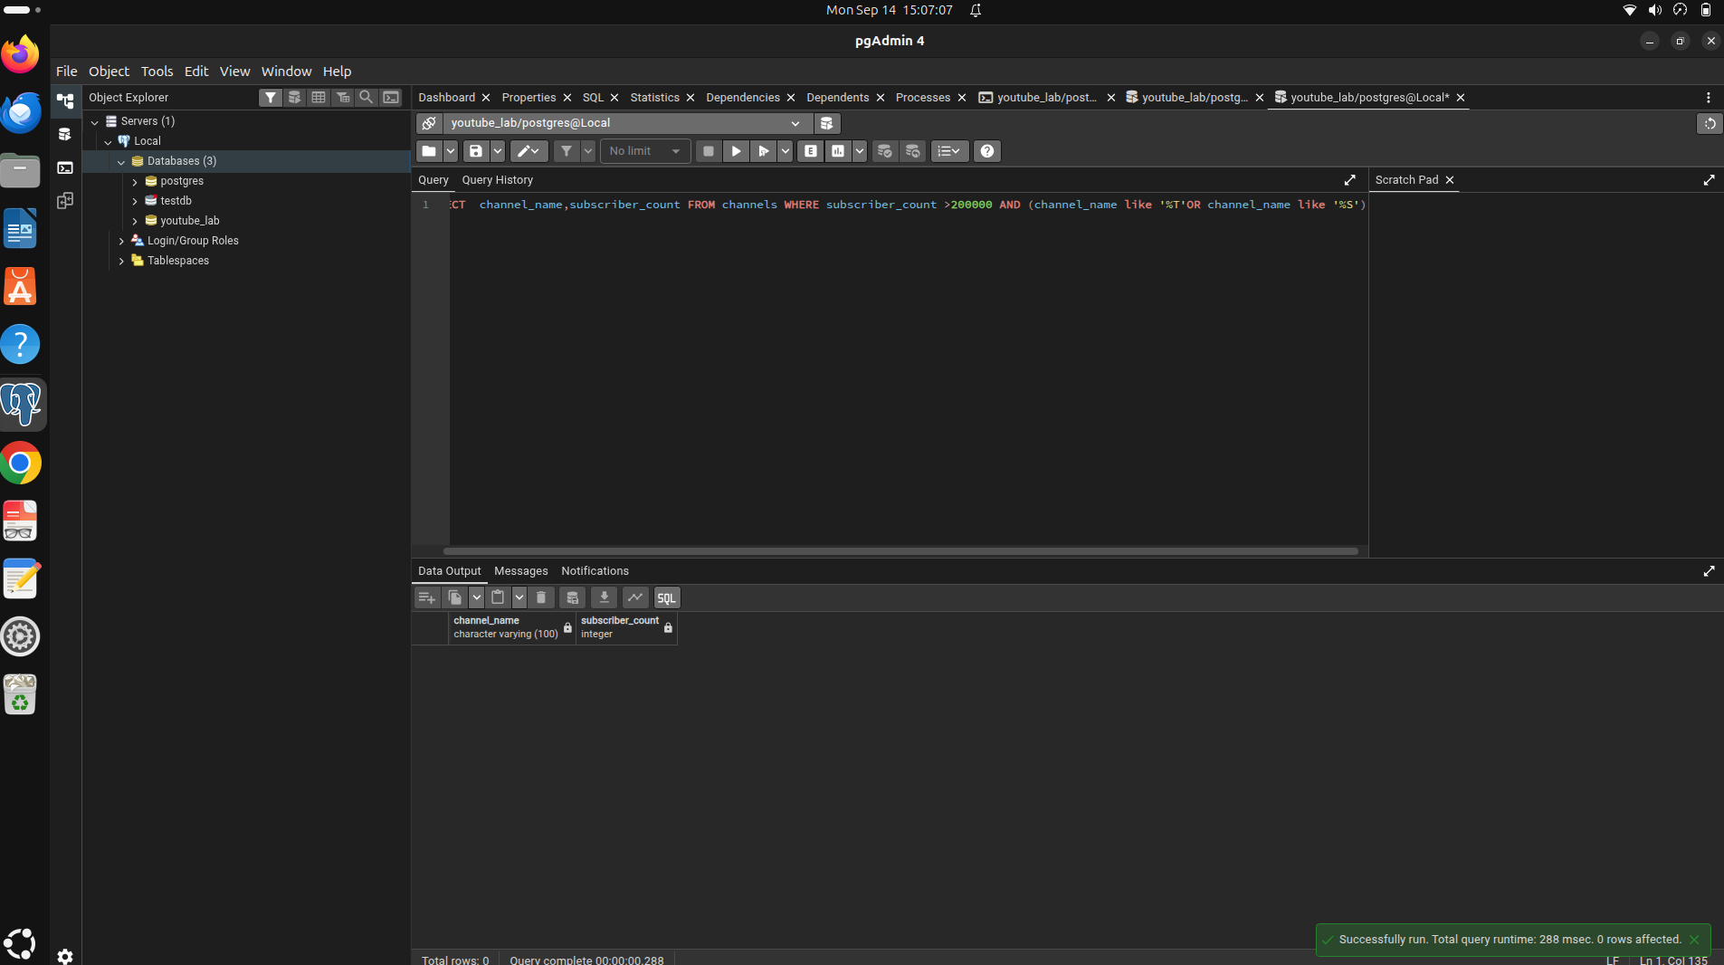
Question 13
SELECT title ,views ,ad_revenue ,ad_revenue*1000/views AS ad_revenue_per_1000_views FROM videos
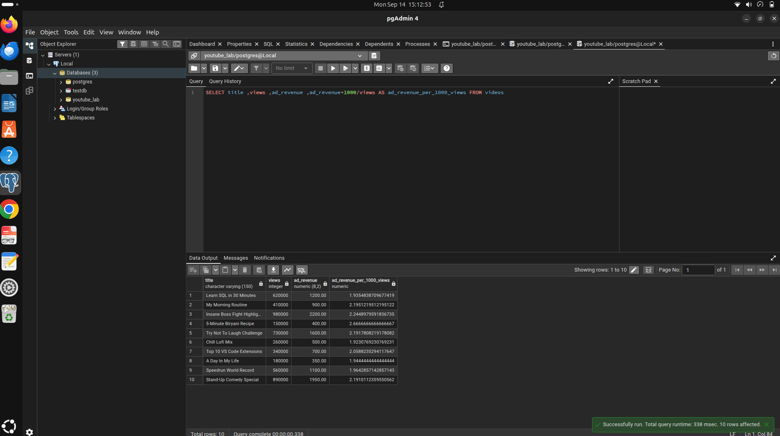
Question 14
SELECT * FROM comments WHERE (rating >3 AND rating<5) OR likes>500 ORDER BY likes DESC
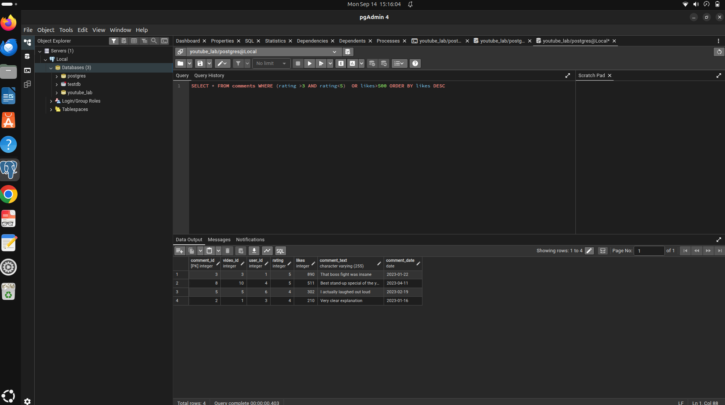
Question No 15
SELECT name,joined_date FROM users WHERE joined_date BETWEEN '2020-01-01'AND '2022-12-01'
ORDER BY joined_date DESC
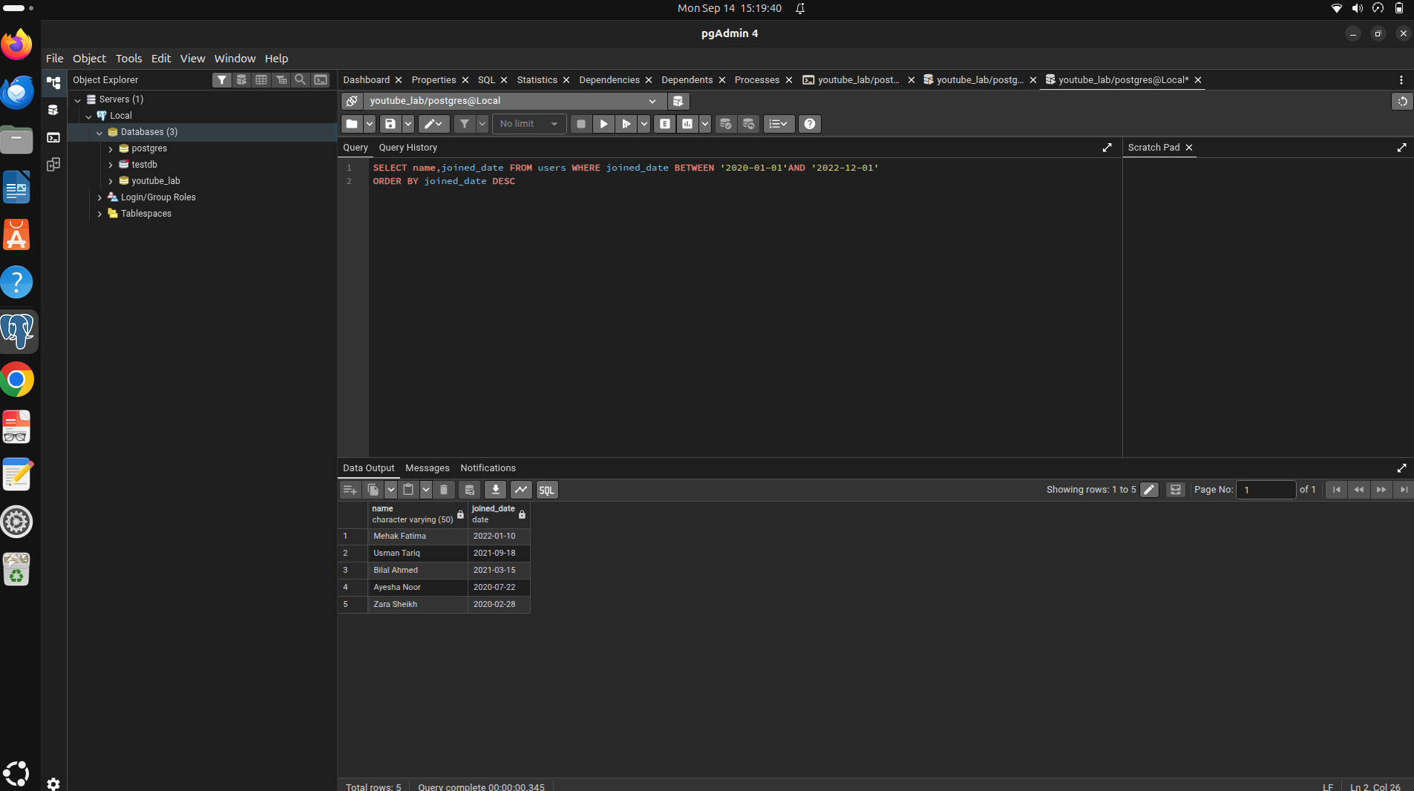
Question NO 16
SELECT title,duration_seconds FROM videos WHERE duration_seconds <300 OR duration_seconds >1200
ORDER BY duration_seconds DESC
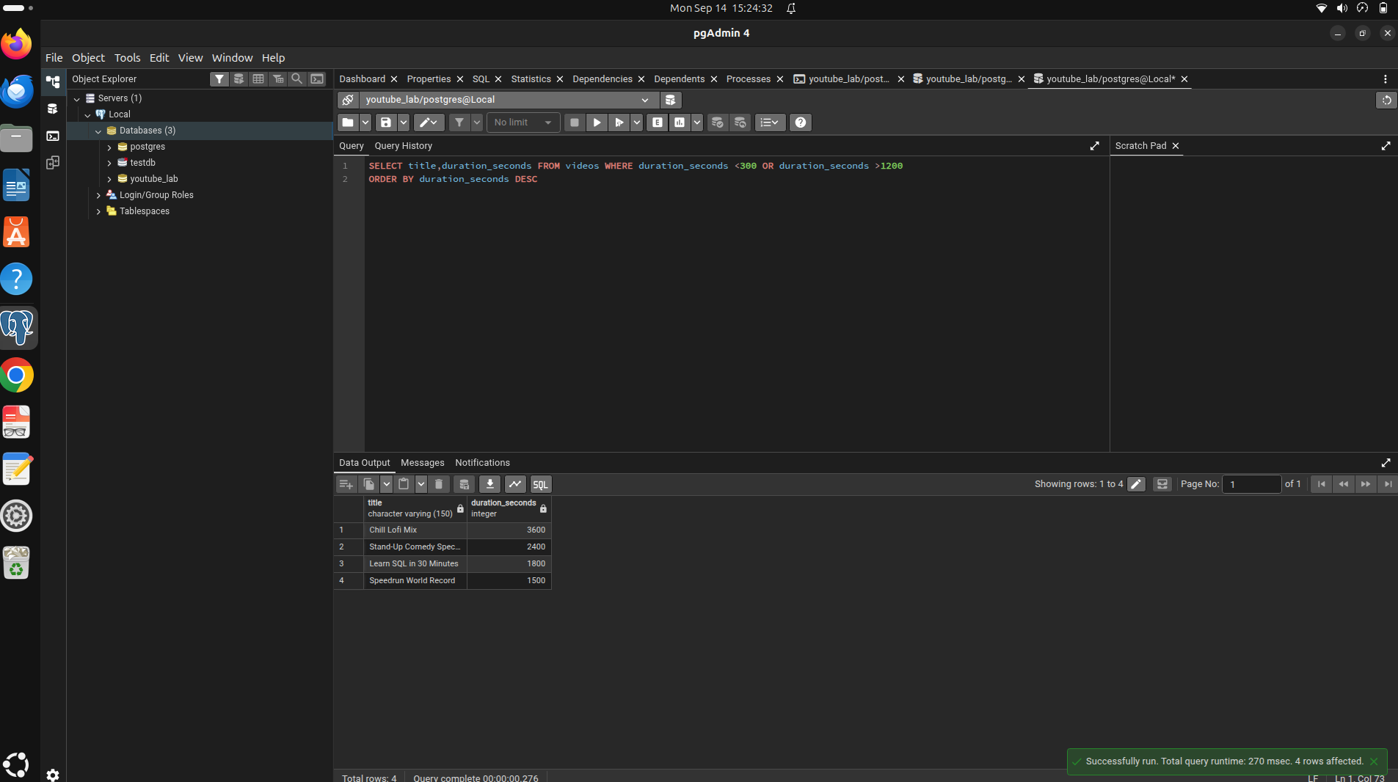
Question 17
SELECT channel_name,subscriber_count FROM channels ORDER BY subscriber_count OFFSET 3 LIMIT 6;

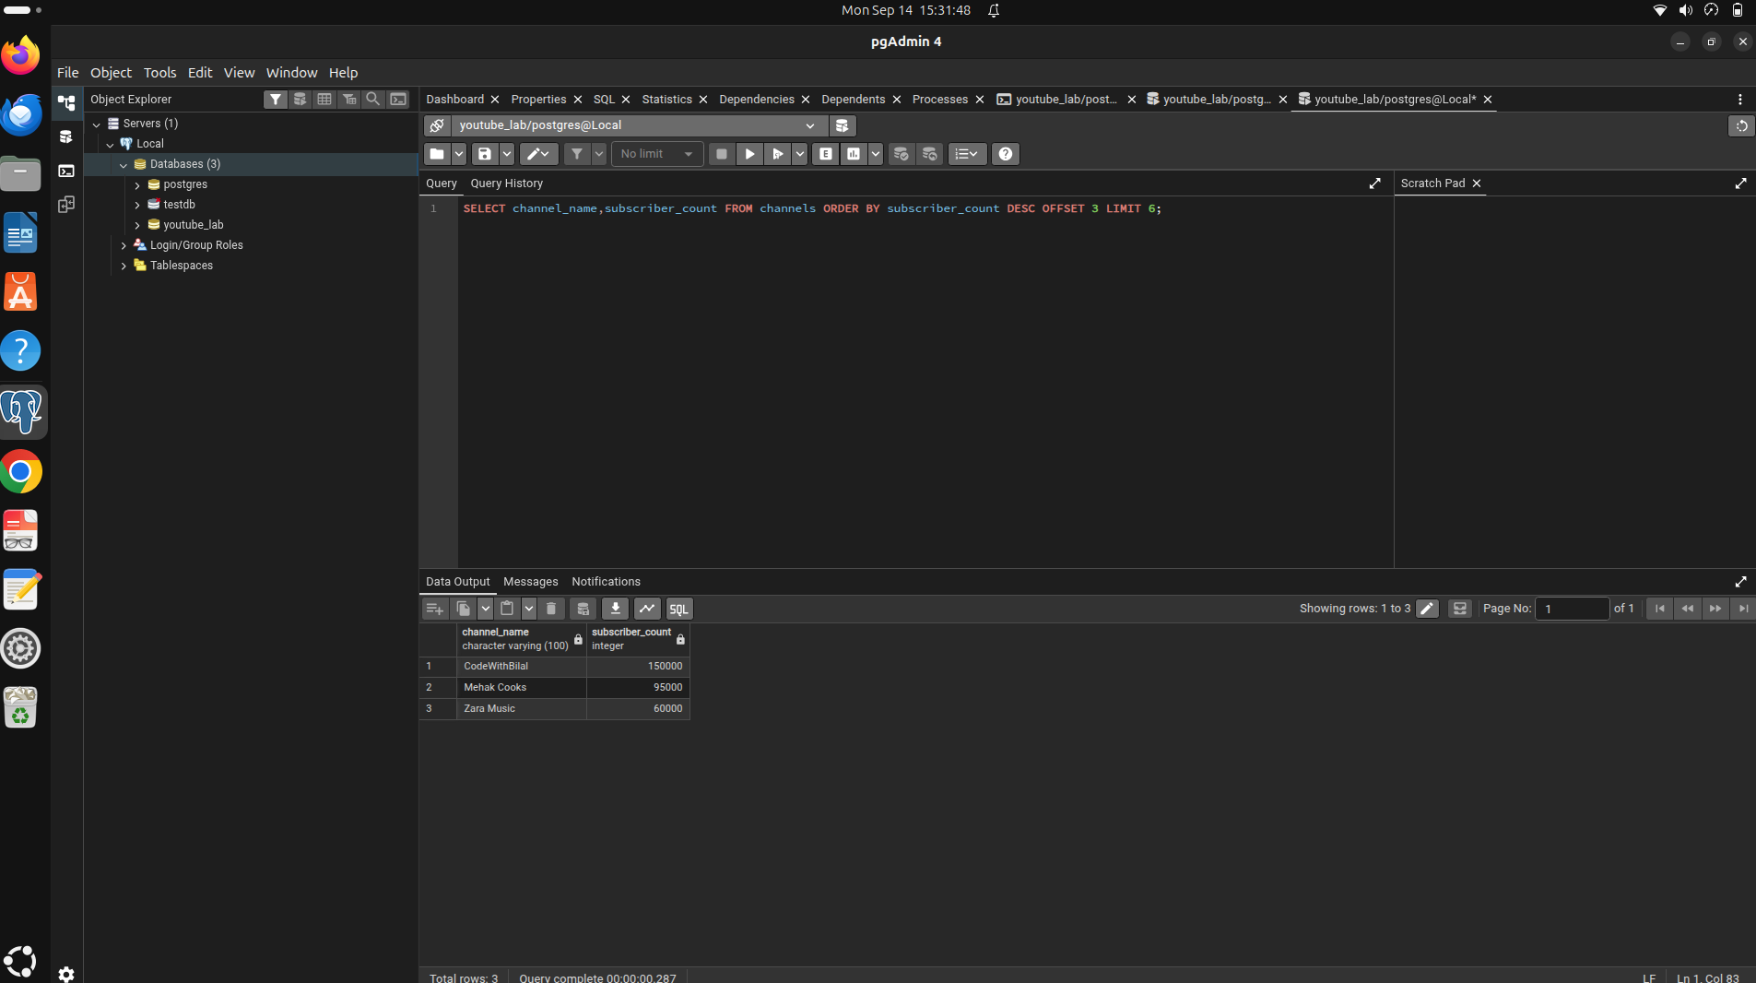
Q18
SELECT title,category ,views ,ad_revenue FROM videos WHERE (category='Technology'AND views>1000)OR(category='Gaming' AND ad_revenue>5000)
ORDER BY ad_revenue DESC
