Question 01
SELECT * FROM Videos;

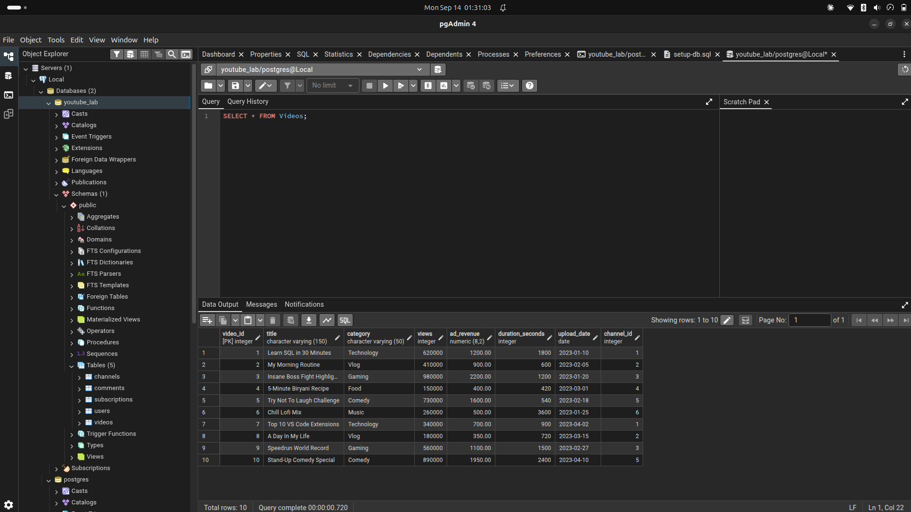
Question 02
SELECT title, category, views FROM Videos;

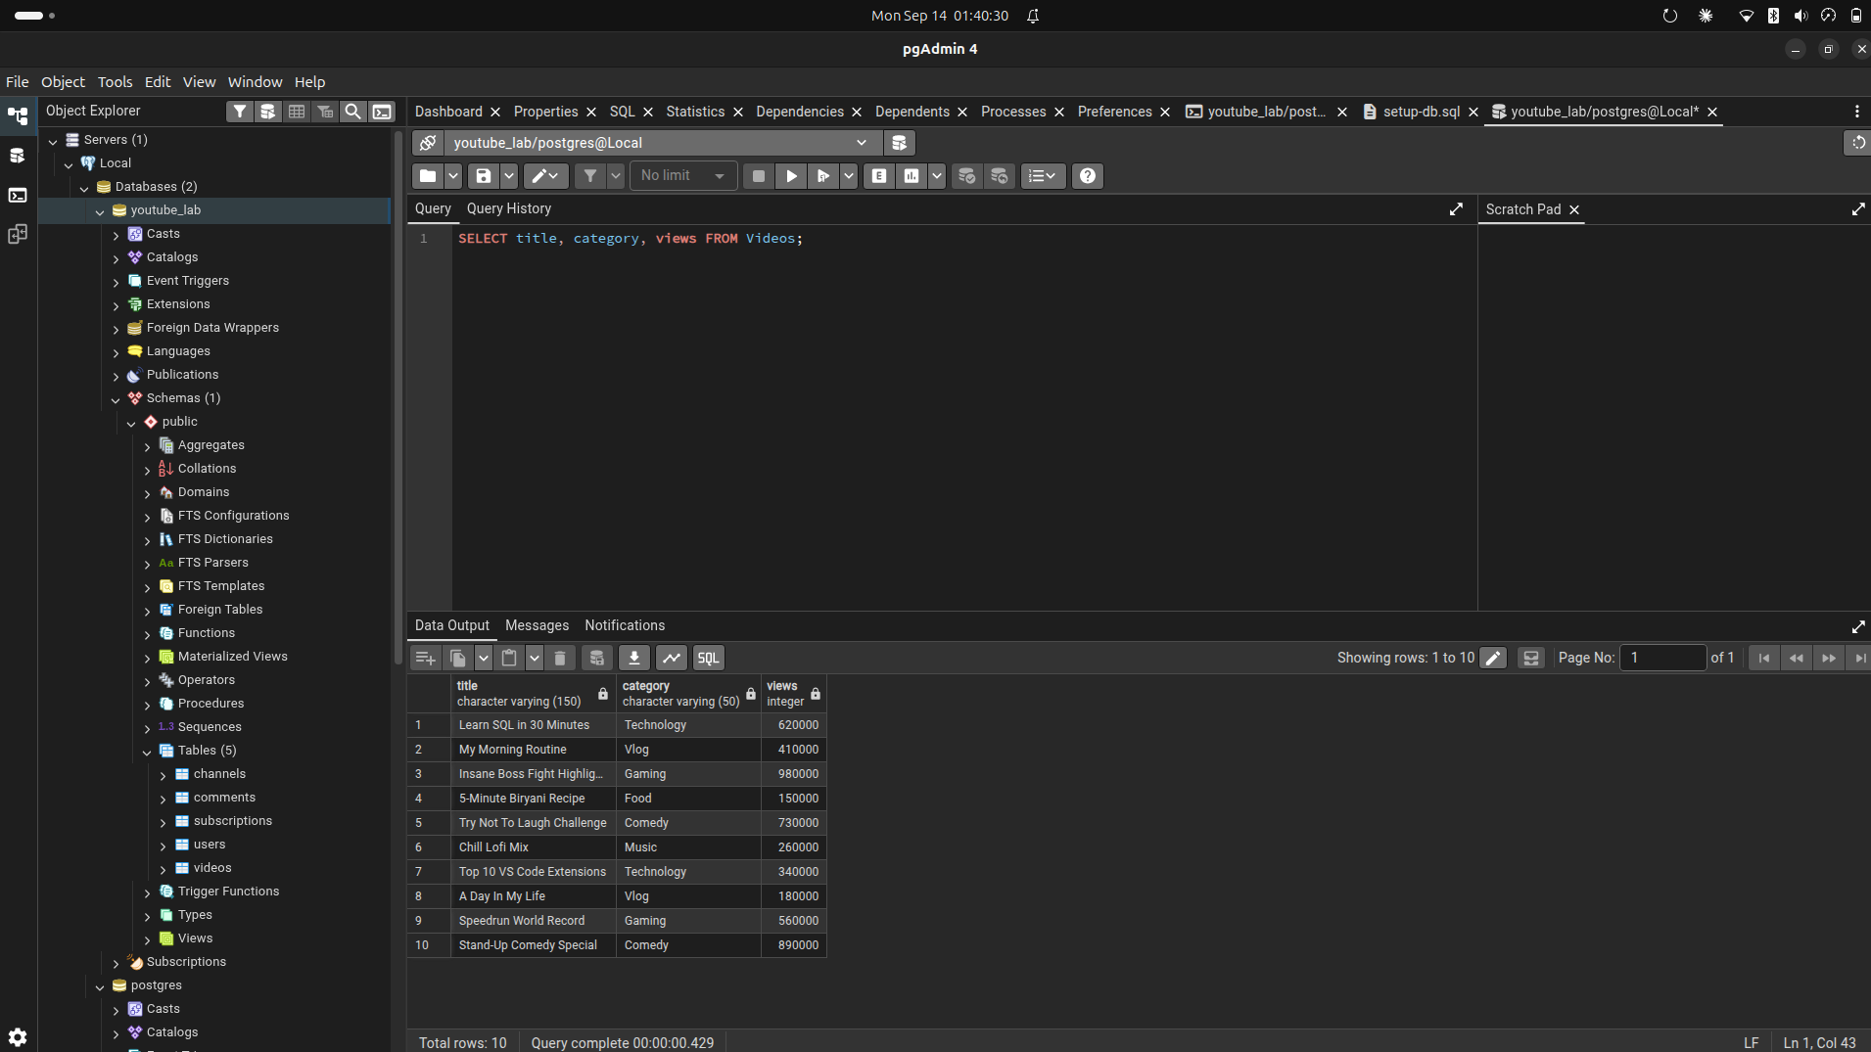
Question 03
SELECT DISTINCT category FROM Videos;

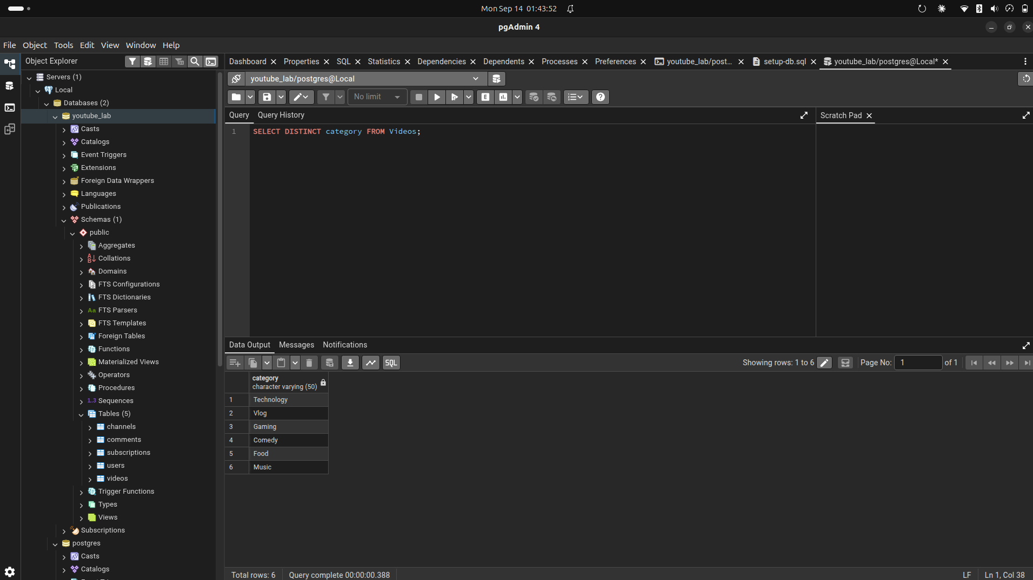
Question 04
SELECT * FROM Videos WHERE views > 500000;

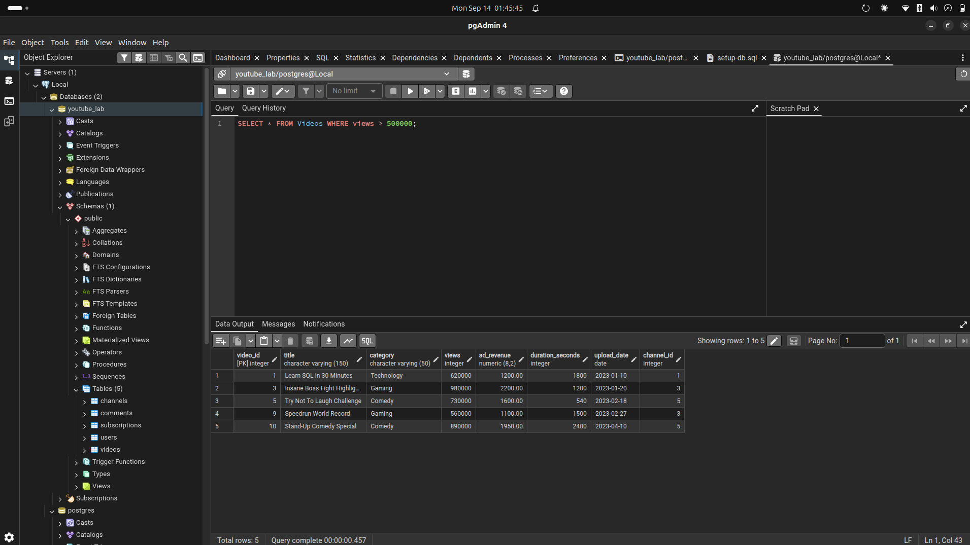
Question 05
SELECT * FROM Users WHERE country <> 'Pakistan';
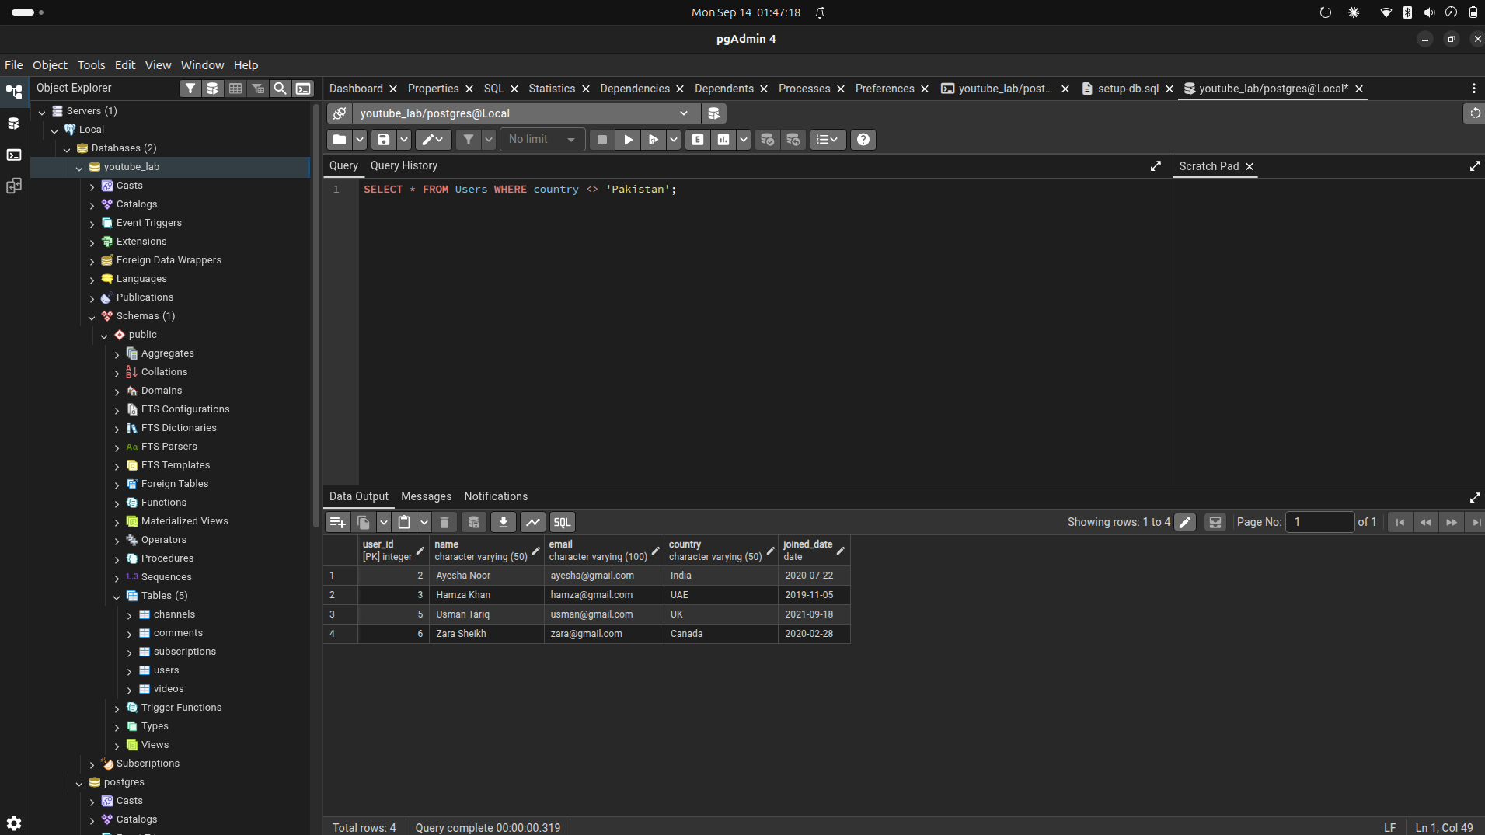
Question 06
SELECT * FROM Channels WHERE status = 'Active' AND subscriber_count > 100000;

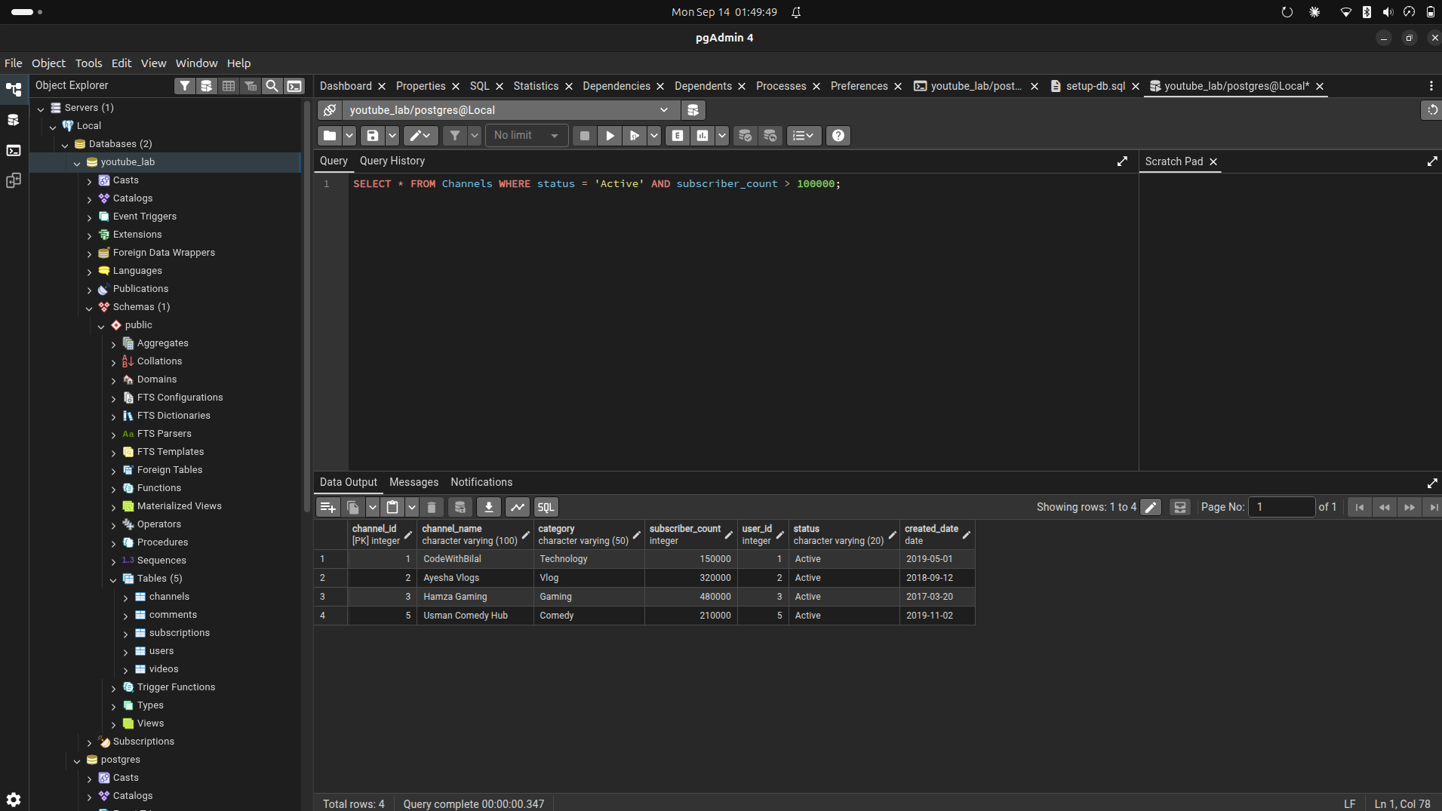
Question 07
SELECT * FROM Videos WHERE category = 'Comedy' OR category = 'Vlog';

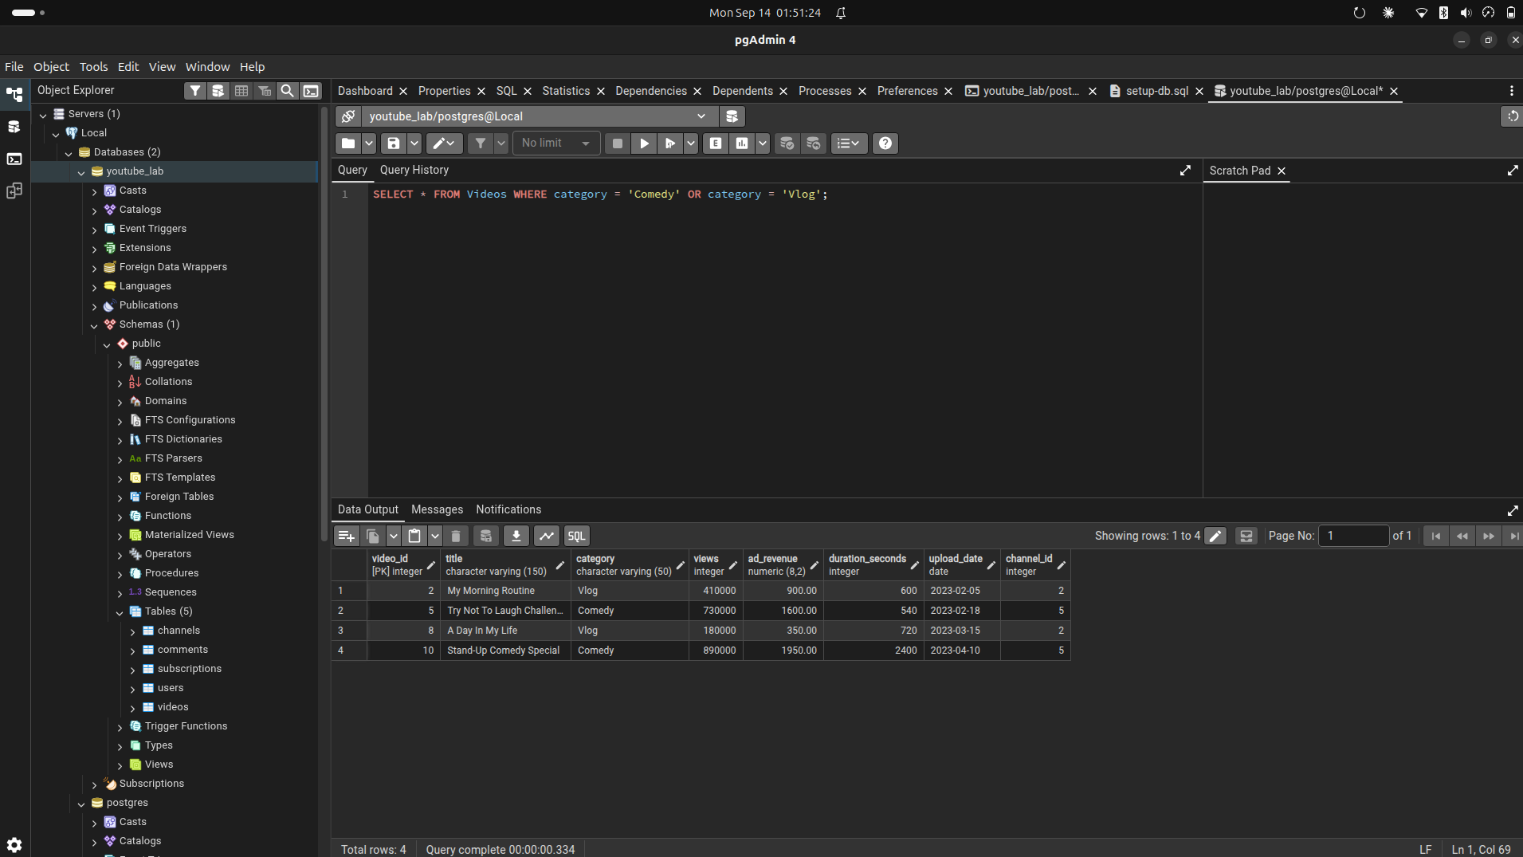
Question 08
SELECT title, ad_revenue, ad_revenue - ad_revenue * 0.10 AS revenue_after_fee FROM Videos;

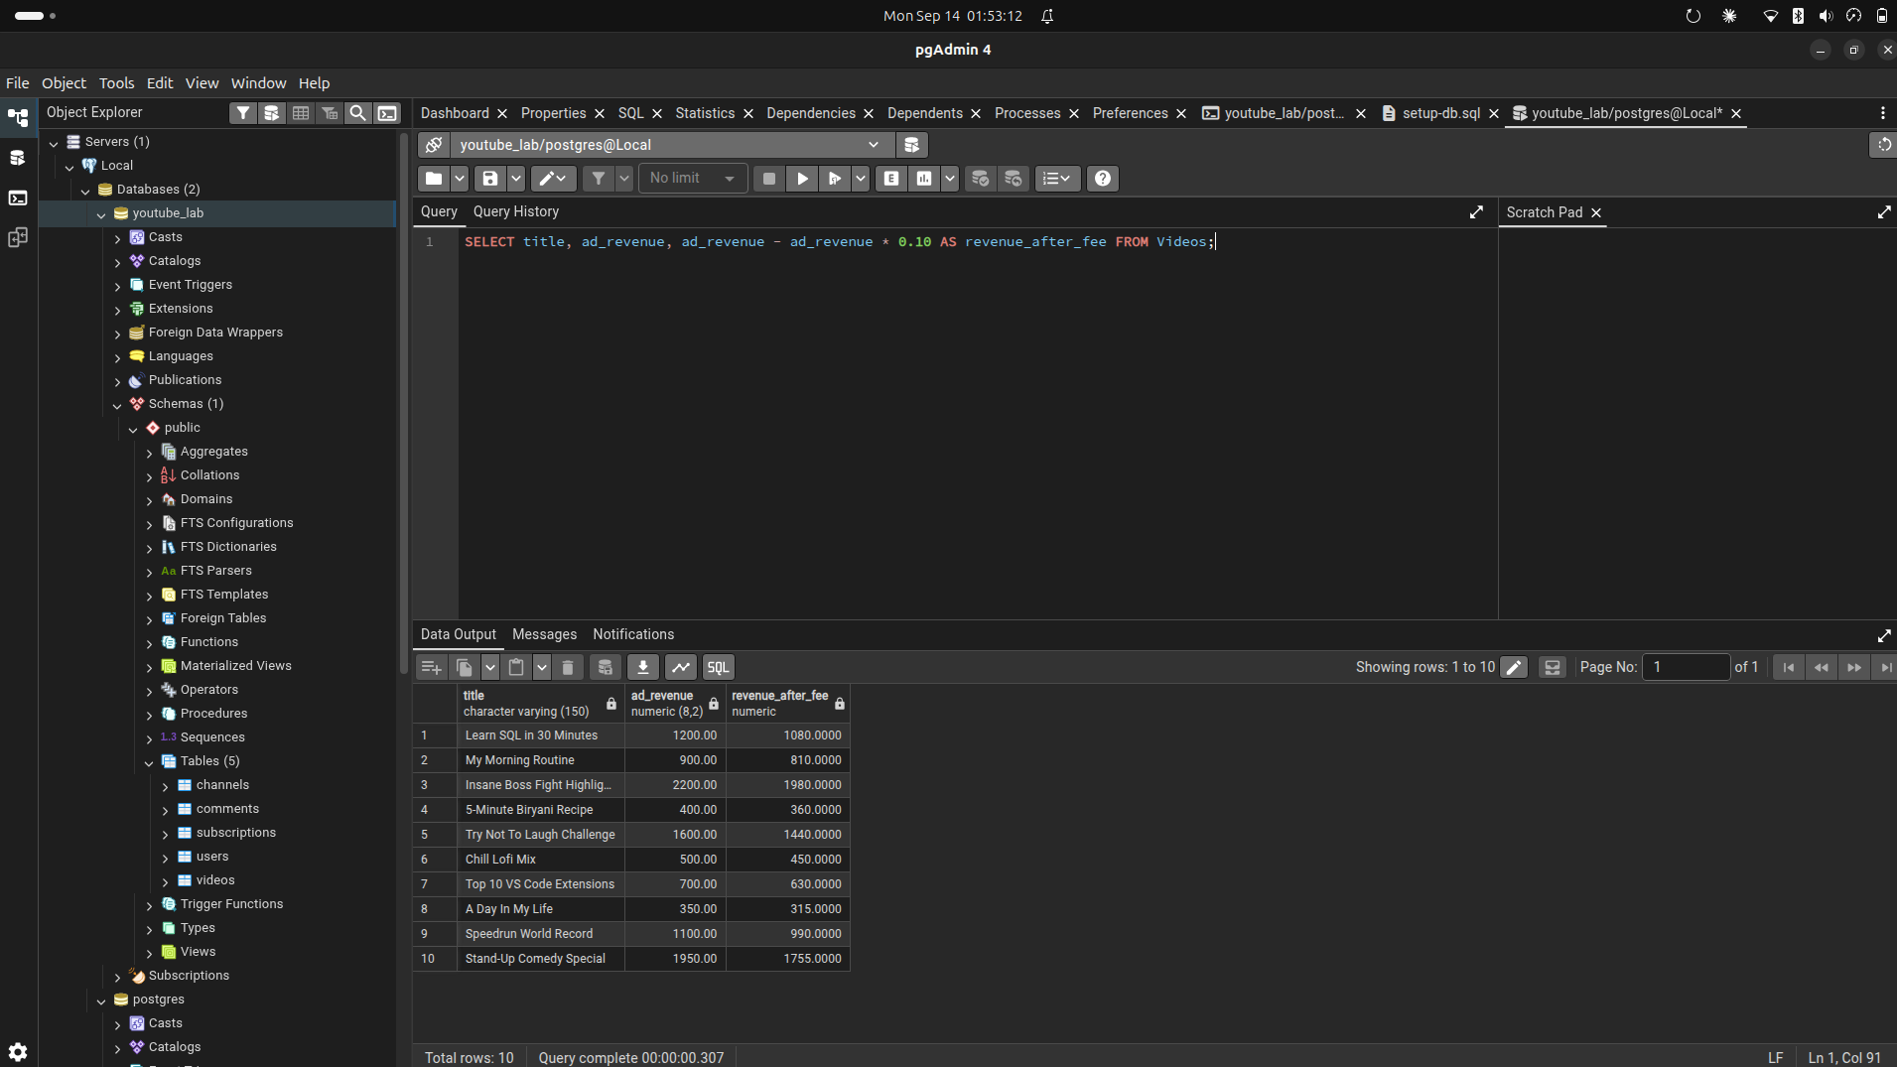
Question 09
SELECT comment_id, likes, likes & 1 AS is_odd FROM Comments;

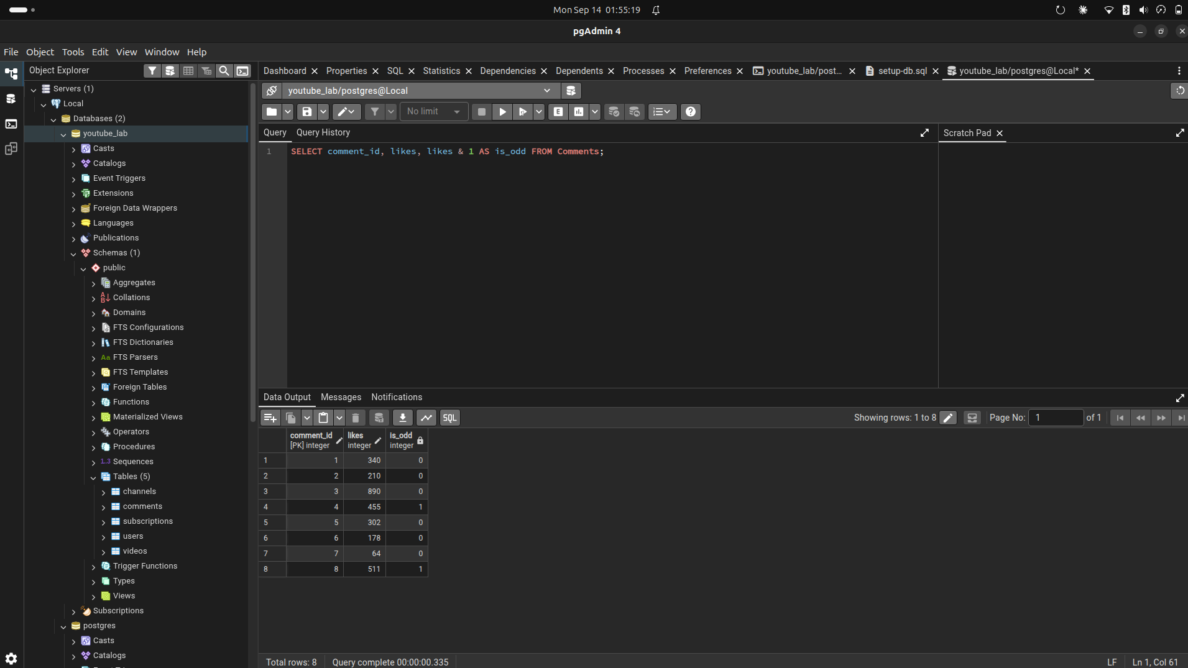
Question 10
SELECT title, views FROM Videos ORDER BY views DESC LIMIT 3;
