Experiment 1 output:
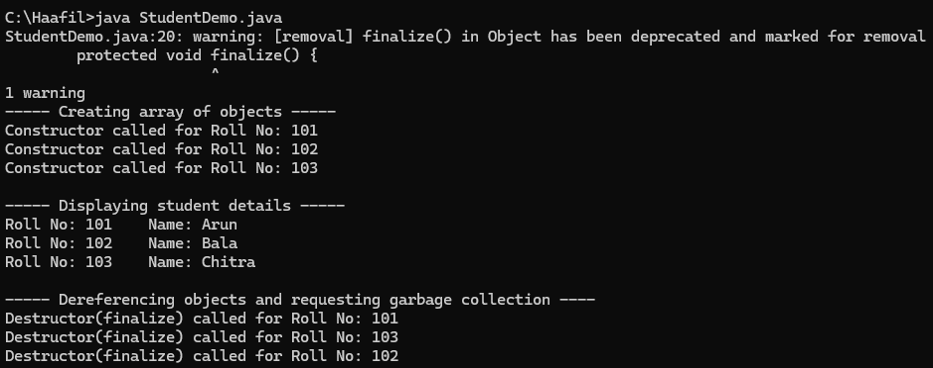
Experiment 2 output:
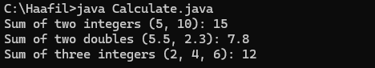
Experiment 3 output:
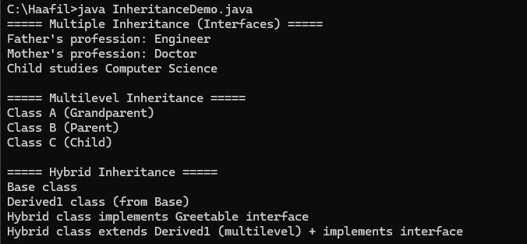
Experiment 4 output:
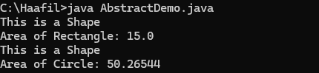
Experiment 5 output:
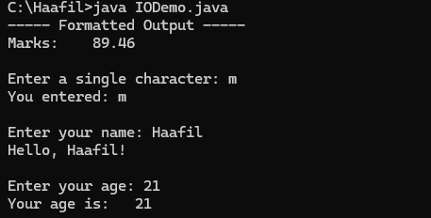
Experiment 6 output: 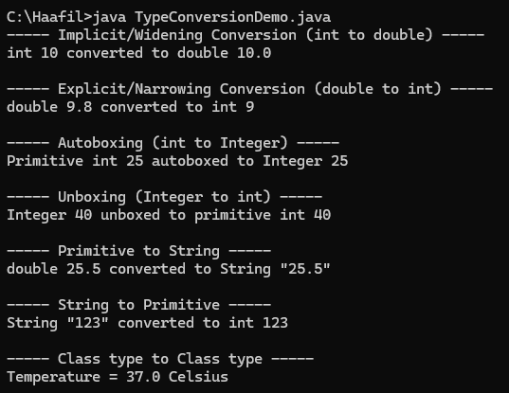
Experiment 7 output:
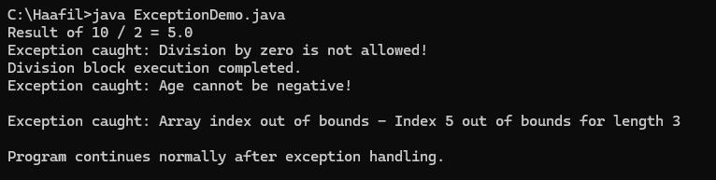
Experiment 8 output:
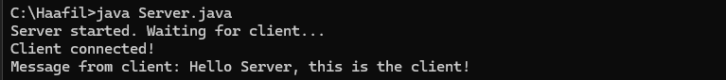
Experiment 10 output:
