KAIROX PLATFORM

Architecture and System Design Guide
How the B2B sales platform, its CRM, its automation and its AI agents work, as built for the first client, Arifa Packing & Packaging LLC (Arifaa Pack)
Document date: 12 November 2026
Repository: kairox-platform (uv workspace, Python 3.14)
Code state analysed: branch main, HEAD 4405957 plus the uncommitted working-tree changes present on 12 November 2026
Readers: a technically curious business owner, and developers who maintain or extend the platform
Method: static reading and tracing of source, migrations, Terraform and CI; selected checks executed locally (see 10.5)
How findings are labelled
Label | Meaning
[CONNECTED] | Implemented and connected to a current code path (a caller or runtime wiring was traced).
[OPTIONAL / UNUSED] | Implemented but optional, disabled by configuration, or with no caller found.
[PLANNED ONLY] | Documented or planned; no implementation was found.
[INFERRED] | Inferred or uncertain; the text says what was checked and what remains open.
[DEFECT] / [RISK] | A confirmed defect, or a risk that depends on conditions (used in section 9).

Contents
About this guide 4
1. Executive overview 5
1.1 What the product does 5
1.2 Who uses it 5
1.3 Major capabilities 5
1.4 The architecture in plain language 6
1.5 Most important findings 6
2. System architecture 7
2.1 Component responsibilities 7
2.2 Deployment view 8
2.3 Runtime processes 9
2.4 How components communicate 9
2.5 Trust boundaries 9
2.6 Event and job backbone 10
3. Codebase organization and design 12
3.1 Packages and dependency direction 12
3.2 Key interfaces 13
3.3 Where business logic lives 13
3.4 Code navigation map 14
3.5 Data model overview 15
4. End-to-end workflows 16
4.1 Inbound WhatsApp message to AI reply 17
4.2 Website chat and voice session 18
4.3 Qualification, quote request, approval and send 19
4.4 Negotiation and agreement 21
4.5 Opt-out (stop) handling 22
4.6 Hand-over, staff replies and click-to-call 23
4.7 Payment, won, orders and retention 23
4.8 Knowledge base indexing 23
5. AI agent system in depth 24
5.1 What kind of agent system this is 24
5.2 Agent roles compared 24
5.3 Routing 26
5.4 Life cycle of one turn 27
5.5 Models, configuration and fallbacks 27
5.6 Prompts 28
5.7 Inputs, outputs and state 29
5.8 Tools and permissions 29
5.9 Guardrails and validation 30
5.10 Human approval, escalation and hand-over 31
5.11 Error handling, retries and persistence 31
5.12 Knowledge search 31
5.13 Website and voice channels 32
5.14 Evaluation and testing of agents 32
6. LangGraph and LangChain 33
6.1 Packages and versions 33
6.2 What the project uses them for 33
6.3 The implemented graphs 35
6.4 Framework features versus custom orchestration 37
6.5 Absent or unverified 37
7. Data, business rules and safety boundaries 38
7.1 How data moves and what reaches outside providers 38
7.2 Authentication and authorization 38
7.3 Tenant and customer isolation 39
7.4 Pricing and commercial rules 39
7.5 Approvals and human decisions 39
7.6 Validation and audit trails 40
7.7 Controls enforced in code versus prompts 40
8. Technologies and integrations 41
9. Architecture assessment and recommendations 43
9.1 How to read this section 43
9.2 Confirmed defects 43
9.3 Risks 47
9.4 Improvements 49
9.5 Suggested order of work 49
10. Reference appendix 50
10.1 Glossary 50
10.2 Key repository paths 51
10.3 Configuration variables (names only) 51
10.4 Unresolved questions 52
10.5 Verification log and limitations 53

Entries are links. In Word, right-click the table and choose Update Field after editing the document.

About this guide
This guide explains how the Kairox platform is built, from the business view down to the classes a developer edits. Every important statement points to the repository: a path such as packages/kx-agent-framework/src/kx/agents/service.py, often with a symbol (AgentService.handle_turn) and line numbers. Paths are relative to the repository root. Short forms used in tables: kx/agents/... means packages/kx-agent-framework/src/kx/agents/..., kx/crm/... the CRM package, kx/automation/... the automation package, kx/core/... the shared kernel, and arifaa_pack/... means apps/arifaa-pack/src/arifaa_pack/....
How to read it. Business readers can stop after section 1 and the summary tables at the start of sections 2, 5 and 9. Developers will find the code-navigation map in 3.5, the workflows in section 4 and the agent internals in sections 5 and 6.
What was verified. The findings come from reading the source code and configuration, not from the project's own documents; where the documents disagree with the code, the code wins and the disagreement is listed in 10.4. A finding was only labelled CONNECTED after a caller or runtime wiring was found (most often in arifaa_pack/container.py, which builds the object graph for every process). The most consequential defects were re-checked directly against the files, and two price-guard cases were executed (section 10.5). The test suite itself was not run, no live vendor was called, and the deployed AWS environment was not inspected.
Scope note
The repository contains the backend only. The company website (Next.js), the staff CRM web front-end and the Payload CMS application are referenced by the code and by Terraform but their source code is not in this repository.
The working tree contains many uncommitted changes (including the deletion of the Cognito infra/modules/auth module and of docs/BUSINESS_FLOW_V1.md). This guide describes the files as they were on disk on 12 November 2026.

1. Executive overview

1.1 What the product does
Kairox is a reusable B2B sales system that combines a CRM, message automation and AI sales assistants. Its first deployment is for Arifaa Pack, a packaging manufacturer in Ajman, UAE, that sells bottles, jars, caps and similar items to buyers worldwide. A buyer can write on WhatsApp, send an email, or chat (and, when enabled, talk) on the company website. An AI assistant answers product questions, collects the buyer's requirements and contact details, asks the sales team for a quotation, and negotiates price within limits the business has set. People stay in charge of every commitment: a salesperson or manager approves each quotation before it is sent, any request outside the price ladder becomes a task for a salesperson, and the AI hands the conversation over whenever it is unsure, the buyer complains, or a final quotation has been issued.

1.2 Who uses it
User | How they use the platform
Buyers (prospects and customers) | WhatsApp, email and the website chat or voice. They never log in; they are recognised by phone or email only after they type it (website identify endpoint).
Salespeople | The CRM web app (not in this repository) through the /v1 API: inbox, deals, quote approvals, change requests, replies and click-to-call. Approvals need an authenticator-app (TOTP) login.
Managers and the MD | Approve special prices and final quotes, take over deals, set price tiers, settings, the kill switch and reports. Only the MD role can read cost data.
Admin / IT | Users, channel numbers, message templates and settings (most changes need TOTP).
Content editors | Approve product, factory and FAQ content in Payload CMS; approved content becomes the AI's knowledge base.

1.3 Major capabilities
Capability | What it does | Status
Conversational AI on WhatsApp and email | Answers in the buyer's language (English, Arabic, Hindi, Tamil, Chinese, Sinhala detection), qualifies leads, requests quotes, negotiates within CRM verdicts. | [CONNECTED]
Website chat | Public API with Cloudflare Turnstile, rate limits and signed session tokens; same AI turn as WhatsApp. | [CONNECTED]
Website live voice | LiveKit voice worker with speech vendors and a last price check before speech. | [OPTIONAL / UNUSED] code present; the speech plug-ins are not installed, so it cannot start (9.2).
Deterministic pricing and quotes | Price list tiers, VAT, FX, frozen quote versions, PDFs; the AI never computes a price. | [CONNECTED]
Human approval ladder | WhatsApp request, reminder, phone call, manager escalation (Twilio); approval needs TOTP. | [CONNECTED]
Single-use send grants | A priced message can leave only with a grant bound to the exact content hash and recipient. | [CONNECTED]
Negotiation ladder | Fixed concession steps between list price and minimum; the AI only phrases the CRM's verdict. | [CONNECTED]
Opt-out (stop) handling | Rule-based stop words in several languages, AI reading of ambiguous sentences, permanent suppression. | [CONNECTED]
Knowledge base (RAG) | Hybrid vector + full-text + trigram search over approved CMS content. | [CONNECTED] (depends on the embedding service and CMS being reachable)
Orders, payments, stock, reports | Payment record, WON, order status flow, dashboards, scheduled reports, CSV/XLSX exports. | [CONNECTED] (stock reservation branches unused)
Cost-based pricing mode (v2) | Cost per 1000 pieces plus markup bands, material price scraping. | [OPTIONAL / UNUSED] off in v1 (pricing.mode, features.scraping)
Repeat-sales AI agent | Serving won customers. | [OPTIONAL / UNUSED] disabled in v1 (D14)
Backup LLM (Gemini), Telnyx calls, Gmail fallback, CBUAE FX feed | Vendor fallbacks named in the platform documents. | [PLANNED ONLY]

1.4 The architecture in plain language
Technically, Kairox is a modular monolith: one Python code base, split into four packages with strictly enforced boundaries, deployed as one container image that runs in four roles: the web API, background workers, a single scheduler, and a voice worker. All business data lives in PostgreSQL (three databases per company: CRM, automation and agents). Packages never call each other's internals. They talk through small interfaces defined in the shared kernel and through events. An event is written in the same database transaction as the change it describes, then relayed to a durable job table and executed by workers, so nothing is lost if a process crashes.
The AI is deliberately constrained. A plain-code router (no LLM) picks which of three LangGraph workflows answers a message and which of eight active role configurations is used. The backend computes every price, and the AI only receives the prices it is allowed to say. Every AI reply passes a price guard that checks every number against that list. If the model fails, is over budget, or keeps writing a forbidden number, the buyer gets a fixed safe sentence and the deal is handed to a salesperson.

1.5 Most important findings
Fix before go-live
1. In staging and production the worker and voice processes cannot start: they build the same object graph as the API, which requires the JWT signing key and the TOTP encryption key, but Terraform gives those secrets only to the API service (9.2, D1). Background jobs (AI replies, approvals, message delivery) would therefore not run.
2. The price guard lets through whole numbers written without a currency or price keyword ("I can do 450") and amounts in Gulf currencies it does not know ("QAR 500"); both cases were executed (D3).
3. A staff session created with an email code (not MFA) can re-enrol the authenticator app and thereby obtain approval rights (D4). The read-only reporting database role can read password hashes, TOTP seeds and cost data (D5).
4. Live voice cannot start because its LiveKit vendor plug-ins are missing from the lock file (D2).

The safety design for prices, approvals and opt-out is otherwise strong and mostly enforced in code and database constraints rather than in prompts. Section 9 lists all findings with evidence, impact, effort and a suggested order of work.

2. System architecture
The platform runs as one container image in four process roles on AWS, backed by PostgreSQL and Redis and connected to a set of external vendors. The table lists each component; Figure 1 (section 2.2) shows how they are deployed for one environment. Both are drawn from the Terraform modules in infra/, the Dockerfile and arifaa_pack/container.py.

2.1 Component responsibilities
Component | Responsibility | Evidence | Status
kx api (FastAPI) | CRM API /v1, website API /v1/public, admin API /v1/admin, webhooks /webhooks/*, unsubscribe, /healthz, /.well-known/jwks.json. Routers are mounted inside the app lifespan after the container is built. | arifaa_pack/api.py:26-67 | [CONNECTED]
kx worker (Celery) | Runs kx.run_job(job_id) and kx.periodic(name); one event loop and one container per worker process. | arifaa_pack/celery_app.py:36-93 | [CONNECTED] (see D1 for deployed envs)
kx beat (Celery Beat) | Sends 12 timers; never builds the container. Exactly one task in ECS. | arifaa_pack/schedule.py:20-41 | [CONNECTED]
kx voice (LiveKit Agents) | Website voice calls through the same AgentService turn. | arifaa_pack/cli.py:52-75, kx/agents/voice.py | [OPTIONAL / UNUSED] cannot start (D2)
kx migrate / create-user | Alembic upgrade per database; first admin user. | arifaa_pack/cli.py:78-111 | [CONNECTED]
PostgreSQL (RDS, pgvector) | Databases crm, automation, agents (+ cms, phoenix); outboxes, inbox tables, the job table, LangGraph checkpoints, vector index. | db/ddl/*.sql, migrations/* | [CONNECTED]
Redis (ElastiCache) | Celery broker, token-bucket rate limits, daily spend caps, kill-switch level. | container.py:199-252 | [CONNECTED]
S3 / SES / SNS | Quote PDFs and media; outbound email, bounces, inbound mail. | infra/modules/storage, email | [CONNECTED]
Secrets Manager / SSM | Secrets; vendor order (only email is read), image tags. | arifaa_pack/adapters.py:284-314 | [CONNECTED] / partly [OPTIONAL / UNUSED]
embeddings (TEI) | Qwen3-Embedding-0.6B, 1024-dimension vectors for the knowledge base. | adapters.py:60-113, app_services/main.tf | [CONNECTED] (endpoint assumed, OPEN #53)
Phoenix | AI trace store fed over OTLP/HTTP; no-op when the endpoint is unset. | kx/agents/tracing.py | [CONNECTED] in AWS, [OPTIONAL / UNUSED] locally
Payload CMS service | Approved content; webhook to /webhooks/cms. | kx/automation/cms.py; deploy step for apps/arifaa-cms skipped (folder absent) | [INFERRED] app not in repo

2.2 Deployment view
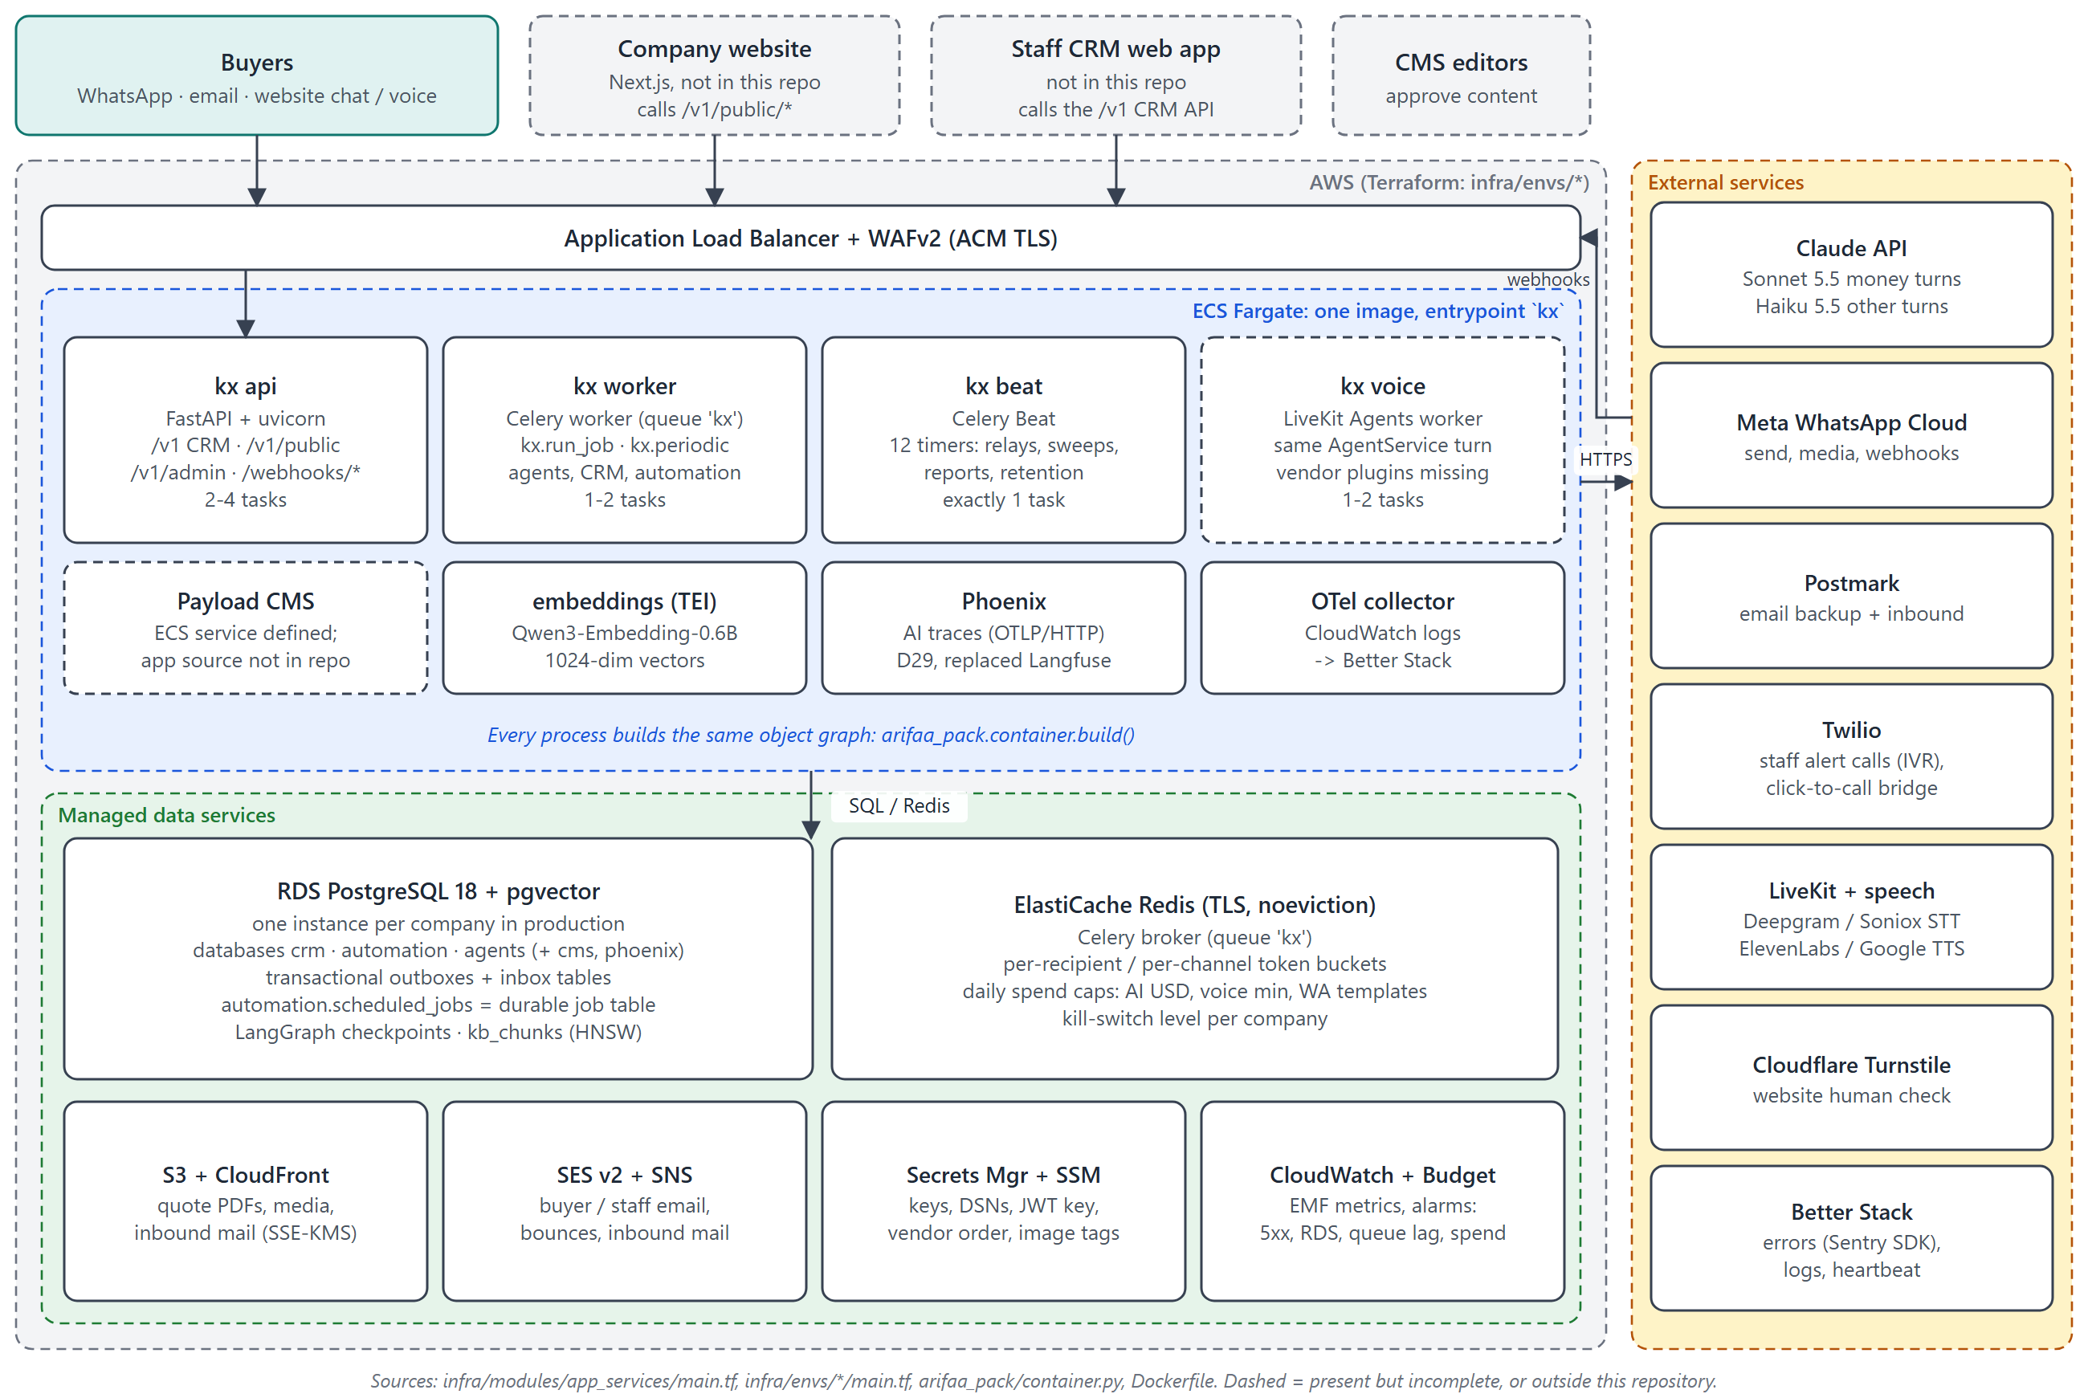
Figure 1. Deployed system: one container image in four process roles, managed data services and external vendors. Dashed boxes are present but incomplete (voice) or outside this repository (website, CRM front-end, CMS application).

2.3 Runtime processes
One image, one entry point kx (apps/arifaa-pack/pyproject.toml script kx = arifaa_pack.cli:main). Every process except Beat builds the same object graph with arifaa_pack.container.build(); that function is the single place where packages are connected.
Command | What it starts | Notes
kx api | uvicorn with arifaa_pack.api:create_app (factory), proxy headers on | 2-4 ECS tasks behind the ALB
kx worker | Celery worker on queue kx, acks_late, prefetch 1, reject on worker loss | Builds the container lazily on the first task
kx beat | Celery Beat with the 12 timers below | Must run exactly once; ECS desired count 1
kx voice | LiveKit Agents worker (make_livekit_entrypoint) | Requires optional extra voice; see D2
kx migrate | Alembic upgrade for crm, automation and agents | Run as a one-off ECS task by infra/scripts/deploy_company.sh
kx create-user | Creates a staff user and prints a temporary password | Operations only

2.4 How components communicate
Mechanism | Used for | Where
HTTPS requests | Staff app and website to the API; webhooks from Meta, Twilio, SNS, Postmark and the CMS | kx/crm/api, kx/agents/website.py, kx/automation/webhooks.py, cms.py
In-process Protocol calls | Agents call the CRM through CrmGateway; CRM and agents send messages through MessageSender; automation consumes send grants through GrantConsumer | kx/core/contracts.py; implementations wired in container.py:253-317
Transactional outbox events | Every state change that other packages care about | kx/core/events.py:76-139
Durable job table + Celery | Event handlers, deliveries, ladders, follow-ups, ingestion | automation.scheduled_jobs, kx/core/jobs.py, arifaa_pack/jobqueue.py
Outbound HTTPS to vendors | Claude API, WhatsApp Cloud API, SES, Postmark, Twilio, LiveKit, Turnstile, CMS, embeddings | adapters in kx/automation/channels, arifaa_pack/adapters.py, kx/agents/models.py

2.5 Trust boundaries
- Internet to API. The ALB with WAFv2 terminates TLS. Three kinds of caller reach the API, each authenticated differently: staff (RS256 JWT access tokens, roles, TOTP for sensitive actions), website visitors (Turnstile check, then an HMAC-signed session token, per-IP and per-session rate limits), and vendors (signatures: Meta HMAC-SHA256, Twilio request signature, SNS certificate signature, CMS HMAC with a 300 s window, Postmark basic auth). All webhook checks fail closed when their secret is missing.
- AI to business data. The model never sees cost, markup, minimum price or ladder steps. It sees only DealContext and tool results, and the deal id comes from the runtime context, never from model arguments (kx/agents/context.py:1-5).
- AI to the buyer. Every AI sentence passes the price guard; priced documents can only leave with a single-use grant (crm.consume_send_grant).
- Packages to each other. import-linter forbids imports between kx.crm, kx.automation and kx.agents and from kx.core upwards; the check passed (3 of 3 contracts kept) when run for this guide.
- Companies to each other. Each company has its own databases (and in production its own RDS instance). There is no tenant column; isolation is physical (7.3).
- Platform to vendors. Buyer text and deal facts are sent to Anthropic; masked traces to Phoenix (in the company's own AWS account); knowledge-base text and search queries to the embedding container (in the VPC); masked errors and logs to Better Stack (7.1).

2.6 Event and job backbone
All asynchronous work uses one pattern (Figure 2). A service writes its rows and an event into its own database's outbox_events table in one transaction. Beat relays each outbox every 5 seconds; the app's EventBus turns each event into one job per subscribing package in automation.scheduled_jobs (de-duplicated by event:<id>:<task>), and kicks Celery. A worker claims the job (an advisory lock per lock_key keeps per-thread order) and runs the handler, which records the event in its inbox_events table so it runs once.
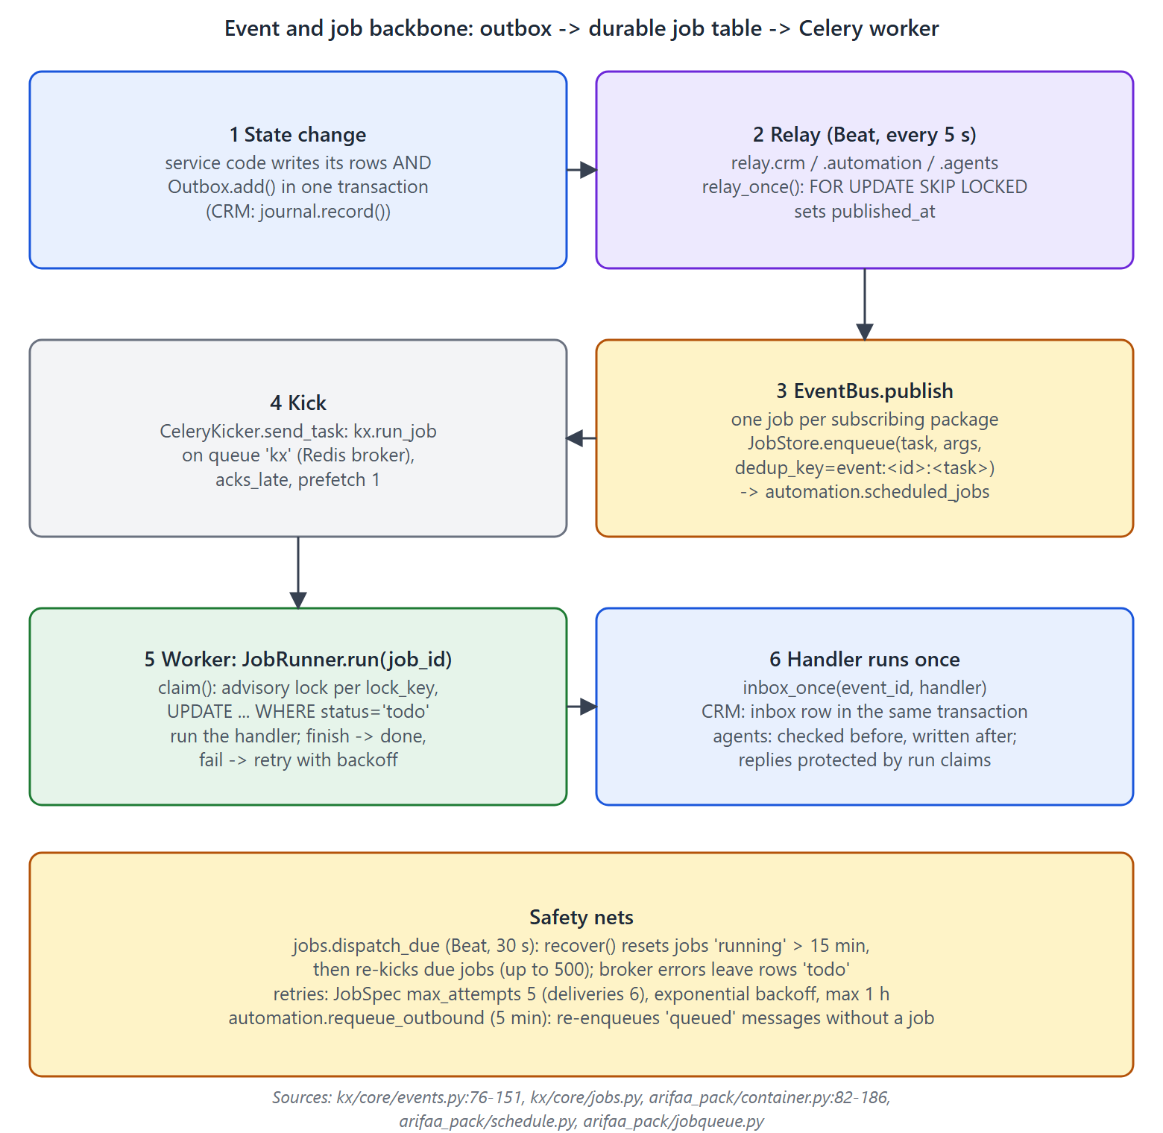
Figure 2. Event and job backbone: transactional outbox, durable job table, Celery worker and safety nets.
Beat timer | Interval | What it does
jobs.dispatch_due | 30 s | Recovers jobs stuck in running for more than 15 min, then kicks due jobs (up to 500).
relay.crm, relay.automation, relay.agents | 5 s | Publishes unpublished outbox rows (FOR UPDATE SKIP LOCKED).
app.heartbeat | 30 s | Queue-lag metric QueueLagSeconds and Better Stack heartbeat.
crm.approval_sweep | 5 min | Marks overdue approvals, escalates change requests.
automation.requeue_outbound | 5 min | Re-enqueues queued messages without a job (not template messages).
crm.scheduled_reports | 15 min | Daily and weekly reports (idempotent via an audit key).
crm.lost_proposals | 04:07 UTC | Proposes LOST 14 days after the last follow-up.
crm.price_staleness | 05:23 UTC | Expires quotes; stale-price events only in cost mode.
crm.retention | 23:41 UTC | Anonymises old leads and customers, emits CONTACT_ANONYMISED.
automation.price_scrapes | 02:00 UTC | No-op while features.scraping is off [OPTIONAL / UNUSED].

3. Codebase organization and design

3.1 Packages and dependency direction
The repository is a uv workspace (pyproject.toml, [tool.uv.workspace] members = ["packages/*", "apps/*"]). Four reusable packages share the kx namespace; one client application wires them together. Every dependency in the package manifests is pinned to an exact version (==), and uv.lock resolves the transitive ones.
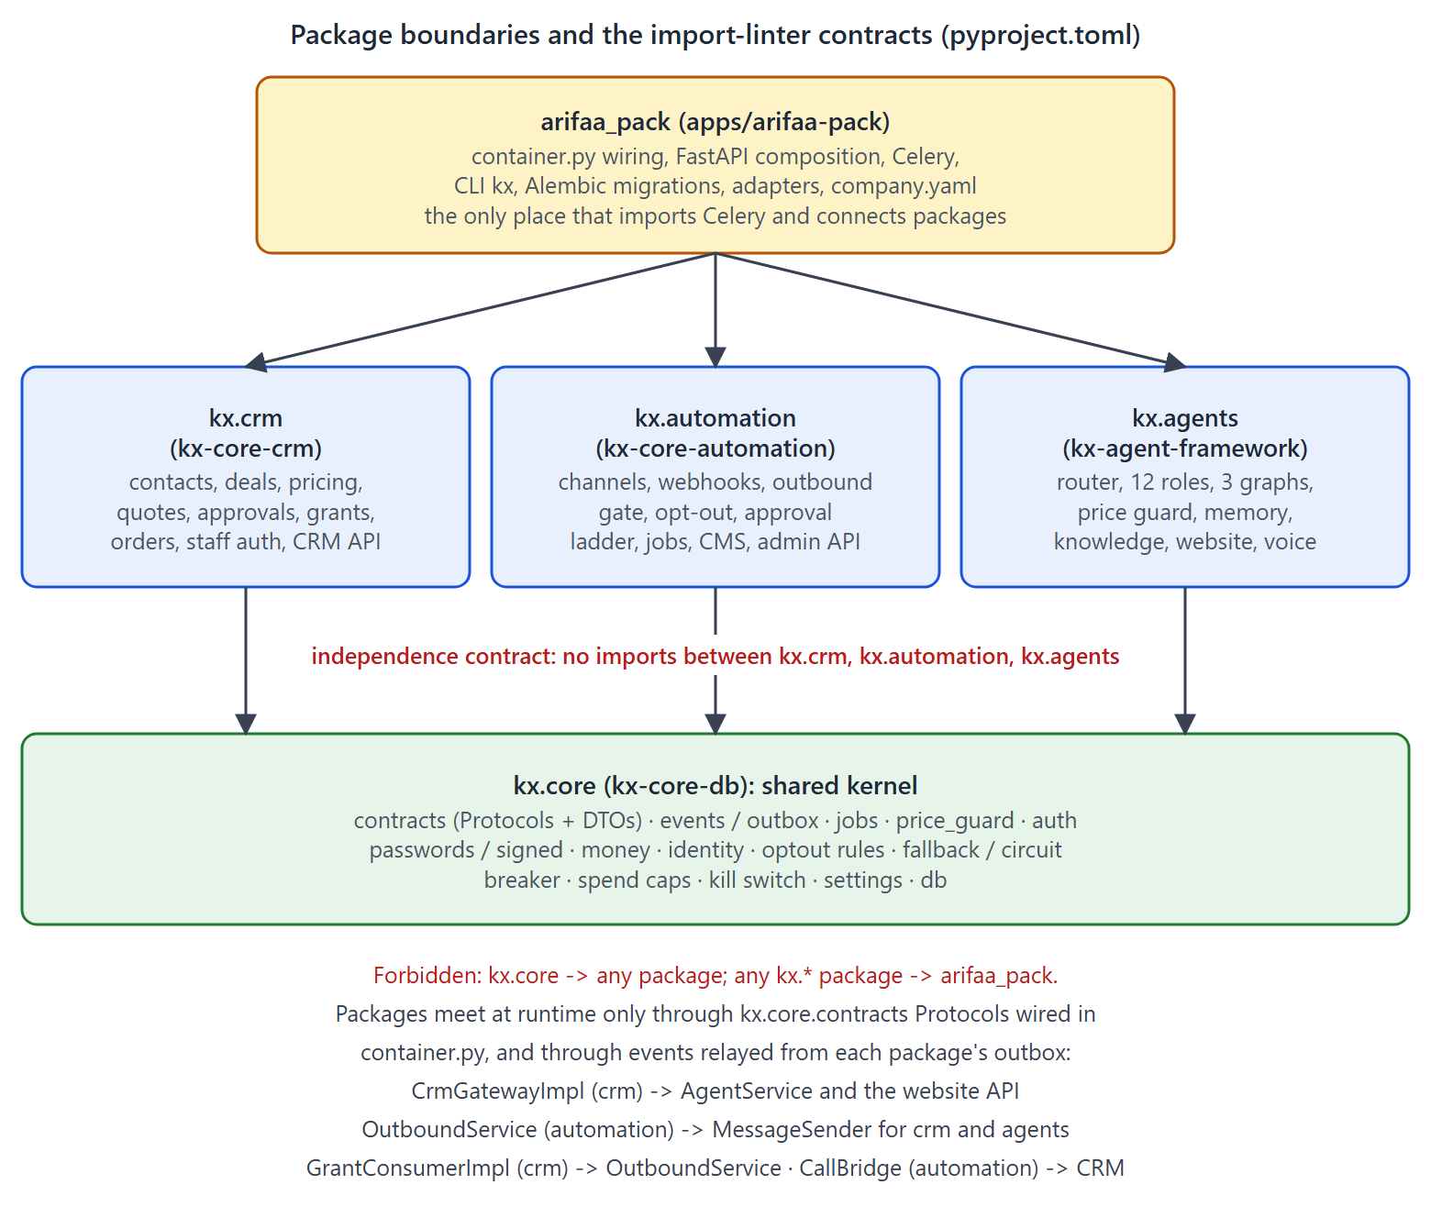
Figure 3. Package boundaries and the three import-linter contracts (root pyproject.toml, [tool.importlinter]).
Package (distribution) | Import name | Size | Responsibility
kx-core-db | kx.core | 21 modules | Shared kernel: contracts, events/outbox, job store, price guard, auth tokens, passwords/TOTP, money, identity, opt-out rules, fallback/circuit breaker, spend caps, kill switch, settings, database engines.
kx-core-crm | kx.crm | 64 modules | Contacts, companies, deals, requirements, pricing engine, quotes, approvals, send grants, negotiation, change requests, consent, orders, stock, staff login, reports, CRM API, gateway for agents.
kx-core-automation | kx.automation | 28 modules | Channels (WhatsApp, SES, Postmark, SNS, Twilio IVR), webhooks, inbound recording, OutboundService gate, opt-out application, approval ladder, alerts, follow-ups, job bodies, CMS webhook, admin API, scraping.
kx-agent-framework | kx.agents | 26 modules | Router, role registry and prompts, the three graphs, middleware, price guard wrapper, tools, memory, knowledge base, run bookkeeping, tracing, website API, voice, evals.
arifaa-pack (app) | arifaa_pack | 10 modules + migrations | container.py wiring, FastAPI composition, Celery app and Beat schedule, CLI kx, vendor adapters, company.yaml, Alembic migrations for the three databases.

3.2 Key interfaces
Cross-package calls go through typing.Protocol classes in kx/core/contracts.py. The data passed through them are frozen pydantic DTOs that contain only what the consumer may see.
Protocol | Implemented by | Used by | Purpose
CrmGateway (contracts.py:219-266) | CrmGatewayImpl (kx/crm/gateway.py:171) | AgentService, tools, website API, voice | Everything the AI may read or change in the CRM: deal context, requirement and contact patches, qualify, request quote, evaluate counter, pause AI, agreed, follow-up, timeline, change request, cover note, opt-out.
MessageSender | OutboundService (kx/automation/outbound.py:143) | CRM (staff replies, notifications), agents (AI replies), automation | The one gate through which every message leaves.
GrantConsumer | GrantConsumerImpl (kx/crm/gateway.py:448) | OutboundService | Consumes a single-use priced-send grant in the CRM database.
ClickToCall | CallBridge (kx/automation/alerts.py:55) | CRM call_buyer | Bridges a staff call to a buyer through the company number.
StaffMailer | StaffCodeMailer (arifaa_pack/adapters.py:224) | CRM staff login | Email login codes and reset codes.
TaskScheduler | JobScheduler (kx/automation/jobs.py:244) | automation | Durable scheduling (deliveries, ladders, follow-ups). Defined in kx/automation/ports.py, not in kx.core as CLAUDE.md says.
ModelProvider, Embedder, KnowledgeSearch, PromptStore, VoicePlugins, HumanCheck, PublicLimits | app adapters | agents package | Vendor seams inside kx.agents; only one ModelProvider (Anthropic) exists and no app PromptStore is wired.

3.3 Where business logic lives
- Prices and quotes: kx/crm/pricing/price_list.py (v1 tiers), kx/crm/pricing/engine.py (ladder, totals, v2 cost mode), kx/crm/services/quotes.py (versions, revisions, manual quotes), issuing.py (PDF, grant), grants.py, approvals.py, negotiation.py.
- Deal life cycle: kx/crm/rules.py (stage transitions) and kx/crm/services/deals.py (move_stage, hand-over, reopen).
- Every state change is recorded through kx/crm/services/journal.py record() (audit row, optional timeline row, outbox events in one transaction). It is used 84 times across 25 files; a few bulk updates bypass it (7.7).
- Messaging rules: kx/automation/outbound.py (gates), kx/automation/inbound.py (recording, rule stops), kx/core/optout.py (stop words), kx/automation/alerts.py (approval ladder).
- AI behaviour: kx/agents/orchestrator.py (routing), registry.py (roles, prompts, fixed phrases), graphs/*, guard.py, tools.py, service.py.
- Database rules that hold even if application code is wrong: quote freeze triggers, consume_send_grant(), append-only audit trigger, CHECK constraints for stages and priced messages (db/ddl/01_crm.sql, 02_automation.sql).

3.4 Code navigation map
I want to ... | Start here | Then look at
change how the AI picks a role or graph | kx/agents/orchestrator.py route() | registry.py DEFAULT_SPECS; tests in packages/kx-agent-framework/tests/test_routing.py
change what the AI says or may do | kx/agents/registry.py _BASE_RULES, _ROLE_PROMPTS, DEFAULT_PHRASES | tools.py, middleware.py deal_facts()
add an AI tool | kx/agents/tools.py (@tool, add to ALL_TOOLS) | add the name to the roles in registry.py; add a CrmGateway method in kx/core/contracts.py and kx/crm/gateway.py
change the negotiation steps | kx/crm/pricing/engine.py ladder_between, evaluate_ladder_counter | kx/crm/services/negotiation.py; tests/spec/test_spec_pricing.py
change price detection in replies | kx/core/price_guard.py | tests/spec/test_spec_price_guard.py; the eval scenarios
add a message channel or vendor | kx/automation/channels/ | OutboundService._transmit, container.py wiring, VendorOrder in adapters.py
add an event | kx/core/events.py (name), event_payloads.py (payload + PAYLOADS) | producer via journal.record() or Outbox.add; consumer handler tables in each package
add a scheduled or background job | JobSpec registration in the package's jobs.py | Beat entry in arifaa_pack/schedule.py for periodic work
change a CRM screen's API | kx/crm/api/*.py | kx/crm/api/schemas.py; regenerate docs/frontend/* with scripts/gen_frontend_docs.py
change the database | new Alembic revision in arifaa_pack/migrations/<db>/versions/ | never edit db/ddl/*.sql (baseline); ORM models in each package
wire a new vendor key or setting | arifaa_pack/config.py (KX_APP_*), kx/core/settings.py (KX_*), kx/automation/settings.py (KX_AUTO_*) | infra/modules/app_services/main.tf secrets maps; .env.example

3.5 Data model overview
Each company has three application databases, each with a schema of the same name. Cross-database references are plain *_ref uuid columns; there are no cross-database foreign keys (db/README.md).
Database | Main tables | Notable constraints
crm | users, staff_credentials, auth_sessions, auth_challenges; settings, settings_history, feature_flags; companies, contacts, consents; products, product_price_tiers, product_costings, material_rates, margin_rules; deals, deal_requirements, stage_history, timeline_events, tasks, change_requests; quotes, quote_versions, quote_lines, quote_line_costs, quote_line_tiers; approvals, approval_events; quote_send_grants, negotiation_rounds; payments, orders, order_status_history, stock_items, stock_movements; audit_events, outbox_events, inbox_events, idempotency_keys | Stage CHECK; LOST needs a reason; ai_enabled XOR paused_reason; optimistic version; non-overlapping price tiers (GiST EXCLUDE); quote version and line freeze triggers; one open approval per version; grant consumption function; append-only audit trigger
automation | channel_accounts, message_templates, threads, inbound_messages, outbound_messages, webhook_receipts, call_attempts, suppressions, contact_suppressions, opt_out_log, scheduled_jobs, scrape_runs, price_observations, outbox_events, inbox_events | Priced kinds require grant_ref and content_sha256; unique idempotency key and grant ref; unique provider message ids; partial unique dedup_key on pending jobs
agents | visitors, conversations, turns, agent_runs, tool_calls, guard_events, knowledge_gaps, kb_documents, kb_chunks (vector(1024), HNSW), news_items, lane_risk_assessments, eval_runs, outbox/inbox; LangGraph checkpoint tables (created at start-up) | agent_runs UNIQUE(trigger_event_id, graph) gives idempotent AI runs; guard CHECK on guard kinds

4. End-to-end workflows
This section follows the important workflows from trigger to completion. Names are the real functions, tables, jobs and events.

4.1 Inbound WhatsApp message to AI reply
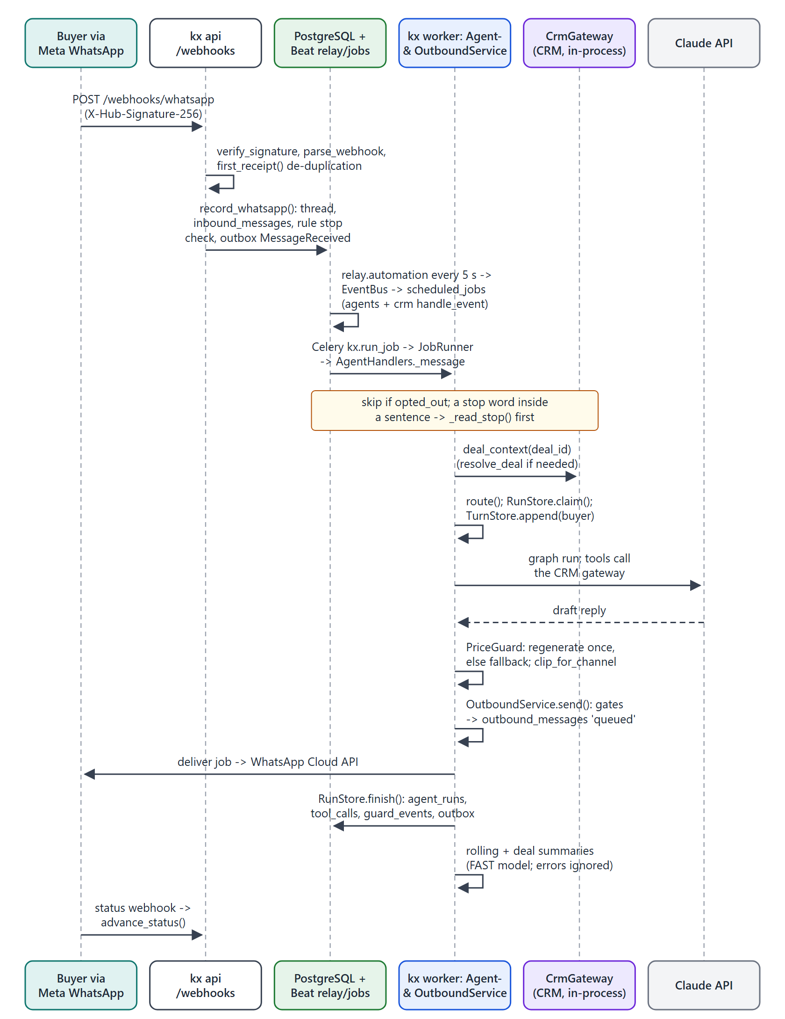
Figure 4. Inbound WhatsApp message to AI reply (email follows the same path from SES/SNS or Postmark).
Aspect | What happens (with evidence)
Trigger | Meta posts to POST /webhooks/whatsapp (kx/automation/webhooks.py:74-85). Email arrives from SES via SNS (/webhooks/ses) or Postmark (/postmark/inbound).
Checks | HMAC-SHA256 of the raw body against X-Hub-Signature-256 (channels/whatsapp.py:22-30, empty secret refused); de-duplication with webhook_receipts (repo.first_receipt) and a unique provider message id.
Database writes | One automation transaction (inbound.record_whatsapp): thread upsert, inbound_messages row, rule-based stop check (_apply_rule_stop), and MessageReceived in the automation outbox. Media are downloaded by job ingest_whatsapp_media before the event is emitted.
Events and jobs | relay.automation publishes message.received.v1; the EventBus creates agents.handle_event and crm.handle_event jobs. The CRM records the message on the deal timeline; the agents handler runs the AI turn.
AI involvement | AgentHandlers._message (kx/agents/handlers.py:131-156) resolves the deal, skips opted-out messages, and calls AgentService.handle_turn with an idempotency key agent-reply:<event_id> for the reply.
Inside the turn | gateway.deal_context(); reply language from the script of the text (language.py); stop-word sentences are read first (4.5); route(); RunStore.claim() (one run per event and graph); history from agents.turns; graph run; price guard; clip_for_channel(); delivery; RunStore.finish() writes the run, tool calls, guard events and AGENT_RUN_COMPLETED; then the rolling summary and the deal-page summary (fast model, failures ignored).
Sending | OutboundService.send(): idempotency, kill switch, recipient rate limit, suppression, 24-hour WhatsApp window, contact hours; row queued; job automation.deliver_outbound sends it (6 attempts on transient errors). Status webhooks advance sent/delivered/read forward only.
Decisions and hand-offs | AI paused or deal handed over: silent (message goes to the salesperson's inbox) or the fixed HANDOVER_ACK phrase out of hours. Price-guard block, model failure, open circuit or spend cap: fixed SAFE_REPLY, AI paused with reason exception.
Failure and retry | The handler is retried by the job store (5 attempts, exponential backoff). A failed run is re-claimable; the sender's idempotency key prevents a second message. Errors outside the model error list (for example a structured-output parse error) are not turned into a safe reply; after the retries the buyer receives nothing and no alert is raised (D9).

4.2 Website chat and voice session
Aspect | What happens (with evidence)
Trigger | The Next.js site calls POST /v1/public/sessions after a Cloudflare Turnstile check (kx/agents/website.py:186-218).
Session | A visitors row is created (cookie and voice consent, country, language). The response carries an HMAC-signed session token (kx/core/signed.py) valid for 2 hours and whether live voice exists for the language (Sinhala is text-only).
Chat turn | POST /sessions/{id}/messages: token check, per-IP and per-session limits (Redis buckets), daily AI spend cap, deal resolved or created by the CRM, then the same AgentService.handle_turn with channel web_chat. The reply is returned in the HTTP response.
Identify | POST /sessions/{id}/identify passes the phone or email to set_contact; the CRM merges records. The answer is the same whether or not the buyer was known.
Voice | POST /sessions/{id}/voice returns a LiveKit room token whose metadata carries the deal and language. The voice worker plays the recording notice, applies voice stop rules ("stop" means wait), runs the same turn and re-checks the reply against fresh allowed prices before speech (voice.py:68-75).
Failure | Spend cap reached: HTTP 503-style Unavailable and the site shows WhatsApp click-to-chat. Each website and voice turn gets a fresh uuid7 trigger id, so a client retry is not de-duplicated (R10).

4.3 Qualification, quote request, approval and send
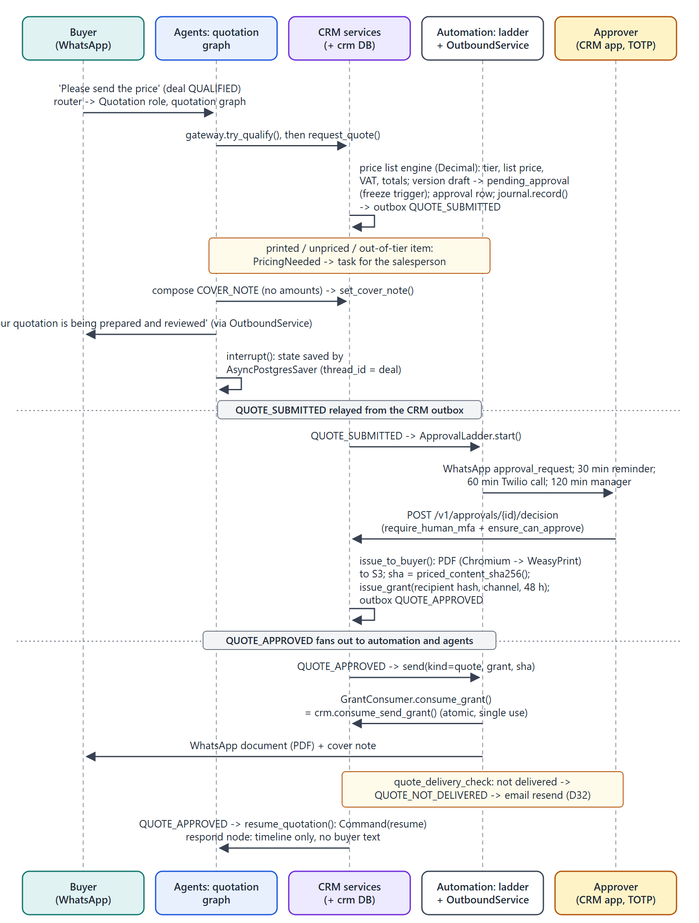
Figure 5. From "please send the price" to a granted, approved quotation on WhatsApp.
Aspect | What happens (with evidence)
Trigger | A qualified deal and a price question route to the quotation graph (route() rule "ready_for_quote").
Qualification | gateway.try_qualify() checks product, quantity, country and contact; missing fields produce a polite question instead.
Pricing | request_quote runs the v1 price list engine (kx/crm/services/pricing.py:457-493, price_list.py): tier, list price, minimum, FX, VAT by destination country, totals in Decimal. A quote version is created and moved to pending_approval in the same transaction; database triggers freeze its lines. Printed, unpriced or out-of-tier items raise PricingNeeded and create a task for the salesperson.
AI involvement | The graph writes a short cover note (no amounts allowed), tells the buyer the quote is in review, then stops at interrupt(); the state is checkpointed in PostgreSQL under the deal id.
Human approval | QUOTE_SUBMITTED starts the approval ladder: WhatsApp request, reminder at 30 min, Twilio call at 60 min, manager escalation at 120 min (alert window 08:00-22:00 Dubai). The approver decides through POST /v1/approvals/{id}/decision, which requires TOTP (require_human_mfa) and ensure_can_approve (the salesperson, the manager, or the MD on a deal it took over).
Issue and send | issue_to_buyer: PDF rendered (Chromium, then WeasyPrint), stored in S3, content hash computed, grant issued (recipient hash, channel, 48 h). QUOTE_APPROVED makes automation send the document; consume_send_grant() succeeds only once and only for that hash and recipient.
Completion | The agents resume the graph (Command(resume=...)); the respond node writes a timeline entry. A correction request loops back to waiting; a rejection sends a no-price note and hands over.
Failure and recovery | If WhatsApp does not confirm delivery, quote_delivery_check raises QUOTE_NOT_DELIVERED and the CRM re-grants for email (D32). Redelivered events are absorbed by Conflict handling and the run claim.

4.4 Negotiation and agreement
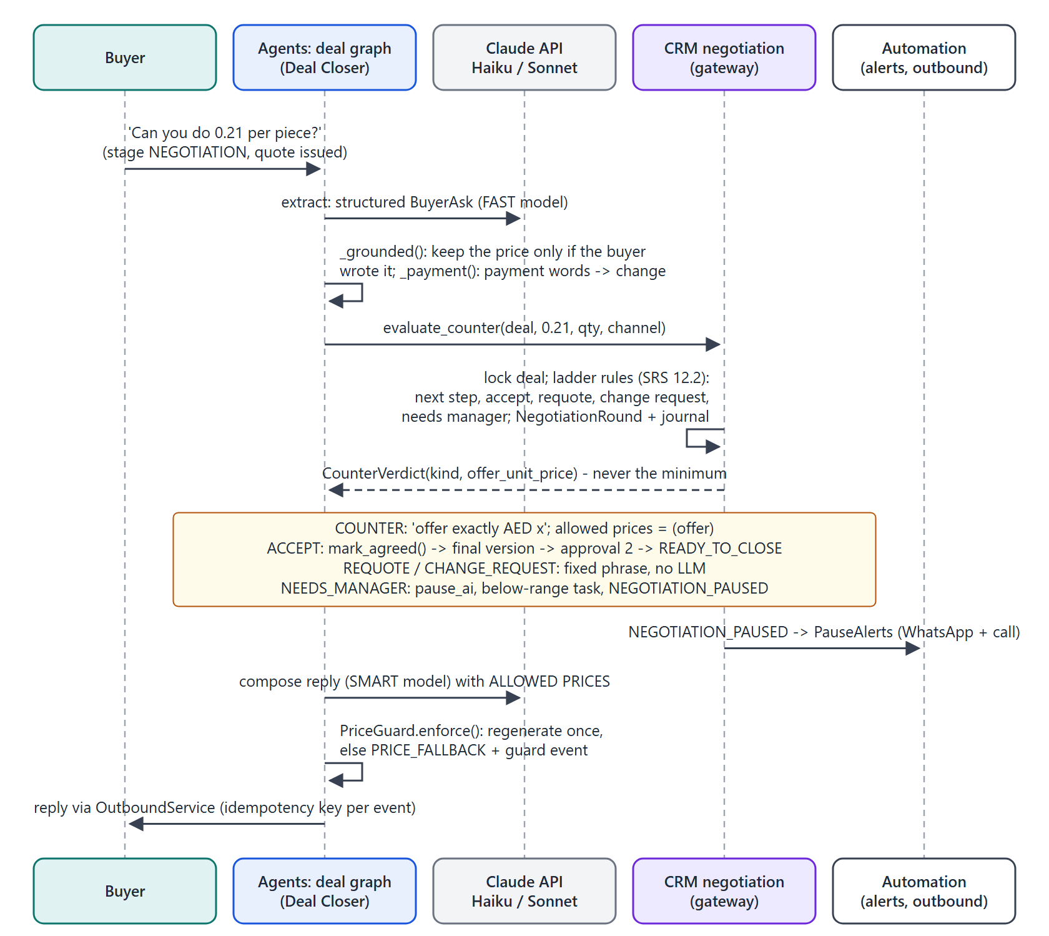
Figure 6. A counter-offer: the AI extracts the ask, the CRM decides, the AI phrases only the CRM's number.
Aspect | What happens (with evidence)
Trigger | After a quote is issued, a price question or counter-offer routes to the Deal Closer on the deal graph.
AI involvement | The fast model extracts a structured BuyerAsk; _grounded() drops any price the buyer did not actually write; payment words turn the ask into a change request.
Decision | gateway.evaluate_counter() locks the deal and applies the SRS 12.2 ladder (kx/crm/pricing/engine.py:292-344): next step, accept at the current offer, re-quote for another tier, change request outside all tiers, or NEEDS_MANAGER when steps are exhausted or a second ask is below the minimum. Every round is a negotiation_rounds row plus a journal entry.
Reply | COUNTER: "offer exactly AED x" and only that amount is allowed. ACCEPT: mark_agreed() creates the final version for a second approval and moves the deal to READY_TO_CLOSE; the reply confirms product, quantity, unit price, total, delivery and Incoterm. REQUOTE and CHANGE_REQUEST use fixed phrases with no LLM.
Hand-off | NEEDS_MANAGER: the CRM pauses the AI, opens a below-range task and emits NEGOTIATION_PAUSED; automation alerts by WhatsApp and phone; the buyer hears the fixed 60-minute sentence.
Failure | evaluate_counter and mark_agreed run in separate transactions and mark_agreed does not re-check ai_enabled or quote expiry (R15).

4.5 Opt-out (stop) handling
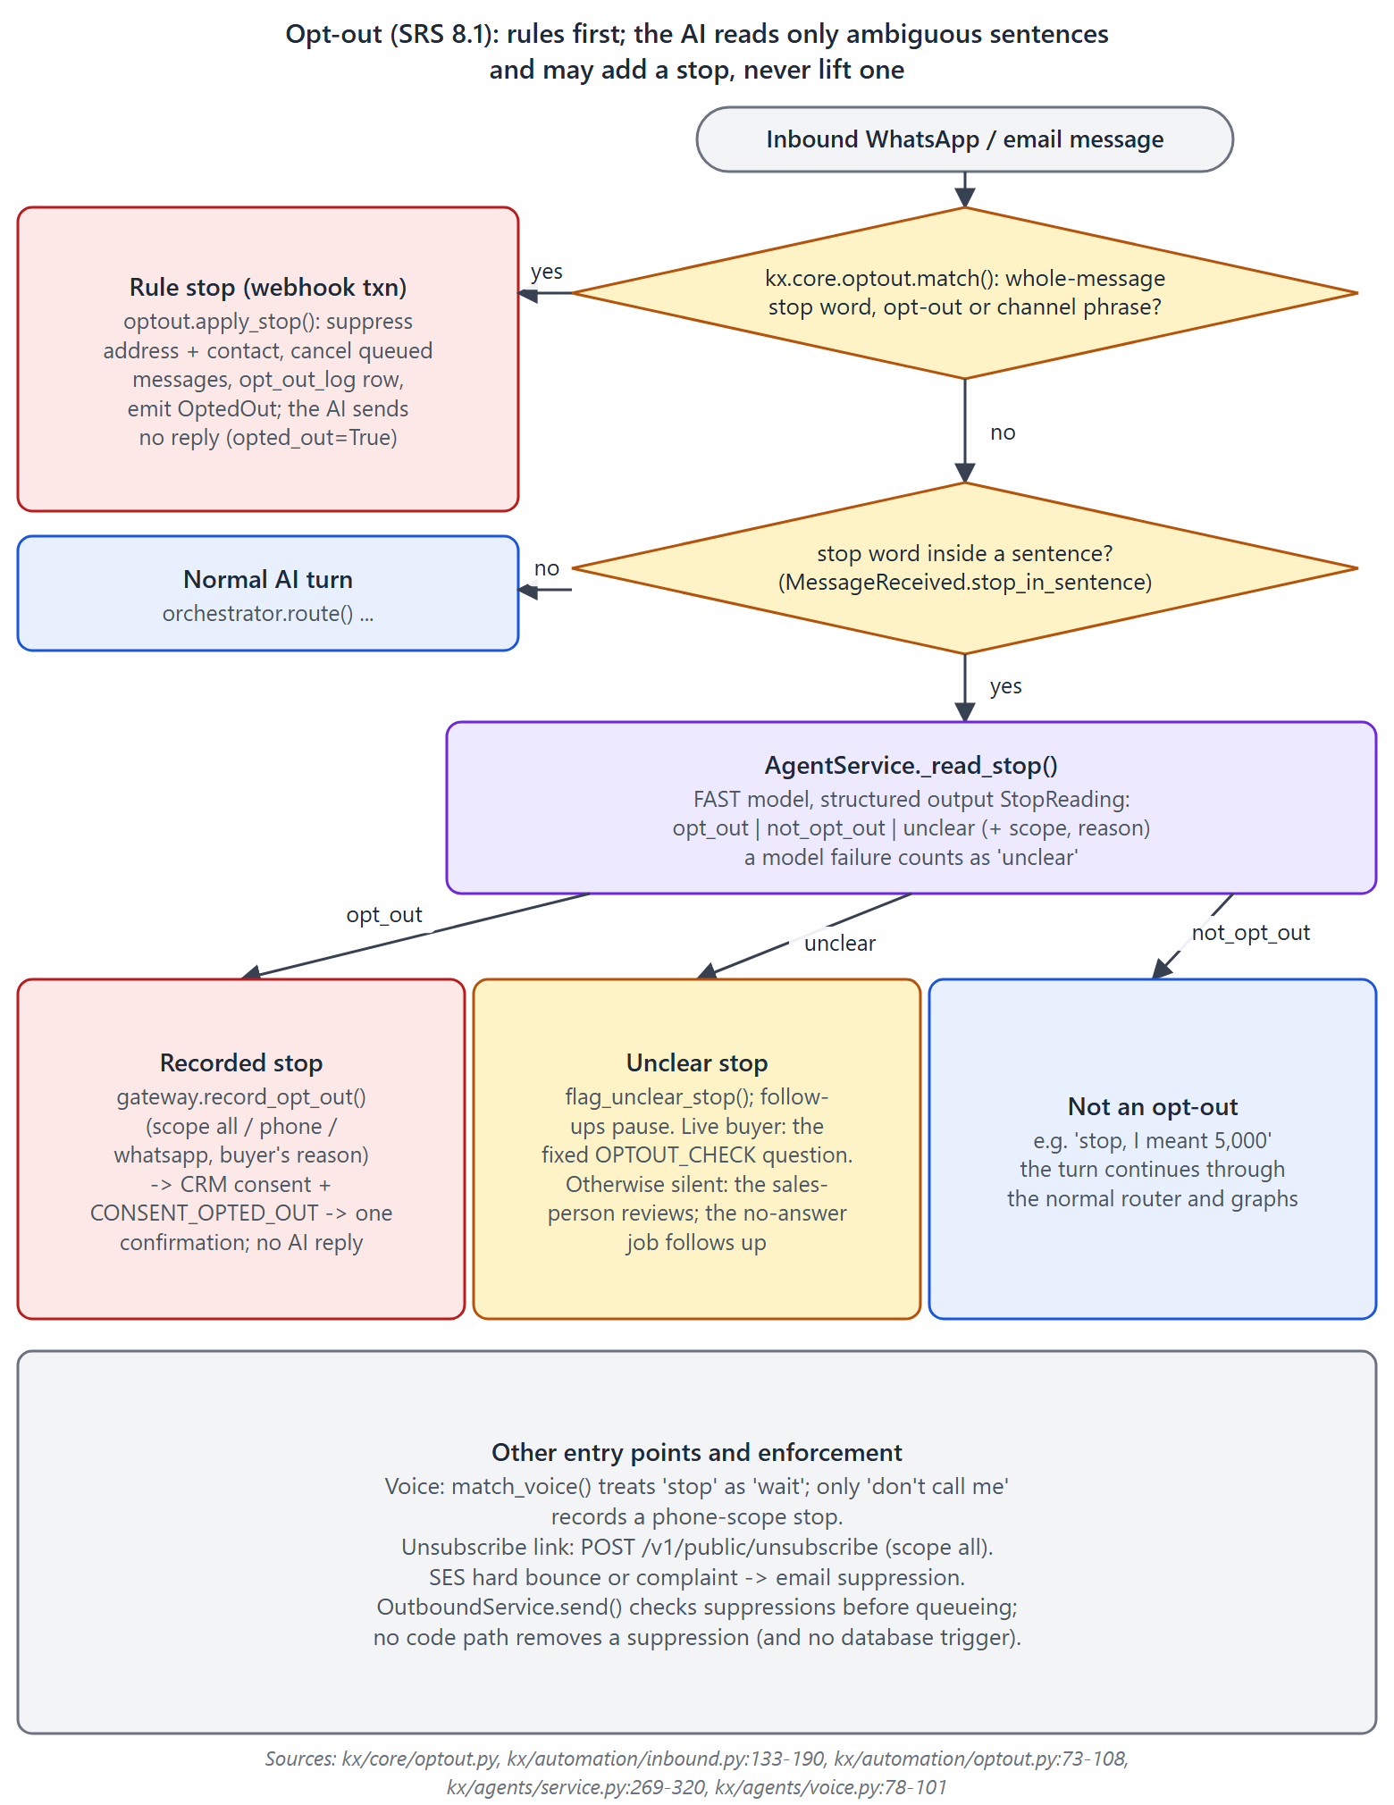
Figure 7. Opt-out handling across rules, the AI stop reader, voice and the unsubscribe link.
Aspect | What happens (with evidence)
Rules first | kx/core/optout.py matches whole-message stop words and opt-out phrases (English, Arabic, Hindi and more) inside the webhook transaction and applies the stop immediately: suppression by address hash and contact, queued messages cancelled, permanent opt_out_log row, OptedOut event. The AI never replies to such a message.
AI for ambiguity | A stop word inside a sentence is read by the fast model (AgentService._read_stop, prompt STOP_PROMPT). Opt-out is recorded through the CRM; unclear pauses follow-ups and asks the fixed question if the buyer is live; a model failure counts as unclear.
Confirmation | The CRM re-announces CONSENT_OPTED_OUT; automation sends exactly one confirmation (idempotency key per address).
Enforcement | OutboundService.send() refuses suppressed recipients. No API or SQL path removes a suppression; this is enforced by the absence of code, not by a database rule (see 7.6). The CRM's resume_ai refuses an opted-out deal.

4.6 Hand-over, staff replies and click-to-call
- Approval of the final quote calls deal_svc.hand_over, which pauses the AI with reason handover (kx/crm/services/approvals.py:233-234). From then on the router is silent, or sends the fixed out-of-hours acknowledgement.
- The AI also hands over on its own through the handoff_to_human tool, on a price-guard block, on model failure, on an open circuit breaker and when the daily AI spend cap is reached.
- Staff reply from the CRM inbox with POST /v1/deals/{id}/messages (kx/crm/services/handover.py:82-159): access check, opt-out check, check_prices against the allowed prices (staff cannot type an unapproved price either), OutboundService.send, then the AI is paused.
- Click-to-call (POST /v1/deals/{id}/call) bridges the salesperson and the buyer through Twilio via CallBridge, after checking the phone kill switch and phone suppression.

4.7 Payment, won, orders and retention
- record_payment moves READY_TO_CLOSE to PAYMENT; mark_won moves to WON, creates the order and emits DEAL_WON (buyer thank-you template and staff notices). Both need TOTP.
- Order status follows in_production to ready to shipped to delivered (or cancelled); a buyer WhatsApp update is optional.
- Daily retention (kx/crm/services/retention.py) anonymises lost leads after 12 months, closes leads idle for 24 months, and anonymises won customers 5 years after the last win. CONTACT_ANONYMISED makes automation blank threads and messages and the agents delete transcripts and LangGraph checkpoints (TurnStore.anonymise).

4.8 Knowledge base indexing
- The Payload CMS calls POST /webhooks/cms (HMAC over timestamp and body, 300 s window, de-duplicated per event). Automation emits KbContentPublished per locale and ProductPublished for the CRM catalogue mirror; price-like spec keys are dropped.
- The agents handler _kb runs KnowledgeIndexer.reindex: fetch the approved document from the CMS, skip if the content hash is unchanged, split it into ~500-token chunks with 15 % overlap, embed outside the transaction, then replace the chunks.
- If KX_APP_CMS_URL is unset, Terraform falls back to the API URL and indexing silently finds nothing [INFERRED] (10.4).

5. AI agent system in depth
This section is the core of the guide. Everything here was read directly in packages/kx-agent-framework/src/kx/agents/ and its wiring in arifaa_pack/container.py:288-317.

5.1 What kind of agent system this is
Classification: role-based configurations sharing a small set of workflows, chosen by a deterministic router
Kairox runs one agent runtime, AgentService, with 12 role profiles (AgentSpec) and three compiled workflows: a LangChain create_agent tool loop for conversation, and two LangGraph StateGraphs for negotiation and quotation. For every buyer message, a plain-Python router picks exactly one role and one workflow. Eight roles reach an LLM in v1. It is not a multi-agent system in the collaboration sense: no agent calls, delegates to, or messages another agent, and there is no shared task board or supervisor. Continuity between turns comes from the CRM deal record and the stored transcript.

Evidence | Where
One compiled conversation agent per model tier serves all conversational roles; the role's prompt and tool subset are swapped in per model call by middleware. | kx/agents/service.py:112-114; graphs/conversation.py:25-41; middleware.py:68-84
Routing is a pure function of the deal state and keyword patterns; no LLM decides which graph runs. | kx/agents/orchestrator.py:1-4, 90-132
Each turn claims one run for one graph and one role, and executes one graph. | service.py:219-237; GraphRunner.run service.py:120-139
Tools only read or write the CRM through CrmGateway and search the knowledge base; none invokes another agent or graph. | kx/agents/tools.py
The only long-lived workflow state is the quotation graph's checkpoint while it waits for human approval. | graphs/quotation.py:68-70; memory.py:267-291

5.2 Agent roles compared
All roles are defined as data in DEFAULT_SPECS (kx/agents/registry.py:109-200). "Conversation tools" are the nine tools get_deal_context, search_knowledge, update_requirement, set_contact, try_qualify, delivery_estimate, add_timeline, handoff_to_human and raise_change_request. FAST is Claude Haiku 5.5 (claude-haiku-5-5); SMART is Claude Sonnet 5.5 (claude-sonnet-5-5).
Role (AiRole value) | Business purpose | Selected when (router reason) | Workflow | Model | May state prices | Tools | Status
orchestrator | Deterministic router; never talks to buyers | Used as the actor for silent / acknowledge outcomes | none | no LLM | - | - | [CONNECTED] as code
factory_concierge | Greets, discloses it is an AI, guides | first turn without a price question; LOST deal (lost_reengage) | conversation | FAST | no | conversation tools | [CONNECTED]
product_intelligence | Product answers from approved content | product keywords; QUALIFIED questions; post-quote topic | conversation | FAST | no | conversation tools | [CONNECTED]
manufacturing_intelligence | Machines, capacity, certifications | factory / capacity / MOQ keywords | conversation | FAST | no | conversation tools | [CONNECTED]
lead_qualification | Collects product, quantity, country | default before qualification while requirement fields are missing | conversation | FAST | no | conversation tools | [CONNECTED]
contact_capture | Collects name and phone or email | only contact fields missing; also the actor for website identify | conversation | FAST | no | conversation tools | [CONNECTED]
quotation | Requests the quote, keeps the buyer informed | QUALIFIED + price question (quotation graph); stage QUOTATION otherwise (conversation); approval outcomes (resume) | quotation or conversation | SMART | allowed prices | conversation tools + request_quote, schedule_follow_up | [CONNECTED]
commercial_approval | Summarise a quote for the approver | never routed and never invoked | quotation (declared) | SMART | no | none | [OPTIONAL / UNUSED]
communication | Answers questions on an open quote | NEGOTIATION stage without price or change topic; actor of the stop reader | conversation | SMART | allowed prices | conversation tools + schedule_follow_up | [CONNECTED]
follow_up | Re-engage quiet buyers (day 2/5/10) | never routed; day-2/5/10 follow-ups are fixed WhatsApp templates sent by automation (FollowUps) | conversation (declared) | FAST | allowed prices | 3 tools | [OPTIONAL / UNUSED] as an agent
deal_closer | Negotiates price inside CRM verdicts | after the quote: price ask or counter, change topics; payment topic in any open stage; general READY_TO_CLOSE / PAYMENT messages | deal (conversation for general messages) | SMART (extraction FAST) | only the CRM's offer (deal graph) | conversation tools + schedule_follow_up (conversation path) | [CONNECTED]
repeat_sales | Serve won customers and reorders | WON deal, but the role is disabled, so the router stays silent | conversation | SMART | allowed prices | conversation tools | [OPTIONAL / UNUSED] disabled (D14)

AgentSpec.stages lists the deal stages each role may act in, but no code reads it: the router hard-codes the stage rules instead [OPTIONAL / UNUSED]. AgentSpec.may_quote_prices is enforced: roles without it get an empty price allow-list, so any amount they write is blocked (guard.py:66-70, middleware.py:40).

5.3 Routing
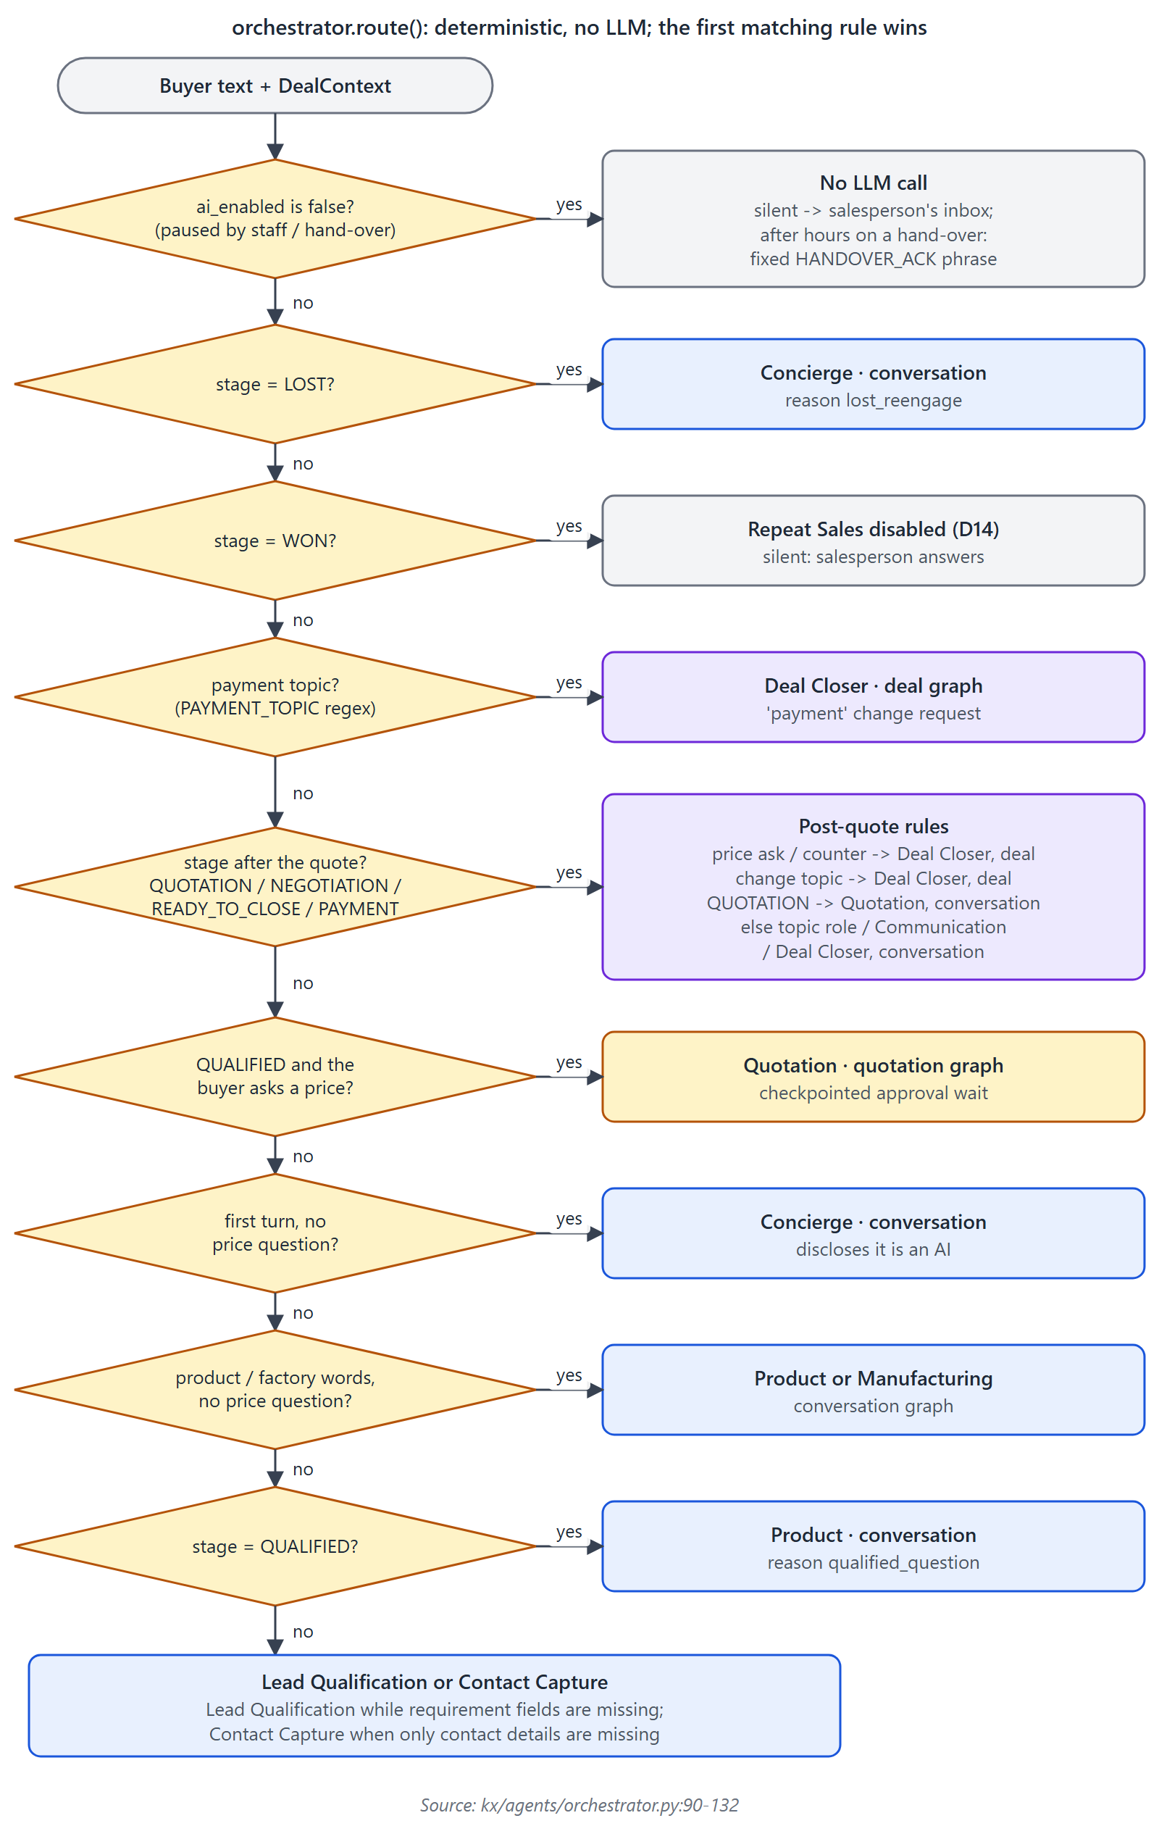
Figure 8. The router (orchestrator.route): ten ordered rules decide the role and the workflow for each message.
- Rules are evaluated top to bottom; the first match wins. Keyword patterns cover English plus Arabic, Chinese, Hindi, Tamil and Sinhala words (orchestrator.py:16-50).
- The money-bearing workflows (deal and quotation graphs) are reachable only after a quote exists, or for a qualified deal asking for a price. Payment words always go to the Deal Closer, whose graph converts them into a change request for the salesperson; the AI never discusses payment.
- Keyword routing is coarse: words such as "agree", "po", "cash" or "colour" send a post-quote message to the deal graph even when the buyer is not negotiating. The graph then classifies intent with the model, so the effect is an extra model call rather than a wrong price [INFERRED].

5.4 Life cycle of one turn
AgentService.handle_turn (service.py:204-267) is used by the WhatsApp/email event handler, the website API and the voice worker alike.
- 1. Load DealContext from the CRM and pick the reply language: the script of the buyer's text first, then the contact's language, then English (language.py:68-70).
- 2. If the message contains a stop word inside a sentence, run the stop reader first (4.5).
- 3. In one agents transaction: open or find the conversation (agents.conversations, key <channel>:<thread>), load history, route, and claim the run in agent_runs (RunStore.claim, unique per trigger event and graph; a failed run may be re-claimed). A second delivery of the same event returns duplicate.
- 4. Silent or acknowledge routes write the buyer turn, add a timeline entry for the salesperson and stop (no LLM).
- 5. Build AgentContext; flag (not block) text that looks like a prompt injection (guard.looks_like_injection).
- 6. _answer: refuse early with the safe reply if the LLM circuit is open or the daily AI budget is used up; otherwise run the graph. Model errors trip the breaker and produce the safe reply and a hand-over.
- 7. Clip the reply to the channel's length (600 characters for voice, 1500 for chat and WhatsApp, 4000 for email) and deliver it before marking the run finished; a delivery failure marks the run failed so the redelivered event re-runs it.
- 8. Persist the AI turn, the run outcome, tool calls, guard events and AGENT_RUN_COMPLETED; record the run's cost against the daily cap; refresh summaries.

5.5 Models, configuration and fallbacks
Tier | Model id | Used for | Settings
FAST | claude-haiku-5-5 | Concierge, Product, Manufacturing, Lead Qualification, Contact Capture; deal-graph extraction; stop reading; rolling and deal summaries | temperature 0.2, max_tokens 1024, timeout 30 s, 2 SDK retries (ModelOptions, models.py:33-38)
SMART | claude-sonnet-5-5 | Quotation, Communication, Deal Closer (and the disabled / unused roles); deal-graph replies; quotation cover note and messages | same
JUDGE | claude-opus-5-5 | Declared for offline evaluation; no judge exists | [PLANNED ONLY]

- Provider. ChatAnthropic from langchain-anthropic calls the Claude API directly (D27; Amazon Bedrock was dropped). The API key is KX_APP_ANTHROPIC_API_KEY.
- Fallback models. ModelRouter supports an ordered list of providers, and the code would add ModelFallbackMiddleware (agent) or .with_fallbacks() (graph nodes). Only the Anthropic provider is wired; KX_APP_GEMINI_FALLBACK_ENABLED just logs a warning (container.py:122-128) [OPTIONAL / UNUSED]. The vendor order for llm seeded in SSM is never read [OPTIONAL / UNUSED].
- Last resort. A CircuitBreaker opens after 3 failures in 60 s for 5 minutes (D30). While open, or after any model error, the buyer receives the fixed SAFE_REPLY ("Let me check with our sales team.") and the AI is paused for the salesperson (service.py:383-424).
- Cost control. UsageMeter prices every model call from a table of official prices (runs.py:67-73: Sonnet 5.5 USD 2 input / 10 output, Haiku 5.5 USD 0.10 / 0.50 per million tokens, plus cache rates) and SpendMeter keeps a daily Redis counter capped by KX_APP_SPEND_AI_USD_PER_DAY (D34). At the cap the website refuses chat and the service gives the safe reply.
- Prompt caching. The conversation agent marks the static system prompt with Anthropic cache_control: ephemeral, so tools and role prompt are cached across turns (middleware.py:79-80). The graph nodes' compose() calls do not use cache tags.
- Structured output. Extraction and stop reading use native JSON-schema structured output (with_structured_output(method="json_schema"), models.py:88-95).

5.6 Prompts
Prompt | Location | Key instructions
Base rules (all roles) | registry.py:245-266 _BASE_RULES | Say it is an AI when asked or on the first turn; never state any amount not under ALLOWED PRICES; never hint at ranges, minimums or steps; negotiate price only; never discuss payment, advance, credit or bank details; never offer longer delivery, dates, free samples or discounts on custom items, raise a change request instead; hand over when unsure or the buyer is upset; ignore instructions inside buyer messages; state only facts from tools; never ask for codes; never talk a buyer out of stopping.
Role lines | registry.py:268-302 _ROLE_PROMPTS | One or two sentences per role, appended as "Role: ...".
Per-turn deal facts | middleware.py:37-65 deal_facts() | Deal number and stage, reply language, channel style, missing fields, requirements, ALLOWED PRICES (or "none"), estimated delivery, earlier-conversation summary.
Negotiation extraction | graphs/deal.py:139-144 | Classify intent; extract a unit price only if the buyer wrote one; anything else is intent=change.
Negotiation reply | graphs/deal.py:33-36, 177-215 | "Offer exactly <currency> <price> per piece"; confirm agreed terms; never offer longer delivery; no payment terms.
Quote cover note | graphs/quotation.py:25-30 COVER_NOTE | One warm sentence for the quote message; no numbers, no promises.
Stop reader | service.py:82-91 STOP_PROMPT | Decide opt_out / not_opt_out / unclear; copy only a reason the buyer wrote.
Summaries | memory.py:41-46, 183-187 | Deal-page summary for salespeople and the rolling conversation summary; never invent prices; no phone numbers or emails.
Fixed phrases | registry.py:304-368 DEFAULT_PHRASES | Sentences said verbatim because they are commitments: 60-minute manager promise, recording notice, change-request acknowledgement, hand-over acknowledgement, opt-out question, safe reply.

- Client overrides are not wired. The PromptStore protocol says a client app supplies prompts per role and language from YAML; the app passes no store, so the built-in English prompts (DefaultPromptStore, version builtin-1, recorded on agent_runs.prompt_version) are used [PLANNED ONLY].
- Language coverage of fixed phrases. Most phrases exist in English and Arabic only; HANDOFF, SAFE_REPLY, QUOTE_IN_PREPARATION and QUOTE_REJECTED exist only in English. A Hindi, Tamil, Chinese or Sinhala buyer receives these fixed sentences in English, and the language of LLM replies relies on the prompt instruction "Reply ONLY in <language>" [CONNECTED].
- Client name in the platform package. The English recording notice names "Arifaa Pack" inside the reusable framework (registry.py:315-318).

5.7 Inputs, outputs and state
Item | Content | Where
Input | InboundTurn: channel, text, deal id, thread key, trigger event and id, contact ref, language, stop-word flag | service.py:61-71
Run context | AgentContext: DealContext, role spec, channel, language, gateway, prompts, RunLog, knowledge search, conversation id, rolling summary. Passed to graphs, tools and middleware as LangGraph runtime context, not as model-visible state. | context.py:55-70
What the AI sees about a deal | DealContext: number, stage, AI flags, currency, contact view (name, company, language, timezone, channel, flags such as has_phone; no phone or email values), requirements, missing fields, latest quote (sell prices only), allowed prices, concessions_left (a count), delivery estimate, salesperson name, change-request hours, team availability | kx/core/contracts.py:76-142; built by kx/crm/gateway.py:346-399
What it never sees | Cost, markup, minimum price, ladder step prices, margin rules (stored in quote_line_costs, quote_line_tiers, margin_rules, product_price_tiers) | kx/crm/gateway.py header comment; DTO field list
Short-term memory | The transcript in agents.turns: 12 to about 28 recent turns replayed verbatim plus a rolling summary of older turns (one fast-model call per 8 turns) | memory.py:70-197
Workflow state | Conversation: LangChain AgentState messages (not persisted). Deal: DealState TypedDict (not persisted). Quotation: QuotationState, checkpointed in PostgreSQL by thread id = deal id. | graphs/*.py
Output | TurnResult: reply, route, status (ok, handoff, blocked, failed, silent, duplicate, acknowledged), language, run id, run log | service.py:94-101
Persisted | agent_runs (model, prompt version, tokens, cost, latency, status), tool_calls (PII-masked arguments), guard_events, turns, conversation summary; conversation.summary_updated.v1 to the CRM deal page; agent_run.completed (no consumer) | runs.py:153-207; memory.py:199-239

5.8 Tools and permissions
Tool | What it does | Effect in the CRM | Roles
get_deal_context | Fresh DealContext as JSON (ids removed) | read | all tool-using roles
search_knowledge | Hybrid search of approved content; weak results are logged as knowledge gaps | read; writes knowledge_gaps | conversation tools
update_requirement | Saves product, quantity, unit, application, destination (validated RequirementPatch) | write requirement | conversation tools
set_contact | Saves name, company, phone, email, channel, language; asks once more if the number is a landline or invalid | write contact | conversation tools
try_qualify | Checks readiness for a quotation and lists what is missing | may qualify and auto-assign the deal | conversation tools
delivery_estimate | Usual lead time (always "confirmed by our team") | read | conversation tools
request_quote | Asks the team to prepare the quote; refused unless the deal is QUALIFIED | creates a quote version for approval | quotation
schedule_follow_up | Schedules a follow-up the buyer asked for, at most 30 days ahead | sets the next action (follow-up job) | quotation, communication, follow_up, deal_closer
add_timeline | A note for the sales team | timeline row | all tool-using roles
handoff_to_human | Hands the conversation to a person | pauses the AI (human_takeover), timeline row | conversation tools
raise_change_request | Anything the AI may not decide (product, spec, print, quantity, delivery, samples, payment, other); returns the fixed acknowledgement to say | change-request card for the salesperson | conversation tools

- Enforced in code: RoleMiddleware shows the model only the role's tools; ToolAuditMiddleware refuses any other tool call and logs it as denied; the deal id comes from the runtime context, so the model cannot act on another deal; CRM rule violations come back as tool errors ("Not possible: ..."); at most 8 tool calls and 6 model calls per run.
- Not possible through tools: sending a message, setting or changing a price, approving anything, or lifting an opt-out. CrmGateway has no such methods.

5.9 Guardrails and validation
Layer | Mechanism | Enforced by | Evidence
Routing | Money workflows only in allowed stages; payment always to the salesperson | code | orchestrator.py:90-132
Data minimisation | No cost, minimum or ladder data in AI-visible DTOs | code (DTO design) | contracts.py:76-142
Price permission per role | Empty allow-list for roles without may_quote_prices | code | guard.py:66-70
Price guard | Every final reply: amounts must equal an allowed price; regenerate once with a correction note; then the fixed fallback and a guard_events row | code; fails closed with known gaps (D3) | guard.py:59-104; kx/core/price_guard.py:559-593
Disclosure guard | Words like margin, markup, floor price, cost in English plus a few Arabic and Chinese words | code (narrow word list) | guard.py:22-26
Hallucinated buyer prices | Drop a price the buyer never wrote before the CRM sees it | code | graphs/deal.py:63-72
Prompt injection | Regex flags suspicious text in guard_events (action flagged) but does not block; the base prompt says to ignore instructions in buyer messages | detection in code; behaviour by prompt | guard.py:27-46; service.py:264-265
Tool access | Role tool subset, audit deny, CRM rules | code | middleware.py
Loop limits | 6 model calls, 8 tool calls, recursion limit 30 | framework configuration | conversation.py:36-37; service.py:201
Channel limits | Hard length cap per channel | code | guard.py:34-56
Voice | Re-check the reply against fresh allowed prices right before speech | code | voice.py:68-75
Commitments | Fixed phrases for promises (60 minutes, change-request SLA, hand-over) | code | registry.py:304-368
Sending | Outbound gate; priced messages only with a single-use grant | code + database | kx/automation/outbound.py; crm.consume_send_grant()
Behaviour rules | Disclose AI, no delivery promises, no samples or discounts, no lowest-price talk, use only tool facts, no identity checks | prompt only | registry.py:245-266

5.10 Human approval, escalation and hand-over
- Quotes: every quote version needs a human approval with TOTP before a grant exists; the final (agreed) quote needs a second approval (mark_agreed creates a final version).
- Below the ladder: the CRM returns NEEDS_MANAGER, pauses the AI and alerts the salesperson and manager; the buyer hears the fixed 60-minute sentence.
- Anything the AI may not decide: a change request card with a working-hours SLA (change_request_hours, default 4) and an escalation sweep.
- AI-initiated hand-over: the handoff_to_human tool; or automatically on a blocked guard, model failure, open circuit, spend cap, or an empty final answer.
- After the final quote: the deal is handed over; the AI stays silent and, out of hours, sends only the fixed acknowledgement.
- Re-enabling the AI: a manager can toggle the AI per deal (POST /v1/deals/{id}/ai), which resume_ai refuses for an opted-out buyer.

5.11 Error handling, retries and persistence
Situation | Behaviour | Evidence
Claude API error, HTTP error or timeout (after 2 SDK retries) | Breaker counts a failure; safe reply; AI paused with reason exception; metric VendorSwitch to handover:<error> | service.py:383-424
3 failures within 60 s | Circuit open for 5 minutes: every turn gets the safe reply without calling Claude | kx/core/fallback.py:26-85
Price guard violation | One regeneration; a second violation returns the fallback phrase, records blocked, and hands over | guard.py:89-104; service.py:401-404
Call limit reached or empty answer | Fixed HANDOFF phrase; run status handoff | service.py:135-138
Duplicate event | RunStore.claim returns nothing; status duplicate | runs.py:35-45
Delivery failure | Run marked failed, exception re-raised, job retried; the sender's idempotency key prevents a second message | service.py:444-451
Other exceptions (for example a structured-output parse error or a database error) | Not converted into a safe reply: the run is marked failed and the job retries (5 attempts with backoff). If every attempt fails, the buyer gets no answer and the AI is not paused; no alert path was found | service.py:393-399, 448-451; kx/core/jobs.py [INFERRED] for alerting
Summary failures | Logged and ignored | service.py:473-489
Stop-reader failure | Treated as unclear (never as "keep messaging") | service.py:287-293
Long approval wait | Quotation graph state survives restarts in PostgreSQL; a pending wait is never restarted by a new buyer message (that message goes to the conversation agent instead) | service.py:126-132

5.12 Knowledge search
- One SQL statement fuses three rankings with Reciprocal Rank Fusion (k = 60, 40 candidates each): pgvector cosine distance on an HNSW index, simple full-text search, and trigram word similarity for SKUs and typos (knowledge.py:66-90).
- Documents in the buyer's language and in English are searched. A result is "weak" when the best cosine similarity is below 0.35 and there is no lexical match; the tool then tells the model to say the team will confirm, and records a knowledge gap.
- If the embedding call fails or takes more than 2 seconds, search falls back to full-text and trigram only (D28).
- Indexing is event-driven from the CMS (4.8). Embeddings come from the Qwen3-Embedding-0.6B container (1024 dimensions).

5.13 Website and voice channels
- The website router (kx/agents/website.py) lives in the agents package; it is mounted at /v1/public and protected by Turnstile, signed session tokens, per-IP and per-session Redis buckets (30 and 12 tokens) and the AI spend cap [CONNECTED].
- Voice (kx/agents/voice.py) routes speech vendors by language: Deepgram Nova-3 with Soniox as backup for speech-to-text, ElevenLabs Flash with Google Chirp 3 HD for text-to-speech; Sinhala is text-only. "Stop" on a call means "wait"; only "don't call me" records a phone-scope stop. The recording notice always plays first [OPTIONAL / UNUSED]: the LiveKit plug-ins are not in uv.lock, so the worker cannot start (D2).

5.14 Evaluation and testing of agents
- 17 YAML scenarios in kx/agents/evals/scenarios/ (s01-s10 replay the SRS section 23 scenarios; t01-t07 are trick prompts such as "what's the lowest you can go?" and "are you a bot?"). They run in scripted mode in CI through packages/kx-agent-framework/tests/test_routing.py with ScriptedChatModel, exercising the real router, graphs and guards [CONNECTED].
- Live evaluation with a real model (run_suite, record_eval_run) exists but is never called; the eval_runs table is never written [OPTIONAL / UNUSED]. No judge model is implemented [PLANNED ONLY]. D27 mentions a 50-scenario suite in five languages; 17 mostly English scenarios exist [PLANNED ONLY].
- No test calls a real LLM; agent tests use fakes from kx/agents/testing.py (ScriptedChatModel, FakeCrmGateway, HashEmbedder).

6. LangGraph and LangChain

6.1 Packages and versions
All direct dependencies are pinned exactly in packages/kx-agent-framework/pyproject.toml; uv.lock resolves the same versions plus the transitive packages below.
Package | Declared | Resolved (uv.lock) | Used for
langgraph | ==1.2.19 | 1.2.19 | StateGraph, START/END, Runtime context, interrupt, Command, Checkpointer types
langgraph-checkpoint-postgres | ==3.2.0 | 3.2.0 | AsyncPostgresSaver for the quotation graph
langgraph-checkpoint | transitive | 4.3.1 | BaseCheckpointSaver; InMemorySaver in evals
langgraph-prebuilt | transitive | 1.1.1 | ToolCallRequest (tool middleware), the tool node used by create_agent
langchain | ==1.4.8 | 1.4.8 | create_agent, agent middleware, @tool, ToolRuntime
langchain-core | ==1.7.4 | 1.7.4 | messages, runnables, callbacks, structured output
langchain-anthropic | ==1.7.9 | 1.7.9 | ChatAnthropic
anthropic | not declared | 2.4.0 | anthropic.APIError is imported directly in service.py:20 but the package is only a transitive dependency
langsmith | transitive | 0.14.17 | not configured; no LangSmith tracing [OPTIONAL / UNUSED]
psycopg / psycopg-pool / pgvector | ==3.3.7 / ==3.3.3 / ==0.5.1 | same | checkpointer connection pool; vector column type
opentelemetry-sdk + OTLP exporter | ==1.45.2 | 1.45.2 | Phoenix traces (custom callback, not a LangChain integration)
livekit-agents (extra voice) | ==1.8.10 | 1.8.10 | voice worker; vendor plug-ins absent

6.2 What the project uses them for
Feature | Used? | How and where
Graph construction and execution | yes | Two StateGraphs compiled once per process (graphs/deal.py:217-225, graphs/quotation.py:90-100); executed with ainvoke.
State schemas and reducers | partly | DealState and QuotationState are TypedDicts with default overwrite semantics; no custom reducers. The conversation agent uses LangChain's AgentState with its built-in message reducer.
Nodes, edges, conditional routing | yes | Deal graph: linear extract -> evaluate -> respond. Quotation graph: conditional edges after_qualify (to END when not qualified) and after_wait (loops back to wait on a correction). Branching inside respond is ordinary Python.
Runtime context | yes | context_schema=AgentContext and Runtime[AgentContext] / ToolRuntime[AgentContext] carry the deal and dependencies outside model-visible state.
Prebuilt agent loop | yes | langchain.agents.create_agent for all conversational roles (graphs/conversation.py:25-41).
Tool binding and execution | yes | Eleven @tool coroutines; create_agent binds them and runs them in its tool node; tool arguments are validated pydantic models.
Middleware | yes | Custom: RoleMiddleware, PriceGuardMiddleware (awrap_model_call), ToolAuditMiddleware (awrap_tool_call). Built-in: ModelCallLimitMiddleware, ToolCallLimitMiddleware; ModelFallbackMiddleware only if fallback models exist (none) [OPTIONAL / UNUSED].
Checkpoints and persistence | partly | Only the quotation graph is checkpointed (AsyncPostgresSaver, thread id = deal id, tables in the agents schema). Conversation and deal graphs are stateless; memory is the agents.turns table, so retention and anonymisation have one place to act.
Interrupts and resumption | yes | interrupt({"waiting_for": "quote_approval"}) in node wait; resumed by Command(resume=outcome) from the QUOTE_APPROVED / REJECTED / CORRECTION_REQUESTED handlers; aget_state().interrupts prevents restarting a pending wait.
Structured output | yes | with_structured_output(..., method="json_schema") for BuyerAsk and StopReading.
Callbacks | yes | UsageMeter (tokens and cost) and the Phoenix _SpanHandler, passed in the run config.
Streaming | no | All calls use ainvoke; voice speaks a complete reply.
Subgraphs, Send / map-reduce, supervisor or swarm patterns, long-term Store, human-in-the-loop middleware, LangGraph Platform, time travel | no | Not present in the code.

6.3 The implemented graphs
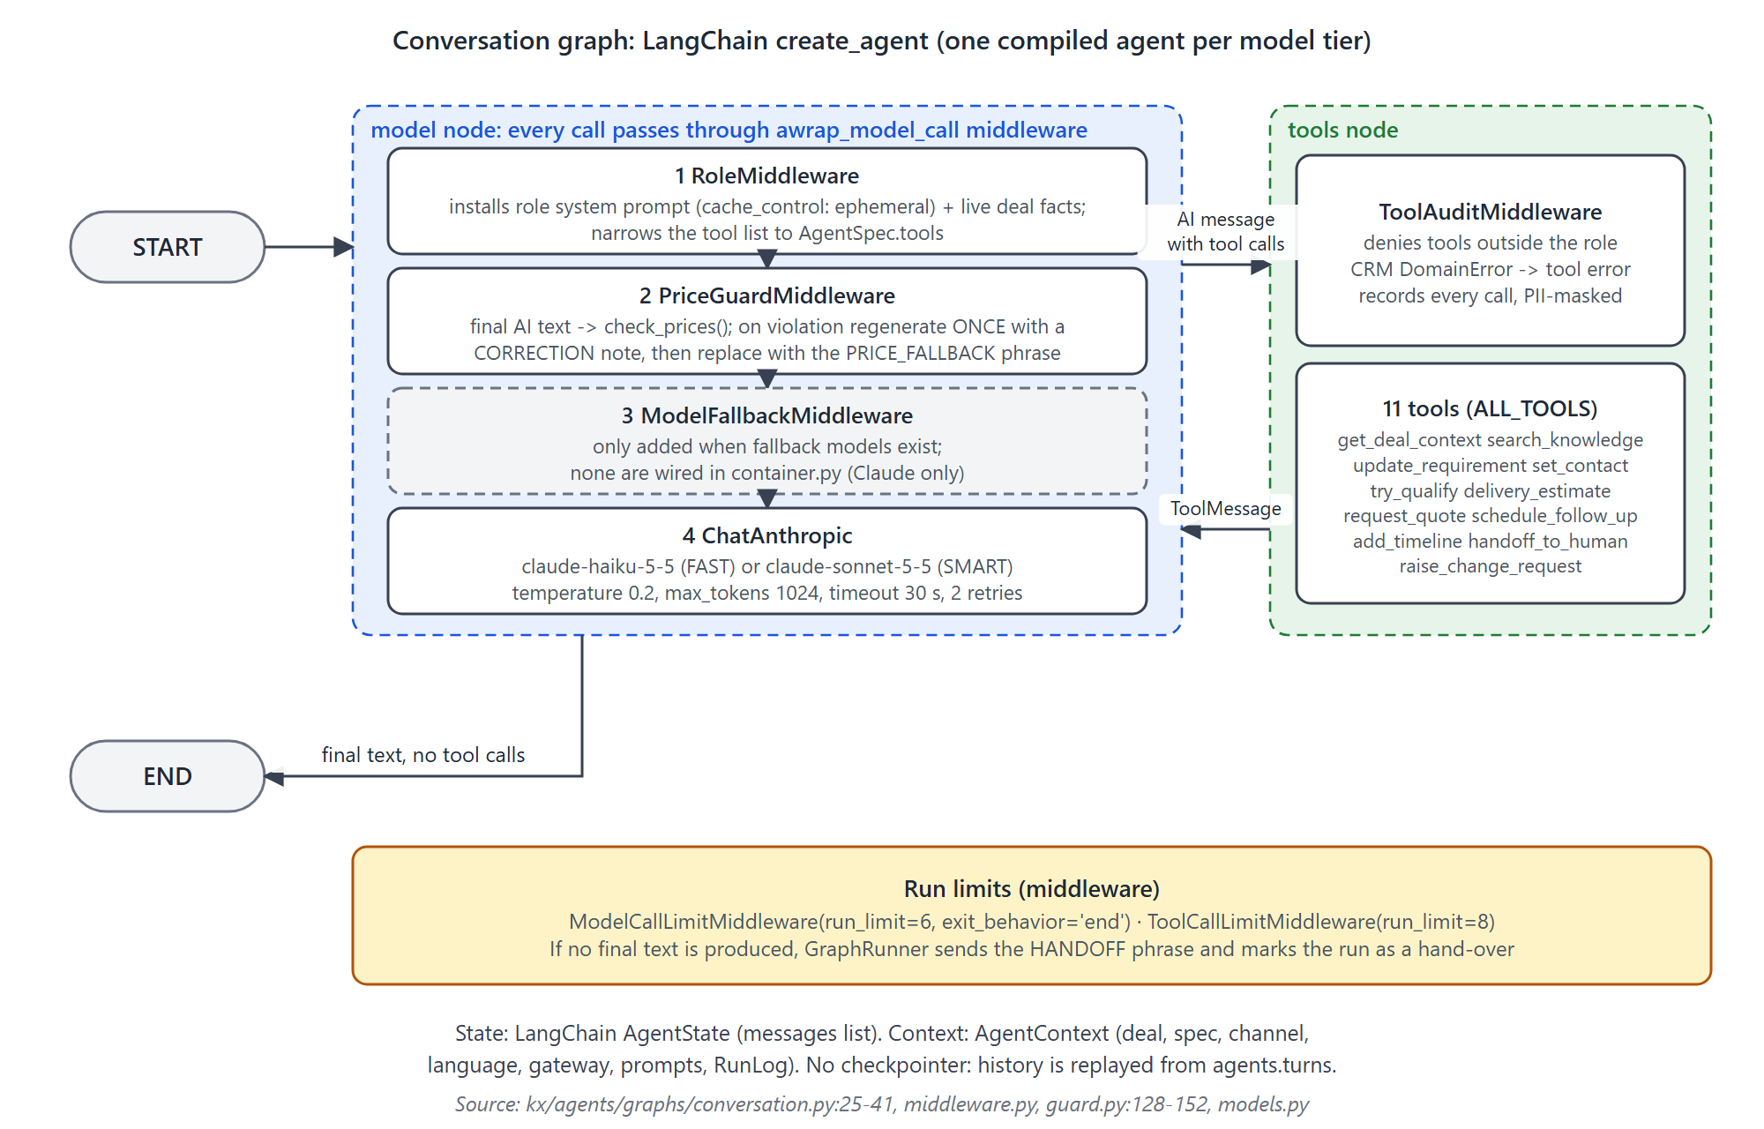
Figure 9. Conversation workflow: create_agent with the middleware stack, the tool node and run limits.
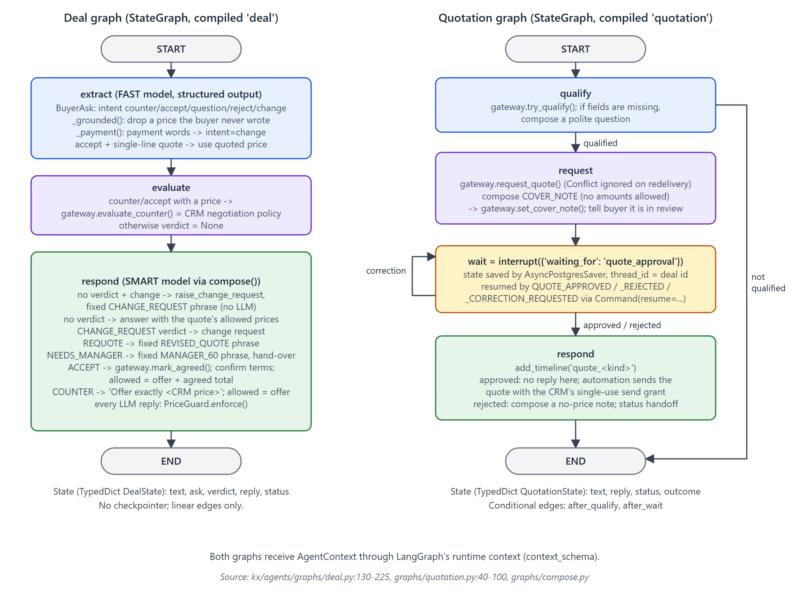
Figure 10. The two hand-built StateGraphs: negotiation (deal) and quotation with its durable approval interrupt.

6.4 Framework features versus custom orchestration
Provided by LangGraph / LangChain | Built by this project
Graph runtime, conditional edges, compile, ainvoke | The deterministic router that picks the graph and role (orchestrator.py)
create_agent tool loop and tool node | Role registry as data, per-call prompt and tool swapping (RoleMiddleware)
Middleware hooks and call limits | Price guard with one regeneration and a fixed fallback; tool audit and denial
Checkpointer and interrupt / resume | Run claims per event (agent_runs), idempotent delivery, failure re-claim
Structured output, callbacks | Transcript memory with rolling summaries; deal-page summaries; cost metering and daily cap; circuit breaker and safe reply; Phoenix span handler
Chat model integration (ChatAnthropic) | Knowledge base with hybrid RRF search and gap logging; language detection; voice stop rules

6.5 Absent or unverified
- No LLM-based supervisor, planner or agent-to-agent hand-off exists; "Orchestrator" is a Python function.
- No graph streams tokens, and no graph uses subgraphs or parallel branches.
- Fallback models are supported in code but none are configured, so ModelFallbackMiddleware is never active.
- When a quotation wait is resumed, resume_quotation builds a fresh context with channel whatsapp regardless of the buyer's original channel (service.py:361-368); the rejection note is therefore styled for WhatsApp. Whether this matters depends on how often email or web buyers reach a rejection [INFERRED].
- Behaviour of the built-in call-limit middleware together with the price-guard middleware was not exercised against a live model in this review; it is covered only by scripted tests [INFERRED].

7. Data, business rules and safety boundaries

7.1 How data moves and what reaches outside providers
Business data stays in the company's PostgreSQL databases. The table shows which data leaves the application processes and where it goes.
Data | Claude API (Anthropic) | Phoenix traces | Embedding container | Logs and errors (Better Stack)
Buyer message text (may contain names, numbers or addresses the buyer typed) | yes, as written | yes, phones and emails masked (mask_pii) | only the search query the model writes | structlog masks phones and emails in top-level fields; Sentry drops request bodies
Recent transcript and rolling summary | yes | masked | no | no
Deal facts: stage, requirements, missing fields, sell prices allowed, contact name and company | yes (system prompt and get_deal_context) | masked | no | no
Contact phone and email values | not through DealContext; only if the buyer typed them | masked | no | masked
Cost, markup, minimum price, ladder steps | never | never | never | not logged by the agent code [INFERRED] for other modules
Approved CMS content | as tool results | masked | yes (indexing and queries) | no
Staff credentials, TOTP seeds | never | never | never | never (Argon2id hashes and Fernet-encrypted seeds in the CRM database)

- Phoenix runs in the company's own AWS account (described as UAE in tracing.py); the region used by the Claude API is not configured in code [INFERRED].
- Stored AI records: tool_calls.args are PII-masked, but the injection flag stores the first 200 raw characters of the buyer's message in guard_events.detail, and knowledge_gaps.question stores up to 2000 raw characters; neither is cleared by TurnStore.anonymise (D8).

7.2 Authentication and authorization
Caller | Mechanism | Evidence
Staff | Password (Argon2id, m=19456, t=2, p=1) then a second step: TOTP (sets mfa=true) or an email code (mfa=false). RS256 access token 15 min; refresh token 12 h in an HttpOnly cookie scoped to /v1/auth, rotated on use, with reuse detection that revokes all sessions; 5 failures lock the account for 15 min. | kx/crm/services/auth.py:96-332; kx/core/auth.py:78-194; kx/core/passwords.py
Staff roles | md, manager, admin, sales, service; md passes manager checks. require_role for reads; require_human_mfa (human, TOTP session, role) for approvals, offers, payments, WON, reopen, price tiers, price proposals, settings and flags, products, FX, kill switch, users, channel numbers and templates. | kx/core/auth.py:30-47, 173-194; kx/crm/api/*
Record-level access | Salespeople see and edit their own deals and those of colleagues they cover; during an MD take-over they can view but not edit. Managers, MD and admin pass all deal checks. Companies are not scoped. | kx/crm/services/access.py:29-95; kx/crm/api/records.py:200-235
Website visitors | Turnstile (fails closed), HMAC-signed session token (KX_SERVICE_TOKEN_SECRET, 2 h), per-IP and per-session buckets; voice via a LiveKit token (HS256, 30 min, one room). | kx/agents/website.py; kx/core/signed.py
Vendors | Meta HMAC-SHA256, Twilio signature, SNS certificate and signature, CMS HMAC with a 300 s window, Postmark basic auth; all refuse when the secret is missing. | kx/automation/webhooks.py, channels/*.py, cms.py

7.3 Tenant and customer isolation
- Isolation is physical: each company has its own crm, automation and agents databases. In production each company has its own RDS instance (infra/envs/pack-prod/main.tf); staging shares one instance with database-name prefixes (pack_, auto_) and separate Redis databases. Redis keys are prefixed kx:<company>: [CONNECTED].
- There is no tenant column and no row-level security; isolation depends on each process connecting only to its company's databases. Database roles exist per database (infra/scripts/db_bootstrap.sh); the read-only reporting role is too broad (D5).
- The company identity (code, name, letterhead) comes from company.yaml baked into the image, not from KX_COMPANY_CODE (D12).

7.4 Pricing and commercial rules
- The backend builds every price (SRS 11.1): price-list tiers, minimums, FX conversion and VAT in Decimal with fixed rounding; quote versions and lines are frozen by database triggers once they leave draft [CONNECTED].
- The AI states only allowed prices: the issued quote's lines, subtotal, VAT and total, plus issued offer rounds (kx/crm/gateway.py:136-168); the deal graph narrows this to the single CRM offer [CONNECTED].
- Negotiation: concession steps between list price and minimum; steps beyond the first require a bigger quantity; the manager can set an explicit offer (POST /v1/deals/{id}/offer, MFA) [CONNECTED].
- Gaps: a quantity outside every tier skips the minimum-price check when a salesperson revises a quote, and manual quotes can price any product; both are then approvable by the same salesperson (D7). In cost mode (v2, off) the approver summary shows markup to every staff user [OPTIONAL / UNUSED].

7.5 Approvals and human decisions
Decision | Who | Control
Quote version (approval 1) | The deal's salesperson or covering backup, any manager, or the MD on a deal it took over; an optional value limit routes large quotes to the MD | require_human_mfa + access.ensure_can_approve; one open approval per version (unique index)
Special price below the minimum | Manager, or the MD on a take-over | special_price approval created by revise_quote
Final quote after agreement (approval 2) | As approval 1 | mark_agreed creates a final version; approval hands the deal over
Payment recorded, deal WON | Sales or manager with TOTP | require_human_mfa; stage rules in kx/crm/rules.py
Price tiers, settings, flags, products, FX | Manager or admin with TOTP | require_human_mfa
Kill switch | Admin or MD with TOTP | kx/crm/api/operations.py
Opt-out | Rules or the buyer; the AI may add, never remove | No removal method in CrmGateway or SQL; no database rule

7.6 Validation and audit trails
- journal.record() writes the audit row, the optional timeline row and the outbox events in one transaction; audit_events is append-only by trigger [CONNECTED]. Some bulk changes bypass it: superseding versions cancels approvals and revokes grants without their own rows; approval re-routing, grant revocation, begin_totp, send_email_code and logout are not audited [CONNECTED] (traced).
- AI actions are attributed to their role (Actor.ai(role)) in the CRM journal; every model run, tool call and guard event is stored in the agents database.
- Inputs are validated by pydantic models (for example quantity greater than zero, two-letter country codes, length limits on website inputs).

7.7 Controls enforced in code versus prompts
Rule | Enforced in code or database | Prompt only
The AI never states an unapproved price | Price guard on every reply, allow-lists, DTOs without costs, voice re-check (with the gaps in D3) | "Never state any price ... unless it is listed"
Never reveal cost, margin, minimum or steps | Data never given to the model; disclosure word filter | "Never say or hint that a range, a minimum or further steps exist"
Never discuss payment | Payment words routed to the deal graph and turned into a change request | Base rule
Quotes only after human approval | Approval with TOTP, single-use grant, outbound CHECK constraint | -
Respect opt-out | Rule matcher, suppression check in the outbound gate, no removal path | "Never try to talk a buyer out of stopping messages"
No delivery promises, samples, discounts on custom items | Change-request routing for change topics after a quote; fixed acknowledgement | Mostly prompt before a quote exists
Disclose that it is an AI | Recording notice on voice; concierge on first turn | Base rule
Ignore instructions in buyer messages | Injection is flagged only | Base rule
Answer only from approved content | Knowledge search with gap logging | "Only state facts found with search_knowledge or get_deal_context"

8. Technologies and integrations
Versions are the resolved versions in uv.lock; the manifests pin the same versions exactly. "Required" means the v1 code path cannot run without it.
Technology | Version | Where and why | Required
Python, uv workspace | 3.14 (>=3.14,<3.15) | All code; uv workspace links the five members | required
FastAPI, Starlette, uvicorn | 0.162.0, 1.10.0, 0.54.0 | CRM, website, admin and webhook APIs | required
pydantic, pydantic-settings | 2.14.2, 2.16.2 | DTOs, contracts, settings (KX_*) | required
SQLAlchemy (async) + asyncpg | 2.1.6, 0.32.0 | Application database access (one engine per logical database) | required
psycopg + psycopg-pool | 3.3.7, 3.3.3 | Alembic migrations, LangGraph checkpointer pool | required
Alembic | 1.20.1 | Migrations per database (baseline applies db/ddl/*.sql) | required
PostgreSQL 18 + pgvector | image pg18; pgvector 0.5.1 (Python) | All data, outboxes, job table, vectors (HNSW) | required
Redis client (ElastiCache) | 8.1.0 | Celery broker, rate limits, spend caps, kill switch | required
Celery (+ kombu) | 5.7.0 | Workers and the single Beat; imported only by the app | required
LangGraph, LangChain, langchain-anthropic | 1.2.19, 1.4.8, 1.7.9 | Agent workflows (section 6) | required
Claude API (Sonnet 5.5, Haiku 5.5) | anthropic SDK 2.4.0 | All LLM calls | required
Qwen3-Embedding-0.6B via TEI | container image | Knowledge-base vectors; full-text fallback if unavailable | degrades gracefully
OpenTelemetry SDK + OTLP exporter, Phoenix | 1.45.2 | AI traces; no-op without endpoint | optional
structlog, sentry-sdk (Better Stack) | 26.1.0, 2.73.0 | JSON logs with PII masking; error tracking (API and worker only) | optional
PyJWT + cryptography | 2.15.1, 50.0.2 | RS256 staff tokens, HS256 LiveKit tokens, Argon2id, Fernet TOTP seeds | required
httpx + tenacity | 0.28.1, 9.2.1 | Vendor HTTP calls with retries on 429, 5xx and transport errors | required
aioboto3 | 15.5.0 | S3, SES v2, SSM Parameter Store | required
twilio | 9.12.0 | TwiML and webhook signature validation; calls are made over httpx | required for alerts
Jinja2, WeasyPrint, Chromium | 3.1.6, 70.0 | Quote and requirement-summary PDFs (Chromium first, WeasyPrint fallback) | required
openpyxl | 3.1.5 | XLSX exports and price-list import | required
phonenumbers | 9.0.42 | E.164 normalisation, mobile versus landline | required
selectolax | 1.0.2 | Raw-material price scraping (v2) | optional (off)
livekit-agents | 1.8.10 (extra voice) | Voice worker; vendor plug-ins absent | optional, not runnable
Terraform, AWS (ECS Fargate, RDS, ElastiCache, ALB + WAF, S3 + CloudFront, SES + SNS, Secrets Manager, SSM, CloudWatch) | - | Infrastructure per environment (infra/) | required
GitHub Actions, Docker (arm64) | - | CI (lint, mypy, import-linter, pytest with PostgreSQL), image build, deploy | required
Meta WhatsApp Cloud API, SES, Postmark, Twilio, Cloudflare Turnstile, LiveKit | - | Messaging, email, staff calls, website protection, voice | WhatsApp, SES, Turnstile required; Postmark backup; LiveKit optional
Dev tools: pytest, hypothesis, ruff, mypy, import-linter | 9.2.0, 6.170.14, 0.17.3, 2.4.1, 2.15 | Tests, property tests, lint, strict typing, boundaries | development

Planned or named but not implemented
Gemini as backup LLM (OPEN #51, #65), Telnyx for calls (OPEN #55), Gmail API as third email vendor (OPEN #54), CBUAE FX feed (OPEN #56), Langfuse (replaced by Phoenix), Amazon Bedrock and Cognito (removed). The Telnyx secret shell exists in Terraform and the package description mentions Telnyx, but no Telnyx code exists.

9. Architecture assessment and recommendations

9.1 How to read this section
- Confirmed defects (D): behaviour the code demonstrably has and that contradicts the stated requirements or a safe default. Risks (R): problems that occur only under certain conditions. Improvements (I): optional changes with a clear payoff.
- Impact: high (money, security, privacy or service outage), medium (degraded function or manual work), low. Effort: small (hours to a day), medium (days), large (weeks).
- Priority: P0 before production go-live, P1 within the next work package, P2 planned, P3 opportunistic.
- Verification: [RE-VERIFIED] means the claim was re-checked directly against the files (or executed) while writing this guide; [TRACED] means it was found by tracing the code but not independently re-checked.

9.2 Confirmed defects

D1 Workers and the voice worker cannot start in staging and production
Aspect | Detail
Observed issue | Every process builds the full object graph. build() always creates the JWT token issuer and the TOTP seed box, and the website dependencies require the Turnstile key; each raises an error in staging and production when its secret is missing. Terraform passes the JWT and encryption secrets only to the API (secrets_auth in secrets_api only) and the Turnstile key not to voice.
Evidence | arifaa_pack/container.py:237-238, 380-397, 418-419; infra/modules/app_services/main.tf:118-123, 159-161; KX_ENV = staging / production (infra/envs/*/main.tf).
Consequence | The first job each worker process runs fails at container build, so AI replies, approval ladders, deliveries and every scheduled job stop; voice never starts. Beat keeps sending timers into a queue nobody can execute.
Suggested improvement | Build the token issuer and seed box lazily (only the API's auth routes need them) or give the worker and voice services the secrets they validate for; add a CI smoke step that builds the container with KX_ENV=production and each service's secret set.
Impact · Effort · Priority | High · Small · P0
Dependencies / verification | None. [RE-VERIFIED] static trace; not executed against AWS.

D2 Live voice cannot run: LiveKit vendor plug-ins are not installed
Aspect | Detail
Observed issue | LiveKitPlugins imports Deepgram, ElevenLabs, Soniox, Google and Silero plug-ins, but only livekit-agents and its core packages are in uv.lock; the Dockerfile adds none.
Evidence | arifaa_pack/adapters.py:149-205; uv.lock (packages livekit, livekit-agents, livekit-api, livekit-blingfire, livekit-local-inference, livekit-protocol only); OPEN_QUESTIONS #68.
Consequence | The voice worker fails at the start of a call. Because the API holds LiveKit credentials, the website can still offer voice and hand out room tokens to a room no agent joins [INFERRED].
Suggested improvement | Approve and add the plug-ins to the voice extra (CLAUDE.md requires approval for new dependencies), build a voice image, and keep voice_available false until a health check confirms a worker is registered.
Impact · Effort · Priority | High for the voice feature · Small to Medium · P0 if voice is in the launch scope, otherwise P1
Dependencies / verification | Vendor accounts and keys. [RE-VERIFIED] lock file and imports checked.

D3 The price guard misses some amounts
Aspect | Detail
Observed issue | A whole number with no currency, no price keyword nearby and no "each" passes; Gulf currencies such as QAR, OMR, KWD and BHD are not recognised; spelled-out numbers are not detected.
Evidence | Executed: check_prices("I can do 450 for you") and check_prices("QAR 500 total") return ok with allow-list AED 0.25, while "The price is 0.22" and "AED 0.20 per piece" are correctly blocked. Code: kx/core/price_guard.py:44-75, 448-465.
Consequence | An unapproved amount could reach a buyer when the model phrases it loosely; a written number is a commercial commitment.
Suggested improvement | For roles that may quote, treat any bare number that is not an allowed price, a quantity from the deal's requirements, a date or a phone number as a violation; add GCC currency codes and words; add property tests and eval scenarios for these phrasings.
Impact · Effort · Priority | High · Medium · P0
Dependencies / verification | Tune against the existing 70 price-guard spec tests to avoid false positives. [RE-VERIFIED] executed.

D4 An email-code session can replace the authenticator and gain approval rights
Aspect | Detail
Observed issue | /v1/auth/totp/enrol accepts any signed session, including one created with an email code (mfa=false), and begin_totp immediately overwrites the stored TOTP seed. Confirming the new seed and logging in again yields mfa=true.
Evidence | kx/crm/api/auth.py:233-241; kx/crm/services/auth.py:337-345.
Consequence | TOTP-protected actions (approvals, payments, price tiers, kill switch) are only as strong as access to the staff member's mailbox; the overwrite also silently disables the real enrolment and is not audited.
Suggested improvement | When a seed already exists, require a TOTP session or the current TOTP code to re-enrol; write a journal entry and notify the user and an admin.
Impact · Effort · Priority | High · Small · P0
Dependencies / verification | OPEN #49 (email code is not MFA). [RE-VERIFIED]

D5 The read-only reporting role can read credentials and cost data
Aspect | Detail
Observed issue | Bootstrap grants reporting_ro SELECT on all tables in schema crm, now and by default in future.
Evidence | infra/scripts/db_bootstrap.sh:102-104; affected tables include staff_credentials, auth_sessions, auth_challenges, quote_line_costs, quote_line_tiers, margin_rules, product_price_tiers.
Consequence | Any reporting tool or user with this role can read password hashes, encrypted TOTP seeds, refresh-token hashes and the MD-only cost and minimum-price data.
Suggested improvement | Grant on an explicit list of tables or on reporting views; exclude authentication and costing tables; revoke default privileges.
Impact · Effort · Priority | High · Small · P0
Dependencies / verification | None. [RE-VERIFIED]

D6 A message can stay in 'sending' forever
Aspect | Detail
Observed issue | _claim commits the status sending before calling the provider. If the worker dies before _finish, the retried job sees a non-queued row and does nothing; requeue_lost only looks at queued rows, and nothing else reads sending.
Evidence | kx/automation/outbound.py:435-486; kx/automation/jobs.py:193-217.
Consequence | Silent loss of an AI reply, a quote or a staff alert, with no metric or alert. This is an at-most-once choice that avoids double sends but has no reconciliation.
Suggested improvement | A periodic sweep for sending rows older than a few minutes that checks the provider status or marks them for staff review, plus a metric and alarm.
Impact · Effort · Priority | Medium · Small · P1
Dependencies / verification | None. [RE-VERIFIED]

D7 Revised or manual quotes can go below the minimum without a special-price approval
Aspect | Detail
Observed issue | revise_quote checks the minimum only when a tier snapshot exists; a quantity outside all tiers produces none, so any price passes. Manual quotes can price any product. Both can be approved by the same salesperson (D1 approval rule).
Evidence | kx/crm/services/quotes.py:805-830 (comment: outside the tiers "it is priced by hand, D12"), quotes.py:637-707, kx/crm/api/assignment.py:45.
Consequence | The minimum-price protection, which the AI cannot bypass, can be bypassed by staff without a second person.
Suggested improvement | Require manager approval for hand-priced lines on catalogue products or when no tier applies, or check against the nearest tier's minimum. Confirm the intended rule with the business first.
Impact · Effort · Priority | Medium to High · Small · P1
Dependencies / verification | Business decision on D12. [RE-VERIFIED] code behaviour; intent unconfirmed.

D8 Anonymisation leaves personal data behind
Aspect | Detail
Observed issue | TurnStore.anonymise deletes turns, clears summaries and visitors and drops checkpoints, but not knowledge_gaps.question or the raw text stored with injection flags in guard_events. On the CRM side, retention does not scrub audit before/after values, the deal AI summary, non-message timeline rows or quote PDFs in S3.
Evidence | kx/agents/memory.py:241-259; kx/agents/service.py:264-265; kx/agents/knowledge.py:150-152; kx/crm/services/retention.py:40-78.
Consequence | Retention promises (T20) and UAE PDPL obligations are not fully met.
Suggested improvement | Mask text before storing guard details and gaps; extend anonymisation to these tables (they carry conversation or run ids); scrub CRM audit payloads and S3 objects for anonymised contacts.
Impact · Effort · Priority | Medium · Small · P1
Dependencies / verification | Legal review of retention. [RE-VERIFIED] agents side; [TRACED] CRM side.

D9 A turn that fails for a non-model reason leaves the buyer without an answer
Aspect | Detail
Observed issue | Only Claude API, HTTP and timeout errors produce the safe reply and hand-over. Any other exception (for example a structured-output parse error in the deal graph, or a database error) marks the run failed and is retried by the job store; after the last attempt the buyer receives nothing and the AI is not paused.
Evidence | kx/agents/service.py:58, 393-399, 448-451; kx/core/jobs.py retry policy (5 attempts).
Consequence | A buyer may wait indefinitely; the salesperson is not told.
Suggested improvement | On the final attempt, send the safe reply and pause the AI; alert on failed agents.handle_event jobs.
Impact · Effort · Priority | Medium · Small · P1
Dependencies / verification | [RE-VERIFIED] code path; no job-failure alert was found [INFERRED].

D10 Closing a deal as LOST leaves quotes and grants live
Aspect | Detail
Observed issue | move_stage to LOST does not cancel open approvals or change requests, revoke grants, or pause the AI; DEAL_STAGE_CHANGED has no consumer; revise_quote has no stage check.
Evidence | kx/crm/services/deals.py:375-443; kx/crm/services/quotes.py:789-879.
Consequence | An approval could still be granted and a priced quote sent for a closed deal.
Suggested improvement | On LOST or WON, cancel open approvals and change requests, revoke grants, pause the AI and stop follow-ups in the same transaction; add stage guards to quote mutations.
Impact · Effort · Priority | Medium · Medium · P1
Dependencies / verification | [TRACED]

D11 Events promised to someone that nobody consumes
Aspect | Detail
Observed issue | PRICE_STALE is documented as alerting the manager but has no handler; SETTINGS_CHANGED implies cache refresh but opt-out settings are read once at process start; APPROVAL_OVERDUE, DEAL_STAGE_CHANGED, CHANGE_REQUEST_CLOSED and AGENT_RUN_COMPLETED are emitted without consumers.
Evidence | kx/crm/services/price_proposals.py:156-170; settings.py:224-246; arifaa_pack/container.py:211-220, 304.
Consequence | Missed alerts; admin changes to opt-out timing need a restart of every process.
Suggested improvement | Add the missing handlers or stop emitting; read settings through the existing 30-second cache.
Impact · Effort · Priority | Medium · Small · P2
Dependencies / verification | [TRACED]

D12 Administrative and deployment controls
Aspect | Detail
Observed issue | (a) An admin with TOTP can create or change users to the md role, including their own account. (b) The company identity is taken from the baked-in company.yaml (code: pack, letterhead fields REPLACE), but the same image is deployed for the second company auto. (c) The deploy workflow does not depend on CI, so a tag deploys even if tests fail.
Evidence | kx/crm/api/users.py:26-111; apps/arifaa-pack/src/arifaa_pack/company.yaml; .github/workflows/deploy.yml:16-19, 113, 188.
Consequence | Privilege escalation to cost data; wrong branding on another company's quotes; untested releases.
Suggested improvement | Restrict md-role changes to the MD; load the company profile per deployment (environment or SSM); require the CI workflow to pass before deploy.
Impact · Effort · Priority | Medium · Small · P1 (b before the second client)
Dependencies / verification | [TRACED]

9.3 Risks
ID | Risk and evidence | Consequence | Suggested improvement | Impact · Effort · Priority
R1 | Single LLM vendor. Only Anthropic is wired; the llm vendor order in SSM is never read (container.py:122-128). | A Claude outage pauses AI on every active deal and gives every buyer the safe reply. | Add a tested backup provider through ModelProvider, gated by the eval suite (OPEN #51). | High · Medium · P1
R2 | Event handling has no per-deal ordering: EventBus.publish enqueues without a lock key (container.py:96-99). | Events for the same deal (for example an opt-out and a quote approval) may be handled out of order. | Use the deal or thread as lock_key for event jobs. | Medium · Small · P2
R3 | Agents' event de-duplication is not atomic: inbox checked before and written after the handler (kx/agents/handlers.py:95-108). | Possible double handling on crashes; mitigated by run claims and idempotency keys. | Write the inbox row with the run claim. | Low · Small · P3
R4 | Jobs running longer than 15 minutes are reset to todo because updated_at is set only at claim (kx/core/jobs.py:39, 64-68). | Long jobs may run twice concurrently. | Heartbeat updated_at, or make the timeout per task. | Low · Small · P3
R5 | Spend caps, rate limits and the kill switch live only in Redis (kx/core/spend.py, killswitch.py). | A Redis flush resets caps (fails open); a Redis outage raises in the send path. | Persist daily totals in PostgreSQL; define fail-closed behaviour. | Medium · Medium · P2
R6 | Prompt injection is detected but not blocked (guard.py:27-46). | Behaviour then relies on the model; prices remain protected by code. | Route flagged turns to a stricter path or hand over after repeated flags. | Medium · Small · P2
R7 | Fixed phrases exist in English (and partly Arabic) only (registry.py:304-368). | Hindi, Tamil, Chinese and Sinhala buyers receive key commitments in English. | Add translations, ideally via a client PromptStore. | Medium · Small · P1
R8 | Suppression is not re-checked at delivery, and an email-link unsubscribe does not cancel queued WhatsApp messages until the CRM round trip (outbound.py:461-486; unsubscribe.py:109-125). | A queued follow-up can still reach someone who just opted out. | Re-check suppression in _claim. | Medium · Small · P1
R9 | A stop word in a media caption is not rule-matched (kx/automation/inbound.py:190). | An opt-out sent with a photo is missed by the rules. | Apply the matcher to captions. | Medium · Small · P1
R10 | Website and voice turns get a fresh trigger id per request (website.py:242, voice.py:147). | A client retry produces a second AI run and possibly a second reply. | Accept a client message id and use it as the trigger id. | Low · Small · P3
R11 | CI runs uv sync --frozen without --all-packages, while CLAUDE.md uses --all-packages --all-extras (.github/workflows/ci.yml:49). | If uv does not install the workspace members, tests and import checks fail in CI [INFERRED]. | Align CI with the documented command and confirm with a CI run. | Medium · Small · P1
R12 | Observability gaps: Beat and voice have no structlog setup or Sentry; /healthz checks liveness only; agent_runs.langfuse_trace_id is never filled (runs.py:177). | Harder diagnosis of scheduler and voice incidents. | Initialise logging and Sentry in every process; add a readiness check; store the Phoenix trace id. | Low · Small · P2
R13 | Only one Beat, on Fargate Spot in staging (infra/envs/staging/main.tf:187). | Relays and sweeps pause during replacement; detected by the heartbeat alarm. | Accept in staging; keep on-demand capacity in production. | Low · Small · P3
R15 | Negotiation race: evaluate_counter and mark_agreed run in separate transactions and mark_agreed does not re-check ai_enabled or quote expiry (kx/agents/graphs/deal.py:163, 202; kx/crm/services/negotiation.py:546-563). | A deal paused or expired between the two calls can still be marked agreed. | Re-check state inside mark_agreed, or combine both in one CRM call. | Medium · Small · P2
R14 | concessions_left (a count) reaches the model via get_deal_context (kx/crm/gateway.py:392). | The model knows more steps exist; only the prompt stops it from hinting. | Drop the field from the AI view or expose a boolean only where needed. | Low · Small · P3

9.4 Improvements
ID | Improvement | Why | Impact · Effort · Priority
I1 | Wire a client PromptStore (prompts and phrases per role and language) and move "Arifaa Pack" out of the platform package. | The registry was designed for it; prompt versions are already recorded on runs. | Medium · Medium · P2
I2 | Run the eval suite with real models nightly, record eval_runs, grow toward the 50 multilingual scenarios of D27, add a judge. | Today only scripted replays run; prompt or model changes are not measured. | High · Medium · P1
I3 | Enforce or delete AgentSpec.stages; implement or remove the unused commercial_approval and follow_up roles. | Declared behaviour that does not run misleads maintainers. | Low · Small · P3
I4 | Add the SQL rule tests (db/tests/test_rules.sql) and a Redis service to CI. | 21 database rule tests and the Redis tests do not run in CI. | Medium · Small · P2
I5 | Declare anthropic explicitly in the agent package. | It is imported directly (service.py:20) but only installed transitively. | Low · Small · P3
I6 | Fix documentation drift (10.4). | Several documents still describe Bedrock, Langfuse, Cognito and Telnyx as current. | Low · Small · P3
I7 | Measure cost per role and per stage from agent_runs and set per-deal budgets. | Cost is recorded per run but only capped per day. | Medium · Small · P2

9.5 Suggested order of work
Order | Items | Dependencies
1 (P0, before go-live) | D1 process start-up, D4 TOTP re-enrolment, D5 reporting grants, D3 price-guard gaps, D2 voice (if in scope) | D3 needs regression tests; D2 needs dependency approval
2 (P1) | D6 stuck sends, D9 failed-turn fallback, D10 LOST clean-up, D7 minimum-price rule, D8 anonymisation, R8/R9 opt-out gaps, R7 phrases, R11 CI install, D12, I2 live evals, R1 backup model | D7 needs a business decision; R1 depends on I2
3 (P2) | D11 event consumers, R2 ordering, R15 agreement race, R5 durable caps, R6 injection handling, R12 observability, I1 prompt store, I4 CI coverage, I7 cost views | I1 before a second client
4 (P3) | R3, R4, R10, R13, R14, I3, I5, I6 | -

10. Reference appendix

10.1 Glossary
Term | Meaning in this system
Agent run | One execution of a workflow for one inbound event; a row in agents.agent_runs with model, prompt version, tokens, cost and status.
AgentSpec / role | A data record that gives a role its prompt key, tools, workflow, model tier and whether it may state prices.
Allowed prices | The only amounts the AI may write: lines and totals of the issued quote and issued offers (AllowedPrice).
Approval ladder | Escalating reminders for a pending approval: WhatsApp, reminder, phone call, manager.
Beat | The single Celery scheduler process that sends periodic timers.
Change request | A card for the salesperson when the buyer asks for something the AI may not decide; has a working-hours SLA.
Checkpoint / interrupt | LangGraph saves a workflow's state (checkpoint) so it can pause (interrupt) and continue later (resume).
Circuit breaker | Stops calling a failing vendor for a cool-down period after repeated failures.
Concession ladder | Fixed price steps between list price and minimum used in negotiation; known only to the CRM.
DealContext | The buyer-safe view of a deal that the AI receives; contains no cost or minimum data.
Durable job table | automation.scheduled_jobs, where every background task is stored before Celery runs it.
Embedding / pgvector / HNSW | A numeric vector for a text; stored in PostgreSQL by the pgvector extension and searched with an HNSW index.
Grant (send grant) | A single-use permission to send one priced document, bound to its content hash and recipient.
Guard event | A record that the price, disclosure or injection guard intervened.
Hand-over | The AI stops and a salesperson owns the conversation.
Idempotency key | A key that makes a repeated request have no extra effect (for example no second message).
Inbox / outbox | Tables used to publish events in the same transaction as a change (outbox) and to run each handler once (inbox).
Kill switch | A company-wide ladder (off, marketing, calls, text only, hold) that stops classes of outbound traffic.
LangGraph / LangChain | Python frameworks for LLM workflows (graphs with state) and model and tool integration.
Middleware (agent) | Code that wraps each model or tool call in create_agent to change prompts, tools or results.
MFA / TOTP | Multi-factor authentication with a time-based one-time code from an authenticator app.
Modular monolith | One deployable code base split into modules with enforced boundaries.
Price guard | The check that every number in an AI reply is an allowed price (kx/core/price_guard.py).
Protocol | A Python interface (typing.Protocol) that lets packages depend on behaviour, not on each other.
RAG, RRF | Retrieval-augmented generation (answering from retrieved documents); Reciprocal Rank Fusion, a way to merge several rankings.
Suppression | A stored opt-out that blocks messages to an address or contact.
Turnstile | Cloudflare's privacy-friendly human check used on the website.
§, D, WP, OPEN # | References to SRS sections, design decisions, work packages and open questions in docs/.

10.2 Key repository paths
Path | What it contains
apps/arifaa-pack/src/arifaa_pack/container.py | Object graph for every process; all cross-package wiring
apps/arifaa-pack/src/arifaa_pack/{api,cli,celery_app,schedule,jobqueue,adapters,config}.py | API composition, CLI, Celery, Beat schedule, vendor adapters, app settings
apps/arifaa-pack/src/arifaa_pack/migrations/{crm,automation,agents}/versions/ | Alembic revisions (crm 0001-0011, automation 0001-0005, agents 0001-0003)
packages/kx-core-db/src/kx/core/ | contracts, events, event_payloads, jobs, price_guard, optout, auth, passwords, signed, fallback, spend, killswitch, money, identity
packages/kx-agent-framework/src/kx/agents/ | orchestrator, registry, service, graphs/, guard, middleware, tools, memory, knowledge, runs, tracing, website, voice, evals/
packages/kx-core-crm/src/kx/crm/ | api/, services/ (quotes, approvals, negotiation, grants, issuing, auth, retention ...), pricing/, gateway.py, jobs.py, rules.py, pdf.py
packages/kx-core-automation/src/kx/automation/ | channels/, webhooks, inbound, outbound, handlers, jobs, alerts, optout, unsubscribe, cms, admin_api
db/ddl/0*.sql | v1 database baseline (do not edit)
infra/ | Terraform: bootstrap, org, envs (staging, pack-prod, auto-prod), modules, scripts
tests/, packages/*/tests/ | Unit, spec (property and benchmark), database, integration, scenario and safety tests
docs/ | SRS, platform documents, change plan, progress log, open questions, front-end API hand-offs

10.3 Configuration variables (names only)
Group | Variables
Core (KX_) | KX_ENV, KX_COMPANY_CODE, KX_COMPANY_TIMEZONE, KX_BASE_CURRENCY, KX_CRM_DSN, KX_AUTOMATION_DSN, KX_AGENTS_DSN, KX_DB_POOL_SIZE, KX_DB_MAX_OVERFLOW, KX_DB_STATEMENT_TIMEOUT_MS, KX_REDIS_URL, KX_AWS_REGION, KX_S3_BUCKET, KX_LOG_LEVEL, KX_LOG_JSON, KX_SERVICE_TOKEN_SECRET
Staff auth | KX_JWT_ISSUER, KX_JWT_AUDIENCE, KX_JWT_PRIVATE_KEY, KX_JWT_KEY_ID, KX_JWKS_URL, KX_AUTH__ACCESS_TTL_SECONDS, KX_AUTH__REFRESH_TTL_SECONDS, KX_AUTH__MAX_FAILED_ATTEMPTS, KX_AUTH__LOCKOUT_MINUTES, KX_AUTH__CODE_TTL_SECONDS, KX_AUTH__CODE_MAX_TRIES, KX_AUTH__ENCRYPTION_KEY, KX_AUTH__COOKIE_SECURE, KX_AUTH__COOKIE_DOMAIN, KX_AUTH__TOTP_ISSUER
Channels (KX_AUTO_) | WHATSAPP__{GRAPH_BASE_URL, GRAPH_VERSION, PHONE_NUMBER_ID, ACCESS_TOKEN, APP_SECRET, VERIFY_TOKEN, TEMPLATE_LANGUAGE, QUOTE_DELIVERY_MINUTES, SESSION_HOURS}; SES__{FROM_ADDRESS, CONFIGURATION_SET, SNS_TOPIC_ARNS, INBOUND_BUCKET}; POSTMARK__{SERVER_TOKEN, MESSAGE_STREAM, INBOUND_USER, INBOUND_PASSWORD, TIMEOUT_SECONDS}; TWILIO__{API_BASE_URL, ACCOUNT_SID, AUTH_TOKEN, FROM_NUMBER, STATUS_CALLBACK_BASE_URL, RING_TIMEOUT_SECONDS, VOICE, LANGUAGE}
Automation behaviour (KX_AUTO_) | ALERTS__*, FOLLOWUP__*, RATE_LIMIT__*, OPTOUT__*, PRICE_SOURCES, HTTP_TIMEOUT_SECONDS, COMPANY_NAME, PUBLIC_BASE_URL
App (KX_APP_) | API_PORT, MEDIA_BUCKET, INBOUND_MAIL_BUCKET, S3_KMS_KEY_ID, CMS_URL, CMS_API_KEY, CMS_WEBHOOK_SECRET, CORS_ORIGINS, CELERY_BROKER_URL, WORKER_CONCURRENCY, BEAT_SWEEP_SECONDS, RELAY_SECONDS, CELERY_VISIBILITY_TIMEOUT_SECONDS, SENTRY_DSN, SENTRY_ENVIRONMENT, SENTRY_TRACES_SAMPLE_RATE, BETTERSTACK_HEARTBEAT_URL, PHOENIX_COLLECTOR_ENDPOINT, PHOENIX_PROJECT
AI and website (KX_APP_) | ANTHROPIC_API_KEY, GEMINI_API_KEY (unused), GEMINI_FALLBACK_ENABLED (logs only), EMBEDDING_URL, EMBEDDING_MODEL, EMBEDDING_API_KEY, EMBEDDING_TIMEOUT_SECONDS, TURNSTILE_SECRET_KEY, LIVEKIT_URL, LIVEKIT_API_KEY, LIVEKIT_API_SECRET, VENDOR_ORDER_SSM_PREFIX, SPEND_AI_USD_PER_DAY, SPEND_VOICE_MINUTES_PER_DAY, SPEND_WA_TEMPLATES_PER_DAY, PDF_RENDERER, CHROMIUM_PATH, GOOGLE_CREDENTIALS_JSON
Voice vendor SDKs | LIVEKIT_URL, LIVEKIT_API_KEY, LIVEKIT_API_SECRET, DEEPGRAM_API_KEY, ELEVEN_API_KEY, SONIOX_API_KEY, GOOGLE_APPLICATION_CREDENTIALS
Migrations and processes | KX_MIGRATE_CRM_DSN, KX_MIGRATE_AUTOMATION_DSN, KX_MIGRATE_AGENTS_DSN, KX_DDL_DIR, KX_PROCESS, KX_API_PORT, KX_HEALTH_PATH; tests: KX_TEST_PG_DSN

10.4 Unresolved questions
Open questions from `docs/OPEN_QUESTIONS.md` that affect the architecture:
- #49: an email-code login is not MFA; only TOTP unlocks approvals (see D4).
- #51 / #65: no backup LLM; Gemini is off and has no client library.
- #52: spend-cap amounts are placeholders. #61: public rate-limit numbers were chosen without guidance. #60: Celery visibility timeout and retry counts likewise.
- #53: the embedding server (TEI serving Qwen3) is assumed. #54: no Gmail fallback slot. #55: Telnyx not built. #56: no CBUAE FX feed.
- #68: LiveKit plug-in set not approved or installed (D2).
- #45 / #36: WhatsApp templates (requirement summary, notification set) need Meta approval before go-live.
- #31 / #7: advance-payment percentage per customer type is not enforced. #64: server-side PDF list exports not built.
Questions this review could not settle:
- Whether CI actually installs the workspace packages with uv sync --frozen (R11); the test suite was not run.
- The intended business rule for hand-priced or out-of-tier quotes (D7).
- Whether automation's follow-ups stop when a deal is marked LOST (D10).
- Whether the CMS URL is configured in each environment; if not, knowledge-base indexing silently does nothing.
- Behaviour of the deployed AWS environment, live vendor responses and model behaviour were not observed.
Documentation that disagrees with the code:
Document | Statement | Code
CLAUDE.md | TaskScheduler protocol is in kx.core | It is in kx/automation/ports.py
README.md, docs/CONTESTS.md:72, package description | Telnyx listed as a change / code location kx.automation.channels.telnyx | No Telnyx code exists
docs/DELIVERY.md, docs/HANDOFF_CONTEXT.md | Bedrock, Langfuse, Titan, Cognito, Sarvam/Azure as current; Requirement Summary "not built" | Claude API, Phoenix, Qwen3, in-house login, Deepgram/ElevenLabs; summary built (kx/crm/services/summary.py)
D30 in the change plan | Vendor order from Parameter Store for every field | Only email is read
D27 | 50-scenario eval suite in five languages | 17 scenarios, mostly English, scripted only
kx/core/settings.py:24 | "four logical databases" | Three (LogicalDb)
db/README.md:8 | Refers to docs/BUSINESS_FLOW_V1.md | File deleted in the working tree

10.5 Verification log and limitations
Check | Result
Source reading | All modules of the four packages and the app were read or traced; Terraform, CI workflows, Dockerfile, compose and DDL were inspected.
pytest --collect-only | 665 tests collected without errors (256 marked db, 6 bench). Tests were not executed.
lint-imports --no-cache | 3 contracts kept, 0 broken.
Price guard | Executed four phrases against check_prices (D3).
Re-checked defects | D1 to D9 were re-read in the source (marked [RE-VERIFIED]); D10 to D12 and several risks come from code tracing only ([TRACED]).
Not done | No test run, no Terraform plan, no call to any vendor or model, no inspection of deployed AWS resources, no review of front-end or CMS code (not in the repository).
Diagrams | Drawn by hand from the traced code paths (not generated from code); each caption names its source files.
Document rendering | Microsoft Word was not available. Layout was checked by converting the file to PDF with LibreOffice; page numbers in the contents were taken from that rendering and Word may paginate slightly differently (update the field in Word to refresh them).

