The Kairox Free-Stack Field Guide
Every free platform we ran for Arifa Pack:
what it is, how it works, what it said, what it ate, what it costs

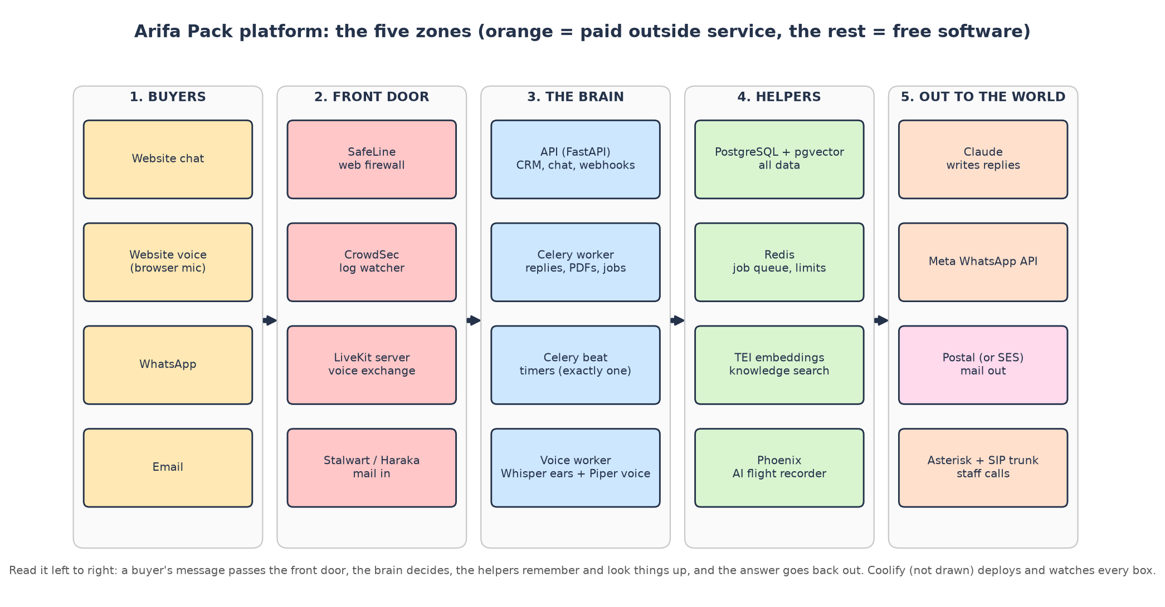
Measured on 14 November 2026 with 10 fake users on a test PC (i5-13400F, 16 threads, 15.8 GB RAM, RTX 5060 8 GB). Branch v1-11nov-work-and-architecture-guide. No platform source code was changed.

How to read this guide (2 minutes)
This guide replaces the pile of files in resource-usage-bench/docs and results. You can read it from start to end like a story, or jump to a platform. Every number has a badge so you always know where it came from:
Badge | Meaning | Example
✅ Measured | We ran it and read the number off the machine | Stalwart stored 1,000 emails in 11 s
💲 Price | Copied from an official price page or the repo's own price documents | Deepgram $0.0092 a minute
🔢 Computed | Arithmetic on measured numbers and prices, by a script you can rerun | SafeLine on Fargate = $18.07/month
⚠️ Assumption | A planning rule we had to choose; it is stated and easy to change | 1 user a day = 10 AI turns
❓ Not tested | We did not run it, so we say so instead of guessing | Pipecat, ALTCHA

📚 The guide in one breath
Your platform is a sales robot with a CRM. Buyers talk to it by website chat, website voice, WhatsApp and email.
It needs about 20 pieces of software to work. Most are free (we ran them all). A few are paid outside services that cannot be replaced for free: Claude (the brain that writes replies), Meta WhatsApp and the phone network.
On a single Namecheap dedicated server (64 GB) managed by Coolify, the free parts fit with lots of room (≈ 16 GB needed). Total cost at 50 users a day: about $290-307 a month, against about $914 a month for the AWS plan with every paid service (chapter 8).
Two catches: Namecheap's servers are in Phoenix, USA (the plan wants data in the UAE) and they have no GPU, so free speech-to-text cannot run there live.

1. The story: one buyer, start to finish
Meet Ahmed, who buys food containers for a restaurant group in Dubai (this is SRS scenario 1). Here is what each free platform does while Ahmed talks to Arifa Pack:
Step | What Ahmed sees | Who does the work (free unless marked)
1 | Opens the website and presses Enter the factory | Next.js website (on Vercel in the plan) + LiveKit opens a voice line
2 | Hears "This conversation is with our AI assistant…" | Piper speaks the recording notice
3 | Asks: "Do you have 750 ml containers with paper lids?" | faster-whisper turns his voice into text; Silero VAD + turn detector notice he stopped talking
4 | Gets a correct answer about the product | TEI + pgvector find the product facts; Claude (paid) writes the reply; price guard checks it
5 | Receives a Requirement Summary on WhatsApp | Celery worker builds and sends it through Meta WhatsApp (paid)
6 | Gets a quote PDF by email | Chromium draws the PDF; Postal (or SES) sends it
7 | Replies to the email | Stalwart receives the reply; the app attaches it to the deal
8 | (behind the scenes) Salesperson Sara is phoned when a quote waits too long | Celery beat timer + Asterisk + paid SIP trunk
9 | (behind the scenes) Every AI call is recorded | Phoenix keeps the trace in Postgres
10 | (behind the scenes) A hacker tries a trick URL | SafeLine answers 403; CrowdSec bans repeat offenders

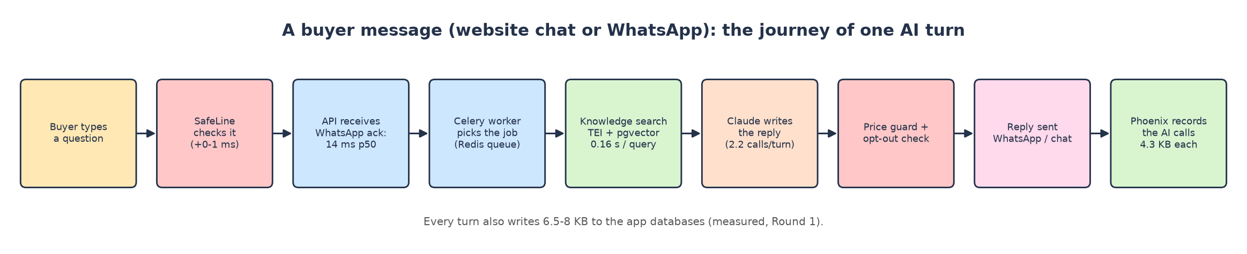
One AI turn, from message to reply, with the measured times.

2. How we tested (the bench)
Nothing in this guide is taken from a marketing page when it could be measured. We built a test bench on one PC and ran every platform from its official image or source code, with fake users:
- 10 fake users for 15 minutes: 5 website chatters, 4 WhatsApp buyers, 1 staff member clicking around the CRM.
- Fake vendors: a local fake Claude (answers after ~3 s), fake WhatsApp, fake email and storage. Nothing was sent outside the PC and nothing was paid.
- Watchers: docker stats every ~2 s for RAM, CPU, network and disk; database sizes before and after.
- Proof of work: every test counted real results (emails really stored, calls really answered, spans really saved, attacks really blocked), not just "it started".
Round | What ran | Load
R1 | The platform itself: API, Celery worker + beat, Postgres, Redis, TEI embeddings, Phoenix | 10 users, 15 min
R2 | Free voice chain: LiveKit + LiveKit Agents + Whisper + Piper; also the platform's own voice code | 1, 3, 10 simultaneous callers
R3 | Speech engines alone: faster-whisper, whisper.cpp, sherpa-onnx, Piper, Chatterbox | 10 clips at once, CPU and GPU
R4 | Embedding models: Qwen3-0.6B, BGE-M3, multilingual-e5-large | 38 hard questions in 4 languages
R5 | AI tracing: Phoenix, Langfuse, Opik | 1,000 AI spans each
R6 | Email: Haraka, Stalwart, Postal | 1,000 quote emails (72 KB each)
R7 | Phone: Asterisk, FreeSWITCH | 10 simultaneous SIP calls with audio
R8 | Security: CrowdSec, BunkerWeb, SafeLine | 100k log lines; 5-min load; 3 attacks

🧪 Honesty corner
We made mistakes on the bench and fixed them; they are all written down in the round files. Two that changed numbers:
1. Our RAM sampler counted every reading twice in rounds 5-8; all those numbers were recomputed (now correct here).
2. FreeSWITCH and Postal first looked broken; the cause was our own set-up (a missing space; a 127.0.0.1 bind). Both then passed.

3. Meet the team: every free platform, one card each
Each card answers the same questions: what it is, what it does for Arifa Pack, how it works, what it really said in the test, how much RAM / CPU / disk it ate, what the paid version costs, which alternatives exist, and the verdict.

3A. The core: the platform's own engine

🗄️ PostgreSQL 18 + pgvector (the database)
In one line: Stores everything: buyers, deals, quotes, messages, AI memory, vectors for knowledge search and AI traces.
🎭 Think of it as…
The filing cabinet of the whole company. Every drawer is a database (crm, automation, agents, cms, phoenix). pgvector adds a special drawer where facts are filed by meaning, not by name.

What it does for Arifa Pack
- Keeps the CRM: contacts, deals, quote versions, approvals, timeline (SRS §7A, §11).
- Keeps the outbox and job schedule so nothing is lost if a server restarts.
- Stores knowledge vectors (pgvector) and Phoenix's traces.
🔎 What we actually saw in the test (real output)
With 10 users: 397 MiB average, 430 MiB peak; 0.03 core average.
Each buyer turn adds 6.5-8 KB to the app databases; each AI call adds 4.3 KB of trace.
Postgres connections after load: 106 at default settings (the default limit is 100!).

Its appetite (measured)
What | Value
RAM idle → with 10 users | 194 MiB → 397 MiB avg / 430 MiB peak ✅
CPU | 0.03 core avg, 0.37 peak ✅
Disk | image 631 MB ✅; grows ≈ 17 KB per AI turn incl. traces ✅ (≈ 0.26 GB/month at 50 users a day 🔢)
Licence | PostgreSQL Licence (open source)

Free vs paid
- Paid version in the plan: AWS RDS PostgreSQL Multi-AZ: $139/month (Light) → $312/month (Normal) 💲.
- Free version: the same PostgreSQL in a container on your own server: $0 software, uses ≈ 0.4 GB RAM.

Alternatives
Option | Type | Price / footprint | Verdict
Aurora Serverless v2 | paid (AWS) | $231 / $450 / $900 a month 💲 | dearest
RDS Multi-AZ (plan) | paid (AWS) | $139 / $312 / $343 💲 | standby takes over in ~1 min
RDS single zone | paid (AWS) | $69 / $69 / $83 💲 | staging only
PostgreSQL on your server | free | 0.4 GB RAM ✅ | you do the backups

🎉 Fun fact
The busiest table is not the deals table: it is scheduled_jobs (≈ 1.7 rows per buyer turn). And nothing ever deletes it (problem 11 in chapter 6).

🏁 Verdict
Keep PostgreSQL. On your own server it is free and tiny at your volume; just raise max_connections or lower the pool sizes, and set up off-site backups.

📌 Redis (job queue and limits)
In one line: A very fast memory store used as Celery's job queue, rate limits, daily spend caps and kill switches.
🎭 Think of it as…
The sticky-note board by the door: "job #123 waiting", "this buyer sent 5 messages this minute". Quick to read, quick to wipe.

What it does for Arifa Pack
- Carries the jobs from the API to the Celery worker (send reply, build PDF, follow-up).
- Holds counters for rate limits and AI spend caps; set to noeviction so jobs are never thrown away.

Its appetite (measured)
What | Value
RAM idle → with 10 users | 10 MiB → 10 MiB avg / 12 MiB peak; only 2 MB of data ✅
CPU | < 0.01 core ✅
Disk | image 204 MB (redis:8.2) ✅; no persistent growth

Free vs paid
- Paid version: AWS ElastiCache, 2 nodes: $29 / $58 / $116 a month 💲 (Valkey 20 % cheaper).
- Free version: one container, ≈ 12 MB RAM.
🏁 Verdict
Free Redis (or Valkey, which you already use locally) is more than enough. It is the smallest thing on the server.

🛎️ The API (FastAPI on uvicorn)
In one line: The platform's front desk: CRM screens, website chat, WhatsApp/email webhooks, staff login.
🎭 Think of it as…
The receptionist: answers instantly, writes the request on a sticky note (Redis) for the back office, and never makes a buyer wait for the slow work.

What it does for Arifa Pack
- Serves the CRM to staff and the chat to website visitors.
- Receives WhatsApp and email webhooks and acknowledges them in milliseconds.
- Checks staff logins with password + authenticator code.
🔎 What we actually saw in the test (real output)
WhatsApp webhook answered in 14 ms (p50), CRM screens in 5-11 ms.
Website reply 5.1 s p50: that includes the fake Claude's ~3 s thinking time.

Its appetite (measured)
What | Value
RAM idle → with 10 users | 350 MiB → 583 MiB avg / 817 MiB peak ✅
CPU | 0.14 core avg, 4.9 cores in short peaks ✅
Disk | inside the app image (2.68 GB, with Chromium) ✅

🏁 Verdict
It is your own code, so it is always free. Runs comfortably in < 1 GB.

🧑‍💼 Celery worker + Celery beat (the back office)
In one line: The worker does the slow jobs (AI replies for WhatsApp/email, PDFs, follow-ups); beat is the one clock that starts timed jobs.
🎭 Think of it as…
The back-office clerks (worker) and the office clock on the wall (beat). There must be exactly one clock, or every reminder would ring twice.

What it does for Arifa Pack
- Writes WhatsApp and email replies with Claude, builds quote PDFs, sends follow-ups (SRS §16).
- Runs the approval ladder: WhatsApp at 30 min, alert call at 1 h, manager at 2 h (SRS §11.3).
🔎 What we actually saw in the test (real output)
Same traffic, same reply times with 3 clerks as with the default 10, but 1.7 GB less RAM.

Its appetite (measured)
What | Value
Worker, 10 children (default) | 0.72 GiB fresh → 2.55 / 2.60 GiB with 10 users ✅
Worker, 3 children | 0.86 → 0.89 / 0.90 GiB ✅
Beat | 38 MiB → 73 / 85 MiB; 0.012 core ✅

Free vs paid
- Free software. On AWS Fargate it is part of the $150/month server line 💲.
🎉 Fun fact
One quote PDF is only 52 KB (the draft guessed 200 KB).

🏁 Verdict
Run the worker with 3 children (KX_APP_WORKER_CONCURRENCY=3) and exactly one beat.

🧠 Claude (paid; the only brain)
In one line: The AI that reads the buyer's message and the rules and writes the reply. Sonnet for money turns, Haiku for the rest.
🎭 Think of it as…
A brilliant consultant on the phone. Your server dials, explains the situation (~20 KB of notes), and writes down the answer. You pay per call.

What it does for Arifa Pack
- Writes every AI reply on every channel; the backend still builds every price (SRS §11.1).
🔎 What we actually saw in the test (real output)
2.2 model calls per buyer turn; 19.4 KB sent and 1.1 KB received per turn.
⚠️ Every Sonnet call failed before leaving the server (problem 1): pricing turns did not work.

Its appetite (measured)
What | Value
On your server | almost nothing: it is an outside service ✅
Network | 19.4 KB up per turn ✅ → 0.29 GB/month at 50 users a day 🔢

Free vs paid
- Price: ≈ $0.0035 per AI turn (Sonnet on 40 % money turns + Haiku): $49 / $228 / $735 a month 💲.
- No free version was tested. It stays paid in every option in chapter 8.

Alternatives
Option | Type | Price / footprint | Verdict
Claude Sonnet every turn | paid | $113 / $526 / $1,701 💲 | strongest, dearest
Gemini 3.8 Flash | paid | $98 / $373 / $1,156 💲 | backup only if it passes the tests
Claude Haiku every turn | paid | $6 / $28 / $91 💲 | cheap; price turns not proven
Sonnet + Haiku mix (plan) | paid | $49 / $228 / $735 💲 | recommended

🏁 Verdict
Stays paid. Fix problem 1 first, otherwise money turns fail.

📚 Knowledge search: TEI + an embedding model
In one line: Turns product text and buyer questions into lists of 1,024 numbers so the AI can find the right fact in any language.
🎭 Think of it as…
A librarian who reads every language. You publish a catalogue; she files each paragraph by meaning. A buyer asks in Arabic; she walks straight to the right English shelf.

What it does for Arifa Pack
- Every AI answer first searches the product knowledge.
- Every CMS publish re-indexes the knowledge (SRS §7).
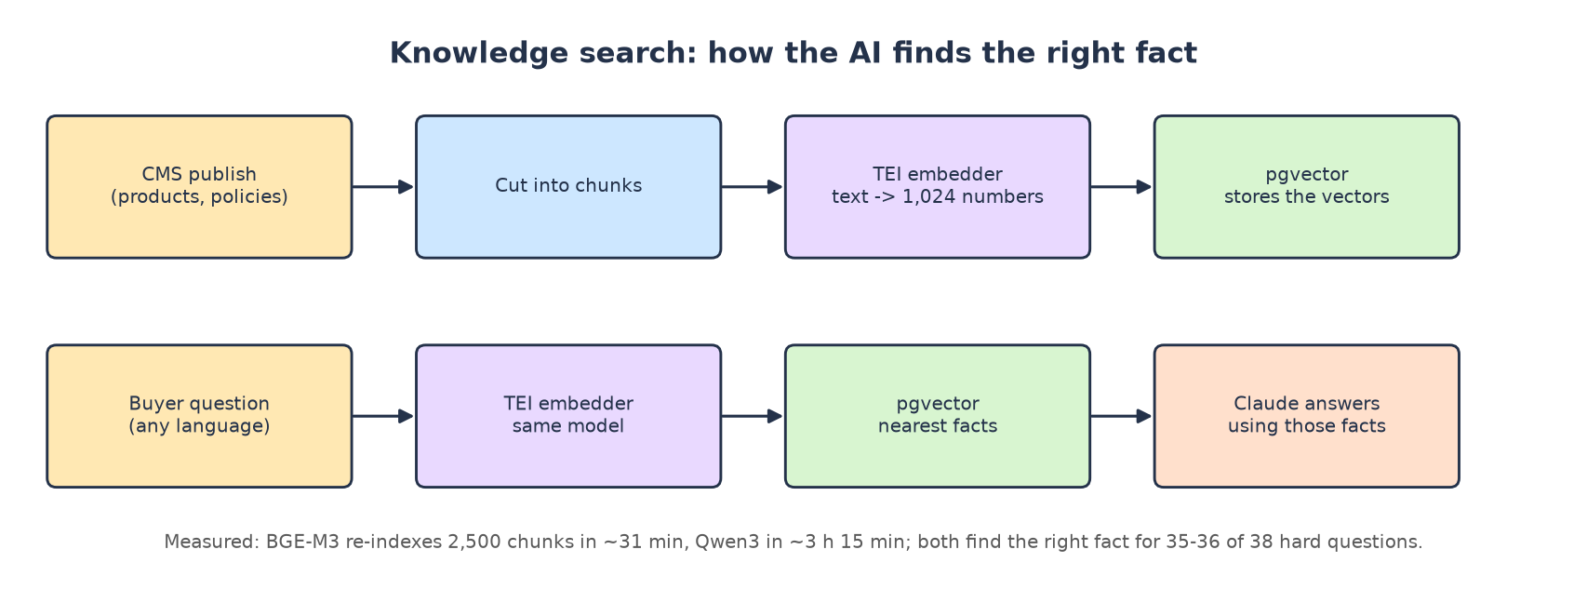
🔎 What we actually saw in the test (real output)
Hard test, 38 questions in en / ar / hi / zh with look-alike facts: BGE-M3 36/38, Qwen3 35/38, e5 35/38.
Example miss (all models): the Chinese "可以放进烤箱吗" (can it go in the oven?) found the paper-lid fact first, the oven fact second (score gap 0.016).
10 questions at the same moment: Qwen3 worst 1.93 s (the app gives up at 2 s); BGE-M3 worst 0.42 s.

Its appetite (measured)
What | Value
Qwen3-0.6B (today's default) | 2.82 GiB idle / 3.10 GiB peak; 4.7 s per chunk; disk 1.2 GB ✅
BGE-M3 | 4.74 / 4.83 GiB; 0.75 s per chunk; disk 2.3 GB ✅
multilingual-e5-large | 4.69 / 4.76 GiB; 0.88 s per chunk; reads only 512 tokens ✅
Re-index 2,500 chunks | Qwen3 ≈ 3 h 15 min; BGE-M3 ≈ 31 min; e5 ≈ 37 min ✅

Free vs paid
- The plan already self-hosts Qwen3 on AWS: $44/month (1 vCPU + 4 GB) 💲. BGE-M3 needs 8 GB: $57.82 🔢.
- Paid alternative: Gemini Embedding 2, $0.28 / $1.30 / $4.20 a month 💲, but buyer questions leave the UAE.
- On your own server: $0, only RAM.

Alternatives
Option | Type | Price / footprint | Verdict
Qwen3-Embedding-0.6B | free | 2.8 GiB RAM ✅ | smallest; slow re-index
BAAI/bge-m3 | free | 4.7 GiB RAM ✅ | best speed, same quality
multilingual-e5-large | free | 4.7 GiB RAM ✅ | 512-token limit
all-MiniLM-L6-v2 | free | small | English only: out
Gemini Embedding 2 | paid API | $0.28-4.20/month 💲 | data leaves the UAE

🏁 Verdict
On a 64 GB server, BGE-M3: same answers, 6× faster indexing, safe under the 2-second limit. Switching needs a small code change and a full re-index.

✈️ Arize Phoenix (AI tracing)
In one line: Records every AI call (prompt, reply, tools, time) so staff can see why the AI said something.
🎭 Think of it as…
The black-box flight recorder. Nobody reads it on a good day; on a bad day it explains everything.

What it does for Arifa Pack
- Audit trail of AI answers; keeps prices and chats inside your own database.
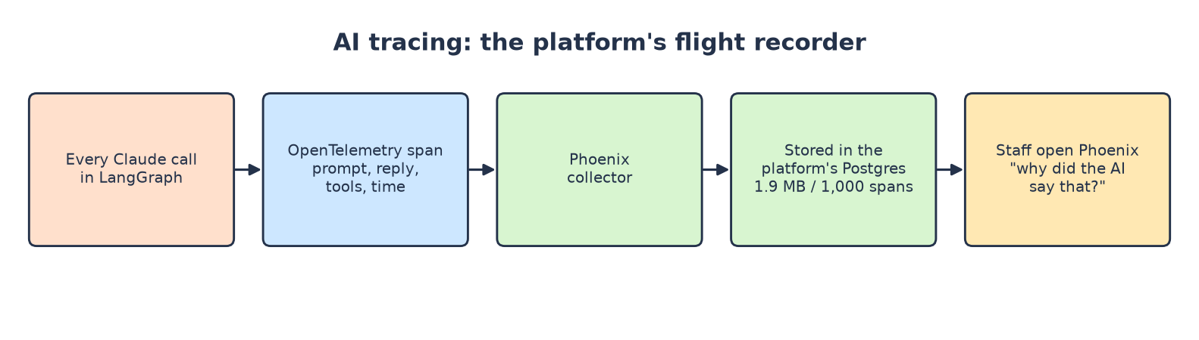
🔎 What we actually saw in the test (real output)
Received 1,000 spans and stored 1,000 (the spans table went from 1,485 to 2,485).
Disk grew 1.9 MB per 1,000 spans; Langfuse needed 29.8 MB and Opik 98.3 MB for the same spans.

Its appetite (measured)
What | Value
Phoenix | 0.48 GB idle → 0.50 GB peak; 0.05 core; 1 container ✅
Langfuse v4 (self-hosted) | 2.49 GB idle; 7 containers incl. ClickHouse; 29.8 MB / 1,000 spans ✅
Opik (self-hosted) | 2.61 GB idle → 3.24 GB peak; 8 containers; 98.3 MB / 1,000 spans ✅

Free vs paid
- Paid version: Langfuse Cloud Core $29 / $47 / $105 a month; Pro $199+ 💲.
- Plan: Phoenix self-hosted, $19/month on AWS 💲; on your own server ≈ 0.5 GB RAM.
🎉 Fun fact
Phoenix wrote zero bytes when idle; Langfuse and Opik wrote 19-30 MB in 2.5 minutes with no traffic at all.

🏁 Verdict
Keep Phoenix. Lightest by far (a fifth of the RAM, 1/15 to 1/50 of the disk).

🖨️ Headless Chromium (quote PDFs)
In one line: A browser without a screen that "prints" the HTML quote, with Arabic shaping, into a PDF.
🎭 Think of it as…
The office printer that also reads Arabic right-to-left properly.

What it does for Arifa Pack
- Draws every quote PDF and Requirement Summary (SRS §11.2).

Its appetite (measured)
What | Value
Size of one quote PDF | 52 KB ✅
RAM / CPU | inside the worker's numbers (not isolated)
Disk | part of the 2.68 GB app image ✅

🏁 Verdict
Free, already inside the app image.

3B. The voice team
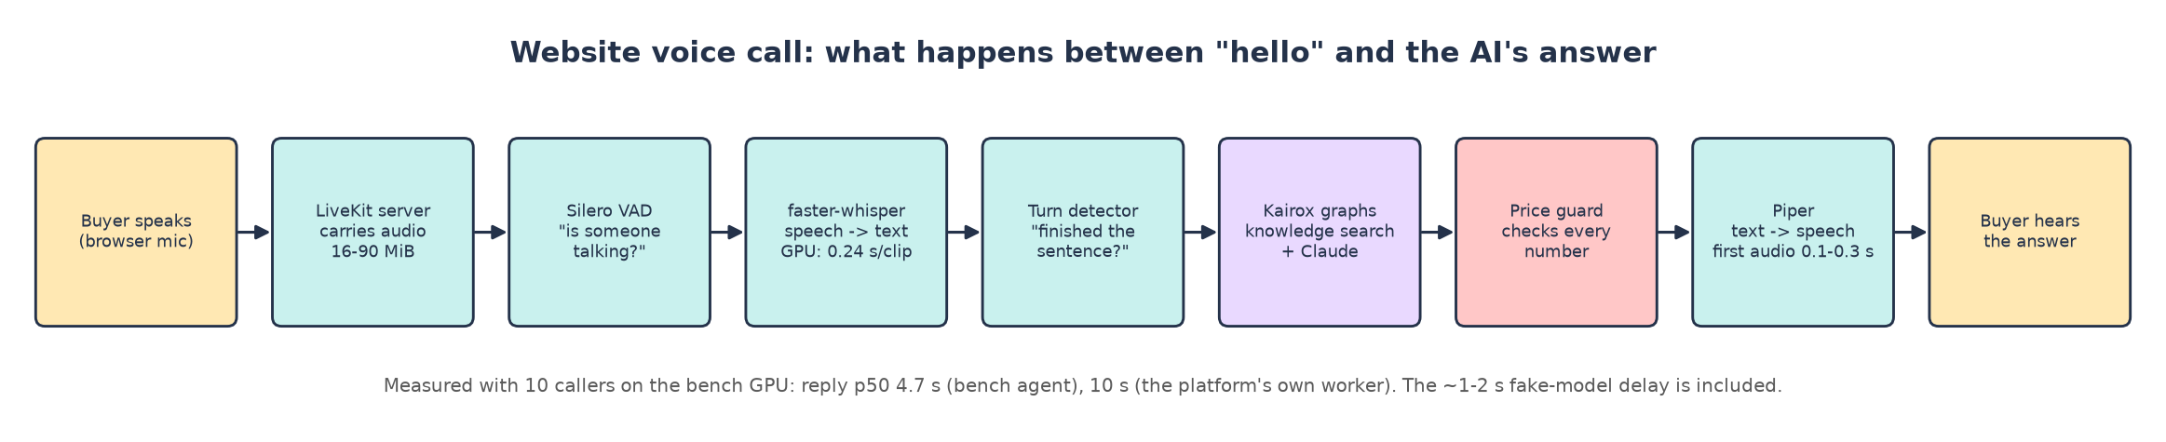
A website voice call, step by step, with measured times.

📞 LiveKit server + LiveKit Agents (voice exchange)
In one line: LiveKit server carries live audio between the browser and the AI; LiveKit Agents is the framework your voice worker is built on.
🎭 Think of it as…
The telephone exchange: it connects the caller to the right agent and carries the sound both ways.

What it does for Arifa Pack
- Every website voice call (SRS §6 step 1, §19).
- Includes Silero VAD (hears when someone talks) and the turn detector (guesses when they finished).
🔎 What we actually saw in the test (real output)
The LiveKit server itself used only 16-90 MiB with 10 callers.
The platform's own voice worker answered 10 of 10 calls, 29 of 40 turns, reply p50 10 s (after two bench fixes).
Bandwidth: 0.3-1.7 MB per call-minute at the server; the caller's leg 0.15-0.85 MB.

Its appetite (measured)
What | Value
LiveKit server | 16-90 MiB, ≤ 1 core; image 133 MB (built from source) ✅
Voice worker (platform code) | 1.41 GiB idle (4 warm processes) → 4.21 GiB, 10 cores peak with 10 calls ✅

Free vs paid
- Paid version: LiveKit Cloud Ship, $50/month incl. 5,000 agent minutes 💲.
- Free: self-host the server; tiny.

Alternatives
Option | Type | Price / footprint | Verdict
LiveKit Cloud Ship (plan) | paid | $50 / $75 / $250 💲 | easiest
Pipecat Cloud | paid | $0.01 / session-minute 💲 | agent rewrite needed
Self-hosted LiveKit | free | 16-90 MiB ✅ | tiny; needs open UDP ports
Pipecat (self-hosted) | free | ❓ not tested | agent rewrite

🏁 Verdict
Self-host the LiveKit server (it is tiny). But the platform's voice code has 3 bugs (problems 2-4) to fix first.

👂 faster-whisper (speech-to-text)
In one line: OpenAI's Whisper large-v3-turbo model, made faster (CTranslate2). Turns speech into text.
🎭 Think of it as…
The ears. On a GPU they are sharp and instant; on a CPU they are sharp but painfully slow.

What it does for Arifa Pack
- Understands what the caller says in the visitor's language (SRS §6 step 3).
🔎 What we actually saw in the test (real output)
SAID: "Our aluminium container holds seven hundred and fifty millilitres and comes with a paper lid."
HEARD: "Our aluminium container holds 750 milliliters and comes with a paper lid." ✅ perfect
SAID (Arabic, same sentence):
حاوية الألمنيوم لدينا تتسع لسبعمائة وخمسين مليلترا وتأتي مع غطاء ورقي.
HEARD (Arabic): the number word "seven hundred" came out split in two; every other word matched; meaning kept:
حاوية الألمنيوم لدينا تتسع لسبع ماء وخمسين مليلترا وتأتي مع غطاء ورقي.
SAID (zh): "我们的铝箔餐盒容量为七百五十毫升，配有纸盖。"
HEARD (zh): "我们的铝博餐和容量为750毫升配有纸杆" ❌ product words wrong

Its appetite (measured)
What | Value
GPU (float16) | 0.24 s per clip; 10 clips (59 s of audio) in 2.7 s; ≈ 3.5 GB VRAM ✅
CPU (int8, 16 threads) | 5.5 s per clip; 10 clips in 39.5 s; 4.3 GB RAM ✅
Live voice on CPU | one caller waited 12.8 s; 10 callers got 0 of 40 replies ✅
Model on disk | 1.62 GB ✅
Licence | MIT (repo)

Free vs paid
- Paid version: Deepgram Nova-3 Multilingual, $0.0092 a minute: $14 / $69 / $230 a month 💲 (no Sinhala).
- Free version needs a GPU. Namecheap sells none; the cheapest UAE GPU on AWS is g6.xlarge, $721.42/month 💲.

Alternatives
Option | Type | Price / footprint | Verdict
Deepgram Nova-3 (plan) | paid | $0.0092/min 💲 | ar, hi, ta, zh
ElevenLabs Scribe v2 | paid | $0.39/hour 💲 | cheaper
Soniox | paid | $0.12/hour 💲 | backup
faster-whisper GPU | free | 3.5 GB VRAM ✅ | rank 1 free, GPU only
whisper.cpp (CPU) | free | 0.6-0.8 GB RAM ✅ | 2× slower than real time
sherpa-onnx (CPU) | free | up to 7.2 GB RAM ✅ | not live

🎉 Fun fact
On the GPU it transcribed 59 seconds of speech in 2.7 seconds: 22× faster than people talk.

🏁 Verdict
Best free ears, but only with a GPU. Without a GPU, keep Deepgram.

🗣️ Piper (text-to-speech)
In one line: A small, fast neural voice engine; one 63 MB file per voice.
🎭 Think of it as…
The voice: quick, clear, runs on any CPU. Like a good radio announcer who never needs a coffee break.

What it does for Arifa Pack
- Speaks the recording notice and every AI answer on a voice call.
🔎 What we actually saw in the test (real output)
First audio after 0.11-0.29 s; 157 s of speech made in 4.3 s with 10 jobs at once.
Arabic, English, Hindi, Chinese voices worked; Tamil and Sinhala voices do not exist in Piper.

Its appetite (measured)
What | Value
RAM | 0.40 GB (4 voices loaded) → 2.07 GB with 10 jobs ✅
CPU | 0.43 core per voice speaking at the same time ✅
Disk | 63 MB per voice ✅
Licence | GPL-3.0

Free vs paid
- Paid version: ElevenLabs Flash, $0.04 per 1,000 characters: $27 / $135 / $450 a month 💲.
- Free: runs on the CPU of your server: no GPU needed. On AWS Fargate: $23.43 (1 voice at once) to $374.93 (10 at once) 🔢.

Alternatives
Option | Type | Price / footprint | Verdict
ElevenLabs Flash (plan) | paid | $0.04 / 1k chars 💲 | best quality
Google Chirp 3 HD | paid | 1M chars free, then $30/1M 💲 | backup
Piper | free | 0.4-2.1 GB RAM, CPU ✅ | rank 1 free
Chatterbox | free | 4 GB VRAM, 5-11 s first audio ✅ | too slow live

🏁 Verdict
Piper is the free voice that works on a plain server. Gap: no Tamil or Sinhala (SRS §6 step 3 asks for both).

3C. The email team
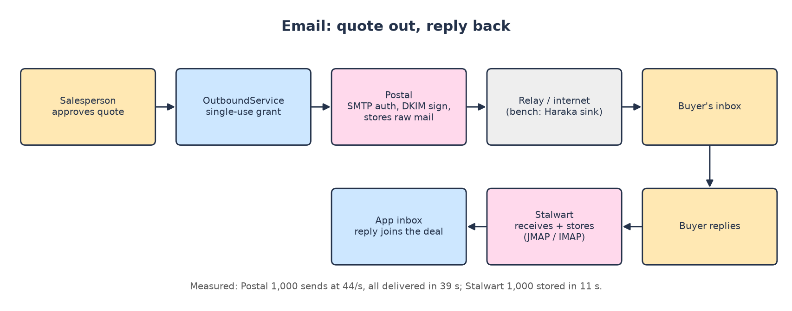

📮 Postal (sending)
In one line: A complete mail-sending platform: SMTP login, DKIM signing, queues, delivery tracking (Ruby + MariaDB).
🎭 Think of it as…
Your own post office: stamps each letter (DKIM), keeps a copy, delivers it, and records "delivered".

What it does for Arifa Pack
- Sends quote emails with PDFs from one company address (SRS §11.4, §19).
🔎 What we actually saw in the test (real output)
250 2.0.0 Message queued for every email; Postal's own table: Sent 1000.
Delivery log: "Message for buyer@bench.test accepted by 172.23.0.3:2525 (haraka)".

Its appetite (measured)
What | Value
RAM idle → peak | 455 MB (4 containers) → 652 MB ✅
CPU | 0.71 core avg, 1.32 peak ✅
Speed | 1,000 emails accepted at 44 a second; all delivered in 39 s ✅
Disk | image 1.9 GB + MariaDB 470 MB; database grows 97 MB per 1,000 emails ✅
Licence | MIT

Free vs paid
- Paid version: Amazon SES ($0.16 per 1,000) + Postmark Pro ($16.50/month for replies): $17 / $19 / $22 💲.
- Free: $0 software, ≈ 0.65 GB RAM. ⚠️ Inbox delivery from your own server's IP could not be tested locally.

Alternatives
Option | Type | Price / footprint | Verdict
Postmark Pro | paid | $16.50 / 10k 💲 | simple
SES + Postmark (plan) | paid | $17-22 💲 | recommended
Gmail API (salesperson's mailbox) | paid seats | Workspace seat 💲 | v2 route
Postal | free | 0.65 GB ✅ | rank 1 free sender

🎉 Fun fact
Its web screen stayed silent for 10 minutes in our first try: it only listens on 127.0.0.1 unless you change one setting.

🏁 Verdict
Works very well. But SES + Postmark costs only ~$17/month and has trusted sending IPs: keep it unless you want everything in-house.

📬 Stalwart (mail server and mailbox)
In one line: A modern all-in-one mail server written in Rust: receives, stores, IMAP/JMAP, spam filter, DKIM.
🎭 Think of it as…
The company mailbox room: receives letters, files them, lets the app read them.

What it does for Arifa Pack
- Receives buyers' replies so they can be attached to the deal (SRS §19).
🔎 What we actually saw in the test (real output)
250 2.1.5 OK then 250 2.0.0 Message queued with id 4b9bc718aa00000.
Mailbox count over JMAP: 136 → 1,136 after the test (1,000 delivered).
With its default limits: 452 4.4.5 Rate limit exceeded, try again later. after 25 messages.

Its appetite (measured)
What | Value
RAM idle → peak | 85 MB → 228 MB ✅
CPU | 0.22 core avg ✅
Speed | 1,000 emails stored in 11 s (90 a second) ✅
Disk | image 469 MB; store grows ≈ 142 KB per 72 KB email ✅
Licence | AGPL-3.0

Free vs paid
- Replaces Postmark's inbound part (inside the $17-22 email line) 💲. Free: ≈ 0.23 GB RAM.
🎉 Fun fact
It starts in "bootstrap mode" with no email at all until you finish a 5-step set-up wizard in its web page.

🏁 Verdict
Rank 1 free mailbox. Note its default limit of 25 messages an hour per sender and recipient.

🚪 Haraka (fast mail receiver)
In one line: A lightweight SMTP server in Node.js with plugins.
🎭 Think of it as…
The mail slot in the door: very fast at taking letters in; what happens next depends on plugins.

What it does for Arifa Pack
- Can receive mail and hand it to the app; in the bench it was also the delivery sink for Postal.

Its appetite (measured)
What | Value
RAM idle → peak | 91 MB → 127 MB ✅
Speed | 1,000 emails in 8.4 s (119 a second), 0 errors ✅
Licence | MIT

🏁 Verdict
Rank 2: fastest and lightest, but storing mail needs extra plugins (not tested).

3D. The phone team
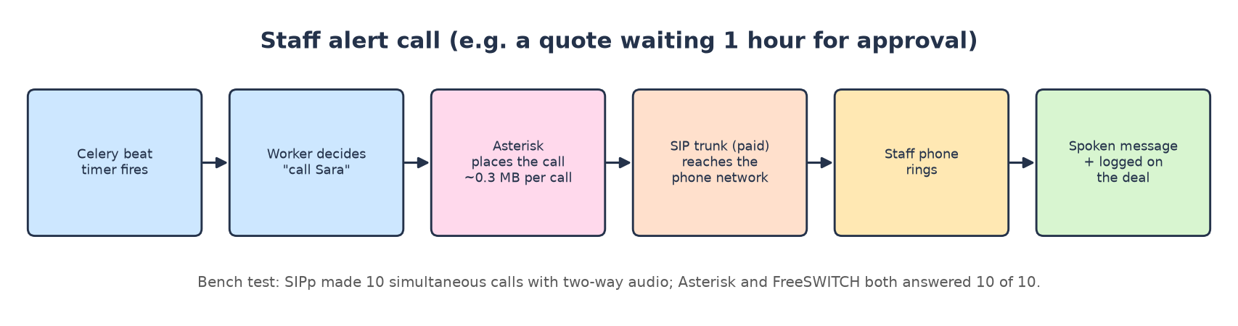

☎️ Asterisk 23.5 (phone switch)
In one line: The classic open-source phone system (PBX): places, answers and routes calls over SIP.
🎭 Think of it as…
The switchboard operator: plugs calls through, plays messages, records who called.

What it does for Arifa Pack
- Staff alert calls (approvals, change requests, below-minimum) and click-to-call (SRS §11.3, §14, §16).
🔎 What we actually saw in the test (real output)
SIPp statistics: SuccessfulCall 10, FailedCall 0, Retransmissions 0.

Its appetite (measured)
What | Value
RAM idle → with 10 calls | 49 MB → 52 MB (≈ 0.3 MB per call) ✅
CPU | 0.05 core avg, 0.17 peak ✅
Disk | image 485 MB ✅
Licence | GPL-2.0

Free vs paid
- Paid version: Telnyx, $0.25/min to UAE mobiles + $0.002/min Voice API: $10 / $46 / $152 💲 (Twilio backup $0.2995/min).
- Free: Asterisk replaces only the $0.002/min part. Reaching real phones still needs a paid SIP trunk.

Alternatives
Option | Type | Price / footprint | Verdict
Twilio | paid | $0.2995/min 💲 | backup, already built
Telnyx (plan) | paid | $0.25/min + $0.002 💲 | test du/Etisalat first
AWS End User Messaging | paid | $0.269/min 💲 | scripted only
Asterisk | free + SIP trunk | ≈ 50 MB ✅ | rank 1 free
FreeSWITCH | free + SIP trunk | ≈ 50 MB ✅ | rank 2

🏁 Verdict
Works perfectly and is tiny, but saves almost nothing: phone minutes are the real cost.

🔀 FreeSWITCH 1.11.3 (phone switch)
In one line: Another open-source telephony engine, popular for large call platforms.
🎭 Think of it as…
A switchboard with more buttons: powerful, but you must set it up carefully.

What it does for Arifa Pack
- Same job as Asterisk.
🔎 What we actually saw in the test (real output)
10 of 10 calls; audio checked both ways: 76 kB in, 70 kB echoed back.
By default it puts your public IP (found by STUN) in its call set-up; we had to set external_rtp_ip.

Its appetite (measured)
What | Value
RAM idle → with 10 calls | 41 MB → 50 MB ✅
Disk | image 352 MB ✅
Licence | MPL-1.1

🏁 Verdict
Rank 2: equally light, needed more set-up.

3E. The security team
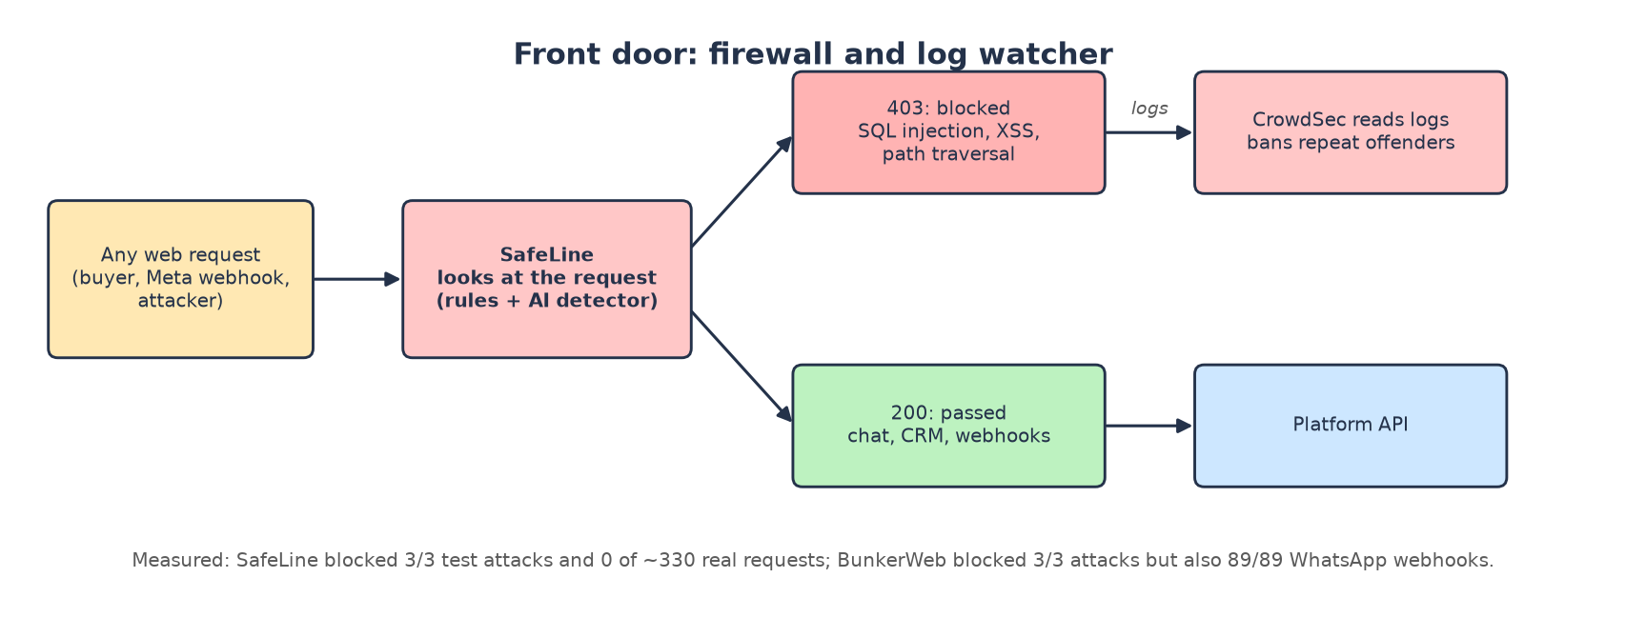

🛡️ SafeLine 9.2.7 (web firewall)
In one line: A web application firewall (reverse proxy) from Chaitin, with its own detection engine and web console.
🎭 Think of it as…
The security guard at the door who reads every visitor's note and turns away the ones carrying a crowbar.

What it does for Arifa Pack
- Protects the CRM, website chat and webhooks (SRS §22).
🔎 What we actually saw in the test (real output)
SQL injection ?id=1' OR '1'='1 → 403; script injection → 403; path traversal → 403.
Signed WhatsApp webhooks → 200 (86 of 86 passed); CRM screens unchanged (±1 ms).

Its appetite (measured)
What | Value
RAM idle → protecting | 1.62 GB (7 containers) → 1.60 GB ✅
CPU | 0.03 core avg ✅
Disk | 7 images ≈ 2.3 GB ✅
Licence | GPL-3.0

Free vs paid
- Paid version: AWS WAF basic + Cloudflare Turnstile: $10 / $11 / $14 💲; Cloudflare Business $250 💲.
- Free: $0 software, ≈ 1.6 GB RAM.

Alternatives
Option | Type | Price / footprint | Verdict
Cloudflare Business | paid | $250/month 💲 | top
AWS WAF + Bot Control + Turnstile | paid | $20-24 💲 | medium
AWS WAF basic + Turnstile (plan) | paid | $10-14 💲 | cheapest managed
SafeLine | free | 1.6 GB RAM ✅ | rank 1 free: works out of the box
BunkerWeb + OWASP CRS | free | 0.3-0.5 GB RAM ✅ | rank 2: blocks WhatsApp until fixed

🏁 Verdict
The free firewall to use: blocks attacks and lets your real traffic through with default settings.

🧱 BunkerWeb 1.6.6 with OWASP Core Rule Set
In one line: nginx + ModSecurity + the OWASP CRS (833 rules) in one container.
🎭 Think of it as…
A very strict guard who also stops the postman, because the word "profile" looks suspicious to him.

What it does for Arifa Pack
- Same job as SafeLine.
🔎 What we actually saw in the test (real output)
3 of 3 attacks → 403.
Signed WhatsApp webhook → 403. Its own log: [id "930120"] [msg "OS File Access Attempt"] matched .profile inside contacts[0].profile.name, a field every Meta webhook has.

Its appetite (measured)
What | Value
RAM idle → proxying | 290 MB → 472 MB ✅
Delay | +4-6 ms per CRM request ✅
Disk | image 1.68 GB ✅
Licence | AGPL-3.0

🏁 Verdict
Rank 2. Usable only after excluding rule 930120 for /webhooks/whatsapp.

📹 CrowdSec 1.7.3 (log watcher)
In one line: Reads web logs, spots attack patterns, and bans the attacking IP (with a shared community blocklist).
🎭 Think of it as…
The CCTV reviewer who watches the tapes and puts troublemakers' photos on the "do not admit" board.

What it does for Arifa Pack
- Adds a second layer: bans IPs that keep attacking, across all services.
🔎 What we actually saw in the test (real output)
Acquisition: file:/logs/access.log read 100.00k lines, parsed 100.00k, whitelisted 96.91k (private test IPs).

Its appetite (measured)
What | Value
RAM | 100 MB avg, 159 MB peak ✅
CPU | 0.91 core avg during a 100,000-line burst ✅
Speed | 100,000 lines in 39 s (2,564 a second) ✅
Licence | MIT

🏁 Verdict
Light and fast; a good extra layer next to SafeLine.

3F. The DevOps helper
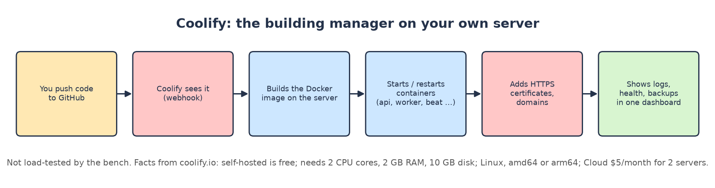

🏗️ Coolify (self-hosted PaaS)
In one line: An open-source "Heroku/Vercel on your own server": deploys Docker apps from Git, adds HTTPS, shows logs and health.
🎭 Think of it as…
The building manager: you hand over the plans (Git), and it builds, opens the doors (HTTPS), keeps the lights on and shows you the logbook.

What it does for Arifa Pack
- Deploys the API, worker, beat, voice worker and every free platform in this guide on one server.
- Gives you one dashboard instead of SSH and docker commands.

Its appetite (measured)
What | Value
Minimum (official docs) | 2 CPU cores, 2 GB RAM, 10 GB disk; Linux; amd64 or arm64 💲
Our test | ❓ not load-tested on the bench

Free vs paid
- Self-hosted: free forever, all features (coolify.io/pricing) 💲.
- Coolify Cloud: $5/month incl. 2 servers, +$3 per extra server 💲.
🏁 Verdict
Use self-hosted Coolify on the same server (≈ 2 GB of the 64 GB), or Cloud for $5 if you want its dashboard off the server.

4. Every field and its alternatives (from "Options by field")
The repo's Options by field.md lists a High / Medium / Low choice for each field with official prices. Here they are side by side with the free platform we measured. Prices: US$ a month at Light / Normal / Heavy 💲.
Field | High | Medium | Low / budget | Free platform measured ✅
AI brain | Sonnet every turn 113/526/1,701 | Gemini 3.8 Flash 98/373/1,156 | Haiku 6/28/91; mix 49/228/735 (plan) | none (stays paid)
Speech-to-text | Deepgram 14/69/230 | ElevenLabs Scribe 10/49/162 | Soniox 3/15/50 | faster-whisper (GPU only)
Text-to-speech | ElevenLabs Flash 27/135/450 | Google Chirp 3 HD 0/71/308 | Google Standard 0/0/29 | Piper (CPU)
Real-time voice | LiveKit Cloud 50/75/250 | Pipecat Cloud 15/75/250 | self-hosted LiveKit on AWS 134/267/534 | LiveKit server (90 MiB)
Alert calls | Twilio 12/55/181 | Telnyx 10/46/152 | AWS End User Msg 10/48/161 | Asterisk / FreeSWITCH + SIP trunk
WhatsApp | Twilio 56/359/1,243 | Telnyx 50/330/1,146 | Meta direct 26/213/756 | none (Meta only)
Email | Postmark Pro 16/20/66 | SES + Postmark 17/19/22 | SES + Mail Manager 50/51/55 | Postal + Stalwart
Servers | Fargate ARM 150/150/188 |  | EC2 t4g 177/177/239 | Namecheap + Coolify (ch. 7)
Database | Aurora 231/450/900 | RDS step 139/312/343 | RDS single zone 69/69/83 | PostgreSQL (0.4 GB)
Cache / queue | ElastiCache Redis 29/58/116 | Valkey 23/46/93 | Redis on Fargate 19/19/37 | Redis (12 MB)
Website + CRM | Vercel Pro 20/40/40 | Netlify 20 | Cloudflare Workers 5 | ❓ self-hosted Next.js not tested
Knowledge search | Qwen3 container 44 | BGE-M3 44 | e5-large 44; Gemini API 0.28-4.20 | BGE-M3 / Qwen3 / e5 (all tested)
AI tracing | Langfuse Pro 199/217/275 | Langfuse Core 29/47/105 | Phoenix 19 | Phoenix / Langfuse / Opik (all tested)
Monitoring | Datadog 93+ | Better Stack 64/64/154 | Grafana Cloud free 0 | ❓ not tested
Staff login | Auth0 35 | Cognito 0 | in-house 0 | in-house (your code)
Firewall + bots | Cloudflare Business 250 | AWS WAF + Bot Control 20-24 | AWS WAF + Turnstile 10-14 | SafeLine / BunkerWeb / CrowdSec
Background jobs | Celery + Beat 0 | Procrastinate 0 |  | Celery (your code)

Bold = the pick in the 11 Nov plan.

5. The source-code shelf (`resource-usage-bench/repos`)
We downloaded the source code of every platform we tested, at the version we ran when that version is tagged. You never need to open these folders to use the platforms; they are there so anyone can check exactly what was tested, read its licence, or rebuild it. They are ignored by git (not part of your project).
Folder | Version cloned | Licence (first line of its file) | Size | What it is
livekit-server | v1.13.11 | Apache-2.0 |  | LiveKit media server (voice exchange); built from this source for the voice test
livekit-agents | livekit-agents@1.8.10 | Apache-2.0 |  | LiveKit Agents framework the platform's voice worker uses; plugins built from it
asterisk | 23.5.0 | GNU GENERAL PUBLIC LICENSE | 59M | Asterisk phone switch
freeswitch | v1.11.3 | Format: http://www.debian.org/doc/packaging-m | 143M | FreeSWITCH phone engine
postal | 3.3.4 | Copyright 2017-2024 Krystal Hosting Ltd | 5.0M | Postal mail-sending platform
haraka | master | MIT License | 6.6M | Haraka SMTP receiver
stalwart | v1.1.0 | folder with AGPL-3.0-only.txt Apache-2.0.txt | 36M | Stalwart mail server
text-embeddings-inference | v1.8.3 | Apache License | 6.7M | Hugging Face TEI, the embedding server the app uses
FlagEmbedding | master | MIT License | 89M | BAAI's code behind the BGE-M3 model
phoenix | arize-phoenix-v21.1.0 | Elastic License 2.0 (ELv2) | 115M | Arize Phoenix AI tracing
langfuse | main | Copyright (c) 2023-2026 ClickHouse, Inc. | 99M | Langfuse AI tracing (alternative)
opik | 2.2.144-7455 | Copyright (c) Comet ML, Inc | 745M | Opik AI tracing (alternative)
bunkerweb | v1.6.6 | ### GNU AFFERO GENERAL PUBLIC LICENSE | 377M | BunkerWeb firewall
crowdsec | v1.7.3 | MIT License | 11M | CrowdSec log watcher
SafeLine | v9.2.7 | GNU GENERAL PUBLIC LICENSE | 17M | SafeLine firewall
coreruleset | v4.20.0 | Apache License | 6.3M | OWASP Core Rule Set used inside BunkerWeb
altcha | v3.6.0 | MIT License | 6.7M | ALTCHA bot challenge (not tested)
faster-whisper | v1.2.1 | MIT License | 43M | faster-whisper speech-to-text
whisper.cpp | master | MIT License | 55M | whisper.cpp speech-to-text (CPU)
whisper | main | MIT License | 18M | OpenAI's original Whisper
sherpa-onnx | master | Apache License | 53M | sherpa-onnx speech toolkit
piper1-gpl | v1.8.0 | GNU GENERAL PUBLIC LICENSE | 53M | Piper text-to-speech
chatterbox | master | MIT License | 3.5M | Chatterbox text-to-speech
pipecat | main | BSD 2-Clause License | 83M | Pipecat voice framework (not tested)
sipp | master | SIPp as a whole is licensed under the GNU Gen | 9.6M | SIPp, the call generator used for the phone test

6. Things that broke (and what to do)
Running the real code under load found problems in the platform itself. Nothing was changed in your code; each item says where to look.
# | Problem | Effect | Fix
1 | Every Claude Sonnet call fails (temperature=0.2 rejected) | Pricing / negotiation turns fail (HTTP 500) | kx/agents/models.py:35: drop the temperature for Sonnet
2 | kx voice cannot start a job (local function cannot be pickled) | No voice call is ever answered | Move the entry function to module level
3 | Voice session has no LLM, so LiveKit skips every reply | Caller hears the notice, then silence | Pass any LLM object to AgentSession
4 | Each voice call builds the whole app at its start | First turns lost under 10 calls | Build in prewarm_fnc
5 | Unparseable WhatsApp number → HTTP 500 | Meta keeps retrying | Log and acknowledge
6 | Heartbeat task fails every 30 s | Queue metrics never sent | kx/core/metrics.py:46
7 | Embedding timeout 2 s; re-index requests take ≈ 26 s on CPU | Catalogue re-index fails | Longer timeout for indexing
8 | 106 Postgres connections at defaults (limit 100) | "Too many clients" | Worker concurrency 3 / smaller pools
9 | Worker needs 2.6 GiB at default; AWS plan gives 2 GB | Out-of-memory restarts on AWS | Concurrency 3 (0.9 GiB)
10 | Pinned TEI cpu-1.7.2 crashes with Qwen3 | Knowledge search does not start | Use cpu-1.8 with --auto-truncate
11 | Some tables are never cleaned up | scheduled_jobs grows forever | Add a retention job
12 | BunkerWeb default rules block every WhatsApp webhook | WhatsApp silently stops | Exclude CRS rule 930120, or use SafeLine

7. Buying the server (Namecheap + Coolify)

How big must it be?
Add up the measured peak RAM of everything that would run on one server (paid speech vendors, everything else self-hosted): about 15.75 GiB.
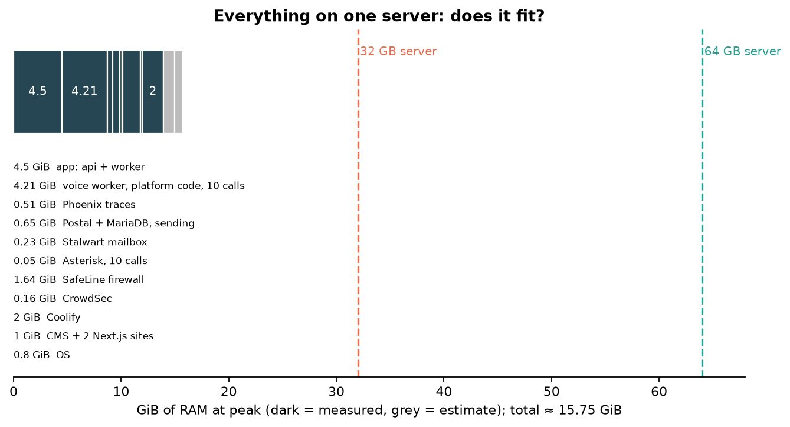
Part | Peak RAM (GiB) | Source
app: api + worker (concurrency 3) + beat + Postgres + Redis + Qwen3 embeddings (R1) | 4.5 | ✅ measured
voice worker, platform code, 10 calls (R2b) | 4.21 | ✅ measured
Phoenix traces (R5) | 0.51 | ✅ measured
Postal + MariaDB, sending (R6) | 0.65 | ✅ measured
Stalwart mailbox (R6) | 0.23 | ✅ measured
Asterisk, 10 calls (R7) | 0.05 | ✅ measured
SafeLine firewall (R8) | 1.64 | ✅ measured
CrowdSec (R8) | 0.16 | ✅ measured
Coolify (its docs: minimum 2 GB) | 2 | ✅ measured
CMS + 2 Next.js sites (not measured, estimate) | 1 | ⚠️ estimate
OS (not measured, estimate) | 0.8 | ⚠️ estimate
Total | 15.75

💡 What this means
32 GB fits with double headroom; 64 GB leaves room for BGE-M3 (+1.9 GB), growth and a second copy of the app during deploys, and costs only a few dollars more.
CPU: short bursts are what matter: the voice worker reached 10 cores with 10 simultaneous calls, and re-indexing takes every core it can get. A 6-core / 12-thread Xeon E-2236 is enough at 50-150 users a day, where the average number of simultaneous calls is well under one (≈ 1,600-4,800 voice minutes a month spread over 300 working hours, i.e. 10 hours × 30 days ⚠️ = 0.09-0.27 calls at once on average 🔢).
Disk: ≈ 0.26 / 0.51 / 0.77 GB a month of database growth at 50 / 100 / 150 users a day 🔢, plus ≈ 18 GB of images and models. 2 × 960 GB SSD is far more than enough; keep backups off the server.
Bandwidth: Namecheap's listing shows 100 TB a month on the E-2236 plans; you need well under 30 GB (voice is the biggest user: 0.15-0.85 MB per call-minute ✅).

Namecheap dedicated server plans (as indexed on 14 Nov 2026)
Namecheap blocks automated reading of its pages, so these list prices come from Namecheap's own configure pages as indexed by search engines on 14 Nov 2026. Prices on the same plan differed between pages (promotions and billing terms), so check the live configurator before buying.
Plan | List price, monthly term | Fits our stack?
Xeon E-2236 (6 cores / 12 threads), 32 GB, 2 x 480 GB SSD | $79.88 | yes, with less headroom
Xeon E-2236, 64 GB, 2 x 960 GB SSD (SATA) | $83.88 | recommended: 64 GB, 2 SSDs for a mirror
Xeon E-2236, 64 GB, 2 x 960 GB SSD (NVMe) | $94.88 | more than needed
Dual Xeon Silver 4208, 64 GB, 2 x 1 TB NVMe | $153.88 | more than needed
Dual Xeon Gold 5218, 128 GB, 4 x 1 TB NVMe | $229.88 | more than needed

⚠️ Read before you buy
Location: Namecheap says all its dedicated servers are in the phoenixNAP data centre in Phoenix, Arizona, USA. The 11 Nov plan keeps prices and chats in the UAE and needs Arifa's approval for each processor. Arifa must agree before customer data goes to a US server.
No GPU: no Namecheap GPU server was found, so the free speech-to-text (faster-whisper) cannot run live there. Keep Deepgram + ElevenLabs + LiveKit Cloud for voice, or rent a GPU elsewhere (cheapest UAE option found: AWS g6.xlarge, $721.42/month 💲).
One server = one point of failure. The AWS plan has two zones, automatic database failover and managed backups. A single dedicated server has none of that unless you add it (off-site backups are not priced here).

Coolify on top
- Install Coolify on the Namecheap server (needs 2 cores, 2 GB RAM, 10 GB disk) 💲.
- Point it at your GitHub repo; it builds the production Dockerfile image and runs api, worker, beat and voice.
- Add the free platforms as Docker services (PostgreSQL, Redis, TEI, Phoenix, SafeLine, CrowdSec, Postal, Stalwart, Asterisk).
- Self-hosted Coolify is free; Coolify Cloud is $5/month for 2 servers 💲.

8. Money: free vs paid, at 50 / 100 / 150 users a day
⚠️ The one assumption in this chapter
1 user a day = 1 buyer conversation of 10 AI turns. Voice minutes, WhatsApp messages, emails and staff-call minutes grow with AI turns at the same ratios as the repo's own "Light" level (per AI turn: 0.107 voice minutes, 0.279 WhatsApp messages, 0.143 emails out, 0.0026 call minutes).
With this rule, 50 users a day ≈ the plan's Light level (15,000 vs 14,000 AI turns a month). Change TURNS_PER_USER in scripts/users_per_day_costs.py and rerun to see other numbers.

Usage per month
 | 50 users / day | 100 users / day | 150 users / day
AI turns | 15,000 | 30,000 | 45,000
Voice minutes | 1,607 | 3,214 | 4,821
WhatsApp messages | 4,179 | 8,357 | 12,536
Emails out / in | 2,143 / 536 | 4,286 / 1,071 | 6,429 / 1,607
Staff call minutes | 39 | 77 | 116
Database growth 🔢 | 0.26 GB | 0.51 GB | 0.77 GB

Table 1: free platforms: full usage, measured
Platform | Job | RAM idle → peak ✅ | CPU ✅ | Disk ✅ | Result ✅ | Cost on your server
PostgreSQL + pgvector | all data | 194 → 430 MiB | 0.03 | 631 MB + 17 KB/turn | 106 conns at default | $0
Redis | queue, limits | 10 → 12 MiB | < 0.01 | 204 MB | 2 MB data | $0
API + worker (c=3) + beat | the app | ≈ 1.3 → 1.8 GiB | 0.2 | 2.68 GB image | webhook 14 ms | $0
TEI + BGE-M3 | knowledge search | 4.74 → 4.83 GiB | bursts | 2.3 GB | 36/38 hard Qs | $0
TEI + Qwen3 (default) | knowledge search | 2.82 → 3.10 GiB | bursts | 1.2 GB | 35/38 hard Qs | $0
Phoenix | AI traces | 0.48 → 0.51 GB | 0.05 | 1.9 MB / 1k spans | 1,000/1,000 stored | $0
LiveKit server | voice transport | 16 → 90 MiB | ≤ 1 | 133 MB | all calls carried | $0
Voice worker (platform) | voice AI | 1.41 → 4.21 GiB | 10 peak | in app image | 10/10 calls | $0
faster-whisper (GPU) | speech → text | +0.16 GB RAM, 3.5 GB VRAM | 6-7 (10 at once) | 1.62 GB | RTF 0.04 | needs GPU
Piper | text → speech | 0.40 → 2.07 GB | 0.43 per voice | 63 MB / voice | RTF 0.03-0.05 | $0
Postal (+MariaDB) | send email | 455 → 652 MB | 0.71 | 2.4 GB + 97 MB/1k | 1,000 sent | $0
Stalwart | mailbox | 85 → 228 MB | 0.22 | 469 MB + 142 KB/mail | 1,000 stored | $0
Haraka | receive email | 91 → 127 MB | 0.18 | 329 MB | 1,000 in 8.4 s | $0
Asterisk | phone switch | 49 → 52 MB | 0.05 | 485 MB | 10/10 calls | $0 + minutes
FreeSWITCH | phone switch | 41 → 50 MB | 0.03 | 352 MB | 10/10 calls | $0 + minutes
SafeLine | firewall | 1.62 → 1.64 GB | 0.03 | 2.3 GB | 3/3 blocked, 0 false | $0
BunkerWeb | firewall | 0.29 → 0.47 GB | 0.05 | 1.68 GB | 3/3, blocks WhatsApp | $0
CrowdSec | log watcher | 100 → 159 MB | 0.91 (burst) | 476 MB | 100k lines / 39 s | $0
Langfuse | AI traces (alt) | 2.49 GB idle | 0.22 | ≈ 4.3 GB (7 images) + 29.8 MB/1k | 1,000 stored | $0
Opik | AI traces (alt) | 2.61 → 3.32 GB | 1.43 | ≈ 5.7 GB (8 images) + 98.3 MB/1k | 1,000 stored | $0
Coolify | DevOps | min 2 GB (docs) | min 2 cores | min 10 GB | ❓ not tested | $0 (Cloud $5)

Table 2: paid services: usage and price per month
Paid service | Unit price 💲 | 50 users / day 🔢 | 100 users / day 🔢 | 150 users / day 🔢
AI replies (Claude Sonnet + Haiku) | ≈ $0.0035 per AI turn | $52.50 | $105.00 | $157.50
WhatsApp (Meta) | Meta fees; 1,000 free service msgs / number | $29.34 | $79.43 | $129.52
speech-to-text (Deepgram) | $0.0092 / minute | $14.79 | $29.57 | $44.36
text-to-speech (ElevenLabs) | $0.04 / 1,000 characters | $28.93 | $57.86 | $86.79
voice transport (LiveKit Cloud Ship) | $50 incl. 5,000 min | $50.00 | $50.00 | $50.00
staff alert calls (Telnyx) | $0.25 / min + $0.002 | $10.65 | $20.27 | $29.93
email (SES + Postmark Pro) | $0.16 / 1,000 + $16.50 | $16.84 | $17.19 | $17.53
Total of paid services |  | $203.05 | $359.32 | $515.63

Table 3: the three ways to run it, per month
Option | What is self-hosted / what is paid | 50 users / day | 100 users / day | 150 users / day
A. The 11 Nov AWS plan | Everything managed on AWS in the UAE (2 zones, RDS, ElastiCache, Fargate, monitoring, support) + all paid services | $914.05 - $1,193.05 | $1,070.32 - $1,349.32 | $1,226.63 - $1,505.63
B. Namecheap + Coolify | One 64 GB server runs app, DB, Redis, embeddings, Phoenix, SafeLine, CrowdSec, Asterisk. Paid: Claude, WhatsApp, voice vendors, phone minutes, SES + Postmark, Vercel | $306.85 | $463.05 | $619.28
C. B + own email | Same as B, but Postal + Stalwart replace SES + Postmark | $290.01 | $445.86 | $601.75
Saving B vs A (low end) |  | $607.20 | $607.27 | $607.35

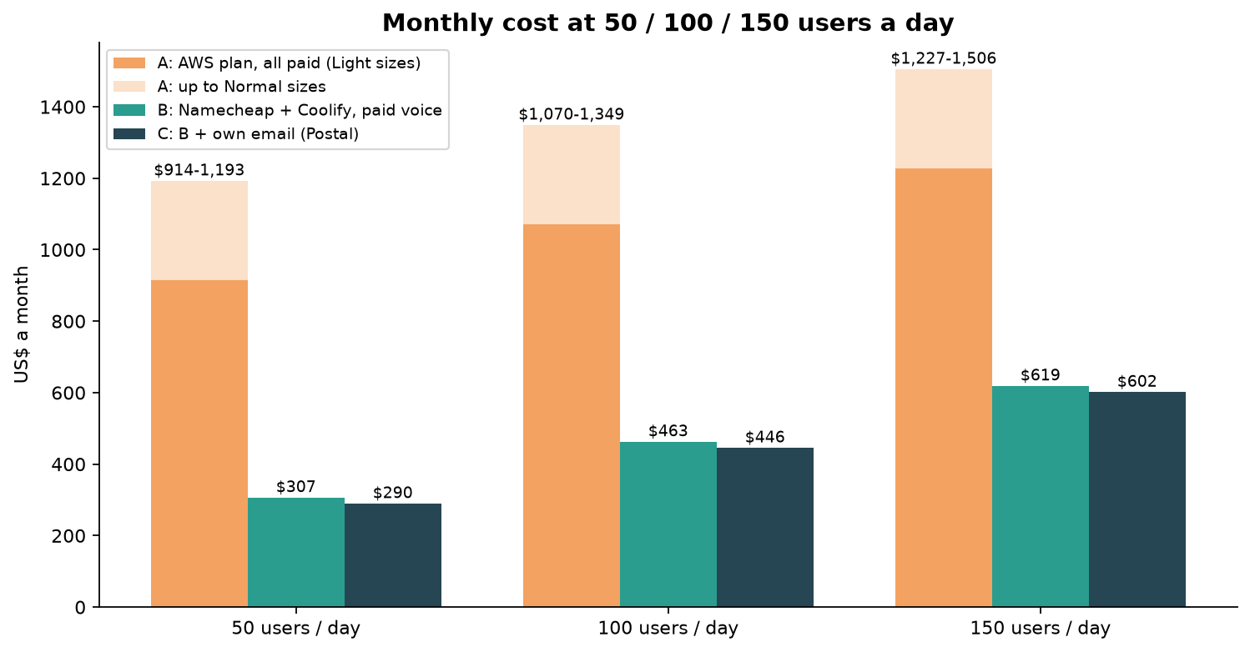
🧾 Inside option B at 100 users a day
Namecheap dedicated server: $83.88
Coolify (self-hosted): $0.00
AI replies (Claude Sonnet + Haiku): $105.00
WhatsApp (Meta): $79.43
speech-to-text (Deepgram): $29.57
text-to-speech (ElevenLabs): $57.86
voice transport (LiveKit Cloud Ship): $50.00
email (SES + Postmark Pro): $17.19
phone minutes (SIP trunk at Telnyx rates; Asterisk replaces only the Voice API part): $20.12
website + CRM (Vercel Pro): $20.00
Total: $463.05

Table 4: service by service, paid vs free
Service | Paid (plan) 💲 L / N / H | Free platform | Free cost | Saving per month L / N / H 🔢 | Verdict
Voice (STT + TTS + transport) | 91 / 279 / 930 | faster-whisper + Piper + LiveKit | GPU server $721 (AWS UAE) | -630 / -442 / +209 | paid wins unless Heavy
Text-to-speech only | 27 / 135 / 450 | Piper on CPU | $0 on your server | +27 / +135 / +450 on own server | free wins (no ta / si)
Alert calls | 10 / 46 / 152 | Asterisk | $0 + SIP minutes | ≈ +0.07 / +0.36 / +1.20 | no real saving
Email | 17 / 19 / 22 | Postal + Stalwart | $0 on your server | +17 / +19 / +22 | free works; delivery risk
Firewall | 10 / 11 / 14 | SafeLine | $0 on your server | +10 / +11 / +14 | free works
AI tracing | Langfuse Cloud 29 / 47 / 105 | Phoenix | $0 on your server | +29 / +47 / +105 | free wins
Knowledge search | plan container 44 | BGE-M3 / Qwen3 | $0 on your server | +44 | free wins
Database + cache | RDS + ElastiCache 168 / 370 / 459 | PostgreSQL + Redis | $0 on your server | +168 / +370 / +459 | free wins; you do backups
AI brain, WhatsApp | 49-735, 26-756 | none | — | 0 | stay paid

Note: "$0 on your server" means no extra cost on a server you already pay for. The server itself ($83.88/month) is counted once, in Table 3, not in each row here.
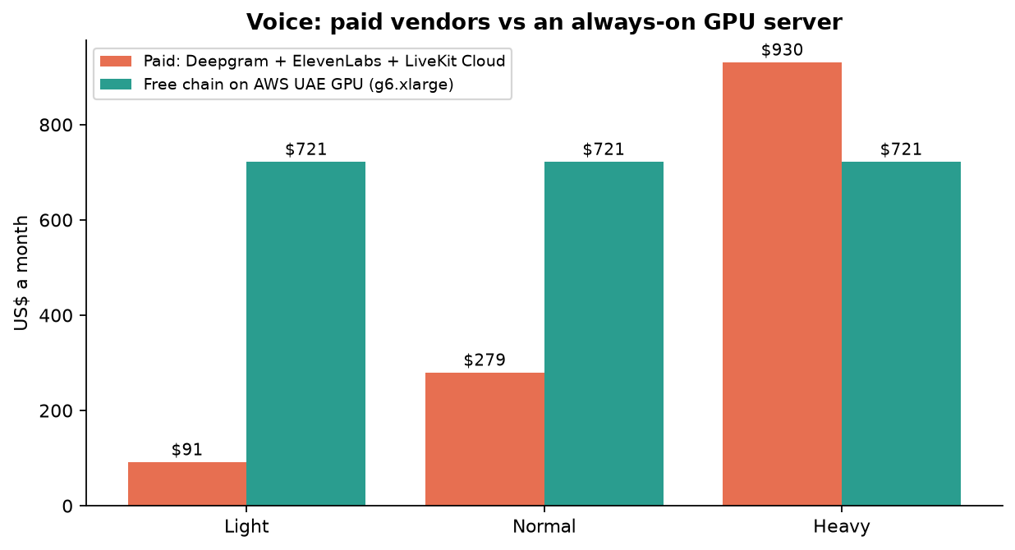
Voice is the one place where "free" needs expensive hardware.
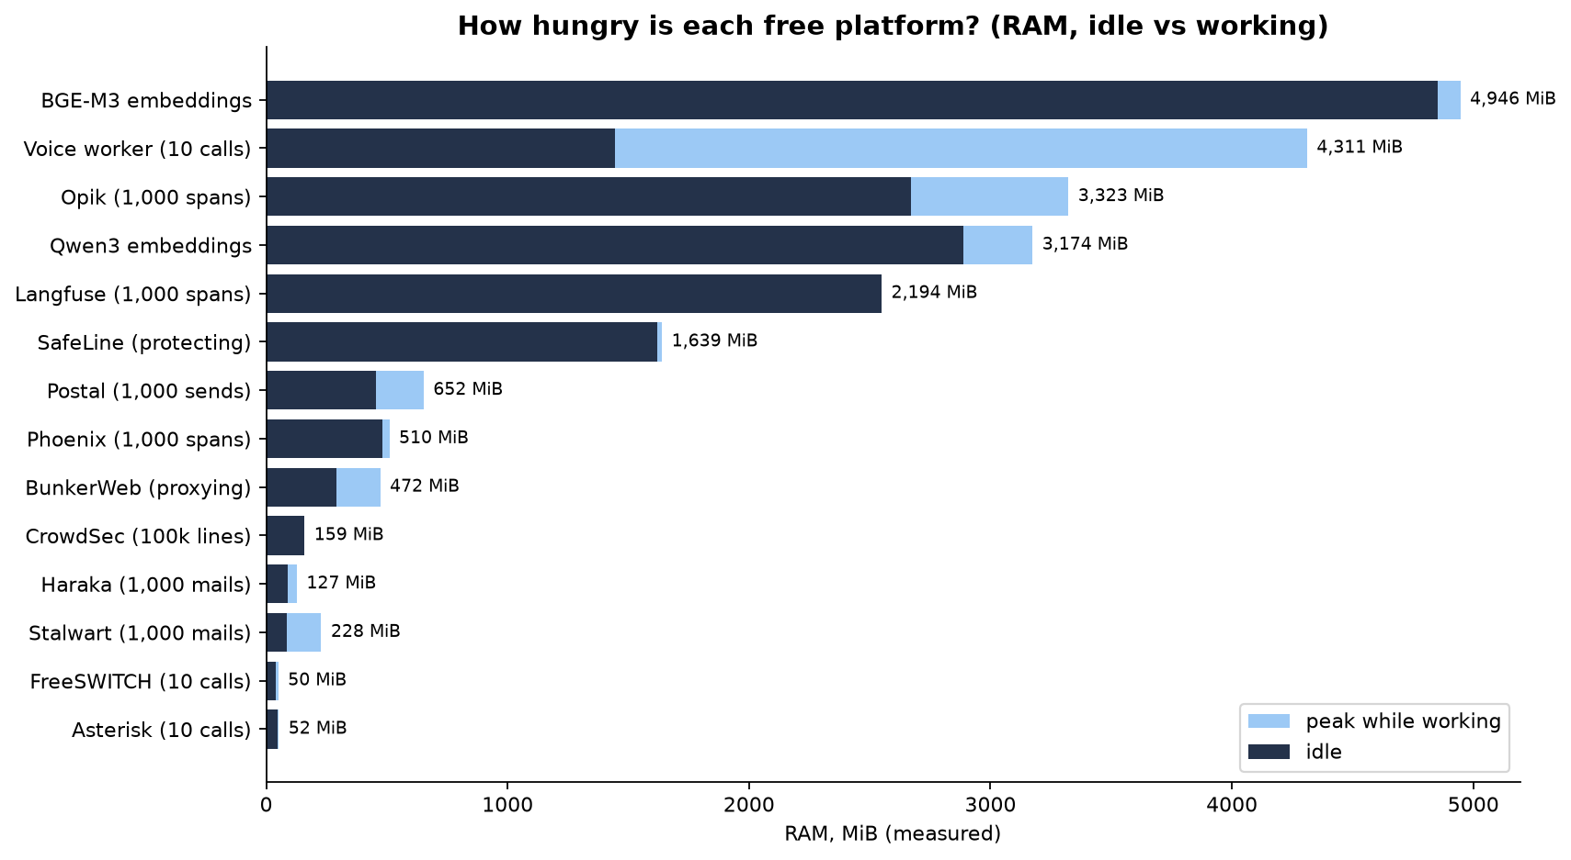
🏆 The bottom line
At 50 / 100 / 150 users a day, running the free platforms on one Namecheap 64 GB server with Coolify costs about $306.85 / $463.05 / $619.28 a month, against $914.05 / $1,070.32 / $1,226.63 for the AWS plan (at its Light sizes).
The saving comes from hosting (database, cache, containers, monitoring), not from replacing the paid AI, WhatsApp or phone minutes, which stay paid in every option.
What you give up: UAE data location, two-zone failover, managed backups and monitoring. Arifa must approve the US location first.
Keep the paid voice vendors on Namecheap (no GPU). Use Piper only if Tamil and Sinhala voices are not needed, or keep ElevenLabs for those.

Glossary (plain words)
Word | Meaning
AI turn | One buyer message and the AI's answer to it
RAM / GiB / MiB | Short-term memory of the server; 1 GiB ≈ 1,074 MB, 1 MiB ≈ 1.05 MB
Core / vCPU | One worker inside the processor; "0.5 core" = half of one, busy all the time
p50 / p95 | Half of the answers were faster than p50; 95 % were faster than p95
RTF (real-time factor) | Seconds of work per second of audio: 0.04 = 25× faster than real time; above 1 = too slow for live
GPU / VRAM | Graphics card and its memory; speech AI runs 20× faster on it
Container / image | A packaged program (image, on disk) and a running copy of it (container)
Webhook | A message another service (like Meta) sends to your server when something happens
SIP / SIP trunk | The language of internet phone calls / the paid line that connects them to real phones
WAF | Web Application Firewall: the guard that checks every web request
Embedding / vector | A list of numbers that captures the meaning of a sentence
Span / trace | One recorded AI call / a group of calls for one answer
DKIM | A digital stamp that proves an email really came from your domain
Coolify | A free dashboard that deploys and watches your apps on your own server

Where everything is
- This guide: resource-usage-bench/docs/Kairox_Free_Stack_Guide.docx (rebuild: scripts/guide/diagrams.py, then build_guide.py).
- Detailed numbers: docs/RESOURCE_USAGE.md, docs/RANK.md, round files docs/R1_RESULTS.md … R6_R8_RESULTS.md.
- Raw data: results/ (every number in this guide). Cost scripts: scripts/rank_costs.py, scripts/users_per_day_costs.py.
- Sources: repos/SOURCES.md. Prices: repo docs, AWS price list files, namecheap.com configure pages (indexed), coolify.io.

