The Kairox Free-Stack Field Guide
Every platform we ran for Arifa Pack, tested almost like real life:
what it is, how it works, how it really performed, what it eats, what it costs,
and which one we recommend
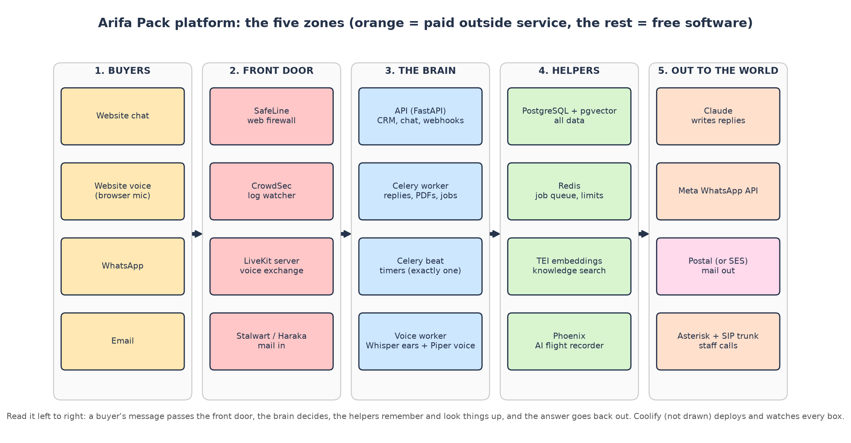
Measured 14 November 2026 on a test PC (i5-13400F, 10 cores / 16 threads, 15.8 GB RAM, RTX 5060 8 GB) with fake users and fake paid vendors. Branch v1-11nov-work-and-architecture-guide. No platform source code was changed.

What is in this guide
Chapter | What you get | Read it when…
How to read | the badges that tell you where every number came from | first, 2 minutes
1. The story | one buyer from first click to quote, and which platform does each step | you want the big picture
2. How we tested | the test bench, the 8 rounds, the fake users and fake vendors | you want to trust the numbers
3. The platforms (A-G) | a detailed card for each platform: what it is, how it works, how we tested it, full results tables from the raw files, real output, resource use, problems, paid version, alternatives, verdict | you want the detail
4. Recommended stack | the best pick for every field, chosen on measured performance, and how each pick performed | you are deciding
5. Options by field | every paid / free alternative from the repo's price document side by side | you compare vendors
6. The source-code shelf | the 25 projects in repos/ | you need a licence or version
7. Things that broke | 12 problems in the platform found under load | you plan fixes
8. The server | how big it must be, Namecheap plans, Coolify | you are buying
9. Money | usage and full cost of the PAID, FREE and RECOMMENDED stacks at 50 / 100 / 150 users a day | you budget

How to read the numbers (2 minutes)
Badge | Meaning | Example
✅ Measured | We ran it and read the number off the machine | Stalwart stored 1,000 emails in 11 s
💲 Price | From an official price page or the repo's own price documents | Deepgram $0.0092 a minute
🔢 Computed | Arithmetic on measured numbers and prices, by a script you can rerun | SafeLine on AWS Fargate = $18.07/month
⚠️ Assumption | A planning rule we had to choose; stated, and easy to change | 1 user a day = 10 AI turns
❓ Not tested | We did not run it, so we say so instead of guessing | Pipecat, ALTCHA

Words you will meet everywhere (full glossary at the end):
- p50 / p95 / max: half of the answers were faster than p50, 95 % faster than p95; max is the slowest one.
- RAM idle → peak: memory used when nothing happens → the highest memory seen during the test.
- CPU in cores: 1.0 = one processor core busy all the time; 0.05 = 5 % of one core.
- RTF (real-time factor): seconds of work per second of audio. 0.04 = 25× faster than talking; above 1.0 = too slow for a live call.
📚 The whole guide in one breath
Your platform is a sales robot with a CRM. Buyers reach it by website chat, website voice, WhatsApp and email.
It is built from about 24 platforms; we ran every one under load. Most are free software; three things stay paid in every option: Claude (writes the replies), Meta WhatsApp and real phone minutes.
Recommended stack (best measured performance per field): one Namecheap 64 GB server with Coolify, running PostgreSQL, Redis, your app, BGE-M3, Phoenix, SafeLine + CrowdSec, the LiveKit server and Piper; paid Claude, WhatsApp, Deepgram, SES + Postmark, Telnyx, Vercel. Cost: $228.00 / $355.34 / $482.72 a month at 50 / 100 / 150 users a day, against $914.05 / $1,070.32 / $1,226.63 for the all-paid AWS plan.
Catches: Namecheap servers are in Phoenix, USA (the plan keeps data in the UAE), have no GPU, and one server has no automatic failover.

1. The story: one buyer, start to finish
Meet Ahmed, who buys food containers for a restaurant group in Dubai (SRS scenario 1). Every row is a moment of his journey, the platform that does the work, and what we measured for that step.
Step | What Ahmed sees | Who does the work | Measured on the bench ✅
1 | Opens the website, presses Enter the factory | Next.js site (Vercel) + LiveKit opens a voice line | LiveKit: 16-90 MiB with 10 callers
2 | Hears "This conversation is with our AI assistant…" | Piper speaks the recording notice | first audio 0.11-0.29 s
3 | Asks about 750 ml containers with paper lids | Silero VAD + turn detector hear him stop; faster-whisper writes it down | 0.24 s per sentence on GPU
4 | Gets a correct product answer | TEI + pgvector find the facts; Claude writes; price guard checks | search 0.16 s; reply p50 4.7 s (GPU chain)
5 | Receives the Requirement Summary on WhatsApp | Celery worker builds and sends it via Meta | webhook answered in 14 ms
6 | Gets a quote PDF by email | Chromium draws it (52 KB); Postal or SES sends it | Postal: 1,000 mails at 44/s
7 | Replies to the email | Stalwart receives it; the app attaches it to the deal | 1,000 stored in 11 s
8 | (hidden) Sara is phoned when the quote waits 1 hour | Celery beat + Asterisk + SIP trunk | 10 of 10 calls
9 | (hidden) every AI call is recorded | Phoenix keeps the trace | 1.9 MB per 1,000 spans
10 | (hidden) a hacker tries a trick URL | SafeLine says 403; CrowdSec bans repeaters | 3 of 3 attacks blocked

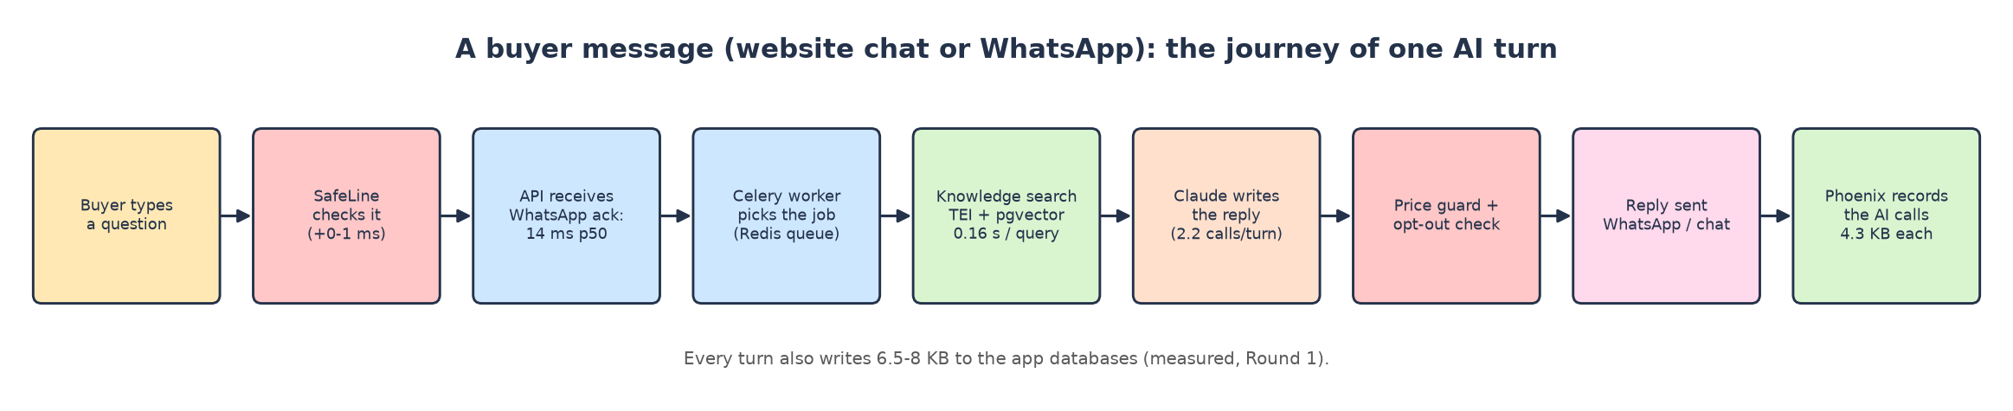
One AI turn, from message to reply.

2. How we tested (almost like real life)
A number you cannot trust is worse than no number. Everything here was run under load, with the real software from its official image or source code, and every test counted real results, not just "it started".

The bench
- Machine: i5-13400F (10 cores / 16 threads), 15.8 GB RAM, Docker VM 8.2 GB, NVIDIA RTX 5060 8 GB.
- Your real platform: the production image built from the repo's Dockerfile (2.68 GB, with Chromium and fonts), running api, Celery worker, Celery beat and the platform's own voice code.
- Fake paid vendors (scripts/fake_services.py): a fake Claude that answers like the real API after about 3 s, fake WhatsApp (Meta Graph), fake SES / Postmark, fake S3, fake CMS. Nothing left the PC, nothing was paid.
- Fake users (scripts/load10.py): 5 website chatters, 4 WhatsApp buyers (real UAE mobile prefixes, signed webhooks) and 1 staff member who logs in with password + authenticator code and works in the CRM.
- Fake callers (scripts/voice_callers.py): browsers joining LiveKit and speaking recorded sentences in English, Arabic, Hindi and Chinese, 4 sentences each.
- Watchers: docker stats every ~2 s (RAM, CPU, network, disk), database sizes before and after, and each platform's own counters (mailbox count, call statistics, stored spans, firewall logs…).

The 8 rounds
Round | What ran | Load | Proof of work counted
R1 | Your platform: API, worker, beat, PostgreSQL, Redis, TEI (Qwen3), Phoenix | 10 users for 25 min; catalogue re-index | 555 + 375 AI turns, 1,237 model calls, per-table growth
R2 | Free voice chain and the platform's real voice worker | 1, 3, 10 simultaneous callers, CPU and GPU | sentences answered, reply time per caller
R3 | Speech engines alone: faster-whisper, whisper.cpp, sherpa-onnx, Piper, Chatterbox | 1 and 10 clips at once | transcripts vs the true text
R4 | Embeddings: Qwen3-0.6B, BGE-M3, multilingual-e5-large | 48 chunks, 10 queries at once, 62 questions | right fact found first
R5 | AI tracing: Phoenix, Langfuse, Opik | 1,000 AI spans at 10 per second | spans counted in each store
R6 | Email: Haraka, Stalwart, Postal | 1,000 quote emails, 72 KB each | messages stored / sent
R7 | Phone: Asterisk, FreeSWITCH | 10 simultaneous SIP calls with audio | SIPp success counters
R8 | Security: CrowdSec, BunkerWeb, SafeLine | 100k log lines; 5-min load; 3 attacks | lines parsed, requests blocked / passed

🧪 Honesty corner: our own mistakes, fixed
• The RAM / CPU sampler counted every reading twice in rounds 5-8 (docker stats prints each frame twice). All those numbers were recomputed from the raw files; the values in this guide are the corrected ones.
• FreeSWITCH first looked broken: our test command had a missing space. Postal's web screen first looked broken: it listens on 127.0.0.1 unless told otherwise. Both passed once fixed.
• The first SafeLine load run had no staff user; it was rerun completely.

3. The platforms, one detailed card each
Each card follows the same order: quick facts → what it is → its job in Arifa Pack → how it works → how we tested it → results (from the raw files) → real output → resource use → problems we hit → paid version → alternatives → verdict.

3A. The core: your platform's own engine

🗄️ PostgreSQL 18 + pgvector (the database)
Quick facts
Version tested | PostgreSQL 18 with pgvector (pgvector/pgvector:pg18)
Licence | PostgreSQL Licence (open source)
Image size | 631 MB
Databases inside | crm, automation, agents, cms, phoenix (5)
Where in the code | every change goes through kx.crm.services.journal.record() (audit + timeline + outbox in one transaction)

What it is
PostgreSQL is the most trusted open-source database in the world: more than 35 years old and used by banks, governments and most software companies. It keeps data in tables and guarantees that every change is either fully saved or not saved at all (a "transaction"), even if the power goes off halfway.
pgvector is an add-on that lets PostgreSQL store and search vectors, the lists of numbers that capture meaning. That is how the AI's knowledge search lives inside the same database, with no separate vector database to run, pay for or back up.
🎭 Think of it as…
The filing cabinet of the whole company. Every drawer is one database. pgvector is a special drawer where facts are filed by meaning instead of by name, so "aluminium tray" and "foil container" end up side by side.

Its job in Arifa Pack
- Keeps the CRM: contacts, deals, quote versions, approvals, the deal timeline and the audit trail (SRS §7A, §11).
- Keeps the outbox and the job schedule (follow-ups at day 2/5/10, the 30/60/120-minute approval ladder) so nothing is lost if a server restarts.
- Stores the knowledge vectors (pgvector) and Phoenix's AI traces.

How it works, step by step
1. The API or worker takes a connection from its pool.
2. It writes the change together with its audit, timeline and outbox rows in one transaction.
3. The outbox relay (every 5 s) picks up new outbox rows and sends the messages.
4. Knowledge search asks pgvector for the vectors closest to the question's vector.

How we tested it
- Ran inside Round 1 with the full app and 10 users for about 25 minutes.
- Snapshots of every table's size and row count before and after each phase gave the bytes per AI turn.
- Open connections counted after each load phase.

Results (measured)
Measurement | Worker with 10 children (default) | Worker with 3 children
RAM avg / peak | 397 MiB / 430 MiB | 266 MiB / 269 MiB
CPU avg / peak (cores) | 0.03 / 0.37 | 0.02 / 0.15
Disk written in the phase | 126 MB | 82 MB
Open connections after load | 106 (agents 59, automation 17, crm 16, phoenix 5, other 9) | 57
Default connection limit (100) | exceeded | fine

Growth per unit (measured) | Size
App databases (crm + automation + agents), per buyer turn | 6.5-8.0 KB
Phoenix traces, per AI model call | 4.3 KB (≈ 9.3 KB per buyer turn)
Biggest grower | automation.scheduled_jobs: ≈ 1.7 rows and ≈ 1.9 KB per buyer turn
Other big growers | crm.audit_events, crm.timeline_events, outbox tables in 3 databases, agents.agent_runs
Database traffic inside the server | ≈ 80 KB per buyer turn (internal, not billed)
Per month at 50 / 100 / 150 users a day 🔢 | 0.26 / 0.51 / 0.77 GB

Resource use at a glance
What | Value
RAM idle → busy | 194 MiB → 397 MiB avg / 430 MiB peak ✅
CPU | 0.03 core avg ✅
Disk | 631 MB image + ≈ 17 KB per AI turn including traces ✅

Problems and surprises we hit
- Connections: 106 open at default settings, above PostgreSQL's default limit of 100. Adding the voice worker or the CMS would cause "too many clients" errors (problem 8).
- Tables never cleaned: outbox, inbox, webhook receipts, idempotency keys and finished scheduled jobs grow forever (problem 11).

Paid version and price
- Paid (plan): AWS RDS PostgreSQL Multi-AZ, $139/month at Light, $312 at Normal, $343 at Heavy 💲. Includes a standby copy in a second zone (takes over in about 1 minute) and point-in-time restore.
- Free: the same PostgreSQL in a container on your server: $0, about 0.4 GB RAM. You set up backups yourself.

Alternatives
Option | Type | Price / footprint | How it did / note
Aurora Serverless v2 | paid | $231 / $450 / $900 💲 | dearest
RDS Multi-AZ (plan) | paid | $139 / $312 / $343 💲 | managed failover
RDS single zone | paid | $69 / $69 / $83 💲 | staging only
PostgreSQL on your server | free | 0.4 GB RAM ✅ | fast and tiny at your volume

🎉 Fun fact
The busiest table is not deals or messages: it is the job schedule (scheduled_jobs), with 1.7 new rows for every buyer message.

🏁 Verdict: keep it (free, on your server)
PostgreSQL is light at your volume (under half a gigabyte). Raise max_connections or lower the pools, add a clean-up job, and set up off-site backups.

📌 Redis 8.2 (job queue, limits and kill switches)
Quick facts
Version tested | redis:8.2, noeviction, no disk persistence
Image size | 204 MB
Alternative you already run | Valkey 8.1 (the open fork; same commands)
Where in the code | Celery broker (arifaa_pack/celery_app.py), rate limits, spend caps, kill switches

What it is
Redis keeps its data in memory, so reading or writing takes microseconds. It is the most common choice for job queues and counters.
With noeviction, Redis refuses new data instead of throwing old data away when memory is full, which is exactly what a job queue needs: a queued job must never silently disappear.
🎭 Think of it as…
The sticky-note board by the door: "job #123 waiting", "this buyer sent 5 messages this minute". Quick to write, quick to read, quick to wipe.

Its job in Arifa Pack
- Carries jobs from the API to the Celery worker (AI reply, PDF, follow-up, delivery).
- Holds rate-limit counters, daily AI spend caps and the admin's kill switches (SRS §19).

How it works, step by step
1. The API puts a job on a Redis list.
2. A Celery worker child takes it, runs it and acknowledges it only at the end (acks_late, so a crash means the job runs again, never that it is lost).
3. Counters use atomic increments that expire.

How we tested it
- Inside Round 1 through every phase.

Results (measured)
Measurement | Idle | 10 users (10 children) | 10 users (3 children)
RAM avg / peak | 10 MiB / 11 MiB | 10 MiB / 12 MiB | 10 MiB / 11 MiB
CPU avg (cores) | 0.007 | 0.009 | 0.008
Network in / out | 0.4 / 0.3 MB | 7.8 / 4.0 MB | 4.7 / 2.4 MB
Data stored |  | 2.0 MB used, 2.9 MB peak

Resource use at a glance
What | Value
RAM | ≈ 10-12 MiB ✅
CPU | < 0.01 core ✅
Disk | 204 MB image ✅

Paid version and price
- Paid (plan): AWS ElastiCache, 2 nodes in 2 zones: $29 / $58 / $116 a month 💲 (Valkey version 20 % cheaper).
- Free: one container, about 12 MB of RAM.

Alternatives
Option | Type | Price / footprint | How it did / note
ElastiCache Redis (plan) | paid | $29 / $58 / $116 💲 | managed, 2 zones
ElastiCache Valkey | paid | $23 / $46 / $93 💲 | same commands
Redis / Valkey on your server | free | 12 MB ✅ | the smallest thing on the server

🏁 Verdict: keep it (free)
Free Redis or Valkey is far more than enough. Keep noeviction.

🛎️ Your app: API (FastAPI) + Celery worker + Celery beat
Quick facts
What | your own code (Python 3.14), built from the repo's Dockerfile
Image size | 2.68 GB (includes Chromium + Noto fonts for Arabic PDFs)
Processes | api (1 uvicorn), worker (Celery, N children), beat (exactly one clock)
Where in the code | apps/arifaa-pack (wiring, API, CLI) and the packages kx-core-*, kx-agent-framework

What it is
The API (FastAPI on uvicorn) answers every web request: the CRM screens, website chat, WhatsApp and email webhooks, and staff login (password + authenticator code).
The Celery worker does the slow jobs in the background: AI replies for WhatsApp and email, quote PDFs, deliveries, follow-ups and reports. Celery beat is the one clock that starts timed jobs every 5 s, 30 s or 5 minutes (outbox relays, schedule sweeps, heartbeats).
🎭 Think of it as…
The receptionist (API) answers instantly and writes the request on a sticky note; the back-office clerks (worker) do the slow work; the office clock (beat) rings for timed tasks. There must be exactly one clock.

Its job in Arifa Pack
- Website chat runs inside the API; WhatsApp and email replies run in the worker (SRS §19).
- The worker runs the approval ladder: WhatsApp reminder at 30 min, alert call at 1 h, manager at 2 h (SRS §11.3).
- The backend builds every price; the AI never calculates one (SRS §11.1).

How we tested it
- Round 1: 10 users for 15 minutes with the default 10 worker children, then 10 minutes with 3 children.
- Every request was timed and its HTTP answer recorded; every container sampled every ~2 s.

Results (measured)
Every action, with the default 10 worker children (15.2 minutes):
Action | Count | HTTP answers | p50 | p95 | max
Website chat: open a session | 53 | 201×53 | 13 ms | 117 ms | 132 ms
Website chat: buyer message → AI reply | 299 | 200×287, 500×12 | 5,062 ms | 9,352 ms | 13,963 ms
WhatsApp: message arrives (webhook) | 256 | 200×254, 500×2 | 14 ms | 45 ms | 210 ms
Staff login: password | 2 | 200×2 | 130 ms | 201 ms | 201 ms
Staff login: authenticator code | 2 | 200×2 | 55 ms | 70 ms | 70 ms
CRM: deals list | 85 | 200×85 | 11 ms | 23 ms | 29 ms
CRM: open one deal | 85 | 200×85 | 6 ms | 13 ms | 31 ms
CRM: deal timeline | 85 | 200×85 | 6 ms | 18 ms | 78 ms
CRM: quotes list | 85 | 200×85 | 5 ms | 10 ms | 12 ms
CRM: inbox | 85 | 200×85 | 8 ms | 18 ms | 74 ms
CRM: approvals list | 14 | 200×14 | 5 ms | 15 ms | 15 ms
CRM: approve a quote | 36 | 200×3, 422×33 | 574 ms | 988 ms | 3,722 ms
CRM: create a quote by hand | 14 | 201×14 | 71 ms | 98 ms | 98 ms
CRM: move deal to Qualified | 14 | 200×14 | 64 ms | 74 ms | 74 ms

The website reply time includes the fake Claude's ~3 s thinking time. The 500 answers are problem 1 (Sonnet) and problem 5 (unparseable WhatsApp number). The 422s on "approve" are correct: those website buyers left no phone or email.
The same with 3 worker children (10.2 minutes):
Action | Count | HTTP answers | p50 | p95 | max
Website chat: open a session | 37 | 201×37 | 10 ms | 131 ms | 143 ms
Website chat: buyer message → AI reply | 200 | 200×193, 500×7 | 5,327 ms | 9,420 ms | 11,367 ms
WhatsApp: message arrives (webhook) | 175 | 200×175 | 13 ms | 32 ms | 170 ms
Staff login: password | 1 | 200×1 | 120 ms | 120 ms | 120 ms
Staff login: authenticator code | 1 | 200×1 | 44 ms | 44 ms | 44 ms
CRM: deals list | 57 | 200×57 | 10 ms | 20 ms | 33 ms
CRM: open one deal | 57 | 200×57 | 6 ms | 11 ms | 36 ms
CRM: deal timeline | 57 | 200×57 | 5 ms | 9 ms | 31 ms
CRM: quotes list | 57 | 200×57 | 5 ms | 8 ms | 14 ms
CRM: inbox | 57 | 200×57 | 8 ms | 15 ms | 41 ms
CRM: approvals list | 10 | 200×10 | 6 ms | 7 ms | 7 ms
CRM: approve a quote | 30 | 200×1, 422×29 | 485 ms | 579 ms | 670 ms
CRM: create a quote by hand | 10 | 201×10 | 68 ms | 84 ms | 84 ms
CRM: move deal to Qualified | 8 | 200×8 | 63 ms | 67 ms | 67 ms

Round 1 ran in five phases (minutes): idle 3, catalogue re-index 16, 10 users with 10 worker children 15, idle with 3 children 1.5, 10 users with 3 children 10. Every container, every phase:
Phase A: idle (nobody using it)
Container | RAM avg | RAM peak | CPU avg (cores) | CPU peak (cores) | Network in / out (MB)
api | 350 MiB | 361 MiB | 0.01 | 0.23 | 0.0 / 0.0
beat | 38 MiB | 48 MiB | 0.01 | 0.24 | 0.0 / 0.1
embeddings | 2.79 GiB | 2.79 GiB | 0.00 | 0.01 | 0.0 / 0.0
phoenix | 176 MiB | 176 MiB | 0.01 | 0.03 | 0.1 / 0.1
postgres | 194 MiB | 197 MiB | 0.01 | 0.07 | 0.2 / 0.2
redis | 10 MiB | 11 MiB | 0.01 | 0.04 | 0.4 / 0.3
worker | 718 MiB | 728 MiB | 0.01 | 0.23 | 0.3 / 0.4

Phase C: 10 users, worker with 10 children (the default)
Container | RAM avg | RAM peak | CPU avg (cores) | CPU peak (cores) | Network in / out (MB)
api | 583 MiB | 817 MiB | 0.14 | 4.91 | 25.7 / 17.1
beat | 73 MiB | 85 MiB | 0.01 | 0.30 | 0.0 / 0.7
embeddings | 2.34 GiB | 2.48 GiB | 0.77 | 8.63 | 0.2 / 3.2
phoenix | 95 MiB | 105 MiB | 0.01 | 0.05 | 9.4 / 1.6
postgres | 397 MiB | 430 MiB | 0.03 | 0.37 | 22.4 / 21.9
redis | 10 MiB | 12 MiB | 0.01 | 0.05 | 7.8 / 4.0
worker | 2.55 GiB | 2.60 GiB | 0.09 | 2.10 | 23.7 / 37.2

Phase D: 10 users, worker with 3 children (recommended)
Container | RAM avg | RAM peak | CPU avg (cores) | CPU peak (cores) | Network in / out (MB)
api | 603 MiB | 804 MiB | 0.14 | 4.65 | 21.2 / 12.1
beat | 74 MiB | 85 MiB | 0.01 | 0.28 | 0.0 / 0.5
embeddings | 2.29 GiB | 2.29 GiB | 0.80 | 5.64 | 0.1 / 2.3
phoenix | 92 MiB | 92 MiB | 0.01 | 0.10 | 5.0 / 1.0
postgres | 266 MiB | 269 MiB | 0.02 | 0.15 | 14.0 / 12.4
redis | 10 MiB | 11 MiB | 0.01 | 0.05 | 4.7 / 2.4
worker | 886 MiB | 902 MiB | 0.05 | 0.57 | 13.2 / 22.4

Phase B: one CMS publish re-indexing the catalogue (100 products × 6 languages)
Container | RAM avg | RAM peak | CPU avg (cores) | CPU peak (cores) | Network in / out (MB)
api | 274 MiB | 359 MiB | 0.03 | 1.43 | — (counter reset)
beat | 33 MiB | 50 MiB | 0.01 | 0.46 | 0.1 / 0.8
embeddings | 2.84 GiB | 3.02 GiB | 8.00 | 10.94 | — (counter reset)
phoenix | 140 MiB | 176 MiB | 0.01 | 0.17 | 0.6 / 0.8
postgres | 259 MiB | 277 MiB | 0.03 | 1.59 | 5.0 / 3.7
redis | 10 MiB | 14 MiB | 0.01 | 0.26 | 4.7 / 2.5
worker | 2.30 GiB | 2.43 GiB | 0.15 | 8.37 | 2.9 / 4.0

Resource use at a glance
What | Value
API | 350 MiB idle → 583 MiB avg / 817 MiB peak; 0.14 core avg, 4.9 cores in short peaks ✅
Worker, 10 children (default) | 0.72 GiB fresh → 2.36 GiB after first jobs → 2.60 GiB peak ✅
Worker, 3 children | 0.86 → 0.90 GiB peak, same reply times ✅
Beat | 38 MiB → 85 MiB peak; 0.012 core ✅
Traffic handled | 555 buyer turns and 1,237 model calls (2.2 per turn) in 15 min ✅

Problems and surprises we hit
- Sonnet calls fail before leaving the server (temperature=0.2 rejected): money turns break (problem 1).
- Heartbeat task fails every 30 s (problem 6). Unparseable WhatsApp number → HTTP 500 (problem 5).
- Worker RAM at default (2.6 GiB) is above the AWS plan's 2 GB (problem 9).

Paid version and price
- Your own code: no licence cost. On AWS it runs on Fargate inside the $150/month server line 💲.
🏁 Verdict: keep it, run the worker with 3 children
With KX_APP_WORKER_CONCURRENCY=3 the same traffic gets the same reply times with 1.7 GB less RAM and half the database connections.

🧠 Claude (paid; the brain that writes replies)
Quick facts
Models | Claude Sonnet 5.5 on money turns, Haiku 5.5 on the rest
Called through | the Claude API directly, from LangGraph agents
Price | ≈ $0.0035 per AI turn at the plan's 40 % money-turn mix 💲

What it is
Claude is Anthropic's large language model. It reads the buyer's message, the conversation so far, the rules and the facts found by knowledge search, and writes the reply or decides which tool to call.
It runs on Anthropic's servers; your server only sends the request and waits, which is why the AI uses almost no CPU on your side.
🎭 Think of it as…
A brilliant consultant on the phone. Your server dials, reads out ~20 KB of notes and writes down the answer. You pay per call; the consultant never sees your filing cabinet.

Its job in Arifa Pack
- Writes every AI reply on every channel (chat, WhatsApp, email, voice).
- Never calculates a price: prices come from the backend and every reply passes the price guard (SRS §11.1).

How we tested it
- Replaced by a fake Claude that answers like the real API after about 3 s, so the platform's real code path ran but nothing was paid.

Results (measured)
Measurement | Value
Model calls per buyer turn | 2.2 (1,237 calls for 555 turns)
Sent per turn | 19.4 KB up, 1.1 KB down (≈ 8.7 KB per call)
Sonnet calls that left the server | 0 (all failed before sending: problem 1)
Monthly traffic at 50 / 100 / 150 users a day 🔢 | 0.29 / 0.58 / 0.87 GB

Problems and surprises we hit
- kx/agents/models.py:35 sends temperature=0.2, which the installed langchain_anthropic rejects for Sonnet 5.5: every pricing / negotiation turn fails (HTTP 500 to the buyer). Tests miss it because they use a fake model.

Paid version and price
- $49 / $228 / $735 a month at Light / Normal / Heavy 💲; $52.50 / $105 / $157.50 at 50 / 100 / 150 users a day 🔢.
- No free replacement was tested, so it stays paid in every stack.

Alternatives
Option | Type | Price / footprint | How it did / note
Sonnet on every turn | paid | $113 / $526 / $1,701 💲 | strongest, dearest
Gemini 3.8 Flash | paid | $98 / $373 / $1,156 💲 | backup only if it passes the tests
Haiku on every turn | paid | $6 / $28 / $91 💲 | cheap; price turns not proven
Sonnet + Haiku mix (plan) | paid | $49 / $228 / $735 💲 | recommended

🏁 Verdict: stays paid
Keep Claude, but fix problem 1 first or every price conversation fails.

📚 Knowledge search: TEI + an embedding model (Qwen3 / BGE-M3 / e5)
Quick facts
Server | Hugging Face Text Embeddings Inference 1.8.3 (CPU image, amd64 only)
Models tested | Qwen/Qwen3-Embedding-0.6B (Apache-2.0), BAAI/bge-m3 (MIT), intfloat/multilingual-e5-large (MIT)
Image size | 938 MB + model files 1.2-2.3 GB
Where in the code | HttpEmbedder in arifaa_pack/adapters.py; vectors in pgvector

What it is
An embedding model turns a piece of text into 1,024 numbers that describe its meaning. Texts with similar meaning get similar numbers, even across languages. TEI is the small server that runs the model and answers "give me the numbers for this text" over HTTP.
Qwen3 runs on TEI's Candle engine; BGE-M3 and e5 run on ONNX Runtime, which turned out to be much faster on a CPU.
🎭 Think of it as…
A librarian who reads every language. When you publish the catalogue she files each paragraph by meaning; a buyer asks in Arabic and she walks straight to the right English shelf.

Its job in Arifa Pack
- Every AI answer first searches the product knowledge (falling back to keyword search if this takes more than 2 s).
- Every CMS publish re-indexes the knowledge (SRS §7: "The AI's knowledge is re-indexed automatically").
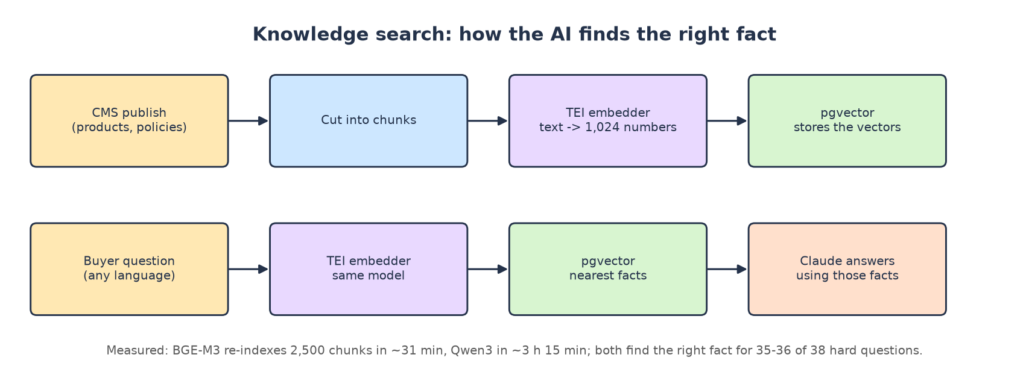

How we tested it
- Each model alone on the same TEI server the app uses, 16 CPU threads.
- Indexed 48 product chunks; timed single queries and 10 queries at the same moment (the app gives up at 2 s).
- Easy test: 24 questions about 8 facts in en / ar / hi / zh. Hard test: 38 questions about 16 facts built as look-alike pairs ("750 ml with lid" vs "1-litre without lid").
- Queries written exactly as each model expects (Qwen3 with the app's instruction, e5 with query: / passage:).

Results (measured)
Model | Engine | RAM idle | RAM peak | Index / chunk | 1 query | 10 at once p50 / max | Easy test | Hard test | MRR | Start
Qwen3-0.6B | candle | 2.75 GiB | 3.03 GiB | 4.66 s | 0.15 s | 1.26 / 1.93 s | 24/24 | 35/38 | 0.961 | 32 s
BGE-M3 | onnxruntime | 4.63 GiB | 4.72 GiB | 0.75 s | 0.07 s | 0.30 / 0.42 s | 24/24 | 36/38 | 0.964 | 33 s
e5-large | onnxruntime | 4.58 GiB | 4.65 GiB | 0.88 s | 0.07 s | 0.38 / 0.44 s | 24/24 | 35/38 | 0.961 | 30 s

Questions a model got wrong or ranked lower (hard test):
Model | Lang | Question | Right fact | Found first | Right fact at rank
Qwen3-0.6B | zh | 可以放进烤箱吗 | oven | paperlid | 2
Qwen3-0.6B | en | is the lid included with the one litre container | lid1000 | lid | 2
Qwen3-0.6B | ar | هل الغطاء مشمول مع علبة اللتر | lid1000 | lid | 2
BGE-M3 | zh | 可以放进烤箱吗 | oven | paperlid | 2
BGE-M3 | ar | هل الغطاء مشمول مع علبة اللتر | lid1000 | lid | 7
e5-large | zh | 可以放进烤箱吗 | oven | paperlid | 2
e5-large | en | is the lid included with the one litre container | lid1000 | lid | 2
e5-large | ar | هل الغطاء مشمول مع علبة اللتر | lid1000 | lid | 2

All three give 1,024-number vectors, so they fit the existing vector(1024) column. Inside the full app under load (Round 1), Qwen3 took 5.5 s per chunk with 10 cores busy and each indexing request ≈ 26 s, which is why the default 2-second timeout breaks re-indexing (problem 7).
🔎 Real output from the test
Chinese "可以放进烤箱吗" (can it go in the oven?) → all three found the paper-lid fact first and the oven fact second (score gap 0.016): the two Chinese facts are close in meaning.
Arabic "is the lid included with the litre box?" → BGE-M3 ranked the right fact 7th: a true look-alike trap.

Resource use at a glance
What | Value
Qwen3 (default) | 2.82 GiB idle, 3.10 GiB peak; 4.7 s per chunk; 6-9 cores while indexing ✅
BGE-M3 | 4.74 GiB idle, 4.83 GiB peak; 0.75 s per chunk; short bursts on all threads ✅
e5-large | 4.69 / 4.76 GiB; 0.88 s per chunk; reads only the first 512 tokens ✅
2,500-chunk re-index | Qwen3 ≈ 3 h 15 min, BGE-M3 ≈ 31 min, e5 ≈ 37 min ✅

Problems and surprises we hit
- The repo pins TEI cpu-1.7.2, which crashes with Qwen3 on CPU; cpu-1.8 works with --auto-truncate and --max-batch-tokens 1024 (problem 10).
- Switching to BGE-M3 needs a small code change (no query instruction) and a full re-index; e5 needs two changes.

Paid version and price
- Plan: Qwen3 self-hosted on AWS Fargate (1 vCPU + 4 GB): $44/month 💲. BGE-M3 needs 8 GB: $57.82 🔢.
- Paid API alternative: Gemini Embedding 2, $0.20 per million tokens: $0.28 / $1.30 / $4.20 a month 💲, but buyer questions leave the UAE.
- On your own server: $0, only RAM.

Alternatives
Option | Type | Price / footprint | How it did / note
BAAI/bge-m3 | free | 4.7 GiB ✅ | 36/38, fastest
Qwen3-Embedding-0.6B | free | 2.8 GiB ✅ | 35/38, slow indexing
multilingual-e5-large | free | 4.7 GiB ✅ | 35/38, 512-token limit
all-MiniLM-L6-v2 | free | small | English only: out
Gemini Embedding 2 | paid API | $0.28-4.20 💲 | data leaves the UAE

🎉 Fun fact
BGE-M3 re-indexes the whole catalogue in the time it takes to drink a coffee (31 min); Qwen3 needs a long lunch (3 h 15 min).

🏁 Verdict: BGE-M3 (rank 1), Qwen3 (rank 2)
On a 64 GB server pick BGE-M3: same answer quality, 6× faster indexing, 4× faster with 10 questions at once and far from the 2-second limit.

✈️ Arize Phoenix 21.1 (AI tracing) vs Langfuse v4 vs Opik
Quick facts
Versions tested | arize-phoenix v21.1.0; Langfuse 4 and Opik from their official compose files
Licence | Phoenix: Elastic License 2.0 · Langfuse: MIT outside ee/ · Opik: Apache-2.0
Image size | Phoenix 1.44 GB; Langfuse ≈ 4.3 GB (7 images); Opik ≈ 5.7 GB (8 images)
Where in the code | kx/agents/tracing.py (OpenInference spans; prompt and reply cut at 8,000 characters)

What it is
Every time the AI calls Claude, the platform records a span: the prompt, the reply, the tools used, the time taken and the tokens spent. A tracing store keeps these spans and shows them on a screen, so staff can open any conversation and see exactly why the AI said what it said.
Phoenix keeps spans in the platform's own PostgreSQL. Langfuse and Opik each need a whole extra set of databases (ClickHouse, object storage, Redis and PostgreSQL or MySQL).
🎭 Think of it as…
The black-box flight recorder. Nobody reads it on a good day; on a bad day it explains everything.

Its job in Arifa Pack
- Audit trail of AI answers; prices and chats stay inside your own database (Options by field §14).
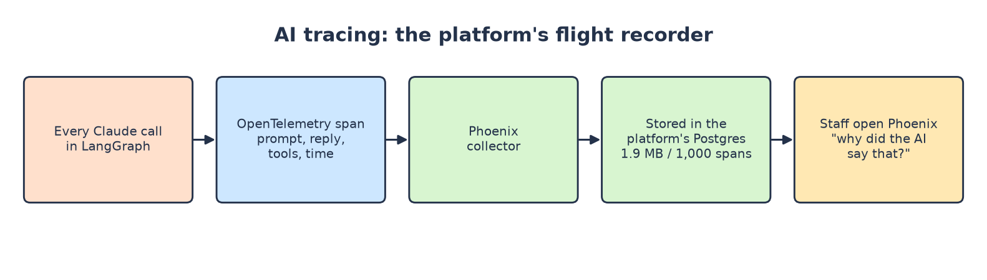

How we tested it
- Each store alone from its official setup; 1,000 spans shaped like the platform's real ones (up to 8,000 characters) sent at 10 a second, then counted in each store's own tables or API.
- A control period with no spans measured background writes, so disk growth is net.

Results (measured)
Store | Containers | RAM idle | RAM avg / peak | CPU avg / peak | Spans stored | Disk / 1,000 spans | Writes, no traffic
Phoenix | 2 | 0.47 GB | 0.49 / 0.50 GB | 0.05 / 0.24 | 1,000 of 1,000 | 1.9 MB | 0 MB
Langfuse | 7 | 2.43 GB | 2.03 / 2.14 GB | 0.22 / 0.74 | 1,000 of 1,000 | 29.8 MB | 19 MB
Opik | 8 | 2.55 GB | 3.04 / 3.24 GB | 1.43 / 10.09 | 1,000 of 1,000 | 98.3 MB | 30 MB

Disk figures are net of a control period of the same length with no spans. ClickHouse (Langfuse, Opik) merges small parts later, so a short test overstates its long-run size per span; Phoenix's figure is exact.
Idle RAM of every container:
Store | Containers and their idle RAM
Phoenix | phoenix 437, postgres 46 (MiB)
Langfuse | langfuse-ai-gateway 2, langfuse-web 1314, langfuse-worker 701, postgres 98, redis 8, clickhouse 304, minio 59 (MiB)
Opik | frontend 34, backend 780, clickhouse 505, minio 88, python-backend 492, redis 5, zookeeper 186, mysql 523 (MiB)

🔎 Real output from the test
Phoenix: spans table 1,485 → 2,485 rows (+1,000); database 18.1 MB → 20.0 MB.
Langfuse: ClickHouse events_core 0 → 1,000 and events_full 0 → 1,000 rows.
Opik: its API answered 404 before the test (no project yet) and 1,000 spans after.
Round 1 with real platform traffic: Phoenix kept 4.3 KB per model call.

Resource use at a glance
What | Value
Phoenix | 0.48 GB idle, 0.51 GB peak, 0.05 core, 1.9 MB per 1,000 spans ✅
Langfuse | 2.49 GB idle, 2.19 GB peak, 0.22 core, 29.8 MB per 1,000 spans ✅
Opik | 2.61 GB idle, 3.32 GB peak, 1.43 cores, 98.3 MB per 1,000 spans ✅

Problems and surprises we hit
- Phoenix 21 turns login on by default; spans were rejected (401) until PHOENIX_ENABLE_AUTH=false (production already sets it).
- Langfuse's compose file publishes ports that clash with an existing PostgreSQL / Redis on the same machine.

Paid version and price
- Paid: Langfuse Cloud Core $29 / $47 / $105 a month; Pro $199 / $217 / $275 💲.
- Plan: Phoenix self-hosted, $19/month on AWS 💲; on your own server ≈ 0.5 GB RAM, $0.

Alternatives
Option | Type | Price / footprint | How it did / note
Phoenix (plan) | free | 0.48 GB, 1 container ✅ | lightest by far
Langfuse self-hosted | free | 2.5 GB, 7 containers ✅ | 15× more disk
Opik self-hosted | free | 2.6 GB, 8 containers ✅ | 50× more disk
Langfuse Cloud Core / Pro | paid | $29+ / $199+ 💲 | data leaves your server

🎉 Fun fact
With no traffic at all, Phoenix wrote 0 bytes; Langfuse and Opik wrote 19-30 MB in 2.5 minutes just keeping themselves busy.

🏁 Verdict: Phoenix (rank 1), Langfuse (rank 2)
Keep Phoenix: a fifth of the RAM, 1/15 to 1/50 of the disk, one container, inside your own PostgreSQL.

🖨️ Headless Chromium (quote PDFs)
Quick facts
What | Chromium browser without a screen, inside the app image, with Noto fonts
Where in the code | pdf.py (a new browser process per PDF)

What it is
To make a quote PDF, the worker builds an HTML page and asks Chromium to "print" it. A real browser engine is the most reliable way to get Arabic letters joined and ordered correctly, right-to-left, next to English and numbers.
🎭 Think of it as…
The office printer that reads Arabic properly.

Its job in Arifa Pack
- Draws every quote PDF and Requirement Summary (SRS §11.2).

Results (measured)
Measurement | Value
Size of one quote PDF | 52 KB (the draft guessed 200 KB)
RAM / CPU | inside the worker's numbers (not isolated)
Disk | part of the 2.68 GB app image

Paid version and price
- Free; on AWS it adds about $7/month of worker memory 💲.
🏁 Verdict: keep it
Free and already inside the app image.

3B. The voice team
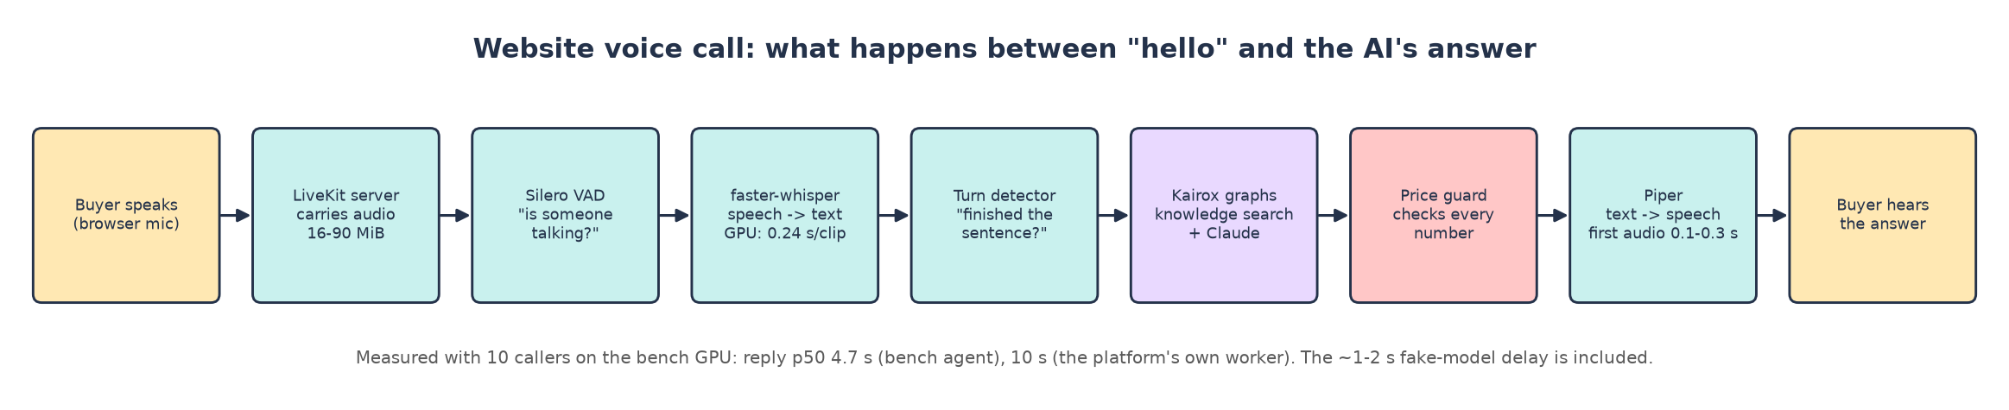
A website voice call, step by step.

📞 LiveKit server + LiveKit Agents (the voice exchange)
Quick facts
Versions tested | LiveKit server v1.13.11 (built from repos/livekit-server), LiveKit Agents 1.8.10 (as the platform pins)
Licence | Apache-2.0; turn-detector model: LiveKit Model License
Image size | 133 MB (server)
Inside the agent | Silero VAD (voice activity detection), LiveKit multilingual turn detector
Where in the code | kx/agents/voice.py (make_livekit_entrypoint), arifaa_pack/cli.py:_voice

What it is
LiveKit server is a real-time media server (WebRTC): it carries live audio between the visitor's browser and the AI agent with very little delay and copes with bad networks.
LiveKit Agents is the framework the platform's voice worker is built on. It joins each call, uses Silero VAD to hear when someone is speaking and a small turn-detector model to guess when they finished a sentence, then hands the text to your Kairox graphs and speaks the answer back.
🎭 Think of it as…
The telephone exchange: it connects each caller to a free agent and carries the sound both ways.

Its job in Arifa Pack
- Every website voice call (SRS §6 step 1, §19 "Website voice and chat").
- Plays the recording notice first, lets the buyer interrupt, ends the call politely on "stop calling me" (SRS §8.1).

How it works, step by step
1. The browser joins a LiveKit room.
2. LiveKit gives the call to a warm agent process (it keeps min(cores, 4) ready).
3. The agent plays the recording notice.
4. Silero VAD + the turn detector notice the buyer has finished.
5. Speech-to-text → Kairox graph (knowledge search + Claude) → price guard → text-to-speech.
6. LiveKit streams the answer back.

How we tested it
- 1, 3 and 10 simultaneous fake callers, each saying 4 sentences in en / ar / hi / zh; first with a small bench agent, then with the platform's own voice worker.
- CPU and GPU speech-to-text compared.

Results (measured)
A. Bench voice agent, speech-to-text on the CPU (faster-whisper int8, 8 threads):
Callers | Sentences answered | Reply p50 / p95 / max | STT RTF | TTS RTF | Agent RAM peak · CPU peak | LiveKit RAM peak · traffic
1 caller | 4 of 4 | 12.8 / 14.2 / 14.2 s | 1.37 | 0.033 | 1.44 GiB · 0.5 | 30 MiB · 2.1 MB
3 callers | 12 of 12 | 25.0 / 27.2 / 27.2 s | 2.61 | 0.048 | 1.59 GiB · 2.2 | 43 MiB · 8.9 MB
10 callers | 0 of 40 | — / — / — s | 24.31 | — | 2.14 GiB · 4.3 | 92 MiB · 27.5 MB

B. Bench voice agent, speech-to-text on the GPU (faster-whisper float16, RTX 5060):
Callers | Sentences answered | Reply p50 / p95 / max | STT RTF | TTS RTF | Agent RAM peak · CPU peak | LiveKit RAM peak · traffic
1 caller | 4 of 4 | 3.9 / 6.9 / 6.9 s | 0.11 | 0.101 | 1.42 GiB · 0.4 | 38 MiB · 2.0 MB
3 callers | 12 of 12 | 4.5 / 6.0 / 6.0 s | 0.07 | 0.085 | 1.57 GiB · 1.4 | 50 MiB · 6.4 MB
10 callers | 36 of 40 | 4.7 / 5.7 / 6.1 s | 0.14 | 0.034 | 2.03 GiB · 3.8 | 89 MiB · 19.5 MB

C. The platform's REAL voice worker (your kx.agents.voice code with its Kairox graphs, price guard and recording notice; two blocking bugs worked around; LiveKit server built from source; GPU speech-to-text):
Callers | Sentences answered | Reply p50 / p95 / max | STT RTF | TTS RTF | Agent RAM peak · CPU peak | LiveKit RAM peak · traffic
1 caller | 4 of 4 | 9.8 / 12.4 / 12.4 s | 0.08 | 0.027 | 1.71 GiB · 1.4 | 28 MiB · 2.5 MB
3 callers | 12 of 12 | 8.6 / 17.7 / 17.7 s | 0.05 | 0.051 | 2.28 GiB · 3.8 | 43 MiB · 8.6 MB
10 callers | 29 of 40 | 10.0 / 16.6 / 18.1 s | 0.06 | 0.087 | 4.11 GiB · 10.1 | 92 MiB · 28.9 MB

Reply time = from the end of the caller's sentence to the first sound of the answer, including the fake Claude's 1-2 s. Every caller says 4 sentences. RTF below 1 = faster than real time.
Per caller, platform worker, 10 callers at once (seconds; "—" = no reply within 60 s):
Caller | Joined after | Recording notice started after | Reply after each of 4 sentences
0 | 0.9 | 29.2 | — · 7.3 · 4.4 · 9.4
1 | 0.9 | 2.1 | — · — · 18.1 · 7.0
2 | 1.0 | 12.6 | — · — · 15.3 · 6.3
3 | 1.0 | 16.6 | — · — · 14.0 · 6.9
4 | 1.0 | 14.2 | — · — · 7.3 · 13.1
5 | 0.8 | 29.8 | — · 10.0 · 7.2 · 11.6
6 | 1.0 | 2.7 | 11.4 · 7.6 · 5.8 · 12.0
7 | 1.0 | 3.5 | 5.8 · 5.7 · 13.2 · 7.5
8 | 1.6 | 5.2 | 16.6 · 4.5 · 10.2 · 12.3
9 | 1.0 | 12.2 | — · 11.1 · 15.0 · 10.6

🔎 Real output from the test
10 callers, platform worker: 10 of 10 calls connected, 29 of 40 sentences answered, reply p50 10.0 s.
Calls 6, 7 and 8 (notice after 2.7-5.2 s) had every sentence answered; the others lost their first one or two sentences while each call's process was still building the whole app (problem 4).
The unmodified kx voice logged Can't pickle local object <function _voice.<locals>.entry> 3,380 times in 90 s and never answered a call (problem 2).

Resource use at a glance
What | Value
LiveKit server | 16-90 MiB, ≤ 1 core with 10 callers ✅
Platform voice worker | 1.41 GiB idle (4 warm processes) → 1.75 / 2.33 / 4.21 GiB with 1 / 3 / 10 calls; 10 cores peak ✅
Bandwidth at the server | 0.3-1.7 MB per call-minute (both legs); the caller's leg 0.15-0.85 MB ✅

Problems and surprises we hit
- Problem 2: kx voice cannot start a job (local function cannot be pickled).
- Problem 3: the session has no LLM, so LiveKit skips every reply: the caller hears the notice, then silence.
- Problem 4: every call builds the whole app at its start: first sentences are lost under 10 calls.
- The platform's worker is about 2× slower and 2× heavier than the small bench agent for the same calls.

Paid version and price
- Paid (plan): LiveKit Cloud Ship, $50/month including 5,000 agent minutes, then $0.01/min, 20 calls at once 💲.
- Free: self-host the server (90 MiB). Needs open UDP ports on the server.

Alternatives
Option | Type | Price / footprint | How it did / note
LiveKit Cloud Ship (plan) | paid | $50 / $75 / $250 💲 | easiest
Pipecat Cloud | paid | $0.01 / session-minute 💲 | agent rewrite
Self-hosted LiveKit on AWS | paid infra | $134 / $267 / $534 💲 (repo estimate) | dearer than Cloud
Self-hosted LiveKit server | free | 16-90 MiB ✅ | tiny
Pipecat (self-hosted) | free | ❓ not tested | agent rewrite

🏁 Verdict: self-hosted LiveKit server (rank 1)
The server is tiny: self-host it and save $50/month. But fix the three voice bugs first, or no call is ever answered.

👂 faster-whisper (speech-to-text) and its rivals
Quick facts
Version tested | faster-whisper 1.2.1 (CTranslate2 4.9), model large-v3-turbo
Licence | MIT (code and Whisper model)
Rivals tested | whisper.cpp (MIT), sherpa-onnx (Apache-2.0)
Model on disk | 1.62 GB
Where it would plug in | the platform's VoicePlugins speech-to-text adapter (OpenAI-compatible endpoint)

What it is
Whisper is OpenAI's open speech-recognition model, trained on 680,000 hours of audio in about 100 languages; large-v3-turbo is its fast, high-quality version.
faster-whisper runs the same model several times faster with the CTranslate2 engine, and on an NVIDIA GPU it is extremely fast. whisper.cpp is a C++ version built for CPUs; sherpa-onnx runs it with ONNX Runtime.
🎭 Think of it as…
The ears of the voice agent: on a GPU sharp and instant; on a CPU just as sharp but painfully slow.

Its job in Arifa Pack
- Turns the caller's speech into text in the visitor's language (SRS §6 step 3: en, ar, hi, ta, zh, si).

How we tested it
- Round 3: each engine alone, 10 clips with known text (3 en, 3 ar, 2 hi, 2 zh), one at a time and all 10 at once.
- Round 2: inside the live voice chain with 1 / 3 / 10 callers, on CPU and on GPU.

Results (measured)
Engine | On | Model | Load time | One clip: time (RTF) | 10 clips (59 s of audio) | Cores busy | Memory peak
faster-whisper float16 | GPU | 1.62 GB | 2.5 s | 0.24 s (0.041) | 2.7 s | 7.0 | VRAM 3.4 GB
faster-whisper int8_float16 | GPU | 1.62 GB | 4.1 s | 0.23 s (0.039) | 3.0 s | 6.0 | VRAM ≈ 2.9 GB
faster-whisper int8 | CPU | 1.62 GB | 16.0 s | 5.55 s (0.94) | 39.5 s | 12.1 | RAM 4.2 GB
sherpa-onnx int8 | CPU | 1.04 GB | 13.9 s | RTF 0.85 | 42.0 s | 14.2 | RAM 7.1 GB
whisper.cpp q5_0 | CPU | 0.57 GB | — | 11.7 s (1.98) | 118 s (one at a time) | 8 threads | RAM 0.76 GB
whisper.cpp full | CPU | 1.62 GB | — | 11.7 s (1.99) | 121 s (one at a time) | 8 threads | RAM 1.74 GB

All engines run the same Whisper large-v3-turbo model, so they produce almost identical text; they differ in speed and memory. The automatic word-error figures in the raw files are not usable (they count "750" vs "seven hundred and fifty" as errors), so the transcripts were read against the true text by hand.
🔎 Real output from the test
SAID: "Our aluminium container holds seven hundred and fifty millilitres and comes with a paper lid."
HEARD: "Our aluminium container holds 750 milliliters and comes with a paper lid." ✅ perfect
SAID (Arabic, same sentence):
حاوية الألمنيوم لدينا تتسع لسبعمائة وخمسين مليلترا وتأتي مع غطاء ورقي.
HEARD (Arabic): the number word "seven hundred" came out split in two; every other word matched; meaning kept:
حاوية الألمنيوم لدينا تتسع لسبع ماء وخمسين مليلترا وتأتي مع غطاء ورقي.
SAID (zh): "我们的铝箔餐盒容量为七百五十毫升，配有纸盖。"
HEARD (zh): "我们的铝博餐和容量为750毫升配有纸杆" ❌ "foil", "box" and "lid" mis-heard
Hindi: meaning intact, small spelling slips (कागस for कागज़, वाटसाप for WhatsApp). Tamil and Sinhala: not tested.

Resource use at a glance
What | Value
GPU (float16) | 0.24 s per clip; 59 s of audio in 2.7 s; ≈ 3.5 GB VRAM; 6-7 CPU cores for audio preparation ✅
CPU (int8) | 5.5 s per clip; 10 clips in 39.5 s; 4.3 GB RAM ✅
Live chain on CPU | 1 caller: 12.8 s reply; 10 callers: 0 of 40 answered ✅
Live chain on GPU | 10 callers: 36 of 40 answered, p50 4.7 s ✅

Problems and surprises we hit
- On a CPU, Whisper processes a fixed 30-second window for every short sentence, so even one caller waits ~13 s.
- faster-whisper 1.2.1 passes an option that PyAV 19 rejects; the bench decoded the audio itself.
- Chinese product words were mis-heard (partly because the test voice was synthetic): test with real Chinese speech.

Paid version and price
- Paid (plan): Deepgram Nova-3 Multilingual, $0.0092/min: $14 / $69 / $230 a month 💲 (ar, hi, ta, zh; no Sinhala).
- Free needs a GPU. Namecheap sells none; the cheapest UAE GPU server with an official price is AWS g6.xlarge (NVIDIA L4 24 GB), $721.42/month 💲.

Alternatives
Option | Type | Price / footprint | How it did / note
Deepgram Nova-3 (plan) | paid | $0.0092/min 💲 | no GPU needed
ElevenLabs Scribe v2 | paid | $0.39/hour 💲 | cheaper
Soniox | paid | $0.12/hour 💲 | backup
faster-whisper GPU | free | 3.5 GB VRAM ✅ | fastest free, GPU only
sherpa-onnx CPU | free | 1.5-7.2 GB RAM ✅ | RTF 0.86, not live
whisper.cpp CPU | free | 0.6-1.8 GB RAM ✅ | RTF 2.0, not live

🎉 Fun fact
On the GPU it transcribed 59 seconds of speech in 2.7 seconds: 22× faster than people talk.

🏁 Verdict: faster-whisper GPU (rank 1 free); Deepgram on a server without GPU
The best free ears, but only with a GPU. On a Namecheap server (no GPU) keep Deepgram.

🗣️ Piper (text-to-speech) vs Chatterbox
Quick facts
Versions tested | piper-tts 1.8.0 (voices en, ar, hi, zh); Chatterbox 0.1.7 multilingual
Licence | Piper: GPL-3.0 · Chatterbox: MIT
Model size | Piper 63 MB per voice; Chatterbox 13.9 GB
Where it would plug in | the platform's VoicePlugins text-to-speech adapter

What it is
Piper is a small, fast neural voice engine from the Home Assistant / Open Home Foundation community. Each voice is one small file, and it runs comfortably on a normal CPU.
Chatterbox (Resemble AI) is a bigger, more natural-sounding model that needs a GPU and generates the whole sentence before you hear anything.
🎭 Think of it as…
The voice of the agent. Piper is a quick, clear radio announcer who never needs a coffee break; Chatterbox is a stage actor, lovely to hear but taking a long breath before every line.

Its job in Arifa Pack
- Speaks the recording notice and every AI answer on a voice call (SRS §6).

How we tested it
- Round 3: each engine alone, one sentence per language, and 10 jobs at once (Piper).
- Round 2: Piper inside the live voice chain with up to 10 callers.

Results (measured)
Language | Piper: first audio | Piper RTF | Piper audio made | Chatterbox: time to audio | Chatterbox RTF | Chatterbox audio
en | 0.11 s | 0.027 | 20.9 s | 5.9 s | 0.83 | 7.1 s
ar | 0.29 s | 0.036 | 32.4 s | 5.6 s | 0.88 | 6.4 s
hi | 0.21 s | 0.051 | 12.4 s | 4.7 s | 0.86 | 5.4 s
zh | 0.17 s | 0.039 | 12.8 s | 11.3 s | 1.98 | 5.7 s

Measurement | Piper (CPU) | Chatterbox (GPU)
Load | 2.9 s for 4 voices; 398 MB | 19.3 s; 5.1 GB RAM while loading
10 jobs at once | 157 s of speech in 4.3 s; first audio p95 2.1 s; 2.02 GB RAM | not tested (one at a time was already about real time)
CPU | 67 CPU-s for 157 s of speech = 0.43 core per voice speaking | GPU
Memory | 0.40 GB loaded | 3.9 GB VRAM (torch peak 3.4 GB)
Model on disk | 63 MB per voice | 13.9 GB repository downloaded

🔎 Real output from the test
Piper was never the slow part of any voice run (RTF 0.03-0.10 even with 10 callers).
Chatterbox needed 11.3 s to produce 5.7 s of Chinese speech (RTF 1.98): slower than real time.

Resource use at a glance
What | Value
Piper | 0.40 GB → 2.07 GB with 10 jobs; 0.43 core per voice speaking ✅
Chatterbox | ≈ 4 GB VRAM, 5.2 GB RAM while loading ✅

Problems and surprises we hit
- Piper has no Tamil and no Sinhala voice; SRS §6 step 3 asks for both.
- Chatterbox first failed with "paging file too small" while other tests ran: it needs a lot of memory to load.

Paid version and price
- Paid (plan): ElevenLabs Flash, $0.04 per 1,000 characters: $27 / $135 / $450 a month 💲.
- Free: Piper runs on your server's CPU at $0 extra; on AWS Fargate $23.43 (1 voice at once) to $374.93 (10 at once) 🔢.

Alternatives
Option | Type | Price / footprint | How it did / note
ElevenLabs Flash (plan) | paid | $0.04 / 1k characters 💲 | best quality, more languages
Google Chirp 3 HD | paid | 1M free, then $30/1M chars 💲 | backup
Google Standard | paid | 4M free, then $4/1M chars 💲 | robotic
Piper | free | 0.4-2.1 GB RAM, CPU ✅ | rank 1 free
Chatterbox | free | 4 GB VRAM, 5-11 s first audio ✅ | too slow live

🎉 Fun fact
Piper made 157 seconds of speech in 4.3 seconds: a 2.5-minute speech in the time it takes to say "hello".

🏁 Verdict: Piper (rank 1), Chatterbox (rank 2, not live)
Piper for English, Arabic, Hindi and Chinese on a plain CPU. Keep ElevenLabs only for Tamil and Sinhala calls.

3C. The email team
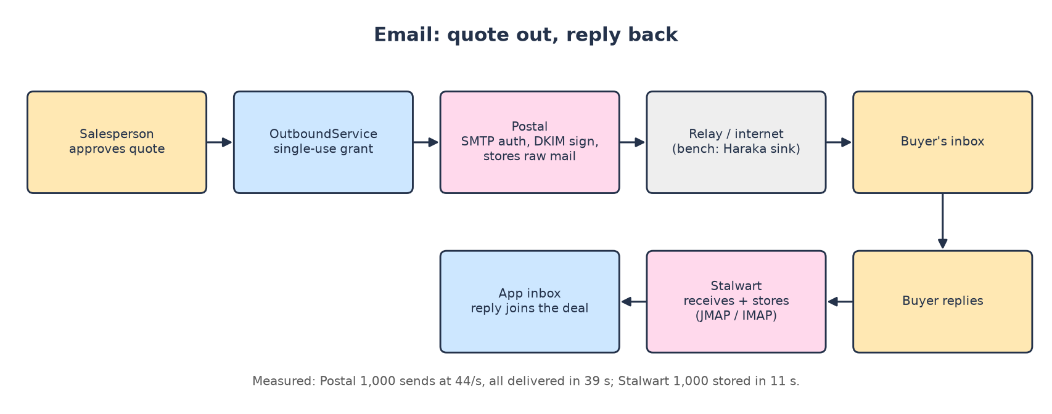

📮 Postal 3.3.4 (sending platform)
Quick facts
Version tested | ghcr.io/postalserver/postal:3.3.4 + MariaDB 11.8 (4 containers: web, SMTP, worker, database)
Licence | MIT
Image size | 1.9 GB + MariaDB 470 MB
Written in | Ruby on Rails

What it is
Postal is a complete mail-sending platform, like running your own Mailgun or SendGrid. Applications log in over SMTP or an HTTP API; Postal signs each message with DKIM, stores it, queues it, delivers it and records the result (sent, bounced, held), with a web dashboard for every mail server.
🎭 Think of it as…
Your own post office: it stamps every letter (DKIM), keeps a copy, delivers it and writes "delivered" in the ledger.

Its job in Arifa Pack
- Sends quote emails with PDFs from one company address (SRS §11.4, §19).

How it works, step by step
1. The app connects with an SMTP credential.
2. Postal accepts and stores the raw message.
3. The worker signs it (DKIM) and delivers it (in the bench: to a local Haraka sink).
4. The status becomes "Sent" with the remote server's answer.

How we tested it
- Set up exactly like an operator would: admin user, organisation, mail server, verified domain, SMTP credential.
- 1,000 authenticated quote emails over 10 connections; every message counted as "Sent" in Postal's own database.
- The same 1,000 emails also went to Haraka and Stalwart, so this table compares all three email servers.

Results (measured)
Server | Accepted / errors | Speed | Per message p50 | max | RAM idle → peak | CPU avg / peak
Haraka (receive + discard) | 1,000 / 0 errors | 118.9 / s | 82 ms | 128 ms | 91 → 127 MiB | 0.18 / 0.32
Stalwart (receive + store) | 1,000 / 0 errors | 90.1 / s | 87 ms | 1306 ms | 85 → 228 MiB | 0.22 / 0.83
Postal (auth, sign, store, deliver) | 1,000 / 0 errors | 44.3 / s | 210 ms | 414 ms | 455 → 652 MiB | 0.71 / 1.32

Proof and storage | Value
Each test email | 72 KB: HTML body + a 52 KB quote PDF
Stalwart mailbox count (JMAP) before → after | 136 → 1136 (+1000)
Stalwart store growth | 142 MB for 1,000 emails = 142 KB per 72 KB email
Postal message status | Sent 1,000; all handed to the relay 38.6 s after the first
Postal database growth | 97 MB for 1,000 emails (97 MB per 1,000)

🔎 Real output from the test
SMTP answer: 250 2.0.0 Message queued for every message.
Delivery record: Sent | Message for buyer@bench.test accepted by 172.23.0.3:2525 (haraka).
Final count in postal-server-1.messages: Sent 1000.

Resource use at a glance
What | Value
RAM | 455 MB idle (4 containers) → 652 MB peak ✅
CPU | 0.71 core avg, 1.32 peak ✅
Disk | ≈ 2.4 GB images + 97 MB per 1,000 emails ✅

Problems and surprises we hit
- Its web screen only listens on 127.0.0.1 by default (its official install uses host networking); in a normal Docker network it stays silent until web_server.default_bind_address is set to 0.0.0.0.
- Not measurable locally: whether mail from your own server's IP lands in buyers' inboxes (sender reputation).

Paid version and price
- Paid (plan): Amazon SES Essentials $0.16 per 1,000 + Postmark Pro $16.50/month for replies: $17 / $19 / $22 a month 💲.
- Free: $0 software, ≈ 0.65 GB RAM on your server.

Alternatives
Option | Type | Price / footprint | How it did / note
Postmark Pro | paid | $16.50 / 10k, then $1.30 / 1k 💲 | simple
SES + Postmark (plan) | paid | $17 / $19 / $22 💲 | trusted sending IPs, cheapest
SES + Mail Manager | paid | $50+ 💲 | dearer
Gmail API (salesperson's mailbox) | paid seats | Workspace seat 💲 | v2 route
Postal | free | 0.65 GB ✅ | rank 1 free sender

🎉 Fun fact
Postal signed and delivered 1,000 quotes with PDFs in 39 seconds: faster than a person can print one.

🏁 Verdict: SES + Postmark (recommended); Postal (rank 1 free)
Postal works very well, but SES + Postmark cost only about $17/month and come with trusted sending IPs: keep them unless you must be 100 % in-house.

📬 Stalwart v1.1 (mail server and mailbox)
Quick facts
Version tested | stalwartlabs/stalwart v1.1.0
Licence | AGPL-3.0 (+ its own enterprise licence for paid features)
Image size | 469 MB
Written in | Rust; storage RocksDB; IMAP, JMAP, SMTP, spam filter, DKIM

What it is
Stalwart is a modern all-in-one mail server: it receives mail (SMTP), stores it, and lets programs and people read it (IMAP and the newer JSON-based JMAP), with spam filtering built in.
🎭 Think of it as…
The company mailbox room: letters come in, get filed by recipient, and the app can open the drawer and read them.

Its job in Arifa Pack
- Receives buyers' email replies so the app can attach them to the deal (SRS §19).

How we tested it
- Finished its 5-step web set-up wizard (hostname, domain, storage, directory, DNS), created a buyer mailbox through its JMAP management API, then sent 1,000 quote emails to it.
- Delivery proven by counting the messages in the mailbox over JMAP.

Results (measured)
Server | Accepted / errors | Speed | Per message p50 | max | RAM idle → peak | CPU avg / peak
Stalwart (receive + store) | 1,000 / 0 errors | 90.1 / s | 87 ms | 1306 ms | 85 → 228 MiB | 0.22 / 0.83

Proof and storage | Value
Each test email | 72 KB: HTML body + a 52 KB quote PDF
Stalwart mailbox count (JMAP) before → after | 136 → 1136 (+1000)
Stalwart store growth | 142 MB for 1,000 emails = 142 KB per 72 KB email

🔎 Real output from the test
250 2.1.5 OK then 250 2.0.0 Message queued with id 4b9bc718aa00000.
With its default limits, after 25 messages: 452 4.4.5 Rate limit exceeded, try again later.
After 10 messages in one session: 452 4.4.5 Maximum number of messages per session exceeded.

Resource use at a glance
What | Value
RAM | 17-23 MB before set-up; 85 MB idle → 228 MB peak ✅
CPU | 0.22 core avg, 0.83 peak ✅
Disk | 469 MB image + ≈ 142 KB per 72 KB email (before compaction) ✅

Problems and surprises we hit
- Starts in bootstrap mode with no email service at all until the web wizard is finished.
- Default limits: 5 connections a second per IP, 25 messages an hour per sender-domain + recipient, 10 messages per session. Fine for real inbound mail; must be raised if it ever receives your own bulk mail.

Paid version and price
- Replaces the inbound part of Postmark (inside the $17-22 email line) 💲. Free: ≈ 0.23 GB RAM.

Alternatives
Option | Type | Price / footprint | How it did / note
Postmark inbound (plan) | paid | inside $17-22 💲 | zero maintenance
Stalwart | free | 0.23 GB ✅ | rank 1 free mailbox
Haraka | free | 0.13 GB ✅ | rank 2: receives only

🏁 Verdict: rank 1 free mailbox
If you self-host email, Stalwart is the one that really stores and serves mail. Know its default limits.

🚪 Haraka 3 (fast SMTP receiver)
Quick facts
Version tested | Haraka 3 from npm on node:22-slim
Licence | MIT
Image size | 329 MB (Node base) + Haraka

What it is
Haraka is a lightweight, very fast SMTP server written in Node.js. Almost everything it does (checking, storing, forwarding) is a plugin, so it can be shaped into a receiver that hands mail straight to your app.
🎭 Think of it as…
The mail slot in the door: very fast at taking letters in; what happens next depends on the plugins you add.

Its job in Arifa Pack
- Can receive mail for the app; in the bench it was also the delivery sink for Postal.

How we tested it
- 1,000 quote emails over 10 connections, configured to accept and discard (it measures receiving only).

Results (measured)
Server | Accepted / errors | Speed | Per message p50 | max | RAM idle → peak | CPU avg / peak
Haraka (receive + discard) | 1,000 / 0 errors | 118.9 / s | 82 ms | 128 ms | 91 → 127 MiB | 0.18 / 0.32

Proof and storage | Value
Each test email | 72 KB: HTML body + a 52 KB quote PDF

Resource use at a glance
What | Value
RAM | 91 MB idle → 127 MB peak ✅
CPU | 0.18 core avg, 0.32 peak ✅
Speed | 1,000 in 8.4 s (119 a second), 0 errors ✅

🏁 Verdict: rank 2 (receiver only)
The fastest and lightest, but storing mail or passing it to the app needs extra plugins (not tested).

3D. The phone team
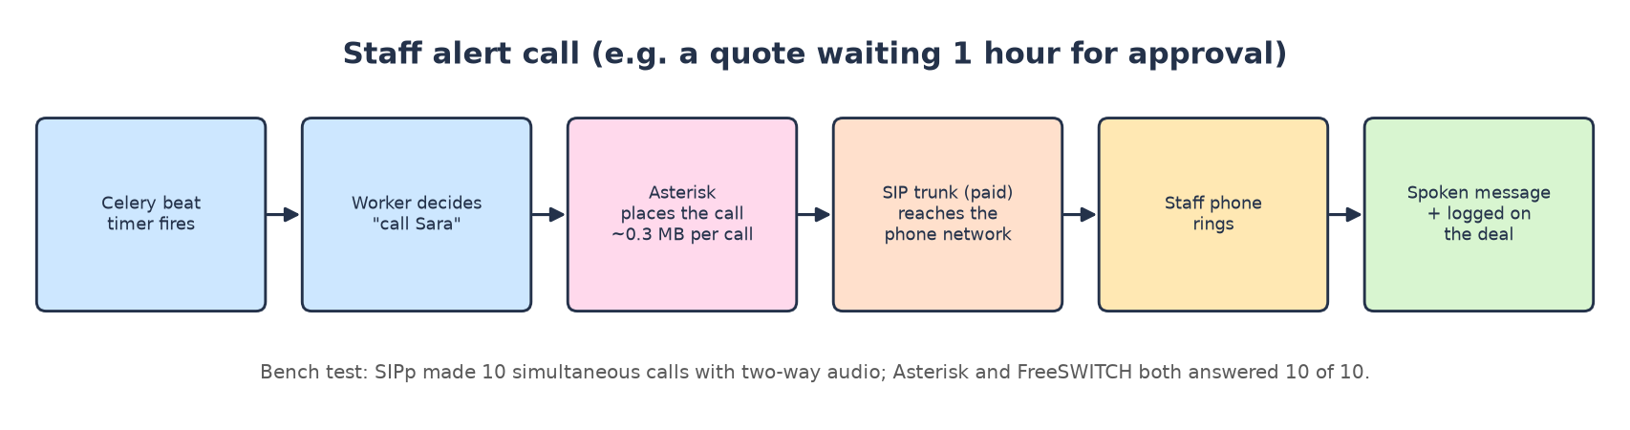

☎️ Asterisk 23.5 (phone switch)
Quick facts
Version tested | Asterisk 23.5.0 (andrius/asterisk image)
Licence | GPL-2.0
Image size | 485 MB
Test tool | SIPp (uac_pcap scenario with G.711 audio)

What it is
Asterisk is the classic open-source phone system (a PBX), around since 1999. It places, answers, routes and records calls over SIP (internet telephony), plays messages and runs call scripts called a "dialplan".
🎭 Think of it as…
The switchboard operator: plugs calls through, plays the message, and writes down who called whom.

Its job in Arifa Pack
- Scripted alert calls to staff (approvals, change requests, below-minimum offers) and click-to-call from the CRM (SRS §11.3, §14, §16).
- Never cold-calls buyers (SRS §19: UAE rules).

How we tested it
- SIPp placed 10 simultaneous calls with two-way G.711 audio (answer + echo), all inside Docker, no phone lines.

Results (measured)
Server | Successful calls | Failed | Retransmissions | Call rate | RAM idle → 10 calls | CPU avg / peak
Asterisk 23.5.0 | 10 | 0 | 0 | 0.71/s | 49 → 52 MiB | 0.05 / 0.17
FreeSWITCH 1.11.3 | 10 | 0 | 0 | 0.71/s | 41 → 50 MiB | 0.03 / 0.05

SIPp's built-in scenario plays an 8-second G.711 a-law recording and hangs up, so each call carried 8-10 s of two-way audio (G.711 is about 80 kbit/s each way per call).
🔎 Real output from the test
SIPp statistics: SuccessfulCall(C) 10 · FailedCall(C) 0 · Retransmissions(C) 0.

Resource use at a glance
What | Value
RAM | 49 MB idle → 52 MB with 10 calls (≈ 0.3 MB per call) ✅
CPU | 0.05 core avg, 0.17 peak ✅

Problems and surprises we hit
- Debian's SIPp package ships without the audio files its own scenario needs; they were taken from SIPp's GitHub.

Paid version and price
- Paid (plan): Telnyx, $0.25/min to UAE mobiles + $0.002/min Voice API: $10 / $46 / $152 a month 💲.
- Free: Asterisk only replaces the $0.002/min Voice API part; real phones still need a paid SIP trunk ("phone-line minutes paid").

Alternatives
Option | Type | Price / footprint | How it did / note
Twilio | paid | $0.2995/min 💲 | backup, already built
Telnyx (plan) | paid | $0.25/min + $0.002 💲 | cheapest; test du / Etisalat
AWS End User Messaging | paid | $0.269/min 💲 | scripted only
Asterisk + SIP trunk | free + minutes | ≈ 50 MB ✅ | rank 1 free
FreeSWITCH + SIP trunk | free + minutes | ≈ 50 MB ✅ | rank 2

🏁 Verdict: Telnyx (recommended); Asterisk (rank 1 free)
Asterisk is perfect and tiny, but it saves almost nothing: the phone minutes are the real cost (≈ $0.07-1.20/month saved).

🔀 FreeSWITCH 1.11.3 (phone engine)
Quick facts
Version tested | FreeSWITCH 1.11.3 (safarov/freeswitch image)
Licence | MPL-1.1
Image size | 352 MB

What it is
FreeSWITCH is a telephony engine built for large call platforms and conferencing. It is very flexible but needs more set-up than Asterisk.
🎭 Think of it as…
A switchboard with more buttons: powerful, but you must set it up carefully.

Its job in Arifa Pack
- Same job as Asterisk.

How we tested it
- Same 10-call SIPp test, to number 5000 on its public profile (answer + echo).

Results (measured)
Server | Successful calls | Failed | Retransmissions | Call rate | RAM idle → 10 calls | CPU avg / peak
FreeSWITCH 1.11.3 | 10 | 0 | 0 | 0.71/s | 41 → 50 MiB | 0.03 / 0.05

SIPp's built-in scenario plays an 8-second G.711 a-law recording and hangs up, so each call carried 8-10 s of two-way audio (G.711 is about 80 kbit/s each way per call).
🔎 Real output from the test
10 of 10 calls; audio verified both ways on a probe call: 76 kB in, 70 kB echoed back.

Resource use at a glance
What | Value
RAM | 41 MB idle → 50 MB with 10 calls ✅
CPU | 0.03 core avg, 0.05 peak ✅

Problems and surprises we hit
- By default it discovers your public IP with STUN and puts it in every call set-up, so audio leaves the network. external_rtp_ip / external_sip_ip had to be set to the server's own address.
🏁 Verdict: rank 2 free
Equally light; needed more configuration.

3E. The security team
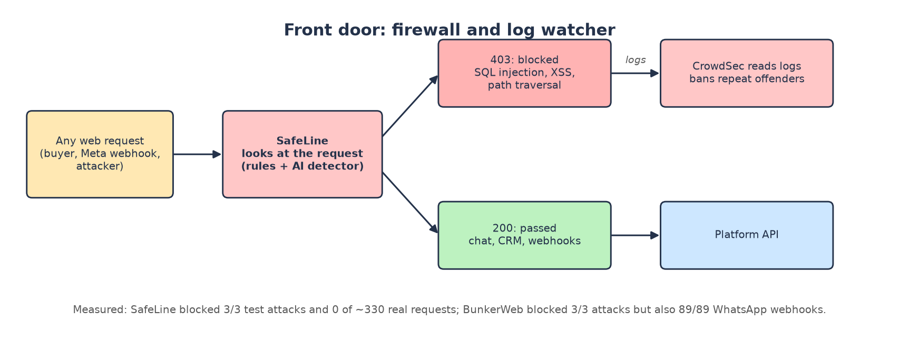

🛡️ SafeLine 9.2.7 (web application firewall)
Quick facts
Version tested | SafeLine 9.2.7 from its official compose (7 containers: tengine proxy, detector, management, …)
Licence | GPL-3.0
Images | ≈ 2.3 GB
Made by | Chaitin Tech; detection by analysing the request's meaning, not only fixed rules

What it is
SafeLine is a web application firewall: a reverse proxy that sits in front of your API, reads every request and blocks attacks such as SQL injection, script injection (XSS) and path traversal before they reach your code.
Instead of only matching fixed patterns, its detector parses the request like a language, which is why it blocked the attacks without blocking your normal traffic.
🎭 Think of it as…
The security guard at the door who reads every visitor's note and turns away anyone carrying a crowbar, but lets the postman in.

Its job in Arifa Pack
- Protects the CRM, website chat and webhooks (SRS §22).

How we tested it
- Protected the platform API through an "Application" set up in its own web console (default protection).
- Same 10-user load for 5 minutes straight and through SafeLine; then 3 textbook attacks and 3 normal requests (including correctly signed WhatsApp webhooks) straight and through it.

Results (measured)
Request | Straight to the API | Through BunkerWeb | Through SafeLine
⚔️ sql injection | 200 | 403 | 403
⚔️ script injection (XSS) | 200 | 403 | 403
⚔️ path traversal | 200 | 403 | 403
✔️ health check | 200 | 200 | 200
✔️ signed WhatsApp webhook (en) | 200 | 403 | 200
✔️ signed WhatsApp webhook (ar) | 200 | 403 | 200

10-user load for 5 minutes, straight vs through SafeLine (RAM 1.58 GB idle; 1.60 GB peak while protecting):
Action | Direct: count · answers | Via SafeLine: count · answers | p50 direct | p50 via SafeLine | Added
Website chat: open a session | 20 · 201×20 | 20 · 201×20 | 9 ms | 12 ms | +3 ms
Website chat: buyer message → AI reply | 103 · 200×98, 500×5 | 101 · 200×95, 500×6 | 5,310 ms | 5,124 ms | -186 ms
WhatsApp: message arrives (webhook) | 88 · 200×88 | 86 · 200×86 | 10 ms | 14 ms | +4 ms
Staff login: password | 1 · 200×1 | 1 · 200×1 | 107 ms | 75 ms | -32 ms
Staff login: authenticator code | 1 · 200×1 | 1 · 200×1 | 89 ms | 44 ms | -45 ms
CRM: deals list | 31 · 200×31 | 28 · 200×28 | 9 ms | 10 ms | +1 ms
CRM: open one deal | 31 · 200×31 | 28 · 200×28 | 6 ms | 6 ms | +0 ms
CRM: deal timeline | 31 · 200×31 | 28 · 200×28 | 5 ms | 5 ms | +0 ms
CRM: quotes list | 31 · 200×31 | 28 · 200×28 | 4 ms | 5 ms | +1 ms
CRM: inbox | 31 · 200×31 | 28 · 200×28 | 8 ms | 8 ms | +0 ms
CRM: approvals list | 5 · 200×5 | 5 · 200×5 | 6 ms | 6 ms | +0 ms
CRM: approve a quote | 15 · 200×2, 422×13 | 15 · 200×1, 422×14 | 495 ms | 473 ms | -22 ms
CRM: create a quote by hand | 5 · 201×5 | 5 · 201×5 | 27 ms | 23 ms | -4 ms
CRM: move deal to Qualified | 4 · 200×4 | 5 · 200×5 | 23 ms | 14 ms | -9 ms

The website 500s are problem 1 (Sonnet) and appear in both runs; the 422s are correct (no contact details).
🔎 Real output from the test
?id=1' OR '1'='1 → 403 · ?q=<script>alert(1)</script> → 403 · ?file=../../../../etc/passwd → 403
Signed WhatsApp webhooks (English and Arabic) → 200 · all 86 webhooks in the load → 200

Resource use at a glance
What | Value
RAM | 1,618 MiB idle → 1,639 MiB peak while protecting (≈ 1.6 GiB) ✅
CPU | 0.03 core avg, 0.12 peak ✅
Delay added | none measurable (±1 ms) ✅

Problems and surprises we hit
- Its proxy uses host networking: on Docker Desktop the protected port was reachable only inside Docker's VM, so the load ran from a host-network container (normal on a Linux server). Not tested on AWS Fargate.
- Its console uses a self-signed certificate and shows a licence agreement on first use.

Paid version and price
- Paid (plan): AWS WAF basic + Cloudflare Turnstile: $10 / $11 / $14 a month 💲 (Cloudflare Business $250).
- Free: $0 software, ≈ 1.6 GiB RAM.

Alternatives
Option | Type | Price / footprint | How it did / note
Cloudflare Business | paid | $250 💲 | top
AWS WAF + Bot Control + Turnstile | paid | $20-24 💲 | medium
AWS WAF basic + Turnstile (plan) | paid | $10-14 💲 | cheapest managed
SafeLine | free | 1.6 GiB ✅ | 3/3 blocked, 0 false blocks
BunkerWeb + OWASP CRS | free | 0.3-0.5 GB ✅ | 3/3 blocked, blocks WhatsApp

🏁 Verdict: rank 1 free
The free firewall to use: it blocked every test attack, let all real traffic through with default settings and added no delay.

🧱 BunkerWeb 1.6.6 with the OWASP Core Rule Set
Quick facts
Version tested | bunkerity/bunkerweb-all-in-one 1.6.6; ModSecurity + OWASP CRS 4.20.0 (833 rules)
Licence | AGPL-3.0 (CRS: Apache-2.0)
Image | 1.68 GB

What it is
BunkerWeb is nginx with security built in. Its firewall is ModSecurity running the OWASP Core Rule Set: 833 hand-written rules where each suspicious match adds points and a request scoring 5 or more is blocked.
🎭 Think of it as…
A very strict guard who also stops the postman, because the word "profile" on the envelope looks suspicious.

Its job in Arifa Pack
- Same job as SafeLine.

How we tested it
- Same 10-user load straight and through it, and the same attack / normal probes after its rules had loaded.

Results (measured)
Request | Straight to the API | Through BunkerWeb
⚔️ sql injection | 200 | 403
⚔️ script injection (XSS) | 200 | 403
⚔️ path traversal | 200 | 403
✔️ health check | 200 | 200
✔️ signed WhatsApp webhook (en) | 200 | 403
✔️ signed WhatsApp webhook (ar) | 200 | 403

10-user load for 5 minutes, straight vs through BunkerWeb:
Action | Direct: count · answers | Via BunkerWeb: count · answers | p50 direct | p50 via BunkerWeb | Added
Website chat: open a session | 18 · 201×18 | 16 · 201×16 | 17 ms | 19 ms | +2 ms
Website chat: buyer message → AI reply | 91 · 200×91 | 93 · 200×91, 403×2 | 5,713 ms | 5,864 ms | +151 ms
WhatsApp: message arrives (webhook) | 88 · 200×88 | 89 · 403×89 | 17 ms | 18 ms | +1 ms
Staff login: password | 1 · 200×1 | 1 · 200×1 | 245 ms | 82 ms | -163 ms
Staff login: authenticator code | 1 · 200×1 | 1 · 200×1 | 76 ms | 24 ms | -52 ms
CRM: deals list | 27 · 200×27 | 30 · 200×30 | 14 ms | 20 ms | +6 ms
CRM: open one deal | 27 · 200×27 | 30 · 200×30 | 5 ms | 9 ms | +4 ms
CRM: deal timeline | 27 · 200×27 | 30 · 200×30 | 4 ms | 8 ms | +4 ms
CRM: quotes list | 27 · 200×27 | 30 · 200×30 | 4 ms | 8 ms | +4 ms
CRM: inbox | 27 · 200×27 | 30 · 200×30 | 7 ms | 11 ms | +4 ms
CRM: approvals list | 5 · 200×5 | 5 · 200×5 | 5 ms | 9 ms | +4 ms
CRM: approve a quote | 15 · 422×15 | 15 · 422×15 | 504 ms | 482 ms | -22 ms
CRM: create a quote by hand | 5 · 201×5 | 5 · 201×5 | 66 ms | 70 ms | +4 ms
CRM: move deal to Qualified | 5 · 200×5 | 4 · 200×4 | 66 ms | 67 ms | +1 ms

🔎 Real output from the test
Its own log for a signed WhatsApp webhook: [id "930120"] [msg "OS File Access Attempt"] matched .profile inside the field contacts[0].profile.name, then [id "949110"] blocked it (anomaly score 5).
Every WhatsApp webhook from Meta contains that field, so with stock rules WhatsApp silently stops working.

Resource use at a glance
What | Value
RAM | 290 MB idle → 425 MB avg / 472 MB peak while proxying ✅
CPU | 0.05 core avg, 0.43 peak ✅
Delay added | +4-6 ms per CRM request ✅

Problems and surprises we hit
- It answers health checks about a minute before its 833 rules are loaded: our first probe passed every attack because the rules were not loaded yet.
🏁 Verdict: rank 2 free
Usable only after excluding rule 930120 for /webhooks/whatsapp. Lighter than SafeLine (−1.2 GB), slower (+4-6 ms).

📹 CrowdSec 1.7.3 (log watcher)
Quick facts
Version tested | crowdsecurity/crowdsec v1.7.3
Licence | MIT
Image | 476 MB

What it is
CrowdSec reads your server's logs, recognises attack patterns (brute force, scanning, bad bots) and bans the attacker's IP. It can also use a community blocklist shared by thousands of servers.
🎭 Think of it as…
The CCTV reviewer who watches the tapes and pins troublemakers' photos on the "do not admit" board.

Its job in Arifa Pack
- A second layer next to the firewall: bans IPs that keep attacking any service on the server.

How we tested it
- Read a 100,000-line web log from start to end (mode: cat).

Results (measured)
Measurement | Value
Lines read / parsed | 100.00k / 100.00k
Sent to detection buckets | 7.85k
Whitelisted (private test IPs) | 96.91k
Time / speed | 39.0 s = 2,564 lines a second
RAM avg / peak / after | 100 / 159 / 158 MiB
CPU avg / peak during the burst | 0.91 / 1.32 cores

Problems and surprises we hit
- The test log used private 10.x addresses, which CrowdSec trusts by default, so detection work was small.
- It refuses to start without a data volume, and by default only reads new log lines.
🏁 Verdict: recommended extra layer
Light and fast; add it next to SafeLine.

3F. The DevOps helper
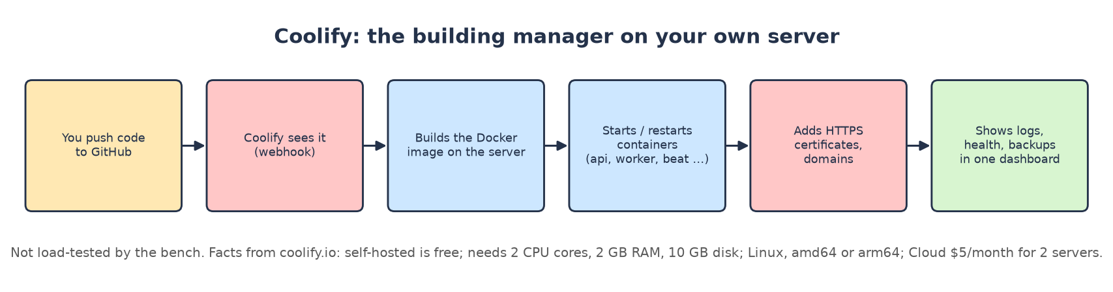

🏗️ Coolify (self-hosted deployment platform)
Quick facts
Type | open-source, self-hosted PaaS (like Heroku / Vercel on your own server)
Minimum (official docs) | 2 CPU cores, 2 GB RAM, 10 GB disk; Linux; amd64 or arm64
Price | self-hosted free; Cloud $5/month incl. 2 servers, +$3 per extra server 💲

What it is
Coolify installs Docker on your server and gives you a web dashboard to deploy apps from Git, run databases and services, add domains and free HTTPS certificates, read logs and set up backups, without typing server commands.
🎭 Think of it as…
The building manager: hand over the plans (Git) and it builds, opens the doors (HTTPS), keeps the lights on and keeps the logbook.

Its job in Arifa Pack
- Deploys your api, worker, beat and voice worker from the repo's Dockerfile, and runs every free platform in this guide on one server.

How it works, step by step
1. Install with its script (installs Docker, creates /data/coolify).
2. Connect your GitHub repo.
3. Add each service (app containers, PostgreSQL, Redis, TEI, Phoenix, SafeLine, CrowdSec …).
4. Add domains; Coolify gets HTTPS certificates.
5. Push to GitHub → Coolify builds and redeploys.

Resource use at a glance
What | Value
Minimum | 2 cores, 2 GB RAM, 10 GB disk (docs) 💲
Our test | ❓ not load-tested on the bench

Paid version and price
- Self-hosted: free forever, all features. Cloud: $5/month for 2 servers 💲.
🏁 Verdict: recommended (self-hosted)
Use self-hosted Coolify on the same server (≈ 2 GB of the 64 GB), or Cloud for $5 if you prefer its dashboard off the server.

3G. The test tools (not part of production)
Tool | What it did | Why it matters
load10.py (fake users) | 5 web chatters, 4 WhatsApp buyers, 1 staff member for 5-15 minutes | real request mix, real timings
fake_services.py (fake vendors) | fake Claude (~3 s), WhatsApp, SES, Postmark, S3, CMS | the real code path, no cost, no data sent
voice_callers.py | browsers joining LiveKit and speaking recorded sentences | reply time measured at the caller's ear
SIPp | 10 simultaneous SIP calls with audio | the standard telephony load tester
smtp_send.py | 1,000 quote emails with PDFs over 10 connections | realistic email size
waf_probe.py | 3 attacks + 3 real requests straight and through a firewall | blocks vs false blocks
sample.py + docker stats | RAM, CPU, network, disk every ~2 s | every resource number

4. The recommended stack (chosen on measured performance)
For every field we pick the platform that performed best in the tests for your situation (one Namecheap server, no GPU, 50-150 users a day). Where a paid service won, because the free one needs a GPU, saves almost nothing, or puts email delivery at risk, we say so.
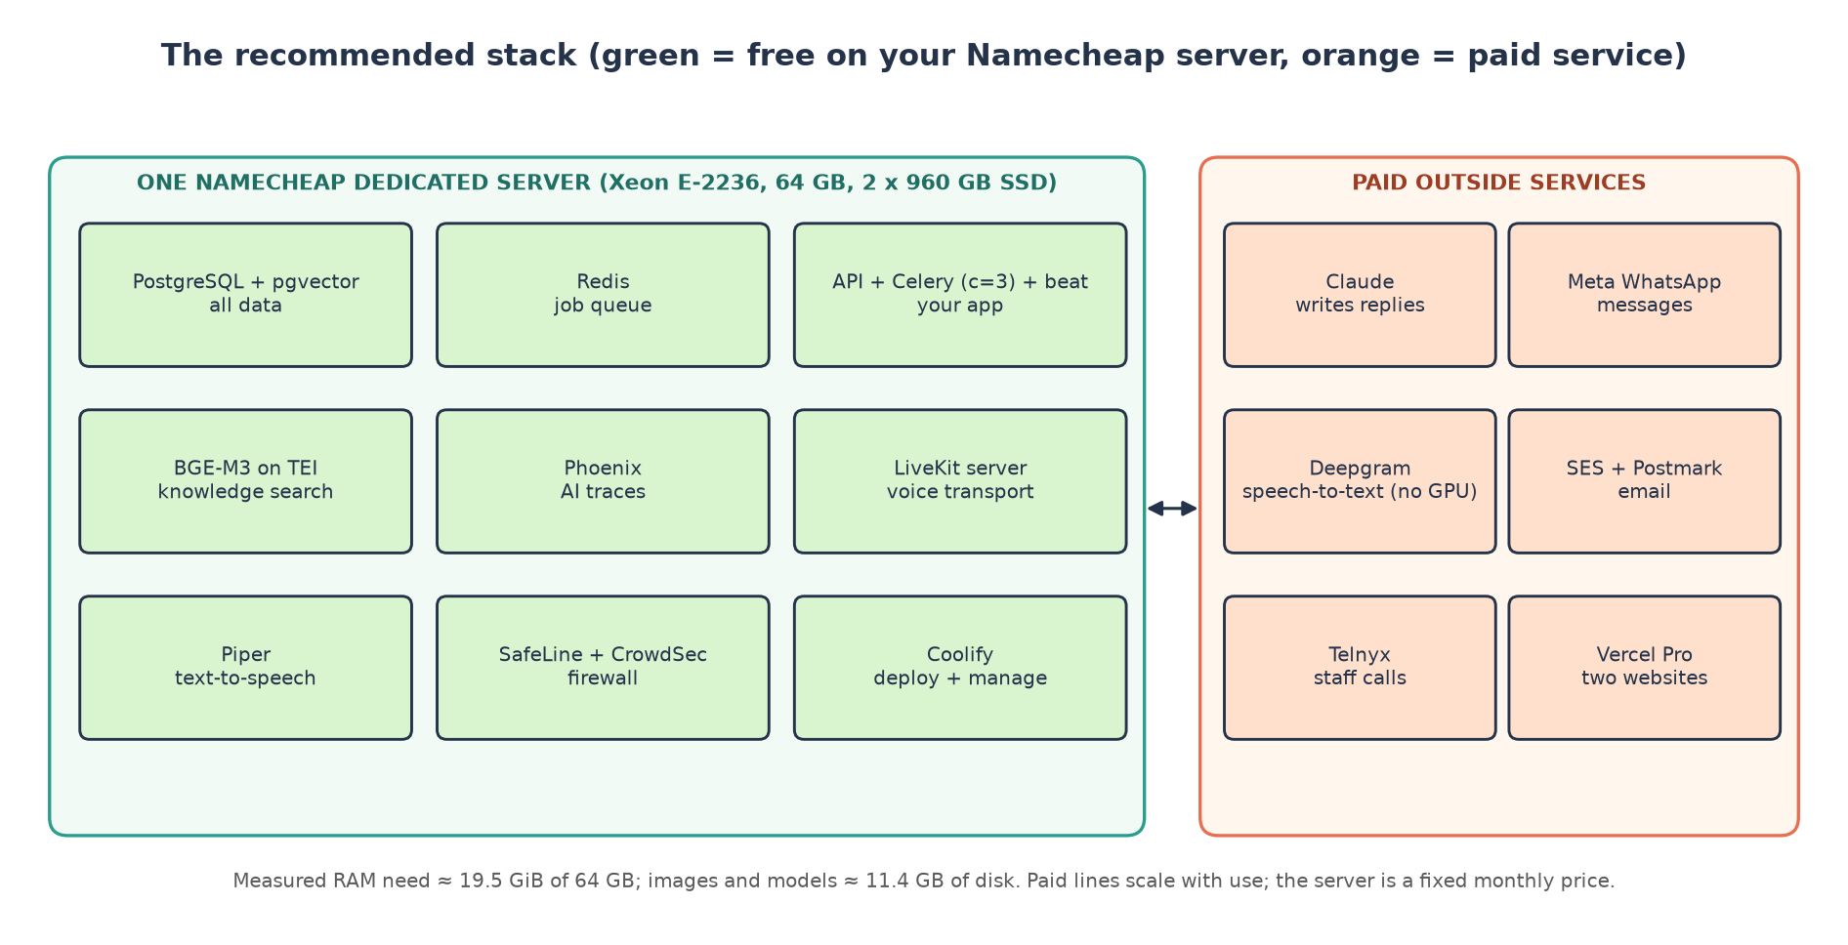
Field | ✅ Recommended | Runner-up | Why (measured)
Database | PostgreSQL + pgvector (free) | RDS Multi-AZ (paid) | 0.43 GB peak; 0.03 core with 10 users
Job queue / limits | Redis / Valkey (free) | ElastiCache | 12 MB; nothing to gain by paying
App processes | api + worker (3 children) + beat | worker with 10 | same reply times, −1.7 GB RAM, 57 vs 106 DB connections
Knowledge search | BGE-M3 on TEI (free) | Qwen3-0.6B | 36/38 vs 35/38; 6× faster indexing; 0.42 s vs 1.93 s worst with 10 queries
AI tracing | Phoenix (free) | Langfuse | 0.5 GB vs 2.5 GB; 1.9 MB vs 29.8 MB per 1,000 spans
AI brain | Claude (paid) | — | no free option tested
Voice transport | LiveKit server, self-hosted (free) | LiveKit Cloud | 16-90 MiB with 10 callers; saves $50/month
Speech-to-text | Deepgram (paid) | faster-whisper GPU | free needs a GPU ($721+/month); free on CPU = 0/40 replies with 10 callers
Text-to-speech | Piper (free) + ElevenLabs only for ta / si | ElevenLabs | RTF 0.03-0.05, first audio 0.1-0.3 s on CPU; no ta / si voices
Email out | SES + Postmark (paid) | Postal | ≈ $17/month with trusted IPs; Postal works but inbox delivery is untestable
Email in | Postmark inbound (paid, in the line above) | Stalwart | same reason; Stalwart is the free fallback
Staff calls | Telnyx (paid) | Asterisk + SIP trunk | minutes cost the same either way; Asterisk saves ≈ $1/month
Web firewall | SafeLine (free) | BunkerWeb | 3/3 attacks blocked, 0 false blocks, no delay
Log-based bans | CrowdSec (free) | — | 100k lines in 39 s, 159 MB
WhatsApp | Meta Cloud API (paid) | Telnyx / Twilio | cheapest per the repo's prices
Websites | Vercel Pro (paid) | self-hosted Next.js ❓ | not measured on the bench
Deploy / manage | Coolify self-hosted (free) | Coolify Cloud $5 | one dashboard for everything
Server | Namecheap Xeon E-2236, 64 GB, 2 × 960 GB SSD | 32 GB version | needs ≈ 19.5 GiB RAM and ≈ 11.4 GB of images

How the recommended platforms performed (the detail behind each pick)
🗄️ PostgreSQL + pgvector
With 10 users: 397 MiB average, 430 MiB peak, 0.03 core. Every CRM screen answered in 5-11 ms (p50).
Each buyer turn added 6.5-8 KB to the app databases, ≈ 17 KB with traces: ≈ 0.77 GB a month at 150 users a day.
Watch: 106 connections at default worker settings (limit 100); with 3 worker children, 57.

🛎️ App with 3 worker children
10 users, 375 buyer turns in 10 minutes: website reply p50 5.3 s (3 s of it is the fake Claude); WhatsApp webhooks acknowledged in 13 ms.
Worker 0.86 → 0.90 GiB (vs 2.60 GiB with 10 children) with identical reply times.

📚 BGE-M3
Right fact first for 36 of 38 hard questions (95 %), including 10 of 11 non-English ones; MRR 0.964.
0.75 s per chunk to index: a 2,500-chunk catalogue in ≈ 31 minutes instead of ≈ 3 h 15 min.
10 buyers asking at the same moment: 0.30 s typical, 0.42 s worst, far below the app's 2-second limit.

✈️ Phoenix
Stored 1,000 of 1,000 spans; 1.9 MB per 1,000 spans; 0 bytes written when idle; ready 9 s after start.
On real platform traffic: 4.3 KB per AI call. 0.48 → 0.51 GB RAM, 0.05 core.

📞 LiveKit server (self-hosted)
Carried every call in every voice test; 16-90 MiB and at most 1 core with 10 callers.
Traffic 0.3-1.7 MB per call-minute at the server: even 4,800 voice minutes a month is under 8.2 GB.

🗣️ Piper
First sound after 0.11 s (English) to 0.29 s (Arabic); 20-37× faster than real time.
10 voices at once: 157 s of speech in 4.3 s, 2.07 GB RAM, 0.43 core per voice speaking.
Never the bottleneck in any of the 9 voice runs.

🛡️ SafeLine + 📹 CrowdSec
SafeLine: 3 of 3 attacks → 403; 86 of 86 WhatsApp webhooks and every CRM and chat request passed; p50 changed by at most 1 ms.
CrowdSec: 100,000 log lines in 39 s on 0.91 core and 159 MB.

💲 The paid picks
Deepgram, because the free ears need a GPU: on CPU one caller waited 12.8 s and 10 callers got no answer at all.
SES + Postmark, because for ≈ $17/month you get sending IPs that inboxes already trust; Postal performed well (44/s) but its inbox delivery cannot be proven without real sending.
Telnyx, because the phone minutes are the cost either way; Asterisk (10/10 calls, 52 MB) would save about $1 a month.

5. Every field and its alternatives (from "Options by field")
The repo's Options by field.md lists High / Medium / Low choices with official prices. Here they are next to the free platform we measured. US$ a month at Light / Normal / Heavy 💲. Bold = the 11 Nov plan's pick.
Field | High | Medium | Low / budget | Free platform measured ✅
AI brain | Sonnet every turn 113/526/1,701 | Gemini 3.8 Flash 98/373/1,156 | Haiku 6/28/91; mix 49/228/735 | none (stays paid)
Speech-to-text | Deepgram 14/69/230 | ElevenLabs Scribe 10/49/162 | Soniox 3/15/50 | faster-whisper (GPU only)
Text-to-speech | ElevenLabs Flash 27/135/450 | Google Chirp 3 HD 0/71/308 | Google Standard 0/0/29 | Piper (CPU)
Real-time voice | LiveKit Cloud 50/75/250 | Pipecat Cloud 15/75/250 | self-hosted LiveKit on AWS 134/267/534 | LiveKit server (90 MiB)
Alert calls | Twilio 12/55/181 | Telnyx 10/46/152 | AWS End User Msg 10/48/161 | Asterisk / FreeSWITCH + SIP trunk
WhatsApp | Twilio 56/359/1,243 | Telnyx 50/330/1,146 | Meta direct 26/213/756 | none (Meta only)
Email | Postmark Pro 16/20/66 | SES + Postmark 17/19/22 | SES + Mail Manager 50/51/55 | Postal + Stalwart + Haraka
Servers | Fargate ARM 150/150/188 |  | EC2 t4g 177/177/239 | Namecheap + Coolify (ch. 8)
Database | Aurora 231/450/900 | RDS step 139/312/343 | RDS single zone 69/69/83 | PostgreSQL (0.4 GB)
Cache / queue | ElastiCache Redis 29/58/116 | Valkey 23/46/93 | Redis on Fargate 19/19/37 | Redis (12 MB)
Website + CRM | Vercel Pro 20/40/40 | Netlify 20 | Cloudflare Workers 5 | ❓ self-hosted Next.js not tested
Knowledge search | Qwen3 container 44 | BGE-M3 44 | e5-large 44; Gemini API 0.28-4.20 | BGE-M3 / Qwen3 / e5 (all tested)
AI tracing | Langfuse Pro 199/217/275 | Langfuse Core 29/47/105 | Phoenix 19 | Phoenix / Langfuse / Opik (all tested)
Monitoring | Datadog 93+ | Better Stack 64/64/154 | Grafana Cloud free 0 | ❓ not tested
Staff login | Auth0 35 | Cognito 0 | in-house 0 | in-house (your code)
Firewall + bots | Cloudflare Business 250 | AWS WAF + Bot Control 20-24 | AWS WAF + Turnstile 10-14 | SafeLine / BunkerWeb / CrowdSec
Background jobs | Celery + Beat 0 | Procrastinate 0 |  | Celery (your code)

6. The source-code shelf (resource-usage-bench/repos)
The source code of every platform we tested, at the version we ran where that version has a tag. You never need to open these folders to use the platforms; they are there so anyone can check exactly what was tested, read its licence or rebuild it. Ignored by git (not part of your project). Full list with commits: repos/SOURCES.md.
Folder | Version cloned | Licence | Size | What it is
livekit-server | v1.13.11 | Apache-2.0 |  | LiveKit media server; built from this source for the voice test
livekit-agents | livekit-agents@1.8.10 | Apache-2.0 |  | LiveKit Agents framework used by the platform's voice worker
asterisk | 23.5.0 | GPL-2.0 | 59M | Asterisk phone switch
freeswitch | v1.11.3 | MPL-1.1 | 143M | FreeSWITCH phone engine
postal | 3.3.4 | MIT | 5.0M | Postal mail-sending platform
haraka | master | MIT | 6.6M | Haraka SMTP receiver
stalwart | v1.1.0 | AGPL-3.0 + Stalwart Enterprise Licence | 36M | Stalwart mail server
text-embeddings-inference | v1.8.3 | Apache-2.0 | 6.7M | TEI, the embedding server the app uses
FlagEmbedding | master | MIT | 89M | BAAI's code behind BGE-M3
phoenix | arize-phoenix-v21.1.0 | Elastic License 2.0 | 115M | Arize Phoenix AI tracing
langfuse | main | MIT (ee/ folders: own licence) | 99M | Langfuse AI tracing
opik | 2.2.144-7455 | Apache-2.0 | 745M | Opik AI tracing
bunkerweb | v1.6.6 | AGPL-3.0 | 377M | BunkerWeb firewall
crowdsec | v1.7.3 | MIT | 11M | CrowdSec log watcher
SafeLine | v9.2.7 | GPL-3.0 | 17M | SafeLine firewall
coreruleset | v4.20.0 | Apache-2.0 | 6.3M | OWASP Core Rule Set inside BunkerWeb
altcha | v3.6.0 | MIT | 6.7M | ALTCHA bot challenge (not tested)
faster-whisper | v1.2.1 | MIT | 43M | faster-whisper speech-to-text
whisper.cpp | master | MIT | 55M | whisper.cpp speech-to-text
whisper | main | MIT | 18M | OpenAI's original Whisper
sherpa-onnx | master | Apache-2.0 | 53M | sherpa-onnx speech toolkit
piper1-gpl | v1.8.0 | GPL-3.0 | 53M | Piper text-to-speech
chatterbox | master | MIT | 3.5M | Chatterbox text-to-speech
pipecat | main | BSD-2-Clause | 83M | Pipecat voice framework (not tested)
sipp | master | GPL-2.0 or later | 9.6M | SIPp call generator used for the phone test

7. Things that broke (and what to do)
Running the real code under load found these problems in the platform. Nothing was changed in your code.
# | Problem | Effect | Fix
1 | Every Claude Sonnet call fails (temperature=0.2 rejected) | Pricing / negotiation turns fail (HTTP 500) | kx/agents/models.py:35: no temperature for Sonnet
2 | kx voice cannot start a job (local function cannot be pickled) | No voice call is ever answered | Move the entry function to module level
3 | Voice session has no LLM, so LiveKit skips every reply | Caller hears the notice, then silence | Pass any LLM object to AgentSession
4 | Each voice call builds the whole app at its start | First sentences lost under 10 calls | Build it in prewarm_fnc
5 | Unparseable WhatsApp number → HTTP 500 | Meta keeps retrying | Log and acknowledge
6 | Heartbeat task fails every 30 s | Queue metrics never sent | kx/core/metrics.py:46
7 | Embedding timeout 2 s; re-index requests take ≈ 26 s on CPU | Catalogue re-index fails | Longer timeout for indexing
8 | 106 PostgreSQL connections at defaults (limit 100) | "Too many clients" | Worker concurrency 3 / smaller pools
9 | Worker needs 2.6 GiB at default; AWS plan gives 2 GB | Out-of-memory restarts on AWS | Concurrency 3 (0.9 GiB)
10 | Pinned TEI cpu-1.7.2 crashes with Qwen3 | Knowledge search does not start | cpu-1.8 with --auto-truncate
11 | Some tables are never cleaned up | scheduled_jobs grows forever | Add a retention job
12 | BunkerWeb default rules block every WhatsApp webhook | WhatsApp silently stops | Exclude CRS rule 930120, or use SafeLine

8. The server: Namecheap + Coolify

How big must it be?
Adding up the measured peak RAM of everything in the recommended stack gives ≈ 19.48 GiB; the maximum-free stack (adds Postal, Stalwart, Asterisk) needs ≈ 20.41 GiB.
Part (recommended stack) | Peak RAM (GiB)
app (api + worker c=3 + beat) + PostgreSQL + Redis | 2.21
BGE-M3 embeddings | 4.83
Phoenix | 0.51
voice worker (10 calls) | 4.21
LiveKit server | 0.09
Piper (10 voices at once) | 2.07
SafeLine | 1.6
CrowdSec | 0.16
Coolify (docs minimum) | 2
CMS + websites (E) | 1
OS (E) | 0.8
Total | 19.48

💡 What this means
32 GB works; 64 GB gives room for growth and for deploying a new version next to the old one, for about $4 a month more.
CPU: bursts matter. 10 simultaneous voice calls pushed the voice worker to 10 cores, and re-indexing takes every core it can get. At 50-150 users a day the average number of calls at once is 0.09-0.27 (1,600-4,800 voice minutes a month over 300 working hours, i.e. 10 hours × 30 days ⚠️ 🔢), so a 6-core / 12-thread Xeon E-2236 is enough.
Disk: images and models ≈ 11.39 GB (recommended) / 14.72 GB (maximum free) + database growth 0.26 / 0.51 / 0.77 GB a month. 2 × 960 GB SSD is plenty; keep backups off the server.
Bandwidth: Namecheap's listing shows 100 TB a month; you need well under 30 GB (voice is the biggest: 0.15-0.85 MB per call-minute ✅).

Namecheap dedicated servers (as indexed on 14 Nov 2026)
Namecheap blocks automated reading of its pages; these list prices come from its own configure pages as indexed by search engines on 14 Nov 2026. The same plan showed different prices on different pages (promotions, billing terms), so check the live configurator before buying.
Plan | List price, monthly term | Fits?
Xeon E-2236 (6 cores / 12 threads), 32 GB, 2 x 480 GB SSD | $79.88 | yes, less headroom
Xeon E-2236, 64 GB, 2 x 960 GB SSD (SATA) | $83.88 | recommended
Xeon E-2236, 64 GB, 2 x 960 GB SSD (NVMe) | $94.88 | more than needed
Dual Xeon Silver 4208, 64 GB, 2 x 1 TB NVMe | $153.88 | more than needed
Dual Xeon Gold 5218, 128 GB, 4 x 1 TB NVMe | $229.88 | more than needed

⚠️ Read before you buy
Location: all Namecheap dedicated servers are in phoenixNAP's data centre in Phoenix, Arizona, USA. The 11 Nov plan keeps prices and chats in the UAE and needs Arifa's approval for every processor.
No GPU: so the free speech-to-text cannot run live there; keep Deepgram (or rent a GPU elsewhere: AWS UAE g6.xlarge $721.42/month 💲).
One server = one point of failure: no automatic database failover, no managed backups, no monitoring unless you add them.

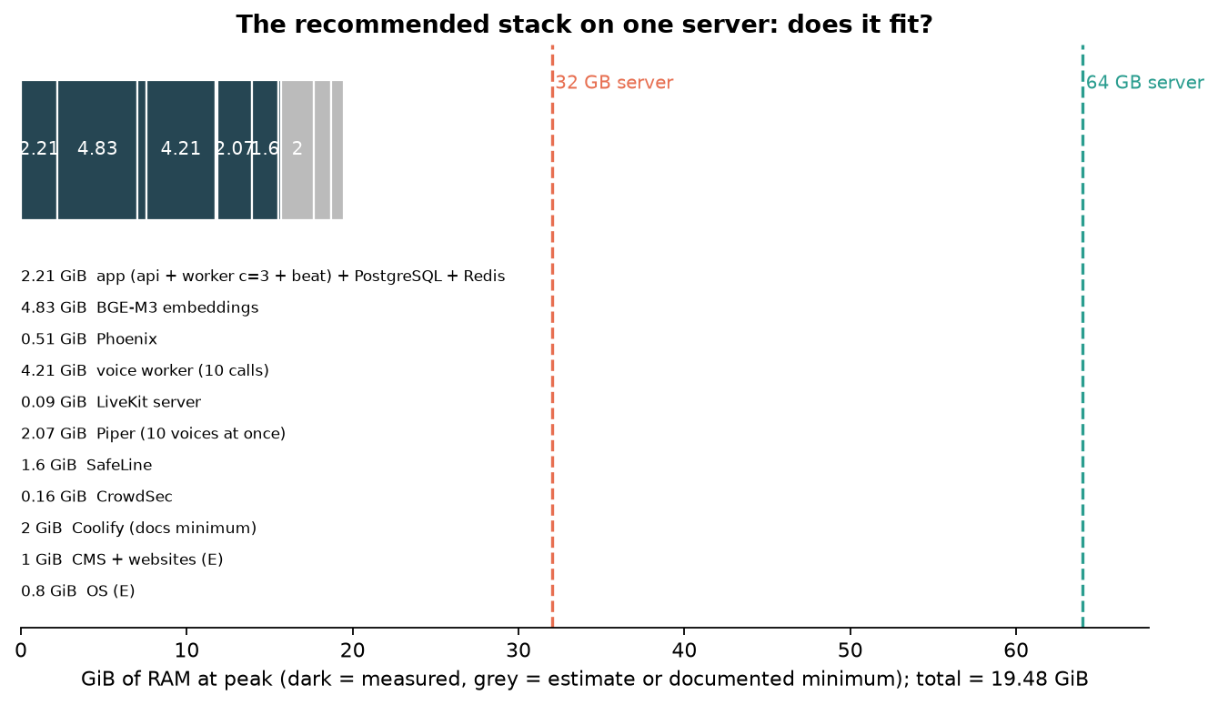

9. Money: PAID vs FREE vs RECOMMENDED, at 50 / 100 / 150 users a day
⚠️ The one assumption in this chapter
1 user a day = 1 buyer conversation of 10 AI turns. Voice minutes, WhatsApp messages, emails and staff-call minutes grow with AI turns at the same ratios as the repo's "Light" level (per AI turn: 0.107 voice minutes, 0.279 WhatsApp messages, 0.143 emails out, 0.0026 call minutes). 50 users a day ≈ the plan's Light level (15,000 vs 14,000 turns).
Change TURNS_PER_USER in scripts/users_per_day_costs.py and rerun to see other numbers.

Usage per month
 | 50 users / day | 100 users / day | 150 users / day
AI turns | 15,000 | 30,000 | 45,000
Voice minutes | 1,607 | 3,214 | 4,821
WhatsApp messages | 4,179 | 8,357 | 12,536
Emails out / in | 2,143 / 536 | 4,286 / 1,071 | 6,429 / 1,607
Staff call minutes | 39 | 77 | 116
Database growth 🔢 | 0.26 GB | 0.51 GB | 0.77 GB
Traffic to Claude 🔢 | 0.29 GB | 0.58 GB | 0.87 GB
Voice traffic at the server 🔢 (0.3-1.7 MB / min) | 0.5-2.7 GB | 1.0-5.5 GB | 1.4-8.2 GB

Table A: the PAID stack (the 11 Nov AWS plan, every service paid)
Everything managed on AWS in the UAE: two zones, RDS Multi-AZ, ElastiCache, Fargate, monitoring, AWS support, plus every paid service. AWS hosting lines are the repo's Light sizes (low) and Normal sizes (high).
Line | Unit price 💲 | 50 users / day | 100 users / day | 150 users / day
AI replies (Claude Sonnet + Haiku) | ≈ $0.0035 / turn | $52.50 | $105.00 | $157.50
WhatsApp (Meta) | Meta fees | $29.34 | $79.43 | $129.52
speech-to-text (Deepgram) | $0.0092 / min | $14.79 | $29.57 | $44.36
text-to-speech (ElevenLabs) | $0.04 / 1k chars | $28.93 | $57.86 | $86.79
voice transport (LiveKit Cloud Ship) | $50 incl. 5,000 min | $50.00 | $50.00 | $50.00
staff alert calls (Telnyx) | $0.25 / min + $0.002 | $10.65 | $20.27 | $29.93
email (SES + Postmark Pro) | $0.16 / 1k + $16.50 | $16.84 | $17.19 | $17.53
AWS hosting (servers, RDS, cache, network, monitoring, support, Vercel, Phoenix, embeddings, WAF) | repo lines | $711.00 - $990.00 | $711.00 - $990.00 | $711.00 - $990.00
Total PAID |  | $914.05 - $1,193.05 | $1,070.32 - $1,349.32 | $1,226.63 - $1,505.63

Table B: the FREE stack (as free as possible)
Every service with a free platform runs free: one Namecheap server + Coolify for the app, database, cache, BGE-M3, Phoenix, SafeLine, CrowdSec, LiveKit, Piper, Postal, Stalwart and Asterisk, plus a GPU server for the free speech-to-text (Namecheap has no GPU). Still paid: Claude, WhatsApp, phone minutes, Vercel.
Line | 50 users / day | 100 users / day | 150 users / day
Namecheap dedicated server (64 GB) | $83.88 | $83.88 | $83.88
Coolify (self-hosted) | $0.00 | $0.00 | $0.00
GPU server for faster-whisper (AWS g6.xlarge, UAE) | $721.42 | $721.42 | $721.42
AI replies (Claude) | $52.50 | $105.00 | $157.50
WhatsApp (Meta) | $29.34 | $79.43 | $129.52
speech-to-text (faster-whisper) | $0.00 | $0.00 | $0.00
text-to-speech (Piper) | $0.00 | $0.00 | $0.00
voice transport (LiveKit) | $0.00 | $0.00 | $0.00
phone minutes (SIP trunk; Asterisk does the rest) | $10.57 | $20.12 | $29.70
email (Postal + Stalwart) | $0.00 | $0.00 | $0.00
website + CRM (Vercel Pro) | $20.00 | $20.00 | $20.00
Total FREE | $917.71 | $1,029.85 | $1,142.02

Server needs: ≈ 20.41 GiB RAM and ≈ 14.72 GB of images on the Namecheap server, plus a GPU server with ≈ 3.5 GB of VRAM. The GPU server alone costs more than all the paid voice services at these volumes.

Table C: the RECOMMENDED stack (paid + free mix)
The best measured performance per field (chapter 4): free where it performed as well or better and saves money; paid where the free one needs a GPU, puts email delivery at risk or saves almost nothing.
Line | 50 users / day | 100 users / day | 150 users / day
Namecheap dedicated server (64 GB) | $83.88 | $83.88 | $83.88
Coolify (self-hosted) | $0.00 | $0.00 | $0.00
AI replies (Claude) | $52.50 | $105.00 | $157.50
WhatsApp (Meta) | $29.34 | $79.43 | $129.52
speech-to-text (Deepgram) | $14.79 | $29.57 | $44.36
text-to-speech (Piper, self-hosted) | $0.00 | $0.00 | $0.00
voice transport (LiveKit server, self-hosted) | $0.00 | $0.00 | $0.00
staff alert calls (Telnyx) | $10.65 | $20.27 | $29.93
email (SES + Postmark) | $16.84 | $17.19 | $17.53
website + CRM (Vercel Pro) | $20.00 | $20.00 | $20.00
Total RECOMMENDED | $228.00 | $355.34 | $482.72

Not included: ElevenLabs for Tamil / Sinhala calls only, at ≈ $0.018 per minute of those calls (their share is not known). Server needs: ≈ 19.48 GiB RAM, ≈ 11.39 GB of images, no GPU.

Table D: the three stacks compared in every way
 | PAID (AWS plan) | FREE (max) | ✅ RECOMMENDED
Cost at 50 users / day | $914.05 - $1,193.05 | $917.71 | $228.00
Cost at 100 users / day | $1,070.32 - $1,349.32 | $1,029.85 | $355.34
Cost at 150 users / day | $1,226.63 - $1,505.63 | $1,142.02 | $482.72
Servers | AWS Fargate + RDS + ElastiCache | Namecheap 64 GB + GPU server | Namecheap 64 GB
RAM in use | ≈ 26 GB reserved on AWS (repo doc) | ≈ 20.41 GiB + 3.5 GB VRAM | ≈ 19.48 GiB
Disk for images / models | managed by AWS | ≈ 14.72 GB | ≈ 11.39 GB
Voice reply time (bench) | vendors not tested live (fakes) | p50 4.7 s (GPU chain, 10 callers) | Piper first audio 0.1-0.3 s; Deepgram not tested live
Languages | all 6 (ElevenLabs; Deepgram has ta) | no Tamil / Sinhala voice | Piper 4 + ElevenLabs for ta / si
Data location | UAE | USA (Namecheap) + UAE GPU | USA (Namecheap)
Failover / backups | two zones, managed | none unless added | none unless added
Who looks after it | AWS (managed) | you (most work) | you, with Coolify
Firewall | AWS WAF + Turnstile | SafeLine + CrowdSec | SafeLine + CrowdSec

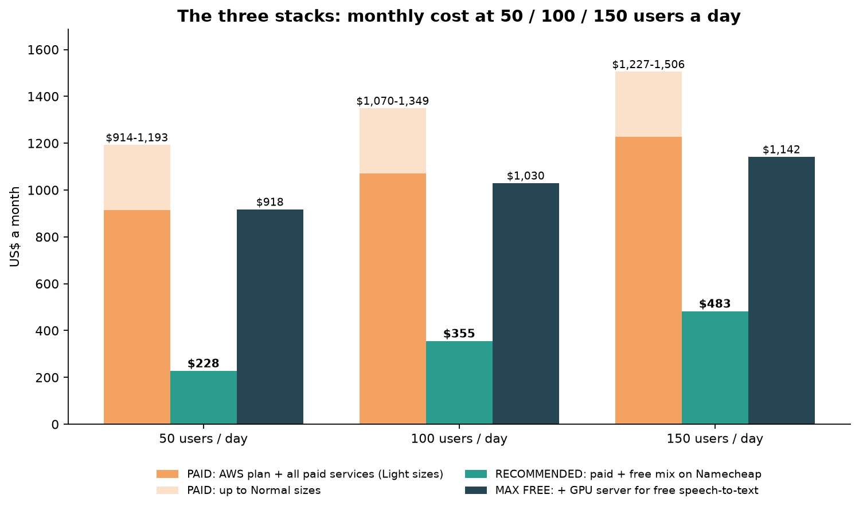

Table E: service by service, paid vs free
Service | Paid (plan) 💲 L / N / H | Free platform | Free cost | Saving L / N / H 🔢 | Verdict
Voice (STT + TTS + transport) | 91 / 279 / 930 | faster-whisper + Piper + LiveKit | GPU server $721 | -630 / -442 / +209 | paid wins unless Heavy
Text-to-speech only | 27 / 135 / 450 | Piper on CPU | $0 extra | +27 / +135 / +450 | free wins (no ta / si)
Voice transport only | 50 / 75 / 250 | LiveKit server | $0 extra | +50 / +75 / +250 | free wins
Alert calls | 10 / 46 / 152 | Asterisk | $0 + minutes | ≈ +0.07 / +0.36 / +1.20 | no real saving
Email | 17 / 19 / 22 | Postal + Stalwart | $0 extra | +17 / +19 / +22 | works; delivery risk
Firewall | 10 / 11 / 14 | SafeLine | $0 extra | +10 / +11 / +14 | free wins
AI tracing | Langfuse Cloud 29 / 47 / 105 | Phoenix | $0 extra | +29 / +47 / +105 | free wins
Knowledge search | plan container 44 | BGE-M3 | $0 extra | +44 | free wins
Database + cache | RDS + ElastiCache 168 / 370 / 459 | PostgreSQL + Redis | $0 extra | +168 / +370 / +459 | free wins; you do backups
AI brain, WhatsApp | 49-735, 26-756 | none | — | 0 | stay paid

"$0 extra" = no extra cost on a server you already pay for; the server ($83.88/month) is counted once, in Tables B and C.
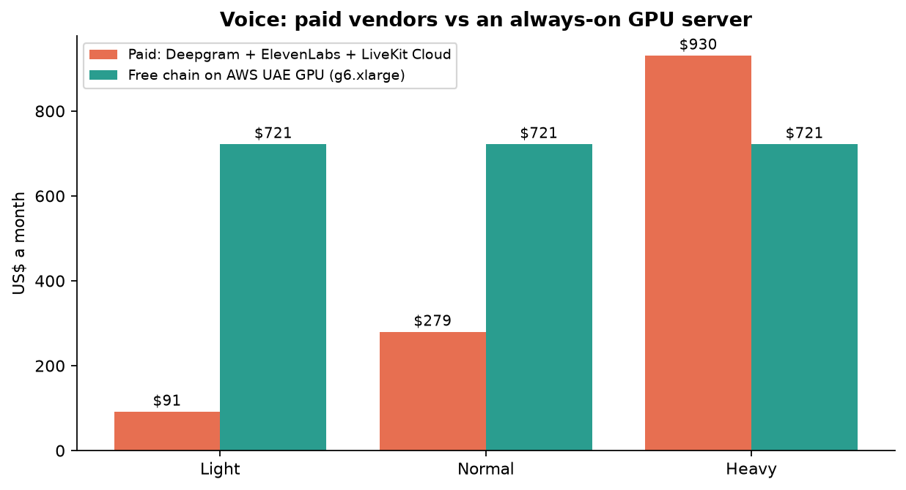
Voice is the one place where "free" needs expensive hardware.
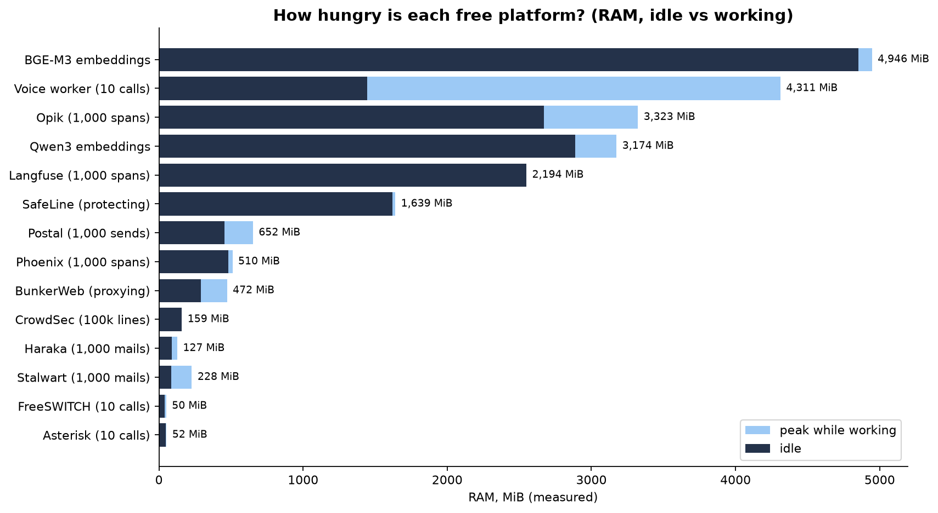
🏆 The bottom line
The recommended mix costs $228.00 / $355.34 / $482.72 a month at 50 / 100 / 150 users a day: about a quarter to a third of the all-paid AWS plan.
Going fully free is *more* expensive at these volumes, because free speech-to-text needs a GPU server.
The saving comes from hosting and from self-hosting the light services (database, cache, knowledge search, tracing, firewall, voice transport, text-to-speech). Claude, WhatsApp and phone minutes stay paid in every stack.
What you give up: UAE data location, two-zone failover, managed backups and monitoring. Arifa must approve the US location first.

Glossary (plain words)
Word | Meaning
AI turn | One buyer message and the AI's answer to it
RAM / GiB / MiB | Short-term memory; 1 GiB ≈ 1,074 MB, 1 MiB ≈ 1.05 MB
Core / vCPU | One worker inside the processor; "0.5 core" = half of one, busy all the time
p50 / p95 / max | Half / 95 % of answers were faster than this; max = the slowest
RTF (real-time factor) | Seconds of work per second of audio: 0.04 = 25× faster than talking; above 1 = too slow live
GPU / VRAM | Graphics card and its memory; speech AI runs 20× faster on it
Container / image | A packaged program (image, on disk) and a running copy of it (container)
Webhook | A message another service (like Meta) sends to your server when something happens
SIP / SIP trunk / G.711 | Internet phone calls / the paid line to real phones / the standard phone audio format
WAF | Web Application Firewall: the guard that checks every web request
Embedding / vector | 1,024 numbers that capture a sentence's meaning
MRR | How high the right answer was ranked on average (1.0 = always first)
Span / trace | One recorded AI call / a group of calls for one answer
DKIM | A digital stamp proving an email came from your domain
JMAP / IMAP | Ways for programs to read a mailbox
Coolify | A free dashboard that deploys and watches your apps on your own server

Where everything is
- This guide: resource-usage-bench/docs/Kairox_Free_Stack_Guide.docx (rebuild: scripts/guide/diagrams.py, then build_guide.py).
- Detailed text: docs/RESOURCE_USAGE.md, docs/RANK.md, round files docs/R1_RESULTS.md … R6_R8_RESULTS.md.
- Raw data: results/. Cost scripts: scripts/rank_costs.py, scripts/users_per_day_costs.py. Sources: repos/SOURCES.md.
- Prices: the repo's price documents, AWS's price list files, namecheap.com configure pages (indexed), coolify.io.

