PDFVault
Product Requirements Document — Sign-In, Onboarding & PDF Composer Revamp
Prepared for: Development Team
Prepared by: Huzaifa Habib
Date: 31 July 2026
Reference product: PDF Guru (pdfguru.com) — used as the UX benchmark for export & checkout flows

1. Purpose
This document specifies a set of UX and flow changes across PDFVault's authentication screens, document/tool upload paths, dashboard, and the PDF Composer. It is based on a walkthrough of the live product on 31 July 2026, with current-state screenshots captured directly from pdfvault.ai, and reference screenshots from PDF Guru showing the target pattern for the export and checkout flow. Each section below lists the current behavior, the required behavior, and concrete acceptance criteria.

2. Summary of Changes
Area | Current Behavior | Required Change
Sign In | Google button + separate email/password fields. Title “Login to PDFVault”, subtitle present, button labeled “Sign In”. | Single sign-on: Google, or email + “Continue” → 6-digit email code. No password field. Title “Welcome back to PDF Vault”, no subtitle.
Sign Up | Google button + Name, Email, Password fields. Password needs 8 characters, upper, lower, number, symbol (5 separate checks). | Google button + Email + Password only. No Name field. Password rule simplified to one line: 8+ characters, alphanumeric.
Document Upload (Tools section) | Picking a specific tool (Edit, Sign, Watermark, Organize Pages, etc.) leads to upload, then always opens the generic PDF Composer. | After upload, land directly in the specific tool the user picked, not the generic composer.
Dashboard | Same as above — tool cards (PDF to Word, Organize Pages, etc.) open the generic composer after upload. | Same fix as Document Upload: route straight into the selected tool's dedicated screen.
PDF Composer – Speed | Upload/processing speed is inconsistent. | Upload and processing should be consistently fast.
PDF Composer – Navigation | No back control in the top bar. | Add a back arrow/button in the top bar (web and mobile) to return to the Dashboard.
PDF Composer – Export controls | Single “Download” button, top right. | Three controls: Print icon, Download icon, and a prominent “Done” button — all opening a format-choice modal (PDF, Word, JPEG, PNG).
PDF Composer – Checkout | Direct download, no paywall step. | After format selection, show a plan/checkout screen modeled on PDF Guru before the file downloads.

3. Authentication — Sign In
CURRENT STATE
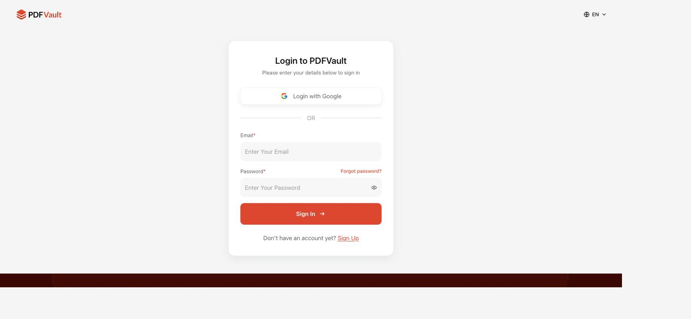
Current sign-in screen — pdfvault.ai/sign-in (captured 31 Jul 2026)
3.1 Problem
- The page mixes two competing sign-in paths: a “Login with Google” button and a separate email + password form. This isn't a true single sign-on (SSO) experience — it just offers Google as an alternative to a password.
- Terminology is inconsistent on this single screen and across the auth flow: the page title says “Login,” the button says “Sign In,” and the link at the bottom says “Sign Up.”
3.2 Required Behavior
- Replace the password-based flow with single sign-on:
  - Keep “Continue with Google” as a one-click option.
  - For the email path: user enters their email and taps “Continue.” Remove the password field from this screen entirely.
  - If the email belongs to an existing account, advance to a second screen requesting a 6-digit verification code that PDFVault emails to that address (email OTP / 2FA).
  - On correct code entry, log the user in and redirect to the Dashboard.
- Copy changes on this screen:
  - Title: “Login to PDFVault” → “Welcome back to PDF Vault.”
  - Remove the subtitle “Please enter your details below to sign in” — no replacement subtitle needed.
  - Primary button label: “Sign In” → “Continue.”
  - Standardize on one term for this action throughout the auth flow (recommend “log in”) instead of mixing “log in” and “sign in.”
3.3 Acceptance Criteria
- Sign-in screen shows: Google button, email field, “Continue” button. No password field is visible on this screen.
- Submitting a registered email advances to a 6-digit code entry screen; the code is emailed to that address.
- Entering the correct 6-digit code logs the user in; an incorrect code shows an inline error and allows retry / resend.
- Title reads “Welcome back to PDF Vault”; no subtitle text is present below it.
- All auth screens use consistent terminology (no mix of “log in” / “sign in” on the same or adjacent screens).

4. Authentication — Get Started / Sign Up
CURRENT STATE
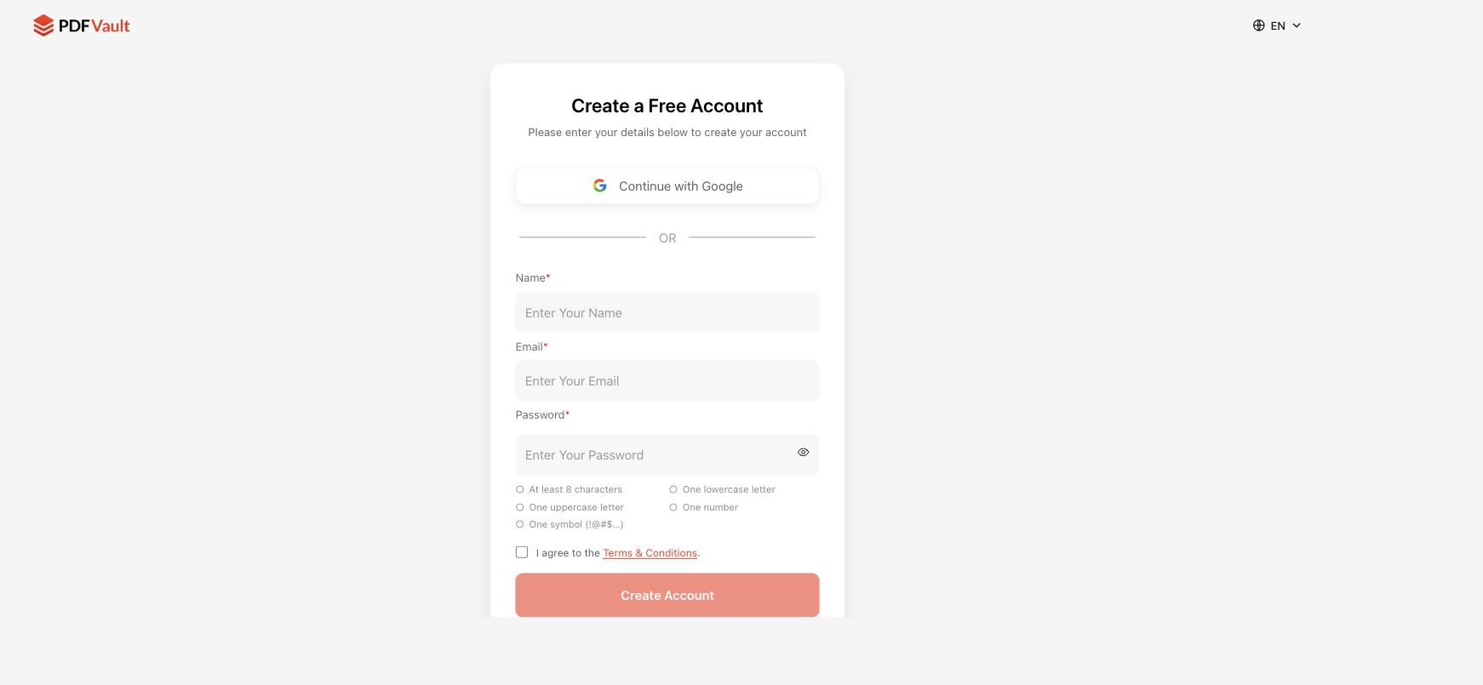
Current sign-up screen — pdfvault.ai/sign-up (captured 31 Jul 2026)
4.1 Problem
- The sign-up form is cluttered: Name, Email, and Password fields, plus five separate live-validation checks for the password (8 characters, lowercase, uppercase, number, symbol).
- The Name field is unnecessary friction for account creation.
4.2 Required Behavior
- Simplify to a minimal sign-up form:
  - “Continue with Google” button (one-click path), same as sign-in.
  - Remove the Name field entirely.
  - Keep Email and Password as the only two fields for the non-Google path.
  - Replace the five separate password validation indicators with a single helper line: “Password must be at least 8 characters, letters and numbers (alphanumeric).” No requirement for uppercase, symbols, etc.
4.3 Acceptance Criteria
- Sign-up form fields, top to bottom: “Continue with Google,” Email, Password. No Name field.
- Only one password rule is shown to the user: minimum 8 characters, alphanumeric. The five-chip checklist (uppercase/lowercase/number/symbol/length) is removed.
- Password validation logic server-side is updated to match (accepts any 8+ character alphanumeric password; does not require symbols or mixed case).

5. Document Upload — Tool-Specific Routing
CURRENT STATE
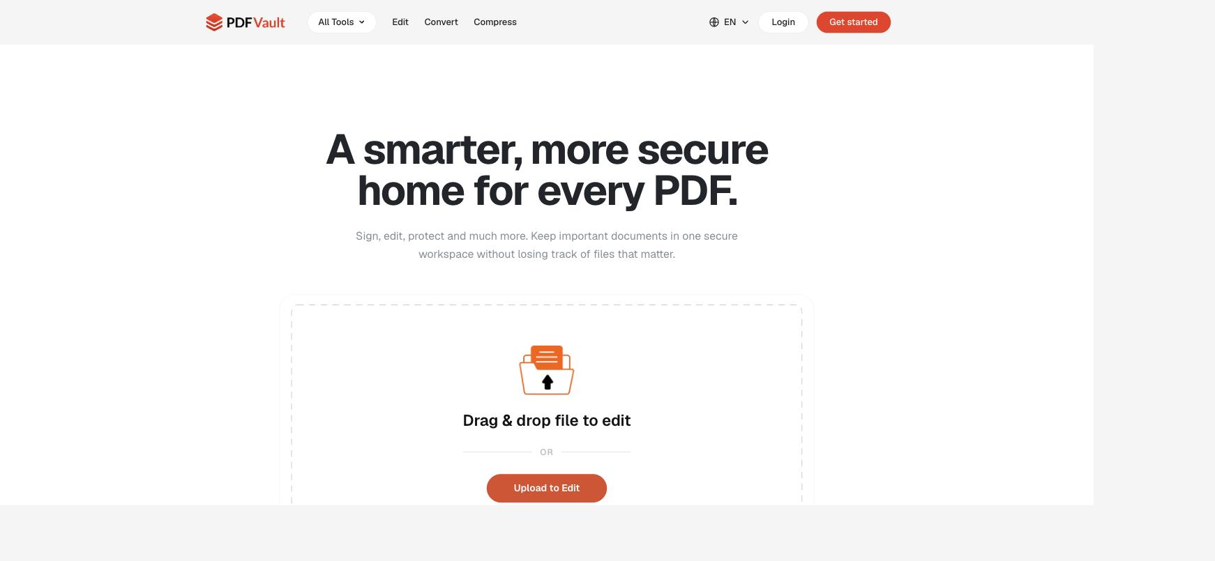
Homepage upload panel — pdfvault.ai (captured 31 Jul 2026)
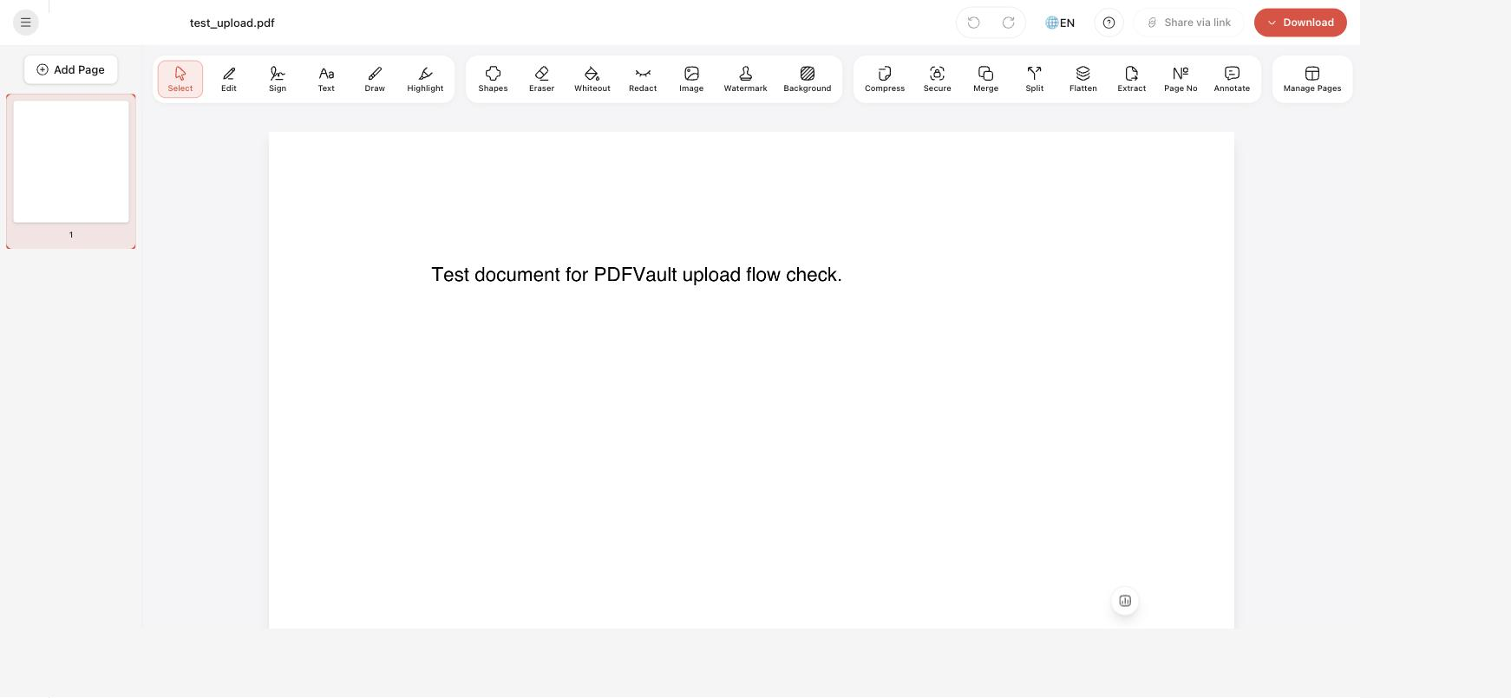
Result after uploading from a specific tool: the generic PDF Composer opens, not the requested tool (verified by uploading a test file directly — 31 Jul 2026)
5.1 Problem
- The base upload experience (drag & drop / “Upload to Edit” on the homepage) works fine on its own.
- However, when a user scrolls to the Tools section and picks a specific tool — e.g. Edit, Sign, Watermark, or Organize Pages — they're taken to an upload screen, and after uploading, they land in the same generic PDF Composer (shown above) instead of the specific tool they selected.
5.2 Required Behavior
- Each tool entry point must remember which operation the user picked.
- After the file finishes uploading, route the user straight into that specific operation's screen (e.g. picking “Organize Pages” opens the page-reorder view directly; picking “Sign & Watermark” opens the sign/watermark view directly) — not the general-purpose composer with every tool icon shown.
5.3 Acceptance Criteria
- For every tool entry point (Edit, Sign, Watermark, Organize Pages, and any others listed in the Tools section), uploading a file lands the user on that tool's dedicated screen, pre-configured for that action.
- The generic composer view (all tool icons visible) is only shown when the user uploads from the generic “Upload to Edit” entry point on the homepage, not from a specific tool link.

6. Dashboard — Tool-Specific Routing
CURRENT STATE — DESCRIBED (screenshot requires an authenticated session; see note)
The Dashboard's “My PDFs” view shows a grid of tool shortcuts — PDF to Word, Word to PDF, Edit PDF, Sign & Watermark, Organize Pages, and Protect PDF — above the saved-files table. This mirrors the Tools section described in Section 5.
6.1 Problem
- Same issue as Section 5: clicking any tool card in the Dashboard (PDF to Word, Organize Pages, etc.) uploads a file and opens the generic PDF Composer instead of the specific operation the card advertises.
6.2 Required Behavior
- Apply the same fix as Section 5 to every card in the Dashboard's tool grid: after upload, route directly into that card's specific tool screen.
6.3 Acceptance Criteria
- Clicking each Dashboard tool card, uploading a file, and landing on the matching dedicated tool screen (not the generic composer) is verified for all six cards: PDF to Word, Word to PDF, Edit PDF, Sign & Watermark, Organize Pages, Protect PDF.

7. PDF Composer — Performance, Navigation & Export Flow
CURRENT STATE
Current PDF Composer top bar — only a single “Download” button and “Share via link,” no back control (captured 31 Jul 2026)
7.1 Upload / Processing Speed
- Problem: Upload and processing speed inside the Composer varies noticeably between files/sessions.
- Required: Investigate and address the cause of the variable speed so that upload/processing time is consistently fast regardless of file or session.
7.2 Back Navigation
- Problem: The top menu bar has no way to return to the Dashboard from inside the Composer — the user is stuck unless they use the browser/app back gesture.
- Required: Add a back button (arrow icon) to the top menu bar, on both the mobile and web layouts, that returns the user to the Dashboard.
7.3 Export Controls (top-right)
- Problem: The top-right of the Composer currently shows a single “Download” button.
- Required: Replace it with three controls, modeled directly on PDF Guru's pattern shown below:
  - A Print icon (print symbol).
  - A Download icon.
  - A large, prominent button with a Done / checkmark symbol.
- All three controls open the same modal, letting the user choose the export format: PDF, Word, JPEG, or PNG.

PDF Guru reference — icon pattern for the composer's top-right action bar (Search / Print / Download / Share / Done)
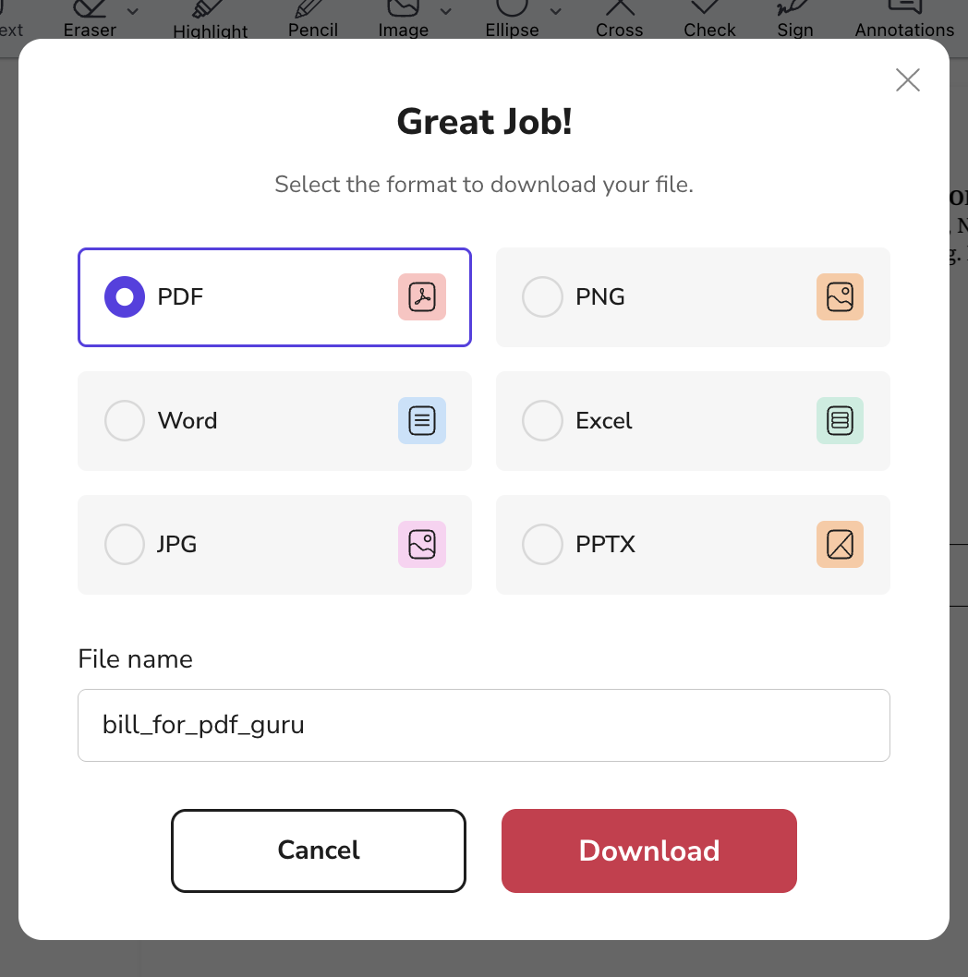
PDF Guru reference — format-selection modal shown after Print, Download, or Done is tapped
7.4 Checkout / Paywall Flow
- Problem: Today, choosing a format downloads the file directly with no monetization step.
- Required: After the user picks a format and confirms, show a plan-selection / checkout screen — modeled on PDF Guru's flow below — before the download completes. This should present a document preview alongside plan tiers (e.g. a short-access trial, a “Most popular” full-access plan, and an annual plan) with a feature checklist per tier.
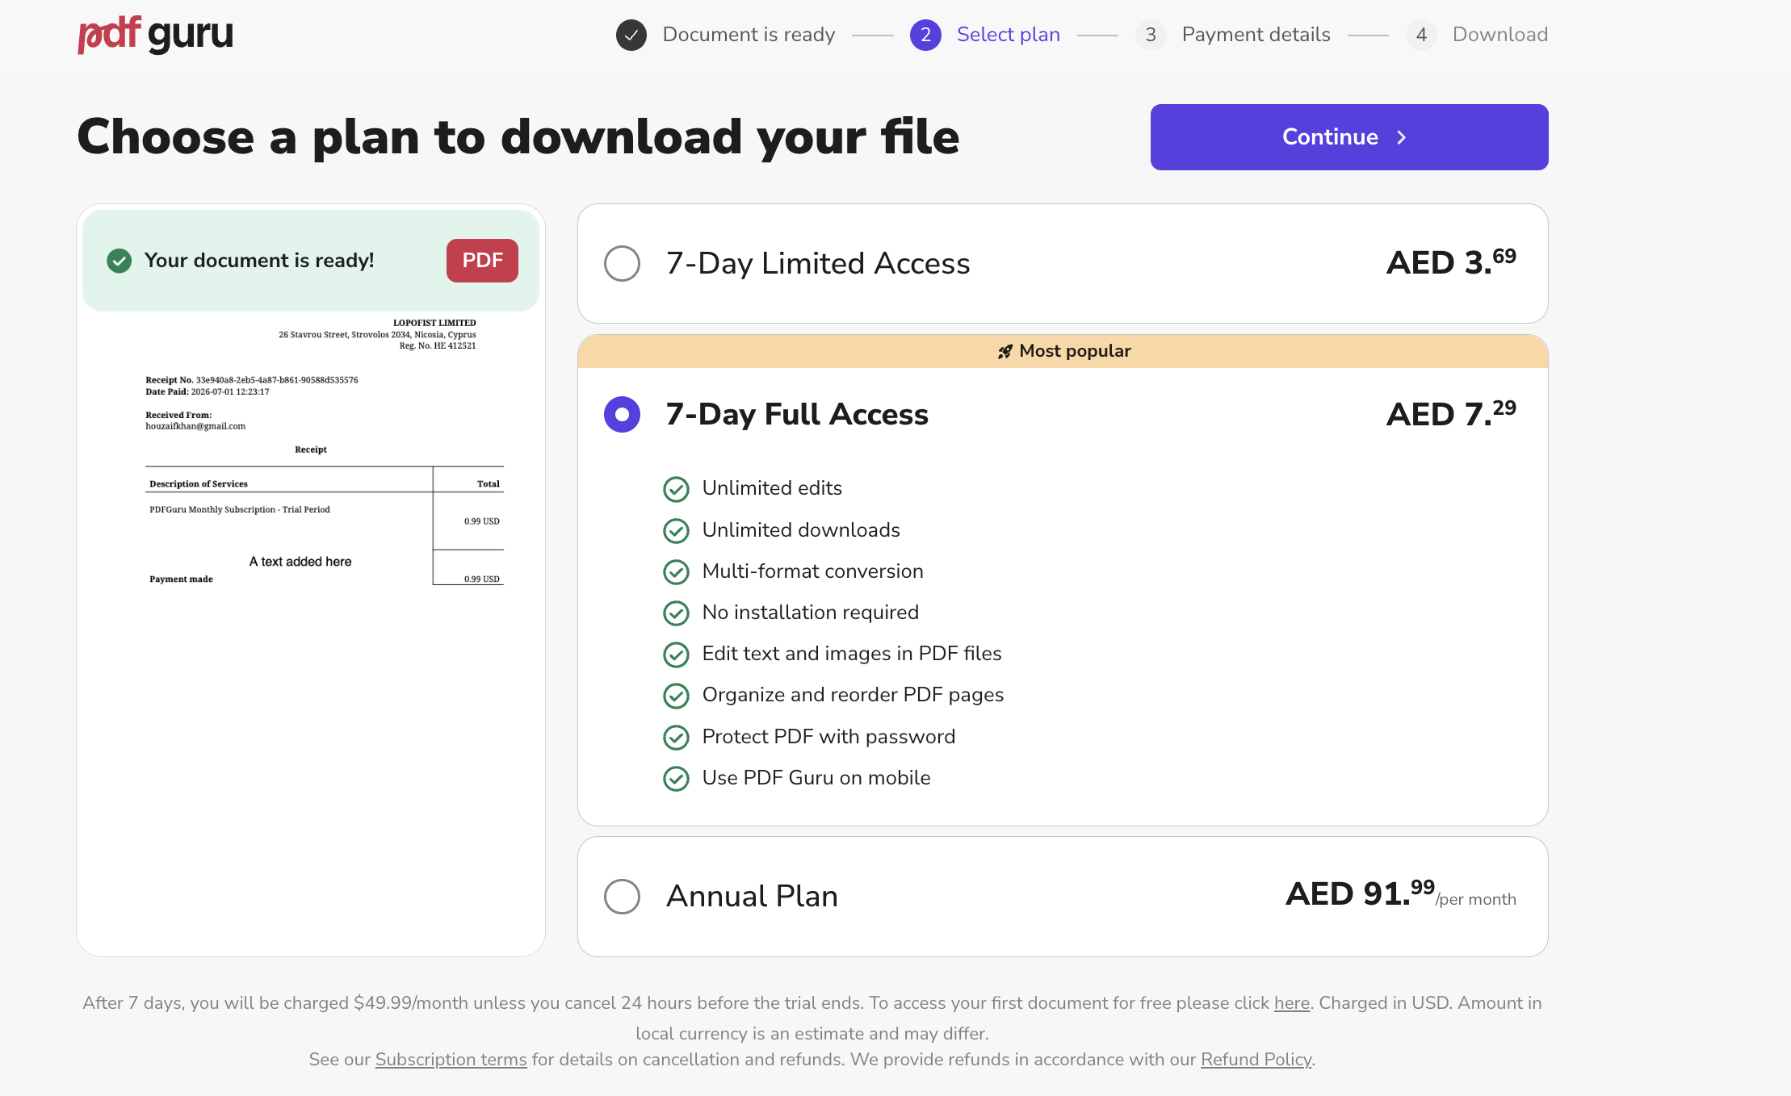
PDF Guru reference — “Choose a plan to download your file” checkout screen, shown after format selection
7.5 Acceptance Criteria
- Composer upload/processing time is consistently within an agreed target range across test files (to be benchmarked against current best-case performance).
- A back arrow is present in the Composer's top bar on both web and mobile, and returns the user to the Dashboard.
- The top-right of the Composer shows exactly three controls: Print, Download, Done — matching the reference icon set.
- Tapping any of the three opens a single format-selection modal offering PDF, Word, JPEG, PNG.
- Confirming a format in that modal routes to a checkout/plan-selection screen before the file is made available for download.

8. Open Questions for Engineering
- 2FA delivery: confirm email OTP provider/service and code expiry window (e.g. 10 minutes).
- Pricing: exact plan names, prices, and feature lists for the new checkout screen are not finalized in this document — to be confirmed by product/marketing before implementation of Section 7.4.
- Whether the simplified alphanumeric password rule (Section 4.2) requires a minimum-entropy check server-side beyond length.
- Scope of “specific tool routing” (Sections 5–6): confirm the full list of tool entry points beyond Edit, Sign, Watermark, Organize Pages, PDF to Word, Word to PDF, and Protect PDF.

Appendix A — Current-State Screenshots (pdfvault.ai, 31 Jul 2026)
A1. Sign-in screen
A2. Sign-up screen
A3. Homepage upload panel
A4. PDF Composer (generic view, current top bar)

Appendix B — PDF Guru Reference Screenshots
B1. Top-right icon pattern (Print / Download / Done)
B2. Format-selection modal
B3. Checkout / plan-selection screen

