

Bahria University, Islamabad

Department of Software Engineering

Artificial Intelligence Lab (Spring-2026)
Instructor: Engr. Saad Mazhar

Student: Muhammad Hamza
Enrollment: 01-131232-057

Lab Journal: 03
Date: 20-02-2026

Task No: | Task Wise Marks |  | Documentation Marks |  |  | Total Marks  (20)
Task No: | Assigned | Obtained | Assigned | Obtained |  | Total Marks  (20)
1
2
3
4
5
Comments:

Signature

LAB # 03
OOP in Python (Part-4) (Functions, Classes, Inheritance, Polymorphism)
Github Link:
Objective
To learn the basics concepts of the oops and their syntax and the basic logic.
Task1:
Create a base class Shape with an abstract method calculate_area(). Implement the calculate_area() method in the following subclasses:
- Rectangle (Length × Width)
- Square (Side²)
- Circle (π × Radius²)
- Cylinder (2πr(r + h))
Test your classes by creating objects for each shape and calculating their areas.
Code Link:
https://github.com/muhammadhamza7057/Machine-Learning-Mastery/blob/main/Lab-03/Task-01.py
Screenshot:

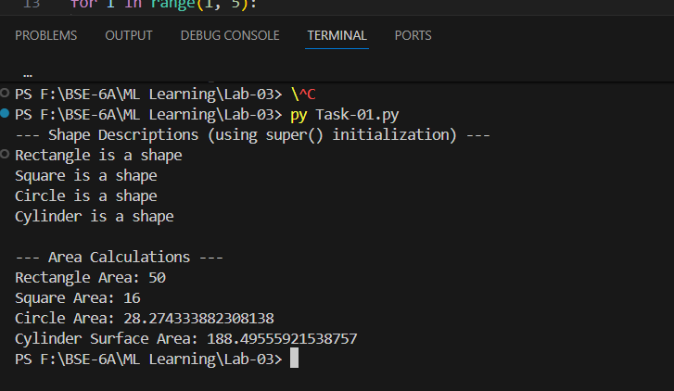

Tasks:
- Implement a lambda expression to calculate square of given number.
- Implement a lambda expression to calculate the length of passed string.
- Create a generator function that returns 5 random numbers between 1 and 100. Use a for loop to print the numbers.
- Implement a generator function that returns the Fibonacci sequence up to a given limit n. Use a for loop to print the sequence.
Code Link:
https://github.com/muhammadhamza7057/Machine-Learning-Mastery/blob/main/Lab-03/Lamda-func.py
Screenshot:
