

Bahria University, Islamabad

Department of Software Engineering

Artificial Intelligence Lab (Spring-2026)
Instructor: Engr. Saad Mazhar

Student: Muhammad Hamza
Enrollment: 01-131232-057

Lab Journal: 05
Date: 03-03-2026

Task No: | Task Wise Marks |  | Documentation Marks |  |  | Total Marks  (20)
 | Assigned | Obtained | Assigned | Obtained
1
2
3
4
5
Comments:

Signature

LAB # 05
Implementing Graph Algorithms (Part-2) (A*)
Github Link: https://github.com/muhammadhamza7057/Machine-Learning-Mastery/tree/main/Lab-05
Objective
To learn the basics concepts of the DFS, BFS & A* Graphs and their implementations and the basic logic.

Graphs Diagrams:
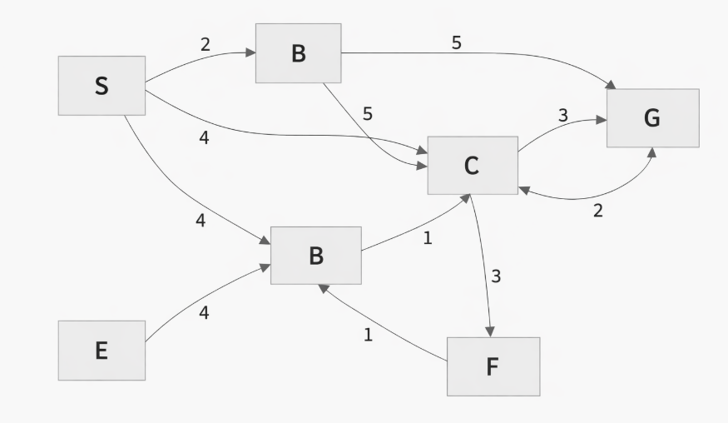
Tasks 1:
represents this graph in code (adjacency list)
Code:
https://github.com/muhammadhamza7057/Machine-Learning-Mastery/blob/main/Lab-05/Task-01.py
Screenshots:
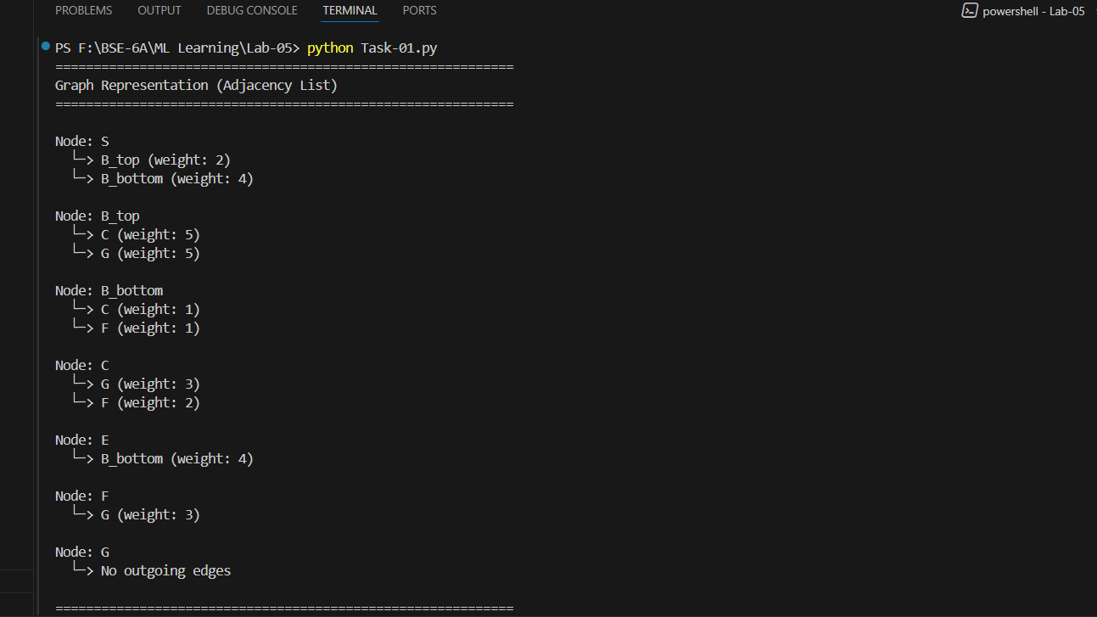

Tasks 2:
implements DFS and BFS to find any valid path from S to G by treating every edge as unweighted (ignore weights for DFS/BFS)
Code:
https://github.com/muhammadhamza7057/Machine-Learning-Mastery/blob/main/Lab-05/Task-02.py
Screenshots:
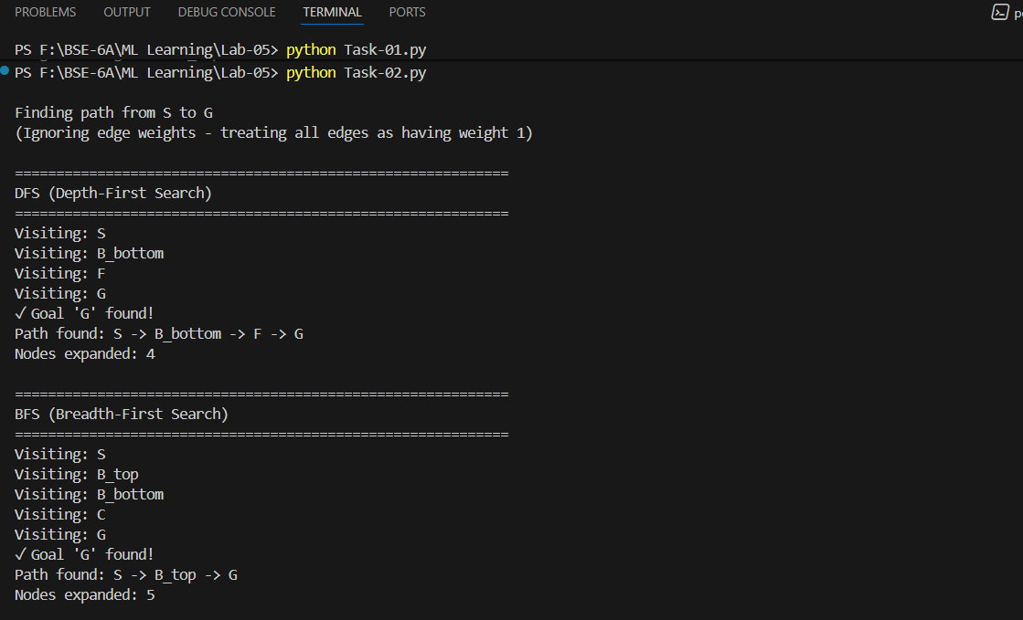

Tasks 3:
Implements A* to find the minimum-cost path from S to G using the given edge weights and a heuristic function you define and justify (e.g., h(n)=0 to reduce to Dijkstra, or a simple admissible estimate based on node layout)
Code:
https://github.com/muhammadhamza7057/Machine-Learning-Mastery/blob/main/Lab-05/Task-03.py
Screenshots:
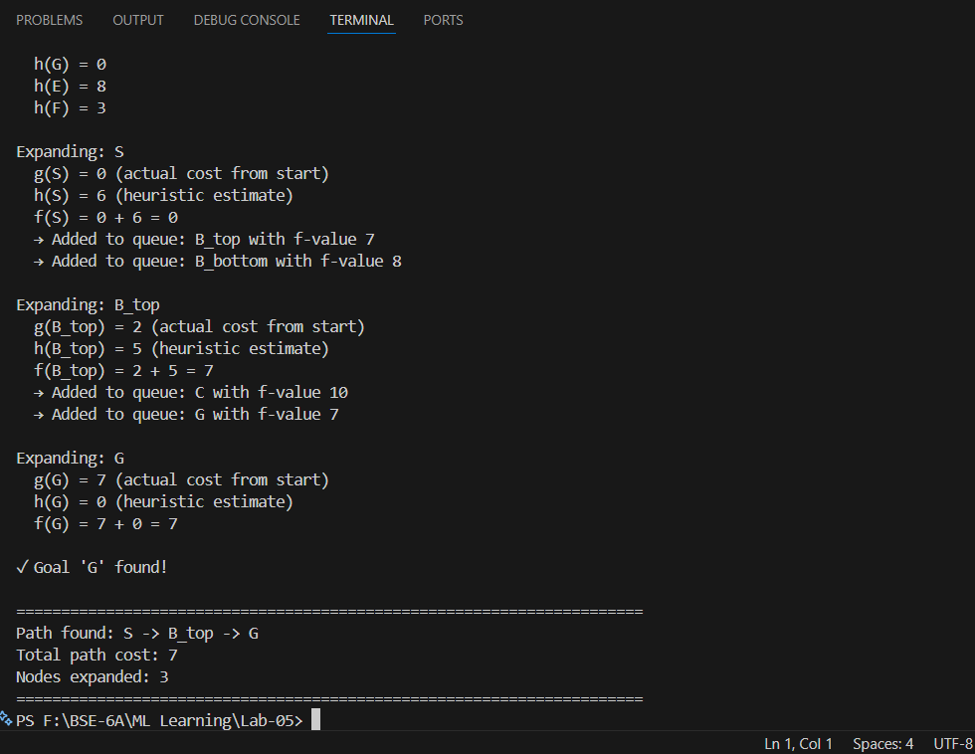
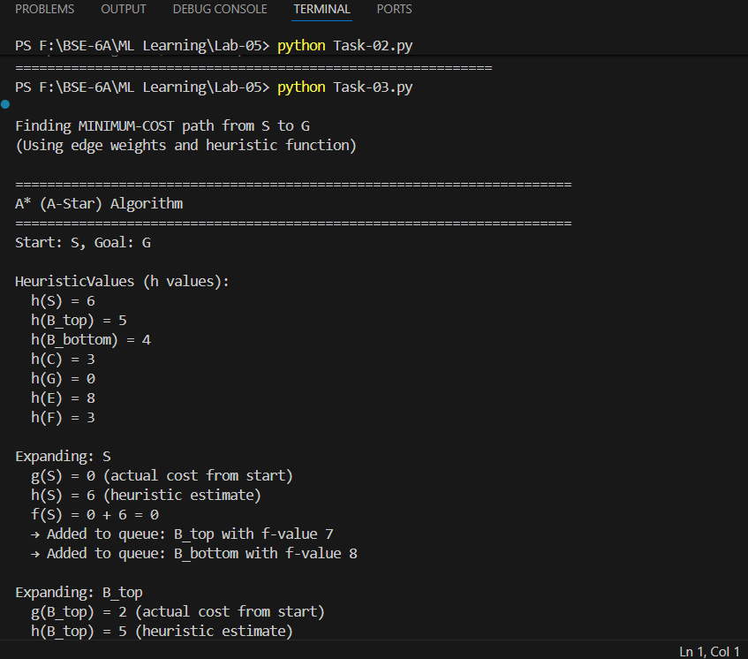
Figure 1.1
Figure 1.0

Tasks 4:
prints for each algorithm the final path and the number of expanded nodes (and for A* also print the total path cost)
Code:
https://github.com/muhammadhamza7057/Machine-Learning-Mastery/blob/main/Lab-05/Task-04.py
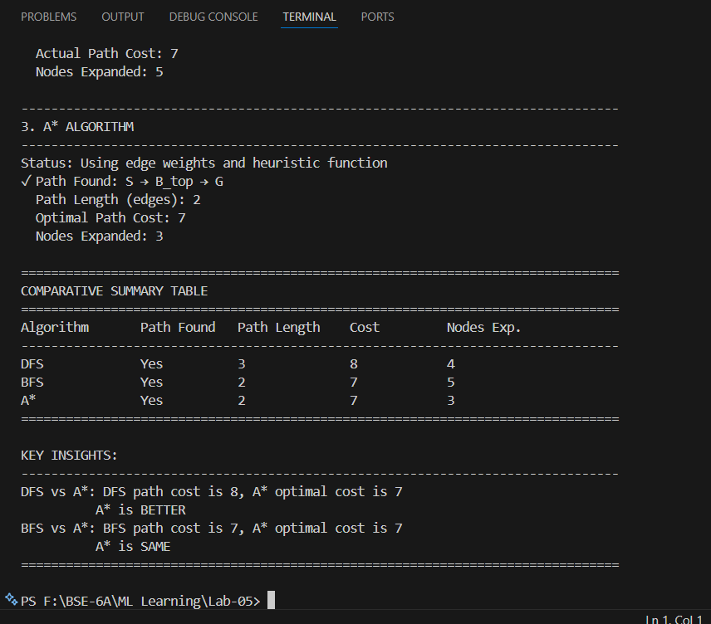
Screenshots:
Figure 2.2
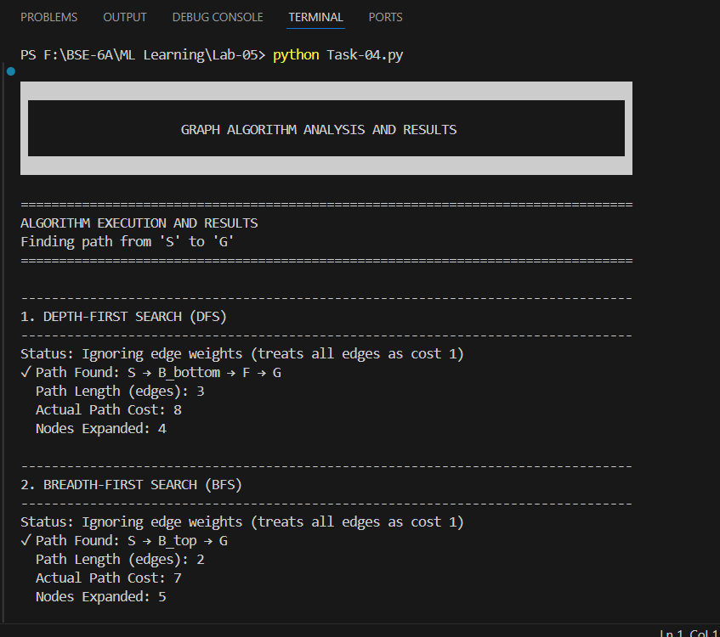
Figure 2.1

Tasks 5:
writes a short comparison that clearly differentiates DFS vs BFS vs A* in terms of data structure used (stack/queue/priority queue), completeness, optimality, time complexity, space complexity, and when each should be used in real applications.

Code:
https://github.com/muhammadhamza7057/Machine-Learning-Mastery/blob/main/Lab-05/Task-05.py
Output:

They have all comparisons so for that reason I cannot attached all the screenshots because they have almost 8 screenshots. Kindly Click on the Github link and see all comparisons.

