

Bahria University, Islamabad

Department of Software Engineering

Artificial Intelligence Lab (Spring-2026)
Instructor: Engr. Saad Mazhar

Student: Muhammad Hamza
Enrollment: 01-131232-057

Lab Journal: 06
Date: 18-03-2026

Task No: | Task Wise Marks |  | Documentation Marks |  |  | Total Marks  (20)
 | Assigned | Obtained | Assigned | Obtained
1
2
3
4
5
Comments:

Signature

LAB # 06
A 8-Puzzle Agent*
Github Link:
https://github.com/muhammadhamza7057/Machine-Learning-Mastery/tree/main/Lab-09
Objective:
- Design a goal-based intelligent agent to solve the 8-Puzzle problem.
- Implement the A* search algorithm for optimal path finding.
- Use heuristic evaluation \(f(n)=g(n)+h(n) ) to guide decision-making.
- Generate and evaluate successor states to reach the goal state efficiently.
- Display the optimal solution path and total moves (cost).

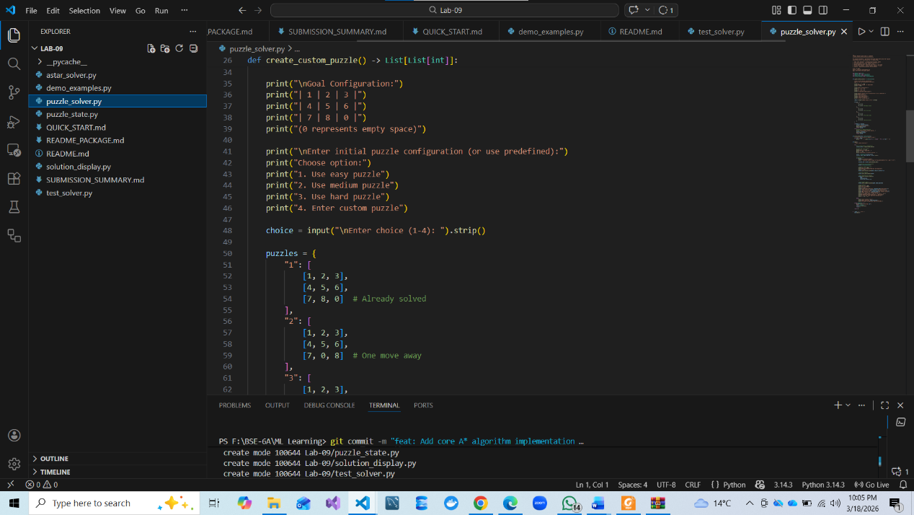
Code:

- For the remaining code visit to Github repository I have mentioned above.

Screenshots:
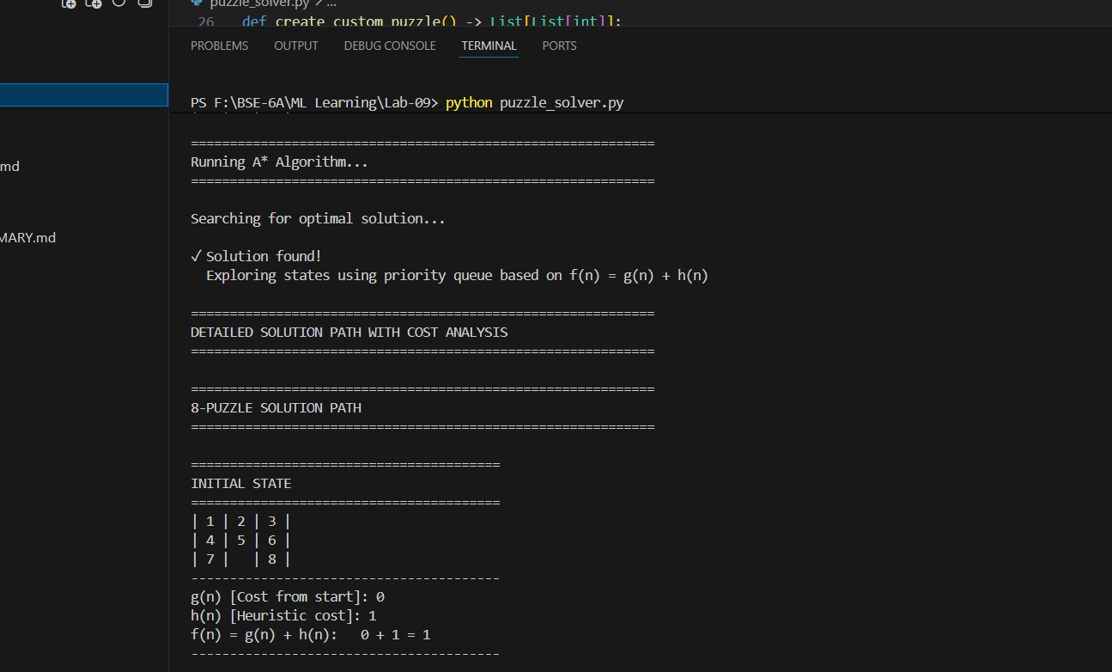
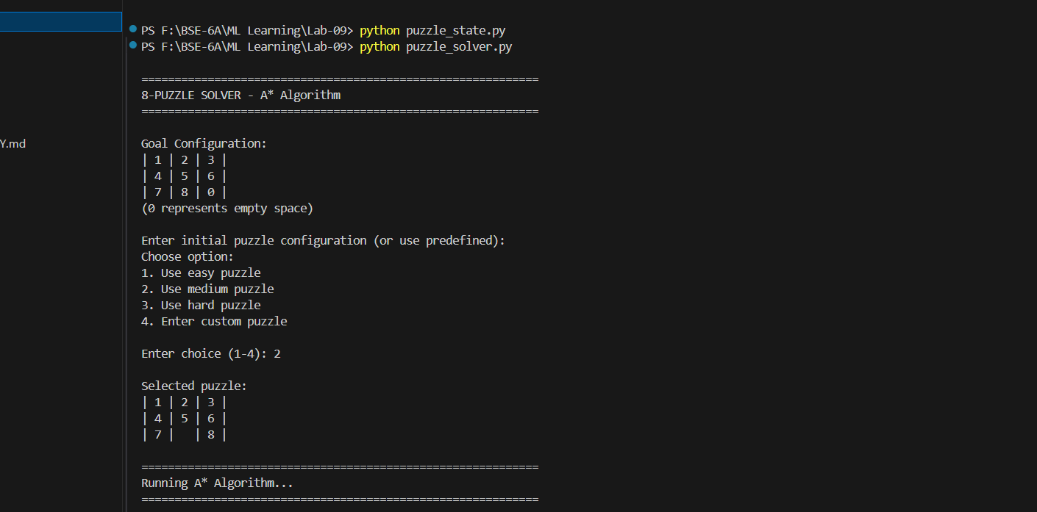
Figure 2
Figure 1

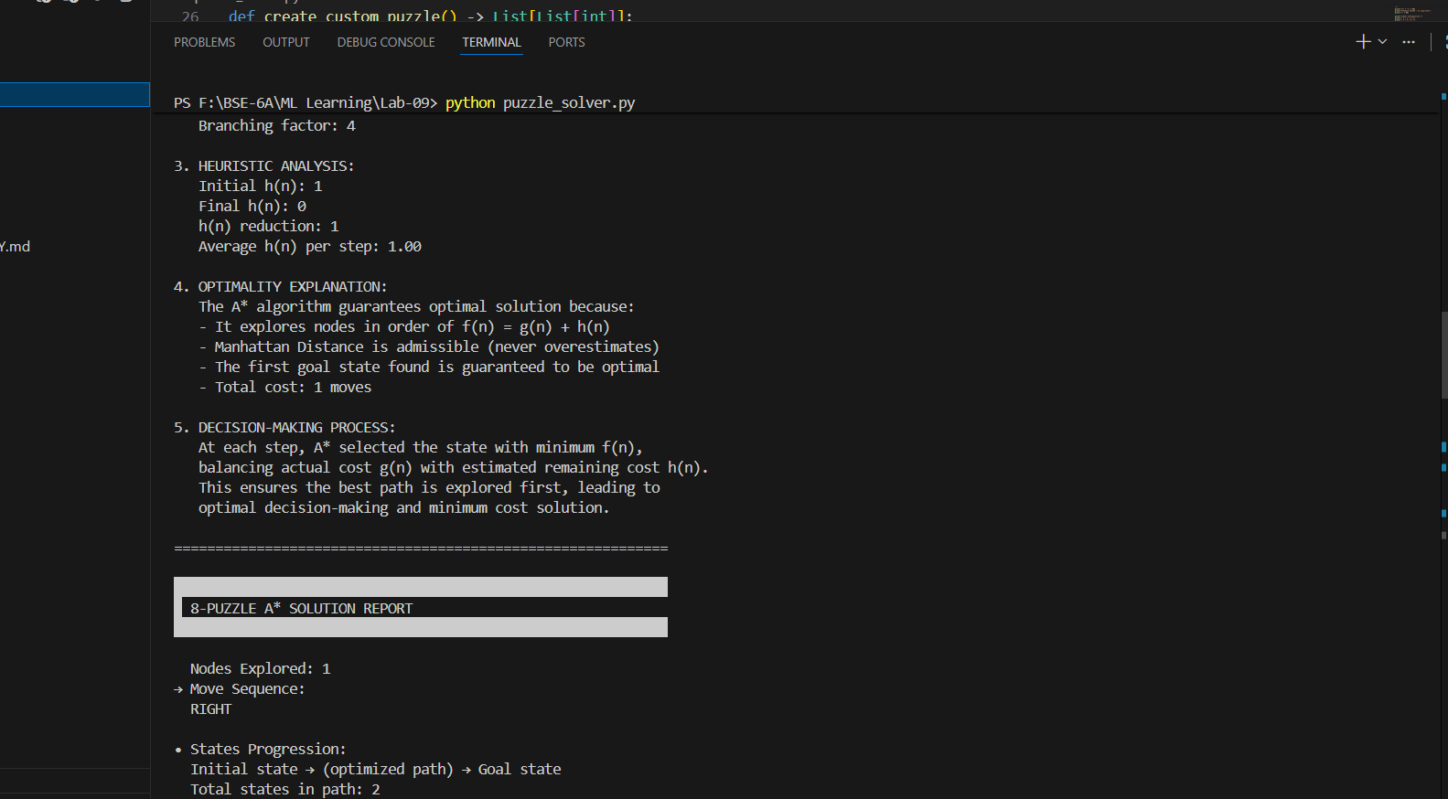
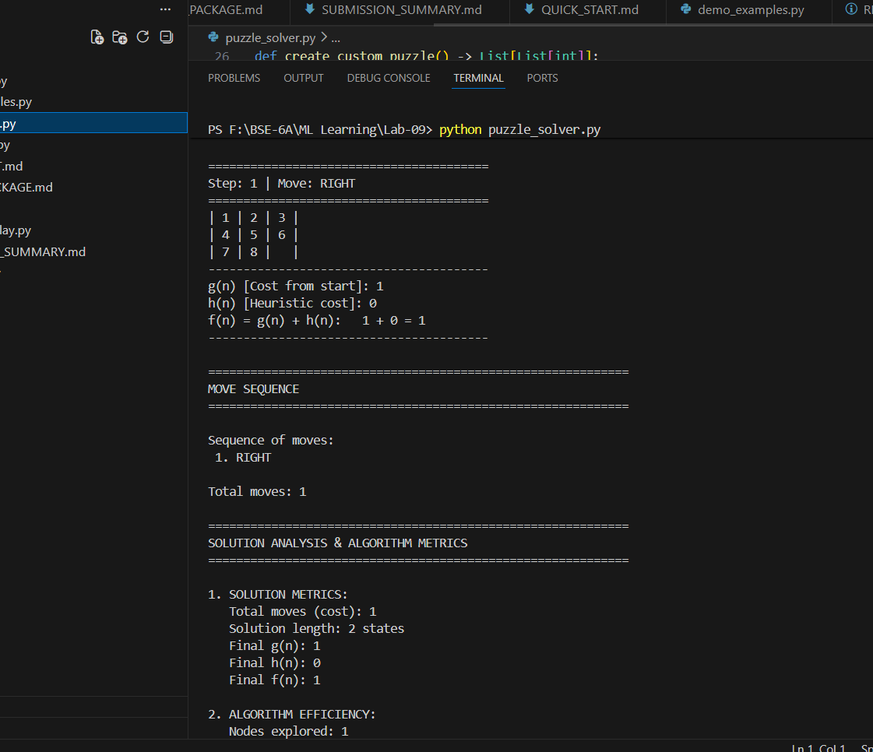
{THE END}
Figure 4
Figure 3

