

Bahria University, Islamabad

Department of Software Engineering

Artificial Intelligence Lab (Spring-2026)
Instructor: Engr. Saad Mazhar

Student: Muhammad Hamza
Enrollment: 01-131232-057

Lab Journal: 04
Date: 24-02-2026

Task No: | Task Wise Marks |  | Documentation Marks |  |  | Total Marks  (20)
 | Assigned | Obtained | Assigned | Obtained
1
2
3
4
5
Comments:

Signature

LAB # 04
Implementing Graph Algorithms (Part-1) (DFS, BFS)
Github

Link: https://github.com/muhammadhamza7057/Machine-Learning-Mastery/tree/main/Lab-04
Objective
To learn the basics concepts of the Graphs and their implementations and the basic logic.
Tasks:
Using the graph below graph code implements BFS and DFS.
Code:
https://github.com/muhammadhamza7057/Machine-Learning-Mastery/tree/main/Lab-04
Screenshots:
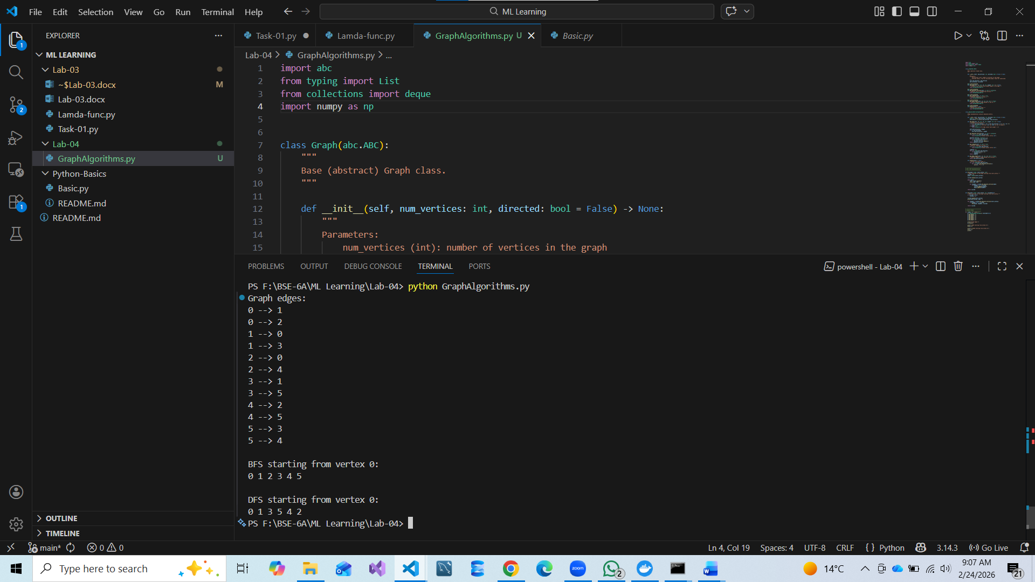

---{ THE END }---

