

Bahria University, Islamabad

Department of Software Engineering

Web Engineering Lab (Spring-2026)
Instructor: Engr. Subas Bilal

Student: Muhammad Hamza
Enrollment: 01-131232-057

Lab Journal: 02
Date: 03-02-2026

Task No: | Task Wise Marks |  | Documentation Marks |  |  | Total Marks  (20)
 | Assigned | Obtained | Assigned | Obtained
1
2
3
4
5
Comments:

Signature

LAB # 02
WORKING WITH HTML
Github Link:
https://github.com/muhammadhamza7057/Web-Engineering
Objective
What is New in HTML5?
Introduction
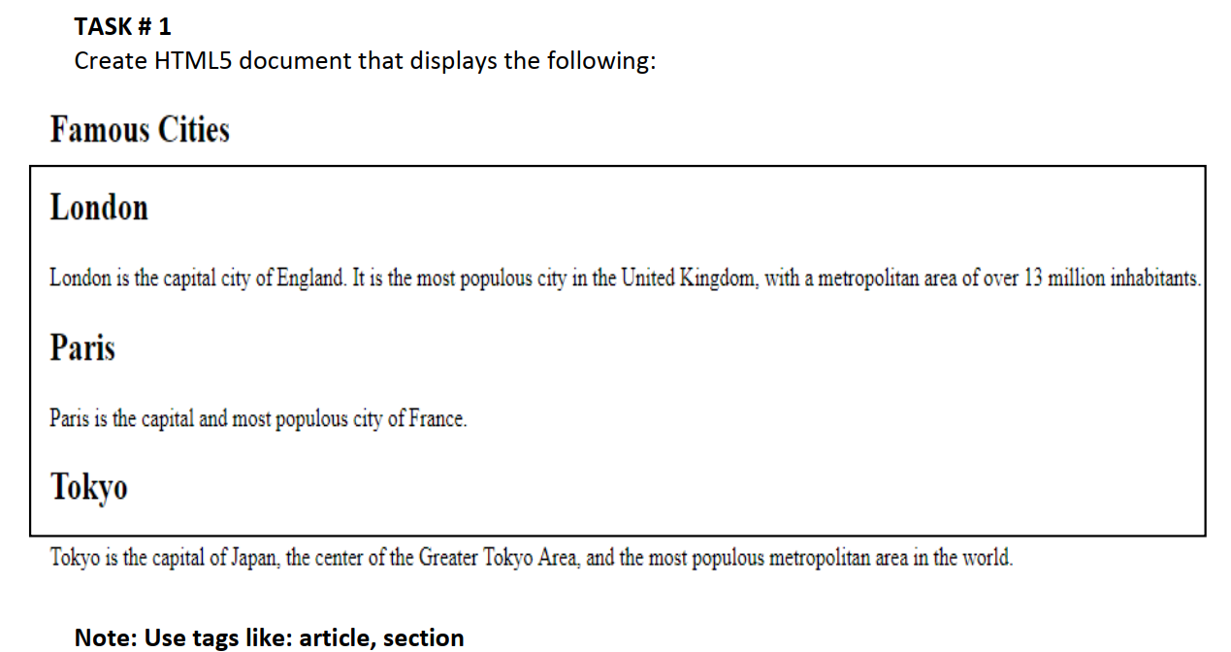
HTML5 is a markup language used for structuring and presenting content on the World Wide Web. It is the fifth and current major version of the HTML standard.

Code:
<!DOCTYPE html>
<html lang="en">
<head>
<meta charset="UTF-8">
<meta name="viewport" content="width=device-width, initial-scale=1.0">
<title>Day-02</title>
</head>
<body>
<h1>Famous Cites</h1>
<div>
<h1>London</h1>
<p><article>London is the capital city of England. Its history dates back to Roman times. The London Bridge is a famous landmark.</article></p>
<h1>Paris</h1>
<p>Paris is the capital of France, known for its art, fashion, and culture. The Eiffel Tower is one of its most iconic structures.</p>
<h1>New York</h1>
<p>New York City is the largest city in the USA. It is famous for its skyline, Broadway shows, and the Statue of Liberty.</p>

</div>
</body>
</html>

Screenshot:
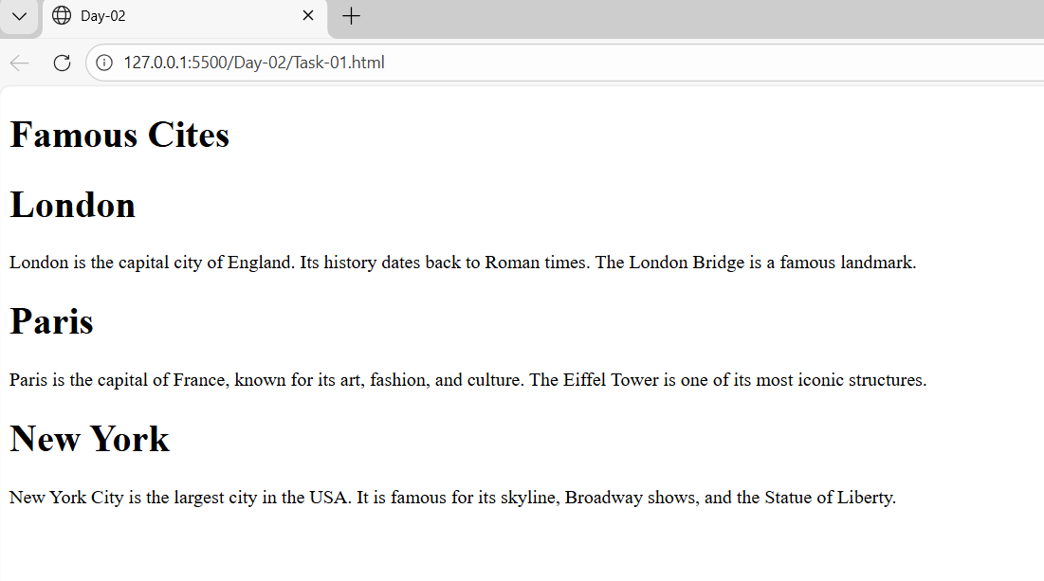
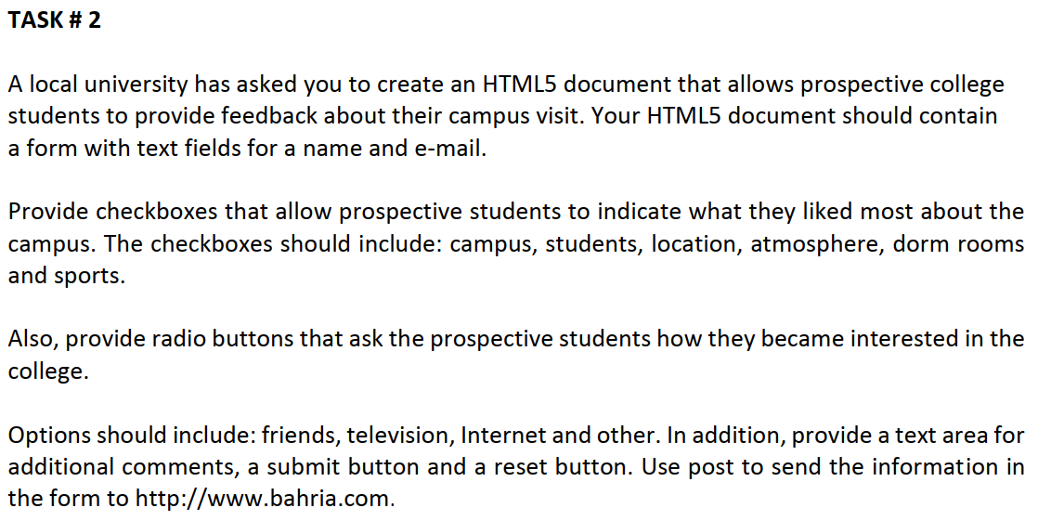
Code:
<!DOCTYPE html>
<html lang="en">
<head>
<meta charset="UTF-8">
<meta name="viewport" content="width=device-width, initial-scale=1.0">
<title>Day-02</title>
</head>
<body>
<h1>Campus Visit Feedback Form</h1>
<form action="http://www.bahria.com" method="post">
<!-- Name and Email Fields -->
<div>
<label for="name">Name:</label>
<input type="text" id="name" name="name" required>
</div>

<div>
<label for="email">E-mail:</label>
<input type="email" id="email" name="email" required>
</div>

<!-- Checkboxes for what they liked most -->
<div>
<label>What did you like most about our campus?</label>
<div>
<label>
<input type="checkbox" name="liked" value="campus">
Campus
</label>
<label>
<input type="checkbox" name="liked" value="students">
Students
</label>
<label>
<input type="checkbox" name="liked" value="location">
Location
</label>
<label>
<input type="checkbox" name="liked" value="atmosphere">
Atmosphere
</label>
<label>
<input type="checkbox" name="liked" value="dorm_rooms">
Dorm Rooms
</label>
<label>
<input type="checkbox" name="liked" value="sports">
Sports
</label>
</div>
</div>

<!-- Radio buttons for how they became interested -->
<div>
<label>How did you become interested in our college?</label>
<div>
<label>
<input type="radio" name="interest" value="friends" required>
Friends
</label>
<label>
<input type="radio" name="interest" value="television">
Television
</label>
<label>
<input type="radio" name="interest" value="internet">
Internet
</label>
<label>
<input type="radio" name="interest" value="other">
Other
</label>
</div>
</div>

<!-- Text area for additional comments -->
<div>
<label for="comments">Additional Comments:</label>
<textarea id="comments" name="comments" rows="5" placeholder="Please share any additional feedback..."></textarea>
</div>

<!-- Submit and Reset buttons -->
<div>
<button type="submit">Submit</button>
<button type="reset">Reset</button>
</div>
</form>
</body>
</html>
Screenshots:
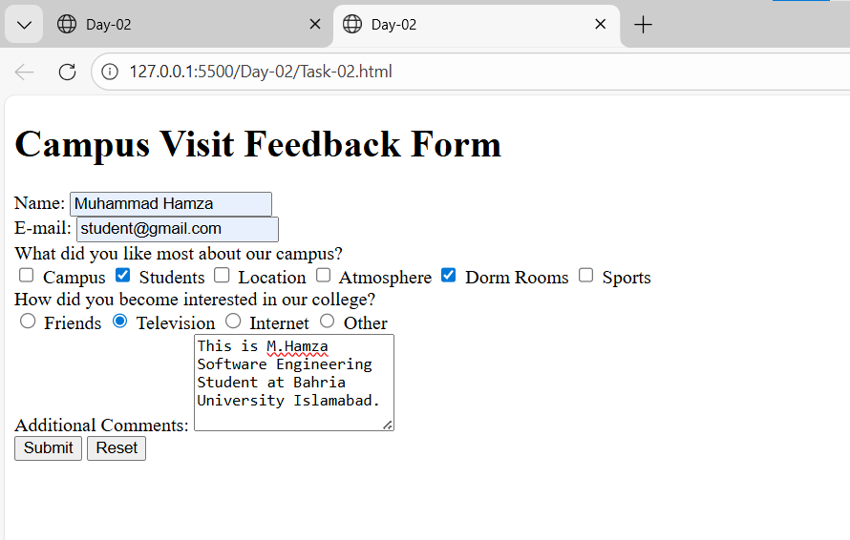

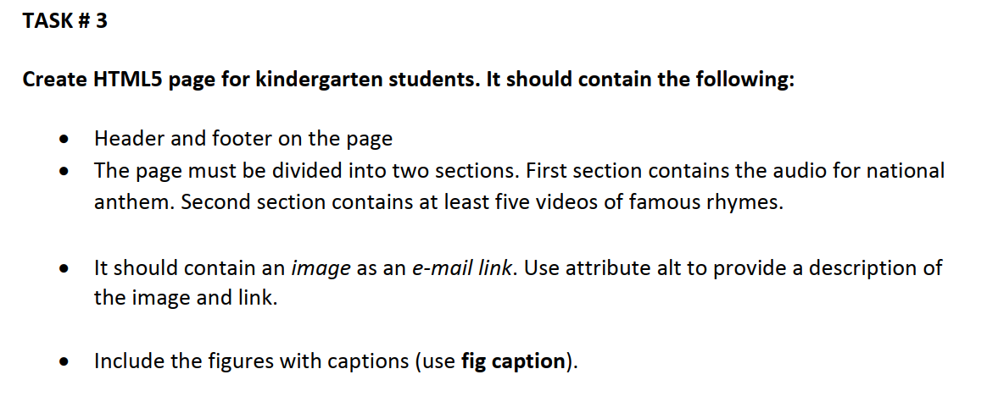

Code:

<!DOCTYPE html>
<html lang="en">
<head>
<meta charset="UTF-8">
<meta name="viewport" content="width=device-width, initial-scale=1.0">
<title>Day-02</title>
</head>
<body>
<!-- Header -->
<header>
<h1>Welcome to Kindergarten Fun Zone</h1>
<p>Learn and Play with Music and Rhymes!</p>
</header>

<!-- Section 1: National Anthem -->
<section>
<h2>Our National Anthem</h2>
<figure>
<audio controls>
<source src="https://www.soundhelix.com/examples/mp3/SoundHelix-Song-1.mp3" type="audio/mpeg">
Your browser does not support the audio element.
</audio>
<figcaption>Listen to our beautiful National Anthem of Pakistan</figcaption>
</figure>
</section>

<!-- Section 2: Famous Rhymes Videos -->
<section>
<h2>Fun Rhymes and Songs</h2>

<figure>
<video width="320" height="240" controls>
<source src="https://www.w3schools.com/html/movie.mp4" type="video/mp4">
Your browser does not support the video tag.
</video>
<figcaption>Twinkle Twinkle Little Star</figcaption>
</figure>

<figure>
<video width="320" height="240" controls>
<source src="https://www.w3schools.com/html/movie.mp4" type="video/mp4">
Your browser does not support the video tag.
</video>
<figcaption>Humpty Dumpty</figcaption>
</figure>

<figure>
<video width="320" height="240" controls>
<source src="https://www.w3schools.com/html/movie.mp4" type="video/mp4">
Your browser does not support the video tag.
</video>
<figcaption>Baa Baa Black Sheep</figcaption>
</figure>

<figure>
<video width="320" height="240" controls>
<source src="https://www.w3schools.com/html/movie.mp4" type="video/mp4">
Your browser does not support the video tag.
</video>
<figcaption>Jack and Jill</figcaption>
</figure>

<figure>
<video width="320" height="240" controls>
<source src="https://www.w3schools.com/html/movie.mp4" type="video/mp4">
Your browser does not support the video tag.
</video>
<figcaption>Mary Had a Little Lamb</figcaption>
</figure>
</section>

<!-- Email Link with Image -->
<section>
<h3>Contact Us</h3>
<p>Have questions? Click on the image below to send us an email!</p>
<a href="mailto:kindergarten@example.com">
<img src="https://via.placeholder.com/150" alt="Click here to send an email to Kindergarten Fun Zone - Mail icon with envelope and colorful letters">
</a>
</section>

<!-- Footer -->
<footer>
<hr>
<p>&copy; 2026 Kindergarten Fun Zone. All Rights Reserved.</p>
<p>Making learning fun for kids everywhere!</p>
</footer>
</body>
</html>

Screenshots:
