

Bahria University, Islamabad

Department of Software Engineering

Web Engineering Lab (Spring-2026)
Instructor: Engr. Subas Bilal

Student: Muhammad Hamza
Enrollment: 01-131232-057

Lab Journal: 04
Date: 17-02-2026

Task No: | Task Wise Marks |  | Documentation Marks |  |  | Total Marks  (20)
 | Assigned | Obtained | Assigned | Obtained
1
2
3
4
5
Comments:

Signature

LAB # 04
WORKING WITH CSS – II
Github Link:
https://github.com/muhammadhamza7057/Web-Engineering/tree/main/Day-03
Objective
- CSS Grid/Flexible Grids
- Media Queries
- Flexible Media & Flexible Images
Introduction
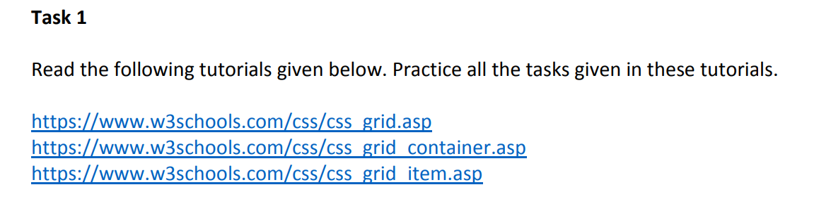
The @media rule, introduced in CSS2, made it possible to define different style rules for different media types. Examples: You could have one set of style rules for computer screens, one for printers, one for handheld devices, one for television-type devices, and so on.
Code:
https://github.com/muhammadhamza7057/Web-Engineering/tree/main/Day-03
Screenshot:
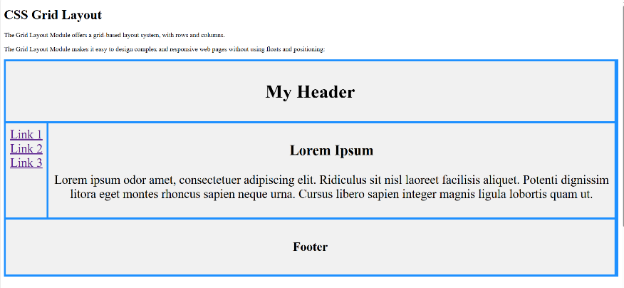
Task1.1
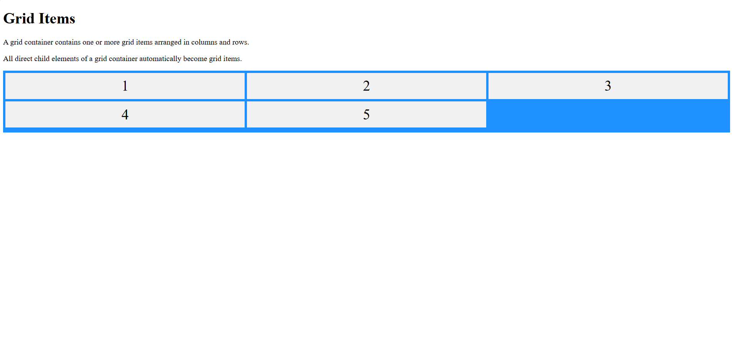
Task1.2
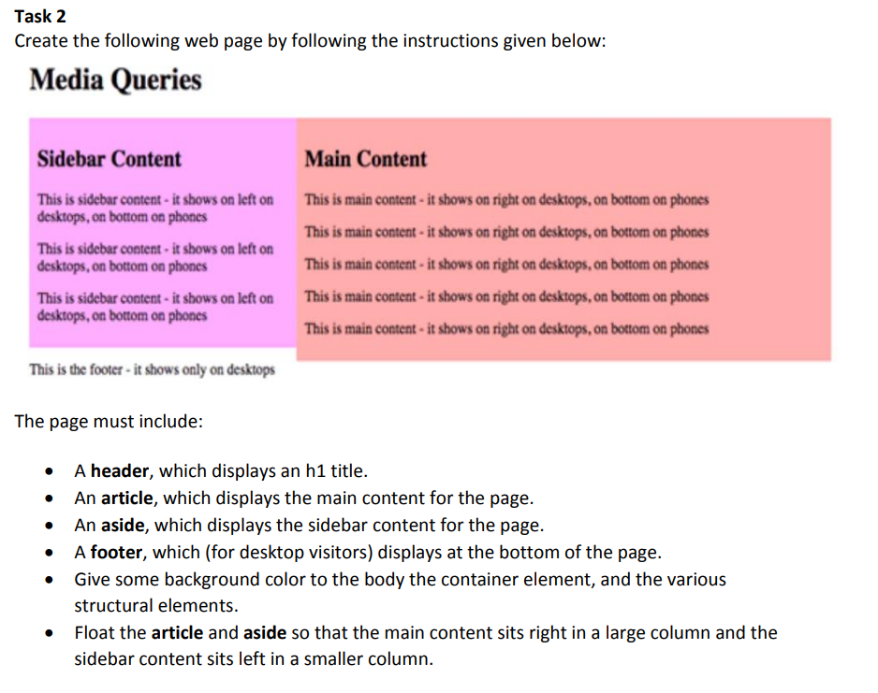

Code:
https://github.com/muhammadhamza7057/Web-Engineering/tree/main/Day-03

Screenshot:
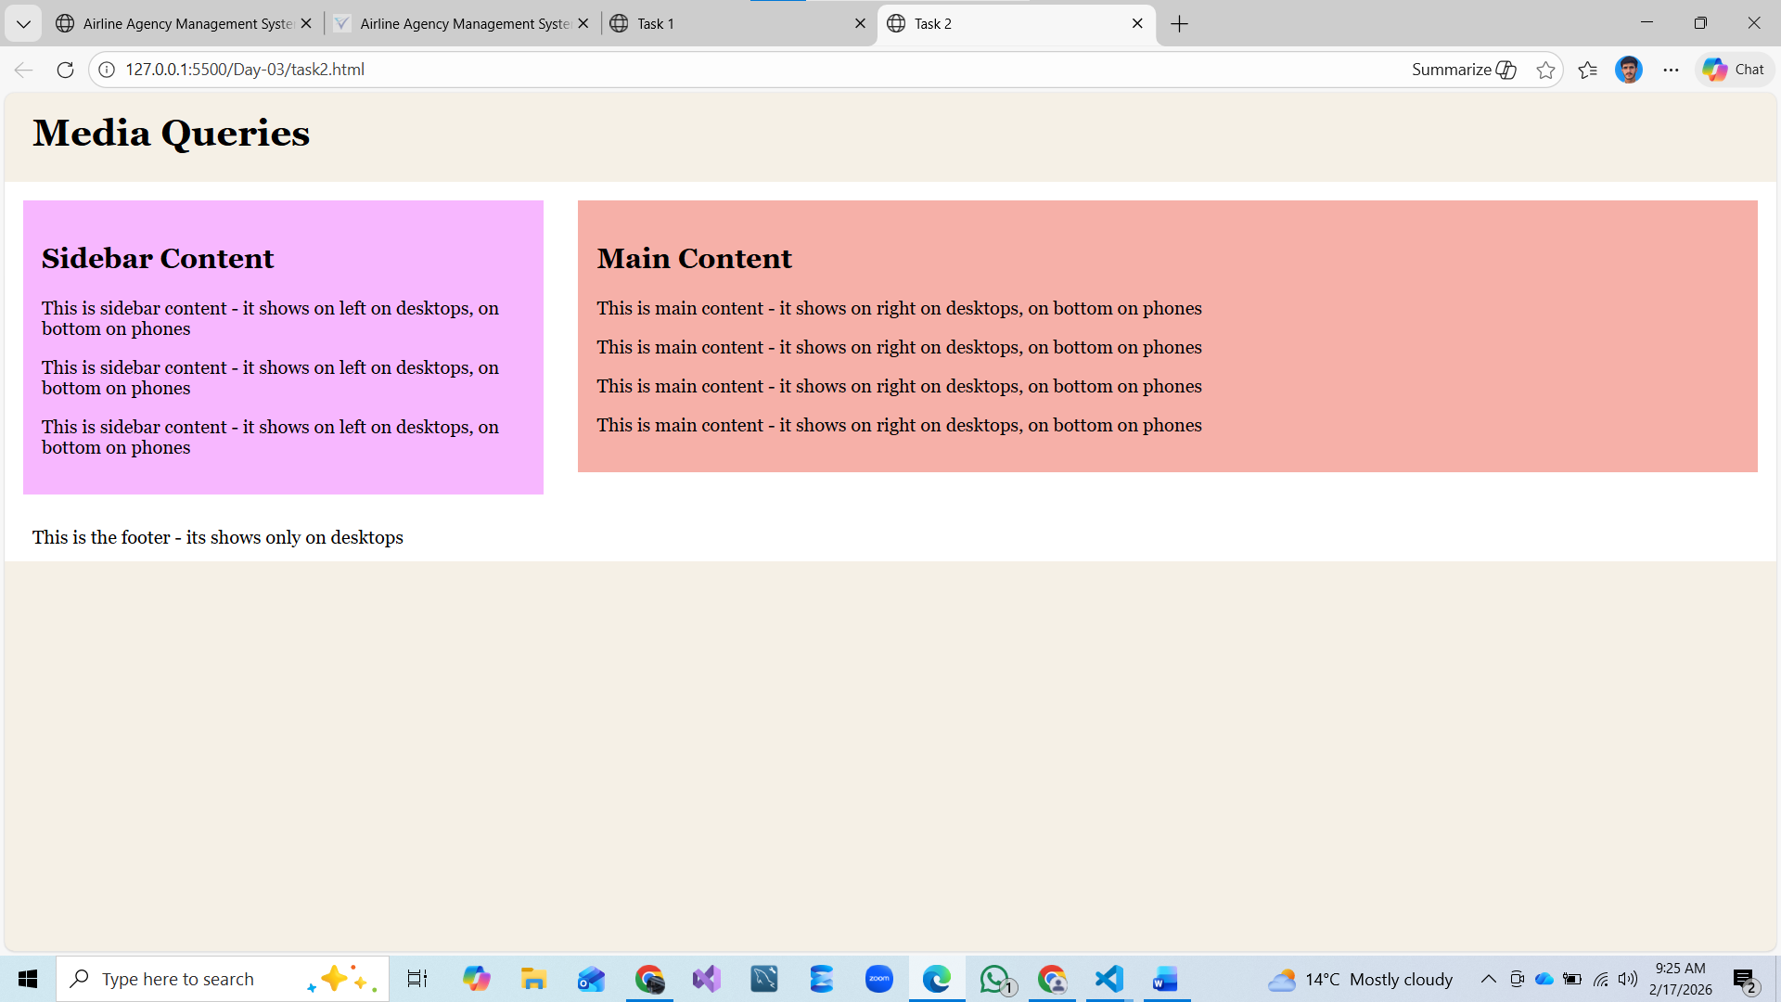

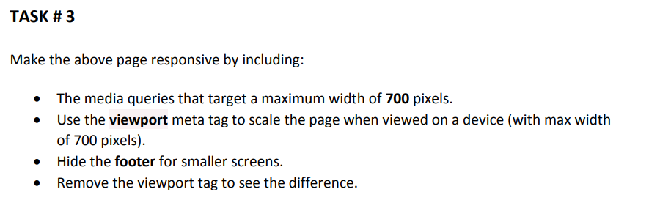
Code:
https://github.com/muhammadhamza7057/Web-Engineering/tree/main/Day-03

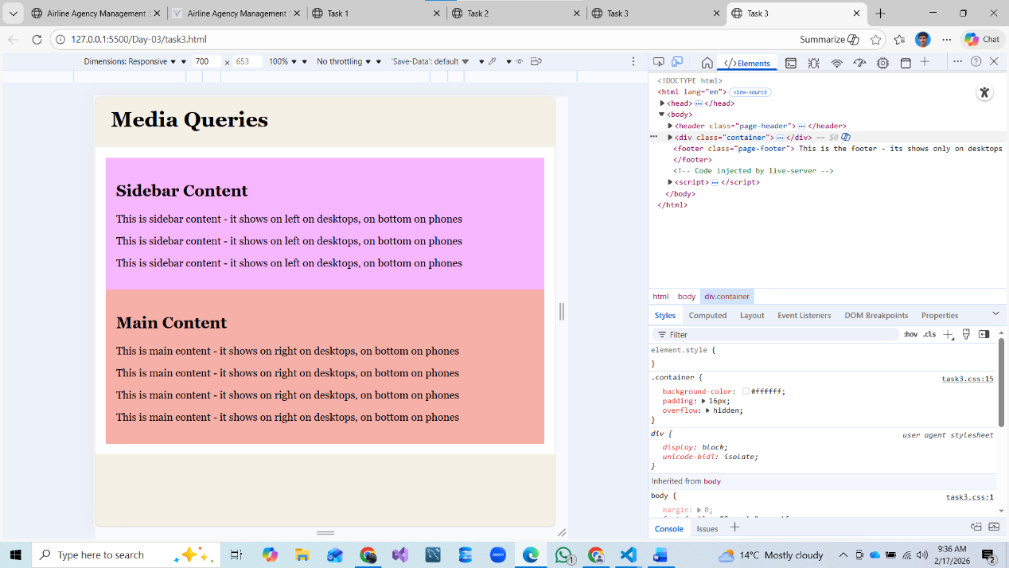
Screenshot:

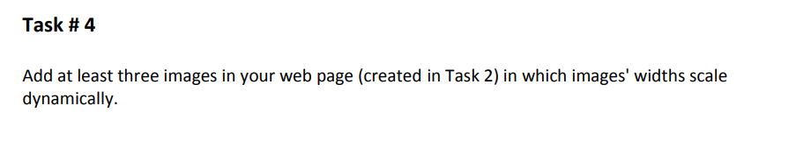
Code:

https://github.com/muhammadhamza7057/Web-Engineering/tree/main/Day-03

Screenshot:

