

Bahria University, Islamabad

Department of Software Engineering

Web Engineering Lab (Spring-2026)
Instructor: Engr. Subas Bilal

Student: Muhammad Hamza
Enrollment: 01-131232-057

Lab Journal: 05
Date: 25-02-2026

Task No: | Task Wise Marks |  | Documentation Marks |  |  | Total Marks  (20)
 | Assigned | Obtained | Assigned | Obtained
1
2
3
4
5
Comments:

Signature

LAB # 05

UI/UX and Typography in Web Engineering
GitHub Link:
https://github.com/muhammadhamza7057/Web-Engineering/tree/main/Day-03
Objective
- Design Basics and concepts
- Typography
- UI/UX
Introduction

What is UI/UX?
- User Interface (UI): The visual elements users interact with on a website.
- User Experience (UX): The overall experience a user has while interacting with a system.
UI (User Interface) and UX (User Experience) are critical aspects of web design. UI refers to the visual layout, buttons, icons, and other elements that users interact with. UX encompasses the overall experience and usability of a website.

Experiment 1: Understanding UI/UX Principles
Objective: Learn the fundamental UI/UX principles and how they improve web design.
Tools Required: HTML, CSS, Online UI/UX design resources
Theory: UI/UX principles guide how users interact with digital interfaces. Key principles include:
- Consistency: Uniform design across pages
- Feedback: Immediate response to user actions
- Affordance: Elements should suggest their functionality
- Simplicity: Minimalist approach for better usability
Procedure:
- Study UI/UX principles.
- Analyze 2-3 existing websites (e.g., Amazon, Netflix, Airbnb, Microsoft, or a local e-commerce site)
- Identify good and bad UI/UX practices.
Document findings with screenshots.

- Good UI/UX:
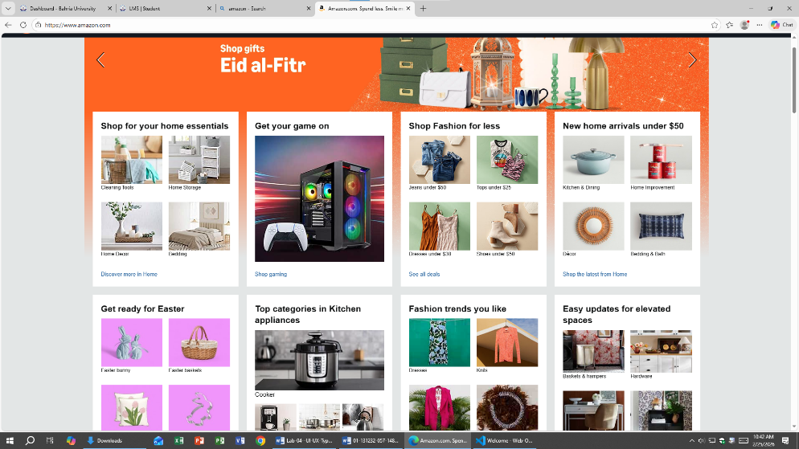
- Everything are organized by categories and prices.

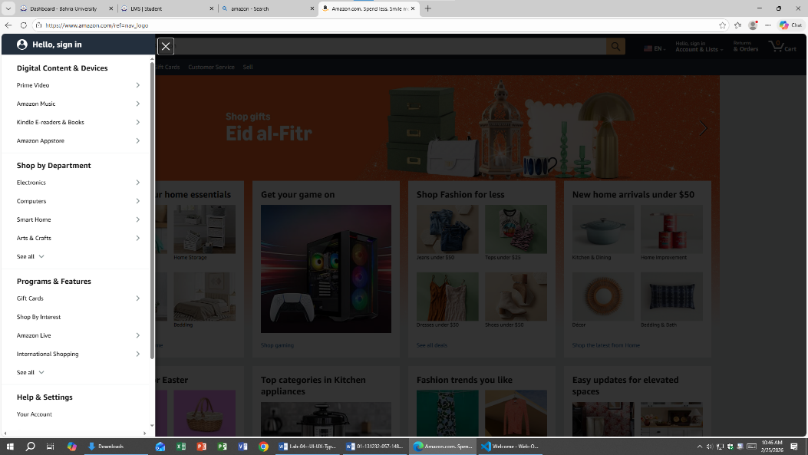
- They have shown a clear slide bar to reduce the cognitive factors of the humans.

- They have a clear Today’s deals with their sidebar and filters.

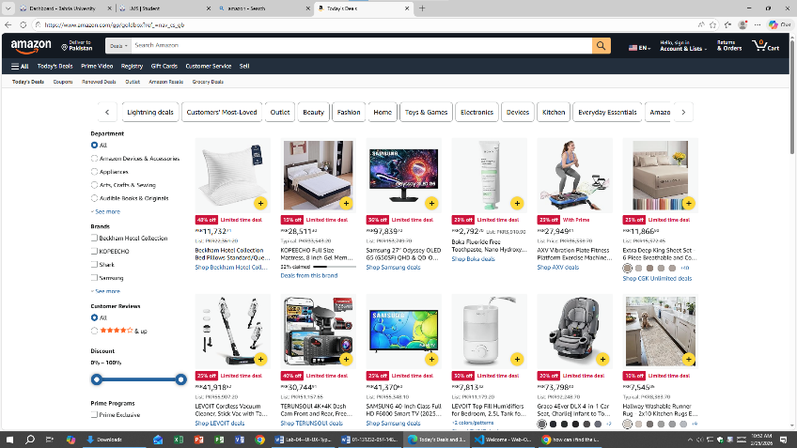

- Bad UI/UX:

- They have too many things in the menus in the headers like prime video and ads.

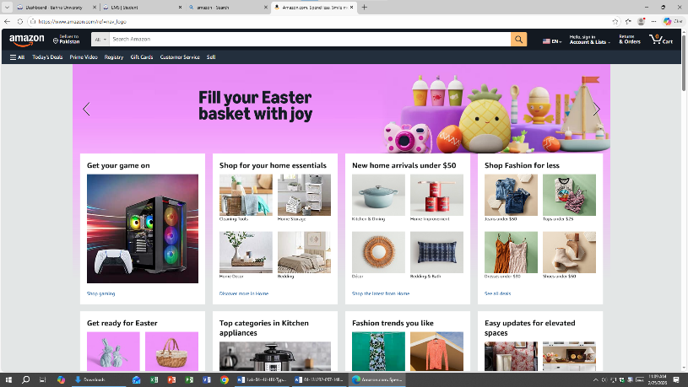

- They have more category in the home page they confused the users and visual difficult UX.
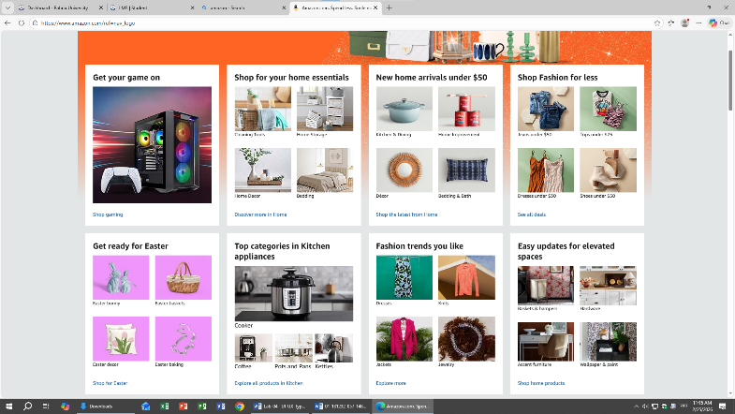

Experiment 2: Wireframing & Prototyping
Objective: Create wireframes for a basic web application.
Tools Required: Figma, Adobe XD, Balsamiq
Theory: Wireframes are low-fidelity representations of a website's layout. Prototyping helps visualize user interactions.
Procedure:
- Select a simple website concept (e.g., e-commerce, blog, or portfolio).
- Sketch a rough wireframe on paper.
- Convert it into a digital wireframe using Figma/Adobe XD.
- Add navigation and interactive elements for a prototype.
Present and get feedback.

Figma Design:
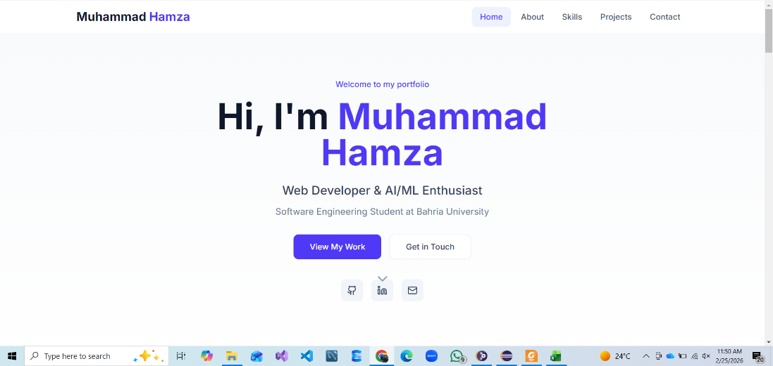

Experiment 3: Typography in Web Design
Objective: Understand typography principles and implement them in a web project.
Tools Required: Google Fonts, CSS Typography, Adobe Fonts
Theory: Good typography enhances readability and aesthetics. Key aspects:
- Font Pairing: Using complementary fonts
- Line Spacing (Leading): Improves readability
- Letter Spacing (Tracking & Kerning): Controls text density
- Hierarchy: Guides user attention
Procedure:
- Explore various fonts and styles (serif, sans-serif, monospace).
- Implement different font styles in a sample webpage using CSS.
- Adjust spacing, line-height, and contrast for readability.
- Compare readability of different typography choices.
- Document the best typography combinations.
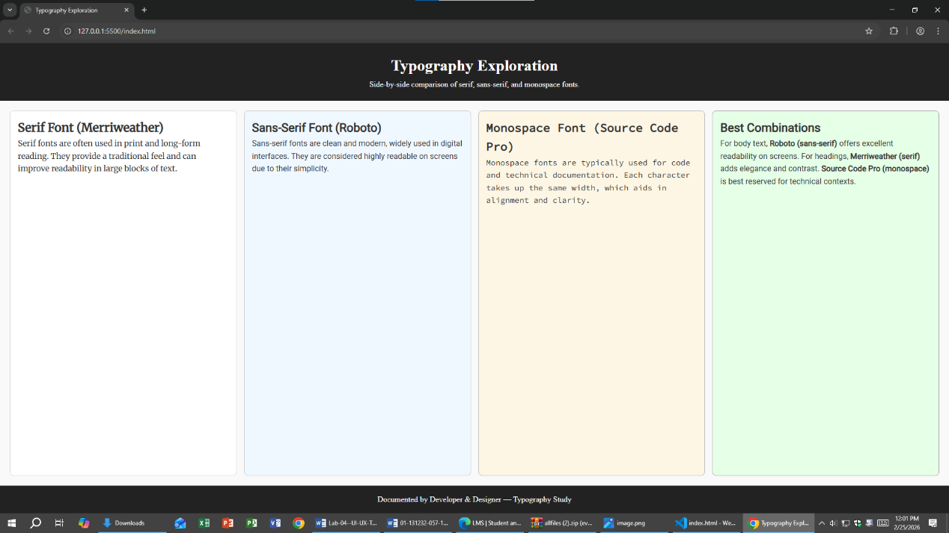
Screenshots:

