

Bahria University, Islamabad

Department of Software Engineering

Web Engineering Lab (Spring-2026)
Instructor: Engr. Subas Bilal

Student: Muhammad Hamza
Enrollment: 01-131232-057

Lab Journal: 08
Date: 19-03-2026

Task No: | Task Wise Marks |  | Documentation Marks |  |  | Total Marks  (20)
 | Assigned | Obtained | Assigned | Obtained
1
2
3
4
5
Comments:

Signature

LAB # 08

React Conditional Rendering and Component Lifecycle
GitHub Link:
https://github.com/muhammadhamza7057/Web-Engineering/tree/main/Day-05
Objective
By the end of this lab, students will be able to: - Implement conditional rendering in React components - Understand the lifecycle of functional components using hooks - Use useEffect to mimic mounting and unmounting behavior - Toggle components on and off based on state changes
Introduction

What is UI/UX?
- Node.js
- npm
- Visual Studio Code
- React project setup (Vite or Create React App)
Lab Exercises
- Create a ToggleMessage.jsx component to show/hide multiple messages with separate buttons.
- Add console logs for mount and unmount in each component.
- Combine conditional rendering with props: pass a message as prop to a child component and display it only if a toggle is true.
- Create a Countdown.jsx component that starts a timer on mount and clears the timer on unmount using cleanup function.
Code:

- I have Push my code to Github so for code review see the day-05 repo which I have added the repository link.

GitHub Link: https://github.com/muhammadhamza7057/Web-Engineering/tree/main/Day-05

Screenshots:

Task 1:

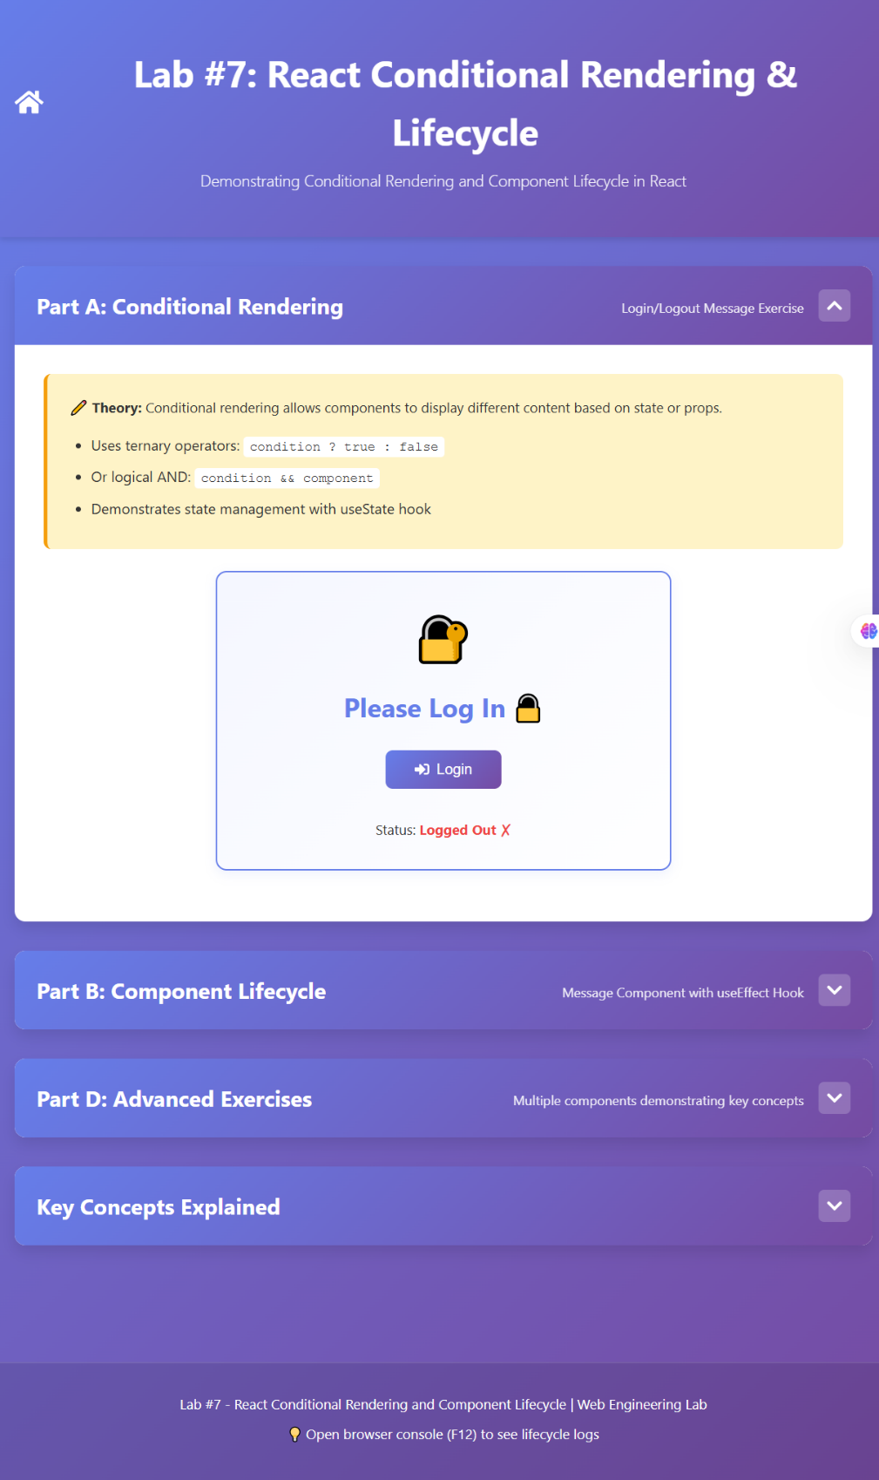

Figure 1

Task 2:

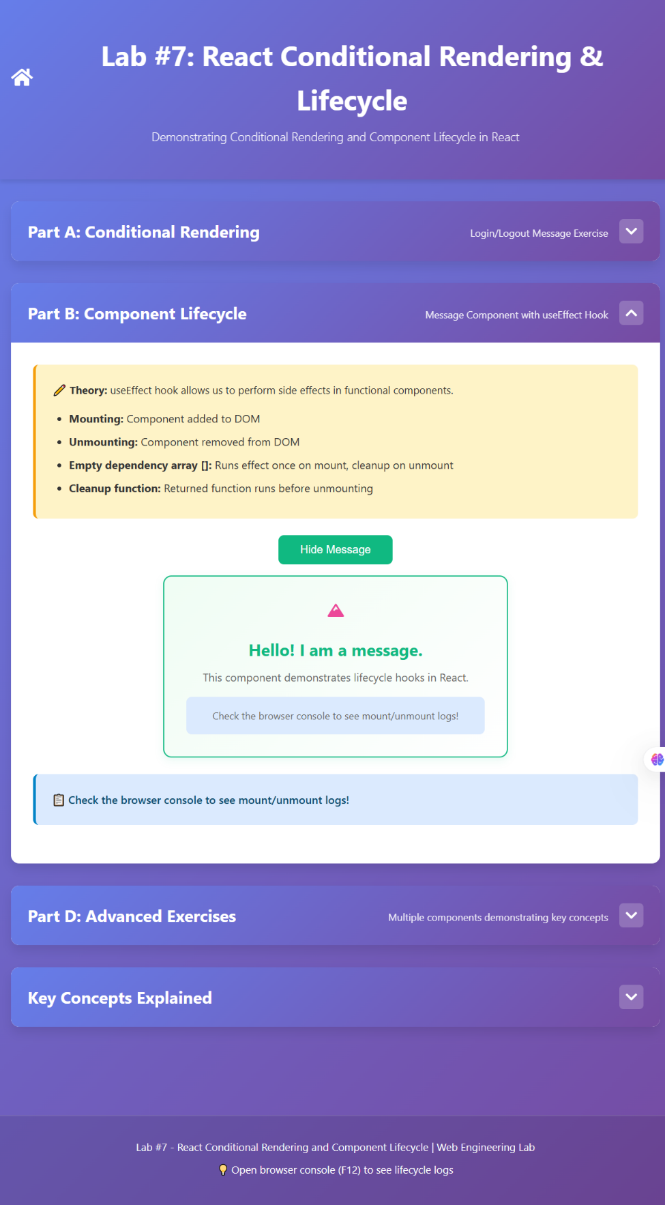
Figure 2

Task 3:
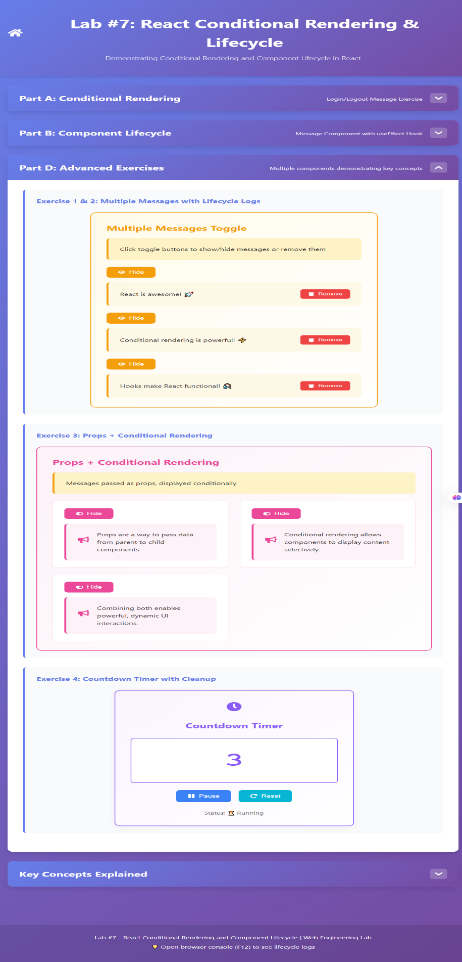

Figure 3

Task 4:
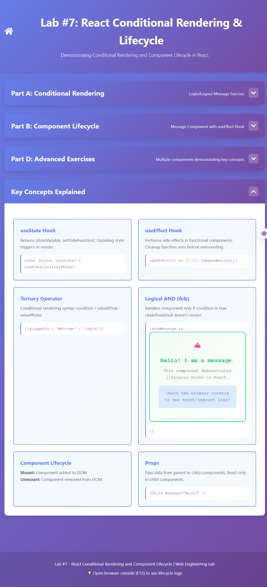
Figure 4

