Git Commands

- git clone
The git clone is used to target an existing repository and create a clone/copy of the target repository.
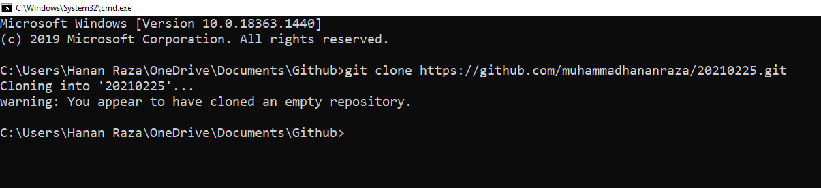

- git add
The git add command adds a change in the working directory to the staging area.
- Staging area
The staging area is where you can git add the version of a file(s) that you want to save in your next commit
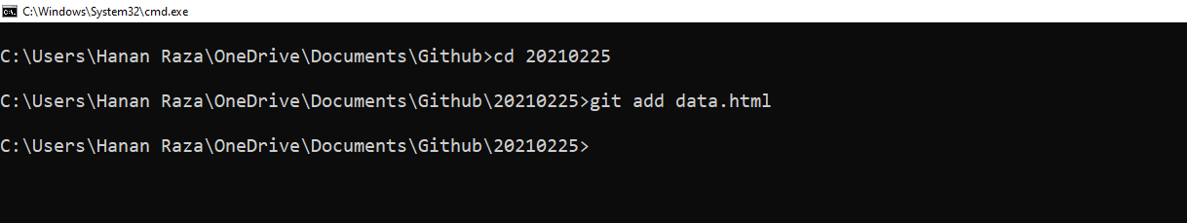
- data.html
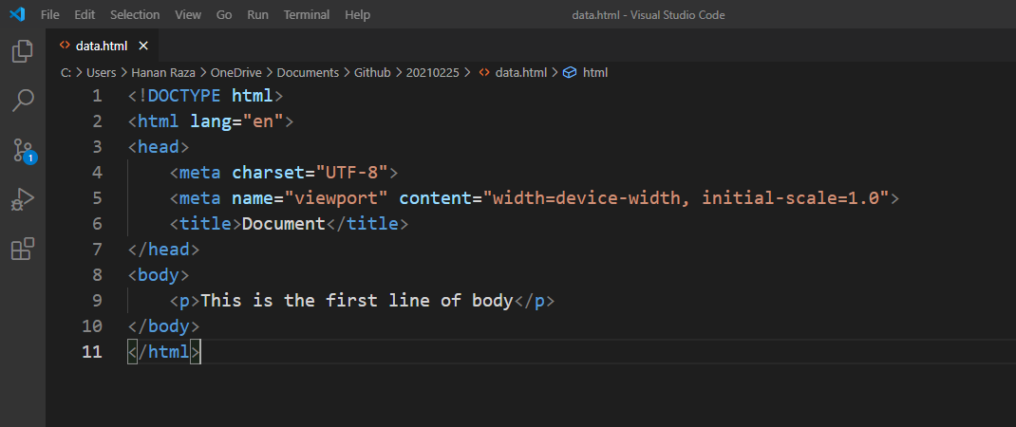

- git commit
The git commit command is used to save your changes to the local repository with an optional message using -m.
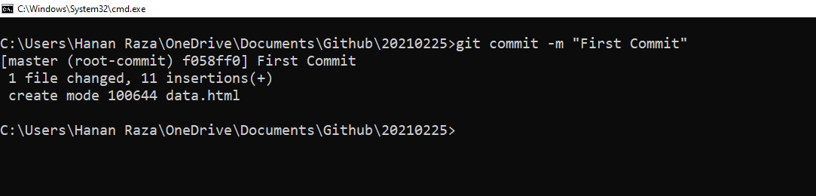

- git push
The git push command is used to upload local repository content to a remote repository
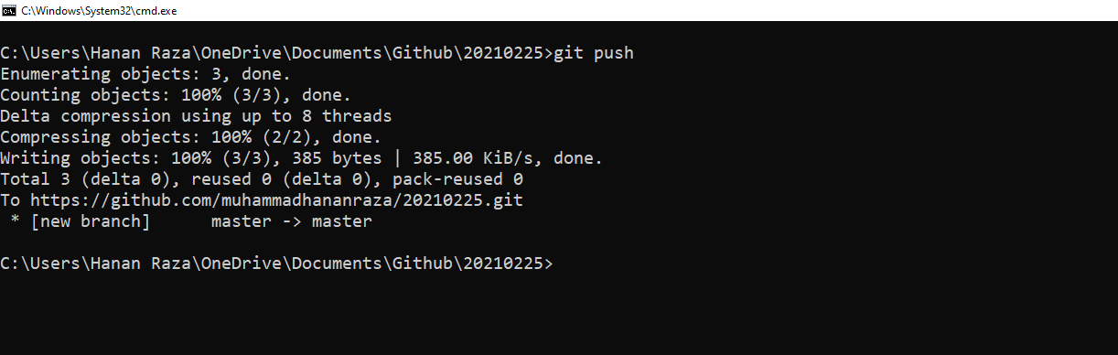

- Remote repository
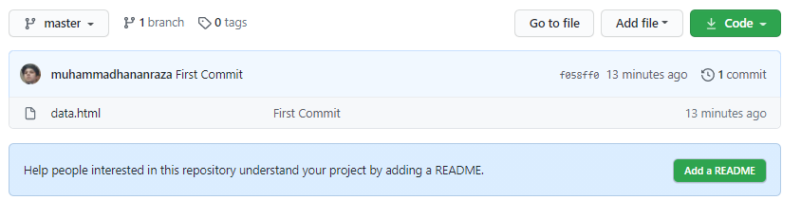

Updating data.html and Committing in remote repository
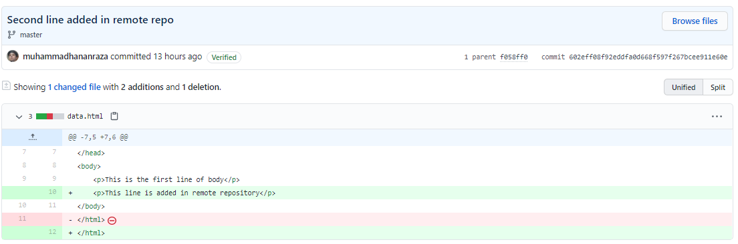

- git pull
The git pull command is used to fetch and download content from a remote repository and immediately update the local repository to match that content.
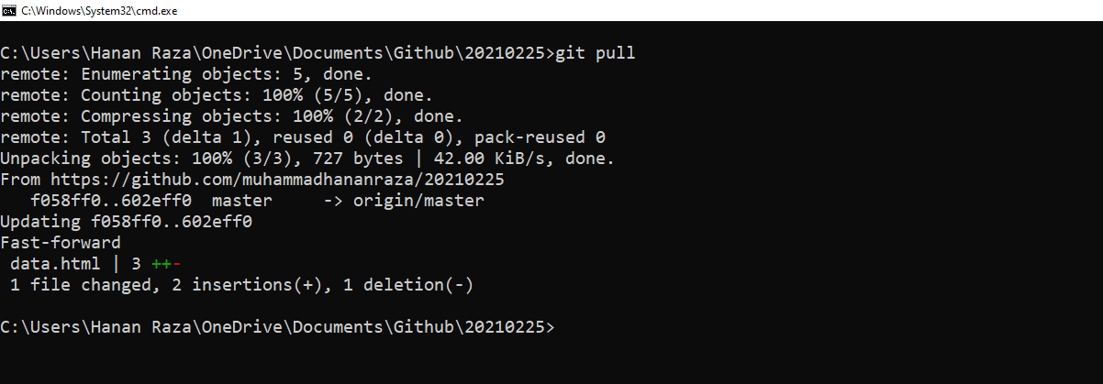
    - data.html
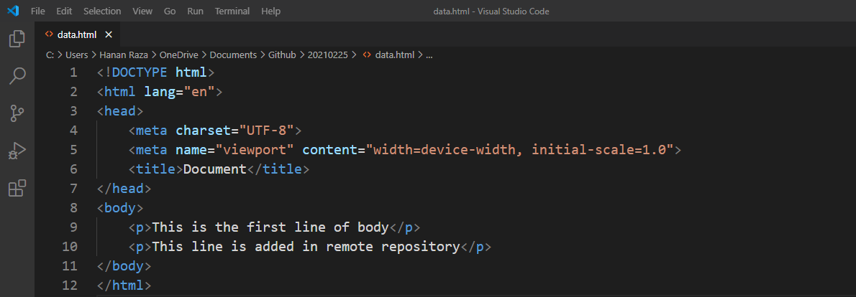
- git status
The git status command displays the state of the working directory and the staging area
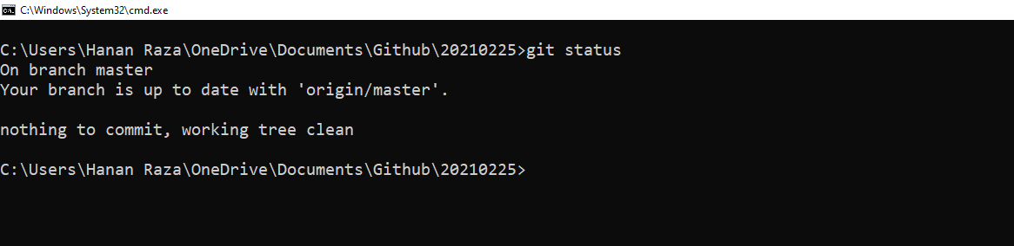

- git log
The git log command displays all the commits details
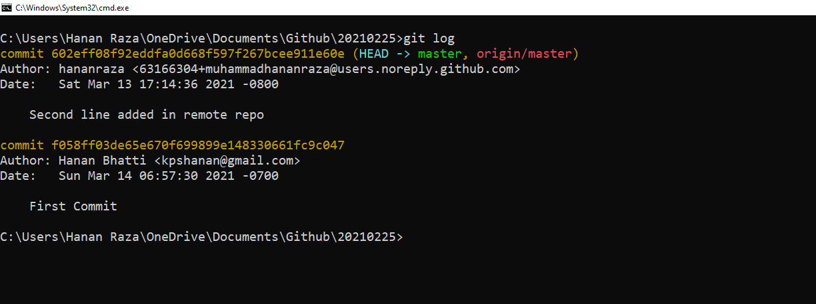

- git branch
Create a new branch using git branch [new_branch_name], display all branches (local and remote) using git branch -a (the asterisk denotes the current branch), git checkout [] and delete branch using git branch -D [branch_name]
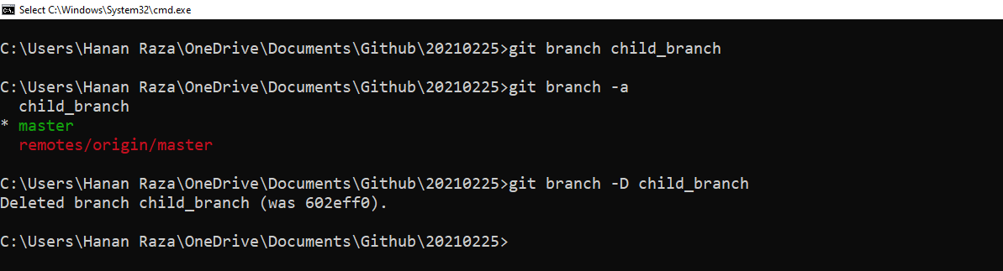

- git checkout
The git checkout command is used to switch the currently active branch
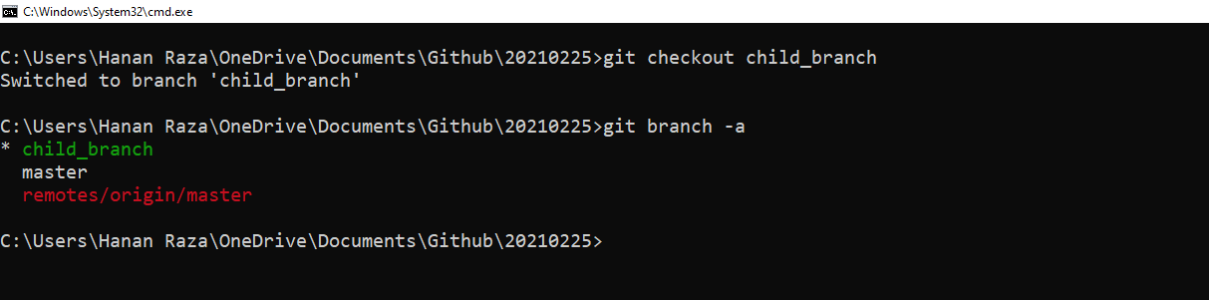

- git merge
The git merge command lets you take the independent lines of development created by git branch and integrate them into a single branch
Creating a new branch child_branch, updating data.html in child_branch, and adding data.html and committing in the child_branch.
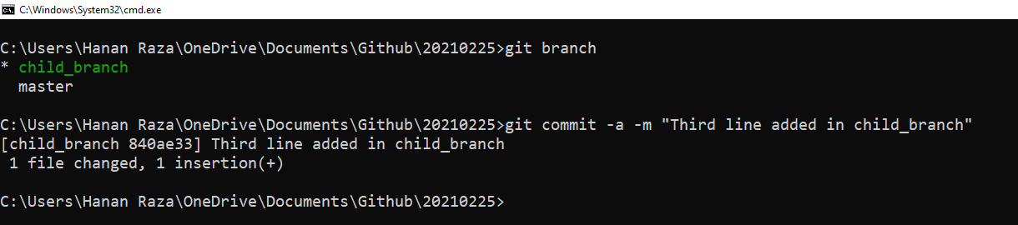

- data.html in master
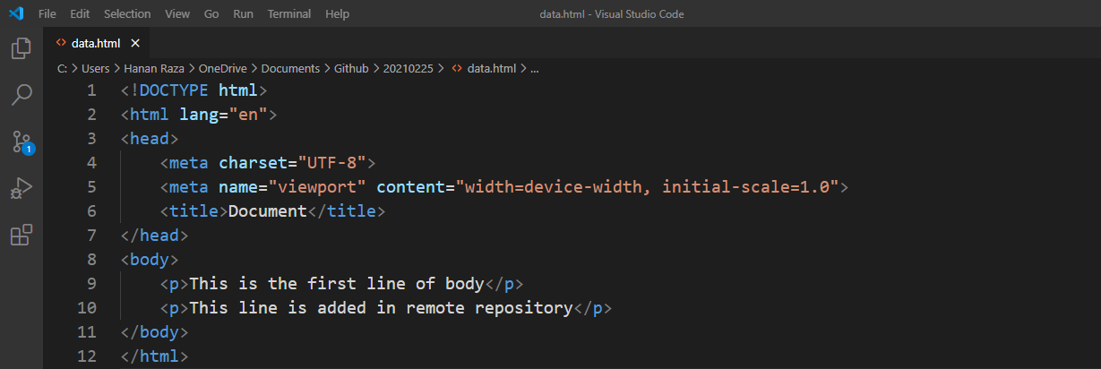

- data.html in child_branch
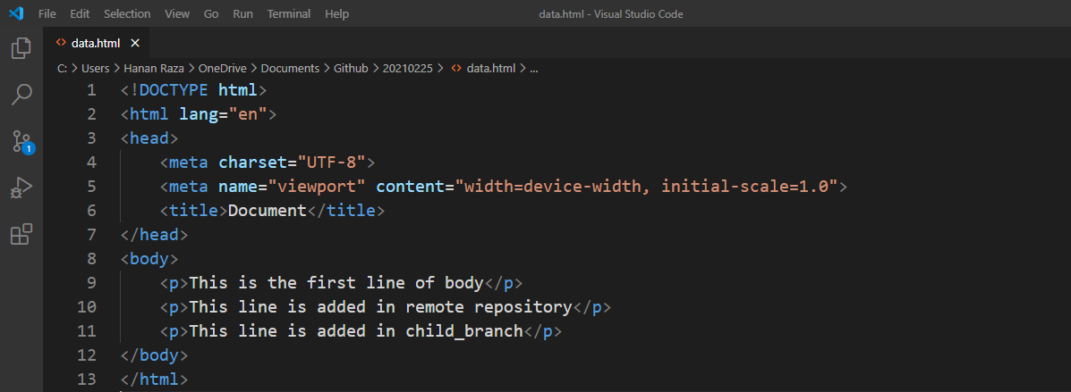

merging child_branch into master
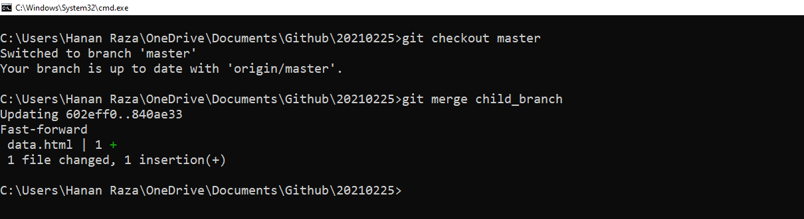
data.html in master after merging
