AI Security Automation Platform

1. Executive Summary
This report details the design and implementation of the AI Security Automation Platform, a comprehensive solution that integrates Data Ingestion, Threat Intelligence, Machine Learning Anomaly Detection, and SOAR orchestration.

2. Architecture & Modules
The platform consists of the following decoupled modules:
- Data Ingestion Layer: Simulates incoming network traffic logs and normalizes them into JSON formats.
- Threat Intelligence Enricher: Analyzes IPs and domains, enriching them with risk scores using simulated queries to AlienVault OTX/AbuseIPDB.
- Machine Learning Detection: A pre-trained Isolation Forest model that evaluates numerical features to assign anomaly scores.
- SOAR Engine: Orchestrates playbooks for High Confidence alerts (e.g. firewall blocking) and Medium Confidence alerts (e.g. ticketing).
- Visualization Dashboard: A real-time Streamlit dashboard that visualizes alerts and threat metrics continuously.

3. Demo Screenshots
Figure: p1.PNG
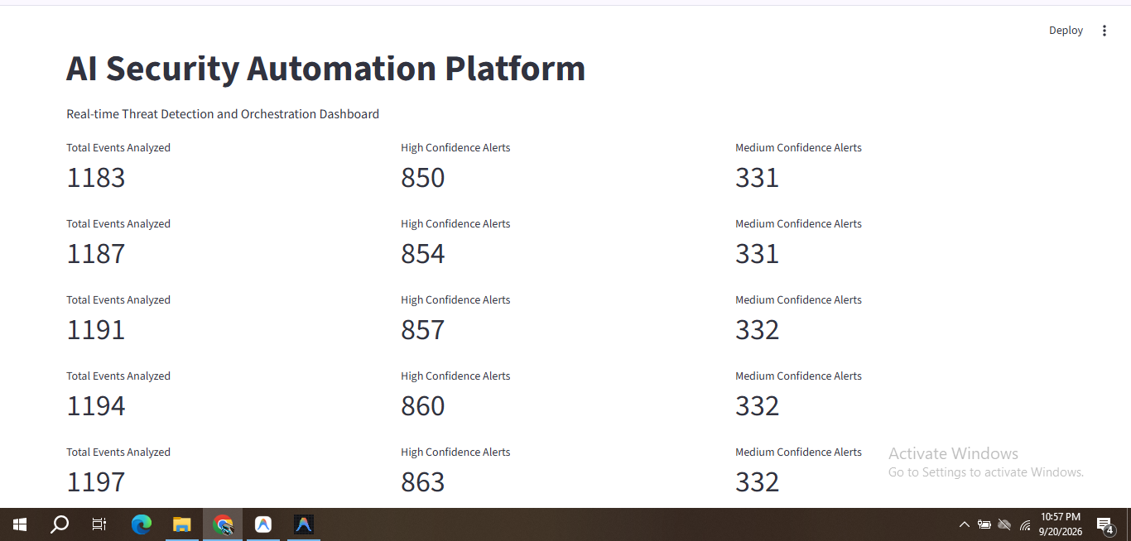
Figure: p2.PNG
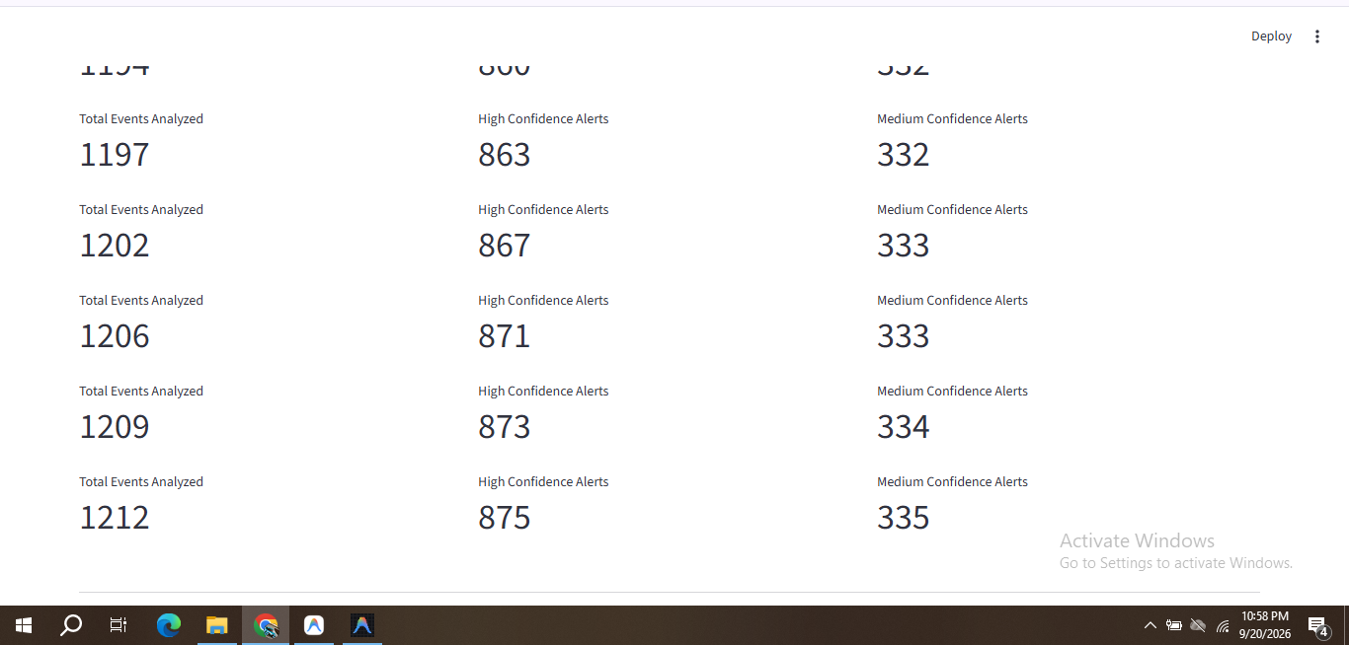
Figure: p3.PNG
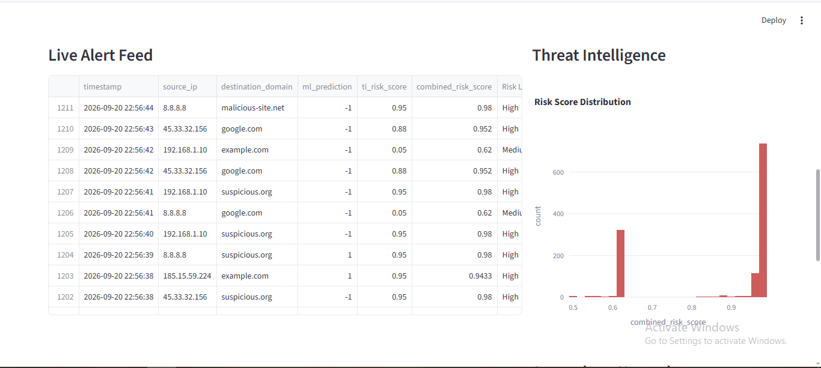
Figure: p4.PNG
