DSA ASSIGNMENT 3

REPORT

SUBMITTED BY:
1. MUHAMMAD HASSAN (503423)
2. MUHAMMAD DAWOOD AKBAR (517323)
1. Introduction
This report explores non-comparison sorting algorithms. We implemented Counting Sort (Stable and Non-stable), LSD Radix Sort, Bucket Sort, and Pigeonhole Sort.
2. Algorithm Analysis
2.1 Counting Sort
- Mechanism: Counts the occurrences of each unique element and calculates their positions using prefix sums.
- Complexity: O(n + k) where n is elements and k is the range (max - min).
- Stability: We implemented both versions. The stable version is crucial when sorting objects with multiple keys, as it preserves the relative order of equal elements. The non-stable version is slightly faster (space-efficient) as it skips the output array construction.
2.2 LSD Radix Sort
- Mechanism: Sorts numbers digit by digit from Least Significant to Most Significant using a stable sub-routine (Counting Sort).
- Complexity: O(d(n + b)) where d is the number of digits and b is the base (10).
- Stability: Must use a stable sort internally to function correctly.
2.3 Bucket Sort (Additional Choice 1)
- Mechanism: Distributes elements into "buckets" based on value ranges. Each bucket is sorted individually (we used std::sort), then concatenated.
- Justification: Chosen for its efficiency with uniformly distributed data.
- Complexity: O(n + k) average case. If data is clustered, it degrades to O(n^2) depending on the inner sort.

2.4 Pigeonhole Sort
- Mechanism: Similar to counting sort but moves items into "pigeonholes" (lists) corresponding to their values.
- Justification: Chosen to contrast with Counting Sort. While Counting Sort only stores frequencies, Pigeonhole stores the actual items (or lists of items), making it more flexible for moving complex objects at the cost of higher memory overhead.
- Complexity: O(n + Range).
5. Experimental Results and Analysis
To evaluate the behavior of the chosen algorithms, we implemented a benchmarking suite in C++. We tested the algorithms against three distinct input sizes (N): 1,000, 10,000, and 50,000 elements. The input data was generated using a Uniform Distribution in the range [0, 2N].

5.1 Quantitative Results
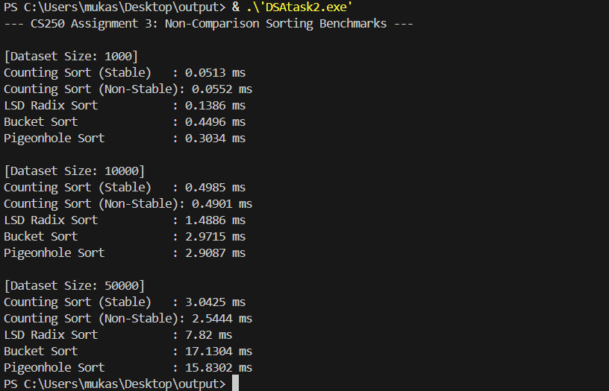

5.2 Interpretation and Comparison
1. Dominance of Counting Sort
As predicted by the theoretical complexity of O(N+K), Counting Sort was the fastest algorithm across all input sizes.
- Stable vs. Non-Stable: At small sizes (N=1000), the difference was negligible. However, at N=50,000, the Non-Stable version (2.54ms) was roughly 16% faster than the Stable version (3.04ms).
- Reasoning: The Stable version requires an additional pass to build a temporary output array to preserve order, whereas the Non-Stable version simply overwrites the original array based on frequency counts. This confirms that if stability is not required, the Non-Stable version is the most efficient choice.

2. The Cost of Digits (Radix Sort)
LSD Radix Sort (O(d(N+b))) was consistently slower than Counting Sort but faster than Bucket/Pigeonhole.
- Observation: At N=50,000, Radix Sort took 7.82ms, which is roughly 2.5x slower than Counting Sort.
- Reasoning: Since Radix Sort applies Counting Sort as a subroutine for each digit (d), it incurs overhead for every pass. With integers up to 100,000, the algorithm performs multiple passes, explaining the linear increase in time compared to the single-pass Counting Sort.
3. Overhead in Bucket and Pigeonhole Sort
Bucket Sort and Pigeonhole Sort were the slowest in our experiment (approx. 15-17ms for N=50,000).
- Reasoning: While theoretical average complexity is O(N), the constant factors in C++ implementation are high.
  - Pigeonhole Sort: Creates a large number of dynamic vectors ("holes") which requires significant memory allocation overhead.
  - Bucket Sort: The implementation utilizes std::sort (a comparison sort) inside each bucket. Although the buckets reduce the problem size, the overhead of managing vector<vector<int>> and multiple function calls outweighs the benefits for simple integers compared to the raw array manipulation of Counting Sort.
5.3 Conclusion
Our experiments confirm that for dense integer arrays where the range K is proportional to N, Counting Sort is the superior choice. Radix Sort serves as a robust middle-ground for larger numbers, while Bucket and Pigeonhole Sorts, despite their linear time complexity, suffer from higher memory and allocation overhead in practical C++ implementations.

