

**LAB - 2**

**Name: Muhammad Hussain**

**Semester: BSCS - 3**

**Course: Digital Logic Design Lab**

**Instructor: Sir Rafay Shaikh**

**Q:1** Verify following Rules of Boolean Algebra by designing them using Circuit Makers.

**1:** Identity Law

**2:** Idempotent Law

**3:** Complement Law

**4:** Involution Law

**5:** Commutative Law

**6:** Associative Law

**7:** Distributive Law

**Q:2** Simplify the expressions

**1:** F = (A + (BC)’)’

**ANS** F = [A]’ [(BC)’]’

F = A’BC

**2:** F = (AB+CD)’

**ANS** F = (AB)’(CD)’

This expression is already simplified.

**Q:3** Use DE Morgan’s Theorem to prove that this NAND gate circuit performs the exact same function:

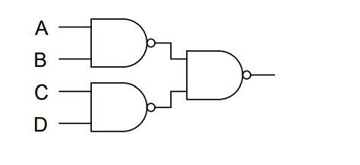

SOL:

F = [(AB)’ (CD)’]’ BREAKING LONGEST COMPLIMENT

F = [(AB)’]’ + [(CD)’]’ COMPLIMENT LAW

F = AB+CD

**Q:4** Apply the principles of DE Morgan’s theorems to the simplification of a gate circuit:

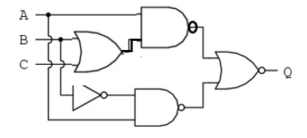

Y1 = [A(B+C)]’

Y2 = B+C

Y3 = B’

Y4 = (AB’)’

Y5 = [ {A(B+C)}’ + (AB’)’ ]’

SOL:

= [ {A (B+C)}’ + (AB’)’ ]’ BREAKING LONGEST COMPLIMENT

= [ {A (B+C)}’ ]’ . [ (AB’)’ ]’ COMPLIMENT LAW

= [A(B+C)] . (AB’) DISTRIBUTIVE LAW

= (AB + AC) . AB’ MULTIPLYING

= (AB’)(AB) + (AB’)(AC) A.A=A , B.B’=0

= A(0) +AB’C

= AB’C