Question 2

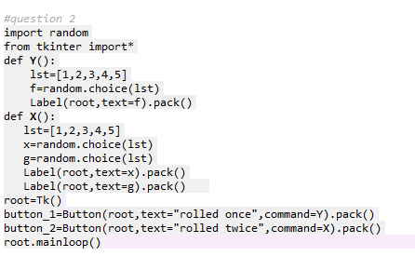

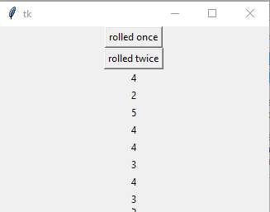

…………………………………………………………………………………………………………………………………………………………………

Question 3

from tkinter import*

import re

import random

def function_1():

txt = "Some analysts say a Buffett-less\n Berkshire Hathaway could be a candidate \nfor being broken up into multiple companies"

x = (re.search("^Some.*companies$", txt))

Label(root,text=x).grid()

def function_2():

str = "Some analysts say a Buffett-less Berkshire\n Hathaway could be a candidate for being broken\n up into multiple companies"

y = re.findall("ou", str)

Label(root,text=y).grid()

def function_3():

str = "Some analysts say a Buffett-less Berkshire\n Hathaway could be a candidate for\n being broken up into multiple companies"

z = re.findall("into", str)

Label(root,text=z).grid()

def function_4():

str = "Some analysts say a Buffett-less Berkshire Hathaway could be a \ncandidate for being broken up into\nmultiple companies"

t = re.search("\s", str)

Label(root,text=t).grid()

def function_5():

str = "Buffett, who is worth almost $90 billion, still lives in \na relatively modest house about 10 minutes outside\n downtown Omaha that he bought in 1958"

a = re.split("\s", str)

Label(root,text=a).grid()

def function_6():

str = "Buffett, who is worth almost $90\n billion, still lives in a relatively modest house about 10 \nminutes outside downtown Omaha that he bought in 1958"

b = re.sub("\s", "*" ,str)

Label(root,text=b).grid()

def function_7():

str = "Buffett, who is worth almost $90\n billion, still lives in a relatively modest house\n about 10 minutes outside downtown Omaha that he bought in 1958"

c = re.sub("\s", "*", str, 4)

Label(root,text=c).grid()

def function_8():

d=(random.choice([1,2,3,4,5,6]))

Label(root,text=d).grid()

def function_9():

e=(random.choice([1,2,3,4,5,6]))

f=(random.random())

Label(root,text=e).grid()

Label(root,text=f).grid()

def function_10():

g=(random.randrange(0,52,5))

Label(root,text=g).grid()

def function_11():

lst_odd = [1,9,7,3,5]

h=(random.shuffle(lst_odd))

Label(root,text=h).grid()

def function_12():

i=(random.uniform(0,52))

Label(root,text=i).grid()

root=Tk()

button_1=Button(root,text="button1",command=function_1).grid(row=0,column=0)

button_2=Button(root,text="button2",command=function_2).grid(row=0,column=1)

button_3=Button(root,text="button3",command=function_3).grid(row=0,column=2)

button_4=Button(root,text="button4",command=function_4).grid(row=0,column=3)

button_5=Button(root,text="button5",command=function_5).grid(row=1,column=0)

button_6=Button(root,text="button6",command=function_6).grid(row=1,column=1)

button_7=Button(root,text="button7",command=function_7).grid(row=1,column=2)

button_8=Button(root,text="button8",command=function_8).grid(row=1,column=3)

button_9=Button(root,text="button9",command=function_9).grid(row=2,column=0)

button_10=Button(root,text="button10",command=function_10).grid(row=2,column=1)

button_11=Button(root,text="button11",command=function_11).grid(row=2,column=2)

button_12=Button(root,text="button12",command=function_12).grid(row=2,column=3)

root.mainloop()

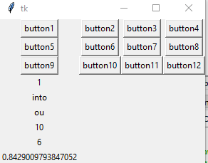

Question 4

