**COMSATS UNIVERSITY ISLAMABAD**



**Department of Electrical and Computer Engineering**

**ROBIAN23**

**RULEBOOK**

Version 1.1

(26th October 2023)

# Introduction

Robian23 invites participants from all over Pakistan to test their skills, build robots and compete to win cash prizes. This contest provides a platform for roboticists to apply their technical knowledge and skills and learn from their peers and seniors. The students also learn to work in groups and teams and develop collaboration and coordination skills.

There will be **two categories** in Robian23.

1. Maze solving race
2. Remote controlled sumo robots

All the categories are **open to everyone.** Whether you are an undergraduate student, a graduate student, an educator, a researcher, a professional or a hobbyist, you are welcome to participate. The rules and regulations of the contest are presented in this document.

## Date and Venue:

**Dates:**

Friday 15th December 2023 Qualifiers

Monday 18th December 2023 Finals (Seminar Hall)

**Time:** 10:00 am to 2:30 pm

**Venue:** Seminar Hall, Academic Block I, EE Department

## Rules and Regulations:

This section describes the rules and regulations regarding groups and teams, the arena, the size and weight of the robot etc for all categories of the contest.

Note: These rules and regulations are not finalized and may be updated in the days leading up to the contest. Kindly visit the contest website regularly for updates.

# Category 1: Maze Solving Race

## Brief Description:

Each participating team will build an autonomous maze solving robot. Each robot will compete with another robot to solve the maze within allotted time. The first robot to reach the end point will be declared the winner of the match. To maintain fairness, each team will be asked to run their robot twice, once on each of the top and bottom arenas. That is, after each run, the teams will switch places.

## The Arena:

* The arena will comprise of a black track drawn on a white background on a lamination sheet of dimensions **4' x 8' feet**.
* The **line for the track** will be black in color and will be **1 inch** wide.
* There are two arenas that are mirror images of each other.
* 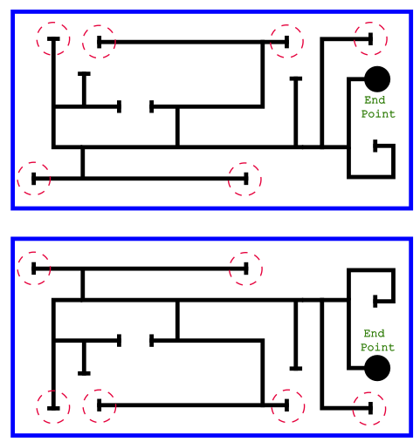There are **6** **possible starting positions** (marked with a dotted red circle). Both the teams will be asked to place their robots at one of these start positions at the beginning of a run.

## Start-Points and the End-Point

The teams will be asked to run their robots twice starting from one of the start-points (selected randomly by the judges). They will run their robot first on one arena and then on the 2nd arena for the next run. The **height** of the Starting-Point is **3 inches** and the width is 1 inch.

The End-Point (filled circle of **diameter 6.3 inches**) marks the end of the maze. A robot should be able to detect the end point and stop. Not stopping at the end point or mis-detecting it as one of the line endings will carry a penalty.

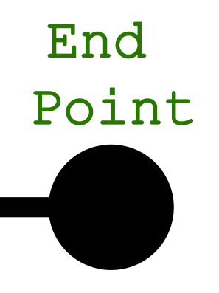

# The Robots:

## Size and Weight:

* The robot must fit in a box of 20 cm x 20 cm (5% tolerance). Teams will face points deductions or disqualification if the robot is larger.
* The height of the robot also must not exceed 20 cm.
* There is no limit on the weight of the robot.

## Cost:

There is **no limitation** on the cost of the robot.

## Other Restrictions:

* The participants must build their own robots. Ready-made robots are not allowed. (simple DIY kits with only chassis, motors, and wheels are allowed).
* Participants must not use items that can damage the arena e.g. Liquids, Fire, Sticky materials etc.

## Penalties:

* **10 point** will be deducted if the robot exceeds the dimensions by more than 5% but is within 10% of the maximum limits in any dimension.
* Team will be **disqualified** if the robot exceeds by more than 10% of the maximum limits in any dimension.

## The Teams:

The contestants will register as teams. Each team will consist of a **maximum of 4 members.** Each team will choose a name for registration and will designate one member as the team lead. All the official communication with the team will be through the team lead.

## Scoring system:

|  |  |  |
| --- | --- | --- |
| **No** | **Task description** | **Points** |
| 1 | Robot moving and sensing | 15 |
| 2 | Successfully marking a line ending | 10 each Max 30 |
| 3 | Stopping at the last designated End-Point | 10 |
| 4 | Completion time bonus = (30 – 0.25 * seconds to complete track), Zero if robot takes more than 120 seconds | 30 |
|  | **Total** | **100** |

The robot to reach the end of the maze first will be declared the winner of the match. If both the robots fail to reach the end point, the winner will be decided based on points. The teams will earn points for their robot's runs according to the following table. Score for the two rounds will be averaged. The decision of the judges in recording the points will be deemed final and will not be contestable.

## Marking a line-ending:

A robot will need to make a 180 degree turn to successfully mark a line ending.

# Category 2: Remote controlled sumo robots

Students will make mobile App controlled Sumo Robots and compete against each other to win a seeded tournament (see ***Figure 4***) like contest. Similar to traditional Sumo wrestling the contesting robots will try to push each other off the ring (Dohyo). Teams will be randomly selected to compete against each other and winning teams from each round will qualify for the next round.

## The Arena (Dohyo):

Figure Sumo Robots on a Dohyo

* The Dohyo will be circular in shape with a diameter of 1.2 meter (5% tolerance).
* The Dohyo will be made of Chip Board and will be flat.
* The Dohyo will be painted black with a white circle to mark the edge of the ring.

# The Robots

## Size and Weight:

* The robot must fit in a box of 15 cm x 15 cm at the start of a match (may open up attachments that do not increase the size of the robot beyond 20 cm x 20 cm)
* There is no limit for the height of the robot.
* The Robot must not weigh more than **1 Kg** including the battery.
* The robot must remain a single unit during the contest.

## Cost:

There is no restriction on the cost of the robot.

## Robot Restrictions

* Parts that could break or damage the ring are not allowed. Do not use parts that are intended to damage the opponent’s robot or it's operator. Normal pushes and bangs are not considered intent to damage.
* Devices that can store liquid, powder, gas or other substances for throwing at the opponent are not allowed.
* Any device that causes a fire flame is not allowed.
* Devices that throw things at your opponent are not allowed.
* Sticky substances to improve traction are not allowed.
* Devices to increase down force, such as vacuum pumps and magnets are not allowed.
* All edges, including but not limited to the front scoop, must not be sharp enough to scratch or damage the ring, other robots, or players.

## Penalties:

* **3 Yuhkoh points** will be deducted if the robot exceeds the dimensions by more than 5% but is within 10% of the maximum limit in any dimension.
* Team will be **disqualified** if the robot exceeds by more than 10% of the maximum limit in any dimension.
* **5 Yuhkoh points** will be deducted if the robot exceeds the weight limit by more than 5% but is within 10%.
* Team will be **disqualified** if the robot exceeds the weight limit by more than 10%.

# The Teams:

The contestants will register as teams. Each team will consist of a **maximum of 4 members.** Each team will choose a name for registration and will designate one member as the team lead. All the official communication with the team will be through the team lead.

## How to Carry Sumo Matches

* One match shall consist of **3 rounds**, within a total time of **3 minutes**, unless extended by the judges.
* The team which wins two rounds, within the time limit, shall win the match
* When the match is not won by either team within the time limit, an extended match may be fought, during which the team who receives the **first Yuhkoh point shall win.** Alternatively, the winner/loser of the match may be decided by judges, by means of lots, or by a rematch.
* **One Yuhkoh point** shall be given to the winner when the judges' decision was called for or lots were employed.

## Scoring:

**One Yuhkoh** point shall be given when:

* A team legally forces the body of the opposing robot to touch the space outside the ring, which includes the side of the ring itself.
* 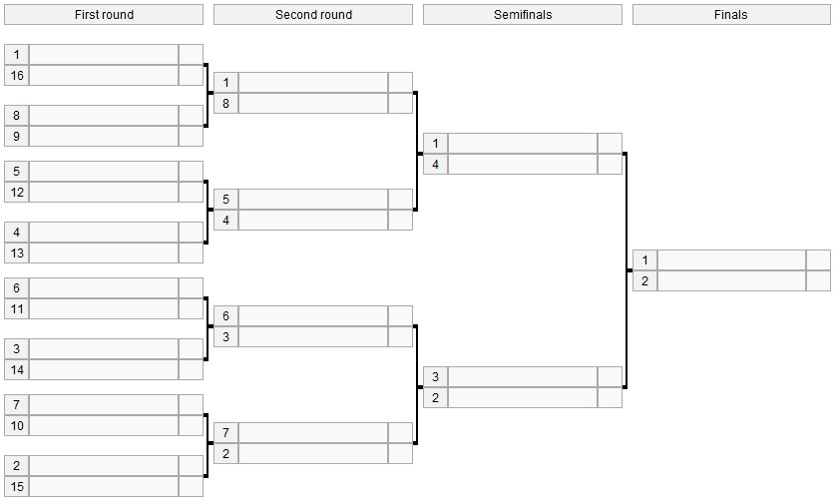The opposing robot has touched the space outside the ring on its own. When a wheeled robot has fallen over on the ring or in similar conditions, Yuhkoh will not be counted, and the match continues.

Figure Seeded tournament structure

********************** End of Document **********************