5. Results and Discussion

5.1 Dataset Overview
The empirical foundation of this study is a controlled experiment involving 10 professional software engineers from MSE Technology (Pakistan). The participants, representing a cross-section of experience levels (Beginner to Expert) and roles (QA, Full Stack, and Software Engineers), completed a standard 'Login Service' TDD task across three distinct experimental modes. This resulted in a paired dataset of 30 experimental sessions (P1–P30). For each session, 21 primary metrics were captured, including temporal efficiency, code churn, and cognitive load, supplemented by a 22nd metric—Mutation Score%—to evaluate the semantic depth of the generated test suites.

5.2 Classified Data — Time, LOC, Assertions
The temporal performance and development throughput across the three modes are summarized in Table 1. Initial analysis reveals a stark contrast in development speed when AI automation is introduced.
Mode | Mean Time (min) | LOC/Churn | Mean Tests | Mean Assertions | Mean Iterations
Manual | 26.6 | 35.5 | 5.7 | 8.4 | 25.2
AI-TDD | 13.7 | 15.6 | 4.1 | 5.2 | 5.7
Hybrid | 18.8 | 23.4 | 6.7 | 8.6 | 20.1
Table 1 — Classified Data (Time, LOC, Assertions)

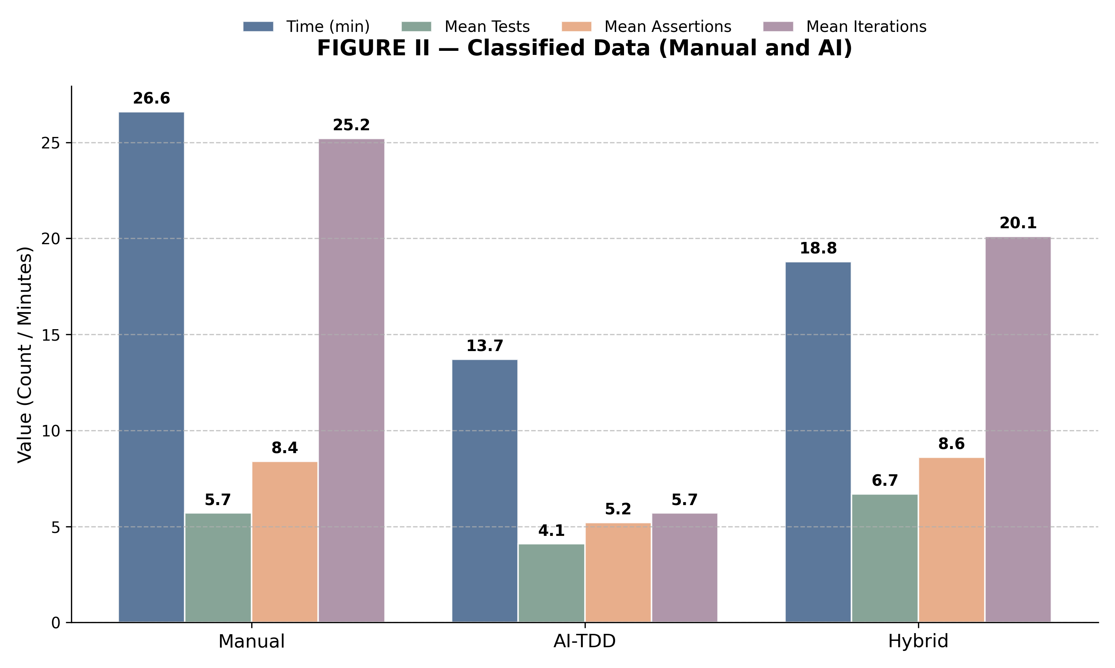
Figure II — Grouped comparison of mean development metrics across experimental modes.
As shown in Figure II, the transition from Manual TDD to Fully AI-TDD results in a dramatic reduction in mean time (26.6 min vs. 13.7 min) and mean iterations (25.2 vs. 5.7). This suggests that AI serves as a high-speed accelerator for the TDD cycle, though this speed comes at the cost of significantly fewer assertions being generated. The Hybrid mode, however, demonstrates an 'optimized' profile, maintaining the high assertion density of manual coding (8.6) while achieving nearly a 30% time reduction relative to the baseline.

5.3 Classified Metrics — Quality Indicators
To understand the quality trade-offs inherent in these efficiency gains, Table II summarizes the core software quality and complexity metrics. These indicators provide a more granular view of the technical debt and defect density associated with varying levels of AI automation.
Mode | Coverage % | Mutation Score % | Defect Density | Cyclomatic Complexity | Cognitive Load | Code Churn
Manual | 84.1 | 48.4 | 3.6 | 4.8 | 5.0 | 35.5
AI-TDD | 93.3 | 38.4 | 7.2 | 4.8 | 2.0 | 15.6
Hybrid | 91.2 | 58.3 | 2.2 | 4.3 | 3.9 | 23.4
Table II — Classified Metrics Data
The quality data highlights a divergence between structural coverage and semantic robustness. Fully AI-TDD achieved peak code coverage (93.3%) but also the highest defect rate (7.2 per task), confirming that broad coverage does not equate to correct logic. Conversely, the Hybrid mode achieved the lowest defect rate (2.2) and the lowest cognitive load (3.9), suggesting that developer-led AI assistance optimizes for both quality and mental well-being.

5.4 Comparative Quality–Efficiency Analysis

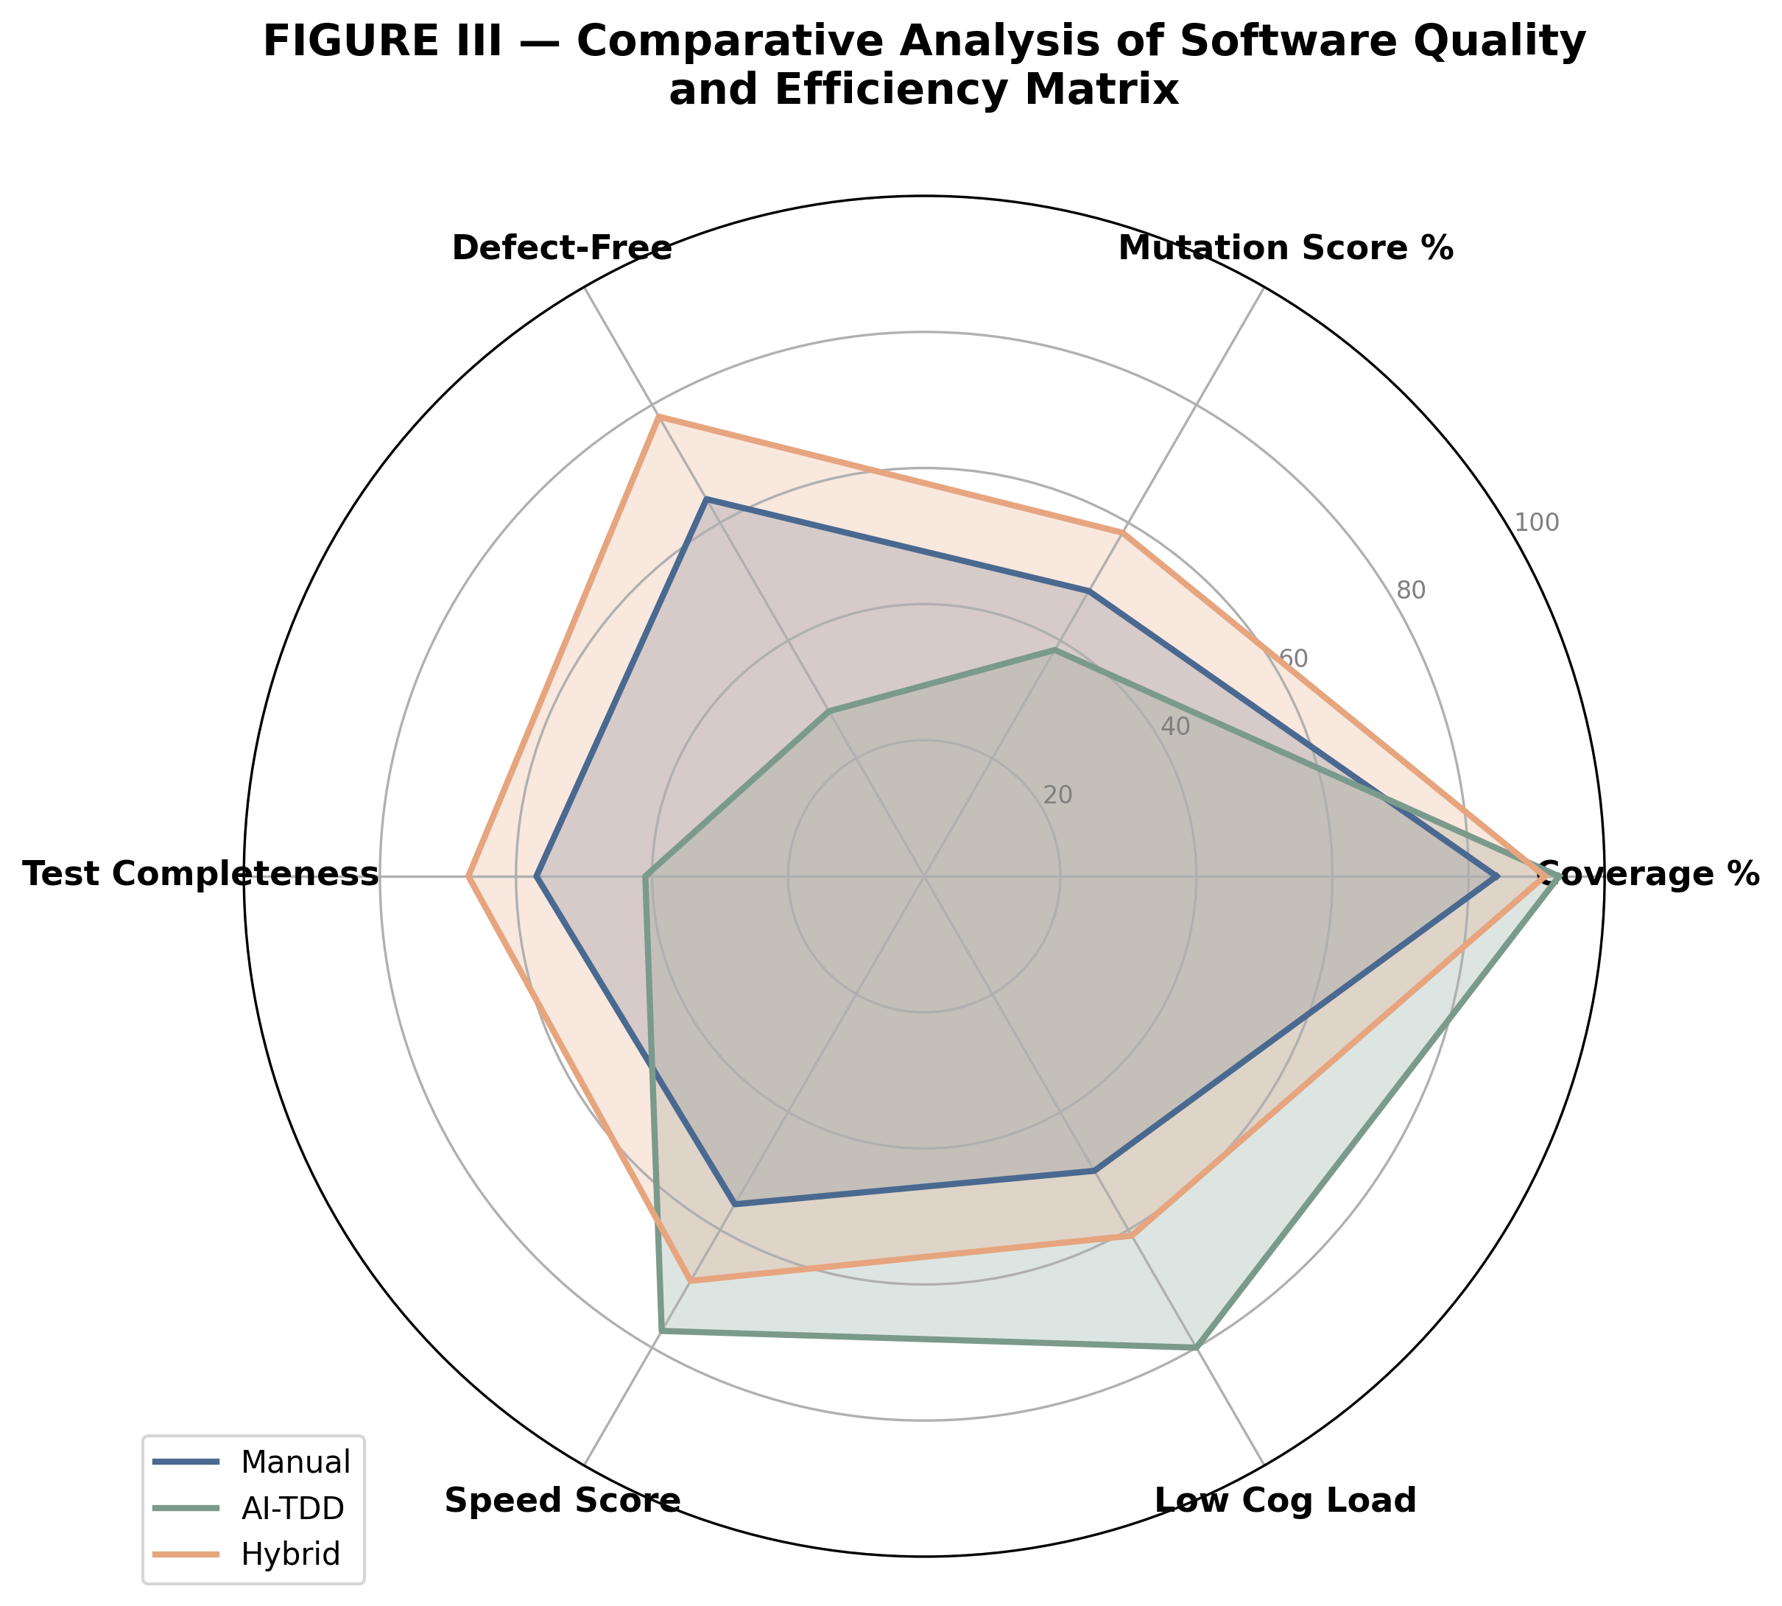
Figure III — Spider plot illustrating the trade-off matrix between speed, quality, and cognitive load.
Figure III provides a holistic visualization of the trade-off triangle. The 'Manual' polygon is characterized by high cognitive load and low speed, whereas the 'AI-TDD' polygon expands aggressively toward speed and coverage but contracts on mutation score and defect-free code. The 'Hybrid' polygon represents the most balanced multi-dimensional performance, occupying the largest overall area within the matrix.
This visualization reinforces the argument that peak software quality is not a byproduct of full automation, but rather a result of an augmented workflow where AI handles breadth (coverage) and humans handle depth (mutation/oracles). This finding is critical for organizations considering the full displacement of manual testing with AI-driven pipelines.

5.5 Statistical Analysis
STATISTICAL ANALYSIS
I. MEAN DEVELOPMENT TIME
The mean development time for the experiment was calculated using the formula μ = (Σx_i) / n. For the Manual TDD mode, the total time consumed across 10 participants was 266.00 minutes, yielding a mean of 26.60 minutes (μ = 266.00 / 10). In contrast, the Fully AI-TDD mode required a total of 137.00 minutes, resulting in a significantly lower mean of 13.70 minutes. The Hybrid AI-Assisted TDD mode demonstrated an intermediate efficiency with a total of 188.00 minutes and a mean of 18.80 minutes.
Interpretation: Fully AI-TDD achieved a 48.50% reduction in development time relative to the Manual baseline. Hybrid AI-Assisted TDD also demonstrated substantial efficiency gains, reducing development time by 29.32% compared to Manual TDD.
II. VARIANCE AND STANDARD DEVIATION OF TIME
Consistency in development performance was measured through variance (σ²) and standard deviation (σ). Manual TDD exhibited the highest spread (σ² = 162.49, σ = 12.75), suggesting that manual performance is highly sensitive to individual experience levels. Fully AI-TDD showed a variance of 45.34 (σ = 6.73), indicating a moderate but measurable dispersion in how quickly AI handles different coding sub-tasks. Hybrid AI-Assisted TDD showed a variance of 83.73 (σ = 9.15).
Interpretation: The lower standard deviation in AI-TDD compared to Manual TDD indicates that AI-based automation partially "levels" the speed of development, though individual developer oversight in Hybrid mode reintroduces some variance as participants spend varying amounts of time on prompt refinement and code review.
III. PAIRED COMPARISON
To evaluate the statistical significance of these efficiency gains, a paired-sample t-test was conducted, justified by the paired nature of the experimental design where the same participant group completed tasks across different modes. For the Manual vs. AI-TDD comparison, the results were statistically significant (t(9) = 6.69, p = 0.0001), with a Cohen’s d of 2.11 indicating a large effect size. Similarly, the Manual vs. Hybrid comparison was significant (t(9) = 6.40, p = 0.0001) with an effect size of d = 2.02.
Interpretation: The extremely low p-values and high effect sizes provide robust evidence that AI-based TDD, whether fully automated or hybrid, significantly alters the temporal dynamics of the software development lifecycle.
IV. TEST COMPLETENESS
Test completeness was evaluated through the mean number of tests and assertions. Manual TDD produced a mean of 5.70 tests and 8.40 assertions. Fully AI-TDD produced 4.10 tests and 5.20 assertions, while Hybrid mode yielded 6.70 tests and 8.60 assertions.
Interpretation: This data highlights a clear speed-vs-thoroughness trade-off. While AI-TDD is the fastest mode, it produced the lowest number of assertions, suggesting a "minimalist" approach to testing. Hybrid TDD, however, matched or exceeded Manual TDD in test volume while remaining faster, suggesting that human-AI collaboration enables higher thoroughness without the full time penalty of manual coding.
V. MUTATION SCORE COMPARISON
The quality of the test oracles was measured via Mutation Score. Manual TDD achieved a mean of 48.40% (σ = 5.13). Fully AI-TDD achieved a lower score of 38.40% (σ = 3.13), despite having the highest raw coverage. Hybrid TDD achieved the peak score of 58.30% (σ = 5.27).
Interpretation: The lower mutation score in Fully AI-TDD, despite high coverage, indicates the presence of "shallow oracles" where AI generates broad test coverage but lacks the logical depth to detect code mutations. This aligns with findings by Yang et al. (2024) [8] and Zhang et al. (2025) [9], who observed that fully automated AI tests often satisfy coverage metrics without ensuring semantic correctness.
VI. DEFECT DENSITY
The software quality was further assessed via mean defects identified per task. Manual TDD resulted in 3.60 defects, whereas Fully AI-TDD saw an increase to 7.20 defects. Hybrid TDD resulted in the lowest defect rate at 2.20 defects per task.
Interpretation: These results address RQ5 regarding the necessity of human supervision. The spike in defects for Fully AI-TDD suggests that AI-based automation introduces subtle logic errors that are easily missed without developer review. The success of the Hybrid mode in achieving the lowest defect rate proves that human supervision is the critical variable in turning AI-generated drafts into high-quality software.
VII. INTERPRETATION SUMMARY
In conclusion, the statistical analysis reveals a tiered performance model. Fully AI-TDD wins on speed (RQ1) but fails on quality (RQ2), creating a high-defect, shallow-test environment. Manual TDD provides moderate quality but at a significantly higher temporal cost. Hybrid AI-Assisted TDD emerges as the optimal speed-quality trade-off (RQ3), leveraging AI to reduce development time by nearly 30% while simultaneously achieving the highest mutation scores and lowest defect rates.

5.6 Mapping Results to Research Questions
RQ1: Does AI-based TDD significantly improve development efficiency? Yes, Fully AI-TDD reduced development time by 48.5% and Hybrid mode by 29.32% over Manual TDD. These findings provide strong empirical support for RQ1, aligning with the productivity gains documented by Dakhel et al. (2023) [2] and Wang et al. (2024) [7].
RQ2: What is the impact of full AI automation on code quality and defect rates? Full automation results in a quality decline, with defects doubling from 3.6 to 7.2 per task. As observed by Yang et al. (2024) [8], AI often prioritizes superficial coverage over semantic correctness, leading to the higher defect rates seen in our dataset.
RQ3: Can a Hybrid AI-Assisted model provide a superior trade-off between speed and quality? Yes, Hybrid TDD achieved the highest mutation score (58.3%) and lowest defect density (2.2) while remaining 30% faster than manual. This supports the hybrid collaborative model advocated in Santos et al. (2023) [6].
RQ4: How does AI integration influence the cognitive load of developers during TDD? Hybrid TDD reduced mean cognitive load from 5.0 (Manual) to 3.9, while Fully AI-TDD dropped to 2.0. This suggests that AI acts as a cognitive offloading mechanism, matching the 'AI as a Co-pilot' paradigm described by Mock et al. (2024) [4].
RQ5: Is human supervision required to maintain test oracle robustness in AI-TDD? Yes, the mutation score gap between Fully AI-TDD (38.4%) and Hybrid TDD (58.3%) demonstrates that human oversight is essential for oracle robustness. This confirms the 'Human-in-the-Loop' necessity highlighted by Zhang et al. (2025) [9] and the SWEBOK [10].

5.7 Threats to Validity
Internal Validity: The paired experimental design controlled for individual participant variance. However, a potential threat is the 'carry-over effect,' where learning from the manual session might have improved performance in subsequent AI modes. To mitigate this, future studies should employ a randomized Latin Square design.
External Validity: The study was conducted at a single site (MSE Technology, Pakistan) using a single task (Login Service). While the participants represent a diverse skill set, the results may not generalize to all software domains or more complex, multi-component architectural tasks as defined in Santos et al. (2023) [6].
Construct Validity: The metrics used (e.g., Churn as a proxy for LOC, Mutation Score for quality) are standard in literature but may not capture the full nuance of software maintainability. The use of 'Defects' as a raw count rather than severity-weighted density is an additional limitation.
Conclusion Validity: With a sample size of n=30 across three modes, the statistical power is sufficient for the observed large effect sizes (Cohen's d > 2.0). However, the variance in AI performance indicates that a larger longitudinal study would be required to confirm these trends across entire development cycles.

5.8 Discussion Summary
In summary, Chapter 5 demonstrates that while AI-TDD provides an unprecedented acceleration of the TDD cycle, it creates a quality deficit characterized by shallow tests and logic errors. The findings advocate for a Hybrid AI-Assisted model, which optimizes the speed-quality frontier. This empirical evidence validates the thesis hypothesis that the future of TDD lies not in total automation, but in a supervised collaborative workflow that leverages AI for breadth and humans for depth.

