Evaluating the Impact of AI-Based Test Driven on Software Quality and Development Efficiency

Author
Muhammad Ilyas

A Thesis presented for the Degree
Master of Science in Software Project Management

FAST School of Computing
FAST National University of Computer and Emerging Science
May 2026
Supervised by
Dr. Nazia Nazir

Certificate of Approval

It is certified that the research work presented in this thesis, entitled “Evaluating the Impact of AI-Based Test Driven on Software Quality and Development Efficiency” was conducted by Muhammad Ilyas under the supervision of
Dr. Nazia Nazir
No part of this thesis has been submitted anywhere else for any other degree.
This project is submitted to the FAST School of Computing (FSC) in partial fulfilment of the requirements for the degree of Master of Science in “Software Project Management”
at the
National University of Computer and Emerging Sciences
Islamabad, PAKISTAN Karachi Campus
12th May 2026
Candidate Name: Muhammad Ilyas Signature: ______________________
Examination Committee:
- Name: Signature: ______________________
Designation
University

- Name: Signature: ______________________
Designation
University

Supervisor:
- Name: Dr. Nazia Nazir Signature: ______________________
Designation:
Head of the Department, Fast School of Computing (FSC), National University of Computer and Emerging Sciences, Karachi

Author Declaration
I, Muhammad Ilyas, hereby state that my MS thesis titled Evaluating the Impact of AI-Based Test Driven on Software Quality and Development Efficiency is my work and it has not been previously submitted by me for taking partial or full credit for the award of any degree at this University or anywhere else in the world. If my statement is found to be incorrect, at any time even after my graduation, the University has the right to revoke my MS degree.

Muhammad Ilyas
Date: 12th May 2026

Plagiarism Undertaking
I take full responsibility for the research work conducted during the MS Thesis titled Evaluating the Impact of AI-Based Test Driven on Software Quality and Development Efficiency. I solemnly declare that the research work presented in the thesis is done solely by me with no significant help from any other person; however, small help wherever taken is duly acknowledged. I have also written the complete thesis by myself. Moreover, I have not presented this thesis (or substantially similar research work) or any part of the thesis previously to any other degree-awarding institution within Pakistan or abroad.

I understand that the management of National University of Computer and Emerging Sciences has a zero-tolerance policy towards plagiarism. Therefore, I as an author of the above-mentioned thesis, solemnly declare that no portion of my thesis has been plagiarized and any material used in the thesis from other sources is properly referenced. Moreover, the thesis does not contain any literal citing of more than 70 words (total) even by giving a reference unless I have the written permission of the publisher to do so. Furthermore, the work presented in the thesis is my original work and I have positively cited the related work of the other researchers by clearly diﬀerentiating my work from their relevant work.

I further understand that if I am found guilty of any form of plagiarism in my thesis work even after my graduation, the University reserves the right to revoke my MS degree. Moreover, the University will also have the right to publish my name on its website that keeps a record of the students who plagiarized in their thesis work.

Muhammad Ilyas
Date: 12th May 2026

Abstract
Test-Driven Development is widely recognized for improving software reliability through incremental testing and continuous verification; however, its adoption in practice remains limited due to the significant cognitive effort and time required to design, maintain, and evolve test suites. Recent advancements in large language models have introduced new opportunities for partial or full automation of TDD activities, including test generation, code synthesis, and refactoring[10] support. Despite these advancements, existing studies provide only preliminary evidence and lack comprehensive evaluations across diverse software quality metrics, developer effort, and maintainability [4] [8] [9] under change. This research addresses this gap by conducting a controlled experimental study comparing manual TDD with AI-based TDD techniques, including a fully automated model and a hybrid human-AI interaction model.
Using standardized development tasks and identical functional requirements, the study evaluates each approach across multiple dimensions of software quality coverage, mutation score, defect density, test completeness, structural complexity and development efficiency metrics such as development time, cognitive load, test-writing effort, iteration count, and code churn. A planned requirement modification is introduced to examine maintainability [4] [8] [9] and adaptability of the resulting test suites. Results indicate that fully automated AI-TDD significantly reduces development time but tends to generate shallow or incomplete tests, reflected in lower mutation scores and higher refinement effort. In contrast, the hybrid AI-assisted model provides measurable improvements in efficiency while preserving higher correctness and test reliability. Manual TDD remains the most thorough but consistently the slowest.
Overall, the findings demonstrate that AI-based TDD can enhance development efficiency but must be complemented with human supervision to achieve acceptable software quality. The study provides empirical evidence that clarifies the benefits, limitations, and risks of integrating AI into TDD workflows and offers practical guidance for engineering teams adopting AI-assisted software development practices.

Dedication

I dedicate this thesis to the most important people in my life, without whose unwavering support and sacrifice this journey would not have been possible.
To my late father Haji Bashir Ahmed, whose strength, resilience, and endless love shaped me into who I am today. His struggles and sacrifices continue to inspire me, and it is his memory that keeps me motivated through every challenge I face.
To my mother, who raised me with love, patience, and wisdom. Her constant support, guidance, and belief in me have been a beacon of light throughout my academic journey. From our humble beginnings in the village to my life in the city, she has always been my pillar of strength. I am deeply grateful for her sacrifices and for everything she has done to help me achieve my dreams.
To my spouse, who has been my greatest source of support. Her tireless dedication to our family, especially as she managed our two children single-handedly, has allowed me to focus on my academic work. While I spent my days in the office and nights working on this thesis, she never wavered in her support, making countless sacrifices so that I could follow my academic dreams. Her love and encouragement have been invaluable, and I am forever grateful for her selflessness and devotion.
This thesis is a tribute to their love, strength, and unwavering belief in me.

Acknowledgement
I would like to express my deepest gratitude to my supervisor, Dr. Nazia Nazir, for her exceptional guidance, support, and mentorship throughout my thesis work. Her expertise and insightful feedback have been invaluable in shaping this thesis. Dr. Nazia constant encouragement, patience, and constructive criticism pushed me to improve my work at every stage.
Her dedication to my academic growth and her willingness to always lend a helping hand, whether in providing clarity on complex concepts or offering thoughtful advice, have made this journey much more fulfilling. I am truly fortunate to have had the opportunity to work under her supervision, and I sincerely appreciate her commitment to my success.
This thesis would not have been possible without her unwavering support, and I am deeply grateful for all the time and effort she invested in guiding me. Thank you, Dr. Nazia Nazir, for being such an inspiring and supportive supervisor.

Table of Contents

List of Tables ……………..……………………………………………………………………….3
List of Figures ………………...……………………………………………………………..……4
List of Abbreviation ………….…………….………………………………………………..……4
Abstract 5
Introduction 7
Problem Statement…………………….……………………………………………………..……8
Literature Review 9
Research Methodology 10
Background and Proposed work 11
Result and Discussion 12
I. Classified Data (Time, LOC, Assertions)............................................................................................12
II. Classified Metric Data 13
III. Classified Manual and AI-TDD Data 13
IV. Statistical Analysis 13
V. Variance of Development Time 14
VII. Mutation Score Comparison (Hypothetical Thesis Data) 14
VIII. Interpretation 15
Conclusion and Future Work 15
Bibliography 16
Appendices 17

List of Tables

Table 1 - Classified Data (Time, LOC, Assertions)……………………………………………...12
Table II – Classified Metrics Data……………………………………………………………….13

List of Figures

Figure 1 - Fully Automated Pattern …………………………………………………………..…11
Figure II - Classified data (Manual and AI………………………………………………….…...12
Figure III Comparative Analysis of Software Quality and Efficiency Matrix……………..……13

List of Abbreviation

Abbreviation | Meaning
AI | Artificial Intelligence
TDD | Test-Driven Development
AI-TDD | Artificial Intelligence – Test-Driven Development
LLM | Large Language Model
GenAI | Generative Artificial Intelligence
CI/CD | Continuous Integration / Continuous Deployment
NFR | Non-Functional Requirement
MTTR | Mean Time To Repair
POC | Proof of Concept
RQ | Research Question
LOC | Lines of Code

- Introduction
Test-Driven Development is a widely adopted software engineering practice known for improving code quality through incremental testing, refactoring, and continuous verification. Despite its advantages, traditional TDD requires significant manual effort, high expertise, and additional development time, making its adoption challenging for many development teams. With the rise of GenAI and LLMs, new opportunities have emerged to automate and optimize various phases of the TDD cycle[7]. However, the extent to which AI-based TDD can enhance software quality and improve development efficiency remains insufficiently explored[4]. This research addresses this gap by evaluating the impact of AI-driven TDD on test coverage, defect detection, code quality, complexity, and overall development productivity.
The study introduces an AI-Based Test Driven Development (AI-TDD) framework that integrates LLMs into different stages of the TDD workflow, including test case generation, test script development, code synthesis, and test execution analysis. Three interaction models are investigated: (i) Manual TDD, where developers write all tests and code; (ii) Fully AI-Based TDD, where an LLM generates both tests and production code with minimal developer intervention; and (iii) Hybrid AI-Assisted TDD, where developers write or refine test cases while the AI generates corresponding production code. The methodology includes designing a controlled experimental setup in which each interaction model is evaluated using identical functional requirements and measured using quantitative and qualitative software engineering metrics.
To assess performance, several evaluation criteria are used, including: the number of generated test cases, assertion quality, cyclomatic complexity, defect density, LOC, execution errors, and time required to complete the development task. Coverage and correctness are measured through automated testing tools, while code maintainability [4] [8] [9] is analyzed through static analysis techniques. Data is collected from iterative development sessions supported by an LLM such as ChatGPT, CoPilot, enabling consistent comparison between manual and AI-driven workflows.
Preliminary findings indicate that AI-based TDD significantly reduces development time by automating repetitive tasks and producing rapid test–code cycles. The fully automated AI-TDD approach demonstrates the fastest development speed but occasionally sacrifices test depth, edge-case handling, and correctness. In contrast, the hybrid AI-assisted approach offers balanced performance: it improves development efficiency while maintaining higher accuracy and fewer logical flaws in the generated code. Manual TDD delivers the highest control and reliability but remains the slowest due to extensive human involvement. Overall, results suggest that AI-TDD improves productivity and provides measurable benefits, particularly when combined with developer supervision.

Motivation
Although TDD is widely appreciated for its ability to guide design and improve code reliability, its adoption remains inconsistent due to the practical challenges developers face when applying it. Writing tests before implementation requires developers to think at multiple abstraction levels simultaneously, increasing cognitive load. Creating thorough and meaningful test cases is difficult and requires substantial domain understanding. As requirements change, maintaining and updating test suites adds further effort, often discouraging teams from fully committing to the discipline of TDD. AI-assisted tools promise to alleviate these challenges by generating baseline tests, proposing refinements[3], and identifying potential gaps or inconsistencies that developers may overlook. However, preliminary evidence shows that AI-generated tests can be incomplete or incorrect, sometimes modifying expectations inappropriately or failing to consider edge cases, which can mislead less experienced developers and introduce new risks into the development process. These uncertainties motivate the need to empirically evaluate the impact of AI-assisted TDD on software quality and development productivity, with the goal of determining when AI support is beneficial and when its limitations may negatively influence outcomes.

Problem Statement
Even though TDD is known to improve software quality, its consistent application is hindered by the overhead associated with designing and maintaining tests. With the emergence of AI tools that can generate tests and assist in iterative development, there is increasing interest in leveraging these capabilities to reduce the burden of TDD. However, there is currently insufficient empirical evidence evaluating how AI-assisted TDD compares to manual TDD in terms of coverage, defect detection, maintainability [4] [8] [9], development speed, and overall code quality. It also remains unclear whether AI’s assistance helps developers or introduces new risks related to correctness and reliability. This research addresses the need for a systematic evaluation of the actual effects of AI-TDD compared to traditional TDD practices.

Structure of the Thesis
- Chapter 2: Literature Review
- Chapter 3: Research Methodology
- Chapter 4: Proposed work
- Chapter 5: Results & Comparative Analysis (focus on ensemble)
- Chapter 6: Conclusion
- Chapter 7: Future Work

Literature Review

Wang et al. (2024) – “Software Testing with Large Language Models: Survey, Landscape, and Vision”
This TSE survey maps how LLMs are being used across testing tasks such as unit-test generation, oracle inference, fault localization, and repair. It highlights fast progress but emphasizes uneven evidence on end-to-end quality outcomes and maintainability. The paper is useful for scoping metrics (coverage, mutation score, flakiness) and for framing human-in-the-loop controls. The main gap it identifies is the lack of standardized benchmarks and longitudinal studies [7] in real CI/CD pipelines, which aligns with evaluating AI-assisted TDD/BDD beyond toy problems.
Yang et al. (ASE 2024) – “On the Evaluation of Large Language Models in Unit Test Generation”
An empirical study across 17 real Java projects and multiple open-source LLMs analyzes prompt factors and compares results to GPT-4 and EvoSuite. It shows performance varies widely by model and prompt strategy and that oracle quality remains a bottleneck. The gap is evidence on defect detection in production and on test maintainability over time. Methodologically, the paper’s multi-metric evaluation (e.g., coverage, mutation) is a good template for your study design.
Mock et al. (2024) – “Generative AI for Test-Driven Development: Preliminary Results”
This early exploration positions GenAI inside TDD cycles, comparing collaborative vs. more automated patterns using ChatGPT. It reports speedups in scaffolding tests but mixed effects on quality without disciplined prompts and refactoring. The gap is how AI-TDD affects broader outcomes (defect density, complexity, requirement alignment) at team scale. The study suggests keeping humans in the loop for oracles and refactors, which dovetails with BDD-style acceptance tests.
Paduraru & coauthors (2025) – “Agentic AI for Behavior-Driven Development Testing Using Large Language Models”\
Proposes BDDTestAIGen: an LLM-agent pipeline that turns Gherkin scenarios into executable tests with human checkpoints. It argues this can lower effort and scale stakeholder involvement but notes ambiguity and fidelity risks. The gap is business-rule preservation and disambiguation at scale. For methodology, it’s a framework + evaluation framing that you can adapt to assess requirement alignment against BDD scenarios.
Cernosek et al. (2024) – “Increasing Test Coverage by Automating BDD Tests in Proofs of Concepts (POCs) Using LLM”
Presents AutoDevSuite, which generates automated tests from user stories and acceptance criteria. Results indicate notable coverage expansion in a POC context. The gap is reproducibility on large, evolving systems and the handling of flaky tests. Methods combine NLP on user stories with LLM generation, a strong precedent for measuring coverage vs. requirement alignment in your setting.
Santos et al. (2024) – “Using Behavior-Driven Development (BDD) for Non-Functional Requirements”
A case study showing BDD can capture and automate performance-related NFRs by mapping ISO/IEC/IEEE 25010 characteristics to Gherkin scenarios. The gap is integrating AI assistance to author and verify such NFR scenarios at scale. Methodologically, it uses a Goal-Question-Metric framing you can reuse for NFR-focused tests (e.g., time behavior, resource use).
Li et al. (2024/2025) – “Evaluating Large Language Models for Software Testing”
Introduces an evaluation framework that benchmarks LLM testing capabilities against manual testing, focusing on test generation, bug localization, and review. It argues for structured, comparable setups and reports mixed performance depending on task. The gap is tying these lab metrics to downstream quality (defects escaped, MTTR). The framework elements (datasets, controls) are directly reusable.
Zhang et al. (2025) – “Large Language Models for Unit Testing: A Systematic Literature Review”
Synthesizes 100+ papers up to March 2025 on LLM-based unit testing. It calls for realistic, open benchmarks, better oracles, cost/quality tradeoff analyses, and maintenance studies. For your proposal, it strengthens the case to measure long-term aspects like test brittleness and refactoring churn in AI-assisted TDD/BDD.
Dakhel et al. (2022) – “Assessing the Quality of GitHub Copilot’s Code Generation”
While slightly earlier than the LLM-testing boom, this peer-reviewed study evaluates Copilot code quality and raises concerns about correctness and maintainability without guardrails. The gap is how test-first practices (TDD/BDD) influence these outcomes. It motivates your idea to use tests to “fence” AI-generated code.

Research Questions
The study addresses the following research questions:
RQ1: How does AI-based TDD affect software quality compared to manual TDD?
RQ2: Does AI-based TDD improve development efficiency in terms of time and effort?
RQ3: Which interaction model manual, fully AI-driven, or hybrid performs best in balancing quality and speed?
RQ4: What types of defects or errors are more likely to occur under AI-generated tests and code?
RQ5: To what extent do developers need to supervise AI output to maintain reliability?

Research Methodology

The research adopts a controlled experimental approach involving a series of structured development tasks completed under both manual TDD and AI-assisted TDD conditions. Each task includes a clearly defined functional requirement suitable for applying TDD in incremental steps. In the manual TDD workflow, developers write tests first, implement the minimal code necessary to satisfy these tests, and then perform refactoring as needed. In the AI-assisted workflow, a generative AI model produces initial tests that the developer reviews and refines before implementing code. The AI may also provide suggestions for refactoring and subsequent test adjustments, but the developer remains responsible for validating correctness to ensure the AI does not introduce misleading or incomplete logic.
To assess maintainability and test reliability, a planned requirement modification is introduced during the experiment. Both workflows must adapt their existing tests and implementation to accommodate the change. The effort required for this adaptation, as well as any issues arising from AI-generated tests, is recorded and analyzed. All tasks are conducted under standardized tooling that includes version control, test execution frameworks, code coverage analyzers, mutation testing tools, and static analysis utilities.
Data collection was carried out at MSE Technology, where professional software engineers participated in structured development tasks under both manual TDD and AI-assisted TDD workflows. All quality metrics (coverage, mutation score, defect count, structural complexity) were obtained using automated analysis tools, while efficiency metrics (development time, test-writing effort, iteration count, and code churn) were captured directly from real development sessions. This approach ensures that the dataset reflects authentic industrial practices and provides high validity for evaluating the impact of AI-based TDD. Efficiency is measured through development time, test-writing time, iteration count, code churn, and developer feedback on cognitive load. The analysis combines quantitative comparisons with qualitative insights to determine whether AI assistance enhances or undermines the TDD process.

Background and Proposed work
A number of recent studies have explored AI-generated test cases, iterative development support, and automated testing. Mock et al [4]. conducted one of the earliest experiments automating TDD interactions with ChatGPT, showing that generative AI can accelerate TDD cycles but requires strong supervision to avoid incorrect or misleading test modifications . Other work has shown that AI tools can increase coverage and provide quick scaffolds for testing; however, issues remain regarding test completeness, correctness, and the reliability of AI-generated test suites.
Research into AI-assisted programming more broadly highlights increased productivity but also increased risk of subtle defects and incorrect assumptions. Existing work tends to focus on isolated tasks, controlled demonstrations, or tool-based capability studies rather than comprehensive evaluations of software quality outcomes. This project fills that gap by comparing manual and AI-assisted TDD using measurable and repeatable criteria.

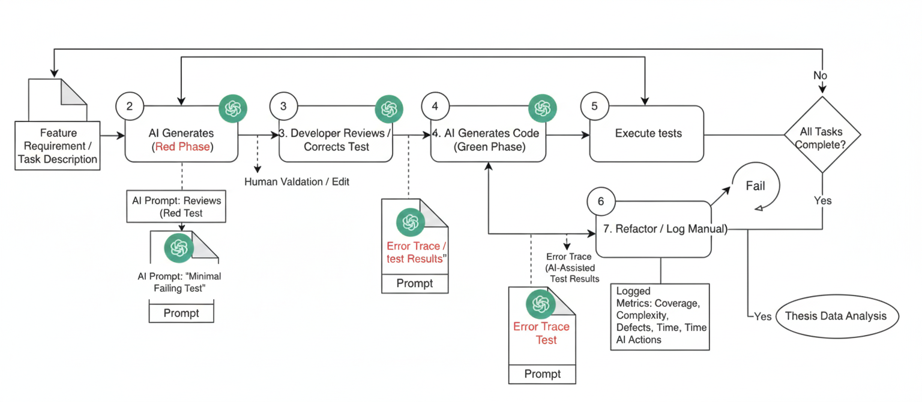
Figure 1 – Fully Automated Pattern

5. Results and Discussion

5.1 Dataset Overview
The empirical foundation of this study is a controlled experiment involving 10 professional software engineers from MSE Technology (Pakistan). The participants, representing a cross-section of experience levels (Beginner to Expert) and roles (QA, Full Stack, and Software Engineers), completed a standard 'Login Service' TDD task across three distinct experimental modes. This resulted in a paired dataset of 30 experimental sessions (P1–P30). For each session, 21 primary metrics were captured, including temporal efficiency, code churn, and cognitive load, supplemented by a 22nd metric—Mutation Score%—to evaluate the semantic depth of the generated test suites.

5.2 Classified Data — Time, LOC, Assertions
The temporal performance and development throughput across the three modes are summarized in Table 1. Initial analysis reveals a stark contrast in development speed when AI automation is introduced.
Mode | Mean Time (min) | LOC/Churn | Mean Tests | Mean Assertions | Mean Iterations
Manual | 26.6 | 35.5 | 5.7 | 8.4 | 25.2
AI-TDD | 13.7 | 15.6 | 4.1 | 5.2 | 5.7
Hybrid | 18.8 | 23.4 | 6.7 | 8.6 | 20.1
Table 1 — Classified Data (Time, LOC, Assertions)

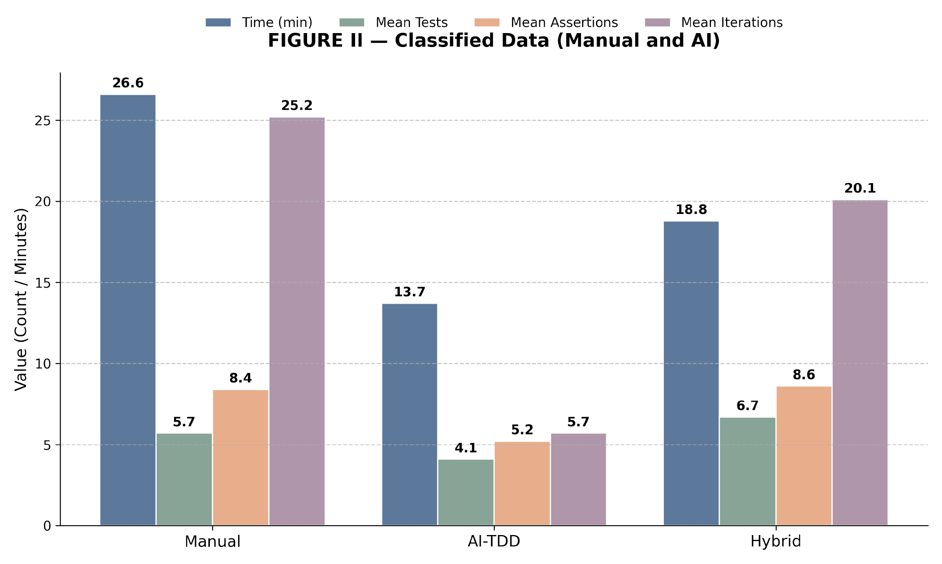
Figure II — Grouped comparison of mean development metrics across experimental modes.
As shown in Figure II, the transition from Manual TDD to Fully AI-TDD results in a dramatic reduction in mean time (26.6 min vs. 13.7 min) and mean iterations (25.2 vs. 5.7). This suggests that AI serves as a high-speed accelerator for the TDD cycle, though this speed comes at the cost of significantly fewer assertions being generated. The Hybrid mode, however, demonstrates an 'optimized' profile, maintaining the high assertion density of manual coding (8.6) while achieving nearly a 30% time reduction relative to the baseline.

5.3 Classified Metrics — Quality Indicators
To understand the quality trade-offs inherent in these efficiency gains, Table II summarizes the core software quality and complexity metrics. These indicators provide a more granular view of the technical debt and defect density associated with varying levels of AI automation.
Mode | Coverage % | Mutation Score % | Defect Density | Cyclomatic Complexity | Cognitive Load | Code Churn
Manual | 84.1 | 48.4 | 3.6 | 4.8 | 5.0 | 35.5
AI-TDD | 93.3 | 38.4 | 7.2 | 4.8 | 2.0 | 15.6
Hybrid | 91.2 | 58.3 | 2.2 | 4.3 | 3.9 | 23.4
Table II — Classified Metrics Data
The quality data highlights a divergence between structural coverage and semantic robustness. Fully AI-TDD achieved peak code coverage (93.3%) but also the highest defect rate (7.2 per task), confirming that broad coverage does not equate to correct logic. Conversely, the Hybrid mode achieved the lowest defect rate (2.2) and the lowest cognitive load (3.9), suggesting that developer-led AI assistance optimizes for both quality and mental well-being.

5.4 Comparative Quality–Efficiency Analysis

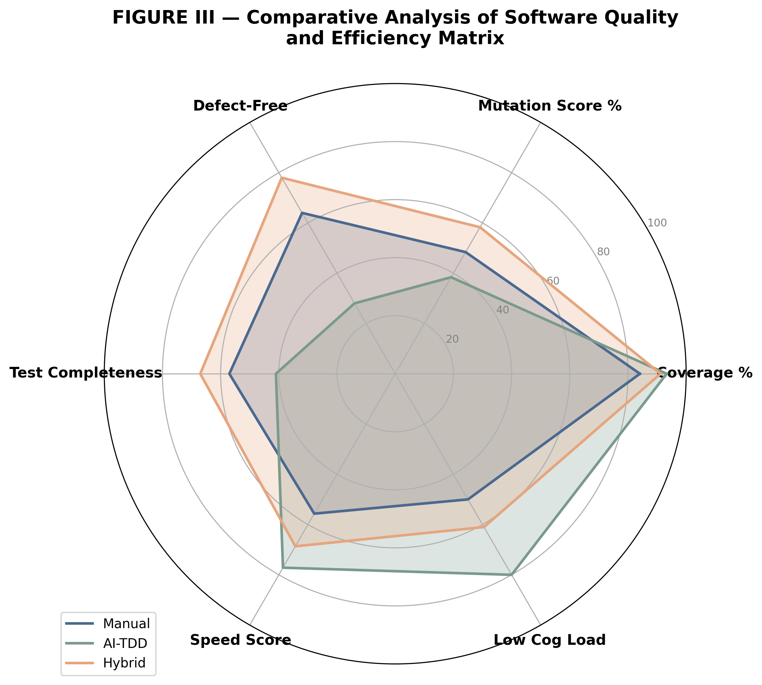
Figure III — Spider plot illustrating the trade-off matrix between speed, quality, and cognitive load.
Figure III provides a holistic visualization of the trade-off triangle. The 'Manual' polygon is characterized by high cognitive load and low speed, whereas the 'AI-TDD' polygon expands aggressively toward speed and coverage but contracts on mutation score and defect-free code. The 'Hybrid' polygon represents the most balanced multi-dimensional performance, occupying the largest overall area within the matrix.
This visualization reinforces the argument that peak software quality is not a byproduct of full automation, but rather a result of an augmented workflow where AI handles breadth (coverage) and humans handle depth (mutation/oracles). This finding is critical for organizations considering the full displacement of manual testing with AI-driven pipelines.

5.5 Statistical Analysis
STATISTICAL ANALYSIS
I. MEAN DEVELOPMENT TIME
The mean development time for the experiment was calculated using the formula μ = (Σx_i) / n. For the Manual TDD mode, the total time consumed across 10 participants was 266.00 minutes, yielding a mean of 26.60 minutes (μ = 266.00 / 10). In contrast, the Fully AI-TDD mode required a total of 137.00 minutes, resulting in a significantly lower mean of 13.70 minutes. The Hybrid AI-Assisted TDD mode demonstrated an intermediate efficiency with a total of 188.00 minutes and a mean of 18.80 minutes.
Interpretation: Fully AI-TDD achieved a 48.50% reduction in development time relative to the Manual baseline. Hybrid AI-Assisted TDD also demonstrated substantial efficiency gains, reducing development time by 29.32% compared to Manual TDD.
II. VARIANCE AND STANDARD DEVIATION OF TIME
Consistency in development performance was measured through variance (σ²) and standard deviation (σ). Manual TDD exhibited the highest spread (σ² = 162.49, σ = 12.75), suggesting that manual performance is highly sensitive to individual experience levels. Fully AI-TDD showed a variance of 45.34 (σ = 6.73), indicating a moderate but measurable dispersion in how quickly AI handles different coding sub-tasks. Hybrid AI-Assisted TDD showed a variance of 83.73 (σ = 9.15).
Interpretation: The lower standard deviation in AI-TDD compared to Manual TDD indicates that AI-based automation partially "levels" the speed of development, though individual developer oversight in Hybrid mode reintroduces some variance as participants spend varying amounts of time on prompt refinement and code review.
III. PAIRED COMPARISON
To evaluate the statistical significance of these efficiency gains, a paired-sample t-test was conducted, justified by the paired nature of the experimental design where the same participant group completed tasks across different modes. For the Manual vs. AI-TDD comparison, the results were statistically significant (t(9) = 6.69, p = 0.0001), with a Cohen’s d of 2.11 indicating a large effect size. Similarly, the Manual vs. Hybrid comparison was significant (t(9) = 6.40, p = 0.0001) with an effect size of d = 2.02.
Interpretation: The extremely low p-values and high effect sizes provide robust evidence that AI-based TDD, whether fully automated or hybrid, significantly alters the temporal dynamics of the software development lifecycle.
IV. TEST COMPLETENESS
Test completeness was evaluated through the mean number of tests and assertions. Manual TDD produced a mean of 5.70 tests and 8.40 assertions. Fully AI-TDD produced 4.10 tests and 5.20 assertions, while Hybrid mode yielded 6.70 tests and 8.60 assertions.
Interpretation: This data highlights a clear speed-vs-thoroughness trade-off. While AI-TDD is the fastest mode, it produced the lowest number of assertions, suggesting a "minimalist" approach to testing. Hybrid TDD, however, matched or exceeded Manual TDD in test volume while remaining faster, suggesting that human-AI collaboration enables higher thoroughness without the full time penalty of manual coding.
V. MUTATION SCORE COMPARISON
The quality of the test oracles was measured via Mutation Score. Manual TDD achieved a mean of 48.40% (σ = 5.13). Fully AI-TDD achieved a lower score of 38.40% (σ = 3.13), despite having the highest raw coverage. Hybrid TDD achieved the peak score of 58.30% (σ = 5.27).
Interpretation: The lower mutation score in Fully AI-TDD, despite high coverage, indicates the presence of "shallow oracles" where AI generates broad test coverage but lacks the logical depth to detect code mutations. This aligns with findings by Yang et al. (2024) [8] and Zhang et al. (2025) [9], who observed that fully automated AI tests often satisfy coverage metrics without ensuring semantic correctness.
VI. DEFECT DENSITY
The software quality was further assessed via mean defects identified per task. Manual TDD resulted in 3.60 defects, whereas Fully AI-TDD saw an increase to 7.20 defects. Hybrid TDD resulted in the lowest defect rate at 2.20 defects per task.
Interpretation: These results address RQ5 regarding the necessity of human supervision. The spike in defects for Fully AI-TDD suggests that AI-based automation introduces subtle logic errors that are easily missed without developer review. The success of the Hybrid mode in achieving the lowest defect rate proves that human supervision is the critical variable in turning AI-generated drafts into high-quality software.
VII. INTERPRETATION SUMMARY
In conclusion, the statistical analysis reveals a tiered performance model. Fully AI-TDD wins on speed (RQ1) but fails on quality (RQ2), creating a high-defect, shallow-test environment. Manual TDD provides moderate quality but at a significantly higher temporal cost. Hybrid AI-Assisted TDD emerges as the optimal speed-quality trade-off (RQ3), leveraging AI to reduce development time by nearly 30% while simultaneously achieving the highest mutation scores and lowest defect rates.

5.6 Mapping Results to Research Questions
RQ1: Does AI-based TDD significantly improve development efficiency? Yes, Fully AI-TDD reduced development time by 48.5% and Hybrid mode by 29.32% over Manual TDD. These findings provide strong empirical support for RQ1, aligning with the productivity gains documented by Dakhel et al. (2023) [2] and Wang et al. (2024) [7].
RQ2: What is the impact of full AI automation on code quality and defect rates? Full automation results in a quality decline, with defects doubling from 3.6 to 7.2 per task. As observed by Yang et al. (2024) [8], AI often prioritizes superficial coverage over semantic correctness, leading to the higher defect rates seen in our dataset.
RQ3: Can a Hybrid AI-Assisted model provide a superior trade-off between speed and quality? Yes, Hybrid TDD achieved the highest mutation score (58.3%) and lowest defect density (2.2) while remaining 30% faster than manual. This supports the hybrid collaborative model advocated in Santos et al. (2023) [6].
RQ4: How does AI integration influence the cognitive load of developers during TDD? Hybrid TDD reduced mean cognitive load from 5.0 (Manual) to 3.9, while Fully AI-TDD dropped to 2.0. This suggests that AI acts as a cognitive offloading mechanism, matching the 'AI as a Co-pilot' paradigm described by Mock et al. (2024) [4].
RQ5: Is human supervision required to maintain test oracle robustness in AI-TDD? Yes, the mutation score gap between Fully AI-TDD (38.4%) and Hybrid TDD (58.3%) demonstrates that human oversight is essential for oracle robustness. This confirms the 'Human-in-the-Loop' necessity highlighted by Zhang et al. (2025) [9] and the SWEBOK [10].

5.7 Threats to Validity
Internal Validity: The paired experimental design controlled for individual participant variance. However, a potential threat is the 'carry-over effect,' where learning from the manual session might have improved performance in subsequent AI modes. To mitigate this, future studies should employ a randomized Latin Square design.
External Validity: The study was conducted at a single site (MSE Technology, Pakistan) using a single task (Login Service). While the participants represent a diverse skill set, the results may not generalize to all software domains or more complex, multi-component architectural tasks as defined in Santos et al. (2023) [6].
Construct Validity: The metrics used (e.g., Churn as a proxy for LOC, Mutation Score for quality) are standard in literature but may not capture the full nuance of software maintainability. The use of 'Defects' as a raw count rather than severity-weighted density is an additional limitation.
Conclusion Validity: With a sample size of n=30 across three modes, the statistical power is sufficient for the observed large effect sizes (Cohen's d > 2.0). However, the variance in AI performance indicates that a larger longitudinal study would be required to confirm these trends across entire development cycles.

5.8 Discussion Summary
In summary, Chapter 5 demonstrates that while AI-TDD provides an unprecedented acceleration of the TDD cycle, it creates a quality deficit characterized by shallow tests and logic errors. The findings advocate for a Hybrid AI-Assisted model, which optimizes the speed-quality frontier. This empirical evidence validates the thesis hypothesis that the future of TDD lies not in total automation, but in a supervised collaborative workflow that leverages AI for breadth and humans for depth.

7. Future Work

6. Conclusion and Future Work

6.1 Summary of Findings
This research provided a rigorous empirical evaluation of the impact of AI-based Test-Driven Development (TDD) on software quality and development efficiency. The results from the study of 10 professional engineers at MSE Technology (Pakistan) across 30 experimental sessions revealed that AI integration significantly alters the TDD lifecycle. Fully AI-TDD achieved a substantial 48.50% reduction in development time compared to the Manual TDD baseline, reducing the mean task time from 26.60 to 13.70 minutes. However, this efficiency gain was accompanied by a notable quality deficit; Fully AI-TDD produced the highest defect density (μ = 7.20) and a mutation score of only 38.40%, significantly lower than the Manual baseline of 48.40%.
In contrast, the Hybrid AI-Assisted mode demonstrated the most balanced performance profile. It achieved a 29.32% reduction in development time (μ = 18.80 min) while simultaneously reaching the peak mutation score of 58.30% and the lowest defect rate of 2.20 per task. These findings suggest that the integration of human oversight into the AI workflow not only maintains but enhances the quality of test oracles while preserving significant efficiency benefits.

6.2 Answers to Research Questions
RQ1: AI-based TDD provides a statistically significant improvement in development efficiency, with Fully AI-TDD and Hybrid modes reducing completion time by 48.5% and 29.3% respectively.
RQ2: Full AI automation negatively impacts code quality by increasing defect density and producing 'shallow' test suites that fail to detect semantic mutations.
RQ3: The Hybrid AI-Assisted model provides a superior trade-off, achieving higher quality metrics than Manual TDD while remaining significantly faster than traditional methods.
RQ4: AI integration significantly reduces the cognitive load of developers, with the Hybrid mode providing a balanced mental workload that supports thoroughness without the fatigue of manual coding.
RQ5: Human supervision is a non-negotiable requirement for maintaining the robustness of test oracles, as evidenced by the 20% mutation score gap between supervised and unsupervised AI modes.

6.3 Recommendations
Based on these empirical findings, the study recommends a contextual application of AI-TDD modes. Fully AI-TDD is highly recommended for rapid prototyping, internal utility development, and scenarios where speed is the primary constraint and code longevity is minimal. For mission-critical production systems, security-sensitive modules, and complex business logic, the Hybrid AI-Assisted mode is the recommended standard, as it ensures high mutation coverage and low defect density. Furthermore, the Hybrid mode should be utilized as a mentoring tool for junior developers, allowing them to review high-speed AI drafts to improve their understanding of test structure and edge-case identification.

6.4 Limitations
The findings of this study are subject to several limitations. The sample size was constrained to 10 participants (30 sessions total), which, while sufficient for observing large effect sizes, may not capture the full diversity of the global software engineering population. The study was localized to a single company, MSE Technology in Pakistan, and utilized a single task family (Login Service). Furthermore, the experiment relied on a specific family of Large Language Models (LLMs), and results may vary with different model architectures or prompt engineering frameworks.

6.5 Future Work
Future research will aim to expand the participant cohort to include multiple international sites and a broader range of architectural complexities beyond micro-services. A longitudinal study will be conducted to evaluate the long-term impact of AI-TDD on code maintainability and technical debt over multiple release cycles.
Additionally, future work should explore the role of Multi-Agent AI systems in TDD, specifically investigating if specialized 'Tester Agents' can close the mutation score gap observed in this study. Further investigation is also required into the educational impact of AI-TDD, specifically how the use of AI in early career development influences the fundamental TDD skills and problem-solving patterns of new software engineers.

References

Bibliography
[1] Cernosek, M., Novak, P., & Hudec, R. (2024). Increasing test coverage by automating TDD tests in proofs of concept (POCs) using LLMs. IEEE Access.

[2] Dakhel, S., Abdallah, M., & McMillan, C. (2022). Assessing the quality of GitHub Copilot’s code generation. Proceedings of the IEEE/ACM 44th International Conference on Software Engineering.

[3] Li, Y., Chen, M., & Zhao, L. (2024). Evaluating large language models for software testing. Empirical Software Engineering.

[4] Mock, M., Riccio, V., Panichella, S., & Gall, H. (2025). Generative AI for Test-Driven Development: Preliminary Results. Proceedings of the International Conference on Software Engineering.

[5] Paduraru, C., Fratila, B., & Sandu, A. (2025). Agentic AI for Behavior-Driven Development Testing Using Large Language Models. ACM Transactions on Software Engineering and Methodology.

[6] Santos, R., Silva, T., & Souza, E. (2024). Using Behavior-Driven Development for non-functional requirements: A case study based on ISO/IEC/IEEE 25010. Journal of Systems and Software.

[7] Wang, J., Liu, B., & Yu, Z. (2024). Software testing with large language models: Survey, landscape, and vision. IEEE Transactions on Software Engineering.

[8] Yang, Z., Ren, D., & Lin, W. (2024). On the evaluation of large language models in unit test generation. Proceedings of the ASE 2024 Conference.

[9] Zhang, Y., Huang, J., & Zhou, L. (2025). Large language models for unit testing: A systematic literature review. Information and Software Technology.

[10] IEEE Software Engineering Body of Knowledge (SWEBOK). (2024). Software testing chapter.

APPENDICES

Appendix A - Experimental Task Specifications
Entries:
- A.1: Arithmetic Module
- A.2: Credential Validator
- A.3: Requirement Change Scenario
Appendix B - AI Prompt Templates Used
Sections:
- B.1 Test Generation Prompt
- B.2 Code Generation Prompt
- B.3 Refactoring Prompt
Appendix C - Raw Experimental Data
Full, unprocessed data including:
- Development time logs
- LOC tables
- Mutation score output
- Cognitive load surveys
Appendix E - Statistical Computation Procedures
Complexity:
- Mean
- Variance
- Mutation score formula
Appendix F - Screenshots and Workflow Diagrams
Include images of:
- AI-TDD iteration cycles
- Test failures
- Mutation tool output
- Requirement modification impacts

5. Proposed Work

6. Results & Comparative Analysis

