NEXORASOLVEX
AI-Powered Digital Solutions

COMPANY PROFILE 2026
Company Profile
Public Edition · 2026
Nexora SolveX

Executive Summary
Nexora SolveX is a modern AI-focused digital innovation startup dedicated to helping local businesses transition toward scalable digital infrastructures, AI-assisted workflows, intelligent chatbot systems, and modern automation ecosystems.
The company operates with a practical engineering mindset focused on lightweight architectures, reusable systems, rapid execution, modular engineering, and AI-assisted productivity.
Rather than following unnecessary enterprise complexity, Nexora SolveX prioritises practical implementation, iterative development, scalable workflows, and adaptive system design.
Nexora SolveX primarily works with local businesses and emerging digital brands by helping them establish professional online infrastructures including websites, dashboard systems, chatbot integrations, automation systems, semantic AI workflows, and reusable digital components.
The startup also focuses heavily on experimentation and research involving: conversational AI systems, reusable chatbot infrastructures, semantic retrieval workflows, AI workflow coordination systems, AI-assisted engineering, modular deployment pipelines, and scalable automation infrastructures.
Nexora SolveX aims to progressively evolve into a scalable AI systems ecosystem capable of building practical, accessible, and intelligent digital solutions for modern businesses.

Company Introduction
Nexora SolveX was founded with the purpose of simplifying digital transformation and AI adoption for local businesses that lack modern online infrastructures and scalable automation systems.
The startup was initiated through direct local outreach and practical client interaction. Nexora SolveX was founded on 1 April 2026. The company currently operates as a virtual company with no physical office.
Instead of depending entirely on large-scale advertising or enterprise-level operations, Nexora SolveX focuses on identifying real businesses that require digital modernization and helping them establish practical, scalable, and professional digital systems.
The company combines:
- frontend engineering,
- backend development,
- AI integrations,
- reusable chatbot systems,
- workflow automation,
- dashboard infrastructures,
- semantic AI systems,
- and modular deployment workflows.
Nexora SolveX believes modern digital products should not only look visually professional, but should also remain scalable, reusable, maintainable, and automation-friendly.

Digital Presence
Nexora SolveX maintains an active digital ecosystem to showcase projects, recruitment opportunities, technical development, and community engagement.

Official Platforms
Official Website
https://nexora-five-topaz.vercel.app/
Career & Opportunities Portal
https://nexora-job-portal.vercel.app/
Nexora SolveX GitHub
https://github.com/muhammadirtizakhan
Founder GitHub (Muhammad Irtiza Khan)
https://github.com/muhmmmadirtizakhan
Instagram
https://www.instagram.com/nexorasolvex?stkn=MTJ6c2c0eDJxNG82Ng==

Contact Details
Email
nexorasolvex@gmail.com
Support Hours
11:00 AM to 11:00 PM
Office & Work Setup
Nexora SolveX is currently a virtual company and has no physical office. The team works entirely online, holding meetings over Google Meet and collaborating through cloud tools.

Vision & Mission

Vision
“To build a modern AI-native digital ecosystem that helps businesses adopt scalable automation systems, reusable infrastructures, conversational AI technologies, and intelligent digital workflows.”

Mission
Nexora SolveX’s mission is to simplify modern digital transformation through practical engineering, AI-assisted development workflows, modular architectures, reusable systems, and scalable automation infrastructures.
The company aims to:
- modernize local businesses,
- simplify AI adoption,
- accelerate digital transformation,
- develop reusable chatbot infrastructures,
- improve business accessibility,
- and continuously research emerging AI systems.

Problem Statement
Many local businesses operate without:
- professional websites,
- digital ordering systems,
- AI-assisted customer support,
- scalable dashboard infrastructures,
- automation workflows,
- structured online presence,
- or intelligent digital systems.
As modern digital ecosystems evolve rapidly, businesses without scalable infrastructures often face:
- reduced customer accessibility,
- inefficient communication systems,
- limited automation,
- weak digital branding,
- slow operational workflows,
- and lack of technological adaptability.
Additionally, many existing solutions available in the market are:
- overly expensive,
- unnecessarily complex,
- difficult to maintain,
- or inaccessible for smaller businesses.
Nexora SolveX was established to provide lightweight, scalable, and practical alternatives that simplify digital transformation and make AI-powered systems more accessible

Target Market
Nexora SolveX primarily focuses on helping local and emerging businesses adopt modern digital infrastructures through practical engineering, scalable systems, and intelligent automation workflows.
The company currently targets businesses operating within:
- Karachi, Pakistan
- Local commercial markets
- Emerging digital businesses
- Service-oriented business ecosystems
Primary target industries include:
- Restaurants & Food Businesses
- Hospitality & Hotel Services
- Retail Stores
- E-Commerce Brands
- Local Service Businesses
- Small & Medium Enterprises (SMEs)
Nexora SolveX’s operational approach focuses on businesses that require modern digital presence, responsive websites, administrative dashboard systems, conversational chatbot integrations, automation workflows, and scalable business infrastructures. The company particularly emphasizes localized business digitalization, where many growing businesses still operate with limited digital systems despite increasing customer demand for modern online experiences.

Nexora SolveX Solution Ecosystem
Nexora SolveX provides practical digital systems designed to modernize business operations through scalable engineering and intelligent automation.
The solution ecosystem includes:
- professional websites,
- AI chatbot systems,
- reusable chatbot infrastructures,
- dashboard systems,
- automation workflows,
- AI-assisted interfaces,
- semantic AI systems,
- deployment infrastructures,
- and reusable UI component ecosystems.
The company focuses on balancing:
- functionality,
- scalability,
- simplicity,
- performance,
- maintainability,
- and rapid deployment.

Service Ecosystem

Website Development
Nexora SolveX develops modern responsive websites designed to provide businesses with professional digital presence and scalable user experiences.

Dashboard Systems
Custom administrative dashboards are developed for operational monitoring, analytics, management systems, and workflow handling.

AI Chatbot Integration
AI chatbot systems are integrated into websites and platforms to improve customer interaction and accessibility.

Automation Workflows
Nexora SolveX researches and develops practical automation systems to reduce repetitive business workflows.

Reusable UI Systems
The company is actively developing reusable chatbot UI systems and modular frontend infrastructures.

Semantic AI Systems
Structured AI knowledge systems are explored to improve contextual understanding and AI-assisted interactions.

Pricing / Service Engagement Models
Note: The following packages represent general service categories. Final pricing may vary depending on project complexity, requirements, integrations, deployment needs, infrastructure scope, and customization level.
Basic Plan PKR 11,000 – 15,000
Suitable For: Small businesses, startups, portfolios, restaurants, and informational websites.
Features
✓ Stunning UI/UX Design
✓ Responsive on All Devices
✓ SEO Optimization
✓ Google Analytics Setup
✓ Dynamic Deployment
✓ Basic Chatbot Integration
✓ Basic Performance Optimization
✓ No Backend Engineering (fast, secure and efficient frontend solution)
✓ Domain Included at the current rate

Pro Plan PKR 17,000 – 24,000
Suitable For: Growing businesses requiring backend systems and advanced functionality.
Features
✓ Domain Included at the current rate (we handle domain setup and configuration)
✓ Stunning UI/UX Design
✓ Active Backend Engineering
✓ Website Statistics & Analytics
✓ LLM-Powered Chatbot Integration
✓ Fully Responsive Design
✓ Database Integration
✓ API Integrations
✓ Agent-Based Solutions (Upon Request)
✓ Monthly Maintenance Plan: PKR 3,000 – 5,000 per month (includes admin activities such as adding, deleting, and managing website content and data)

Enterprise Plan PKR 30,000 – 50,000+
Suitable For: Businesses requiring scalable infrastructures and custom solutions.
Features
✓ System Architecture Planning
✓ Custom Integrations
✓ Team Collaboration Workflows
✓ Advanced Backend Infrastructure
✓ Maintenance & Updates
✓ Premium UI/UX Design
✓ Scalable Deployment Strategy
✓ Business Automation Solutions
✓ Advanced Conversational Systems

Important Note: Final pricing is determined after project analysis and requirement evaluation. Costs may increase or decrease depending on project scope, complexity, third-party integrations, deployment requirements, maintenance expectations, and custom feature requests.

Competitive Landscape
The current digital solutions market contains a large number of freelancers, template-based website builders, and generalized digital agencies. Nexora SolveX differentiates itself by focusing on practical engineering, scalable deployment systems, conversational workflows, and business-oriented technical infrastructures.

Compared to Generic Freelancers
Many freelance solutions focus primarily on isolated website delivery. Nexora SolveX emphasizes complete operational systems including responsive frontend infrastructures, dashboard ecosystems, deployment workflows, chatbot integrations, and scalable administrative architectures.

Compared to Template-Based Builders
Platforms such as Wix, Webflow, and generic template systems provide simplified website generation but often lack customization flexibility, scalable backend control, and business-specific workflow integration. Nexora SolveX focuses on custom workflow implementation, modular infrastructures, scalable architectures, and conversational system integration.

Compared to Traditional Digital Agencies
Many traditional agencies separate development, automation, branding, and deployment into disconnected services. Nexora SolveX approaches projects through integrated engineering workflows combining frontend systems, automation workflows, conversational AI integration, deployment management, and scalable experimentation. The company’s engineering-focused philosophy prioritizes practical execution, maintainable infrastructures, lightweight scalable systems, and continuous technical experimentation tailored for modern businesses.

Technology Infrastructure

Frontend Technologies (depending on the client need and project estimation)
- HTML5
- CSS3
- JavaScript
- Responsive UI Systems
- Modular Frontend Components
- React

Backend Technologies
- Node.js
- Express.js
- Lightweight API Architectures
- Modular Backend Structures

Databases & Infrastructure (depending on the client need and project estimation)
- MongoDB
- Firebase
- Supabase
- Neon
- Vector dbs

AI Systems (depending on the client need and project estimation)
- OpenAI APIs
- Gemini APIs
- Semantic Retrieval Systems
- Contextual Knowledge Pipelines
- AI Workflow Experimentation

Deployment Systems
- Cloud Deployment Platforms
- Lightweight Hosting Architectures
- Modular Deployment Pipelines

AI Systems & Knowledge Architecture
Nexora SolveX focuses heavily on structured AI knowledge systems and contextual AI workflows.
The company explores methods for improving AI responses through:
- structured data preparation,
- contextual retrieval,
- semantic information organisation,
- AI grounding systems,
- and business-specific knowledge structures.
Rather than relying entirely on generic conversational models, Nexora SolveX researches approaches that improve contextual understanding and reduce inaccurate or off-context responses.
Key research areas include:
- semantic search systems,
- contextual retrieval workflows,
- structured knowledge preparation,
- AI grounding pipelines,
- business-specific AI systems,
- reusable conversational infrastructures,
- and intelligent response optimization.

Chatbot Component Ecosystem
Nexora SolveX is actively developing a growing ecosystem of reusable chatbot UI components and conversational interfaces.
The objective of this ecosystem is to simplify chatbot integration and reduce development overhead for businesses requiring conversational systems.
The architecture is designed toward:
- reusable UI components,
- configurable themes,
- scalable deployment patterns,
- rapid integration workflows,
- lightweight frontend systems,
- and modular conversational interfaces.
The component ecosystem is intended to support:
- multiple chatbot styles,
- customizable UI structures,
- responsive layouts,
- adaptable conversational workflows,
- and scalable frontend integration.

AI-Assisted Engineering Philosophy
Nexora SolveX strongly believes AI can significantly improve engineering productivity when combined with human-guided architecture and practical development workflows.
The company integrates AI-assisted development approaches to:
- accelerate productivity,
- reduce repetitive engineering tasks,
- improve workflow efficiency,
- assist documentation processes,
- optimize deployment workflows,
- and improve project organization.
The engineering approach emphasizes:
- prompt engineering,
- structured AI workflows,
- modular development,
- practical automation,
- clean project organisation,
- and scalable engineering practices.
Rather than replacing human engineering decisions, AI systems are treated as productivity-enhancing tools that assist development workflows.

Research & Innovation Division
Research and experimentation are core aspects of Nexora SolveX’s operational philosophy.
The company continuously researches:
- AI workflow systems,
- conversational AI interfaces,
- semantic retrieval systems,
- reusable infrastructures,
- AI agents,
- automation systems,
- scalable frontend architectures,
- and emerging digital technologies.
Research activities include:
- API exploration,
- workflow experimentation,
- deployment optimization,
- AI-assisted engineering strategies,
- and scalable system design.
Nexora SolveX strongly encourages continuous learning and technical experimentation.

Growth Strategy
Nexora SolveX aims to grow progressively through:
- client satisfaction,
- reusable product ecosystems,
- modular infrastructures,
- AI-assisted systems,
- scalable deployment workflows,
- online branding,
- and continuous innovation.
The company focuses on sustainable growth rather than unrealistic expansion models.
Future growth areas may include:
- reusable chatbot systems,
- automation platforms,
- scalable frontend ecosystems,
- and AI-assisted business tools.

Team Structure & Leadership
The team works under the direct leadership of the founders, with flexible working hours.
Muhammad Irtiza Khan | Co-Founder, Chief Executive Officer (CEO) & Chief Technology Officer (CTO)
Responsibilities include: technical direction, system architecture, AI integrations, product engineering, development workflows, and infrastructure planning.
Muhammad Taimoor | Co-Founder & Chief Operating Officer (COO)
Responsibilities include: operations management, client communication, workflow coordination, project handling, deadline management, and organizational operations.
Muhammad Saad Pervaiz | Full Stack Web Developer
Responsibilities include: frontend and backend web development, API and database work, deployment, and bug fixing for client and company projects.
Hammad | Chatbot UI Component Engineer
Responsibilities include: reusable chatbot systems, frontend chatbot workflows, UI experimentation, and conversational component development.
Dua Enam | Mid-Level Full Stack Developer
Responsibilities include: frontend and backend development, API and database integration, AI chatbot integration, deployment, and bug fixing for client and company projects.
Hania Khan | Graphic & Web Designer
Responsibilities include: designing graphics and branded digital content in Canva, designing and building website pages in Framer, and preparing design assets for the development team.
Muhammad Faseeh | AI Operations & Growth Manager
Responsibilities include: building systems with AI tools and AI-assisted coding, managing AI tools and workflows, supporting business growth, and handling tool subscriptions and domain purchases.
Maaz Shahid | Application Security Engineer
Responsibilities include: reviewing the code of delivered client projects, testing security-critical components, reporting findings, and helping fix and re-test issues.
AI Agent Research Engineer (Ahmad) | Research Engineer
Responsibilities include: AI workflow experimentation, automation systems research, AI agent exploration, and workflow coordination systems.

Engineering Principles
Nexora SolveX follows several engineering principles that guide system development and technical decision-making.

Core Principles
- Simplicity over unnecessary complexity
- Modular architecture design
- Reusable system engineering
- Practical implementation
- Lightweight deployment workflows
- AI-assisted productivity
- Continuous optimization
- Scalable infrastructure thinking
- Rapid iterative improvements
- Maintainable project organization

Selected Internal Projects

Hot N Tasty Roll — Restaurant Website & Conversational Chatbot System

Overview
A modern restaurant website developed with responsive frontend architecture and backend as well and conversational chatbot integration designed to improve customer interaction, accessibility, and digital business presence.
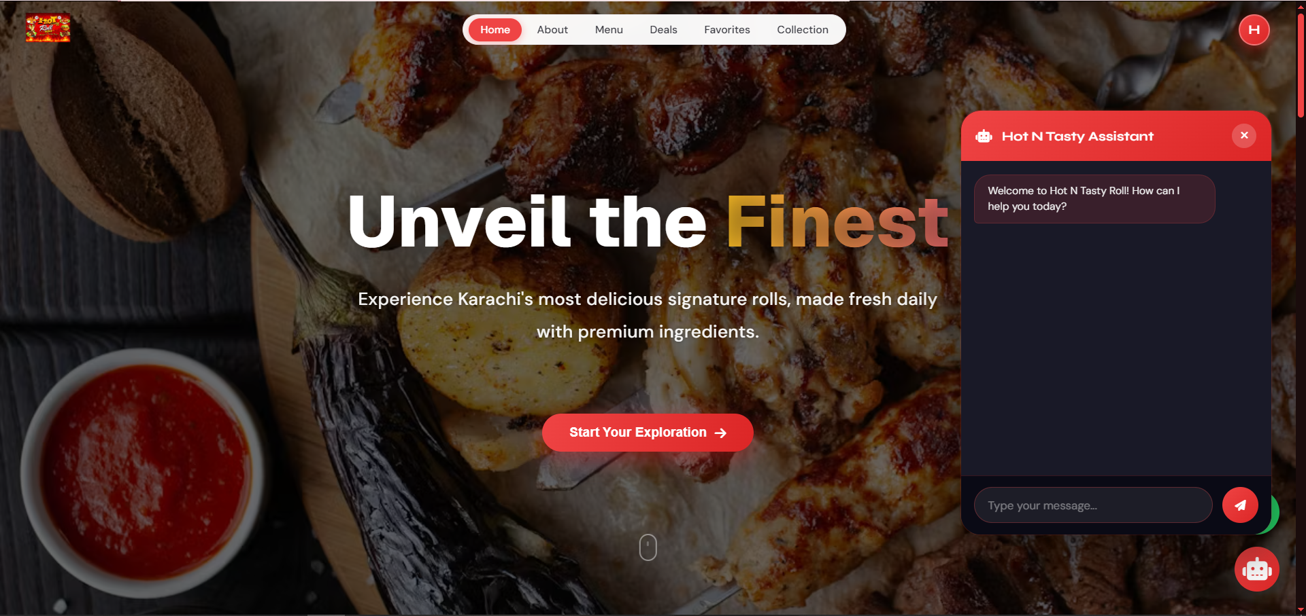

Key Features
- Responsive restaurant UI
- Conversational chatbot integration
- Business information accessibility
- Modern frontend structure
- Interactive customer experience
- Deployment-ready architecture

Technologies Used
- HTML5
- CSS3
- JavaScript

Backend Technologies
- Node.js
- Express.js
- Firebase (Authentication)
- Supabase (Database)
- Conversational AI Integration
- Vercel Deployment

Live Deployment
Hot N Tasty Roll Demo
Link: https://hot-n-tasty-roll.vercel.app/

Project Status
Live & Deployed

Aetheric — Full E-Commerce Infrastructure



Overview
A scalable e-commerce infrastructure developed with modern storefront systems, authentication workflows, product management architecture, and responsive frontend ecosystems.

Key Features
- E-commerce storefront
- Authentication workflows
- Product management systems
- Responsive frontend architecture
- Scalable deployment workflow
- Modern UI infrastructure

Technologies Used
- HTML5
- CSS3
- JavaScript
- Node.js
- Express.js
- Firebase (Authentication)
- Supabase (Database)
- Vercel Deployment

Live Deployment
Aetheric Ecommerce Platform
Link: https://aetheric-neon.vercel.app/

Project Status
Live & Deployed

Aetheric Admin Dashboard
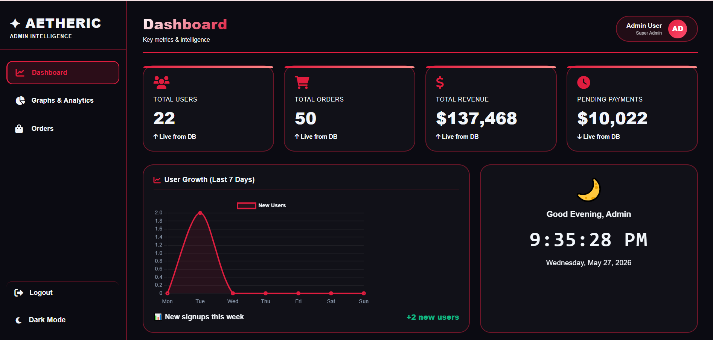

Overview
A scalable dashboard infrastructure designed for administrative workflows, operational management, product monitoring, and business system organization.

Key Features
- Admin authentication system
- Product management workflows
- Dashboard analytics structure
- Operational workflow management
- Scalable admin architecture
- System management infrastructure

Technologies Used
- HTML5
- CSS3
- JavaScript
- Live Dynamic Data Integration
- Dashboard Infrastructure
- Administrative Workflow Systems

Live Deployment
Aetheric Admin Dashboard
Link:https://aetheric-admin-panel.vercel.app/

Project Status
Live & Deployed

Hotel Booking Platform
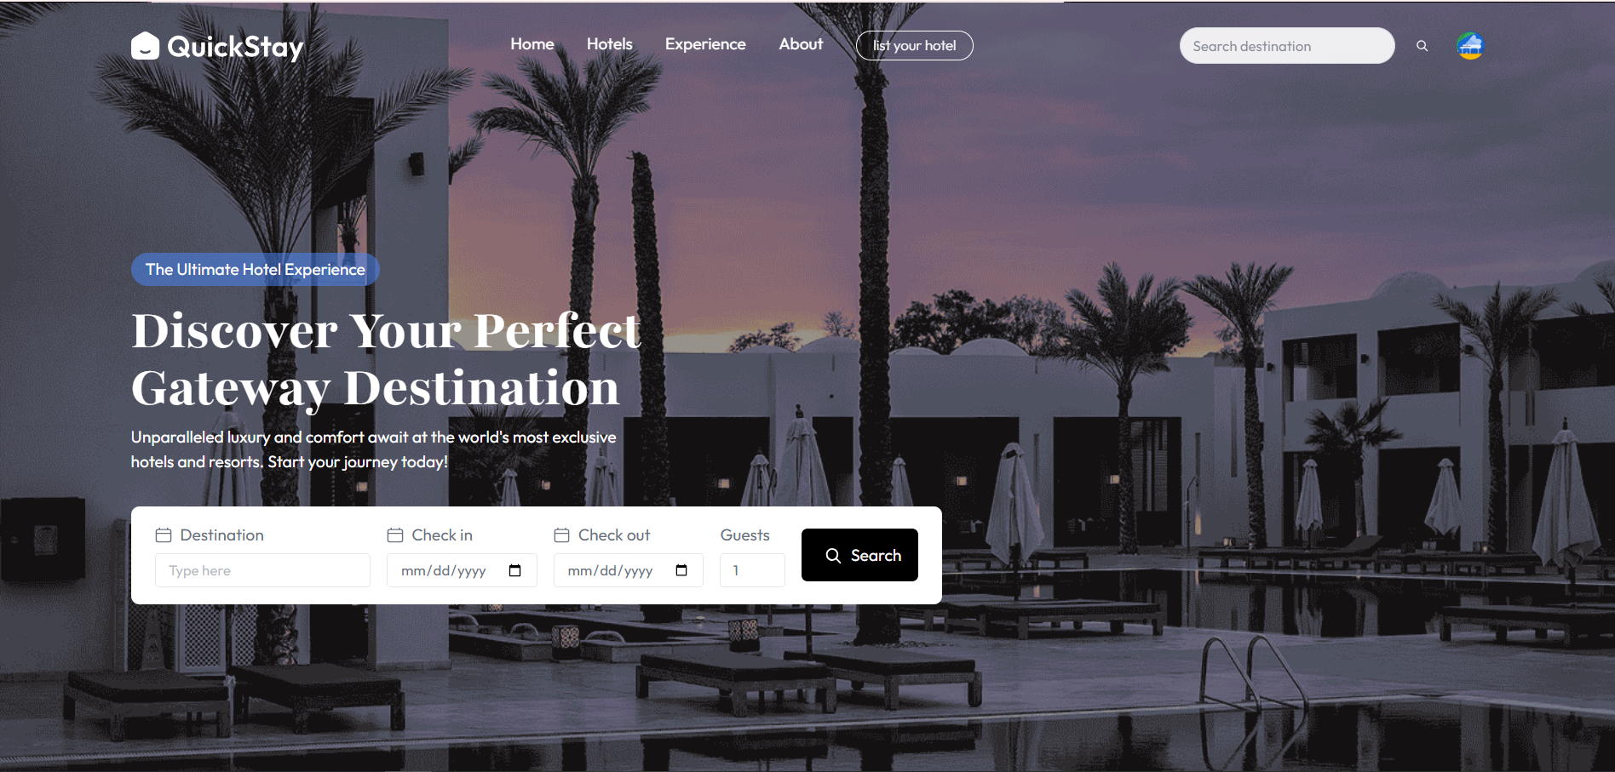

Overview
A modern hotel booking interface designed with responsive frontend systems, scalable booking workflows, and interactive user experience architecture.

Key Features
- Responsive booking UI
- Hotel discovery workflows
- Interactive frontend systems
- Modern visual architecture
- Scalable user interface structure
- Deployment-ready frontend ecosystem

Technologies Used
- HTML5
- CSS3
- JavaScript
- Frontend Booking Workflows
- Node.js
- Express.js
- MongoDB
- Clerk (Authentication)
- Vercel Deployment

Live Deployment
Hotel Booking Platform
Link: https://hotel-booking-app-amber-omega.vercel.app/

Project Status
Live & Deployed

Data Handling & Security Practices
Nexora SolveX encourages responsible and privacy-conscious development practices.
The company focuses on: secure API handling, structured data organization, responsible credential management, modular authentication workflows, and practical deployment security.
Confidentiality agreements may be established for projects involving sensitive client information.
- Continuous Security Updates: Security is ongoing work, not a one-time task. Software versions and dependencies are continuously reviewed and upgraded.

Communication Philosophy
Nexora SolveX believes strong communication is essential for successful project execution.
The company values: transparency, collaborative planning, iterative feedback, practical communication, and consistent support.
Client communication focuses on: understanding business requirements, improving workflows, simplifying technical processes, and maintaining project clarity.

Long-Term Vision
Nexora SolveX aims to evolve into a scalable AI-focused digital systems ecosystem dedicated to: practical automation, reusable infrastructures, intelligent digital systems, conversational AI technologies, and scalable engineering solutions.
The long-term objective is to create modern digital products that simplify AI adoption while maintaining accessibility, scalability, and practical usability.

Why Nexora SolveX
Nexora SolveX differentiates itself through: practical engineering, lightweight architectures, AI-assisted workflows, reusable systems, modular infrastructures, rapid execution, continuous experimentation, scalable engineering thinking, and direct local business transformation.
The company prioritises: functionality over unnecessary complexity, scalable design over short-term implementation, and practical execution over unrealistic enterprise positioning.

Closing Statement
Nexora SolveX represents a modern engineering-focused startup built around practical innovation, scalable digital systems, AI-assisted workflows, and continuous experimentation.
The company believes the future of digital systems lies in: intelligent automation, modular engineering, reusable infrastructures, conversational AI, scalable deployment workflows, and accessible digital transformation.
Through practical execution, technical research, and collaborative engineering, Nexora SolveX aims to continuously evolve into a scalable ecosystem capable of delivering modern AI-powered digital experiences.
NEXORASOLVEX
Building Practical AI-Powered Digital Systems Through Scalable Engineering & Modern Automation

