

Compiler Construction

Project Phase-1

Name: Muhammad Ismail
Roll: L1F22BSCS0895

Submitted to: Ma’am Aneela Mehmood

1. Introduction and Rationale (Slang++):
The design of this Mini C++ language is centered around Slang Roman Urdu to ensure the compiler project fully satisfies the Uniqueness & Creativity requirement. Instead of using conventional English programming terms, the syntax is built using common, expressive Urdu phrases, making the code readable like informal instructions. This language defines 20 unique keywords , 9 unique operators, and 6 punctuations.

2. Keywords and Program Flow (20 Total):

Keyword | Standard Equivalent | Category | Rationale & Placement
dikhao<- | cout / print | I/O Command | Defined as a top-level rule (Show out).
pakro-> | cin / input | I/O Command | Defined as a top-level rule (Catch in).
SceneChalau | main() / function | Structure/Function | Starts the main 'scene' of execution.
DenaWapis | return | Function/Structure | Commands the function to 'give back' the result.
SabitRakho | const | Structure/Type | Commands a variable to 'keep it fixed' (Constant).
KlassBanao | class | Structure | Command to 'make a class'.
BarBar | for / loop | Loop | Command to 'Repeat continually'.
JitniDairTak | while | Loop | 'As long as' (conditional loop).
BreakMaro | break | Loop | 'Hit break' (exit loop).
AgayChalo | continue | Loop | 'Go forward' (skip iteration).
MaanLo | if | Conditional | 'Assume'
ParAgar | else if | Conditional | 'But if' (secondary check).
WarnaYeh | else | Conditional | 'Otherwise, this' (the default fallback).
SadiGinti | int | Data Type | 'Simple count' (integer).
PointWali | float | Data Type | 'Point-having value' (decimal/float).
Harf | char | Data Type | 'Letter/character'.
Alfaz | string | Data Type | 'Words/characters' (string).
Haqeeqat | bool | Data Type | 'Reality/Truth' (Type name).
TheekBaat | true | Boolean Literal | 'Correct point'.
JhootHai | false | Boolean Literal | 'It is a lie'.

3. Operator Nomenclature (9 Total)

Operator | Standard Symbol | Function | Rationale for Design
rakhle | = | Assignment | Commands the variable to 'keep' or 'store' the value.
sameTOsame | == | Equality Check | Commands a direct check for equivalence.
jama | + | Addition | 'Collect' or 'Sum'.
kaatDo | - | Subtraction | 'Cut it off' or subtract.
timesKaro | * | Multiplication | Direct command for multiplication.
baantDo | / | Division | 'Divide it' or distribute.
kamHai | < | Relational: Less Than | 'Is less'.
aur | && | Logical AND | 'And'.
yaaPhir | || | Logical OR | ‘OR’.

4.Punctuation Nomenclature (6 Total)

Punctuation | Standard Equivalent | Function/Role | Type
!! | ; (Semicolon) | End of Statement Marker (Custom Design) | Custom
@ | :: (Scope Resolution) | Namespace/Scope Marker (Custom Design) | Custom
( | ( | Opens function calls and conditional expressions. | Standard
) | ) | Closes function calls and conditional expressions. | Standard
{ | { | Opens a block of code (e.g., function body, MaanLo block). | Standard
} | } | Closes a block of code. | Standard

5. Regex Definitions Table:

Token Type | Regex Definition | Description
DIGIT | [0-9] | A single digit from 0 to 9.
LETTER | [A-Za-z_] | A single uppercase letter, lowercase letter, or underscore.
ID | {LETTER}({LETTER}|{DIGIT})* | An identifier that must start with a letter and can be followed by any number of letters or digits.
INT | {DIGIT}+ | One or more digits (a whole number).
EXP | ([eE][+-]?{DIGIT}+) | The exponential part of a number (e.g., e10, E-5).
FLOAT | ({DIGIT}+"."{DIGIT}*{EXP}?|{DIGIT}+{EXP}) | A number containing a decimal point or an exponent (e.g., 12.34, 5e10).
STRING | \"([^\\\"]|\\.)*\" | Characters enclosed in double quotes.
CHAR | \'([^\\\']|\\.)\' | A single character enclosed in single quotes.
WS | [ \t\r]+ | Whitespace characters (ignored by the scanner).

6. FA:

a. Identifier:

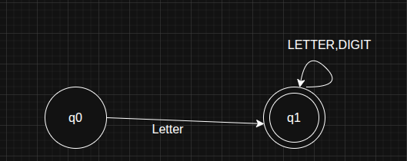

b. integer:

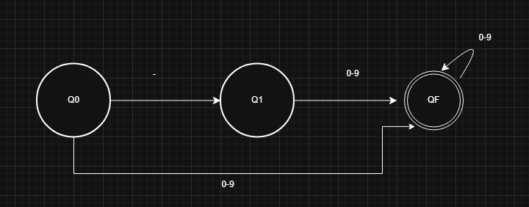

c. float:

