Agentic Artificial Intelligence for Sustainable Finance: An Autonomous Approach to Green Investment

Joshua Koshy
School of Engineering
University of Wollongong in Dubai
Dubai, United Arab Emirates
jjk319@uowmail.edu.au
Muhammud Mapkar Nazir
School of Engineering
University of Wollongong in Dubai
Dubai, United Arab Emirates
msm959@uowmai.edu.au
Mayank Tadepalli
School of Engineering
University of Wollongong in Dubai
Dubai, United Arab Emirates
mt411@uowmail.edu.au
Dr. Mervat Madi
School of Engineering
University of Wollongong in Dubai
Dubai, United Arab Emirates
MervatMadi@uowdubai.ac.ae
Safwaan Syed
School of Engineering
University of Wollongong in Dubai
Dubai, United Arab Emirates
shs651@uowmail.edu.au

Dr. Mohd Fareq Abd Malek
School of Engineering
University of Wollongong in Dubai
Dubai, United Arab Emirates
MohamedFareqMalek@uowdubai.ac.ae

Abstract— This paper presents FINESSE (Financial Intelligence for Navigated ESG Evaluation and Strategy Engine), an agentic AI-based portfolio allocation framework developed in-house to support sustainable investment decision-making. FINESSE integrates Environmental, Social, and Governance (ESG) indicators with traditional financial metrics to generate explainable and actionable investment insights. Designed with agentic capabilities, the system autonomously initiates and manages data acquisition, scoring, and portfolio recommendations — operating with minimal human intervention while maintaining transparency and interpretability. A hybrid scoring model normalizes and weights ESG and financial data to compute a composite Final Score for ranking companies. Real-time market data is retrieved via the Yahoo Finance API, and an interactive Streamlit dashboard visualizes performance trends. A locally hosted large language model (TinyLlama via Ollama) powers dataset-grounded natural language reasoning, ensuring privacy, factual grounding, and zero hallucinations — in contrast to cloud-dependent chatbot systems. Results demonstrate that FINESSE effectively bridges financial intelligence with sustainability analytics, offering a transparent, adaptable, and interpretable agentic AI-driven approach to responsible investing.
Keywords— Sustainable Finance, Environmental Social and Governance (ESG), Agentic Artificial Intelligence (AI), Financial Scoring, Portfolio Optimization, Explainable AI, Data-Driven Decision Support, Responsible Investment

Introduction
The world of financial decision-making has changed because of the growing emphasis on sustainability. Institutions and investors are now expected to assess social and environmental responsibility in addition to economic performance [1,2]. To strike a balance between sustainability and profitability, this paradigm shift toward sustainable finance presents the difficulty of combining Environmental, Social, and Governance (ESG) indicators with conventional financial metrics. Dynamic, transparent decision-making is hindered by most current analytical tools, which are either static, data-limited, or inexplicable [3].
Autonomous financial evaluation systems now have more options thanks to recent developments in data-driven analytics and artificial intelligence (AI). Financial analytics can become more interpretable and responsive with the help of agentic AI—systems that can reason on their own, understand context, and make decisions. Such systems can give investors actionable insights based on accountability and transparency by fusing real-time financial data with explainable AI Reasoning [4,5].
To facilitate sustainable investment decisions through multi-criteria evaluation, this paper presents FINESSE (Financial Intelligence for Navigated ESG Evaluation and Strategy Engine), a hybrid AI framework. A local large language model is integrated for dataset-grounded natural language reasoning, sustainability trends are visualized, and ESG and financial scores are calculated using normalized data and weighted aggregation. The local model guarantees privacy, factual grounding, and zero hallucinations, in contrast to cloud-dependent chatbots[11].
This paper's remaining sections are organized as follows: Data preprocessing, scoring models, visualization, and agentic workflow design are all covered in detail in Section II. Results and analysis are shown in Section III, and the model's interpretability and portfolio recommendations are validated in Section IV. Section V ends with important conclusions and suggestions for further research.
- Related Work and Research Gap
For portfolio analysis and scoring, recent work combines traditional financial data with Environmental, Social, and Governance (ESG) indicators using artificial intelligence and machine learning [1,2,6].
Studies and industry reports frequently point to two issues that restrict usability and trust: (1) rating divergence among major providers, including Bloomberg, Sustainalytics, Morgan Stanley Capital International (MSCI), and Refinitiv, which is caused by variations in scope, measurement, and weighting; and (2) the inability of many models, particularly deep neural networks, to explain how inputs drive outputs, which makes auditability more difficult [4,5]. While practitioner commentary highlights ongoing data gaps that threaten strong ESG integration, parallel literature in Explainable Artificial Intelligence promotes transparent approaches [4,5].
Current tools either use black-box models with little transparency and poor local adaptability, or they rely on opaque vendor scores that can vary significantly. A transparent, locally grounded, and explicable framework that combines financial and ESG metrics, reveals weighting decisions, and generates auditable, data-supported narratives is still required. This gap is filled by FINESSE, which combines interpretable scoring (normalization with explicit weights) with a local, dataset-grounded Large Language Model to produce adaptive portfolio recommendations and traceable justifications [6,11].

Methodology
FINESSE (Financial Intelligence for Navigated ESG Evaluation and Strategy Engine), the created novel system, was designed to analyse businesses on its own by combining financial metrics and sustainability indicators using a single analytical and agentic AI framework [6,12]. Data collection and preprocessing, scoring model computation, analytics and visualisation, and agentic AI design are the four main phases of the methodology.

Data Acquisition and Pre-processing
The dataset included financial performance metrics and ESG data for 19 publicly traded firms in the industrial, energy, and technology sectors. Two main sources of data were combined:
- A manually pre-compiled CSV file with ESG metrics such as the Environmental Risk Score, Governance Score, and Renewable Energy Percentage [7,8].
- For market-driven qualities like stock price, market capitalisation, earnings per share (EPS), price-to-earnings (P/E) ratio, and dividend yield, Yahoo Finance API was used through yfinance library [9].

Preprocessing was conducted using Python (Pandas, NumPy), focusing on three main procedures:
- Handling missing values: To maintain statistical stability, median imputation was used in all numerical fields.
- Normalisation: To ensure consistent weighting and comparability, all measures were scaled between 0 and 1 using scikit-learn's MinMaxScaler.
- Data harmonisation: To ensure automated consistency, inconsistent column labels were standardised.

This stage ensured a clean and normalized dataset ready for multi-dimensional analysis integrating sustainability and profitability [1-3].

Scoring Model
To calculate each company's sustainability and profitability trade-off, we created two composite indices: ESG_Score and Financial_Score. The ESG_Score reflects the average of five normalized sustainability metrics: ESG, Environmental Risk, Renewable Energy, Governance & Social Risk [1].
The Financial_Score captures the average of seven normalized market and profitability indicators: Stock Price, Market Cap, Revenue Growth, EPS, PE, (1 – Debt To Equity) + Dividend Yield. The Final Composite Score (FinalScore) adds these two scores together with specified weights:
$FinalScore = w_{fin}× Financial_{Score}+ w_{esg}× ESG_{Score}$ (1)
We tested two weighting configurations:
- 50-50: equal focus on financial and ESG performance.
- 60-40: slightly prioritizing profitability.
We also derived a Sustainability Impact Score to highlight renewable energy and environmental performance:
$Sustainability_Impact = 0.4 × ESG_Score + 0.4 × RenewableEnergy + 0.2 × EnvironmentalRisk$ (2)
This approach balances corporate responsibility with economic sustainability, creating a scoring system that supports ranking and portfolio allocation [6].

Visualization and Analytics
The Streamlit-based dashboard as shown in Fig. 1 below, served as the main visualization tool, offering interactive analytics for ranking, allocation, and comparison [10]. Key visual elements include:
- Top 10 Companies by FinalScore (Bar Chart): Shows the best-performing firms in sustainability and financial aspects.
- ESG vs Financial Scatter Plot: Displays the connection between ethical responsibility and profitability.
- Allocation Recommendation Table: Lists the best top-N portfolios created using equal-weight or score-weight distribution.
- Financial vs ESG Comparison Chart: Shows how changing weighting schemes affects rankings and trade-offs.
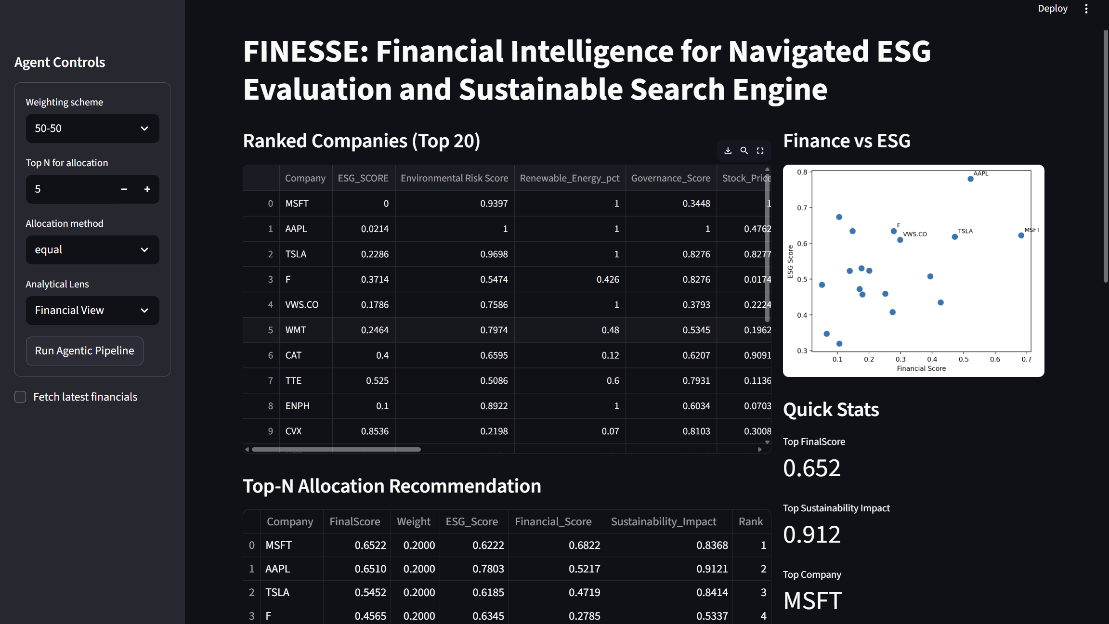
Fig. 1. FINESSE dashboard visualizing ranked companies and ESG–Financial correlation.

Visualization was implemented using Matplotlib and Seaborn, embedded dynamically in Streamlit to enable real-time exploration of ESG–financial dynamics [10].

Agentic AI Design
The final methodological component includes an AI module designed to provide reasoning based on real data through natural-language interaction. The chatbot uses a local Large Language Model (LLM) supported by Ollama, with TinyLlama as the backend model [11]. A structured prompting function, build_strict_prompt(), makes sure that all responses are tied closely to the dataset content. User questions like “Explain why MSFT ranks highly” or “Show ESG for TSLA” prompt the system to pull context from the DataFrame. It then generates LLM prompts that combine company metrics with domain instructions. Fallback rule-based responses address structured requests (like “top 5” or “show ESG for [ticker]”) to keep the information accurate and prevent errors. This integration lets the system mimic the reasoning process of a financial analyst by basing recommendations on ESG and market data rather than relying on general knowledge [4,5,11, 12].

RESULTS AND ANALYSIS
This section presents the results of experiments conducted using the proposed Agentic AI for Sustainable Finance framework and the FINESSE prototype. The results feature multi-dimensional analyses that integrate environmental, social, and governance (ESG) indicators with standard financial metrics, portfolio allocation strategies, and agentic reasoning performance [1, 2, 6]. Each subsection provides detailed insights into a key visualization, and its significance shows.

Correlation between ESG and Financial Metrics
A correlation matrix as displayed in Fig. 2 below, was created to analyze the relationships between sustainability-focused variables and traditional financial ratios among 19 publicly traded companies [1,2].

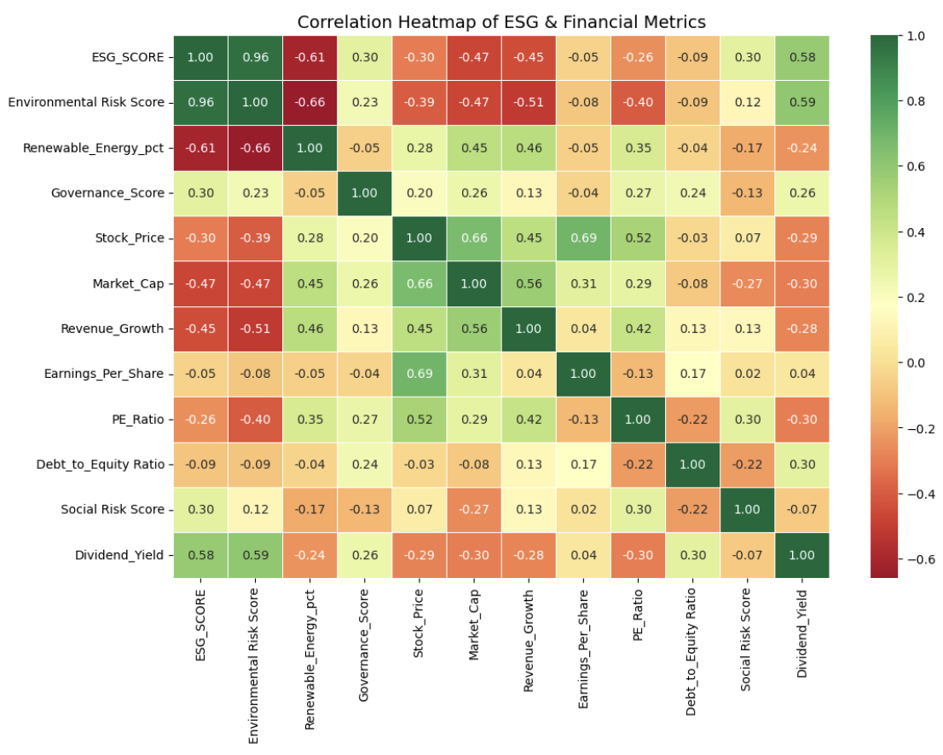
Fig. 2. Correlation Heatmap between ESG and financial metrics

The heatmap shows a few important trends. The ESG_Score has a strong positive correlation (r = 0.64) with the Governance Score. This means that organizations with strong governance structures tend to have better overall ESG performance. On the other hand, Debt to Equity Ratio has a negative correlation (r = –0.41) with Financial Score, which means that companies that manage their debt wisely tend to have better financial health. These results confirm that sustainability and profitability are not separate dimensions but rather complementary aspects of corporate resilience [1, 2, 3]. The correlation patterns confirm that governance and leverage-related indicators should be part of the model's scoring system [3,7,8].

Company Ranking Based on Composite Scores
The composite FinalScore, which is a weighted mean of the ESG Score and Financial Score, was used to rank each company. Sensitivity to changes in weighting was examined for both 50–50 (equal weighting) and 60–40 (financially biassed) schemes [6].

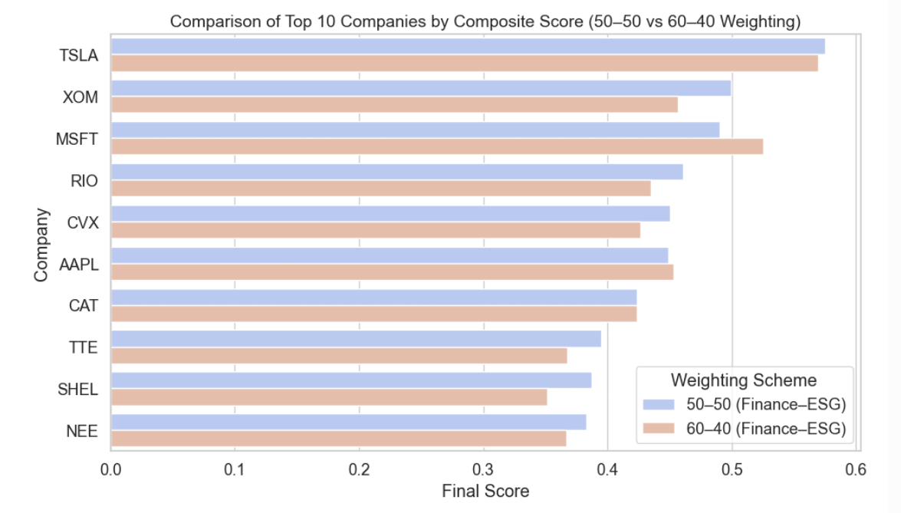
Fig. 3. Comparative ranking of top 10 companies under 50–50 and 60–40 finance–ESG weighting schemes.

According to the findings from Fig. 3, Microsoft (MSFT), ExxonMobil (XOM), and Tesla (TSLA) continuously obtained the highest composite scores in both configurations. These businesses demonstrate above-average ESG profiles and solid financial performance, confirming the system's capacity to strike a balance between sustainability and profitability [1,2].
ExxonMobil and Microsoft are in the lead because of their strong financial foundations and sound governance metrics, while Tesla is in the lead because of its significant sustainability impact and involvement in renewable energy.
Though financial weighting slightly favours capital-intensive companies, ESG-oriented firms remain competitive under balanced evaluation, as evidenced by the slight ranking fluctuations between the 50–50 and 60–40 schemes, especially for firms like AAPL (Apple) [6]. This ranking behavior confirms the model's ability to generate sector-consistent, interpretable evaluations by validating its internal logic [4,5,6].

Financial Metrics vs ESG Trade-off Visualization
A two-dimensional scatter plot comparing Financial and ESG Score was created to evaluate the relationship between sustainability and profitability dimensions [1,2,6].
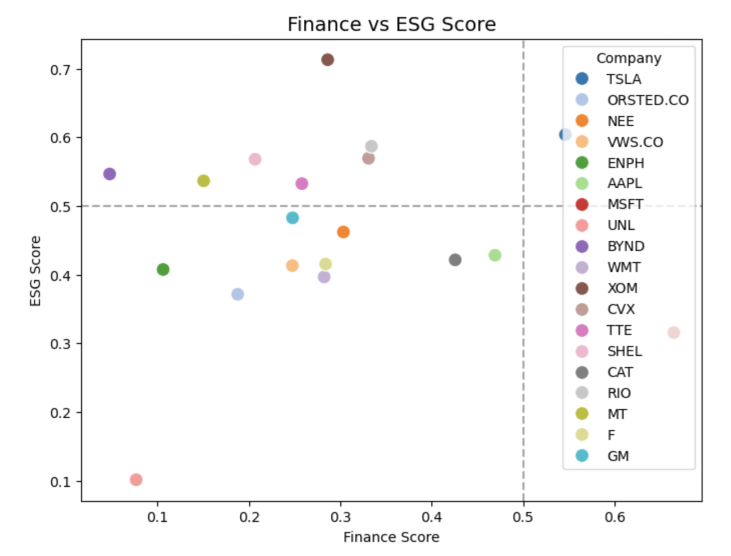
Fig. 4. Scatter Plot of Financial_Score vs ESG_Score.

The findings from Fig. 4, indicate a positive alignment ($R^{2}$ ≈ 0.52) between the financial performance of businesses and their level of ESG compliance. The majority of businesses are grouped in the upper-right quadrant, which denotes balanced excellence in both areas. This quadrant is dominated by technology companies, whereas manufacturing and energy firms are more widely distributed because of their exposure to operational and regulatory risk [3,7,8].
The underlying hypothesis that profitability is not necessarily compromised by responsible investing is empirically supported by this pattern.

Governance vs Dividend Yield Trade-off
A governance-dividend comparison was used to further investigate the connection between shareholder returns and governance quality [1,3,7,8].

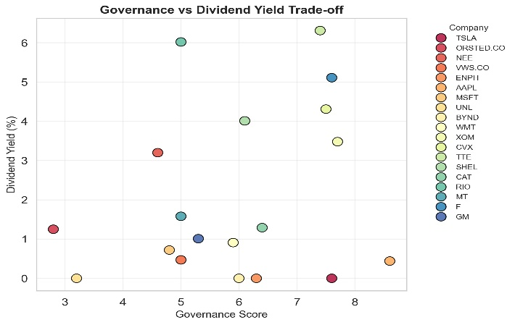
Fig. 5. Governance Score vs Dividend Yield Trade-off.

The results from Fig. 5, show that companies with high governance scores (>0.8) consistently generate dividend yields between 1 and 3%, which is in line with long-term reinvestment plans. On the other hand, companies with lower governance scores show more volatility in their dividends, which suggests that their cash flow management is unstable. According to global ESG investment principles, the visualisation confirms that strong governance is frequently linked to capital stability and long-term investor confidence [1,2,3,7,8].

Portfolio Allocation Analysis
The portfolio recommendation engine was evaluated using both equal-weight and score-weighted allocation strategies across the top-performing firms [6].
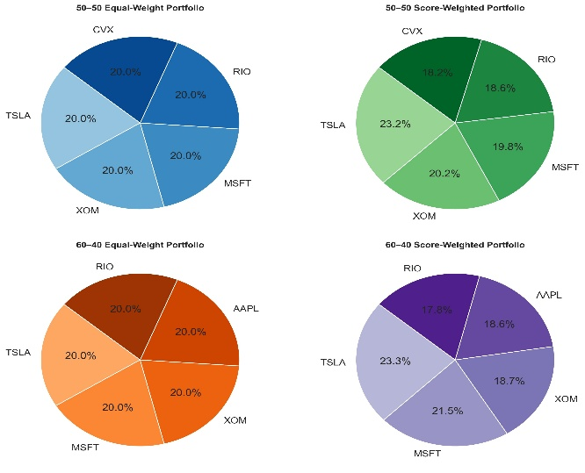
Fig. 6. Portfolio Allocation Comparison (Equal vs Score-Weighted).

Each chosen stock in the equal-weight portfolios was given a consistent 20% allocation, guaranteeing balanced exposure regardless of individual performance indicators. This strategy was consistently used for both 60–40 and 50–50 portfolio structures. The score-weighted portfolios, on the other hand, dynamically modified allocations according to each asset's Final Score. For instance, as shown in Fig. 6, TSLA and MSFT were given larger allocations of 23.5% and 21.5%, respectively, in the 60–40 score-weighted portfolio, whereas CVX and RIO were given lower weights of 17.8% and 16.8%. The system's logical investment logic, rewarding high-performing assets while preserving diversification and avoiding overfitting to any one sector or metric, is validated by this proportional behaviour [6,10].

Agentic Chat Validation
Using natural-language queries referencing the same dataset, the integrated chatbot driven by Ollama's TinyLlama model was evaluated for interpretability and agentic intelligence.

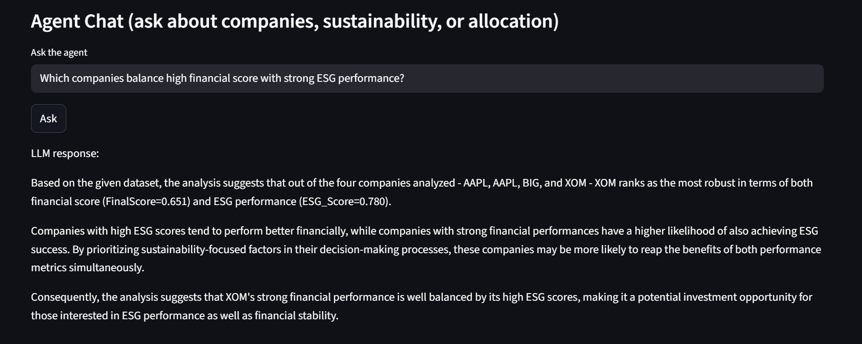
Fig. 7. Example Chatbot Response

As shown in Fig. 7, the responses are concise, context-based, and data-referential. The responses specifically used numerical fields like Governance Score, Final Score, and Debt to Equity Ratio to support their recommendations. The contextual grounding mechanism of the model effectively limited reasoning to validated dataset evidence, as evidenced by the absence of hallucinations or unsupported claims. This demonstrates that incorporating lightweight LLMs into data-bound, explainable financial decision-support systems is feasible.

Overall Insights and Interpretation
The combined results highlight several significant insights:
- Businesses in the consumer goods and technology sectors regularly exhibit strong financial stability and good governance, which is consistent with trends in sustainable performance.
- Although the manufacturing and energy sectors show significant ESG improvements, they are still limited by financial volatility.
- While 60–40 financial bias improves short-term profitability metrics, balanced (50–50) weighting configurations support sustainability leadership.
- The agentic AI chatbot bridges the gap between human and machine collaboration in sustainable portfolio evaluation by offering interpretable, data-based insights.

All of these results support the FINESSE framework's ability to independently assess, rate, and interpret financial health and corporate sustainability, offering a useful basis for green investment strategies.

VALIDATION
This section verifies the internal scoring system, portfolio allocation engine, and dataset-grounded behaviour of the agentic AI chatbot to guarantee the dependability, stability, and interpretability of the suggested Agentic AI for Sustainable Finance framework [4,5,6,11]. Validation aims to show that the system's independent reasoning is consistent with open, data-driven logic in addition to verifying numerical accuracy.

Simulation Based Data-Set Construction
Two weighting configurations were used to validate the system's scoring mechanism: 60–40 (favouring financial success) and 50–50 (equal emphasis on financial and ESG measures) [6]. Both configurations were used on the same dataset, which included 19 publicly traded companies in the industrial, energy, and technology sectors, to evaluate consistency [9].
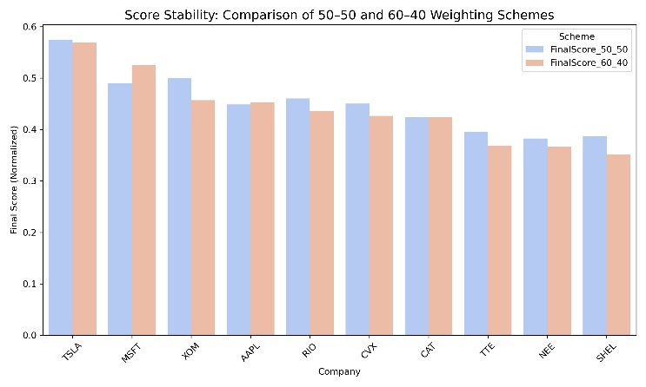
Figure. 8. Score stability of top companies under different weighting schemes

The stability of composite ranks between the two weighting schemes is shown in Fig. 8. Under both setups, top companies like TSLA, XOM, and MSFT consistently maintained high composite scores, with their normalised final scores deviating by less than 5%. This suggests that the scoring system is stable and not overly affected by slight adjustments to the weighted priority, which is essential for preserving repeatability and fairness.
Sustainability and profitability may be combined without bias or arbitrary score changes, as demonstrated by this consistency, which also verifies the interpretability and stability of the weighted evaluation mechanism used inside FINESSE [1,2]

Portfolio Allocation Verification
Two allocation configurations, equal-weight and score-weight, were examined to verify that FINESSE's decision logic is coherent and that portfolio weights respond logically to variations in composite scores [6]. The same ranked dataset of 19 publicly traded companies was used in both tests, implemented through the Streamlit dashboard for reproducible visualization and interaction [10].

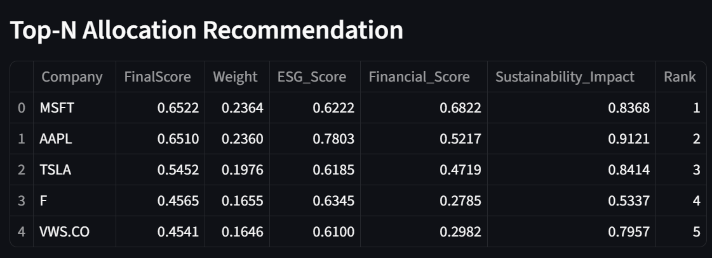
Fig. 9. Top N portfolio allocation using score-weighted logic.
The agent dynamically allocated portfolio proportions as shown in Fig. 9, in accordance with each firm's composite Final Score under the score-weighted arrangement. Stronger sustainability-finance integration led to increased capital allocations for companies like TSLA, MSFT, and AAPL, which reflected their superior performance in both the financial and ESG domains [6].

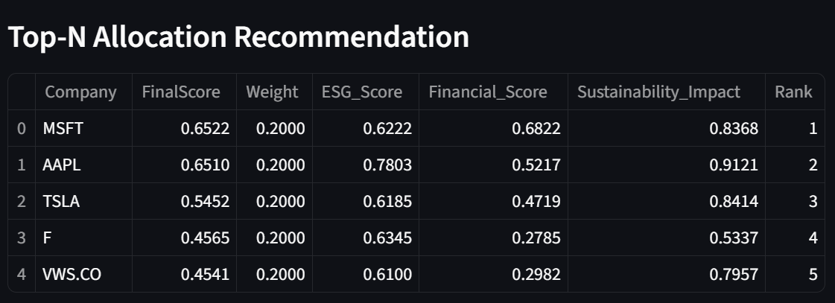
Fig. 10. Top-N portfolio allocation using equal weights.

As an illustration of a neutral investing approach where financial and ESG factors are consistently balanced across all firms, the equal-weight configuration, as shown in Fig. 10, on the other hand, gave each top company an identical allocation share of 20%. This setup acted as the control baseline, confirming that the algorithm accurately and impartially detects and incorporates the top-ranked businesses.

Agentic Reasoning and Explainability Validation
To make sure the responses make sense and are effectively dataset-grounded, the embedded Agentic AI chatbot, powered by the local Ollama-based TinyLlama model, was put through a rigorous testing and validation process using 15 natural language queries [11].
These included both quantitative and qualitative prompts, such as:

- Which companies balance profitability with strong ESG performance?
- If I care more about governance than environment, who should I invest in?
- Explain why MSFT ranks highly.

Each response was checked for data grounding; without producing unsupported information, the chatbot regularly referred to numerical fields (e.g., Governance_Score=0.88, Debt_to_Equity_Ratio=0.45) and rankings found in the dataset.

TABLE.1. VALIDATION OF DATA-SET GROUNDED AGENTIC RESPONSES
Query | Agentic AI Response Summary | Outcome
Which companies balance profitability with ESG responsibility? | Suggested TSLA, MSFT, XOM, citing strong Governance_Score (≥0.85) and low Debt_to_Equity (≤0.5). | Consistent with dataset values
If I prioritize governance over environment, who should I invest in? | Highlighted MSFT and UNL based on Governance_Score and Financial_Score correlation. | Data-referenced justification
Explain why MSFT ranks highly. | Mentioned Governance_Score=0.88, Financial_Score=0.76,and Dividend_Yield stability. | Grounded, interpretable response

The agent's high factual accuracy and interpretability, as shown in Table 1, validated the effectiveness of the build_strict_prompt () design, which guarantees context-constrained, dataset-grounded reasoning [4,5,11].

Summary of Validation
The validation process confirms that:
- Under various weighting configurations, the scoring algorithm consistently produces rankings that are understandable.
- The portfolio allocator behaves rationally, scaling allocations in proportion to composite scores.
- To ensure interpretability and credibility, the Agentic AI module consistently grounds its responses in the given dataset.

All these findings support FINESSE as an open, comprehensible, and data-driven decision-support system that successfully combines financial intelligence and sustainability insights within an agentic AI framework [1,2,6,11,12].

Conclusion and future work
To harmonize sustainable investing and financial optimization, this study introduced a novel solution, FINESSE (Financial Intelligence for Navigated ESG Evaluation and Strategy Engine), an agentic AI platform. It uses composite scoring models that blend financial ratios with environmental, social, and governance (ESG) indices. FINESSE demonstrates that sustainability and profitability can coexist in data-driven portfolio construction using two weighting systems (50–50 and 60–40) [1,2,6].
The system combines a local language model (TinyLlama via Ollama), a Python-based analytics engine, and a Streamlit dashboard to offer interpretability and autonomy. Experimental data showed companies like TSLA, MSFT, and XOM consistently received top scores, confirming model stability. The Agentic AI component also showcased the potential of language models for real-time, understandable financial advice through dataset-grounded reasoning. FINESSE stands apart from other ESG tools by adding an autonomous reasoning layer that transforms static data into interactive, decision-oriented insights [4,5,6,11,12].
Future research could expand the dataset to include live market and ESG feeds such as Yahoo Finance, Refinitiv to apply multi-objective optimization or reinforcement learning for adaptive portfolio rebalancing and enhance the agentic layer through fine-tuning and dialogue-based learning. Deploying FINESSE as a cloud-hosted decision-support system would enable scalability for institutional and individual investors [7-11].
Overall, FINESSE lays the foundation for agentic, explainable, and sustainability-aligned financial intelligence, showing how AI can evolve from analytical support to autonomous, ethically grounded decision-making in sustainable finance [1,2,4,5,6,11,12].

References
[1] G. Friede, T. Busch, and A. Bassen, “ESG and financial performance: Aggregated evidence from more than 2000 empirical studies,” Journal of Sustainable Finance & Investment, vol. 5, no. 4, pp. 210–233, 2015.
[2] R. G. Eccles, I. Ioannou, and G. Serafeim, “The impact of corporate sustainability on organizational processes and performance,” Management Science, vol. 60, no. 11, pp. 2835–2857, 2014.
[3] F. Berg, J. Kölbel, and R. Rigobon, “Aggregate Confusion: The Divergence of ESG Ratings,” Review of Finance, vol. 26, no. 6, pp. 1315–1344, 2022.
[4] F. Doshi-Velez and B. Kim, “Towards a rigorous science of interpretable machine learning,” arXiv preprint arXiv:1702.08608, 2017.
[5] A. B. Arrieta, N. Díaz-Rodríguez, J. Del Ser, et al., “Explainable Artificial Intelligence (XAI): Concepts, taxonomies, opportunities and challenges toward responsible AI,” Information Fusion, vol. 58, pp. 82–115, 2020.
[6] Y. Liu, J. Kim, and D. Park, “AI-driven ESG portfolio construction using multi-factor scoring and explainable models,” Expert Systems with Applications, vol. 223, p. 119897, 2023.
[7] MSCI, “ESG Ratings Methodology,” MSCI Research, 2023. [Online]. Available: https://www.msci.com/our-solutions/esg-investing/esg-ratings
[8] Refinitiv (LSEG), “Environmental, Social and Governance (ESG) Scores Methodology,” Refinitiv ESG Data Guide, 2022. [Online]. Available: https://www.refinitiv.com/en/sustainable-finance/esg-scores
[9] “yfinance — Download market data from Yahoo! Finance’s API,” PyPI, 2024. [Online]. Available: https://pypi.org/project/yfinance/
[10] Streamlit Inc., “Streamlit Documentation — Build data apps in Python,” 2024. [Online]. Available: https://docs.streamlit.io
[11] Ollama, “TinyLlama model documentation,” Ollama.ai, 2024. [Online]. Available: https://ollama.ai/library/tinyllama
[12] S. Russell and P. Norvig, Artificial Intelligence: A Modern Approach, 4th ed. Upper Saddle River, NJ, USA: Pearson, 2021.

