INSTITUTE OF MANAGEMENT SCIENCES
HAYATABAD, PESHAWAR
Database Management Systems Lab— Semester IV

Travel Itinerary Planner — Database Schema & ERD
Student 1 | Muhammad Meher Ali
Student 2 | Ghazal Khan
Submitted To | Ali Hassan
Subject | Database Management Systems Lab
Semester | IV
Session | 2024–2028 (Fall)
Project Title | Travel Itinerary Planner

Project Milestone Tracker
Milestone | Version
ERD & Schema | 1.0

Entity Relationship Diagram (ERD)
The following ERD illustrates all tables, attributes, and relationships of the Travel Itinerary Planner database system. This ERD is made by using (Draw.io) drawing tool.

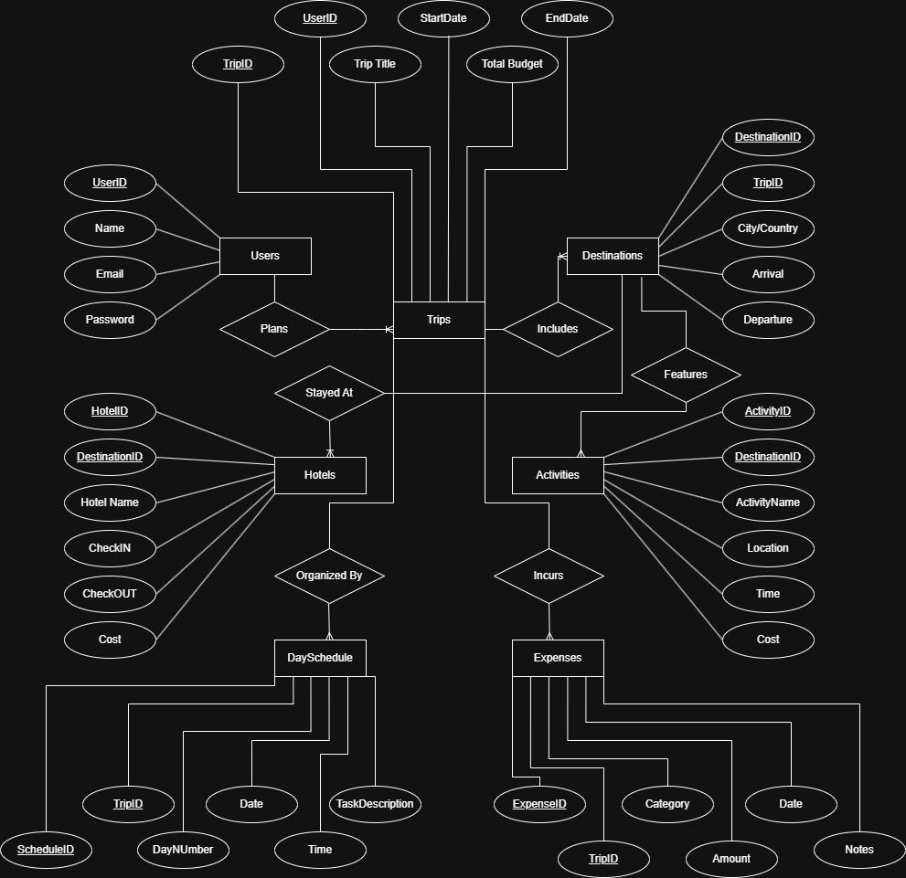

Database Schemas (MySQL Workbench)
The following CREATE TABLE statements define the complete relational schema for the Travel Itinerary Planner. All tables use primary keys, foreign keys, NOT NULL constraints, and CHECK constraints as per the project design.

Users Table
CREATE TABLE Users (
UserID INT PRIMARY KEY AUTO_INCREMENT,
Name VARCHAR(100) NOT NULL,
Email VARCHAR(150) NOT NULL UNIQUE,
Password VARCHAR(255) NOT NULL
);

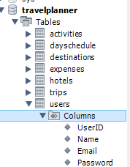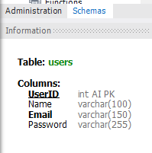

2. Trips Table
CREATE TABLE Trips (
TripID INT PRIMARY KEY AUTO_INCREMENT,
UserID INT NOT NULL,
TripTitle VARCHAR(200) NOT NULL,
StartDate DATE NOT NULL,
EndDate DATE NOT NULL,
TotalBudget DECIMAL(10,2) NOT NULL CHECK (TotalBudget >= 0),
CONSTRAINT FK_Trips_Users FOREIGN KEY (UserID) REFERENCES Users(UserID),
CONSTRAINT CHK_Trips_Dates CHECK (EndDate > StartDate)
);

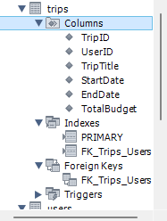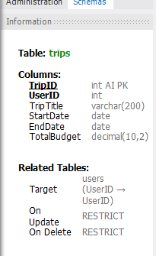

3. Destinations Table
CREATE TABLE Destinations (
DestinationID INT PRIMARY KEY AUTO_INCREMENT,
TripID INT NOT NULL,
City VARCHAR(100) NOT NULL,
Country VARCHAR(100) NOT NULL,
ArrivalDate DATE NOT NULL,
DepartureDate DATE NOT NULL,
CONSTRAINT FK_Dest_Trips FOREIGN KEY (TripID) REFERENCES Trips(TripID), CONSTRAINT CHK_Dest_Dates CHECK (DepartureDate > ArrivalDate)
);

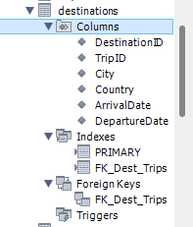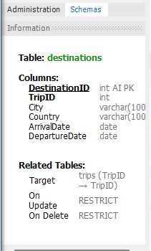

4. Hotels Table
CREATE TABLE Hotels (
HotelID INT PRIMARY KEY AUTO_INCREMENT,
DestinationID INT NOT NULL,
HotelName VARCHAR(200) NOT NULL,
CheckIn DATE NOT NULL,
CheckOut DATE NOT NULL,
CostPerNight DECIMAL(10,2) NOT NULL CHECK (CostPerNight >= 0),
CONSTRAINT FK_Hotels_Dest FOREIGN KEY (DestinationID) REFERENCES Destinations(DestinationID), CONSTRAINT CHK_Hotel_Dates CHECK (CheckOut > CheckIn)
);

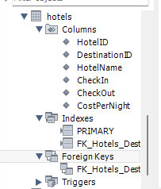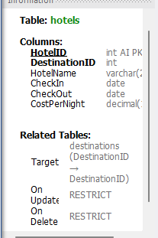

5. Activities Table
CREATE TABLE Activities (
ActivityID INT PRIMARY KEY AUTO_INCREMENT,
DestinationID INT NOT NULL,
ActivityName VARCHAR(200) NOT NULL,
Location VARCHAR(200) NOT NULL,
ActivityTime TIME NOT NULL,
Cost DECIMAL(10,2) NOT NULL CHECK (Cost >= 0),
CONSTRAINT FK_Activities_Dest FOREIGN KEY (DestinationID) REFERENCES Destinations(DestinationID)
);

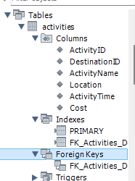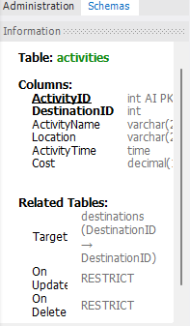

6. DaySchedule Table
CREATE TABLE DaySchedule (
ScheduleID INT PRIMARY KEY AUTO_INCREMENT,
TripID INT NOT NULL,
DayNumber INT NOT NULL CHECK (DayNumber >= 1),
ScheduleDate DATE NOT NULL,
ScheduleTime TIME NOT NULL,
TaskDescription VARCHAR(500) NOT NULL,
CONSTRAINT FK_DaySched_Trips FOREIGN KEY (TripID) REFERENCES Trips(TripID)
);
select * from DaySchedule;

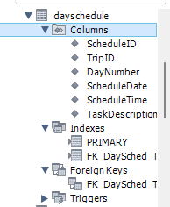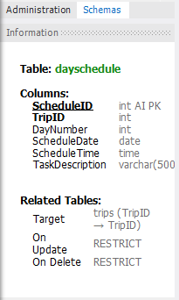

7. Expenses Table
CREATE TABLE Expenses (
ExpenseID INT PRIMARY KEY AUTO_INCREMENT,
TripID INT NOT NULL,
Category VARCHAR(100) NOT NULL
CHECK (Category IN ('Hotel','Transport','Food','Activities','Shopping','Other')),
Amount DECIMAL(10,2) NOT NULL CHECK (Amount >= 0),
ExpenseDate DATE NOT NULL,
Notes VARCHAR(500),
CONSTRAINT FK_Expenses_Trips FOREIGN KEY (TripID) REFERENCES Trips(TripID)
);

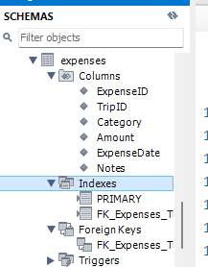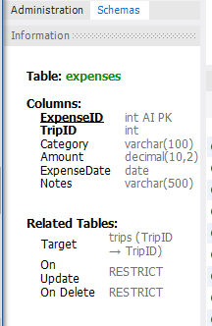

Table Relationships Summary
The table below summarizes all foreign key relationships between the seven core tables.
Relationship | Type | Foreign Key
Users → Trips | One-to-Many | Users.UserID → Trips.UserID
Trips → Destinations | One-to-Many | Trips.TripID → Destinations.TripID
Destinations → Hotels | One-to-Many | Destinations.DestinationID → Hotels.DestinationID
Destinations → Activities | One-to-Many | Destinations.DestinationID → Activities.DestinationID
Trips → DaySchedule | One-to-Many | Trips.TripID → DaySchedule.TripID
Trips → Expenses | One-to-Many | Trips.TripID → Expenses.TripID

