Iris Flower Classification Report

1. Introduction
This report presents a machine learning model to classify iris flowers into species based on measurements.

2. Dataset
The dataset contains sepal and petal measurements of iris flowers with three species: setosa, versicolor, and virginica.

3. Sample Data
sepal length (cm) | sepal width (cm) | petal length (cm) | petal width (cm) | species
5.1 | 3.5 | 1.4 | 0.2 | setosa
4.9 | 3.0 | 1.4 | 0.2 | setosa
4.7 | 3.2 | 1.3 | 0.2 | setosa
4.6 | 3.1 | 1.5 | 0.2 | setosa
5.0  4. Python Code | 3.6 | 1.4 | 0.2 | Setosa
import pandas as pd
from sklearn.model_selection import train_test_split
from sklearn.preprocessing import LabelEncoder
from sklearn.tree import DecisionTreeClassifier
from sklearn.metrics import accuracy_score

# Load data
df = pd.read_csv("Iris.csv")

# Drop Id if exists
if 'Id' in df.columns:
df = df.drop('Id', axis=1)

# Split data
X = df.drop("Species", axis=1)
y = df["Species"]

# Convert labels
le = LabelEncoder()
y = le.fit_transform(y)

# Train/test split
X_train, X_test, y_train, y_test = train_test_split(
X, y, test_size=0.2, random_state=42
)

# Train model
model = DecisionTreeClassifier()
model.fit(X_train, y_train)

from sklearn.metrics import classification_report, confusion_matrix

y_pred = model.predict(X_test)

# Accuracy
print("Accuracy:", accuracy_score(y_test, y_pred))

# Classification Report
print("\nClassification Report:\n")
print(classification_report(y_test, y_pred))

# Confusion Matrix
print("\nConfusion Matrix:\n")
print(confusion_matrix(y_test, y_pred))

5. Visualization
Scatter Plot:
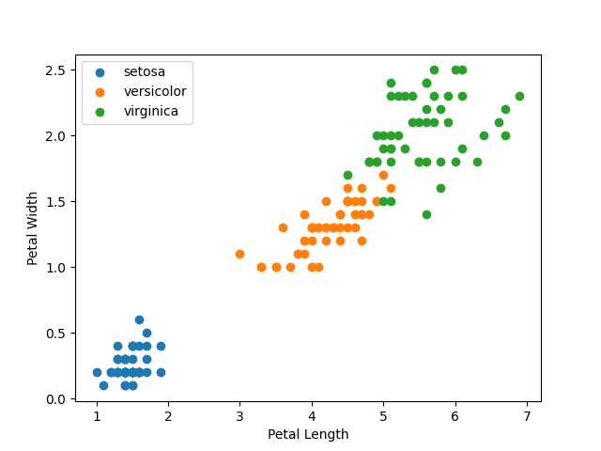

6. Model Performance
Accuracy: 1.00
Confusion Matrix:
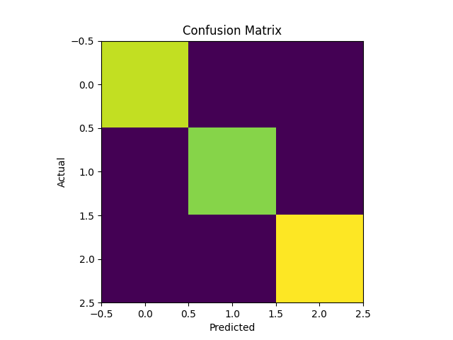

7. Conclusion
The model achieved excellent performance and correctly classified iris species.

