.

FALL - 2026
SECTION BS AI – 3B
PROGRAMMING FOR AI – AL2001
LAB # 3

SUBMITTED TO
Mr. Riyan Athar

SUBMITTED BY
Muhammad Moaz Shafie
25F-0029

SUBMISSION DATE
September 10, 2026

DEPARTMENT OF AI AND DS, FAST – NU, CFD.
TASK-1
CODE:
# Starting Data
Model_Scores = {
"LogisticRegression": [0.82, 0.85, 0.81, 0.86, 0.83],
"RandomForest": [0.89, 0.91, 0.88, 0.92, 0.90],
"NeuralNet": [0.95, 0.94, 0.93, 0.96, 0.95]
}
Best_Model = ""
Highest_Average = 0
for Model, Scores in Model_Scores.items():
Average = sum(Scores) / len(Scores)
if Average > Highest_Average:
Highest_Average = Average
Best_Model = Model
print("Best Model:", Best_Model)
print("Average Accuracy:", Highest_Average)

OUTPUT:
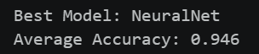

TASK-2
CODE:
Raw_Distances = [12.5, -3.2, 45.1, 105.8, 8.9, 0.0, 99.9, -0.1]
Clean_Distances = [Distance for Distance in Raw_Distances if 0 <= Distance <= 100]
print(Clean_Distances)

OUTPUT:
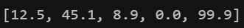

TASK-3
CODE:
Text = "AI is Transforming AI . The Future of AI is Now."
def build_vocab(Text):
Words = Text.lower().split()
Vocab = {}
for Word in Words:
if Word in Vocab:
Vocab[Word] = Vocab[Word] + 1
else:
Vocab[Word] = 1
return Vocab
print(build_vocab(Text))

OUTPUT:

TASK-4
CODE:
Graph = {
"Node_A": [{"node": "Node_B", "cost": 2}, {"node": "Node_C", "cost": 4}],
"Node_B": [{"node": "Node_A", "cost": 2}],
"Node_C": [{"node": "Node_A", "cost": 4}]
}
Graph.update({"Node_D": [{"node": "Node_A", "cost": 5}]})
Graph["Node_A"].append({"node": "Node_D", "cost": 5})
for Node in Graph:
print(Node, ":", Graph[Node])

OUTPUT:
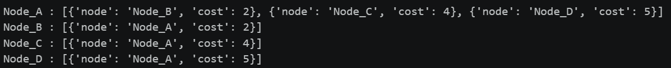
TASK-5
CODE:
Default_Config = {
"learning_rate": 0.01,
"batch_size": 32,
"epochs": 100,
"optimizer": "adam"
}
User_Config = {
"learning_rate": 0.005,
"epochs": 200,
"dropout_rate": 0.2,
"use_gpu": True
}
for Key, Value in User_Config.items():
if Key in Default_Config:
Default_Config[Key] = Value
print(Default_Config)

OUTPUT:

