.

FALL - 2026
SECTION BS AI – 3B
PROGRAMMING FOR AI – AL2001
LAB # 1

SUBMITTED TO
Mr. Riyan Athar

SUBMITTED BY
Muhammad Moaz Shafie
25F-0029

SUBMISSION DATE
August 19, 2026

DEPARTMENT OF AI AND DS, FAST – NU, CFD.
TASK-1
CODE:
my_var=786
address=id(my_var)
result=str(my_var)+" "+str(address)
print("Result is "+result)
OUTPUT:

TASK-2
CODE:
marks=int(input("Enter your Marks in PAI between 0 and 100: "))
if 0<= marks <=100:
if marks>=90:
print("Grade A")
elif marks>=80:
print("Grade B")
elif marks>=70:
print("Grade C")
else:
print("Fail")
else:
print("Invalid Marks")
OUTPUT:

TASK-3
CODE:
print("Loop 1 Values")
for i in range(10):
print(i)
print("Loop 2 Values")
for i in range(10,31,2):
print(i)
print("Loop Finished")
OUTPUT:
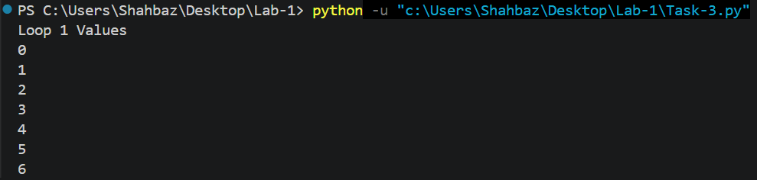
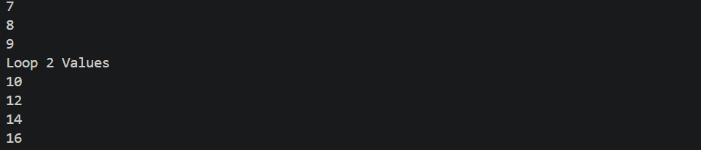
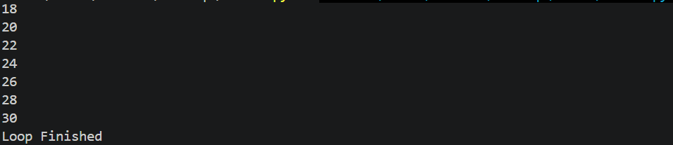

TASK-4
CODE:
text="Artificial Intelligence Lab"
print(text[11:23])
data=[10,20,30,40,50,60]
slicing=data[-3:]
print(slicing)
reverse=data[ : :-1]
print(reverse)
OUTPUT:


