PROJECT REQUIREMENTS DOCUMENT
AI Underwriting Assistant
AI-Powered Real Estate Investment Analysis Tool

Field | Details
Prepared By | Muaz
Role | Intern
Prepared For | Internship Supervisor, Career Institute
Document Type | Project Requirements Document (PRD)
Version | 2.0 (Updated — reflects implemented features)
Date | July 20, 2026

Table of Contents
1. Introduction 3
2. What This Project Is 3
3. Project Goal 3
4. Project Scope 3
5. Overall Architecture 4
6. Project Structure 5
7. Dashboard Design 5
8. Modules — What Each Part Does 7
8.1 Financial Calculator 7
8.2 Risk Engine 7
8.3 AI Chatbot 7
8.4 Charts 7
8.5 Database 8
8.6 PDF Report 8
8.7 ML Market Insights (New) 8
9. Functional Requirements 9
10. Technology Stack 9
11. Development Plan 10
12. Success Criteria 12
13. Future Enhancements (Beyond Current Version) 12
14. Why This Project Is Strong 12
15. Current Status 13
16. Application Screenshots 14
16.1 Property Details & Market Insights 14
16.2 Market Price Prediction & Historical Trend 14
16.3 Analysis Results — KPI Cards & Income vs Expenses 15
16.4 Cash Flow, Expense Breakdown, Chatbot & Memo 15
17. Approval 16

1. Introduction
This document is a Product Requirements Document (PRD) for the AI Underwriting Assistant. It explains the purpose of the project, what it does, how it was built, and the plan followed to build it.
This is an updated version (v2.0) of the original PRD. It reflects the project as actually built, including a machine learning feature (market price prediction and price trend analysis) that was added after the initial MVP and was originally listed as a future/bonus feature.
It is being submitted by Muaz to the internship supervisor at Career Institute for review.

2. What This Project Is
The AI Underwriting Assistant is a tool that helps real estate investors quickly check if a property is a good investment. The user enters basic property numbers (price, rent, expenses), and the tool automatically calculates the key financial numbers, checks the risk level, explains everything in simple language through an AI chatbot, and can create a downloadable report.
The tool also includes a machine learning model, trained on real Pakistan property market data (190,000+ listings from Zameen.com), that estimates a property's fair market price and shows historical price trends for the selected city/location — helping the user judge whether the entered purchase price is fair, overpriced, or a good deal.

3. Project Goal
Build an AI assistant that helps real estate investors analyze a property by:
- Calculating financial metrics
- Identifying investment risks
- Explaining results in simple language
- Generating investment memos
- Displaying insights on a dashboard
- Answering user questions through an AI chatbot
- Predicting a fair market price and price trend using a machine learning model trained on real market data

4. Project Scope

In Scope (Implemented)
- Streamlit dashboard with a property input form (all values in PKR)
- Financial calculations (NOI, Cash Flow, ROI, Cap Rate)
- Rule-based risk engine (Low / Medium / High)
- AI chatbot connected to Google Gemini API
- Charts built with Plotly
- SQLite database to save analyses and chat history
- Downloadable PDF investment memo
- Machine learning model for market price prediction and historical price trend, trained on a real Pakistan property dataset (Zameen.com, 190,000+ listings)

Out of Scope (Later Versions)
- CSV/Excel upload of multiple properties
- Comparing multiple properties side by side
- Live/real-time market data integration (current ML model uses a static historical dataset, not live listings)
- User accounts / authentication
- Voice-enabled chatbot and email sharing

5. Overall Architecture
The user interacts with a Streamlit dashboard. The top of the dashboard always shows two permanent sections side by side: the Property Details form and the ML Market Insights panel. Filling in the property form and clicking Analyze sends the data to three parts at the same time: the Financial Calculator, the Risk Engine, and the AI Chatbot. Everything is also saved to a Database. The results appear below as charts, a chatbot, and an investment memo (PDF). The ML Market Insights panel works independently — the user can predict a market price and see a price trend at any time, without needing to click Analyze first.
Step | What Happens
1. User | Opens the dashboard; Property Details and Market Insights are both visible immediately
2. Streamlit Dashboard | Takes property input through the form; ML Market Insights panel works independently
3. Analysis Controller | On 'Analyze', sends the data to the calculator, risk engine, chatbot, and database
4. Calculator / Risk Engine / Chatbot / Database | Each does its own job with the data at the same time
5. ML Model | Predicts fair market price and shows historical price trend, using a pre-trained model
6. Output | Charts, an investment memo (PDF), and ML predictions are shown to the user

6. Project Structure
AI_Underwriting_Assistant/
- app.py — the main Streamlit app
- requirements.txt — list of Python packages needed
- .env — stores the API key and settings safely
- data/zameen_data.csv — real property dataset used to train the ML model
- database/ — database.py, models.py, underwriting.db
- calculations/ — noi.py, roi.py, cap_rate.py, cashflow.py, dcf.py
- chatbot/ — ai_chat.py, prompts.py, context.py
- risk/ — risk_engine.py
- visualization/ — charts.py
- reports/ — report_generator.py
- ml_model/ — data_prep.py, train_model.py, predict.py, trend_analysis.py
- assets/logo.png — logo/branding

7. Dashboard Design

Header
“AI Underwriting Assistant” shown at the top of the page.

Top Row — Always Visible (Permanent)
Two panels shown side by side, visible as soon as the page loads:
- Left: Property Details form — Purchase Price, Down Payment, Monthly Rent, Vacancy Rate, Property Tax, Insurance, Maintenance, Utilities, Management Fee, Other Expenses. Buttons: Analyze Property, Save Analysis.
- Right: Market Insights (ML) panel — City, Property Type, Bedrooms, Bathrooms, Area, Location, and a 'Predict Market Price & Trend' button. Works independently of the Analyze button.

Below — Shown After Clicking Analyze
Cards showing: NOI, Cash Flow, Cap Rate, ROI, Risk Level
Charts: Income vs Expense and Cash Flow shown side by side; Expense Breakdown shown below.

AI Chatbot Panel
A chat box (with quick-question buttons for first-time use) where the user can ask things like:
- Is this property a good investment?
- Why is the cap rate low?
- Explain the risks.
- Summarize this analysis.
- Generate an investment memo.

8. Modules — What Each Part Does

8.1 Financial Calculator
Calculates: Gross Rental Income, Operating Expenses, NOI, Cash Flow, ROI, Cap Rate, and optionally DCF.

8.2 Risk Engine
A rule-based engine checks the calculated numbers against five fixed thresholds. Each threshold that is crossed adds one “risk flag” to the result:
Condition Checked | Threshold (Flag Triggers If...)
Vacancy Rate | Above 10%
ROI | Below 6%
Operating Expense Ratio | Above 50% of gross income
Cap Rate | Below 4%
Cash Flow | Negative (below PKR 0)
Overall Risk Level is then decided from the number of flags triggered:
Risk Level | Rule
🟢 Low | No flags triggered
🟡 Medium | 1–2 flags triggered
🔴 High | Cash flow is negative, OR 3 or more flags triggered

8.3 AI Chatbot
Uses the calculated metrics and property details to answer the user's questions and explain the results in plain language.
Example prompt sent to the AI: “Based on the following property analysis, explain whether this is a good investment and justify your recommendation.”
Loading & error handling: while waiting for a response, the chat shows a “Thinking...” loading indicator. If the Gemini API is slow or temporarily overloaded, the app automatically retries a few times with a short delay. If it still fails (e.g. the service is down or unreachable), a clear error message is shown in the chat instead of the app crashing.

8.4 Charts
Built with Plotly. Shows: Income vs Expenses, Cash Flow, Expense Distribution (pie chart), and KPI cards.

8.5 Database
Stores: property details, analysis results, chat history, and generated reports. SQLite is enough for this first version.

8.6 PDF Report
Creates a professional report with: property information, financial metrics, risk assessment, an AI-generated summary, and a recommendation.

8.7 ML Market Insights (New)
Trained on a real Pakistan property dataset (Zameen.com, 190,000+ listings) using a Random Forest regression model. Given a property's city, location, type, bedrooms, bathrooms, and area, it predicts a fair market price and compares the user's entered purchase price against it (flagging it as overpriced, underpriced, or fair). It also shows a historical price-per-Marla trend chart for the selected city/location, based on the date ranges available in the dataset.
Confidence range: instead of showing only a single predicted number, the model reports a price range (10th–90th percentile), calculated from the individual predictions of all 200 decision trees inside the Random Forest — e.g. “PKR 27.1M – PKR 29.6M” instead of just one number. This gives a more honest picture of the model's uncertainty, and the overpriced/underpriced/fair comparison is checked against this full range rather than a single point value.
Model Performance (evaluated on a held-out 20% test split):
- R² score: 0.826 (the model explains about 82.6% of the variation in property prices — a strong result)
- Mean Absolute Error: PKR 3,533,935 (on average, predictions are off by about this amount, which is expected given the wide price range across cities and property types)
Limitations of the ML Model
This model is based on a static, historical dataset (scraped from Zameen.com around 2018–2019), not a live market feed. This means:
- Predicted prices reflect the market conditions at the time the data was collected, not current/live prices — actual prices today are likely higher due to inflation and market growth since then.
- The model cannot account for property-specific factors it wasn't trained on (e.g. exact condition, recent renovations, unique views, corner-plot premiums).
- Locations with very few listings in the dataset may produce less reliable predictions.
- The historical “trend” is based only on the date range present in the dataset, not a continuously updated multi-year time series.
For this reason, the model's output should be treated as a reference estimate to support the user's own judgement, not as a certified valuation.

9. Functional Requirements
A simple summary of what the system needs to do, module by module:
- The user can enter all property details (price, rent, expenses) in the input form.
- The system will calculate NOI, Cash Flow, ROI, and Cap Rate automatically.
- The system will check the numbers against risk rules and show a Low, Medium, or High risk level.
- The user can ask the chatbot questions and get answers based on the actual property numbers.
- The user can generate and download a PDF investment memo.
- The user can save an analysis and view it again later from the database.
- The dashboard will show clear error messages if the user enters invalid data (like negative numbers).
- The user can get an ML-predicted fair market price and price trend for a property based on its city, location, type, and size, independently of the main analysis.

10. Technology Stack
Component | Technology
Programming Language | Python
Frontend | Streamlit
AI Chatbot | Google Gemini API (google-genai SDK)
Machine Learning | Scikit-learn (Random Forest), joblib
Data Processing | Pandas
Calculations | NumPy
Charts | Plotly
Database | SQLite
ORM | SQLAlchemy
PDF Reports | ReportLab
Configuration | python-dotenv
Version Control | Git & GitHub

11. Development Plan

Phase 1 — Foundation
- Set up the project structure.
- Configure Streamlit.
- Install dependencies.
- Create the input form.

Phase 2 — Financial Calculations
- Implement NOI.
- Implement Cash Flow.
- Implement ROI.
- Implement Cap Rate.

Phase 3 — Dashboard
- Add KPI cards.
- Add Plotly charts.
- Display results dynamically.

Phase 4 — AI Chatbot
- Connect the Google Gemini API.
- Create a system prompt focused on real estate underwriting.
- Pass property metrics as context.
- Display conversational responses, with quick-question buttons for first-time use.

Phase 5 — Risk Analysis
- Implement rule-based risk detection.
- Display risk level and explanations.

Phase 6 — Database
- Save property analyses.
- Store chat history.
- Allow users to view previous analyses.

Phase 7 — Report Generation
- Build a PDF template.
- Include charts and AI summary.
- Allow users to download the report.

Phase 8 — Testing & Polish
- Validate calculations.
- Improve UI.
- Handle invalid inputs.
- Refine AI prompts.
- Write documentation.

Phase 9 — ML Market Insights (Added Post-MVP)
- Source and clean a real Pakistan property dataset (Zameen.com, 190,000+ listings).
- Engineer features (standardize area to Marla, encode categorical fields).
- Train and evaluate a Random Forest regression model to predict market price.
- Build a historical price-trend view by city/location.
- Integrate the model into the dashboard as a permanent, independent panel.

12. Success Criteria
Version 1 will be considered complete and successful when:
- All financial calculations (NOI, Cash Flow, Cap Rate, ROI) are correct and tested against manual examples.
- The risk engine correctly labels test properties as Low, Medium, or High risk.
- The chatbot gives relevant answers based on the actual property data, not generic responses.
- A complete PDF memo can be generated and downloaded for any analyzed property.
- The dashboard runs without errors and handles bad input gracefully.
- The ML model gives reasonable market price estimates — achieved: R² = 0.826, Mean Absolute Error = PKR 3,533,935 on the test set.

13. Future Enhancements (Beyond Current Version)
The following are not yet built and could be added later:
- CSV/Excel upload
- Compare multiple properties
- Live/real-time market data integration (instead of the current static dataset)
- User authentication
- Dark mode
- Voice-enabled chatbot
- Email report sharing

14. Why This Project Is Strong
This project shows skills in:
- Python programming
- Data analysis
- Financial modeling
- AI integration with LLMs
- Machine learning (regression modeling with real-world data)
- Prompt engineering
- Dashboard development
- Database design
- PDF automation
- Software architecture
It is a complete, real-world application, well suited for an AI/ML internship portfolio.

15. Current Status
The MVP (dashboard, financial calculations, AI chatbot, risk analysis, PDF report, SQLite storage) is complete and working. The ML Market Insights feature, originally planned as a future enhancement, has also been built and integrated. The project is considered feature-complete for this internship submission.

16. Application Screenshots
The following screenshots show the working application, captured directly from the running dashboard.

16.1 Property Details & Market Insights (Top Row — Always Visible)
The Property Details form (left) and the ML-powered Market Insights panel (right) are both visible as soon as the app loads, without needing to click Analyze first.
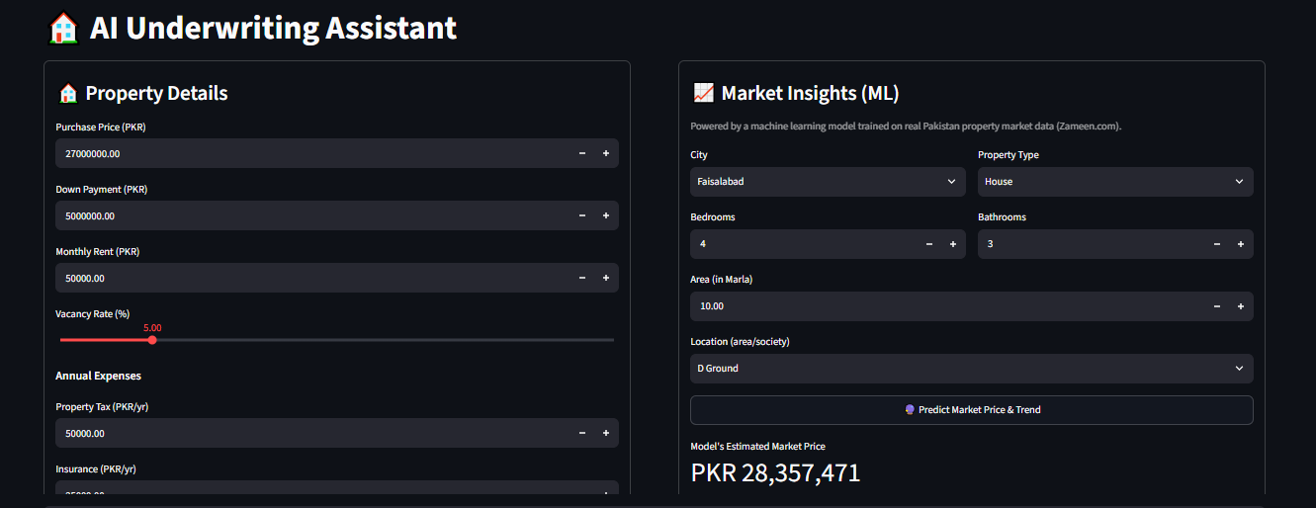
Figure 1 — Property Details form and Market Insights (ML) panel, shown side by side.

16.2 Market Price Prediction & Historical Trend
After entering the property's city, location, type, and size, and clicking 'Predict Market Price & Trend', the model returns an estimated fair market price, a comparison against the entered purchase price, and a historical price trend chart.
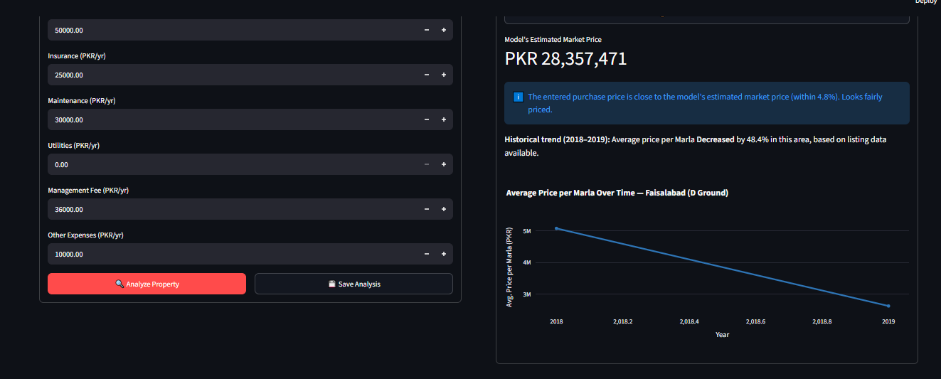
Figure 2 — ML-estimated market price, fair-price comparison, and historical price trend for the selected location.

16.3 Analysis Results — KPI Cards and Income vs Expenses
Clicking 'Analyze Property' displays the calculated financial metrics (NOI, Cash Flow, Cap Rate, ROI, Risk Level) along with an Income vs Expenses chart.
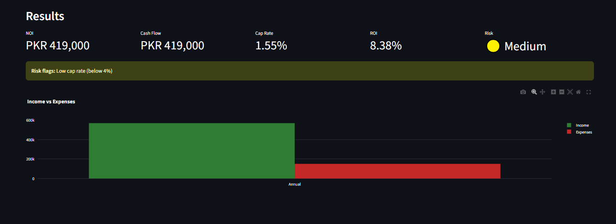
Figure 3 — Results panel showing key financial metrics and the Income vs Expenses chart.

16.4 Cash Flow, Expense Breakdown, AI Chatbot & Investment Memo
Below the main results, the dashboard shows the Cash Flow and Expense Breakdown charts, the AI chatbot (with quick-question buttons), and the option to generate a downloadable PDF investment memo.
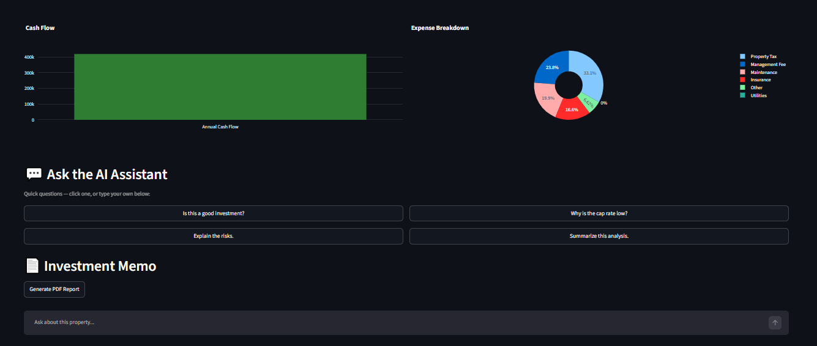
Figure 4 — Cash Flow and Expense Breakdown charts, AI Chatbot panel, and Investment Memo section.

17. Approval
Submitted by Muaz for review by the internship supervisor at Career Institute before development begins.

Role | Name | Signature | Date
Prepared By | Muaz
Reviewed By | Internship Supervisor

