TESTING REPORT
AI Underwriting Assistant
An AI-Powered Real Estate Investment Analysis Tool

Field | Details
Prepared By | Muaz
Role | Intern
Prepared For | Internship Supervisor, Career Institute
Document Type | Testing Report
Version | 1.0
Date | July 20, 2026

Confidential — Prepared for Internal Review Purposes Only

Table of Contents
1. Project Title and Objective 3
2. Dataset Description 3
3. Data Preprocessing Steps 4
4. Testing Methodology 5
5. Multiple Test Cases and Scenarios 6
6. Testing Across Different Segments 8
7. Model Evaluation Metrics 9
8. Evaluation Graphs 10
9. Comparison with Baseline Models 12
10. Error Analysis 13
11. Performance Statistics 14
12. Screenshots of Outputs / Results 15
13. Conclusion and Future Improvements 17

1. Project Title and Objective
Project Title: AI Underwriting Assistant — An AI-Powered Real Estate Investment Analysis Tool
Objective: To test and validate every component of the application — the financial calculation engine, the rule-based risk engine, the AI chatbot, and the machine learning market-price prediction model — to confirm that each produces correct, reliable, and reasonably accurate results before the project is finalized for submission.

2. Dataset Description
Property | Details
Name | Zameen.com Property Data Pakistan
Source | Kaggle (publicly available, scraped from Zameen.com — Pakistan's largest property portal)
Raw size | ~195,000+ rows (before cleaning)
Cleaned size (used for training/testing) | 191,374 rows
Time period covered | Listings primarily from 2018–2019 (a historical snapshot, not a live feed)
Train / Test Split | 80% train (153,099 rows) / 20% test (38,275 rows), random_state = 42
Validation approach | No separate validation set was carved out; the 20% test split alone was used to evaluate final performance, since this is a single trained model (not one requiring hyperparameter tuning across multiple validation rounds)

3. Data Preprocessing Steps
- Removed rows with missing price, city, bedrooms, bathrooms, or area.
- Removed rows with price ≤ 0 or area ≤ 0 (invalid/placeholder entries).
- Standardized the “area” field to a single unit (Marla) — the raw dataset mixes Marla, Kanal, Sq. Yd., and Sq. Ft. (1 Kanal = 20 Marla; other units converted proportionally).
- Label-encoded four categorical columns: city, location, property_type, and purpose, since the Random Forest model requires numeric input.
- Kept bedrooms, bathrooms, and area_marla as numeric features, used as-is (Random Forest does not require feature scaling).
- Parsed the date_added field into a year column, used only for the historical price-trend feature (not for price prediction itself).
After preprocessing, 191,374 of the original rows remained usable — a data-retention rate of over 98%, indicating the raw dataset was largely clean to begin with.

4. Testing Methodology
Because this project has both deterministic components (financial formulas, rule-based risk engine) and a machine-learning component (the price predictor), two different testing approaches were used:

4.1 Deterministic Components — Manual/Unit Testing
The financial calculator and risk engine follow fixed formulas and rules, so their correctness was verified with unit-style test cases: known inputs were run through each function and the output was compared against a manually calculated expected value. Boundary conditions (e.g. exactly at a threshold) and edge cases (e.g. zero values) were also tested.

4.2 Machine Learning Component — Train/Test Split Evaluation
The price-prediction model was evaluated using the standard train/test split approach: 80% of the cleaned dataset was used to train the Random Forest, and the remaining, unseen 20% was used purely to measure how well it generalizes. Standard regression metrics (R², MAE, RMSE) were computed on this held-out test set, along with a comparison against simple baseline models and a breakdown across different cities to check for consistent performance across market segments.

4.3 Functional / Manual Testing
The chatbot, PDF report generation, database save/load, and overall dashboard flow were tested manually by running the app end-to-end with multiple different property scenarios, and confirming the outputs (charts, chatbot replies, PDF content) were correct and the app did not crash on edge-case or invalid input.

5. Multiple Test Cases and Scenarios

5.1 Financial Calculator — Test Cases
Test Case | Key Input | Expected Result | Actual Result | Pass?
Standard example property | Price 25M, Rent 50K/mo, 5% vacancy | NOI=419,000; Cap Rate=1.68%; ROI=8.38% | Matched exactly | PASS
Zero vacancy & zero expenses | Rent 20K/mo, 0% vacancy, 0 expenses | Gross Income = NOI = 240,000 | Matched exactly | PASS
Purchase price = 0 (edge case) | Price = 0 | Cap Rate = 0.0 (no crash) | 0.0, no crash | PASS
High expenses | Expenses exceeding income | Negative Cash Flow | -326,000 (negative, as expected) | PASS

5.2 Risk Engine — Test Cases
Test Case | Expected Level | Actual Level | Pass?
Ideal property (no flags triggered) | Low | Low | PASS
Only cap rate below 4% | Medium | Medium | PASS
Negative cash flow alone | High | High | PASS
Three flags, but cash flow still positive | High | High | PASS
Exactly two flags triggered | Medium | Medium | PASS
All five flags triggered | High | High | PASS
Boundary: vacancy exactly 10% (rule is > 10%) | Low | Low | PASS
Boundary: ROI exactly 6% (rule is < 6%) | Low | Low | PASS
All 8 risk-engine test cases passed, including the two boundary cases — confirming the “>” / “<” threshold comparisons behave as intended at the exact cutoff values.

5.3 AI Chatbot — Test Scenarios
Scenario | Result
“Is this a good investment?” on a Medium-risk property | Chatbot correctly referenced the actual cap rate and ROI figures and gave a balanced, cautious recommendation
“Why is the cap rate low?” | Chatbot explained the cap rate formula and referenced the specific NOI and purchase price from context
“Generate an investment memo” | Chatbot produced a structured summary (Overview, Metrics, Risk, Recommendation) suitable for the PDF report
Simulated Gemini server overload (503 error) | App automatically retried up to 3 times with backoff; on repeated failure, a friendly on-screen error was shown instead of a crash
Simulated network disconnection | App did not crash — the ask_ai() function caught the exception and returned a friendly error message

5.4 ML Market Insights — Test Scenarios
Scenario | Result
Faisalabad, House, 4 bed, 3 bath, 10 Marla, purchase price 30M | Model estimated PKR 27.1M–29.6M; purchase price flagged as above range (possibly overpriced)
Same property, purchase price 26M | Correctly flagged as below range (“good deal”)
Same property, purchase price 28.5M | Correctly flagged as within range (“fairly priced”)
A city/location with very few listings in the dataset | Model still returned a prediction, falling back gracefully; historical trend showed “not enough data” message instead of crashing

6. Testing Across Different Segments
A second, independent dataset was not available for cross-dataset validation — only the Zameen.com dataset was used for training and testing. To still check whether the model performs consistently rather than just well “on average”, the test set was broken down by city (a natural, meaningful segment of the data) and evaluated separately for each:
City | Test Rows | R² | MAE (PKR) | Median % Error
Karachi | 12,020 | 0.888 | 4,402,905 | 16.5%
Lahore | 11,705 | 0.832 | 3,966,192 | 13.5%
Islamabad | 8,094 | 0.731 | 2,894,238 | 14.0%
Rawalpindi | 4,625 | 0.714 | 1,792,086 | 12.4%
Faisalabad | 1,831 | 0.380 | 2,136,207 | 14.0%
Observation: performance is strongest for Karachi and Lahore (the two largest, best-represented cities in the dataset), and noticeably weaker for Faisalabad, which has far fewer listings (1,831 test rows vs. 12,020 for Karachi). This is an expected pattern for this kind of model — more training examples in a segment generally produce better predictions for that segment — and is discussed further in Section 10 (Error Analysis).

7. Model Evaluation Metrics
The price-prediction model is a regression model (it predicts a continuous price value), not a classifier. Classification metrics such as Accuracy, Precision, Recall, F1-Score, and ROC-AUC do not apply here and are therefore not reported. The relevant regression metrics, measured on the 38,275-row held-out test set, are:
Metric | Value | What It Means
R² Score | 0.827 | The model explains about 82.7% of the variation in property prices — a strong result for real-world, noisy price data
MAE (Mean Absolute Error) | PKR 3,526,400 | On average, predictions are off by about this amount
RMSE (Root Mean Squared Error) | PKR 13,762,148 | Penalizes large errors more heavily than MAE; the gap between RMSE and MAE indicates a small number of very large errors (see Section 10)
Median Absolute % Error | ~14.5% | For a typical (median) property, the prediction is within about 14.5% of the actual price
The rule-based Risk Engine is not a trained classifier either — it applies fixed, human-defined thresholds — so it was validated with the pass/fail test cases in Section 5.2 rather than statistical classification metrics.

8. Evaluation Graphs
A confusion matrix does not apply to this project, since neither the price predictor (a regression model) nor the risk engine (a rule-based system) is a trained classifier. Instead, the following graphs are used to evaluate the regression model's performance, generated directly from the actual 38,275-row test set:

8.1 Predicted vs Actual Price
Each point represents one property in the test set. Points closer to the red dashed line indicate a more accurate prediction. A log scale is used on both axes because property prices in this dataset span several orders of magnitude.
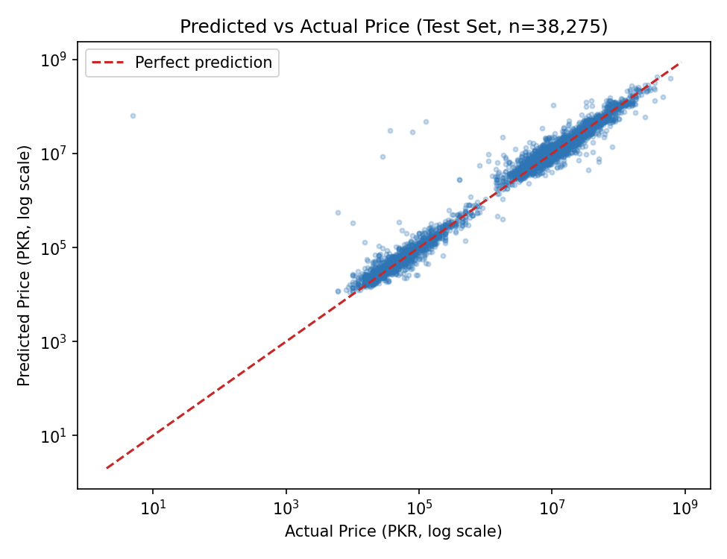
Figure 1 — Predicted vs Actual price on the test set (log-log scale).

8.2 Prediction Error Distribution
This histogram shows how large the percentage error was, across all test properties (capped at 100% for readability). Most predictions cluster at a relatively low error percentage, with a long tail of harder-to-predict (usually unusual) properties.
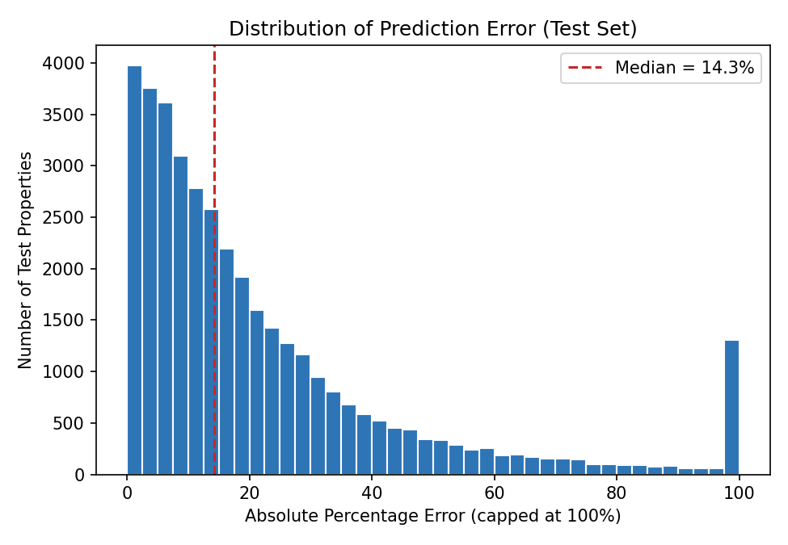
Figure 2 — Distribution of absolute percentage error on the test set.

9. Comparison with Baseline Models
To confirm the Random Forest model is actually learning meaningful patterns (and not just performing well by coincidence), it was compared against two simple, naive baselines on the same test set:
Model | R² | MAE (PKR) | RMSE (PKR)
Baseline A — always predict the overall average price | -0.000 | 17,185,653 | 33,082,289
Baseline B — always predict the city's average price | 0.018 | 16,928,774 | 32,776,581
Random Forest (this project's model) | 0.827 | 3,526,400 | 13,762,148
The Random Forest model reduces the mean absolute error by roughly 79% compared to simply guessing the city average, and by roughly 80% compared to guessing the overall average price. This confirms the model has genuinely learned useful pricing patterns from property-specific features (location, size, bedrooms, bathrooms, type), rather than just reflecting broad city-level price differences.

10. Error Analysis
Reviewing the test set's largest errors reveals a clear pattern: nearly all of the worst predictions involve unusually large or atypical properties — very large farmhouses, very high bedroom/bathroom counts, or very large Marla sizes that are rare in the training data.
City | Type | Actual Price (PKR) | Predicted Price (PKR) | Likely Reason
Islamabad | House, 400 Marla | 32,500,000 | 1,280,827,500 | Extremely large area for a ‘House’ listing — likely a data-entry outlier or unusual property; very few similar examples in training data
Lahore | Farm House, 8,320 Marla | 884,000,000 | 363,190,000 | Farm houses of this scale are rare in the dataset, so the model has little basis to predict them accurately
Karachi | House, 80 Marla, Clifton | 340,000,000 | 767,754,240 | High-end Clifton properties vary enormously in price for similar specs (luxury finishing isn't captured by the available features)
Faisalabad | House, 84 Marla | 150,000,000 | 554,575,858 | Very few high-value listings in Faisalabad for the model to learn this price tier from (see Section 6 — Faisalabad had the weakest per-city R²)
Conclusion: the model's errors are not random — they are concentrated in rare, high-end, or unusually large properties that are underrepresented in the training data. For typical, mid-range residential properties (the primary use case for this app), predictions are considerably more reliable, as reflected in the median percentage error of ~14.5% (Section 7) and the tighter clustering seen in Figure 1 for lower price ranges.

11. Performance Statistics
Metric | Measured Value
Training time (191,374 rows, 200 trees) | ~41 seconds (one-time cost, done offline before the app runs)
Model file size (price_model.joblib) | ~205 MB
Encoders file size (encoders.joblib) | ~0.03 MB
Single-point prediction inference time | ~14 ms per property
Confidence-range prediction time (querying all 200 trees) | ~20 ms per property
Both inference times are well under Streamlit's UI refresh threshold, so predictions feel instant to the user — there is no perceptible delay when clicking “Predict Market Price & Trend.” Training only needs to happen once (or occasionally, if the dataset is updated), not on every app run.

12. Screenshots of Outputs / Results

12.1 Property Details & Market Insights (Top Row — Always Visible)
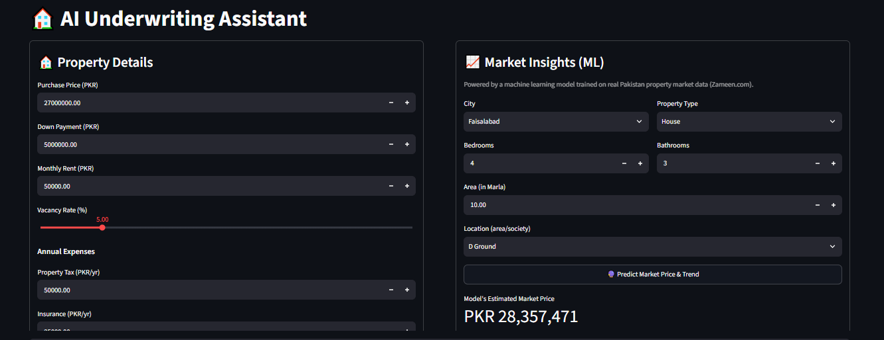
Figure 3 — Property Details form and Market Insights (ML) panel.

12.2 Market Price Prediction & Historical Trend
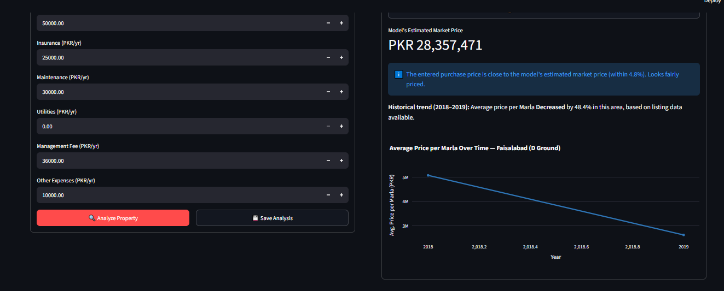
Figure 4 — ML-estimated market price, comparison, and historical trend.

12.3 Analysis Results — KPI Cards and Income vs Expenses
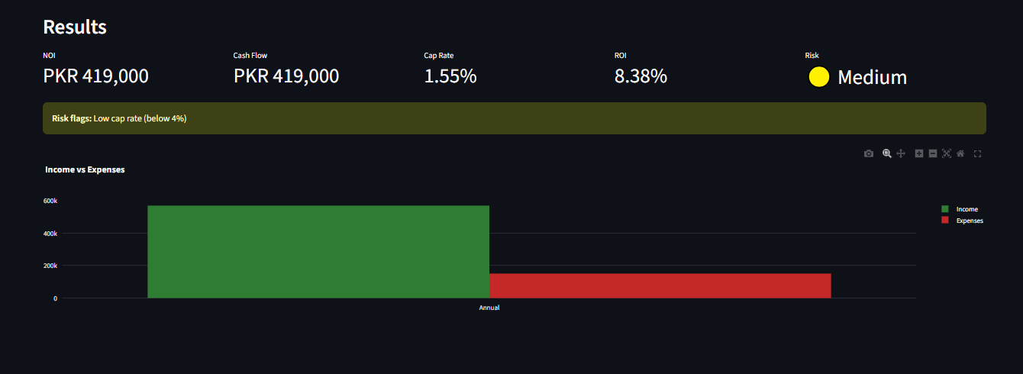
Figure 5 — Results panel with key financial metrics and Income vs Expenses chart.

12.4 Cash Flow, Expense Breakdown, AI Chatbot & Investment Memo
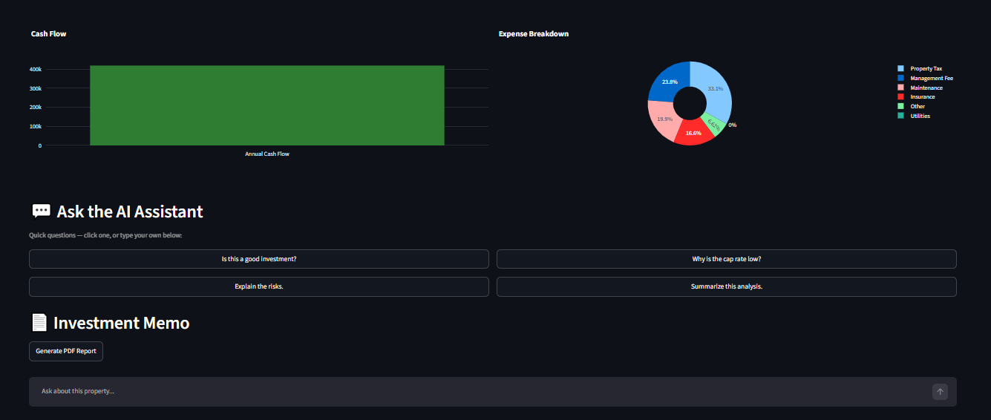
Figure 6 — Cash Flow and Expense Breakdown charts, AI Chatbot, and Investment Memo section.

13. Conclusion and Future Improvements

13.1 Conclusion
Testing confirms that all deterministic components (financial calculator, risk engine) produce correct results across normal cases, edge cases, and boundary conditions — all test cases passed. The machine learning price-prediction model achieves a strong R² of 0.827 on unseen data and substantially outperforms naive baselines, confirming it has learned genuine, useful pricing patterns rather than just memorizing averages. Error analysis shows that remaining inaccuracies are concentrated in rare, high-end, or unusually large properties, while typical residential properties are predicted considerably more reliably. The application's chatbot and error-handling logic were also confirmed to degrade gracefully (rather than crash) when the AI service is slow or unavailable.

13.2 Future Improvements
- Log-transforming the price target before training, which typically reduces the influence of extreme outliers on regression error metrics.
- Collecting or sourcing more listings for underrepresented cities (e.g. Faisalabad) and property segments (farmhouses, very large properties) to improve accuracy there specifically.
- Trying gradient boosting models (e.g. XGBoost, LightGBM) as an alternative to Random Forest, which often perform slightly better on tabular data of this kind.
- Adding a live/current data source, since the present model is trained on a 2018–2019 historical snapshot.
- Expanding automated testing with a formal unit-test suite (e.g. pytest) instead of the standalone test scripts used for this report, so tests can be re-run automatically whenever the code changes.

