Q7. Find the top 3 highest-value orders per customer using RANK(). Display CustomerID, CustomerName, OrderID, and TotalAmount.
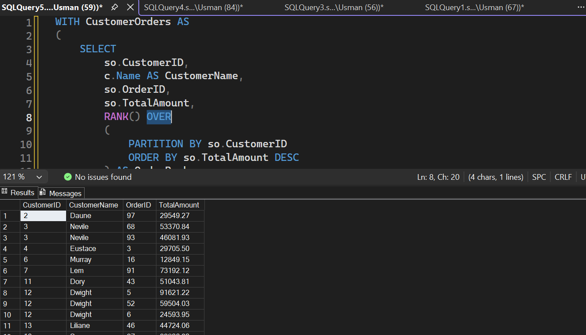n

