Q9. Create a view named vw_CustomerOrderSummary that shows for each customer:
CustomerID, CustomerName, TotalOrders, TotalAmountSpent, and LastOrderDate.
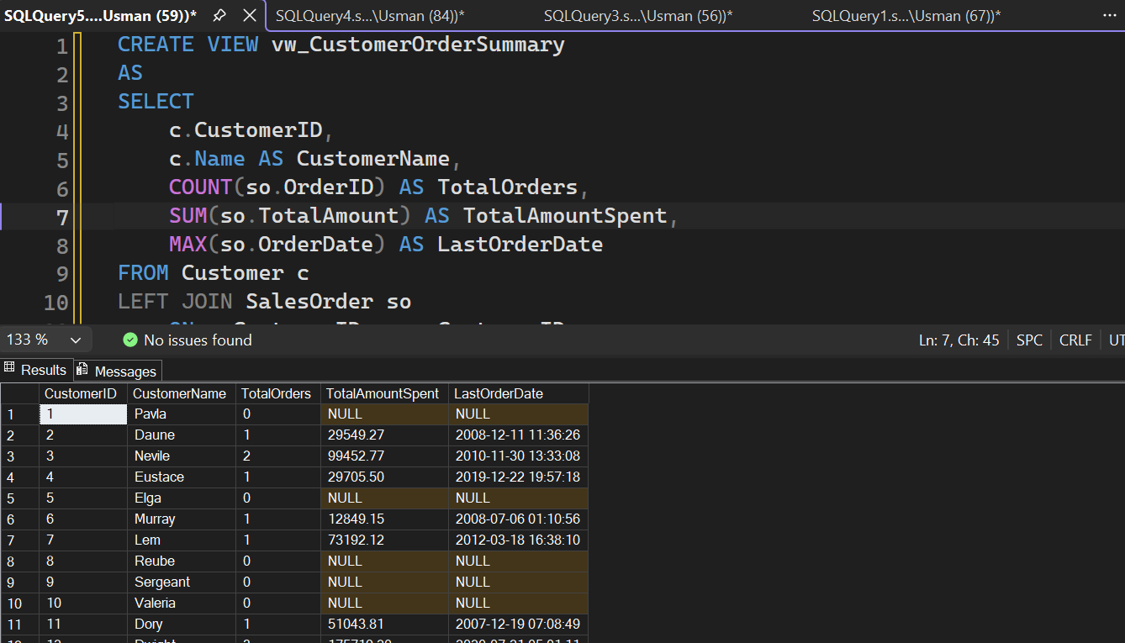n

