**College Invaders Specifications in SRS Section 3 Organized by Object**

**Table of Contents**

3.1-2 External Requirements and Gameplay/Programming Reqs ………………... P.2

3.3.1 Player Object …………………………………………………………………….. P.2

3.3.2 Barrier Object ……………………………………………………………………. P.3

3.3.3 Admin Enemy Object …………………………………………………………… P.6

3.3.4 Trustee Enemy Object ………………………………………………………….. P.7

3.3.5 Sound Object …………………………………………………………………….. P.8

3.3.6 Environment/Menus Object …………………………………………………….. P.10

**3.1 External interface requirements**

3.1.1Communications interfaces

* Mouse, Keyboard and monitor

**3.2 Gameplay/Programming Requirements**

* Player will have 3 “lives” before they reach a game over
  + When the player’s score reaches 1500, they will earn an extra life
* A pause button
* Game Over Conditions:
  + When the enemies advance forward enough to reach the same row as the player sprite, it is a GAME OVER
  + When the player is struck by enemy fire
  + When the player loses their last life
  + The text “GAME OVER” will appear on the screen and the screen will return to the main menu
  + For more information regarding GAME OVER screens, please refer to section 3.3.6

3.3 Classes/Objects

**3.3.1 Class/Object 1 (Player)**

**3.3.1.1 Attributes (direct or inherited)**

* Position: The player's position on the screen, can be represented by an X coordinate and a Y coordinate.
* Score: The player's current score.
* Weapon: The type of weapon or bullet the player is currently using.
* Movement Speed: How fast the player moves left or right on the screen.

***3.3.1.2 Functions***

* Left and right movement: Players can move horizontally around the screen to avoid enemy bullets and shoot enemy invaders. Players can use the arrow keys or other input methods to move left or right.
* Shooting: Players can shoot bullets to destroy enemy invaders. The player's bullets can collide with enemy invaders and destroy them. (There could be an explosion/bomb)
* Defense: Players can use shields to defend against enemy bullets. (maybe shields can be activated and deactivated by the player)
* Score: Players can earn points by destroying enemy invaders. The more invaders destroyed, the higher the player's score will be.
* Losing lives: The player loses lives when the enemy bullets hit it. (players usually start with a certain number of lives and lose one life each time they are hit)
* Respawn: it’s when a player loses a life, they can respawn with a new set of lives at the same position.

**3.3.1.3 Messages**

* Move Left: This message instructs the player object to move to the left on the screen.
* Move Right: This message instructs the player object to move right on the screen.
* Shoot: This message instructs the player object to fire a bullet at the enemy invader.

**3.3.2 Class/Object 2 (Barriers)**

**3.3.2.1 Attributes (direct or inherited)**

* Barriers are made up of 10 segments
* Barriers disintegrate as they are shot at
  + Disintegration starts where bullets hit
    - A completely solid segment can be struck 4 times by bullets before it completely disappears

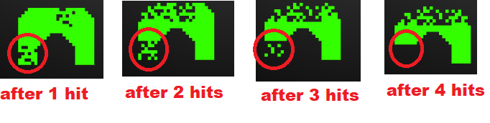

* Depending on how enemy fire hits the shield, the shield will break up into segments differently
* Player fire will also break apart the shield
* A  barrier can be shot at 40 times before completely disappearing
* For reference:

* Red circles indicate damage from player fire

**3.3.2.2 Functions**

* Act as a shield for the player character from enemy bullets
* The player will start off with 4 complete shields at the start of the level

**3.3.2.3 Messages**

* If possible, one of the 4 shields could be made to resemble the Brooklyn College library w/ the clock tower for College Invaders

**3.3.3 Class/Object 3 (Enemies (Admins))**

**3.3.3.1 Attributes (direct or inherited)**

* Movement: The college admins move horizontally across the screen, similar to the original Space Invaders game. They move in unison and change direction when they reach the edge of the screen. Enemies have a movement animation → <https://64.media.tumblr.com/c3e269f7c441828d7948847562557348/233bc3a97db6d4e4-d5/s1280x1920/2d6cd762173702eec80bcf8c49d2cf1f1ca67136.gif>

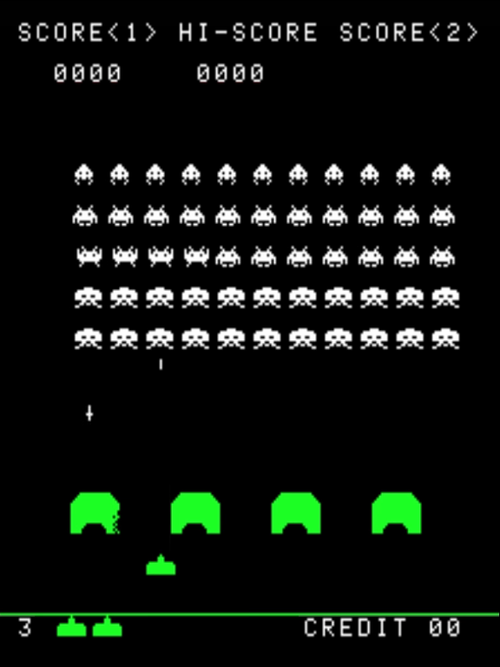

* Types of enemies: There could be different types of college admins, each with unique properties such as different health points, movement speed, firing rate, and projectile speed.

* Size: Enemies are the same size as the player
* Points: Enemies give different amounts of points depending on their position in the line. Lower enemies give 10 points. Middle enemies give 20. Upper enemies give 30.
* Difficulty levels: The behavior of the college admins could change based on the difficulty level selected by the player. For example, they may move faster, fire more frequently, or have more health points.

**3.3.3.2 Functions**

* Firing: The college admins fire projectiles at the player, similar to the original Space Invaders game. The frequency of firing may increase as the player progresses to higher levels.
* Arrangement: Enemies are arranged in 5 rows with 11 enemies per each row. If an enemy is killed, they won’t fill in any spaces, they’ll continue to stay in their own part of the line. The first 2 rows consist of lower enemies, the next 2 contain middle enemies, and the final row at the top has the upper enemies.

**3.3.4 Class/Object 4 (Special Enemy (The Trustee))**

**3.3.4.1 Attributes (direct or inherited)**

* Movement: the Trustee moves horizontally on the top of the Admins
  + From left to right or right to left; changes direction when reaches the edge of the screen
  + The moving speed of the Trustee is twice as fast as the Admins
* Health: one life
* Characteristics:
  + Shape: human shaped
  + Size: the size of the Trustee is 50% larger than the Admins
  + Color: the color of the Trustee is red (it can be the color of Brooklyn College)

**3.3.4.2 Functions**

* Action: the Trustee appears as the player reaches 250 points
* Score for player: the player gets 500 points when killed the Trustee
* Sound: When the Trustee defeats, it screams, the sounds of pain or anger; then exploded, and blood splatters on the background; the color of the blood is the same as its color

**3.3.5 Class/Object 5 (Sound)**

**3.3.5.1 Attributes (direct or inherited)**

* Gameplay Soundtrack
  + Should start as soon as a new game/session is launched and continue until the end of the game (when user input is no longer accepted and final score is shown).
  + Gameplay sound track should consist of notes in descending tone (higher pitch to lower pitch) in conjunction with a 4/4 time signature.  Google “metronome” for an example.  It should be a replication of a metronome going off at different pitches.
* User Weapon Sound-effect
  + Sound effect should be a futuristic sounding noise that can easily be identifiable/imaginable as a laser gun firing.
  + Only one sound effect is necessary.
  + This sound effect should be twice as loud as gameplay soundtrack
* College Admin Sound Effect Upon Destruction
  + Sound effect should sound like a muted explosion and length of sound should be 1.5 seconds
  + Should be as loud as gameplay soundtrack
* Player Sound Effect Upon Destruction
  + Should be identical to College Admin Sound Effect Upon Destruction
* Trustee Sound-effect Before Destruction/ During Gameplay
  + Continuous alarm like sound plays for as long as trustee is on screen
  + This sound effect should be twice as loud as gameplay soundtrack
* Trustee Sound Effect Upon Destruction
  + A four second scream will be played at the same time as the blood explosion animation when the trustee is destroyed.
  + This sound effect should be twice as loud as Gameplay Soundtrack
* Bell Tower Shield/Barrier Sound Effect Upon Destruction
  + When Bell Tower is destroyed a bell will chime three times
  + Each chime will be 1 second long

**3.3.5.2 Functions**

* Gameplay Soundtrack
  + Should start off at 50 beats per minute (BPM) and increase by increments of 15 BPM a total of 12 times.
  + Soundtrack should speed up only before enemy field gets one step closer to player
  + Soundtrack should continuous throughout entire session regardless of sound effects being played
* User Weapon Sound Effect
  + This sound should only play when the user presses input to fire weapon
* College Admin Sound Effect Upon Destruction
  + This sound should only play when the animation for a college admin being destroyed is shown
* Player Sound Effect Upon Destruction
  + This sound should only play when animation for player sprite being destroyed is shown
* Trustee Sound Effect Before Destruction/ During Gameplay
  + This sound effect should only play when trustee sprite is visible on screen and can be hit by player projectile
* Trustee Sound Effect Upon Destruction
  + This sound effect should only play when trustee destruction/blood splatter animation is played
* Bell Tower Shield/Barrier Sound Effect Upon Desctruction
  + This Sound effect should only be played when the bell tower is completely vanished
  + It should not play for any other animations including other shields/barriers being destroyed

**3.3.6 Class/Object 6 (Environment/Menus)**

**3.3.6.1 Attributes (direct or inherited)**

* Game Start Menu Environment: Nothing fancy. Something like a gateway to indicate we’re about to enter a college campus. Example:  
    
  A picture containing building, grate

  Description automatically generated
* Gameplay Environment: Again, nothing fancy. Maybe some grass at the bottom of the screen to indicate that we’re on campus (bottom of the screen so there aren’t any contrast issues with UI elements and player/enemy graphics) Example:  
  Background pattern

  Description automatically generated
* Gameplay Environment Border (new): A border indicating to the player where the gameplay environment ends and website background begins. If possible, the border on the sides can be made to look like two buildings e.g. Ingersoll Hall on the left and Boylan Hall on the right.
* Game Start Menu (UI): User interface for the start menu. Contains the following:
  + Name of the game
  + “Start game” text (the text can be anything as long as it indicates that clicking on it starts the game)
  + Score earned by defeating each enemy (see: [Space Invaders start menu](https://imgur.com/a/Vk58oUl))
  + Current high score
* Scoreboard (UI): User interface that allows players to look at previous high scores
  + Accessed from within the **Game Start Menu**
  + Scores ranked from highest to lowest
  + Date and time of when each score was recorded
  + Player’s username
* General Gameplay (UI): UI elements that we see during gameplay. Contains the following:
  + The player’s current session score
  + Number of player lives remaining
  + Small pop-up message when a new high score is earned (preferably at the top/side of the screen where it doesn’t get in the way of gameplay)
  + “Quit game” text (the text can be anything as long as it indicates that clicking on it exits the current game session)
  + Submenu for “Quit game” asking the player if they really want to quit
  + “Game Over” screen when the player runs out of live

**3.3.6.2 Functions**

* “Start game” (UI): Begins a brand new game session.
* Scoreboard (UI): Opens a menu separate from the **Game Start Menu** with previously recorded scores. Scores are entered at the end of every game session with the player being asked for their username. Scores are recorded whether the player quit the game or r
* an out of lives.
* “Quit game” (UI): While in-game, the player may choose to quit their current game session at any time. This exits the session and saves the player’s score.
* Pause game (UI): While in-game, the player may choose to pause their current game session at any time. Temporarily suspends processes and allows the player to resume with session progress intact.