

**Course Title: Operating Systems**

**Class: BSCS-5(A)**

|  |  |  |  |
| --- | --- | --- | --- |
| **Name:** | Muhammad Naeem Tahir | **Enrollment:** | 01-134202-117 |

**Assignment 03**

1. Suppose that we have 3 queues in the Multi-level feedback queue, 1st queue uses Round Robin with 3 quantum, 2nd queue have Round Robin scheduling with 6 quantum and 3rd queue uses FCFS scheduling. Show how the processes execute using Gantt chart. Calculate the average waiting and turnaround time.

|  |  |  |  |  |  |
| --- | --- | --- | --- | --- | --- |
| **Process** | **P1** | **P2** | **P3** | **P4** | **P5** |
| Burst Time | 11 | 04 | 14 | 09 | 21 |
| Arrival Time | 05 | 0 | 0 | 01 | 02 |

**Solution.**

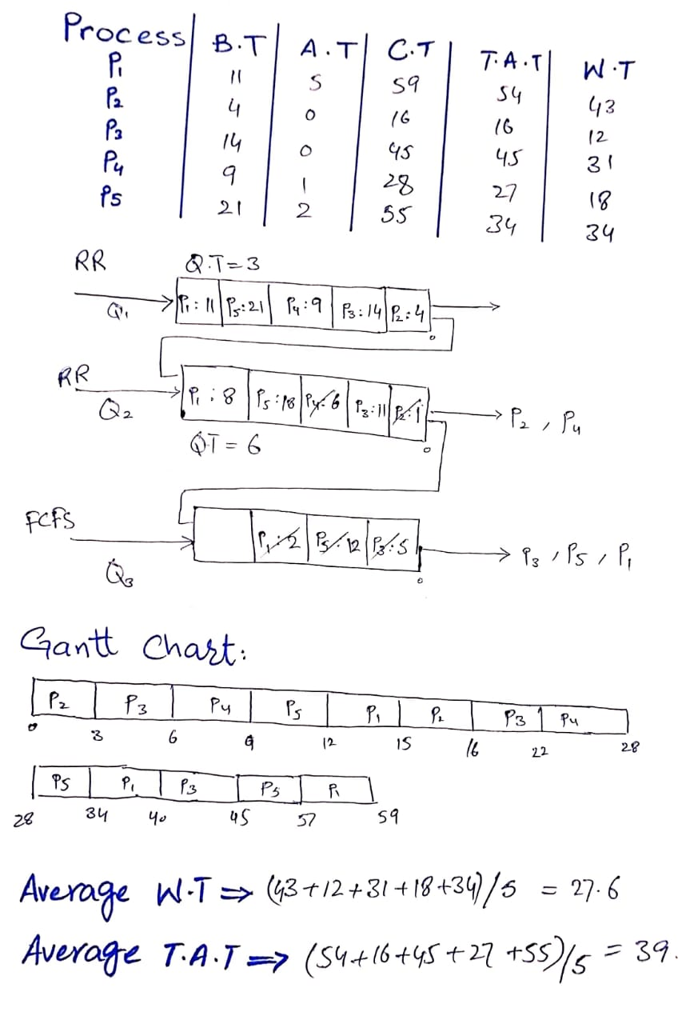

1. **Why is it necessary to synchronize the processes? And where we don’t need synchronization among the processes?**

**Solution.**

Process synchronization should be carried out to prevent data irregularity among processes, process deadlocks, and prevent race conditions, which are when two or more activities are executed simultaneously, not planned for the legitimate succession, and not left in the critical section accurately.

Synchronization is not needed when file is only being read.