BASERA
Development Master Plan & Phased Roadmap
What is built, what ships next, and exactly how to deploy Phase 1 to Railway and Netlify

Basera — Development Master Plan & Phased Roadmap
How Basera was built, what's already done, and exactly what's left to do — with Phase 1 scoped specifically to reach a live, deployable state on Railway (backend) and Netlify (frontend).
____________________________________________________________

1. Purpose of This Document
This is the single reference for planning and sequencing Basera's ongoing development. It merges the original phased roadmap, the deployment runbook, and every follow-up item surfaced during the rebrand audit and the legacy-document review into one prioritized plan. Pair this with the Feature & Requirements Specification (which describes what Basera does) — this document is about when and how it gets built and shipped.
____________________________________________________________

2. Architecture Recap
Layer | Technology | Hosting
Web frontend | React 19, Vite, Tailwind, Zustand | Netlify
Backend API | Node.js, Express 5, MongoDB/Mongoose, Socket.io | Railway
Database | MongoDB Atlas (free M0 tier) | MongoDB Atlas
Mobile app | Expo / React Native | Not yet published (Phase 2)
The platform's defining convention is dual-mode demo/live behaviour — every route falls back to realistic in-memory data when no database is connected, so the whole app is explorable before a single environment variable is set. Preserve this pattern for every future feature.
____________________________________________________________

3. Phased Roadmap Overview
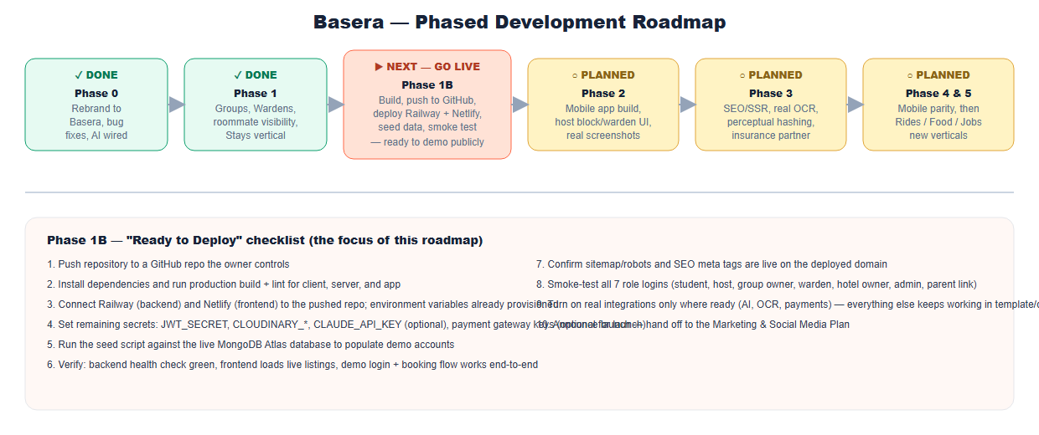
Phase | Status | Scope
Phase 0 — Rebrand & Foundation | ✅ Complete | Rebrand to Basera, bug fixes, first round of advanced features, cloud infrastructure provisioning
Phase 1 — SaaS Expansion | ✅ Complete | Hostel Groups, Blocks/Wardens, manual seat override, roommate visibility, Hotels & Guest Houses vertical, mobile app source tree
Phase 1B — Go Live | ▶ Next — this is the deployment milestone | Push to GitHub, build, deploy to Railway + Netlify, seed data, verify end-to-end
Phase 2 — Real Installed Build | ○ Planned | Mobile app build & store submission prep, host-facing block/warden UI, real screenshots
Phase 3 — Trust & Intelligence Hardening | ○ Planned | SEO/SSR, real OCR, perceptual-hash fraud detection, insurance partner, analytics
Phase 4 — Mobile App Feature Parity | ○ Planned | Bring the mobile app to parity with the web student experience, then extend to hosts
Phase 5 — New Verticals | ○ Planned | Rider booking, food ordering, job/internship board
____________________________________________________________

4. Phase 1B — "Ready to Deploy" Runbook (Do This Next)
This phase has one goal: get the current, fully-built codebase live on the internet, on the infrastructure already provisioned, so it can be demoed publicly and handed to real users.

4.1 What's already provisioned (no action needed)
MongoDB Atlas
- Organization Own, Project Basera, Cluster basera-cluster — free M0 tier, AWS us-east-1.
- Database user basera_app (readWrite scoped to the basera database only).
- Network access is open to 0.0.0.0/0 (still requires username/password) — tighten later to Railway's specific egress ranges if desired, via Atlas → Network Access.
Railway (backend)
- Project Basera, service basera-api, public domain already generated: https://basera-api-production.up.railway.app.
- Non-secret environment variables already set (client URL, escrow/commission/fee defaults, rate limits, map cache TTL, etc.) — see Appendix A for the full list.
- railway.json at the repo root already configures startCommand: npm run start --prefix server for this monorepo layout.
Netlify (frontend)
- Site basera-pk, URL once deployed: https://basera-pk.netlify.app.
- netlify.toml at the repo root already configures base=client, build=npm install && npm run build, publish=client/dist, SPA redirect, and security headers.
- Environment variables already set: VITE_API_URL, VITE_SITE_URL, VITE_ALLOW_DEMO_FALLBACK=false, VITE_SUPPORT_WHATSAPP.

4.2 Deployment architecture
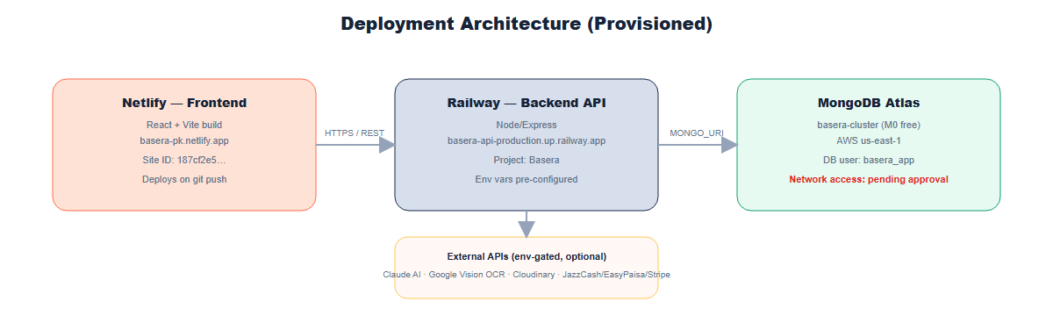

4.3 Step-by-step checklist
- Push the code to a GitHub repository you control. The repo's current Git remote points to a repository that is not yours — do not push there. From your own machine:
bash
cd path\to\Hostel_Hub
git remote set-url origin https://github.com/<your-username>/<your-new-repo>.git
git add -A
git commit -m "Basera: rebrand, features, and Phase 1 SaaS expansion"
git push -u origin main
- Install and build locally first, to catch anything a build step would catch:
bash
npm install --prefix client && npm run build --prefix client && npm run lint --prefix client
npm install --prefix server
- Connect Railway to the pushed repo. Railway dashboard → Basera project → basera-api service → Settings → Source → connect your GitHub repo. railway.json already handles the monorepo root/start command — no manual path configuration should be needed.
- Connect Netlify to the pushed repo. Netlify dashboard → basera-pk → Site configuration → Build & deploy → Link repository → connect the same repo. netlify.toml already handles the build path.
- Add the remaining secrets directly in each dashboard (never share these in chat with an AI assistant or paste them into a document):
- Railway → basera-api → Variables: JWT_SECRET (long random string, never reused from the database password), CLOUDINARY_CLOUD_NAME / CLOUDINARY_API_KEY / CLOUDINARY_API_SECRET, CLAUDE_API_KEY (optional — activates real AI features), OCR_API_KEY + OCR_PROVIDER=google-vision (optional), payment gateway keys (optional for a soft launch — the platform runs fully in demo-payment mode without them), VAPID_PUBLIC_KEY / VAPID_PRIVATE_KEY, CRON_SECRET.
- Netlify → basera-pk → Environment variables: confirm VITE_ENABLE_CLIENT_DEMO_LOGIN=false is saved (a prior connector hiccup stopped this from saving automatically).
- Trigger the first deploy on both services (push-to-deploy takes over automatically once connected).
- Seed demo data against the live database once the backend is reachable:
bash
npm run seed --prefix server
This populates the demo accounts (student@basera.pk, landlord@basera.pk, owner@basera.pk, admin@basera.pk, warden@basera.pk, all password password123) into the real database.
- Verify:
- Backend health check: https://basera-api-production.up.railway.app/api/v1/health
- Frontend loads real listings (not just the offline fallback) at https://basera-pk.netlify.app
- A demo login and full booking flow works end to end
- The AI concierge responds (once CLAUDE_API_KEY is set)
- Smoke-test all seven role logins (student, independent host, hostel group owner, warden, hotel/guest-house owner via /host/stays, admin, and the parent share-link flow) using the Demo Guide for All Roles document.
- Hand off to marketing — once verified live, proceed to the Marketing & Social Media Plan for launch content.

4.4 Rollback / safety notes
- Rotate the Atlas database password if it is ever pasted into an insecure channel (Atlas → Database Access).
- Do not skip setting a strong, unique JWT_SECRET — the codebase currently warns loudly if it's missing in production but does not refuse to boot, so this is a manual must-do, not an automatic safeguard.
- Payment gateway keys, CLAUDE_API_KEY, and OCR_API_KEY are all optional at launch — every feature they power has a documented, working fallback, so a soft launch without them is a legitimate choice, not a broken deployment.
____________________________________________________________

5. Working Conventions for Whoever Builds the Next Phase
- Always support both demo and live mode. Check mongoose.connection.readyState === 1; fall back to an in-memory array otherwise. This is not optional polish — it's how the entire platform stays explorable without a database.
- Contact gating is a deliberate trust mechanism, not an oversight. Any new feature that connects two users should default to withholding direct contact details until there's a real commitment, unless there's a specific, documented reason not to (as with short-stay guest bookings).
- New "AI" features must be genuinely gated and genuinely optional. Follow the aiService.js pattern: env-key-gated, timeout-bounded, silent fallback to deterministic logic on any failure. Never claim AI/ML behaviour that's actually a fixed heuristic.
- Every new page needs a route in client/src/App.jsx and, where relevant, a nav entry. Several features have historically been "backend-complete, not yet linked from the main dashboard nav" — an easy thing to leave half-done.
- Reconcile, don't silently pick, when historical specs disagree (SaaS tier names/pricing, commission tiers) — see the Feature Specification's Monetization section for the specific conflicts to resolve.
____________________________________________________________

6. Phase-by-Phase Backlog

Phase 2 — Real Installed Build
- npx expo install --fix inside app/ to reconcile dependency versions against Expo SDK 51.
- Export real PNG icon/splash assets from client/public/logo.svg for the mobile app.
- Take real screenshots of the running app, replacing the illustrative diagrams in this document set.
- Add a host-facing UI for creating blocks and assigning wardens (POST/PUT /api/v1/blocks already supports this server-side; only the warden-side dashboard was built in Phase 1).
- Add a "My Properties" link to the host dashboard for the Stays manager (/host/stays is currently only reachable by direct URL).
- Prepare Apple App Store / Google Play Store submission materials.

Phase 3 — Trust & Intelligence Hardening
- Server-side rendering or static prerendering for public marketing/listing pages, so search engines index Basera properly (highest-impact item on this list).
- Move duplicate-photo detection from the coarse fallback hash to true perceptual hashing (npm install sharp), and add address-matching as the second half of duplicate-listing detection.
- Onboard a real OCR provider (OCR_API_KEY, Google Vision) to replace the current metadata-only document check.
- Extend real Claude usage to any newly added AI-adjacent surfaces.
- If pursued, onboard a real deposit-insurance underwriting partner to replace the current pilot/fee-only version.
- Add product analytics (GA4 or PostHog) — currently no event tracking is implemented; Sentry error tracking exists but is optional/unconfigured.
- Build the SEO content hub (city/university guide articles) and register Google Business Profile + Search Console.
- Wire SMS (Twilio) for OTP and rent-reminder escalation, and add the /auth/refresh-token and /auth/reset-password flows specified in the original plans but not yet built.
- Implement the SuperHost reduced-commission tier and the auto-triggered Loyalty/Early-Bird/Last-Minute discount types.
- Give property_manager and finance roles (already present in the User schema) real, scoped dashboards, or remove them from the schema if they're not going to be pursued.
- Consider self-hosting OSRM/Overpass on Railway if map traffic grows beyond what the public instances comfortably serve.

Phase 4 — Mobile App Feature Parity
Bring the mobile app to parity with the web app's student experience (saved searches, chat, documents/receipts, push notifications via the existing VAPID setup), then extend it to hosts with a lightweight app for booking requests and messaging on the go.

Phase 5 — New Verticals (the "Coming Soon" features)
Each of these is close to its own product, not a Basera feature extension, and should get its own focused planning pass (data model, moderation approach, monetization) before implementation begins:
- Rider booking — likely a thin integration with an existing ride-hailing API/partner rather than building dispatch logic from scratch; scope as "get a ride to campus."
- Food ordering — start with hostel mess-menu partners (the mess-menu rating system already exists) before expanding to nearby restaurants.
- Job seeker — part-time/internship listings targeted at the same student base, plausibly monetizable via employer-paid listings, reusing the existing verification/trust infrastructure to vet employers.
____________________________________________________________

7. Risk Register / Known Follow-Ups
Risk | Recommended Action
JWT_SECRET unset in production | Set before go-live; server warns but does not refuse to boot
Atlas DB password exposure | Rotate immediately via Atlas → Database Access if ever shared insecurely
SPA has no server-side rendering | Prioritize in Phase 3 — currently limits organic search visibility
SaaS tier naming/pricing inconsistent across historical docs | Resolve explicitly (see Feature Spec §7.2) rather than leaving ambiguous
Deposit Protection is not underwritten | Keep UI copy explicit that this is a pilot/platform-backed add-on, not licensed insurance, until a partner is onboarded
Legacy .docx planning documents | Superseded by this document set; archived out of the active repository (see the top-level README)
____________________________________________________________

Appendix A — Environment Variables Reference (Non-Secret Defaults)
Variable | Purpose
ESCROW_HOLD_HOURS | Hours after move-in before payout releases (default 48)
COMMISSION_RATE_DEFAULT | Platform commission on bookings (default 0.07)
STUDENT_SERVICE_FEE_PKR | Flat per-booking service fee
LATE_FEE_PKR | Recurring rent late fee
DEPOSIT_PROTECTION_FEE_RATE / _CAP_PKR | Optional deposit-protection add-on pricing
OFF_PLATFORM_REPORT_CREDIT_PKR | Incentive credit for reporting off-platform payment attempts
BASERA_MANAGEMENT_FEE_PKR | Host subscription management fee
RICKSHAW_FARE_PER_KM | Used in commute/fare estimate cards
MAP_CACHE_TTL_HOURS, OSRM_BASE_URL, OVERPASS_BASE_URL | Map intelligence configuration
AI_PROVIDER, CLAUDE_API_KEY | AI feature gating
OCR_PROVIDER, OCR_API_KEY | Real ID-document OCR gating
ALLOW_DEMO_MODE, VITE_ALLOW_DEMO_FALLBACK | Dual-mode demo/live toggles
Secrets (never store in a document — set directly in the Railway/Netlify dashboards): JWT_SECRET, CLOUDINARY_*, payment gateway keys (JAZZCASH_*, EASYPAISA_*, STRIPE_*), VAPID_PUBLIC_KEY/VAPID_PRIVATE_KEY, CRON_SECRET.

