BASERA
Demo Guide for Every Role
A plain-language, step-by-step walkthrough for demoing Basera to any audience

Basera — Demo Guide for Every Role
A plain-language, step-by-step walkthrough of what to show and say when demonstrating Basera to anyone — an investor, a potential host, a university administrator, or a family. No technical background needed. Every feature described below works today in "demo mode," with no database or setup required.
____________________________________________________________

How to Use This Guide
Basera serves seven different kinds of people, and each one sees a different side of the same platform. Pick the role that matches who you're demoing to — or use the "Full Combined Demo Flow" at the end for a single 15–20 minute walkthrough that touches every role in one narrative.
All demo accounts use the password password123.
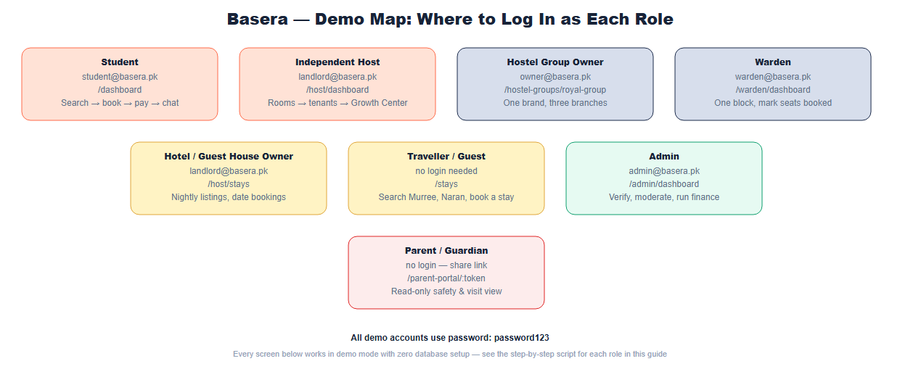
Role | Login Email | Demo Entry Point
Student | student@basera.pk | /dashboard
Independent Host / Landlord | landlord@basera.pk | /host/dashboard
Hostel Group Owner | owner@basera.pk | /hostel-groups/royal-group
Warden | warden@basera.pk | /warden/dashboard
Hotel / Guest House Owner | landlord@basera.pk (same host login) | /host/stays
Admin | admin@basera.pk | /admin/dashboard
Parent / Guardian | no login needed | a share link generated by a student
____________________________________________________________

Role 1: Student — "I need a safe place to live near my university"
Who this is: An outstation student or young professional moving to a new city for university or work, worried about being scammed, ending up with a bad roommate, or paying a deposit for a room that doesn't match its photos.
What Basera solves for them: A search experience where every listing carries real verification, rent is held safely until move-in, and — uniquely — they can see what kind of person they'd be rooming with before ever committing.
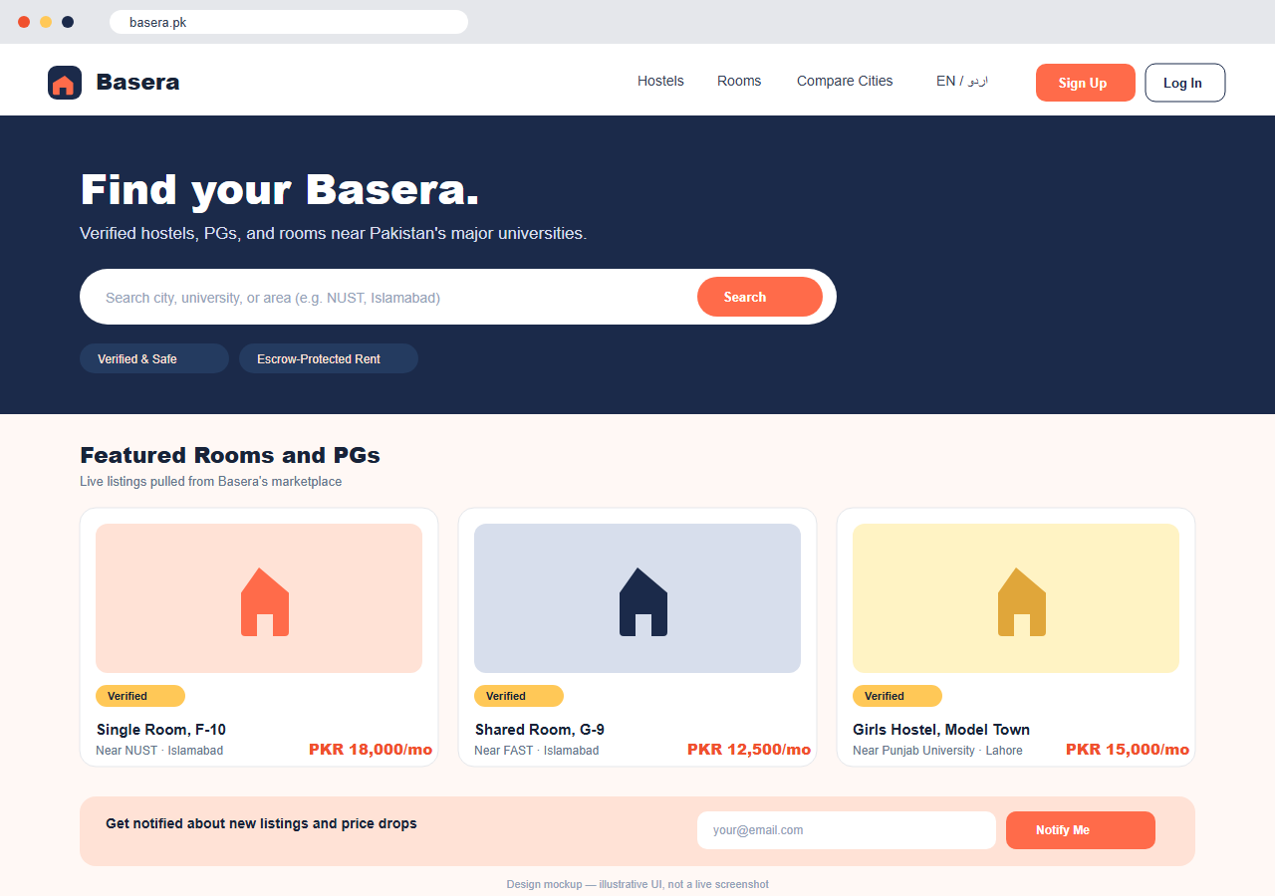
Demo script:
1. Open the homepage with no login. Point out the listings are real (pulled live from the platform, not placeholder content), and the "Verified & Safe" / "Escrow-Protected Rent" badges in the hero section.
2. Search a city or university (try "NUST" or "Royal" — the latter demonstrates Hostel Groups, surfacing every branch of a chain under one badge).
3. Open a room with existing occupants and scroll to the Roommates panel:
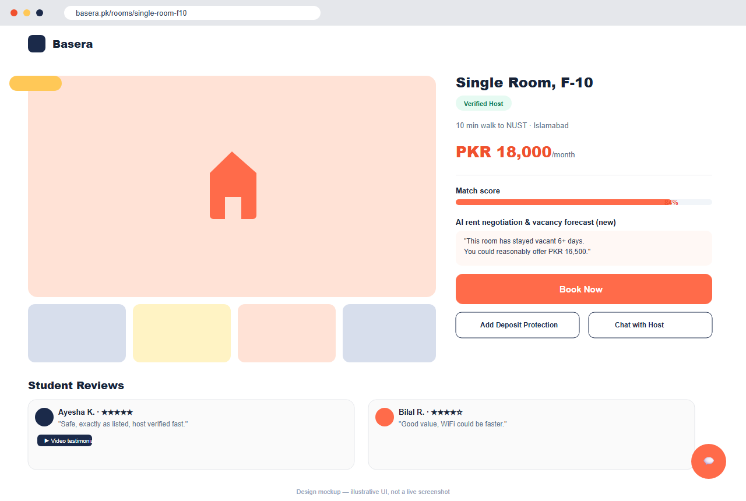
- Log in as student@basera.pk and open the Dashboard:
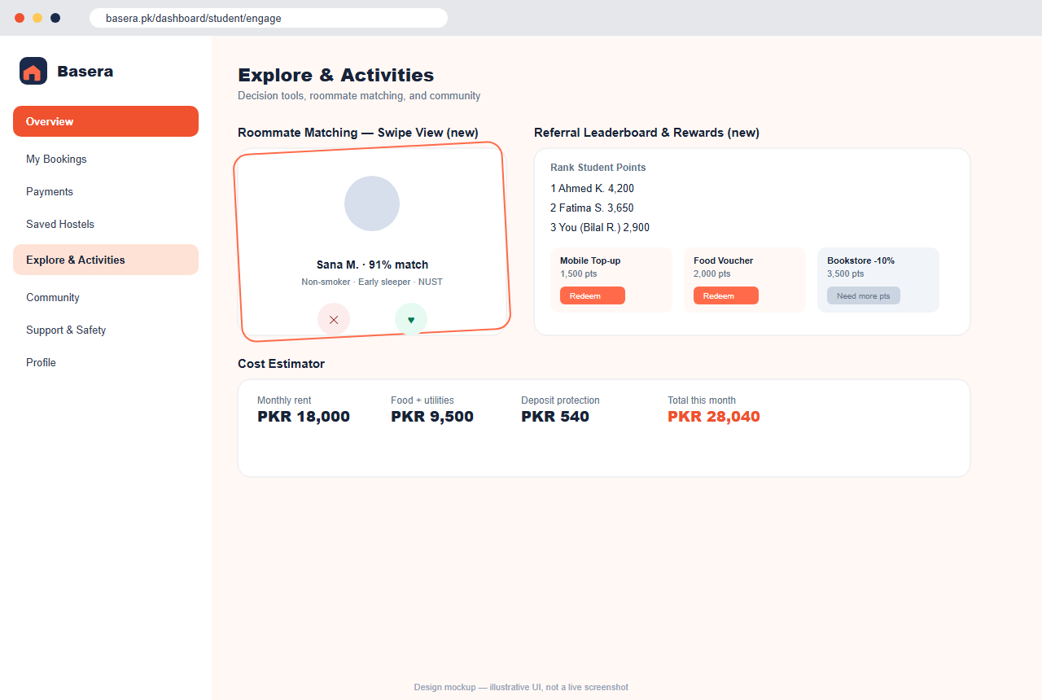
- Walk through starting a booking — point out that the host's phone/email stay hidden until payment, and the optional Deposit Protection add-on at checkout.
- Open the AI concierge and ask something like "What documents do I need to book a room?" — if CLAUDE_API_KEY is configured, this is a real AI response, not a scripted chatbot.
Be upfront if asked: Deposit Protection is a real fee/claims flow on the platform side, but not yet backed by a licensed insurance underwriter.
____________________________________________________________

Role 2: Independent Host / Landlord — "I want to fill my rooms faster and get paid reliably"
Who this is: Someone who owns or manages one hostel, PG, or a handful of rooms and currently relies on word of mouth or informal listings.
What Basera solves for them: A dashboard that fills vacancies, prices rooms intelligently, and guarantees payment without them having to chase tenants for rent.
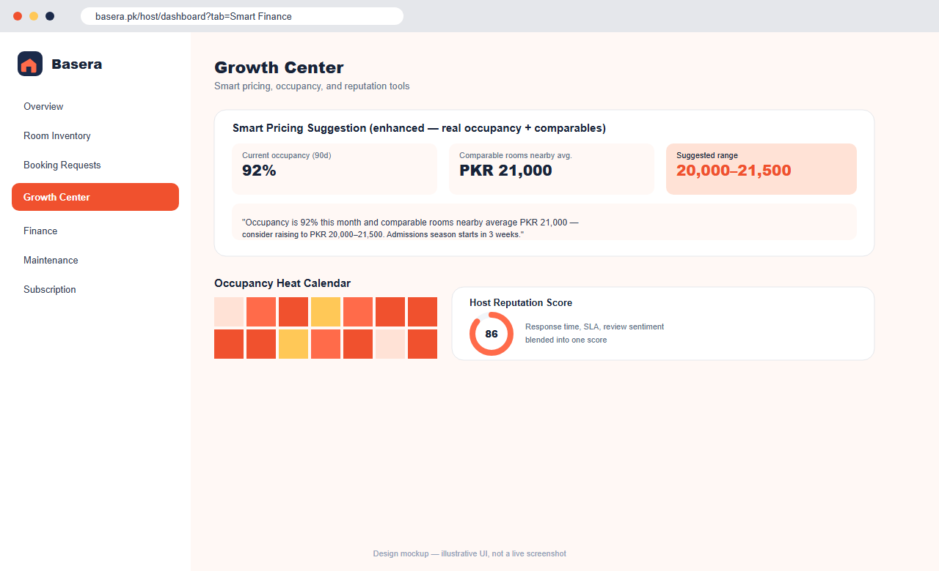
Demo script:
1. Log in as landlord@basera.pk and open the Growth Center.
2. Show the Smart Pricing card — explain that it reads out a plain-language explanation, not just a number, based on actual occupancy and nearby comparable prices.
3. Show the room inventory, tenant list, and finance/ledger view.
4. Point out the SaaS subscription tiers (Starter/Pro/Premium) for hosts who want more visibility and tools.
Be upfront if asked: SaaS tier pricing is still being finalized — don't quote specific PKR figures until the pricing page is published.
____________________________________________________________

Role 3: Hostel Group Owner — "I run multiple hostels under one brand"
Who this is: An owner or operator with several hostel branches across one or more cities, who wants to be recognized as a trusted, established brand rather than a series of unrelated listings.
What Basera solves for them: A single verified identity for the whole chain, so searching for the brand name surfaces every branch, and each branch benefits from the group's collective reputation.
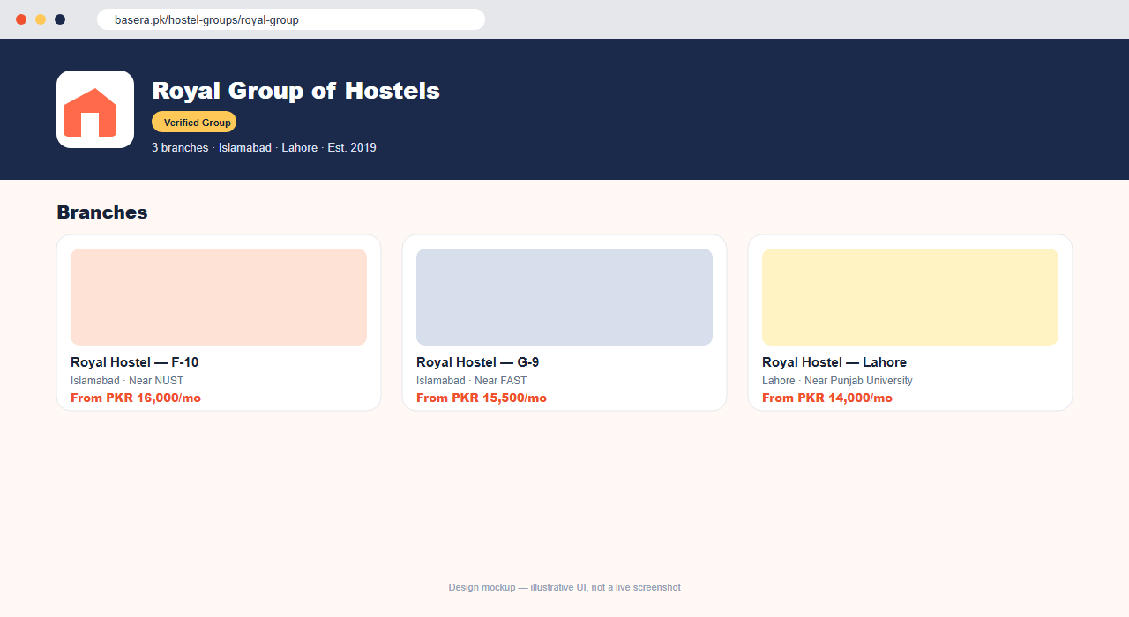
Demo script:
1. From the homepage, search "Royal" — every branch of Royal Group of Hostels appears in results.
2. Click through to /hostel-groups/royal-group to show the branded group page listing all branches with their own pricing and location.
3. Log in as owner@basera.pk to show the property listing flow a group owner uses to attach a new branch hostel to their existing group.
The pitch to a real group owner: "List your whole chain under one verified brand on Basera" — this is as much a B2B acquisition tool as a student-facing feature.
____________________________________________________________

Role 4: Warden — "I manage one block of a larger hostel day-to-day"
Who this is: Staff responsible for a specific physical section (block) of a larger property — not the owner, and not authorized to see or manage the rest of the property.
What Basera solves for them: A focused dashboard scoped only to their block, plus a way to record real-world situations (like a seat filled through an informal, off-platform arrangement) without needing the owner to re-list anything.
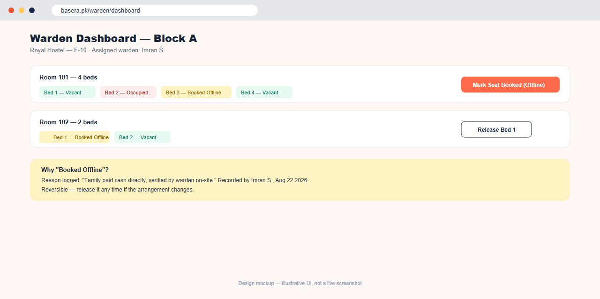
Demo script:
1. Log in as warden@basera.pk and open /warden/dashboard — note that only their assigned block's rooms and seats are visible (this is enforced by the server, not just hidden in the interface).
2. Demonstrate Mark Seat Booked (Offline): click it on a vacant bed, enter a reason (e.g. "family paid cash directly, verified on-site"), and show it turn into the distinct amber "Booked Offline" state.
3. Click Release to show the action is fully reversible.
The real-world problem this solves: seats filled through informal arrangements no longer show as falsely available online, without needing a full re-listing cycle.
____________________________________________________________

Role 5: Hotel / Guest House Owner — "I rent out a property nightly, not monthly"
Who this is: An owner of a guest house, hotel, or short-stay property in a tourist destination (Murree, Naran, etc.) — a different business from student housing, but one that benefits from the same trust infrastructure.
What Basera solves for them: Access to the same verification and booking system as the student marketplace, tailored for nightly rates and date-range bookings instead of monthly rent.
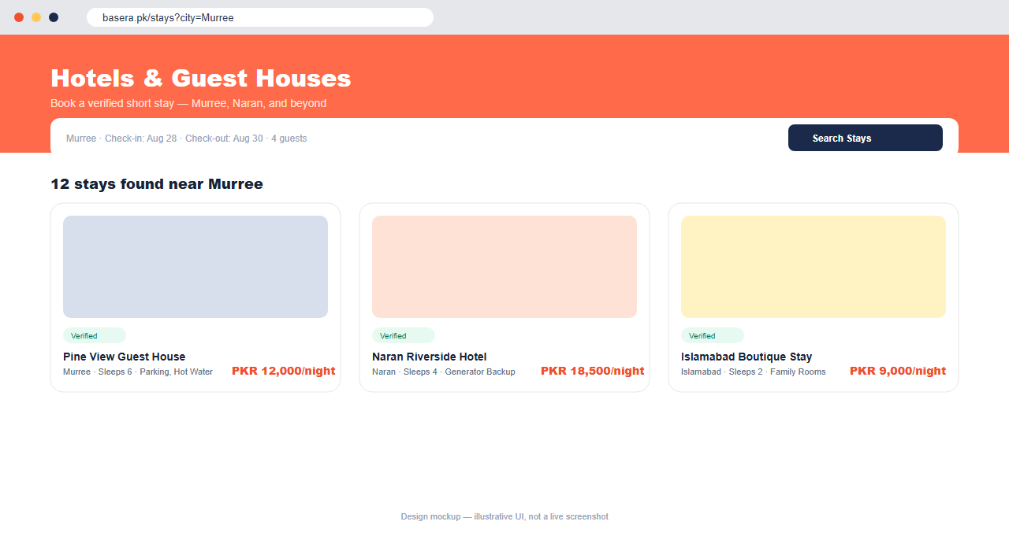
Demo script:
1. Navigate to /stays and search "Murree." Point out the nightly-rate cards, deliberately styled differently from the monthly student listings.
2. Open a property and show the date-range booking form.
3. Log in with the host account and open /host/stays to show the owner-facing manager for these listings.
Be upfront if asked: unlike the student flow, guest contact is shared at booking time rather than gated — a deliberate choice given the shorter, lower-risk nature of a 1–3 night stay, not an inconsistency.
____________________________________________________________

Role 6: Admin / Trust & Finance Ops — "I keep the whole platform honest"
Who this is: Internal Basera staff responsible for verifying new listings, resolving disputes, and monitoring the platform's finances.
What Basera solves for them: A command center for everything that keeps the marketplace trustworthy — without this role, none of the trust promises made to students and hosts would be enforceable.
Demo script:
1. Log in as admin@basera.pk and open /admin/dashboard.
2. Show the verification queue (new hosts/listings awaiting approval), the finance command room (escrow balances, payout approvals), and the dispute resolution workflow.
3. Show the trust center — moderation queues, review classification, and the incident timeline.
____________________________________________________________

Role 7: Parent / Guardian — "I want reassurance without micromanaging"
Who this is: A parent who wants visibility into their child's living situation without needing an account or having to personally verify anything.
What Basera solves for them: A read-only view, shared by the student on their own terms, showing safety-relevant information without requiring the parent to learn a new platform.
Demo script:
1. From the student dashboard, show the Parent Share Link feature being generated.
2. Open that link in a private/incognito window to show the parent's read-only view — safety summary, visit scheduling, no ability to message the host or make changes.
3. Note the bilingual English/Urdu toggle, which today is most fully built out on this specific portal.
____________________________________________________________

Full Combined Demo Flow (~15–20 minutes)
Use this sequence when presenting to a single audience that wants the whole story, not just one role:
- Open with the problem (2 min). Land on the homepage with no login. Point out real listings and trust badges — this is the trust-first framing that differentiates Basera from informal Facebook-group room hunting.
- Search and discovery (2 min). Show city/university filtering, the map view, and search "Royal" to demonstrate Hostel Groups.
- Roommate visibility — the differentiator (3 min). Open a shared room, show the Roommates panel, then log in as a student to show how visibility is controlled (including the opt-out toggle).
- Booking and escrow (2 min). Walk through starting a booking, contact gating, the Deposit Protection add-on, and the escrow explanation.
- Warden Dashboard — operational trust (2 min). Show the manual seat-booked override and its reversibility.
- Host side: Growth Center (2 min). Show Smart Pricing reasoning from real data.
- Hotels & Guest Houses — the new vertical (2 min). Search "Murree," show the nightly booking flow.
- AI concierge (1 min). Ask a real question and call out that it's a genuine AI response, not a script.
- Close on the mobile app and roadmap (2 min). Mention the "Coming Soon" placeholders (rider booking, food ordering, job seeker) as visible proof the platform is built to grow.
____________________________________________________________

Things to Be Upfront About, Across Every Demo
- Deposit Protection is a real fee/opt-in/claims flow on the platform side, but not yet backed by a licensed insurance underwriter — say so plainly rather than overclaiming coverage.
- AI-labeled scoring features (DNA score, trust score, vacancy forecast) are legitimate deterministic calculations, not machine learning — only the concierge, listing-description, finance-anomaly, dispute-summary, and review-classifier features call a real AI model, and only when an API key is configured.
- The mobile app is a complete, real source tree, not yet installed, built, or published — a good one-liner: "the app is written and ready to run; the app-store submission is the next phase."
- Hotel/guest-house guest contact is shared at booking time (not gated like the long-term student flow) — a deliberate choice given the shorter, lower-risk nature of a short stay.
____________________________________________________________

If Presenting Against a Real Live Deployment
Confirm beforehand:
- The Railway backend health check returns OK: https://basera-api-production.up.railway.app/api/v1/health
- Demo data has been seeded (npm run seed --prefix server) so the accounts above actually exist in the live database rather than only in in-memory demo mode.
- The frontend at https://basera-pk.netlify.app loads real listings, not just the offline fallback.
See the Development Master Plan for the full deployment checklist if any of the above isn't yet true.

