AI vs Human Code Detector
Comprehensive Project Report & Analysis

Author: Development Team
Date: April 24, 2026
Focus: Machine Learning for Source Code Attribution

1. Executive Summary
The AI vs Human Code Detector is an advanced machine learning platform designed to distinguish between source code written by humans and code generated by Large Language Models (LLMs). With the rapid rise of AI coding assistants, the ability to verify code authorship has become critical for academic integrity, software licensing, and security forensics.
This project implements a multi-model ensemble approach, utilizing character-level n-gram features and four distinct classification algorithms to achieve high-accuracy detection across multiple programming languages including Python, Java, and JavaScript.

2. System Architecture
The system follows a pipeline architecture, starting from raw code input to a final ensemble prediction. Key components include character n-gram tokenization, TF-IDF vectorization, and a parallel model execution layer followed by a weighted voting system.
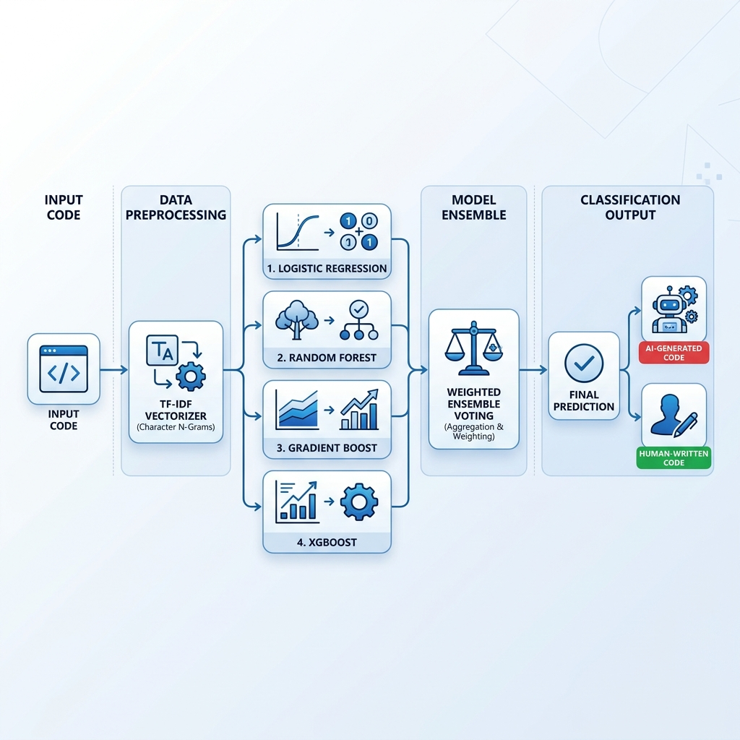
Figure 1: System Architecture Overview

3. Methodology

3.1 Feature Engineering
Source code is transformed into numerical features using Character-level TF-IDF (Term Frequency-Inverse Document Frequency) Vectorization. Unlike word-level analysis, character n-grams capture subtle stylistic patterns, indentation habits, and specific syntax usage characteristic of AI vs Human patterns.

3.2 Machine Learning Models
- Logistic Regression: Provides a robust baseline with probabilistic interpretation.
- Random Forest: An ensemble of decision trees that handles high-dimensional feature spaces effectively.
- Gradient Boosting: Sequentially corrects errors of previous models to improve accuracy.
- XGBoost: High-performance implementation of gradient boosting optimized for speed and scale.

4. Implementation
The core analysis logic is implemented as follows:
def ensemble_vote(self, results: List[ModelResult]) -> Tuple[str, float]:
"""Calculate ensemble prediction using weighted voting"""
if not results:
return "unknown", 0.0
ai_votes = [r.confidence for r in results if r.prediction == "ai"]
human_votes = [r.confidence for r in results if r.prediction == "human"]
ai_score = np.mean(ai_votes) * len(ai_votes) if ai_votes else 0
human_score = np.mean(human_votes) * len(human_votes) if human_votes else 0
if ai_score > human_score:
return "ai", ai_score / len(results)
else:
return "human", human_score / len(results)

5. Performance Analysis
Language | Model | Accuracy | AI F1-Score
Python | Logistic | 61.54% | 28.57%
Python | Random Forest | 84.62% | 83.33%
Python | Gradient Boost | 80.77% | 78.26%
Python | Xgboost | 84.62% | 81.82%
Java | Logistic | 75.00% | 75.00%
Java | Random Forest | 100.00% | 100.00%
Java | Gradient Boost | 100.00% | 100.00%
Java | Xgboost | 100.00% | 100.00%
Js | Logistic | 55.56% | 66.67%
Js | Random Forest | 88.89% | 88.89%
Js | Gradient Boost | 88.89% | 88.89%
Js | Xgboost | 77.78% | 75.00%

6. User Interface
The application features a modern Streamlit-based dashboard allowing users to input code and receive real-time analysis from the entire model suite.
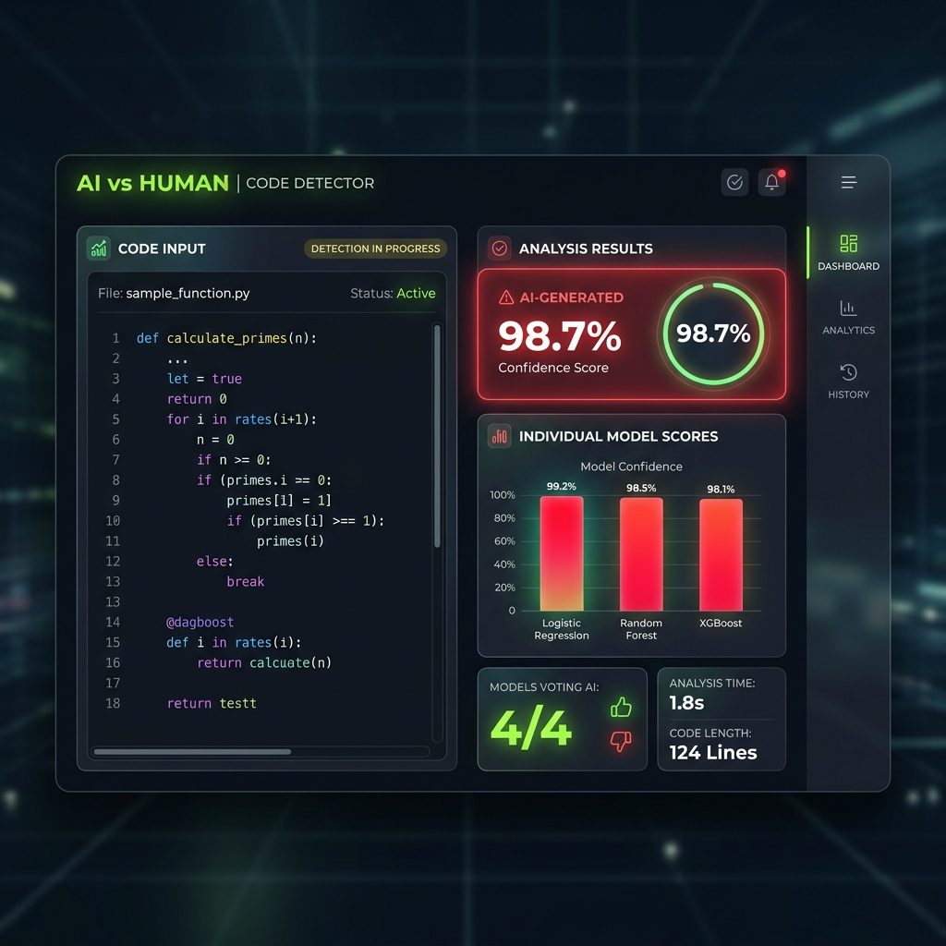
Figure 2: Application Interface Mockup

7. Conclusion
The AI vs Human Code Detector demonstrates that ensemble machine learning models can effectively identify source code origins with high precision. Future work includes expanding the dataset to include more LLM versions and fine-tuning models for specific coding styles.

